Appendices
STEP 4: Total papers at the end, under study
32 studies assessed for full text eligibility
STEP 1: The search query
-Search strings:
ecolabel* AND food AND business, OR ecolabel* AND food AND management, OR eco-label* AND food AND business, OR eco-label* AND food AND management, OR ‘sustainab* label*’ AND food AND business, OR ‘sustainab* label*’ AND food AND management, OR ‘Eco-friendly label*’ AND food AND business, OR ‘Eco-friendly label*’ AND food AND management, OR ‘environmental label’ AND food AND business; OR ‘environmental label’ AND food AND management.
In titles, abstracts, or keywords.

-Document type ‘article, review article, letter, and note’
Study period: 2002–2022
Databases: Web of Science Core Collection

-Questions emerge in our study
RQ1. What is the structure of research on food eco-labels in the business and management research domains?
RQ2. What are the research gaps in the existing literature, and what are avenues for future research in the field of food eco-labels in these domains?

STEP 2: Documents exclusively in outlets related to ‘business’ research and ‘management’ research areas
Total = 79

WoS in ‘Business’ category= 62 WoS in ‘Management’ category= 17
STEP 3: Exclusion criteria
Papers discarded for not being aligned with the research focus: 25
Papers that were duplicated: 19
Papers that were literature reviews: 3

Figure A.1. Inclusion and exclusion criteria
Source: Authors’ elaboration

Figure A.2. Annual scientific production. Source: Authors’ elaboration
Source: Authors’ elaboration

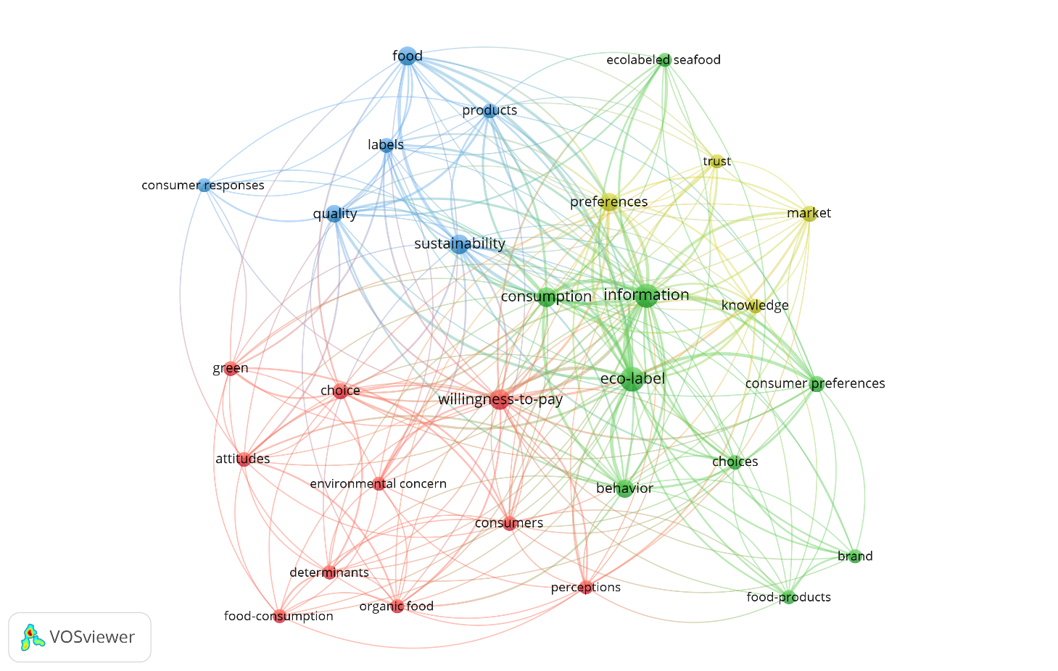
Figure A.3. Co-occurrence of keywords analysis
Source: Authors’ elaboration

Table A.I. Principal journals. Source: Author's elaboration based on WoS

R | Journal | H | TC | TP | TC/TP | Q | JCR Category
1 | International Journal of Consumer Studies | 3 | 202 | 4 | 50,5 | Q2 | Business in SSCI
2 | Business Strategy and the Environment | 3 | 102 | 3 | 34 | Q1 | Business in SSCI
3 | Journal of Business Research | 3 | 60 | 3 | 20 | Q1 | Business in SSCI
4 | Journal of Consumer Affairs | 2 | 246 | 2 | 123 | Q4 | Business in SSCI
5 | Journal of Retailing and Consumer Services | 2 | 12 | 3 | 4 | Q1 | Business in SSCI

Note: Minimum of two publications to be considered in the ranking. Database: WoS
Q= quartile; JCR Category= Journal Citation Reports Category; TP = total papers; TC = total citations; C/Y = citations per year; R = rank; H = h-index.
Source: Authors' elaboration

Table A.II. Country and their total number of citations. Countries’ level of scientific effort

Country | TC | TP | TC/TP | GDP*2022
US | 682 | 13 | 52,5 | $23,149.01 billion
Denmark | 220 | 2 | 110,0 | $405.01 billion
Netherlands | 219 | 2 | 109,5 | $1,141.21 billion
France | 169 | 2 | 84,5 | $3,532.91 billion
UK | 143 | 5 | 28,6 | $3,478.51 billion
Italy | 104 | 5 | 20,8 | $3,179.64 billion
Spain | 74 | 2 | 37,0 | $2,301.29 billion
South Korea | 62 | 2 | 31,0 | $2,881.11 billion
Canada | 37 | 2 | 18,5 | $2,105.77 billion
Australia | 22 | 2 | 11,0 | $1,457.17 billion
Norway | 17 | 2 | 8,5 | $424.22 billion
Note: GDP: Gross domestic product, from World Economics. TP = total papers, TC = total citations, C/Y = citations per year.
Source: Authors’ elaboration

Table A.III. Ten most-cited papers
R | Source Title | Title | Author | TC | Year | C/Y
1 | International Journal of Research in Marketing | Willingness to pay for organic products: Differences between virtue and vice foods | Van Doorn, J; Verhoef, PC | 218 | 2011 | 21,8
2 | European Journal of Marketing | Consumer responses to ecolabels | Thøgersen, J; Haugaard, P; Olesen, A | 214 | 2010 | 19,5
3 | Journal of Consumer Affairs | Will consumers pay a premium for eco-labeled apples? | Loureiro, ML; McCluskey, JJ; Mittelhammer, RC | 211 | 2002 | 11,1
4 | International Journal of Consumer Studies | Consumers' perceptions of individual and combined sustainable food labels: a UK pilot investigation | Sirieix, L; Delanchy, M; Remaud, H; Zepeda, L; Gurviez, P | 140 | 2013 | 17,5
5 | Journal of Business Ethics | Third-Party Certification, Sponsorship, and Consumers' Ecolabel Use | Darnall, N; Ji, H; Vazquez-Brust, DA | 73 | 2018 | 24,3
6 | Business and Society | Eco-Premium or Eco-Penalty? Eco-Labels and Quality in the Organic Wine Market | Delmas, MA; Lessem, N | 61 | 2017 | 15,3
7 | Journal of Environmental Economics and Management | Can household consumers save the wild fish? Lessons from a sustainable seafood advisory | Hallstein, E; Villas-Boas, SB | 57 | 2013 | n/a
8 | International Journal of Advertising | The impact of consumer confusion from eco-labels on negative WOM, distrust, and dissatisfaction | Moon, SJ; Costello, JP; Koo, DM | 46 | 2017 | n/a
9 | Business Strategy and the Environment | Sustainable Development and the Consumer: Exploring the Role of Carbon Labelling in Retail Supply Chains | Hornibrook, S; May, C; Fearne, A | 42 | 2015 | 7,0
10 | Journal of Consumer Affairs | The Effect of Information on Willingness to Pay for Canned Tuna Fish with Different Corporate Social Responsibility (CSR) Certification: A Pilot Study | De Magistris, T; Del Giudice, T; Verneau, F | 39 | 2015 | 6,5
Note: Based on the WoS (January 2023), C/Y: Total number of citations divided by the number of years since article publication. R: Ranking, ordered by number of sites. Source: Author's elaboration4.1.1 Co-occurrence of keywords analysis
Source: Authors' elaboration
Table A.IV. Co-occurrence Keywords
Ranking | Keyword | Cluster Number | Links | Occurrences | Total Link Strength
1 | information | 2 | 27 | 16 | 82
2 | eco-label | 2 | 26 | 17 | 77
3 | consumption | 2 | 25 | 9 | 54
4 | willingness-to-pay | 1 | 26 | 10 | 49
5 | sustainability | 3 | 21 | 9 | 44
6 | preferences | 4 | 21 | 7 | 40
7 | behavior | 2 | 20 | 7 | 39
8 | food | 3 | 17 | 8 | 35
9 | quality | 3 | 17 | 6 | 31
10 | consumer preferences | 2 | 15 | 5 | 27
Note: Minimum co-occurrence of keywords = 3. Of 275 keywords, 29 met the threshold.
Source: Authors’ elaboration

Table A.V. Theories in foods eco-label research in business and management domain outlets
Theories | Author
Cue utilisation theory | Orlowski et al. (2022)
Signalling theory | Sigurdsson et al. (2022)
TPB | Chen (2020); Siraj et al. (2022)
Attribution theory | Legendre and Coderre (2018)
Cognitive theory | Darnall et al. (2018)
Consumers' lay theories | Cho and Baskin (2018)
Information overload theory | Moon et al. (2017)
Persuasion knowledge model, identity-based motivation theory | Zepeda et al. (2013)
Source: Authors' elaboration
Table A.VI. Consumer-related antecedents featured in food eco-label research
Variable | Authors
Consumer attitude toward a sustainability label | Chen (2020); Eldesouky et al. (2020); Kwak et al. (2020); Siraj et al. (2022)
Consumers' knowledge about eco-labels | Lee et al. (2020); Sirieix et al. (2013); Thøgersen et al. (2010)
Consumer preferences regarding eco-label products/sustainability certification | Canavari and Coderoni (2019); De Canio et al. (2021)
Consumers' environmental concerns | Delmas and Lessen (2017); Van Doorn and Verhoef (2011)
Consumer environmental attitudes | Kwak et al. (2020); Loureiro et al. (2002); Van Doorn and Verhoef (2011)
Consumer health attitudes/consumers' health consciousness | Van Doorn and Verhoef (2011)
Consumer perception of shared characteristics of food labels | Chen et al. (2023)
Consumers' preference for sustainable retailers | De Canio et al. (2021)
Consumers' perceptions of environmental labels | Eldesouky et al. (2019)
Consumer preferences, the importance of price | Canavari and Coderoni (2019)
Consumers' Green consumption values | Sigurdsson et al. (2022)
Consumer confusion (Similarity, overload, and ambiguity) | Moon et al. (2017)
Source: Authors' elaboration

Table A.VII. Dependent variables in food eco-label research in business and management domains
Variable | Authors
Attitude toward eco-labels | de Brabandere et al. (2022); Donato and Adıgüzel (2022); Gidlöf et al. (2021).
Perception toward eco-labels | Amos et al. (2019); Ischen et al. (2022); Moon et al. (2017); Sirieix et al. (2013).
Purchase Intention | Chen (2020); Cho and Baskin (2018); de Brabandere et al. (2022); De Canio et al. (2021); D’Souza et al. (2021); Lee et al. (2020); Orlowski et al. (2022).
Purchase Behaviour | Darnall et al. (2018); Eldesouky et al. (2019); Hallstein and Villas-Boas (2013) Hornibrook et al. (2015); Siraj et al. (2022); Thøgersen et al. (2010).
Source: Authors' elaboration

Table A.VIII. Data analysis methods employed in food eco-label research in business and management domains

Method | Authors
Frequency analysis | Zepeda et al. (2013)
ANOVA | Cho and Baskin (2018); Gidlöf et al. (2021); Ischen et al. (2022); Kwak et al. (2020); Lee et al. (2020)
MANCOVA | Amos et al. (2019); Ertz et al. (2017)
Regression analysis | Canavari and Coderoni (2019); Delmas and Lessen (2017); Kwak et al. (2020); Van Doorn and Verhoef (2011)
Regression analysis TOBIT / LOGIT | Chen et al. (2023); de Magistris et al. (2015); Darnall et al. (2018); Limnios et al. (2016); Loureiro et al. (2002)
Moderation regression analysis | Chen (2020); De Brabandere et al. (2022); Orlowski et al. (2022); Thøgersen et al. (2010)
Mediation regression analysis | Chen (2020); Donato and Adıgüzel (2022); Moon et al. (2017); Sigurdsson et al. (2022)
Structural equation model | De Canio et al. (2021); D’Souza et al. (2021); Legendre and Coderre (2018); Siraj et al. (2022)
Differences in Differences analysis | Hallstein and Villas-Boas (2013)
Source: Authors’ elaboration

