APPENDIX A - MEASUREMENT OF THE VARIABLES

Construct | Items
Dynamic capabilities | α =0.931  Sensing capability  The firm continually expands its portfolio of technological competencies.  The firm promotes internal knowledge development through R&D&I.  The firm works to identify and acquire external knowledge.  The firm continuously scans the environment to identify trends in its relevant technologies.  The firm, is able to process and assimilate external knowledge and combine it with internal knowledge to usefully apply it to new applications.  Seizing capability  The firm has the capacity to exploit and apply knowledge to the development of product innovations.  The firm has the capacity to exploit and apply knowledge to the development of process innovations.  The firm effectively integrates new technological knowledge with the existing knowledge base.  Transforming capability  The firm continually renews its innovation management approaches and practices to improve its competitiveness.  The firm strives to improve its innovation management in order to increase its ability to adapt to changes in the environment.  The firm continuously analyses the redesign and reconfigurations of its technology management processes to optimize their alignment with changes in the environment.  The firm continuously adjusts its management of R&D&I to meet the needs and opportunities arising from new technologies or new markets.
Coordination and cohesion capabilities | α =0.941  The firm has introduced systems to enrich the experience of working, such as variety in the work, autonomy in the preparation and undertaking of the work, information about results of the work, extension of tasks, or rotation of jobs.  The firm encourages internal cooperation and teamwork.  Employees do not feel a sense of personal commitment to quality*.  There is an interest in the training and development of staff members.  The firm has introduced flexible ways or organising that enhance employees’ autonomy and encourage decentralisation in decision-making.  Organisational processes are elastic and flexible.  Members of the firm identify with its values and culture.  Managers continually support employees’ initiatives and suggestions.  There is intense horizontal and inter-functional communication in the firm.  Staff members are generally committed to the achievement of the firm’s mission, objectives and strategy.  Staff are aware of the firm’s mission and objectives.  The firm encourages cross-functional or inter-departmental teams to solve specific problems.
Environmental performance | α =0.897  Reduction in the consumption of materials for service provision.  Reduction in energy consumption for service provision.  Reduction in the time required for service provision.  Reduction in the environmental impact.  Improvement of equipment efficiency.

Source: own elaboration

APPENDIX B

RESIDUAL ANALYSIS

 | Minimum | Maximum | Mean | Std. deviation
Predicted value | 1,6391 | 6,0289 | 3,6187 | ,67041
Residual | -3,67029 | 3,95986 | ,00000 | 1,21402
Std. predicted value | -2,953 | 3,595 | ,000 | 1,000
Std. residual | -3,001 | 3,238 | ,000 | ,993

Source: own elaboration

HOMOCEDASTICITY

Scatterplot of standardized predicted value by standardized residual

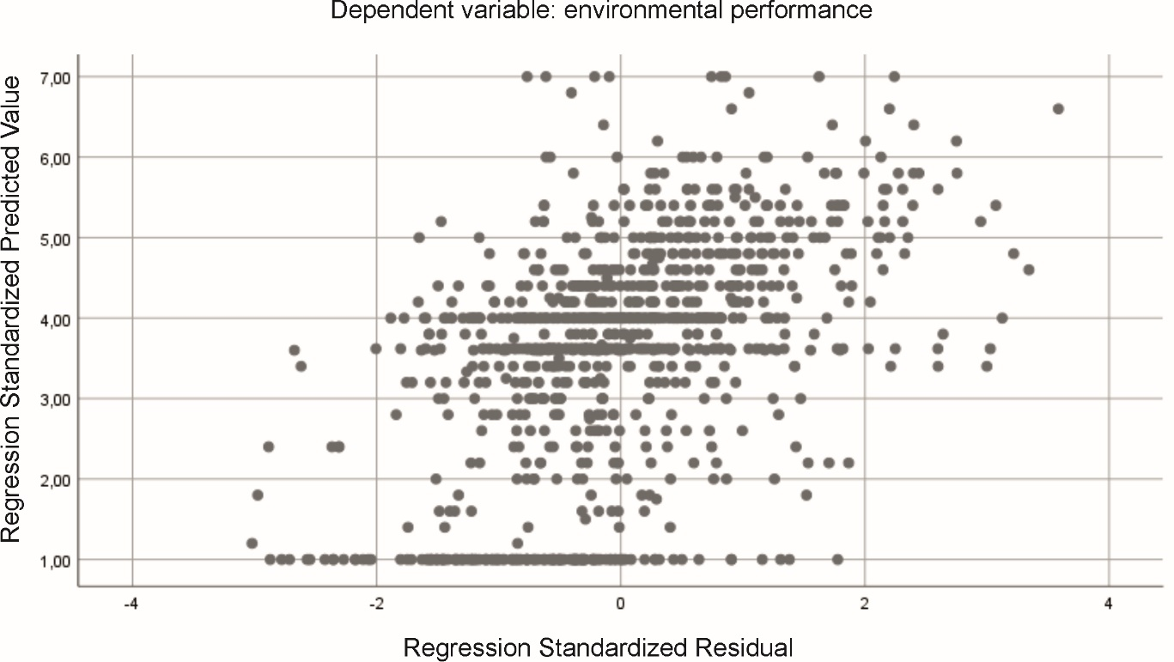

Source: own elaboration

NORMALITY

Histogram of standardized residual

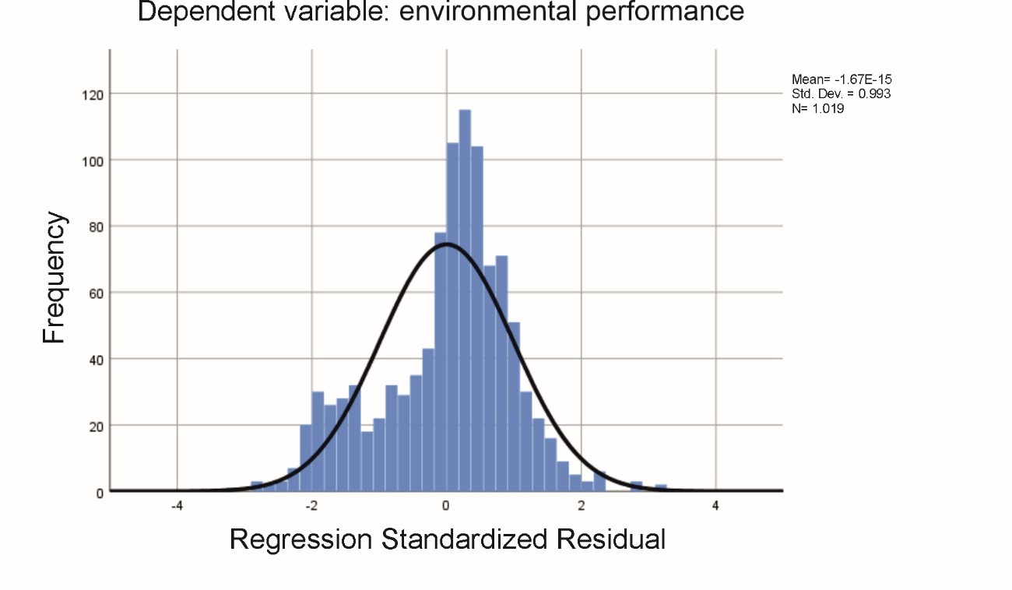
Source: own elaboration

Normal probability plot of standardized residual

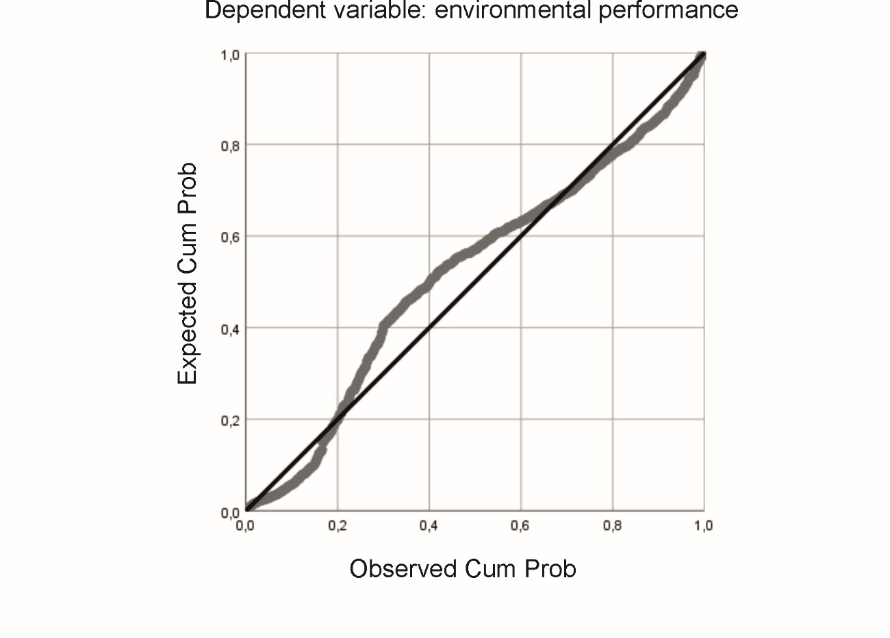
Source: own elaboration

