Duty Orientation

Supervisor-provided Resources
Organisational Justice

H1
H2
H3
H4

Appendix A: Conceptual framework of the relationships among organisational justice, supervisor-provided resources and duty orientation
Source: Figure by authors

Appendix B: Profile of Respondents
Variable | Option | Frequency | Percentage
Gender | Males | 188 | 64.6
 | Females | 103 | 35.4
Age | 18-30 | 57 | 19.6
 | 31-45 | 199 | 68.4
 | 46-60 | 31 | 10.7
 | 60 above | 4 | 1.4
Experience | Less than 2 years | 75 | 25.8
 | 3-5 | 71 | 24.4
 | 6-8 | 37 | 12.7
 | 9 and above | 108 | 37.1
Source: Table by authors

Appendix C: Measurement items
Items
Procedural Justice
The following items refer to the procedures used to arrive at your work outcome. To what extent:
Have you been able to express your views and feelings during those procedures?
Have you had influence over the (outcome) arrived at by those procedures?
Have those procedures been applied consistently?
Have those procedures been free of bias?
Have those procedures been based on accurate information?
Have you been able to appeal the (outcome) arrived at by those procedures?
Distributive Justice
The following items refer to your work outcome. To what extent:
Have those procedures upheld ethical and moral standards?
Does your (outcome) reflect the effort you have put into your work?
Is your (outcome) appropriate for the work you have completed?
Does your (outcome) reflect what you have contributed to the organization?
Is your (outcome) justified, given your performance?
Interpersonal justice
The following items refer to (the authority figure who enacted the procedure). To what extent:
Has (he/she) treated you in a polite manner?
Has (he/she) treated you with dignity?
Has (he/she) treated you with respect?
Has (he/she) refrained from improper remarks or comments?
Informational justice
The following items refer to (the authority figure who enacted the procedure). To what extent:
Has (he/she) been candid in (his/her) communications with you?
Has (he/she) explained the procedures thoroughly?
Were (his/her) explanations regarding the procedures reasonable?
Has (he/she) communicated details in a timely manner?
Has (he/she) seemed to tailor (his/her) communications to individuals' specific needs?
Supervisor-provided resources
My supervisor provides complete information to me
My supervisor gives me the things I need to do my job
My supervisor makes time to help me out when needed
My supervisor thinks highly of me
My supervisor likes working with me.
My supervisor is confident in my abilities
My supervisor increases my pay
My supervisor gets me a rise in my activity.
My supervisor increases my financial compensation.
Duty orientation
I put the interests of my team ahead of my personal interests
I do all that I can to support the organization
I am faithful to my team members
I am loyal to my leaders and team
I accept personal risk or loss in support of the mission/organisation goals
I make personal sacrifices to serve the mission/organisation goals
I do whatever it takes to not let the mission/organisation goals fail
I get the job done under the toughest conditions
I do what is right always
I demonstrate personal integrity when challenged
I will not accept dishonour
I set the example for honorable behaviour for others
Source: Table by authors

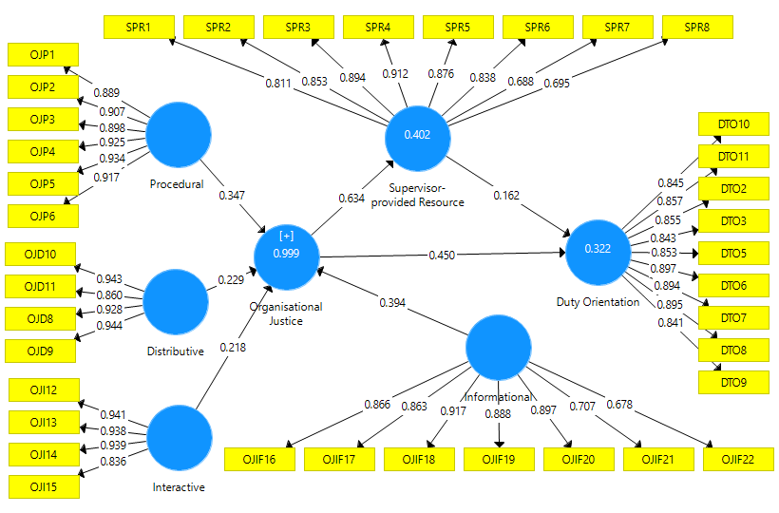
Notes: a) R² of 0.999 on OJ is derived from IJ, ItJ, DJ and PJ; b) R² of 0.322 on DO is derived from OJ & SPR; and c) R² of 0.402 on SPR is derived from OJ.
Appendix D: Specified PLS-SEM model
Source: Figure by authors

