ONLINE SUPPLEMENTARY MATERIAL

Description and Rationale for the Eye-Tracking Metrics Used in the Study

One fundamental metric is fixation count (FC), which measures the total number of times a participant fixates on a specific area. Higher fixation counts may indicate visual appeal or cognitive difficulty, prompting repeated inspection for better understanding. Wedel and Pieters (2008a) reported that FC correlates with visual attention and consumer interest. However, FC alone is a general measure and must be complemented with additional metrics related to cognitive processing (Holmqvist et al., 2011). Therefore, this study also included fixation duration (FD, in milliseconds) and pupil dilation (PD, measured as pupil’s diameter, in millimeter) as additional measures.

FD measures the time spent fixating on a specific area. Longer fixations suggest deeper cognitive processing or greater interest, whereas shorter fixations may indicate quick decision-making or low engagement. Rayner (1998) noted that longer fixations are associated with complex evaluative processes, such as comparing product options. Pieters and Wedel (2004) found that FD is a strong predictor of brand recognition in print advertising. In studies where stimulus duration is controlled, FC and FD often show an inverse relationship (Ernst and Wolfe, 2022).

PD reflects changes in pupil size in response to visual or emotional stimuli. Typically, dilation increases with emotional arousal or cognitive load or effort. Research has established that pupil size serves as an indicator of attentional processes and cognitive effort in consumer interactions (e.g., Deltomme et al., 2018; Kiefer et al., 2016). Furthermore, PD is linked to neural processes related to approach-avoidance behaviour and emotional arousal. Increased pupil dilation can indicate heightened interest or a positive emotional response. Bradley et al. (2008) demonstrated that PD is strongly correlated with emotional engagement, making it a valuable metric in sensory and emotional marketing research.

Metrics such as time to first fixation (TFF) and fixations before (FB) were not included, as they depend on predefined areas of interest (AOIs). In contrast, this study assessed overall visual attention to the full image, starting from the moment the stimulus was fully presented, rather than focusing on specific regions.

References

Bradley, M. M., Miccoli, L., Escrig, M. A. and Lang, P. J. (2008), “The pupil as a measure of emotional arousal and autonomic activation”, Psychophysiology, Vol. 45 No. 4, pp. 602-607. https://doi.org/10.1111/j.1469-8986.2008.00654.x
Deltomme, B., Mertens, G., Tibboel, H. and Braem, S. (2018), “Instructed fear stimuli bias visual attention”, Acta Psychologica, Vol. 184, pp. 31-38. https://doi.org/10.1016/j.actpsy.2017.08.010
Ernst, D. and Wolfe, J. M. (2022), “How fixation durations are affected by search difficulty manipulations”, Visual Cognition, Vol. 30 No. 5, pp. 339-353. https://doi.org/10.1080/13506285.2022.2063465
Holmqvist, K., Nyström, M., Andersson, R., Dewhurst, R., Jarodzka, H. and Van de Weijer, J. (2011), Eye tracking: A comprehensive guide to methods and measures, Oxford University Press, Oxford.
Kiefer, P., Giannopoulos, I., Duchowski, A. T. and Raubal, M. (2016), “Measuring cognitive load for map tasks through pupil diameter”, in Miller, J., O'Sullivan, D. and Wiegand, N. (Ed.s), Proceedings of the Ninth International Conference on Geographic Information Science (GIScience 2016), Vol. 9927, Springer, Cham, pp. 323-327.
Pieters, R. and Wedel, M. (2004), “Attention capture and transfer in advertising: brand, pictorial, and text-size effects”, Journal of Marketing, Vol. 68 No. 2, pp. 36-50. https://doi.org/10.1509/jmkg.68.2.36.27794
Rayner, K. (1998), “Eye movements in reading and information processing: 20 years of research”, Psychological Bulletin, Vol. 124 No. 3, pp. 372-422.
Wedel, M. and Pieters, R. (2008a), “A review of eye-tracking research in marketing”, in Malhotra, N.K. (Ed.), Review of Marketing Research, Emerald, Vol. 4, pp. 123-147. https://doi.org/10.1108/S1548-6435(2008)0000004009

Table A1. Multivariate tests for FD, PD and FC.
Effect | Value | F | d.f.1 | d.f.2 | Sig. | Eta squared | Observed power
Brightness | .206 | 46.50 | 6 | 232 | < .001 | .546 (0.828*) | 1.000
Images | .470 | 16.88 | 45 | 2623,95 | < .001 | .223 (.986*) | 1.000
Images*Brightness | .900 | 2.106 | 90 | 5291.84 | < .001 | .034 | 1.000
Complexity | .322 | 29.50 | 6 | 232 | < .001 | .433 (.798*) | 1.000
Images | .450 | 17.98 | 33 | 1906.89 | < .001 | .234 (.939*) | 1.000
Images*Complexity | .590 | 11.34 | 66 | 3884.00 | < .001 | .161 | 1.000
The tables in this section have been prepared with the help of SPSS
*eta squared value in MANOVA test.

Table A2. Linear regression 1, 2 and 3 results
Dependent variable | Predictor | β | t | p
Pleasant lightning (LR1) | FD_D | .486 | 4.363 | < .001***
Pleasant lightning (LR1) | FC_N | .496 | 4.451 | < .001***
General tidiness (LR 2) | FD_M | .919 | 3.589 | .001***
General tidiness (LR 2) | FC_M | .494 | 4.700 | < .001****
General tidiness (LR 2) | FD_H | −.431 | −1.690 | .097*
Interior layout quality (LR 3) | FD_L | .416 | 1.962 | .055*
Interior layout quality (LR 3) | FC_L | .470 | 5.055 | < .001****
Interior layout quality (LR 3) | FD_M | .575 | 2.469 | .017**
Interior layout quality (LR 3) | FD_H | −.472 | −1.995 | .051*
Notes: FD = Fixation duration; FC = Fixation count; D = Dark brightness condition; N = Neutral; L = Low complexity condition; M = Medium complexity condition; H = High complexity condition. Backward stepwise regression. ****p < .001; ***p < .01; **p < .05; *p < .10.
LR1: linear regression results predicting perceived pleasant atmospheric lighting.
LR2 and LR3: linear regression results predicting perceived general orderliness, in terms of general tidiness and interior layout quality, respectively.

Figure A1. Images of home interiors, categorized into four types of rooms

BATHROOM
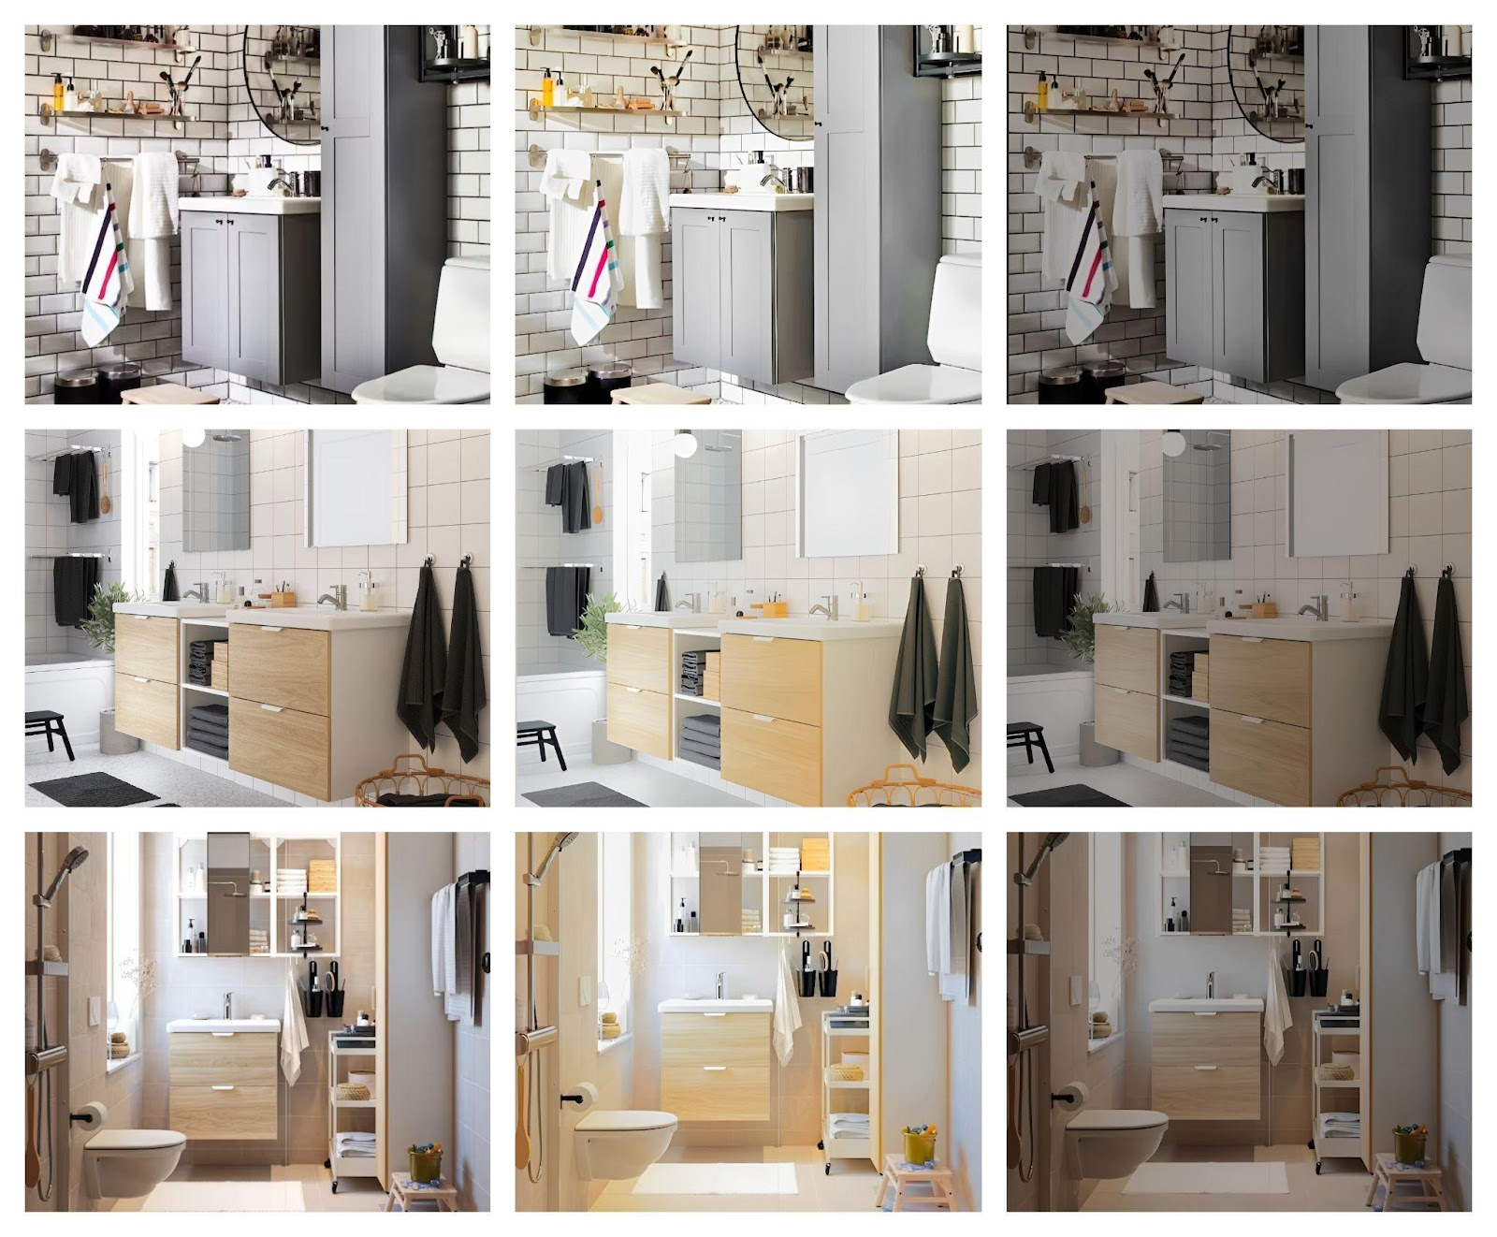

KITCHEN
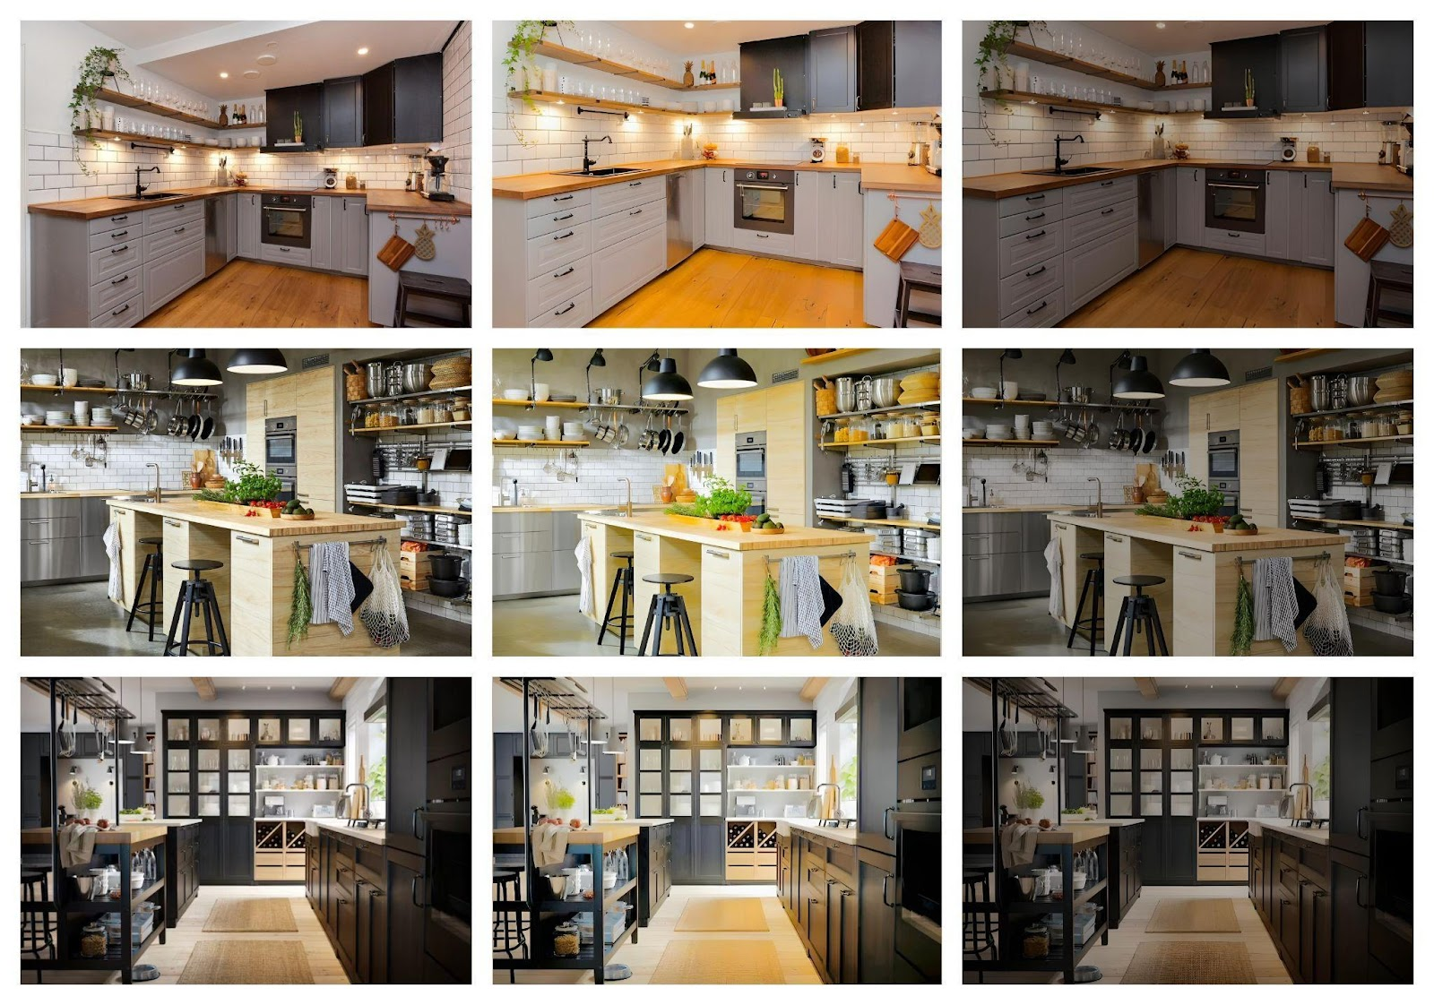
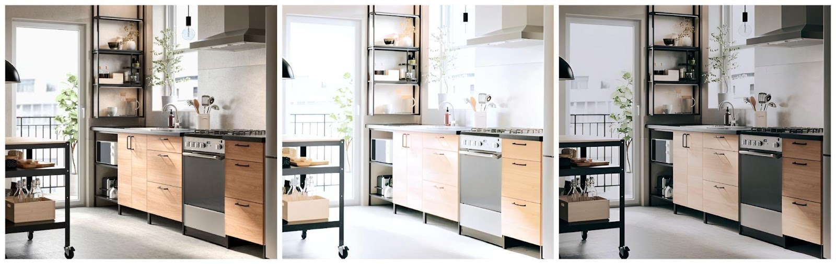
BEDROOM
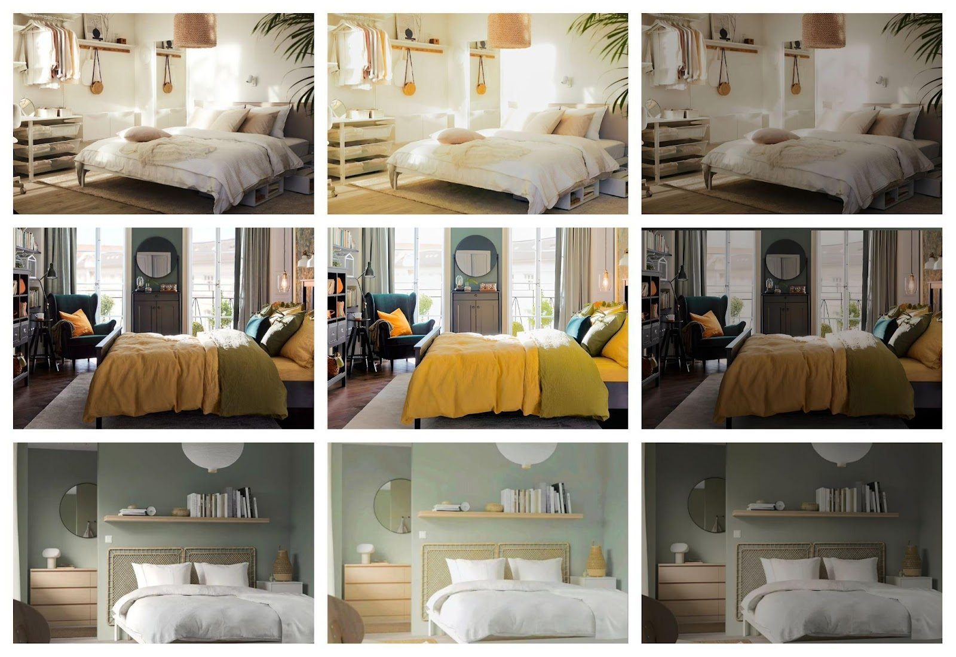


LOUNGE
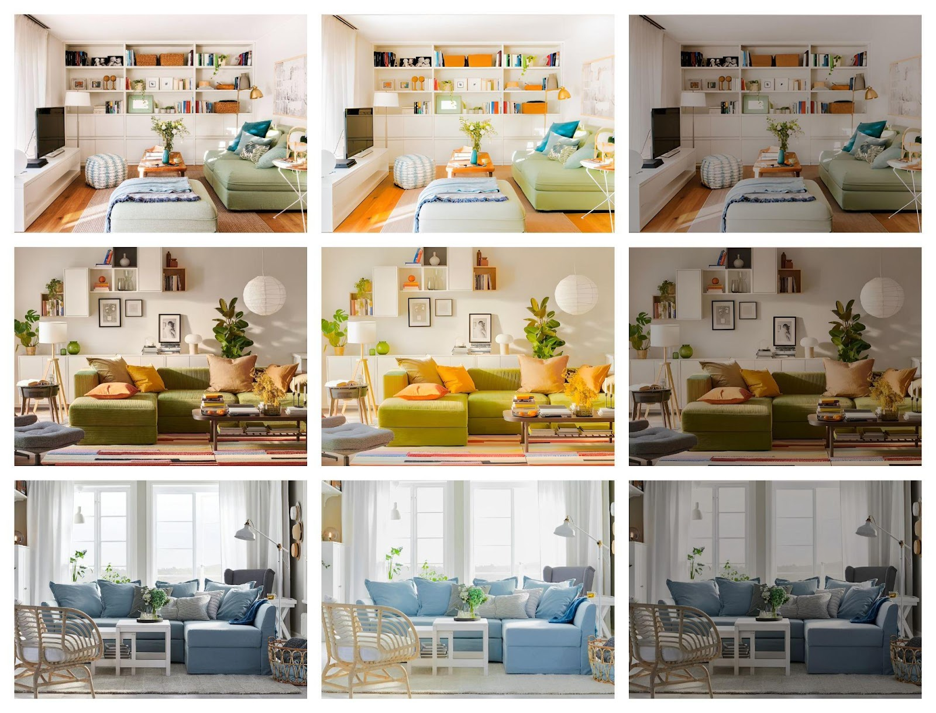

Figure A2. Practical, theoretical and interdisciplinary implications for furniture e-retailing
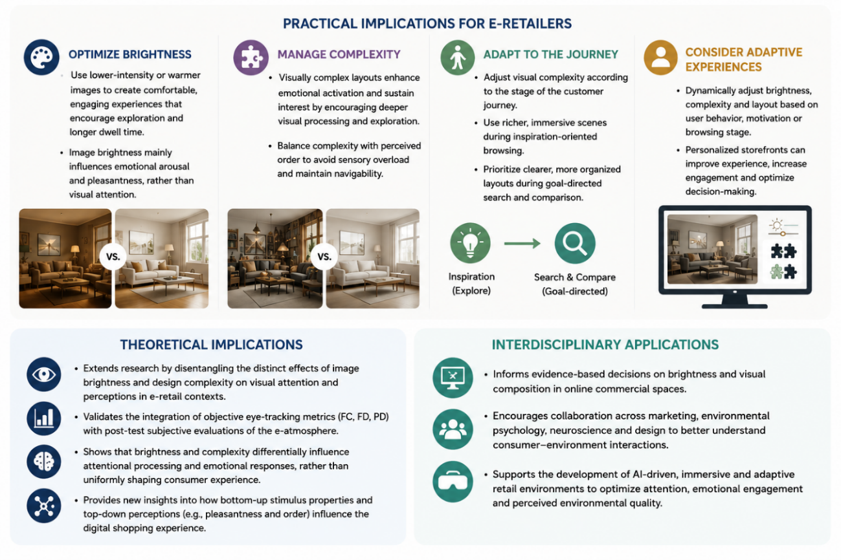Source: The authors

