Web Appendix I – Platform Context: BeReal Interface, RealBrands, and Notification Features
This appendix provides visual context for readers who may be unfamiliar with the BeReal platform. It includes examples of core interface features, the RealBrands section, and the “Time to BeReal” notification, which are referenced in the introduction and motivate the focus on candid, authenticity-first content formats.
BeReal.com
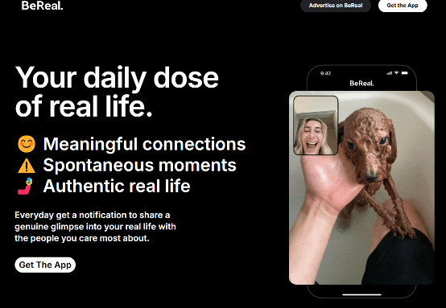
Advertise on BeReal
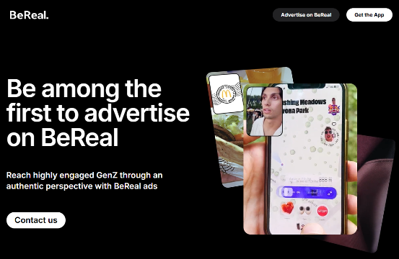
RealBrands
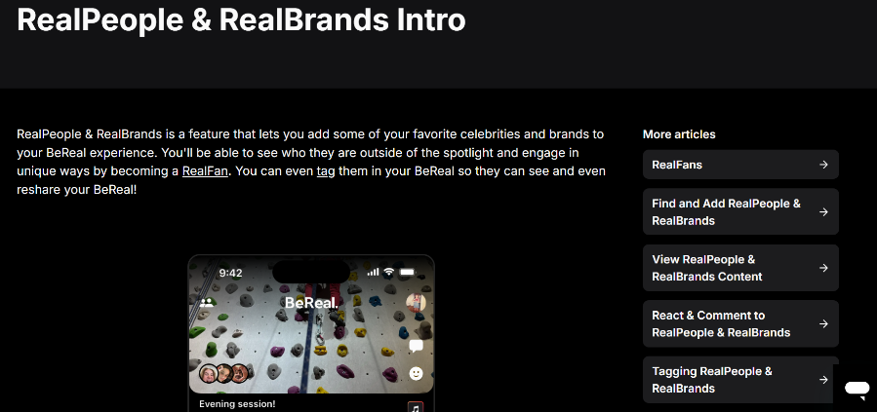


Time to BeReal Notification
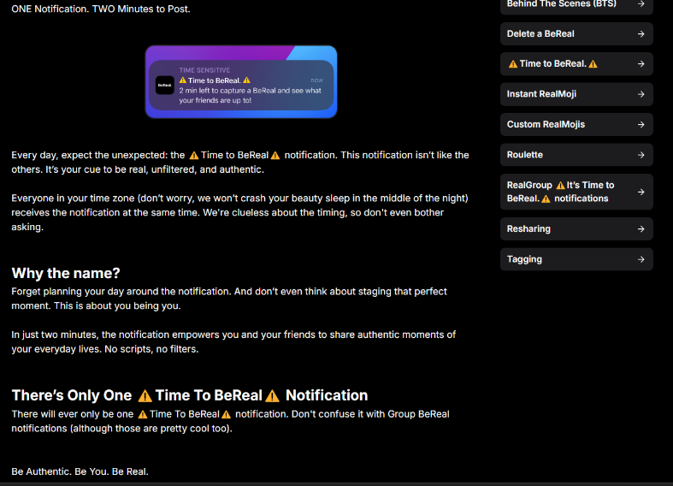
BeReal Brands Examples
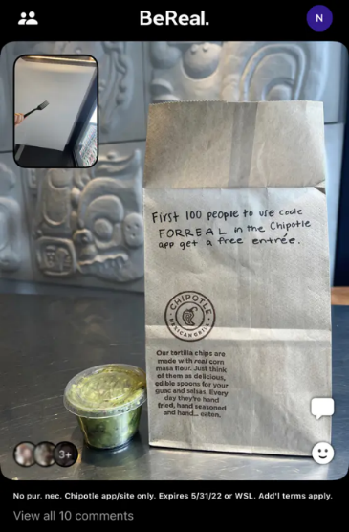
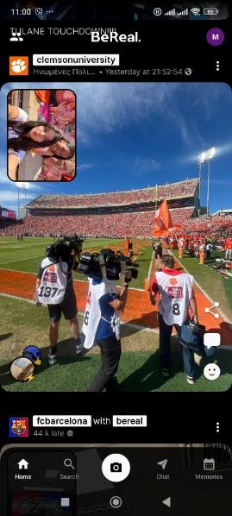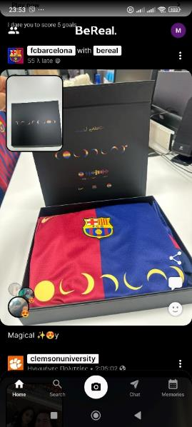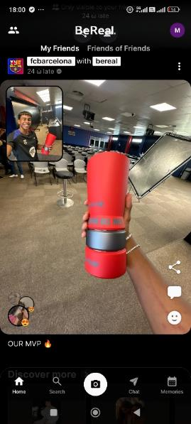

Web Appendix II – Contextual Overview (X/Twitter Data Analysis)
Table 1. Descriptive statistics of the total sample (N=14,998)
Variables | M | SD | Min | Max | Q1 | Q2 | Q3
followers | 360 | 5911 | 0 | 484874 | 7 | 34 | 125
friends | 501 | 1155 | 1 | 73726 | 80 | 214 | 536
likes | 11172 | 27396 | 0 | 814967 | 278 | 2099 | 9683
year_created | 2019 | 4 | 2006 | 2023 | 2018 | 2020 | 2022
tweets_number | 3602 | 12226 | 0 | 356699 | 25 | 330 | 2160
Note. followers'– the number of followers of the examined followers, 'friends' – the number of friends of the examined followers, 'likes' – the number of likes by the examined followers, 'year_created' – the year of the account creation of the examined followers, 'tweets_number' – total number of tweets by the examined followers; M – Mean, SD – Standard Deviation, Min – Minimum, Max – Maximum, Q1 – Quartile 1 – 25%, Q2 – Quartile 2 – 50%, Q3 – Quartile 3 – 75% of the sample.

Figure 1: World heatmap of "@bereal_app" follower distribution in X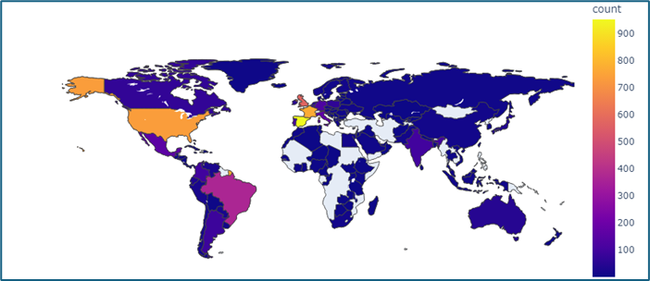

Web Appendix III – Study 1: Full Measures, Correlations, and PROCESS Outputs

Sample
To better understand the characteristics of BeReal users and their attachment to brands, we employed a convenience sampling approach, followed by the snowball technique, due to the specific and challenging nature of the target audience. An online survey was conducted with 208 Gen Z active BeReal users who participated voluntarily from a Mediterranean country. Eight participants were excluded from further analysis due to acquiescence bias, as they completed the questionnaire only with agree statements (MacKenzie and Podsakoff, 2012; Podsakoff et al., 2003). Additionally, ten participants were excluded because they reported having the BeReal app but were inactive users. The final sample comprised 190 individuals (24% male and 76% female; 70% undergraduate students; 49% residing in large cities) born between 1997 and 2007 (M=2003, SD=2), who reported frequent use of the BeReal platform (M=3.67, SD=0.97; (1) seldom to (5) very frequently). Respondents were asked about their frequency of SNS use, selfie behaviors, and whether they had ever posted brand selfies on SNSs. They were also queried about their level of self-brand connection, narcissism, and demographic information (gender, age, level of education, and place of residence).

Measures
Participants were asked about their social media use frequency across various platforms, including BeReal (M=3.67, SD=0.97), Instagram (M=4.77, SD=0.55), TikTok (M=4.09, SD=1.35), Facebook (M=2.68, SD=1.05), Facebook Messenger (M=3.66, SD=1.07), YouTube (M=3.67, SD=1.08), Twitter/X (M=1.28, SD=0.69), WhatsApp (M=1.51, SD=0.92), Snapchat (M=1.84, SD=1.12), and LinkedIn (M=1.41, SD=0.86). The response scale ranged from (1) "not at all" to (5) "very much."
Questions from Sung, Kim, and Choi (2018) were adopted to measure perceived information credibility on SNSs (M=3.05, SD=0.64), and participants' selfie behaviors were also assessed. This included the frequency of sharing brand (M=1.64, SD=0.95), beauty (M=2.07, SD=0.99), simple/everyday (M=2.61, SD=1.01), food (M=2.29, SD=0.94), and party selfies (M=3.06, SD=1.02). The scale for selfie behaviors ranged from (1) "not at all" to (5) "very much" (M=2.34, SD=0.75; α=.817).
Participants' self-brand connection was measured using seven items ranging from (1) "strongly disagree" to (5) "strongly agree" (Sprott et al., 2009). An example item is "I often feel a personal connection between my brands and me" (M=3.42, SD=0.77; α = .859). Additionally, participants' level of narcissism was measured with four items from Webster and Jonason (2013), such as "I tend to want others to admire me" (M=2.78, SD=0.91; α=.833).

Results
Before examining the research questions, inferential statistics were computed to analyze the respondents' SNS usage. Bivariate correlation analysis revealed that BeReal usage is positively correlated with TikTok (β= .356, p<.001), Instagram (β= .316, p<.001), Facebook Messenger (β= .265, p<.001), Facebook (β= .151, p=.038), and Snapchat (β= .148, p=.042), and negatively correlated with LinkedIn (β= -.15, p=.039). Additionally, females were found to use BeReal (t(188)=-2.813, p=.005), TikTok (t(62.12)=-3.656, p=.001), and Facebook Messenger (t(188)=-1.995, p=.048) more than males, and Twitter/X (t(64.08)=1.958, p=.055) less than males. Thus, no high positive correlation with other SNSs was found, suggesting that there may be a unique target group of GenZs that is primarily active on BeReal and not on other platforms.
Narcissism was positively correlated with BeReal usage (β = .165, p = .023), Instagram usage (β = .216, p = .003), self-brand connection (β = .415, p < .001), sharing selfies in general (β = .267, p < .001), all specific types of selfies (ps < .05), and perceived social media information for brands as reliable (β = .22, p = .004). Additionally, self-brand connection was positively correlated with BeReal (β = .201, p = .005) and Instagram (β = .255, p < .001) usage, sharing selfies in general (β = .269, p < .001), and all specific types of selfies (ps < .05). BeReal usage was also positively correlated with sharing selfies in general (β = .429, p < .001), all specific types of selfies apart from food selfies (ps < .05), and perceived social media information for brands as reliable (β = .161, p = .026). All correlation results are presented in the Web appendix.
We also used the Process macro Model 6 with 10,000 bootstrap samples to explore the serial mediation effect of selfie sharing and narcissism in the relationship between BeReal usage and self-brand connection, with gender as a covariate. The total effect (β = .152, SE = .06, p = .009, 95% CI = [.038, .268]) and the indirect effect (β = .035, SE = .05, 95% CI = [.01, .07]) were statistically significant, while the direct effect was not (β = .065, SE = .06, p = .269, 95% CI = [-.05, .179]). This indicates a full serial mediation. Specifically, BeReal usage leads to increased selfie sharing (β = .306, p < .001), which subsequently leads to higher levels of narcissism (β = .293, p = .003), ultimately resulting in a stronger self-brand connection (β = .31, p < .001; Table 1).

Table 1: Full serial mediation analysis of BeReal usage on self-brand connection
Variable | β (SE) | t-value | p-value | 95% CI | standardized β
Outcome variable: selfies
constant | .997 (.2) | 5.061 | <.001 | [.608, 1,385]
BeReal | .306 (.05) | 5.958 | <.001 | [.204, .407] | .395
gender | .288 (.12) | 2.496 | .013 | [.06, .515] | .166
Outcome variable: narcissism
constant | 1,885 (.28) | 6.822 | <.001 | [1,340, 2,431]
BeReal | .06 (.07) | .811 | .419 | [-.086, .205] | .064
selfies | .293 (.1) | 3.044 | .003 | [.103, .483] | .242
gender | -.018 (.15) | -.119 | .905 | [-.323, .286] | -.009
Outcome variable: self-brand connection
constant | 1,984 (.24) | 8.136 | <.001 | [1,503, 2,465]
BeReal | .065 (.06) | 1.109 | .269 | [-.05, .179] | .081
selfies | .137 (.08) | 1.765 | .079 | [-.016, .291] | .133
narcissism | .31 (.06) | 5.360 | <.001 | [.196, .424] | .365
gender | .021 (.12) | .172 | .863 | [-.219, .261] | .012

Web Appendix IV – Study 2: Stimuli, Manipulation Checks, and Moderated Mediation Results

Sample
This study focuses on the effectiveness of promotional brand communication targeted at GenZs through the BeReal platform. Given the specific and challenging nature of the target audience, a convenience sampling approach was initially employed, followed by the adoption of the snowball technique. A total of 211 Gen Z individuals who were active BeReal users participated in the study. Following the exclusion of 12 participants based on their responses to invalid questions, the final sample comprised 199 individuals (30% males and 70% females; 68% undergraduate students; and 67% stayed in middle or large cities) born between 1997 and 2007 (M=2003, SD=2) and reported frequent use of the BeReal platform (M=3.51, SD=1.12; (1) seldom to (5) very frequently).

Stimuli Selection
A focus group consisting of 30 GenZs was convened to select the experimental stimuli. The aim was to identify both high- and low-involvement products that held their interest. The outcomes of this session indicated that participants were particularly interested in food (specifically restaurant options) and coffee as examples of low-involvement products. On the other hand, high-involvement products that garnered attention included air-pods (from Apple) and shoes (from Nike). Subsequently, eight advertisements were crafted, comprising two versions (candid and non-candid) for each product category. The non-candid versions indicated that someone had prepared the photograph before sharing it on the BeReal application for the optimal presentation of the product. In contrast, the candid versions were more spontaneous and relaxed and seemed to have been taken at that moment. To highlight the difference in the non-candid versions, there was a time delay indication (e.g., 4 hrs late, see Appendix I), whereas in the candid one, the upload time was displayed, proving that it was posted within the timeframe set by BeReal. The non-candid versions were created by a professional photographer who conducted a photo shoot, while the candid ones are actual photos from BeReal users. The Picsart application was used to create a standard template for all ads, where the environment of the BeReal application served as a model. A pre-test on 26 GenZs was also conducted regarding the perceived spontaneity, product involvement, and brand familiarity for each version. The ads with Nike (high-involvement) and Chipotle (low-involvement) were selected for further research since they had statistically significant differences in brand familiarity (t(26)=-7.62, p<.001, M_{Chipotle}=2.31, M_{Nike}=4.62), product involvement (t(26)=-4.54, p<.001, M_{Chipotle}=2.54, M_{Nike}=3.46), and perceived spontaneity (Chipotle: t(26)=-13.46, p<.001, M_{non-candid}=1.62, M_{candid}=4.62; Nike: t(26)=-3.76, p<.001, M_{non-candid}=2.54, M_{candid}=4).

Measures
All the continuous variables of this experiment were measured using 5-point Likert scales. Ad irritation (Duncan and Nelson 1985; 3-items; α = .853), brand attitude (Geuens and De Pelsmacker 1998; 4 items; α_{before} = .953; α_{after} = .972), and purchase intention (Geuens and De Pelsmacker 1998; 3-items; α = .807). Three attention checks were included (DeSimone, Harms, & DeSimone, 2015). Bipolar single-item measurements were only used for the manipulation variable, the perceived spontaneity (i.e., This image is: (1) non-candid to (5) candid), and ad and brand familiarity ((1) unknown to (5) known). Product involvement was also measured by two items (frequency of buying and using the product category; α = .807).

Results

Manipulation Checks
For the manipulation checks, an initial two-way MANOVA was conducted to examine the effects of the type of ad (candid vs. non-candid) and product involvement (low-Chipotle vs. high-Nike) as independent variables on perceived spontaneity, product involvement, and brand familiarity as dependent variables. The MANOVA revealed a non-statistically significant effect (Wilks’ λ = .99, F(3, 390) = .9, p = .441).
Further univariate analyses indicated that the type of ad had a statistically significant effect only on the perceived spontaneity F(1, 392) = 271.7, p < .01), while product had a statistically significant effect on reported product involvement (F(1, 392) = 300.02, p < .01) and brand familiarity (F(1, 392) = 1109.3, p < .01). Specifically, candid advertisements were perceived as more spontaneous compared to non-candid ones, while Nike products exhibited higher levels of product involvement and brand familiarity compared to Chipotle products. Complete details, including pairwise comparisons, means, and standard deviations, are presented in Table 1.
Furthermore, based on one-sample t-tests, all stimuli demonstrated statistically significant differences (p_{s} < .01) with the midpoint of the scale (3) across all dependent variables (see Table 1). Therefore, it could be inferred that the manipulation was successful.

Table 1. Manipulation Checks
 |  | Brand |  | Low-involvement (Chipotle) |  |  |  | Low-involvement (Nike)
Variable |  | Candid |  | M | SD | t-test (p<.01) |  | M | SD | t-test (p<.01) |  | dif
Perceived spontaneity |  | No |  | 2.49 | 1.1 | t(97) = -4,458 |  | 2.27 | 1.1 | t(99) = -6,378 |  | p=.16
Perceived spontaneity |  | Yes |  | 4.22 | 1.0 | t(99) = 11,837 |  | 4.17 | 1.1 | t(97) = 10,808 |  | p=.77
Perceived spontaneity |  | dif |  | p<.01 |  |  |  | p<.01
Product involvement |  | Yes |  | 2.27 | .91 | t(97) = -8,004 |  | 3.64 | .81 | t(99) = 7,871 |  | p<.01
Product involvement |  | No |  | 2.24 | .91 | t(99) = -8,420 |  | 3.85 | .79 | t(97) = 10,555 |  | p<.01
Product involvement |  | dif |  | p=.80 |  |  |  | p=.08
Brand familiarity |  | Yes |  | 1.67 | 1.2 | t(97) = -10,576 |  | 5.00 | .00 |  |  | p<.01
Brand familiarity |  | No |  | 1.56 | 1.1 | t(99) = -13,382 |  | 4.93 | .50 | t(97) = 37,988 |  | p<.01
Brand familiarity |  | dif |  | p=.35 |  |  |  | p=.56
Note. dif – pairwise comparisons reported by MANOVA; one-sample t-tests with comparison value (midpoint=3)

Hypotheses Testing
Before conducting the main analysis for hypothesis testing, correlation analyses were deemed important (Table 2). IBM SPSS Statistics 24.0 was utilized for all statistical analyses in this study (Table 3).
Table 2. Correlations
 | 1 | 2 | 3 | 4 | 5 | 6 | 7 | 8 | 9 | 10
1. perceived spontaneity
2. product involvement | .021
3. brand familiarity | .082 | .592**
4. ad recognition | -.540** | .061 | -.016
5. Abr prior | .090 | .623** | .765** | -.088
6. ad irritation | -.042 | -.116* | -.156** | .057 | -.208**
7. Abr after | .129* | .616** | .755** | -.116* | .909** | -.285**
8. Abr change (after-before) | .110* | .105* | .125* | -.083 | -.025 | -.226** | .395**
9. PI | .107* | .398** | .457** | -.126* | .621** | -.309** | .701** | .311**
10. gender | -.087 | .188** | .090 | .075 | .105* | -.223** | .146** | .119* | .133**
11. BeReal use frequency | -.063 | .154** | -.043 | .067 | .037 | -.046 | .054 | .047 | .114* | .228**
Note. **p<.01, *p<.05; Gender: 0-males 1-females; perceived spontaneity: (1) non-candid to (5) candid, brand familiarity: (1) unknown to (5) known.

Table 3: Full moderated mediation analysis of BeReal usage on self-brand connection
Variable | β (SE) | t-value | p-value | 95% CI | Partial η²
Outcome variable: Ad recognition
Constant | 2.798 (.19) | 15.125 | <.001 | [2.434, 3.161]
Ad spontaneity | -.651 (.05) | -13.532 | <.001 | [-.746, -.556] | .319
Brand familiarity | -.001 (.03) | -.051 | .96 | [-.052, .049] | <.001
BeReal usage | .029 (.04) | .649 | .517 | [-.058, .116] | .001
Gender | .174 (.11) | 1.612 | .108 | [-.038, .386] | .007
Outcome variable: Ad irritation
Constant | 2.905 (.25) | 11.750 | <.001 | [2.419. 3.391]
Ad spontaneity | .050 (.05) | .998 | .319 | [-.049, .150] | .003
Ad recognition | .089 (.04) | 2.035 | .042 | [.003, .176] | .011
Involvement | .441 (.15) | 2.977 | .003 | [.150, .733] | .022
Ad recognition X involvement | -.123 (.04) | -3.301 | .001 | [-.196. -.050] | .027
Brand familiarity | -.098 (.05) | -2.006 | .046 | [-.194. -.002] | .01
BeReal usage | .017 (.04) | .437 | .662 | [-.060, .094] | <.001
Gender | -.380 (.09) | -4.038 | <.001 | [-.565. -.195] | .04
Outcome variable: Brand attitude (change)
Constant | -.062 (.13) | -.478 | .633 | [-.317, .193]
Ad spontaneity | -.009 (.02) | -.393 | .694 | [-.055, .036] | <.001
Ad recognition | -.018 (.02) | -.888 | .375 | [-.057, .022] | .002
Ad irritation | -.083 (.02) | -3.614 | <.001 | [-.128. -.038] | .033
Involvement | -.312 (.09) | -3.646 | <.001 | [-.480. -.144] | .033
Ad recognition X involvement | -.011 (.02) | -.645 | .519 | [-.045, .023] | .001
Ad irritation X involvement | .100 (.02) | 4.375 | <.001 | [.055, .145] | .047
Brand familiarity | .055 (.02) | 2.465 | .014 | [.011, .099] | .015
BeReal usage | .012 (.02) | .696 | .487 | [-.022, .047] | .001
Gender | .064 (.04) | 1.464 | .144 | [-.022, .149] | .006
Outcome variable: Purchase intention
Constant | 3.286 (.18) | 18.663 | <.001 | [2.940. 3.633]
Ad spontaneity | .025 (.04) | .689 | .491 | [-.046, .095] | .001
Ad recognition | -.050 (.03) | -1.603 | .11 | [-.111, .011] | .007
Ad irritation | -.154 (.04) | -4.279 | <.001 | [-.225. -.083] | .045
Brand attitude (change) | .363 (.08) | 4.697 | <.001 | [.211, .515] | .054
Brand familiarity | .152 (.02) | 9.544 | <.001 | [.121, .183] | .19
BeReal usage | .075 (.03) | 2.748 | .006 | [.021, .128] | .019
Gender | .016 (.07) | .24 | .811 | [-.117, .150] | <.001
Source 5: Authors' own work

