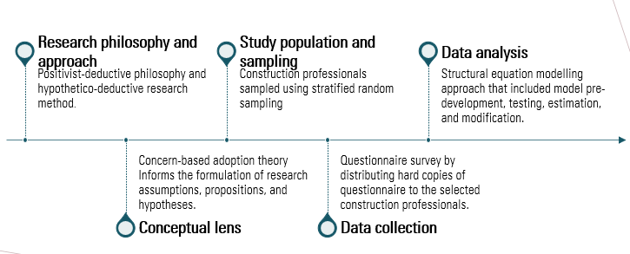
Figure S1: Research flowchart (figure by authors)

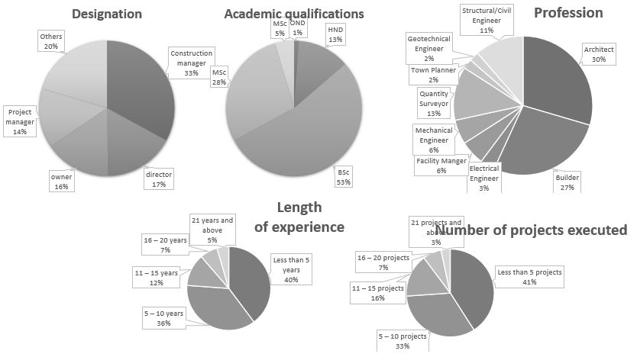
Figure S3: Characteristics of the research participants (figure by authors)
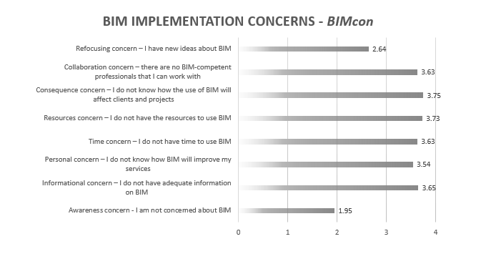
A: BIM implementation concerns – BIMcon
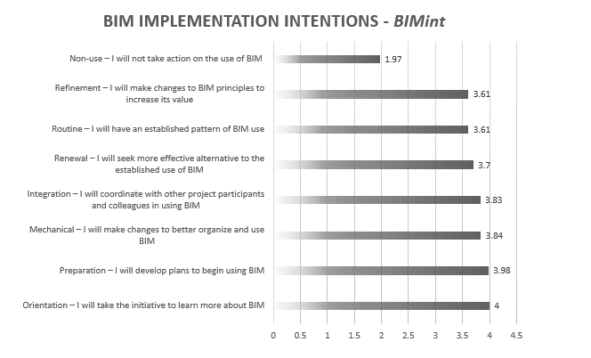
B: BIM implementation intentions – BIMint
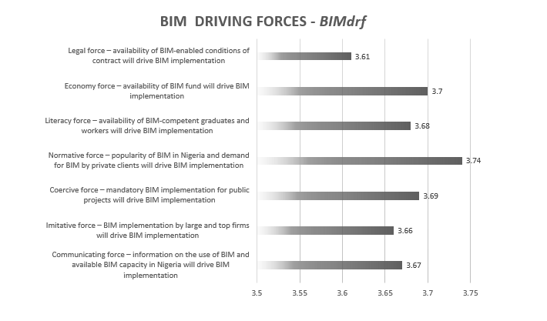
C: BIM driving forces – BIMdrf
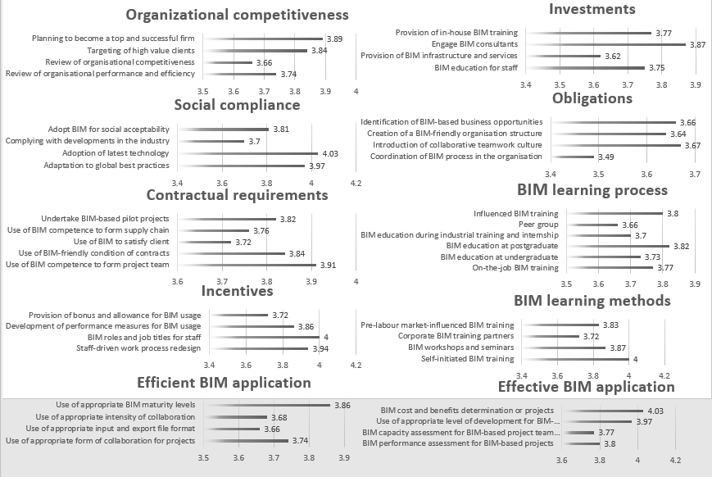
D: BIM implementation strategies – BIMips
Figure 4: Measured variables and their significance (A: BIM implementation concerns – BIMcon; B: BIM implementation intentions – BIMint; C: BIM driving forces – BIMdrf; D: BIM implementation strategies – BIMips) (figure by authors)

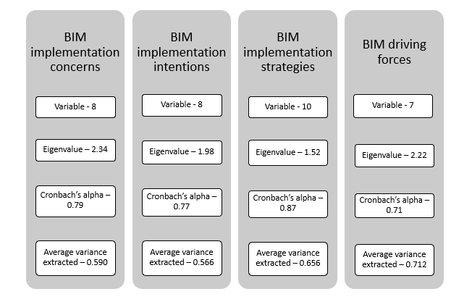
Figure S5: Reliability and consistency test results for the key constructs (figure by authors)
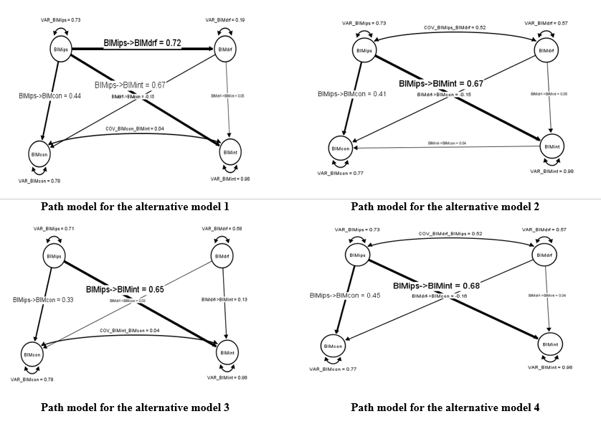
Figure S6: Alternative path models (figure by authors)

