Supplementary Materials

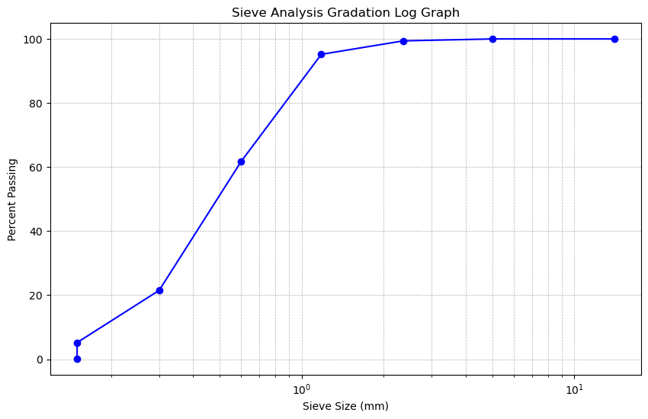
- Fine aggregates gradiation curve
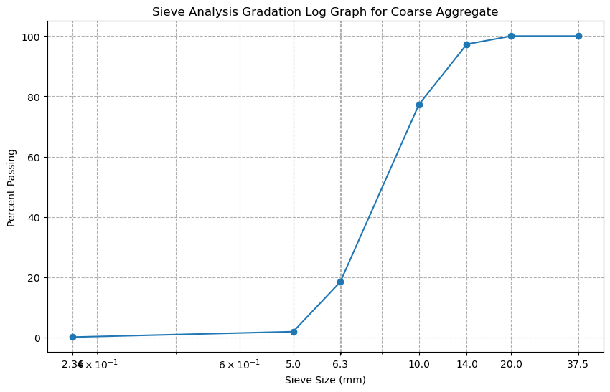
- Coarse aggregates gradiation curve

Figure S1(a,b) Gradation curves for fine and coarse aggregates showing detailed particle size distribution

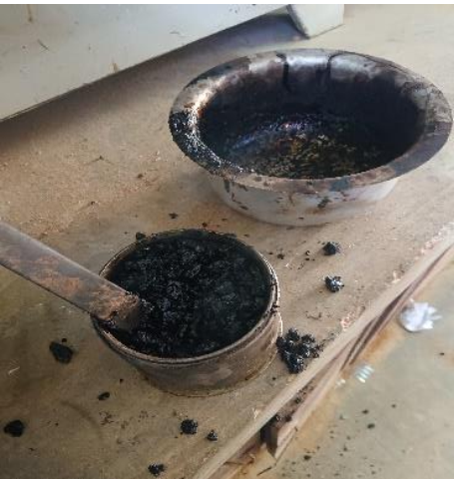
Figure S2: Detailed mixing process for specimen preparation

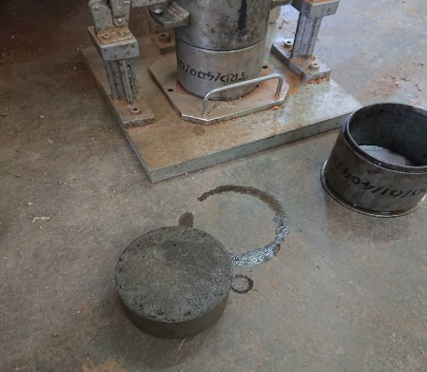 | 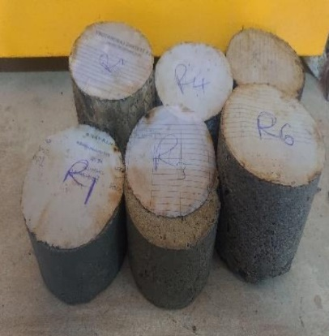 | 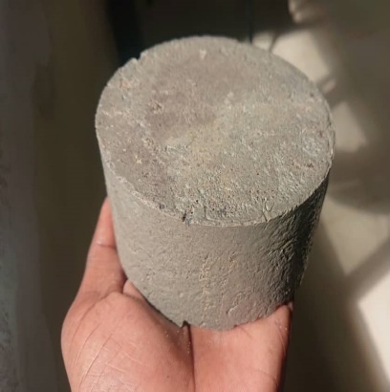
Figure S3: Sample specimens demonstrating the molding and compaction process

Figure S4: Stiffness modulus results for various mixtures
These supplementary materials provide additional technical details and visual documentation of the experimental procedures and results discussed in the main text.

