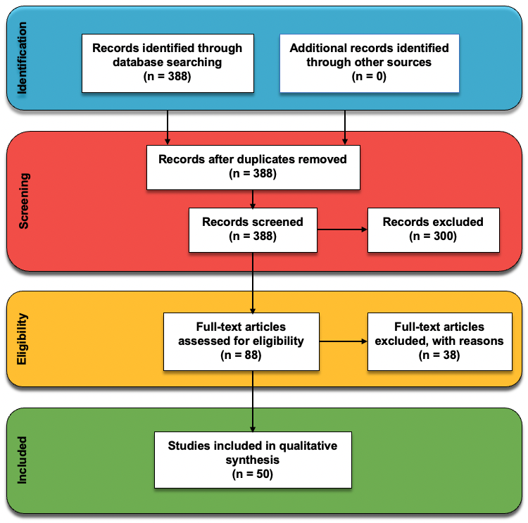

SFig1: Flow diagram of research selection process.

STable1: The summary of study characteristics
SN | Study | Delay Drivers |  | Source Type | Country | Project Type | Research Method
1 | (Narlawar et al., 2019) | - Conflicts between contractor and sub-contractor (s).  - Natural disasters e.g., floods, earthquakes etc. |  | Journal | India | Residential Building | Quantitative
2 | (Narlawar G.S. et al., 2017) | - Changes in specifications.  - Poor contract management. |  | Journal | Malaysia | General construction | Mixed methods (semi-structured interview and Questionnaire)
3 | (Ryu et al., 2015) | - Traffic restrictions.  - Changes in site topology after design. |  | Journal | Korea | Tunnel | Quantitative
4 | (Nawi et al., 2014) | - Ineffective project supervision. |  | Journal | Malaysia | Industrialised Building System (IBS) Construction Projects | Qualitative
5 | (Li et al., 2017) | - Client’s cash flow issues. |  | Journal | Hong Kong | General construction | Qualitative and Experimental
6 | (Subramani and Ammai, 2018) | - Contractor’s cash flow issue. |  | Journal | Multinational | General construction | Qualitative
7 | (Amany et al., 2020) | - Ineffective project plan.  - Shortage of materials on market. |  | Journal | Multinational | General construction | Quantitative
8 | (Husin, 2019) | - Conflicts between contractor and consultant. |  | Journal | Indonesia | High-rise building | Quantitative
9 | (Abdelbary et al., 2020) | - Schedule/program of work. |  | Journal | Egypt | General construction | Quantitative
10 | (Shin et al., 2018) | - Limited space for temporal equipment. |  | Journal | South Korea | Railway Site | Mixed methods
11 | (Park and Lee, 2017) | - Discrepancies in contract documents. |  | Journal | Korea | hospital building | Quantitative
12 | (Park et al., 2017) | - Changes in client requirements.  - Reworks due to error in construction. |  | Journal | Multinational | General construction | Experimental
13 | (Sepasgozar et al., 2019) | - Late delivery of construction materials.  - Inflation or sudden increase in commodities. |  | Journal | Generic | General construction | Qualitative, Quantitative and Experimental
14 | (Chiponde et al., 2017) | - Building permit from authorities.  - Corruption issues.  - Variation in structural design. |  | Journal | Zambia | General construction | Mixed methods
15 | (Sami Ur Rehman et al., 2020) | - Schedule/program of work.  - Labour dispute or strikes. |  | Journal | Multinational | General construction | Mixed methods
16 | (Giel and Issa, 2013) | - Reworks due to error in construction. |  | Journal | Multinational | General construction | Qualitative
17 | (Jang and Lee, 2018) | - Contractors’ financial difficulties. |  | Journal | Korea | General construction | Quantitative
18 | (Chen and Tang, 2019) | - Staff’s productivity level.  - Shortage of resources (human resources, machinery, equipment etc). |  | Journal | China | Residential Building | Quantitative
19 | (Ern, Ooi and Al-Ashmori, 2020) | - Contractor’s poor decision |  | Journal | Malaysia | General construction | Quantitative
20 | (Elhusseiny et al., 2021) | - Client’s cash flow issues.  - Consultant’s cash flow issues.  - Conflicts between contractor and consultant |  | Journal | Egypt | General construction | Quantitative
21 | (Malacarne et al., 2018) | - Contractors’ financial difficulties. |  | Journal | Italy | General construction | Qualitative
22 | (Handayani et al., 2019) | - Change in economic conditions.  - Shortage of resources (human resources, machinery, equipment etc). |  | Journal | Thailand | Story Buildings | Qualitative
23 | (Wong et al., 2018) | - Variation in structural design.  - Reworks due to error in construction.  - Poor communication amongst stakeholders |  | Journal | China | General construction | Quantitative
24 | (Tserng et al., 2014) | - Poor site investigation or management.  - Staff’s productivity level. |  | Journal | Taiwan | General construction | Experimental
25 | (Liu et al., 2020) | - Ineffective project plan.  - Pandemic |  | Journal | China | Residential Building | Experimental
26 | (Vilventhan et al., 2020) | - Delay in site delivery. |  | Journal | India | Infrastructure construction project | Qualitative and Experimental
27 | (Delgado et al., 2015) | - Site accident.  - Political influence. |  | Journal | Spain | Residential Building | Experimental
28 | (Hossain et al., 2018) | - Late payment by the client. |  | Journal | Singapore | Story Building | Experimental
29 | (Stegnar and Cerovšek, 2019) | - Damage storage materials.  - Contractors’ financial difficulties.  - Natural disasters e.g., floods, earthquakes etc.  - Unforeseen site conditions e.g., unanticipated groundwater, quicksand, mud, rock formation etc. |  | Journal | Slovenia | Office Building | Quantitative
30 | (Khalesi et al., 2020) | - Building material’s price fluctuation.  - Inflation or sudden increase in commodities.  - Unskilled labourers |  | Journal | Multinational | Residential Building | Quantitative
31 | (Tahir et al., 2018) | - Use of outdated technologies by staffs. |  | Journal | Multinational | General construction | Qualitative
32 | (Vahdatikhaki and Mawlana, 2017) | - Project quality control. |  | Conference | Canada | General construction | Experimental
33 | (Tahir Muhammad et al., 2019) | - Building material’s price fluctuation.  - Equipment breakdown. |  | Conference | Malaysia | General construction | Quantitative
34 | (Btoush and Harun, 2017) | - Use of outdated technologies by staffs.  - Change order.  - Damage storage materials.  - Equipment breakdown. |  | Conference | Jordan | General construction | Qualitative
35 | (Dallasega et al., 2019) | - Change order.  - Discrepancies in contract documents |  | Conference | Italy | Hospital construction project | Experimental
36 | (Diaz et al., 2019) | - Site accident.  - Labour dispute or strikes. |  | Conference | Peru | Road projects | Experimental
37 | (Ansah et al., 2016) | - Variation in structural design. |  | Conference | Malaysia | General construction | Qualitative
38 | (Chou and Chen, 2017) | - Late delivery of construction materials |  | Conference | Taiwan | General construction | Quantitative
39 | (Wang et al., 2015) | - Inaccurate budgeting |  | Conference | Australia | Liquefied Natural Gas Construction | Quantitative
40 | (Kermanshahi et al., 2020) | - Shortage of materials on market.  - Ineffective government regulations. |  | Conference | Malaysia | Police Headquarter Building | Quantitative
41 | (Couto and Ericson, 2017) | - Ineffective project supervision.  - Building material’s price fluctuation |  | Conference | USA | Airport Building | Experimental
42 | (Vacanas et al., 2015) | - Shortage of resources (human resources, machinery, equipment etc). |  | Conference | Multinational | Infrastructure construction project | Qualitative
43 | (Suermann and Issa, 2009) | - Poor site investigation or management. |  | Conference | USA | Air Force Building | Experimental
44 | (Liu and Liu, 2020) | - Inaccurate resource planning. |  | Conference | China | Substation Construction | Qualitative and Experimental
45 | (Ibrahim et al., 2019) | - Use of outdated construction methods (e.g., precast twin wall technology, 2D drawing etc.). |  | Conference | Malaysia | General construction | Quantitative
46 | (Zhang and Liu, 2021) | - Conflicts between contractor and sub-contractor(s).  - Level of BIM usage.  - Inaccurate resource planning. |  | Conference | Multinational | General construction | Qualitative
47 | (Ocheoha and Moselhi, 2013) | - Limited space for temporal equipment. |  | Conference | Canada | General construction | Quantitative
48 | (Sigalov and König, 2018) | - Inaccurate resource planning. |  | Conference | Multinational | General construction | Experimental
49 | (Teng et al., 2013) | - Unfavourable weather conditions.  - Use of outdated construction methods (e.g., precast twin wall technology, 2D drawing etc.).  - Changes in client requirements. |  | Book | China | General construction | Qualitative
50 | (Srao, Rai and Mann, 2018) | - Level of BIM usage. |  | Book | India | General construction | Qualitative

Stable2: Delay Drivers Category Ranking
Delay Drivers | List of Sources | Number of Sources | Delay Category | Total Number of Citations | Category Ranking
Shortage of resources (human resources, machinery, equipment etc) | (Vacanas et al., 2015), (Chen and Tang, 2019), (Handayani et al., 2019) | 3 | Contractor related driver | 24 | 1
Contractors’ financial difficulties | (Jang and Lee, 2018), (Malacarne et al., 2018), (Stegnar and Cerovšek, 2019) | 3 | Contractor related driver | 24 | 1
Level of BIM usage | (Srao et al., 2018), (Zhang and Liu, 2021), (Liu et al., 2020) | 3 | Contractor related driver | 24 | 1
Inaccurate resource planning | (Zhang and Liu, 2021), (Sigalov and König, 2018), (Kermanshahi et al., 2020) | 3 | Contractor related driver | 24 | 1
Schedule/program of work | (Sami Ur Rehman et al., 2020), (Abdelbary et al., 2020) | 2 | Contractor related driver | 24 | 1
Limited space for temporal equipment | (Shin et al., 2018), (Ocheoha and Moselhi, 2013) | 2 | Contractor related driver | 24 | 1
Ineffective project supervision | (Couto and Ericson, 2017), (Nawi et al., 2014) | 2 | Contractor related driver | 24 | 1
Poor site investigation or management | (Suermann and Issa, 2009), (Tserng et al., 2014) | 2 | Contractor related driver | 24 | 1
Contractor’s poor decision | (Ern et al., 2020) | 1 | Contractor related driver | 24 | 1
Ineffective project plan | (Amany et al., 2020) | 1 | Contractor related driver | 24 | 1
Contractor’s cash flow issue | (Subramani and Ammai, 2018) | 1 | Contractor related driver | 24 | 1
Project quality control | (Vahdatikhaki and Mawlana, 2017) | 1 | Contractor related driver | 24 | 1
Traffic restrictions | (Ryu et al., 2015) | 1 | External related driver | 19 | 2
Building material’s price fluctuation | Tahir Muhammad et al., (2019), Khalesi et al., (2020), Couto and Ericson, (2017) | 3 | External related driver | 19 | 2
Inflation or sudden increase in commodities | Khalesi et al., (2020), Sepasgozar et al., (2019) | 2 | External related driver | 19 | 2
Site accident | (Diaz et al., 2019), (Delgado et al., 2015) | 2 | External related driver | 19 | 2
Natural disasters e.g., floods, earthquakes etc. | (Narlawar et al., 2019), (Stegnar and Cerovšek, 2019) | 2 | External related driver | 19 | 2
Pandemic | (Liu and Liu, 2020) | 1 | External related driver | 19 | 2
Shortage of materials on market | (Amany et al., 2020), (Kermanshahi et al., 2020) | 2 | External related driver | 19 | 2
Change in economic conditions | (Handayani et al., 2019) | 1 | External related driver | 19 | 2
Political influence | (Delgado et al., 2015) | 1 | External related driver | 19 | 2
Ineffective government regulations | (Kermanshahi et al., 2020) | 1 | External related driver | 19 | 2
Unforeseen site conditions e.g., unanticipated groundwater, quicksand, mud, rock formation etc | (Stegnar and Cerovšek, 2019) | 1 | External related driver | 19 | 2
Building permit from authorities | (Chiponde et al., 2017) | 1 | External related driver | 19 | 2
Corruption issues | (Chiponde et al., 2017) | 1 | External related driver | 19 | 2
Unfavourable weather conditions | (Teng et al., 2013) | 1 | External related driver | 19 | 2
Labour dispute or strikes | (Diaz et al., 2019), (Sami Ur Rehman et al., 2020) | 2 | Labour related driver | 11 | 3
Staff’s productivity level | (Tserng et al., 2014), (Chen and Tang, 2019) | 2 | Labour related driver | 11 | 3
Use of outdated construction methods (e.g., precast twin wall technology, 2D drawing etc.). | (Teng et al., 2013), (Ryu et al., 2015),(Ibrahim et al., 2019) | 3 | Labour related driver | 11 | 3
Use of outdated technologies by staffs | (Btoush and Harun, 2017), (Tahir et al., 2018) | 2 | Labour related driver | 11 | 3
Unskilled labourers | (Khalesi et al., 2020) | 1 | Labour related driver | 11 | 3
Change order | (Btoush and Harun, 2017), (Dallasega et al., 2019) | 2 | Owners related driver | 10 | 4
Client’s cash flow issues | (Li et al., 2017), (Elhusseiny et al., 2021) | 2 | Owners related driver | 10 | 4
Changes in client requirements | (Park and Lee, 2017), (Teng et al., 2013) | 2 | Owners related driver | 10 | 4
Delay in site delivery | (Vilventhan et al., 2020) | 1 | Owners related driver | 10 | 4
Changes in specifications | (Narlawar G.S., Chaphalkar N.B., 2017) | 1 | Owners related driver | 10 | 4
Late payment by the client | Hossain et al., (2018) | 1 | Owners related driver | 10 | 4
Changes in site topology after design | (Ryu et al., 2015) | 1 | Owners related driver | 10 | 4
Variation in structural design | (Wong et al., 2018), (Chiponde et al., 2017), (Ansah et al., 2016) | 3 | Design related driver | 6 | 5
Reworks due to error in construction | (Park and Lee, 2017), (Giel and Issa, 2013), (Wong et al., 2018) | 3 | Design related driver | 6 | 5
Consultant’s cash flow issues | (Elhusseiny et al., 2021) | 1 | Consultant related driver | 4 | 6
Inaccurate budgeting | (Wang et al., 2015) | 1 | Consultant related driver | 4 | 6
Poor communication amongst stakeholders | (Wong et al., 2018) | 1 | Consultant related driver | 4 | 6
Poor contract management | (Narlawar G.S., Chaphalkar N.B., 2017) | 1 | Consultant related driver | 4 | 6
Discrepancies in contract documents | (Dallasega et al., 2019), (Park et al., 2017) | 2 | Project related driver | 4 | 6
Damage storage materials | (Btoush and Harun, 2017), (Stegnar and Cerovšek, 2019) | 2 | Project related driver | 4 | 6
Conflicts between contractor and sub-contractor (s) | (Narlawar et al., 2019), (Teng et al., 2013), (Zhang and Liu, 2021) | 3 | Contractor & sub-contractor related driver | 3 | 7
Late delivery of construction materials | (Sepasgozar et al., 2019), 80] | 2 | Suppliers related driver | 2 | 8
Conflicts between contractor and consultant | (Elhusseiny et al., 2021), (Husin, 2019) | 2 | Contractor & consultant related driver | 2 | 8
Equipment breakdown | (Btoush and Harun, 2017), (Tahir Muhammad et al., 2019) | 2 | Equipment related driver | 2 | 8

