Appendix A. Summary statistics and estimation of weighting values

Table A1. Summary statistics
 |  |  | $$μ$$
 | Population (thousand people) | Retail sales of goods and services (bill. dongs) | Average per capita income (thousand dongs/year) | Volume of freight carried by road (thousand tons) | Volume of freight carried by all modes (thousand tons)
Columns | (1) | (2) | (3) | (4) | (5)
Nationwide | 98,506 | 4,407,812 | 50,460 | 1,303,327.9 | 1,615,654.9
Red River Delta | 23,225 | 1,143,113 | 60,312 | 440,888.9 | 588,472.5
Hanoi | 8,331 | 513,843 | 72,024 | 126,624.6 | 129,719.8
Vinh Phuc | 1,192 | 56,723* | 54,132 | 15,233 | 20,773
Bac Ninh | 1,463 | 50,274 | 59,004 | 18,264 | 27,345
Quang Ninh | 1,351 | 118,779 | 47,904 | 47,260 | 51,229
Hai Duong | 1,937 | 59,189 | 51,648 | 37,110 | 66,887
Hai Phong | 2,072 | 150,969 | 61,116 | 103,982 | 128,609
Hung Yen | 1,285 | 36,658 | 50,304 | 31,113 | 33,063
Thai Binh | 1,876 | 44,423 | 52,008 | 8,423 | 22,666
Ha Nam | 875 | 26,780 | 52,464 | 13,246 | 14,956
Nam Dinh | 1,836 | 48,864 | 52,956 | 12,597 | 34,778
Ninh Binh | 1,008 | 36,611 | 51,384 | 27,036 | 58,446
Northern Midlands and Mountainous Area | 12,925 | 269,708 | 34,044 | 153,372 | 166,476
Ha Giang | 887 | 11,905 | 23,196 | 2,440 | 2,440
Cao Bang | 542 | 7,313 | 27,276 | 1,802 | 1,802
Bac Kan | 324 | 6,083 | 25,500 | 1,267 | 1,267
Tuyen Quang | 802 | 19,036 | 34,464 | 14,738 | 14,758
Lao Cai | 762 | 16,889 | 30,180 | 5,981 | 5,982
Yen Bai | 843 | 21,083 | 30,480 | 7,887 | 8,061
Thai Nguyen | 1,323 | 39,073 | 45,768 | 45,133 | 45,133
Lang Son | 797 | 21,086 | 29,652 | 5,154 | 5,154
Bac Giang | 1,875 | 37,370 | 47,592 | 24,246 | 25,810
Phu Tho | 1,508 | 35,156 | 43,068 | 27,943 | 39,014
Dien Bien | 625 | 11,824 | 21,852 | 2,350 | 2,350
Lai Chau | 478 | 5,918 | 24,600 | 1,669 | 1,669
Son La | 1,288 | 22,994 | 22,008 | 5,227 | 5,300
Hoa Binh | 872 | 13,978 | 31,728 | 7,535 | 7,737
North-central and Central Coastal Area | 11,153 | 727,053 | 41,916 | 368,328 | 378,629
Thanh Hoa | 3,716 | 120,150 | 43,824 | 51,848 | 56,006
Nghe An | 3,410 | 72,254 | 37,140 | 124,311 | 128,192
Ha Tinh | 1,314 | 31,610 | 35,772 | 29,726 | 29,995
Quang Binh | 911 | 26,343 | 40,056 | 24,495 | 25,030
Quang Tri | 648 | 32,712 | 36,312 | 11,160 | 11,170
Thua Thien Hue | 1,154 | 38,458 | 42,300 | 9,272 | 9,376
Da Nang | 1,195 | 75,172 | 62,760 | 30,414 | 30,449
Quang Nam | 1,518 | 32,224 | 43,836 | 15,114 | 15,786
Quang Ngai | 1,244 | 50,396 | 38,628 | 9,820 | 10,027
Binh Dinh | 1,508 | 73,878 | 41,628 | 25,440 | 25,502
Phu Yen | 876 | 29,479 | 39,552 | 9,704 | 9,704
Khanh Hoa | 1,248 | 60,729 | 38,832 | 17,456 | 17,820
Ninh Thuan | 596 | 24,180 | 34,260 | 4,957 | 4,957
Binh Thuan | 1,246 | 59,470 | 48,924 | 4,611 | 4,616
Central Highlands | 6,034 | 208,802 | 34,272 | 59,759 | 59,759
Kon Tum | 569 | 23,645 | 30,204 | 6,219 | 6,219
Gia Lai | 1,570 | 50,287 | 27,948 | 16,039 | 16,039
Dak Lak | 1,909 | 76,509 | 33,732 | 18,797 | 18,797
Dak Nong | 664 | 16,076 | 32,940 | 1,452 | 1,452
Lam Dong | 1,322 | 42,285 | 44,616 | 17,252 | 17,252
Southeast | 18,315 | 1,224,228 | 69,528 | 238,004 | 286,733
Binh Phuoc | 1,024 | 47,114 | 48,024 | 2,555 | 2,555
Tay Ninh | 1,182 | 75,810 | 48,432 | 14,564 | 14,582
Binh Duong | 2,597 | 158,642 | 85,476 | 63,039 | 63,543
Dong Nai | 3,169 | 169,347 | 69,012 | 40,277 | 41,528
Ba Ria - Vung Tau | 1,176 | 67,662 | 53,028 | 8,183 | 9,111
Ho Chi Minh City | 9,167 | 705,653 | 72,096 | 109,386 | 155,414
Mekong River Delta | 17,423 | 834,908 | 44,556 | 42,977 | 135,586
Long An | 1,726 | 68,857 | 44,700 | 6,054 | 18,289
Tien Giang | 1,779 | 62,544 | 47,184 | 2,446 | 11,233
Ben Tre | 1,296 | 47,255 | 40,404 | 3,473 | 8,157
Tra Vinh | 1,019 | 29,036 | 39,480 | 2,775 | 6,553
Vinh Long | 1,029 | 41,895 | 38,076 | 2,025 | 3,514
Dong Thap | 1,601 | 94,110 | 50,388 | 2,817 | 7,234
An Giang | 1,910 | 77,346 | 40,872 | 8,247 | 42,342
Kien Giang | 1,752 | 98,069 | 47,832 | 2,110 | 7,652
Can Tho | 1,247 | 85,990 | 57,528 | 2,222 | 6,143
Hau Giang | 730 | 36,229 | 45,132 | 2,238 | 6,715
Soc Trang | 1,207 | 70,562 | 38,952 | 4,977 | 8,342
Bac Lieu | 919 | 62,508 | 43,704 | 2,873 | 8,277
Ca Mau | 1,209 | 60,508 | 38,868 | 720 | 1,137
Source: assembled from General Statistics Office database, 2021 figures and prices
*Retail sales of goods and services value for Vinh Phuc province is only available up to 2020

The centrality weighting $γ$ used in this analysis is the estimated transport location coefficient of a province – the share of transportation traffic by a certain type of mode in a province over the share of transportation traffic of the same type of mode among the total transportation traffic of all provinces. At the national level, the transportation location coefficient $γ_{i}$ is calculated as:
$$γ_{i}={\frac{V_{ri}}{\sum_{1}^{n}{V_{ri}}}}/{\frac{V_{mi}}{\sum_{1}^{n}{V_{mi}}}}$$
In which $V_{ri}$ refers to the volume of freight carried by road in province $i$ (column 4, table A1); $V_{mi}$ refers to the volume of freight carried by all modes in province $i$ (column 5, table A1). $\sum_{1}^{n}{V_{ri}}$ and $\sum_{1}^{n}{V_{mi}}$ correspondingly refers to the total volume of freight carried by road and by all modes for all provinces $i= 1, 2, …, n$; with $n$ being the total number of provinces considered in the scope of study. The number and selection of total provinces $n$ is flexible to allow for calculation of nationwide and regionwide levels (see Table A2).
There are three possible outcomes of $γ_{i}$: a value equal to 1 implies the same share of freight volume carried by road in province $i$ as is the case nationwide/regionwide; a value lower/higher than 1 implies a lower/greater share of freight volume carried in province $i$ than is the case nationwide/regionwide. Here, road type is selected as the primary mode to calculate $γ_{i}$ because transportation via the road network is the most dominant form of transportation in Vietnam and, as $γ_{i}$ is the weighting value applied to $R$ (equation 3.9)⎯the value of retail sales of goods and services as proxy for provincial market size⎯the volume of freight carried (rather than number of passengers) is a more appropriate figure. It is perhaps arguable that provinces with $γ$ values greater than 1 may have roles as more important transport hubs, and thus are more “central” in the overall transport network.
Table A2. Estimated values of centrality index
Provinces | $$γ$$
Provinces | Nationwide (n=63) | Regional |  | Combined regional |  | City-regions
Hanoi | 1.21 | Red River Delta (n=11) | 1.30 | Combined North (n=25) | 1.24 | 1.16 | Hanoi Capital Region (n=10)
Vinh Phuc | 0.91 | Red River Delta (n=11) | 0.98 | Combined North (n=25) | 0.93 | 0.87 | Hanoi Capital Region (n=10)
Bac Ninh | 0.83 | Red River Delta (n=11) | 0.89 | Combined North (n=25) | 0.85 | 0.79 | Hanoi Capital Region (n=10)
Quang Ninh | 1.14 | Red River Delta (n=11) | 1.23 | Combined North (n=25) | 1.17 |  | Hanoi Capital Region (n=10)
Hai Duong | 0.69 | Red River Delta (n=11) | 0.74 | Combined North (n=25) | 0.70 | 0.66 | Hanoi Capital Region (n=10)
Hai Phong | 1.00 | Red River Delta (n=11) | 1.08 | Combined North (n=25) | 1.03 |  | Hanoi Capital Region (n=10)
Hung Yen | 1.17 | Red River Delta (n=11) | 1.26 | Combined North (n=25) | 1.20 | 1.11 | Hanoi Capital Region (n=10)
Thai Binh | 0.46 | Red River Delta (n=11) | 0.50 | Combined North (n=25) | 0.47 |  | Hanoi Capital Region (n=10)
Ha Nam | 1.10 | Red River Delta (n=11) | 1.18 | Combined North (n=25) | 1.13 | 1.05 | Hanoi Capital Region (n=10)
Nam Dinh | 0.45 | Red River Delta (n=11) | 0.48 | Combined North (n=25) | 0.46 |  | Hanoi Capital Region (n=10)
Ninh Binh | 0.57 | Red River Delta (n=11) | 0.62 | Combined North (n=25) | 0.59 |  | Hanoi Capital Region (n=10)
Ha Giang | 1.24 | Northern Midlands and Mountainous Area (n=14) | 1.09 | Combined North (n=25) | 1.27 |  | Hanoi Capital Region (n=10)
Cao Bang | 1.24 | Northern Midlands and Mountainous Area (n=14) | 1.09 | Combined North (n=25) | 1.27 |  | Hanoi Capital Region (n=10)
Bac Kan | 1.24 | Northern Midlands and Mountainous Area (n=14) | 1.09 | Combined North (n=25) | 1.27 |  | Hanoi Capital Region (n=10)
Tuyen Quang | 1.24 | Northern Midlands and Mountainous Area (n=14) | 1.08 | Combined North (n=25) | 1.27 |  | Hanoi Capital Region (n=10)
Lao Cai | 1.24 | Northern Midlands and Mountainous Area (n=14) | 1.09 | Combined North (n=25) | 1.27 |  | Hanoi Capital Region (n=10)
Yen Bai | 1.21 | Northern Midlands and Mountainous Area (n=14) | 1.06 | Combined North (n=25) | 1.24 |  | Hanoi Capital Region (n=10)
Thai Nguyen | 1.24 | Northern Midlands and Mountainous Area (n=14) | 1.09 | Combined North (n=25) | 1.27 | 1.18 | Hanoi Capital Region (n=10)
Lang Son | 1.24 | Northern Midlands and Mountainous Area (n=14) | 1.09 | Combined North (n=25) | 1.27 |  | Hanoi Capital Region (n=10)
Bac Giang | 1.16 | Northern Midlands and Mountainous Area (n=14) | 1.02 | Combined North (n=25) | 1.19 | 1.11 | Hanoi Capital Region (n=10)
Phu Tho | 0.89 | Northern Midlands and Mountainous Area (n=14) | 0.78 | Combined North (n=25) | 0.91 | 0.85 | Hanoi Capital Region (n=10)
Dien Bien | 1.24 | Northern Midlands and Mountainous Area (n=14) | 1.09 | Combined North (n=25) | 1.27 |  | Hanoi Capital Region (n=10)
Lai Chau | 1.24 | Northern Midlands and Mountainous Area (n=14) | 1.09 | Combined North (n=25) | 1.27 |  | Hanoi Capital Region (n=10)
Son La | 1.22 | Northern Midlands and Mountainous Area (n=14) | 1.07 | Combined North (n=25) | 1.25 |  | Hanoi Capital Region (n=10)
Hoa Binh | 1.21 | Northern Midlands and Mountainous Area (n=14) | 1.06 | Combined North (n=25) | 1.24 | 1.15 | Hanoi Capital Region (n=10)
Thanh Hoa | 1.15 | North-central and Central Coastal Area (n=14) | 0.95 | Combined Central (n=19) | 0.95 |  | Source: table by author
Nghe An | 1.20 | North-central and Central Coastal Area (n=14) | 1.00 | Combined Central (n=19) | 0.99 |  | Source: table by author
Ha Tinh | 1.23 | North-central and Central Coastal Area (n=14) | 1.02 | Combined Central (n=19) | 1.01 |  | Source: table by author
Quang Binh | 1.21 | North-central and Central Coastal Area (n=14) | 1.01 | Combined Central (n=19) | 1.00 |  | Source: table by author
Quang Tri | 1.24 | North-central and Central Coastal Area (n=14) | 1.03 | Combined Central (n=19) | 1.02 |  | Source: table by author
Thua Thien Hue | 1.23 | North-central and Central Coastal Area (n=14) | 1.02 | Combined Central (n=19) | 1.01 |  | Source: table by author
Da Nang | 1.24 | North-central and Central Coastal Area (n=14) | 1.03 | Combined Central (n=19) | 1.02 |  | Source: table by author
Quang Nam | 1.19 | North-central and Central Coastal Area (n=14) | 0.98 | Combined Central (n=19) | 0.98 |  | Source: table by author
Quang Ngai | 1.21 | North-central and Central Coastal Area (n=14) | 1.01 | Combined Central (n=19) | 1.00 |  | Source: table by author
Binh Dinh | 1.24 | North-central and Central Coastal Area (n=14) | 1.03 | Combined Central (n=19) | 1.02 |  | Source: table by author
Phu Yen | 1.24 | North-central and Central Coastal Area (n=14) | 1.03 | Combined Central (n=19) | 1.02 |  | Source: table by author
Khanh Hoa | 1.21 | North-central and Central Coastal Area (n=14) | 1.01 | Combined Central (n=19) | 1.00 |  | Source: table by author
Ninh Thuan | 1.24 | North-central and Central Coastal Area (n=14) | 1.03 | Combined Central (n=19) | 1.02 |  | Source: table by author
Binh Thuan | 1.24 | North-central and Central Coastal Area (n=14) | 1.03 | Combined Central (n=19) | 1.02 |  | Source: table by author
Kon Tum | 1.24 | Central Highlands (n=5) | 1.00 | Combined Central (n=19) | 1.02 |  | Source: table by author
Gia Lai | 1.24 | Central Highlands (n=5) | 1.00 | Combined Central (n=19) | 1.02 |  | Source: table by author
Dak Lak | 1.24 | Central Highlands (n=5) | 1.00 | Combined Central (n=19) | 1.02 |  | Source: table by author
Dak Nong | 1.24 | Central Highlands (n=5) | 1.00 | Combined Central (n=19) | 1.02 |  | Source: table by author
Lam Dong | 1.24 | Central Highlands (n=5) | 1.00 | Combined Central (n=19) | 1.02 |  | Source: table by author
Binh Phuoc | 1.24 | Southeast (n=6) | 1.20 | Combined South (n=19) | 1.50 | 1.28 | Ho Chi Minh City Metropolitan Area (n=8)
Tay Ninh | 1.24 | Southeast (n=6) | 1.20 | Combined South (n=19) | 1.50 | 1.28 | Ho Chi Minh City Metropolitan Area (n=8)
Binh Duong | 1.23 | Southeast (n=6) | 1.20 | Combined South (n=19) | 1.49 | 1.27 | Ho Chi Minh City Metropolitan Area (n=8)
Dong Nai | 1.20 | Southeast (n=6) | 1.17 | Combined South (n=19) | 1.46 | 1.24 | Ho Chi Minh City Metropolitan Area (n=8)
Ba Ria - Vung Tau | 1.11 | Southeast (n=6) | 1.08 | Combined South (n=19) | 1.35 | 1.15 | Ho Chi Minh City Metropolitan Area (n=8)
Ho Chi Minh City | 0.87 | Southeast (n=6) | 0.85 | Combined South (n=19) | 1.06 | 0.90 | Ho Chi Minh City Metropolitan Area (n=8)
Long An | 0.41 | Mekong Delta Region (n=13) | 1.04 | Combined South (n=19) | 0.50 | 0.42 | Ho Chi Minh City Metropolitan Area (n=8)
Tien Giang | 0.27 | Mekong Delta Region (n=13) | 0.69 | Combined South (n=19) | 0.33 | 0.28 | Ho Chi Minh City Metropolitan Area (n=8)
Ben Tre | 0.53 | Mekong Delta Region (n=13) | 1.34 | Combined South (n=19) | 0.64
Tra Vinh | 0.52 | Mekong Delta Region (n=13) | 1.34 | Combined South (n=19) | 0.64
Vinh Long | 0.71 | Mekong Delta Region (n=13) | 1.82 | Combined South (n=19) | 0.87
Dong Thap | 0.48 | Mekong Delta Region (n=13) | 1.23 | Combined South (n=19) | 0.59
An Giang | 0.24 | Mekong Delta Region (n=13) | 0.61 | Combined South (n=19) | 0.29
Kien Giang | 0.34 | Mekong Delta Region (n=13) | 0.87 | Combined South (n=19) | 0.41
Can Tho | 0.45 | Mekong Delta Region (n=13) | 1.14 | Combined South (n=19) | 0.54
Hau Giang | 0.41 | Mekong Delta Region (n=13) | 1.05 | Combined South (n=19) | 0.50
Soc Trang | 0.74 | Mekong Delta Region (n=13) | 1.88 | Combined South (n=19) | 0.90
Bac Lieu | 0.43 | Mekong Delta Region (n=13) | 1.10 | Combined South (n=19) | 0.52
Ca Mau | 0.79 | Mekong Delta Region (n=13) | 2.00 | Combined South (n=19) | 0.95

Appendix B. Estimation of distance and travel time of an administrative unit to itself
Essentially, the attempt to estimate the distance of an administrative unit to itself in this paper adheres to a comment by Carrothers (1956, p. 96) that “in practice, the distance of the given area from itself ($D_{ii}$) has been taken as the average of the distance from the center of the area to its periphery.” Technically, the center point for every single province can be geometrically calculated using GIS software; it is usually referred to as “centroid” in specific terms and does not concern topographical or demographical heterogeneity within a province.
It is assumed that for a province, the location of the People’s Committee Head Office is selected as the center of growth for a province. However, there are multiple cases where such center might not necessarily be the provincial centroid or in approximate distance to the centroid. Indeed, we calculate the “as the crow flies” distance between the center of growth (which is the location of the People’s Committee Head Office) and the centroid (Figure B1, Table B1). The calculated $D_{ii}$ ranges from 2.83 km (i.e., Hai Duong) to 97.51 km (i.e., Nghe An). The data set for $D_{ii}$ distance of 63 provinces is positively skewed with some outliers (see Table B2).
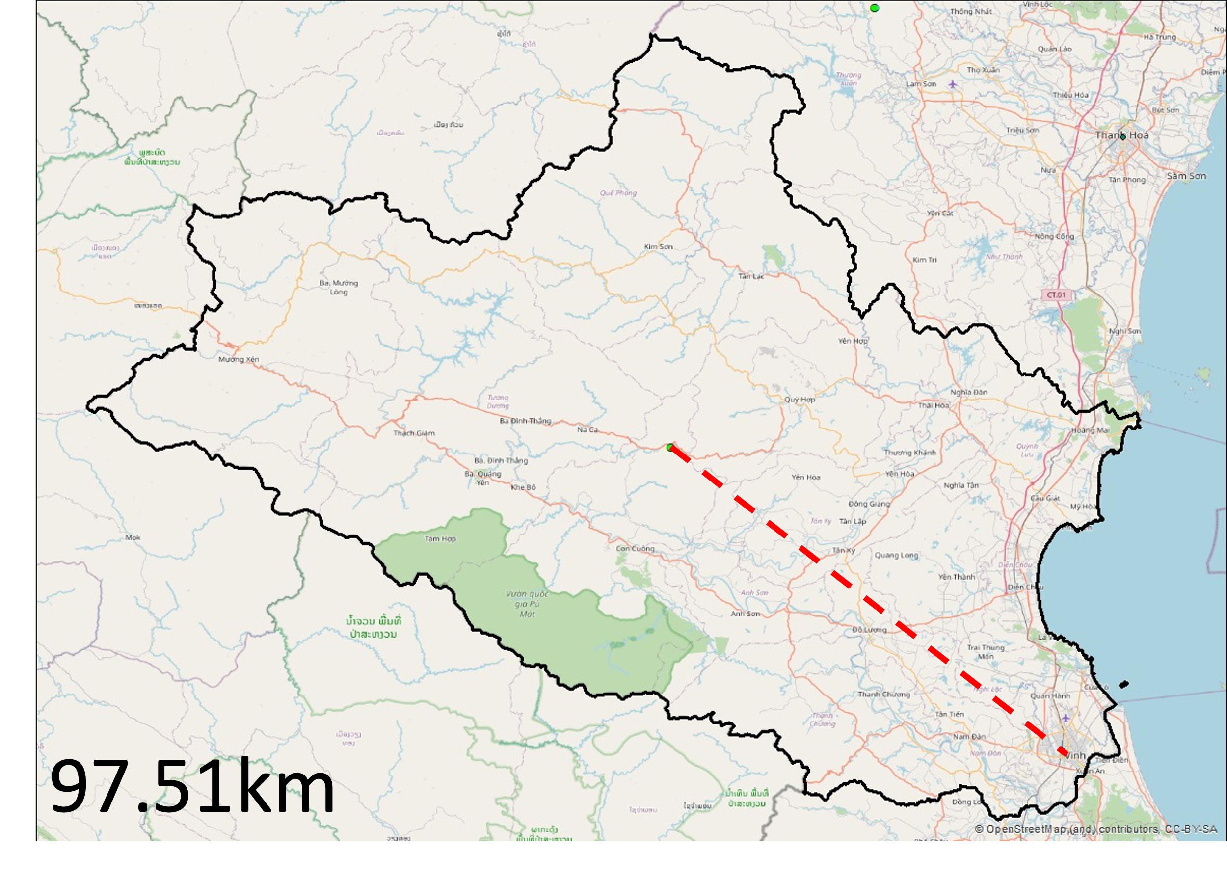  Nghe An Province | 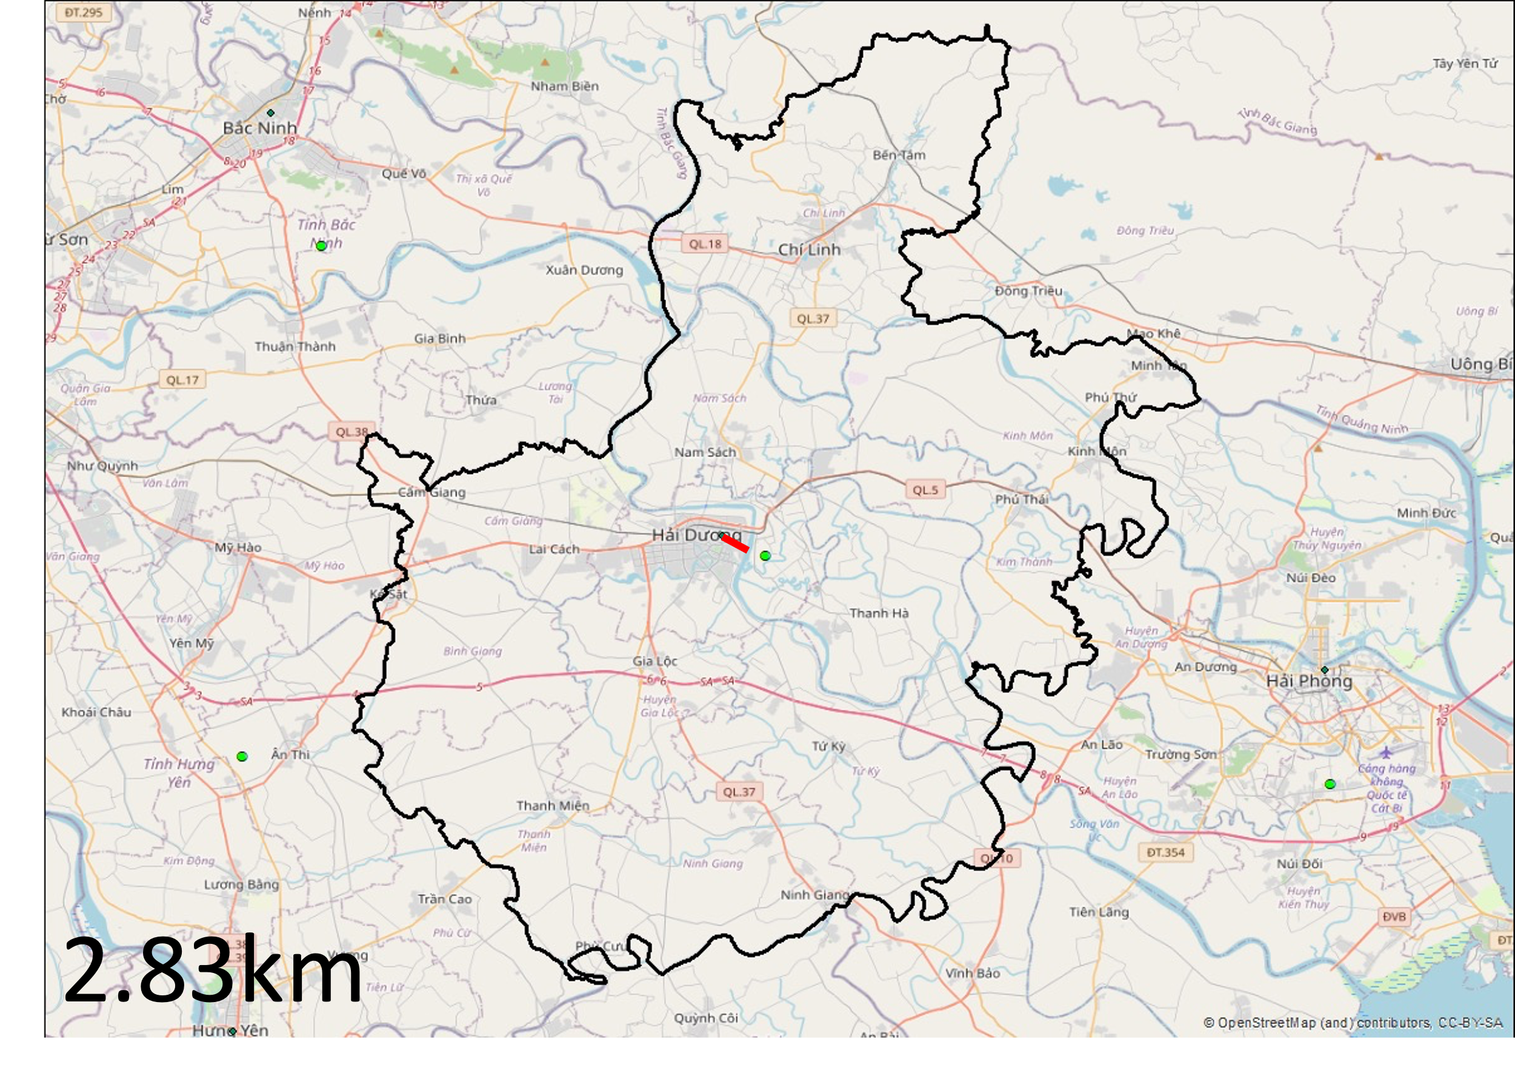  Hai Duong Province
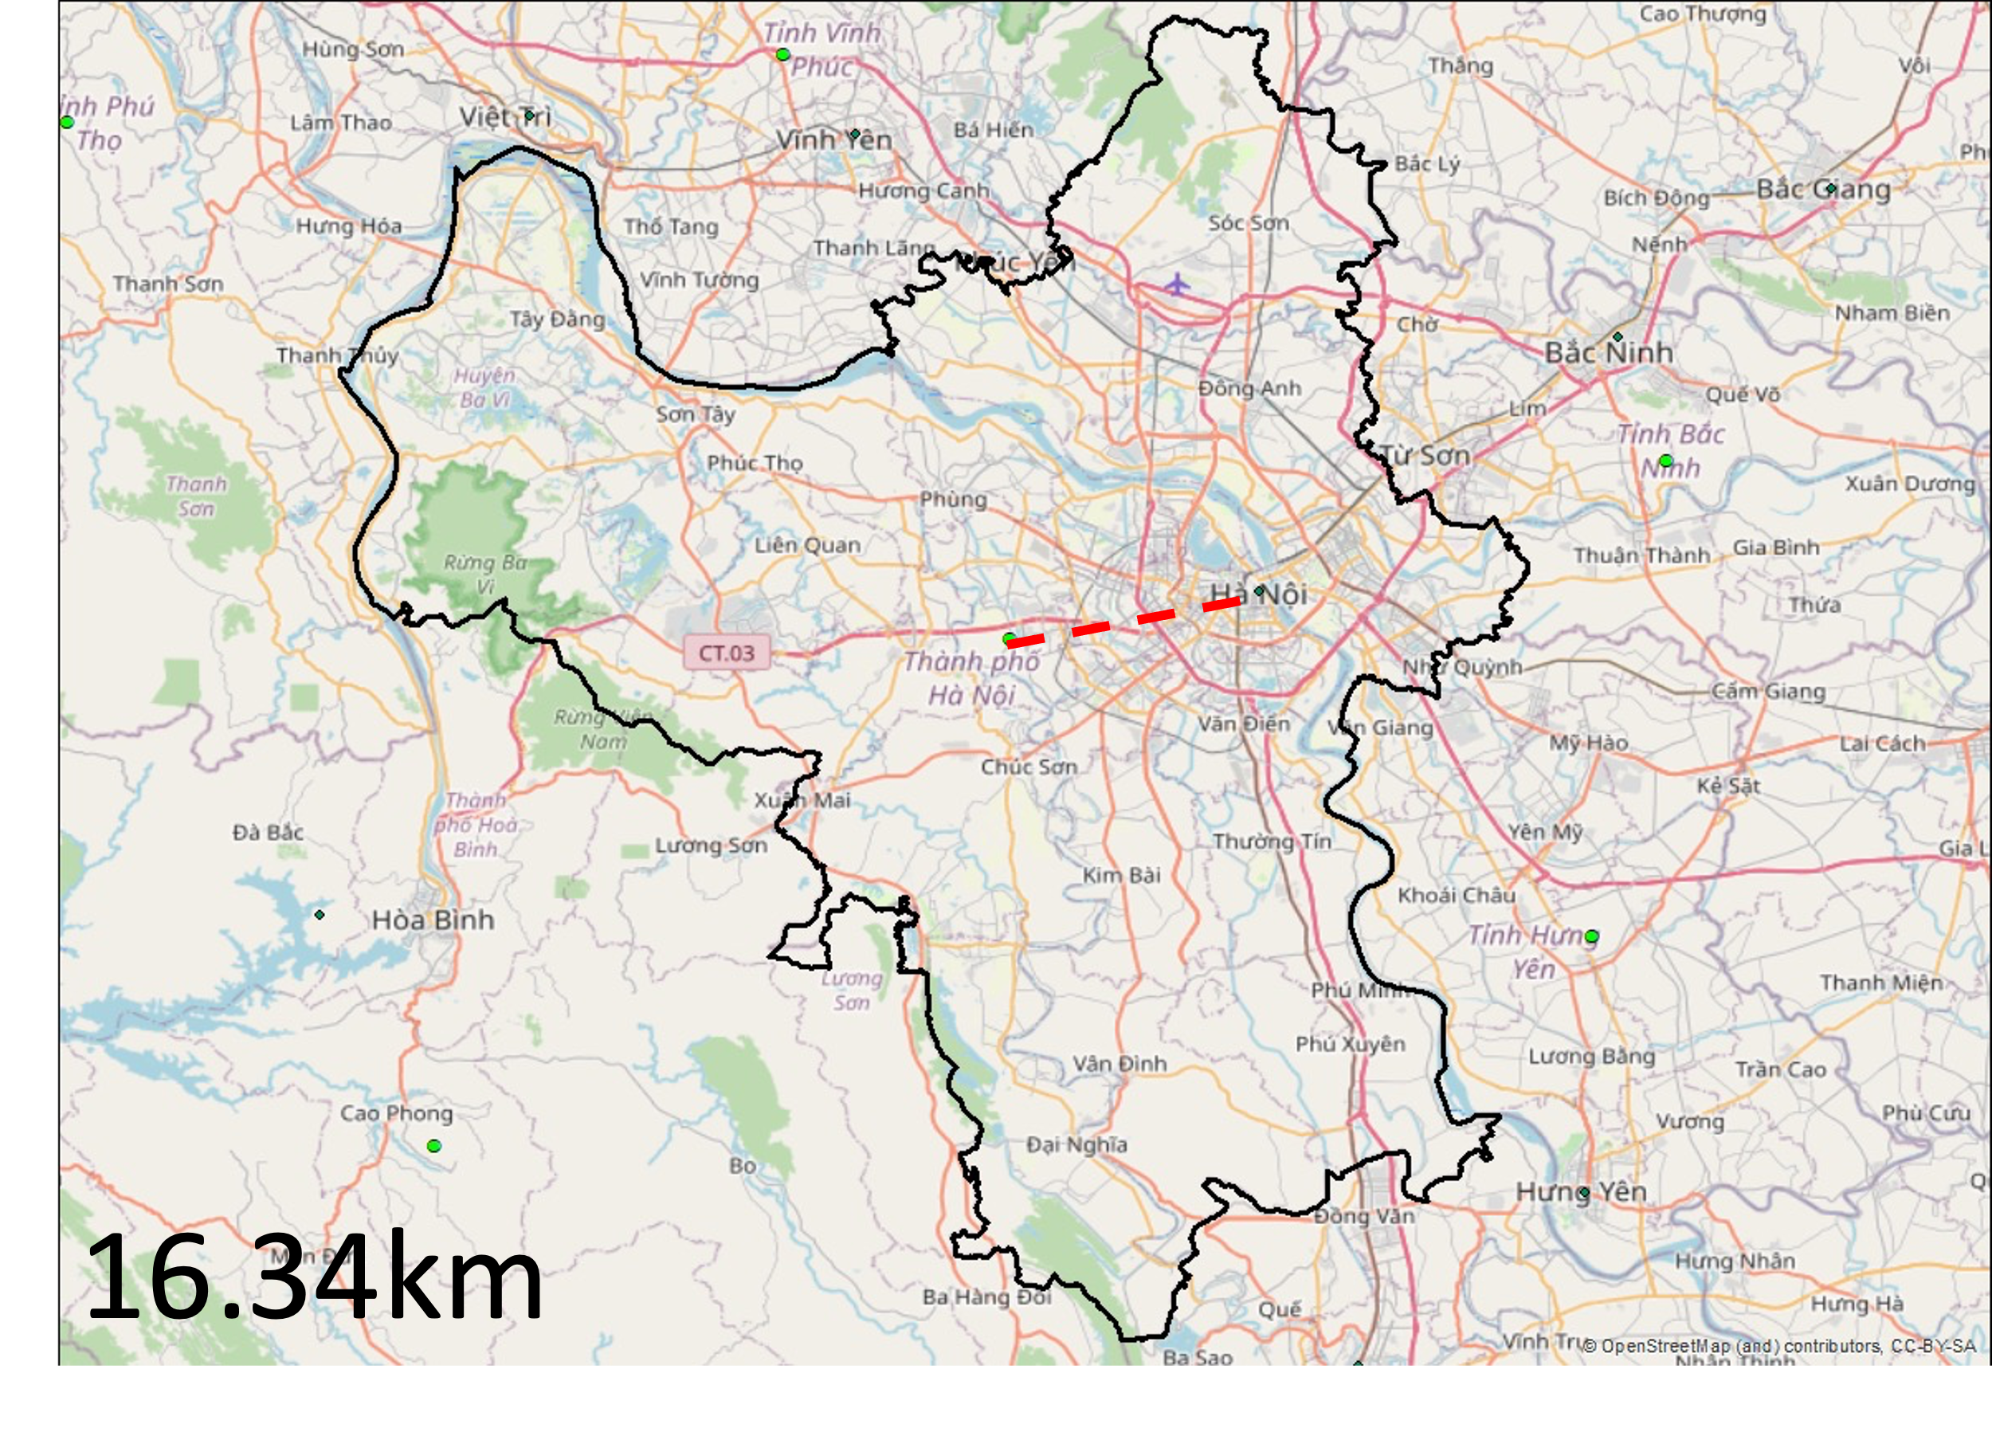  Hanoi | 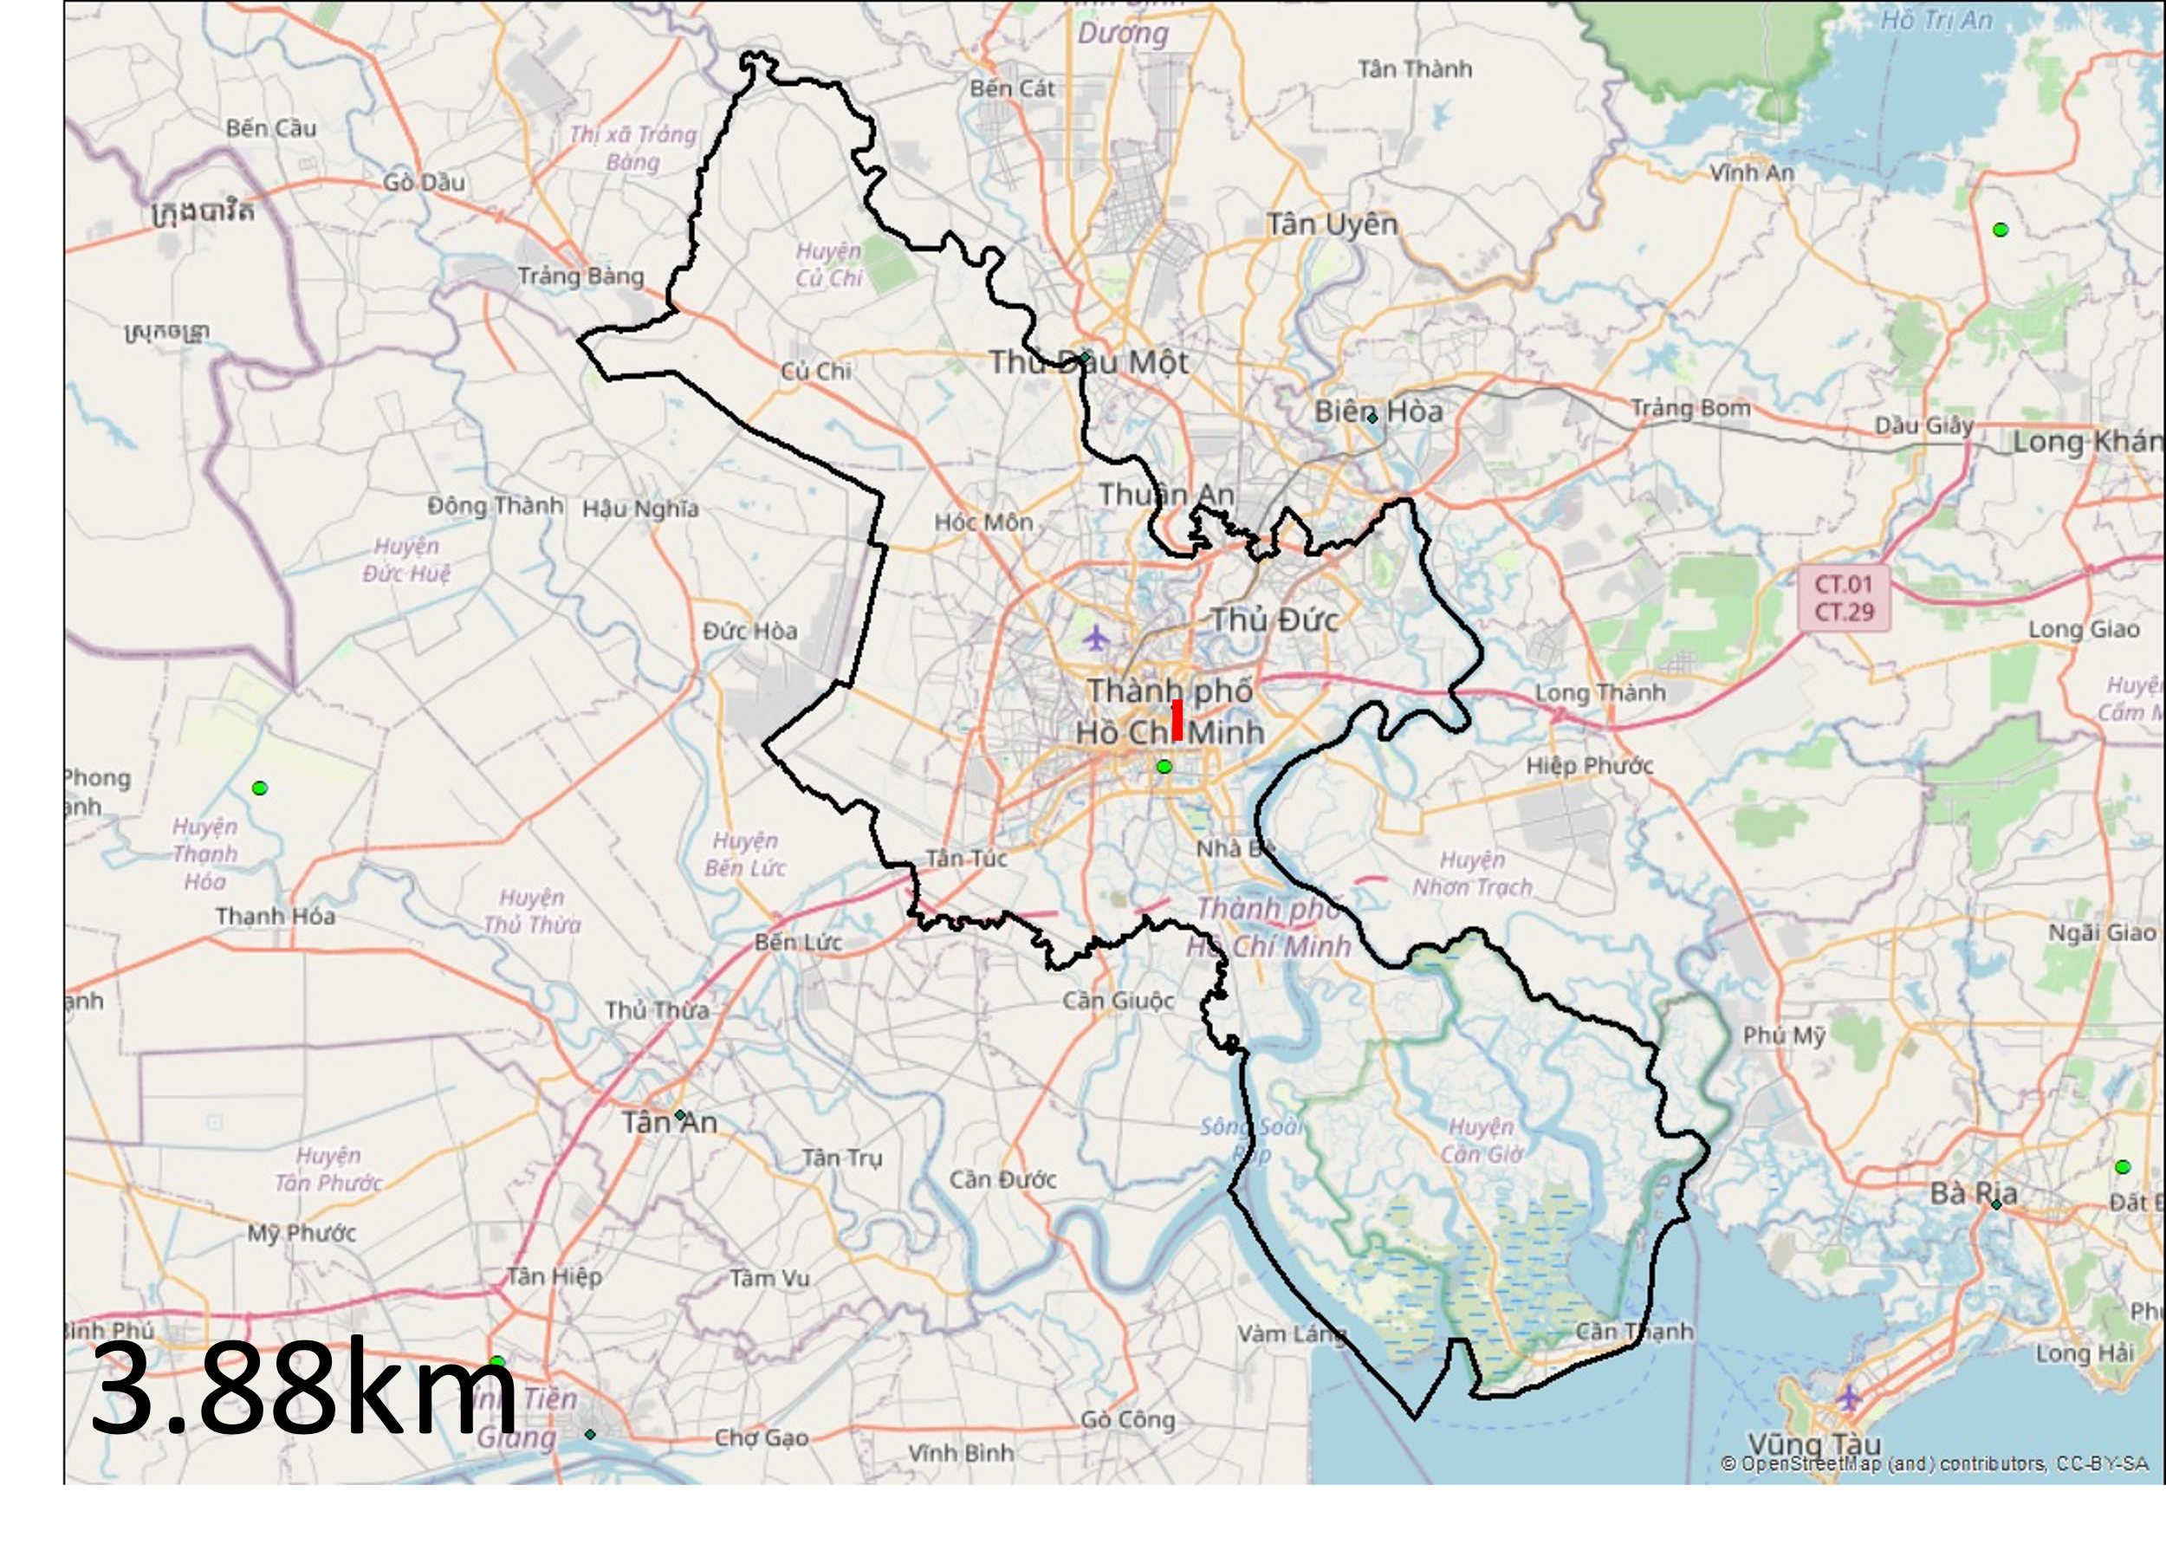  Ho Chi Minh City
Figure B1. Distance as the crow flies between provincial centroid and People’s Committee Head Office locations for Nghe An, Hai Duong, Hanoi, and Ho Chi Minh City.
Note: the estimated distance is displayed as the red dashed line
If the average of the distance from such selected centers to their provincial periphery is calculated as remarked by Carrothers (1956), such $D_{ii}$ distance might not be representative for all provinces considered and thus might not be appropriate to calculate $iV$ values. So instead, the median distance of 19.45 km is applied to all $i$- $i$ pairs. We further assume that it takes 01 minute to travel 01 kilometer as the crow flies, and thus travel time for all $i$-$i$ pairs is also 19.45 minutes. Note that the values of $D_{ii}$ and $T_{ii}$ only apply to the 63 $i$-$i$ pairs. For all $i$-$j$ pairs, the actual road kilometers and travel time is calculated between People’s Committee Head Office locations using Microsoft Bing Map Application Programming Interface (API) as outlined in section 3.2.
Table B1. Distance between the assumed center of growth and centroid in the analysis
 | Origin-Destination | $$D_{ii}$$  (kilometer) |  | Origin-Destination | $$D_{ii}$$  (kilometer)
Red River Delta | Hanoi | 16.34 | North-central and Central Coastal Area | Thanh Hoa | 54.48
Red River Delta | Vinh Phuc | 7.17 | North-central and Central Coastal Area | Nghe An | 97.51
Red River Delta | Bac Ninh | 9.04 | North-central and Central Coastal Area | Ha Tinh | 21.11
Red River Delta | Quang Ninh | 37.24 | North-central and Central Coastal Area | Quang Binh | 35.75
Red River Delta | Hai Duong | 2.83 | North-central and Central Coastal Area | Quang Tri | 19.79
Red River Delta | Hai Phong | 7.34 | North-central and Central Coastal Area | Thua Thien Hue | 16.46
Red River Delta | Hung Yen | 17.54 | North-central and Central Coastal Area | Da Nang | 16.81
Red River Delta | Thai Binh | 7.63 | North-central and Central Coastal Area | Quang Nam | 54.78
Red River Delta | Ha Nam | 5.47 | North-central and Central Coastal Area | Quang Ngai | 21.73
Red River Delta | Nam Dinh | 19.97 | North-central and Central Coastal Area | Binh Dinh | 49.17
Red River Delta | Ninh Binh | 8.82 | North-central and Central Coastal Area | Phu Yen | 30
Northern Midlands and Mountainous Area | Ha Giang | 6.73 | North-central and Central Coastal Area | Khanh Hoa | 19.45
Northern Midlands and Mountainous Area | Cao Bang | 19.37 | North-central and Central Coastal Area | Ninh Thuan | 18.14
Northern Midlands and Mountainous Area | Bac Kan | 12.3 | North-central and Central Coastal Area | Binh Thuan | 21.86
Northern Midlands and Mountainous Area | Tuyen Quang | 32.56 | Central Highlands | Kon Tum | 35.37
Northern Midlands and Mountainous Area | Lao Cai | 14.02 | Central Highlands | Gia Lai | 32.7
Northern Midlands and Mountainous Area | Yen Bai | 36.14 | Central Highlands | Dak Lak | 24.31
Northern Midlands and Mountainous Area | Thai Nguyen | 10.11 | Central Highlands | Dak Nong | 25.04
Northern Midlands and Mountainous Area | Lang Son | 14.18 | Central Highlands | Lam Dong | 43.01
Northern Midlands and Mountainous Area | Bac Giang | 29.64 | Mekong Delta Region | Long An | 33.99
Northern Midlands and Mountainous Area | Phu Tho | 29.71 | Mekong Delta Region | Tien Giang | 7.59
Northern Midlands and Mountainous Area | Dien Bien | 35.72 | Mekong Delta Region | Ben Tre | 16.73
Northern Midlands and Mountainous Area | Lai Chau | 35.35 | Mekong Delta Region | Tra Vinh | 16.07
Northern Midlands and Mountainous Area | Son La | 22.62 | Mekong Delta Region | Vinh Long | 17.25
Northern Midlands and Mountainous Area | Hoa Binh | 17.48 | Mekong Delta Region | Dong Thap | 11.84
Southeast | Binh Phuoc | 24.38 | Mekong Delta Region | An Giang | 30.81
Southeast | Tay Ninh | 12.36 | Mekong Delta Region | Kien Giang | 14.64
Southeast | Binh Duong | 25.99 | Mekong Delta Region | Can Tho | 29.58
Southeast | Dong Nai | 41.77 | Mekong Delta Region | Hau Giang | 15.46
Southeast | Ba Ria - Vung Tau | 8.41 | Mekong Delta Region | Soc Trang | 6.51
Southeast | Ho Chi Minh City | 3.88 | Mekong Delta Region | Bac Lieu | 26.37
 |  |  | Mekong Delta Region | Ca Mau | 19.25
Source: table by author
Table B2. Descriptive statistics for $D_{ii}$ pairs
$D_{ii}$ matrix only
Mean | 23.105873
Standard Error | 1.9574076
Median | 19.45
Mode | #N/A
Standard Deviation | 15.5364412
Sample Variance | 241.381005
Kurtosis | 7.39946796
Skewness | 2.03848171
Range | 94.68
Minimum | 2.83
Maximum | 97.51
Sum | 1455.67
Count | 63
Confidence Level (95.0%) | 3.91280205
Source: table by author
Table B3. Descriptive statistics for $D_{ij}$ distance matrix (road kilometer)  Source: table by author | Table B4. Descriptive statistics for $T_{ij}$ distance matrix (minutes travelled)  Source: table by author
  $$D_{ij}$$
  Mean | 894.200139
  Standard Error | 9.68353805
  Median | 864
  Mode | 19.45
  Standard Deviation | 610.062897
  Sample Variance | 372176.738
  Kurtosis | -1.4502948
  Skewness | 0.12469959
  Range | 2093
  Minimum | 17
  Maximum | 2110
  Sum | 3549080.35
  Count | 3969
  Confidence Level (95.0%) | 18.9851769
  $$T_{ij}$$
  Mean | 910.9575
  Standard Error | 9.329522
  Median | 894
  Mode | 19.45
  Standard Deviation | 587.7599
  Sample Variance | 345461.6
  Kurtosis | -1.44926
  Skewness | 0.054497
  Range | 2038.55
  Minimum | 19.45
  Maximum | 2058
  Sum | 3615590
  Count | 3969
  Confidence Level (95.0%) | 18.29111

Appendix C. Summary of spatial interpolation procedures and associated assumptions
An interesting quality of gravity models in general, and the potential gravity model in particular, is its ability to demonstrate, via heat maps, the extent to which urban centers exert their influence (i.e., varying intensities with contour lines), and the option to do so using alternative demographic or economic size measurements. Obtaining data from every point in a surveyed area is often very expensive or difficult to perform, so interpolation to estimate data at unobservable locations is a way to overcome the problem of imperfect information. In essence, this technique increases the illustrative and analytical value of data.
To calculate $D_{ij}$ and $T_{ij}$, the Microsoft Bing Map API was utilized to calculate actual travel distance in kilometers, and travel time in minutes respectively, between every $i$-$j$ pair in a specifically defined region and for the nationwide indicator. The Microsoft Bing Map API provides real-time shortest travel distance and average travel time between two locations, which is more practical than published atlas data that is often outdated.
For this methodology to work, we must make several assumptions. The first assumption is that the center of growth for a province is the location of the People’s Committee Head Office. The coordinates of all People’s Committee Head Office locations were taken in accordance with the WGS 84.
The second assumption is on the distance $D_{ii}$ – precisely in calculating potentials of a given province on itself. In formulas 3.4, 3.8, 3.9, it is implied that for $j$ = $1→n$, it is $j$ = $1, 2, …, i, …n$. The estimation of $D_{ii}$ and $T_{ii}$ is presented in Appendix B.
The third assumption is the technique used is the Inverse Distance Weight (IDW) spatial interpolation tool via ArcGIS software.
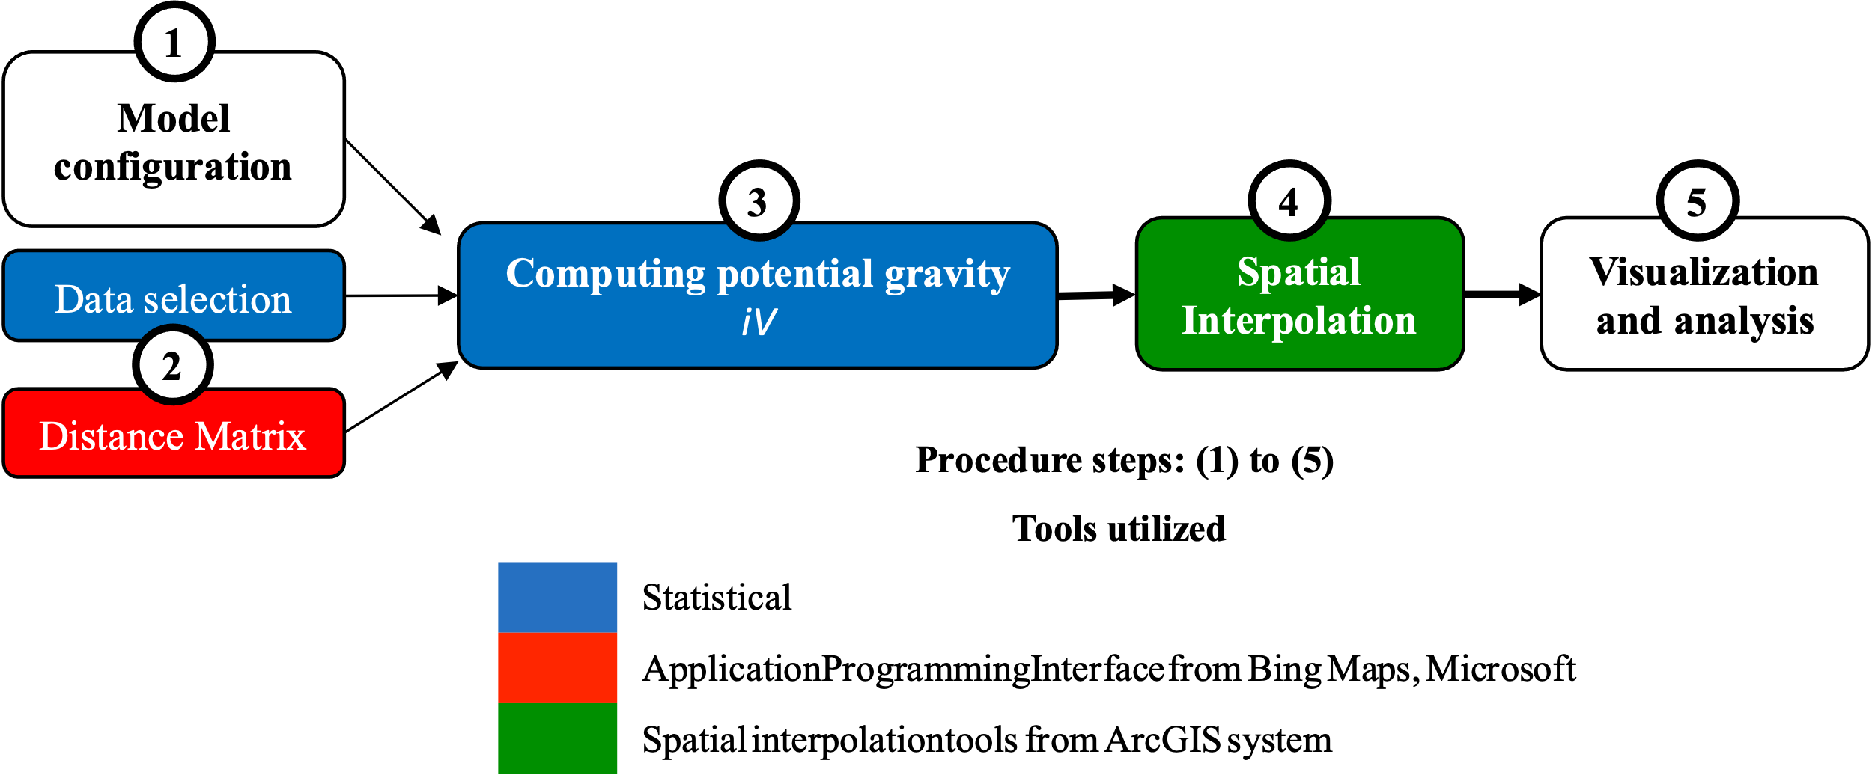
Figure C1. Five-step analysis procedure
Source: figure by author
The analytical process is summarized in a five-step procedure as follows (Figure C1). The first step is to clearly set out the research area and to configure suitable models for examination, from which formulas are defined; this is followed by the second step of data selection and calculating distance/time travelled matrices. In the third step, the value of $iV$ is computed for every single unit $i$, and is inputted into respective $i$ People’s Committee Head Office locations and then run through the process of spatial interpolation, which is the fifth step. The final step is finishing up the visualization and analyzing results.

