Supplementary material

SI Appendix Companion to
Navigating the Networking Myth: Women’s Struggle for
Equity in Corporate Hierarchies

Methods
The first phase of our mixed research methodology consists of developing, administering, and validating an Implicit Association Test (IAT). We used Zlotnick et al. (2015)’s computer program and followed Bar-Anan (2020)’s instructions to embed our test within an online survey. All in all, the purpose of the IAT is to associate concepts (i.e., networking vs. getting work done) with a set of attributes (i.e., illegitimacy vs. legitimacy). Depending on the speed and rate at which concepts and attributes are correctly matched, a measure of implicit association is derived.
In order to describe the structure of the IAT, we present Table I, where we summarize the different stages and the tasks constituting the designed IAT. Overall, the test has seven stages. The purpose of the first two stages is for participants to become familiar with both i) the stimuli used for the different categories and attributes, and ii) the dynamics of classifying stimulus into left or right responses (classification of stimuli into left or right responses was assigned randomly for each participant). In the third and fourth stages of the test, participants are presented with a combined task containing stimuli from either categories or attributes. Each stimulus has to be classified into left or right responses corresponding to the category-attribute pair it belongs to (See Figure 1). In the fifth stage, the stimuli are presented again, but this time, the left and right positions are switched from the ones used in the first stage. In the sixth and seventh stages, the attributes and categories are presented just like in the third and fourth stages, but with the new switched configuration. The response times from both the fourth and the seventh stages are recorded and analyzed to measure implicit associations. Response time will be faster for the category-attribute pair that the participant implicitly consider more congruent.

Administering the IAT
To ensure a relevant and representative participant sample, we recruited 59 women managers in Spain through LinkedIn. The selection process was based on individuals who had a managerial background and a demonstrated interest in leadership development, as evidenced by their participation in a women’s leadership program, (see Martínez-Martínez et al., 2021). We identified these participants using a targeted hashtag
TABLE I: Description and illustration of the Implicit Association Test used as a pre-interview intervention tool in our study. A pair of concepts and a pair of attributes are presented in the first two stages, respectively. Categories for each of these concepts and attributes are assigned to a left (L) or right (R) response. These categories are then combined in the third and fourth steps, i.e., combined tasks. In the fifth step, the concepts are reversed. Last, the categories are recombined in a reversed manner in the sixth and seventh steps, i.e., reversed combined tasks. Response classification into left (L) or right (R) was assigned randomly for each participant.

Stage | Task description | Task instructions | Sample stimuli
1 | Familiarization with categories | L Networking  R Getting work done | R Hiring staff  L Attending conferences
2 | Familiarization with attributes | L Legitimacy R Illegitimacy | R Unfair L Noble
3 | Initial combined task | L Networking  L Legitimacy  R Getting work done | R Hiring staff  L Noble  L Attending conferences
 |  | R Illegitimacy | R Unfair
4 | Second combined task | L Networking  L Legitimacy  R Getting work done | R Organizing  L Honest  L Attending conferences
 |  | R Illegitimacy | R Fake
5 | Reversed categories | L Getting work done R Networking | R Sending company presents L Strategic planning
6 | Initial reversed combined task | L Getting work done  L Legitimacy  R Networking | R Drinking out with colleagues  L Noble  L Making decisions
 |  | R Illegitimacy | R Unfair
7 | Second reversed combined task | L Getting work done  L Legitimacy  R Networking | R Drinking out with colleagues  L Noble  L Making decisions
 |  | R Illegitimacy | R Unfair
Source: Authors’ own work

search in LinkedIn. It is important to note that our sample is relatively homogeneous in terms of age, years of experience, and current organizational roles.
Once recruited, we sent the IAT through an online survey to all 59 women managers. The test began with a set of instructions for answering the test. The instructions mainly concerned avoiding distractions and making sure that the test was answered in one go. Then, they were asked to answer a 7-point Likert scale question concerning their (explicit) preference to engage in networking behavior versus getting work done. Next, an overview of the stimuli and categories was presented followed by the actual test. Last, participants received the results of their test which is a summary of their implicit associations toward networking.

FIGURE 1: Sample stimulus of our Implicit Association Test
Categories (networking

PREPARE REPORTS
LEGITIMACY
or
NETWORKING
ILLEGITIMACY
or
GETTING WORK
DONE
vs.
getting work done

)
and attributes
(
legitimacy
vs.
illegitimacy
)
labels
appear in the top corners
of the screen
Stimulus to be categorized
appears in the center of
the screen
L
(
)
Left
R
(
)
Right
Correct behavioral
response
Source: Authors’ own work

Validating the IAT
Since we designed our own Implicit Association Test (IAT) for the purposes of this research, we also validated. In this section, we explain the validation process.
Once all the recruited participants answered the IAT, we proceeded to validate it. We decided to validate it, since we purposefully developed the test for our study. Following Greenwald et al. (2003), we examine the IAT scores obtained as follows. First, we analyze IAT effects and effect sizes. Then, we compare the correlations among IAT effects with implicit and explicit measures. All in all, the validation of our IAT is in line with previous studies, such as Greenwald et al. (1998); Talaska et al. (2008) and Kraus (1995).
We begin by reporting the IAT effect. This is conventionally defined as the difference in the mean latency between the compatible and incompatible conditions. The unit of measurement is milliseconds (ms). For completeness, we also report log latencies, median latencies, and reciprocal latencies as suggested in Greenwald et al. (2003). See Table II.
For each variant of the IAT effect, we report the standard deviation, D, t-statistic, and p-values. Higher values for IAT effects, with the exception of the reciprocal latency, suggest stronger implicit preferences for concepts with a positive valence (getting work done), or weaker association of that concept with negative valence (networking). To illustrate, Greenwald et al. (1998) find an IAT effect equal to 145 ms and 113 ms for the flower and insect studies, respectively. While the conventional IAT effect is measured as the difference in the mean latencies between the compatible and incompatible conditions, the median, the log, and the reciprocal are also used to account for skewnness. The D score divides the difference in latencies by their standard deviation. According to Greenwald et al. (1998), conventional small, medium, and large values of explicit are 0.2,
0.5, and 0.8, respectively.
Thus, our IAT indicates slightly above medium effect size for the difference in mean, median and reciprocal latencies with D values equal to 0.5237, 0.6155, and 0.6620, respectively. And, a slightly below medium effect for the difference in median latency with a D value equal to 0.4678. Last, the t-statistics and p-values indicate that all differences regardless of how they are calculated are statistically different at the 1% level of significance, for a sample size of 59.

TABLE II: Summary statistics for IAT effects
Positive scores indicate preference for getting work done over networking. The effect size measure D = Mean / S.D.
IAT Effect | Mean | S.D. | D score | t(58) | p-values
Mean latency | 434.59 | 829.77 | 0.52 | 4.02 | 0.00
Log latency | 0.21 | 0.34 | 0.62 | 4.73 | 0.00
Median latency | 273.19 | 583.97 | 0.47 | 3.59 | 0.00
Reciprocal latency | 0.15 | 0.23 | 0.66 | 5.085 | 0.00
Source: Authors’ own work

To illustrate the latencies incompatible and incompatible conditions for our IAT, we present Figure 2. For consistency, we report mean latencies (Figure 2a), median latencies (Figure 2b), mean log latencies (Figure 2c), and mean reciprocal latencies (Figure 2d). For validation purposes, it is important to focus on the compatible combined task (yellow bar) and the incompatible combined task (grey bar) latencies. Consistent with the results reported in Table II, the response time for the incompatible combined task is statistically larger than the response time for the compatible combined task. This suggests a stronger implicit preference for concepts with a positive valence (getting work done), or weaker association of that concept with negative valence (networking). Drawing attention to Figure 2a), we can compute the IAT effect equal to 434.5932 ms we report in Table II as the difference in response time between the incompatible combined task latency (2,030.27 ms) and the compatible combined task latency (1,595.68 ms).
Next, we compute the correlations among the explicit and implicit attitude measures. These correlations are in Table III. We compute these correlations because a central assumption is that higher implicit-explicit correlations for an IAT effect can indicate greater construct validity as a measure of association strengths. This central assumption depends on a further assumption that association strength is a latent component of both the implicit and explicit measures (Greenwald et al., 2003).
In line with Greenwald et al. (1998), all correlations between explicit and IAT effects are weak and in the expected positive correlation. Only the IAT effects measured with the median and reciprocal latency are statistically significantly correlated with the explicit measure at the 10% and 5% level, respectively.
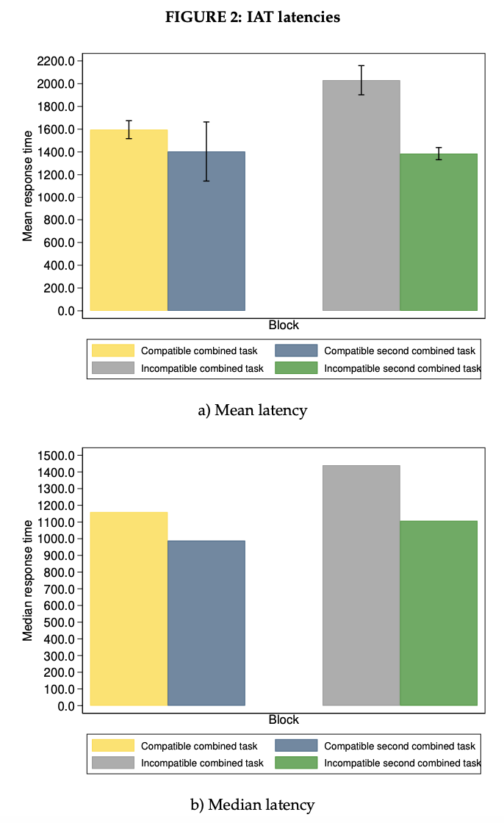
Source: Authors’ own work

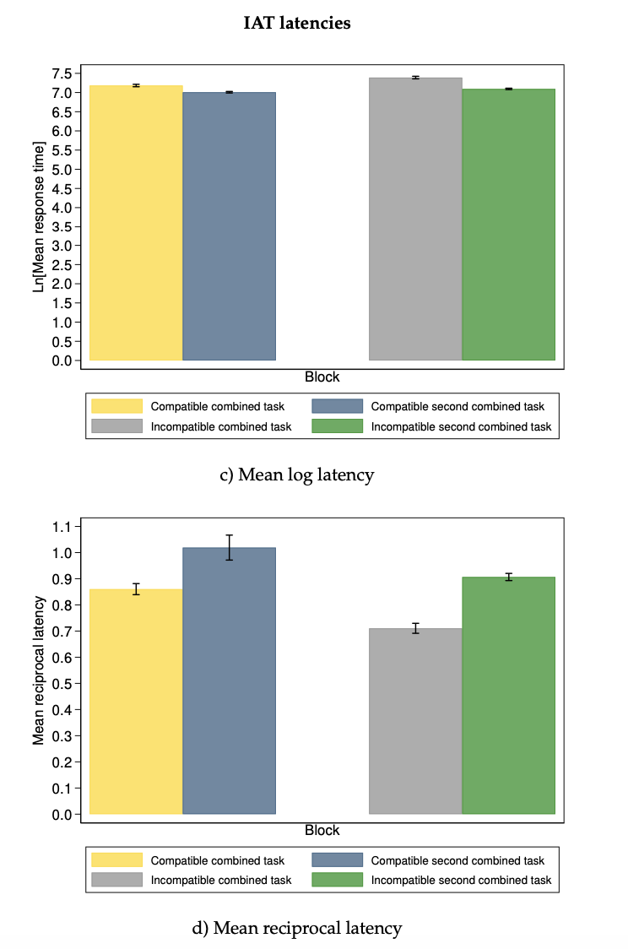

Source: Authors’ own work

TABLE III: Pearson correlations among implicit and explicit attitude measures All measures are scored so that higher scores indicate more positive attitudes toward getting work done. N=59.
Measure | Explicit | Implicit
- IAT effect (mean latency) | 0.13 | 0.64***
- IAT effect (mean log latency) | 0.19 | 0.84***
- IAT effect (median latency) | 0.23* | 0.85***
- IAT effect (reciprocal latency) | 0.30** | 0.75***
*p<0.10
**p<0.05
***p<0.010
Source: Authors’ own work

Emerging themes from interviews
Table IV presents a summary of the emerging sub-themes discussed during the interviews. These themes and concepts are further discussed in the main manuscript.
TABLE IV: Themes overview and definitions
Themes | Description | Examples
Delegitimizing networking
Exclusionary old boys' networks | Informal networks of influential men that may, inadvertently or deliberately, exclude women, thus creating barriers to their professional advancement. | "Men usually go out to eat and have coffee. Sometimes I ask them why only men go. [...] Women managers don't join them very often. It's difficult if you are not in those spaces."
The 'subordinate trap' | This dilemma arises when women's participation in networking activities is undervalued, perpetuating their perceived subordination. Simultaneously, their absence from these activities results in a state of professional stagnation. | Women report being treated as secretaries ("Will you be taking the notes during the meeting?"), assigned the housework ("Will you serve the coffee?"), being "manterrupted", and suffering from "bropriating" which lead women in management to question their aspirations and settle for less, often resulting in them not reaching their full potential.
Legitimizing networking
'Casuistic self-justification' | Cognitive strategy women managers use to reconcile their ethical concerns about networking with the perceived necessity of participation for career advancement. This psychological process enables them to frame their engagement in networking activities as necessary, even when such actions may conflict with their personal values or beliefs. | I "used to see networking as something for social climbers, something negative [...] Maybe I was focusing on the negative side of it and not seeing the other side."  "In certain positions, talent does not only have to do with hard skills. It does not only have to do with what you are capable of doing. It has to do with [...] networking.?”
Self-imposed higher standards' | An internalized perspective where women, attributing their lack of networking success to personal deficiencies, establish elevated benchmarks for themselves, setting the bar higher than what might be traditionally expected. These standards are driven by a belief that their current efforts are insufficient and that a more intense approach is needed to achieve successful networking. | "I am adopting a networking discipline, for example, by meeting someone for lunch every week."  "You have to make the effort to be present, become visible, and actively ask for invitations."  "I, of course, personally find it very difficult to do networking. I mean, going out for dinner, going to sports events is much more challenging for me [...] The fact that it's hard for me doesn't mean I don't do it, because in the end you force yourself to do it, but it's not something you initially want to do."
Source: Authors’ own work

References
Bar-Anan, Y., 2020. Running project implicit’s IAT from qualtrics. https://minnojs.github.io/minnojs-blog/qualtrics-iat/.
Greenwald, A.G., McGhee, D.E., Schwartz, J.L., 1998. Measuring individual differences in implicit cognition: the implicit association test. Journal of Personality and Social Psychology 74, 1464–1480.
Greenwald, A.G., Nosek, B.A., Banaji, M.R., 2003. Understanding and using the implicit association test: I. an improved scoring algorithm. Journal of Personality and Social Psychology 85, 197–216.
Kraus, S.J., 1995. Attitudes and the prediction of behavior: A meta-analysis of the empirical literature. Personality and Social Psychology Bulletin 21, 58–75.
Martínez-Martínez, M., Molina-López, M.M., Mateos de Cabo, R., Gabaldón, P., Gonzalez-Pérez, S., Izquierdo, G., 2021. Awakenings: An authentic leadership development program to break the glass ceiling. Sustainability 13, 7476.
Talaska, C.A., Fiske, S.T., Chaiken, S., 2008. Legitimating racial discrimination: Emotions, not beliefs, best predict discrimination in a meta-analysis. Social Justice Research 21, 263–296.
Zlotnick, E., Dzikiewicz, A., Bar-Anan, Y., 2015. Minno.js (version 0.3) [computer software].

To illustrate previous studies have found correlations of 0.16 (Talaska et al., 2008), 0.19 (Greenwald et al., 1998), and 0.24 (Kraus, 1995).

