Supplementary Materials
Table of Contents
Supplementary Material A | Arrival Survey Instrument | Page 2
Supplementary Material B | Departure Survey Instrument | Page 2
Supplementary Material C | Examples to demonstrate Analysis of Pictorial Data | Page 3

Supplementary Material A: Arrival Survey Instrument
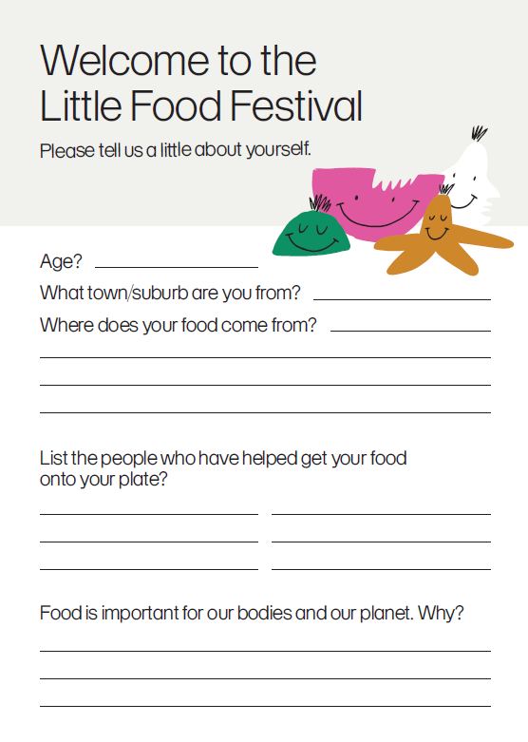
Supplementary Material B: Departure Survey Instrument
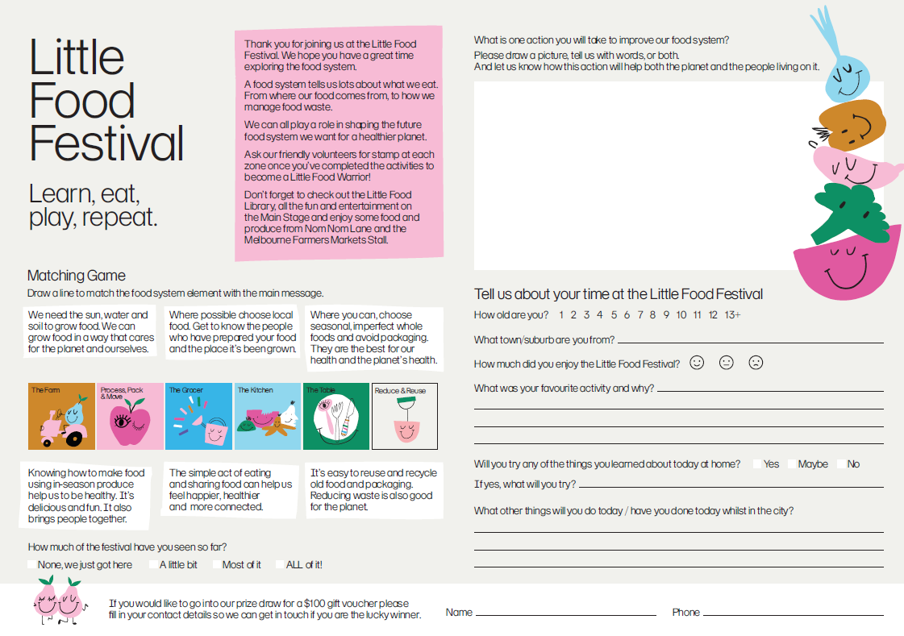
Supplementary Material C: Examples to demonstrate Analysis of Pictorial Data
Example 1 | Illustration | 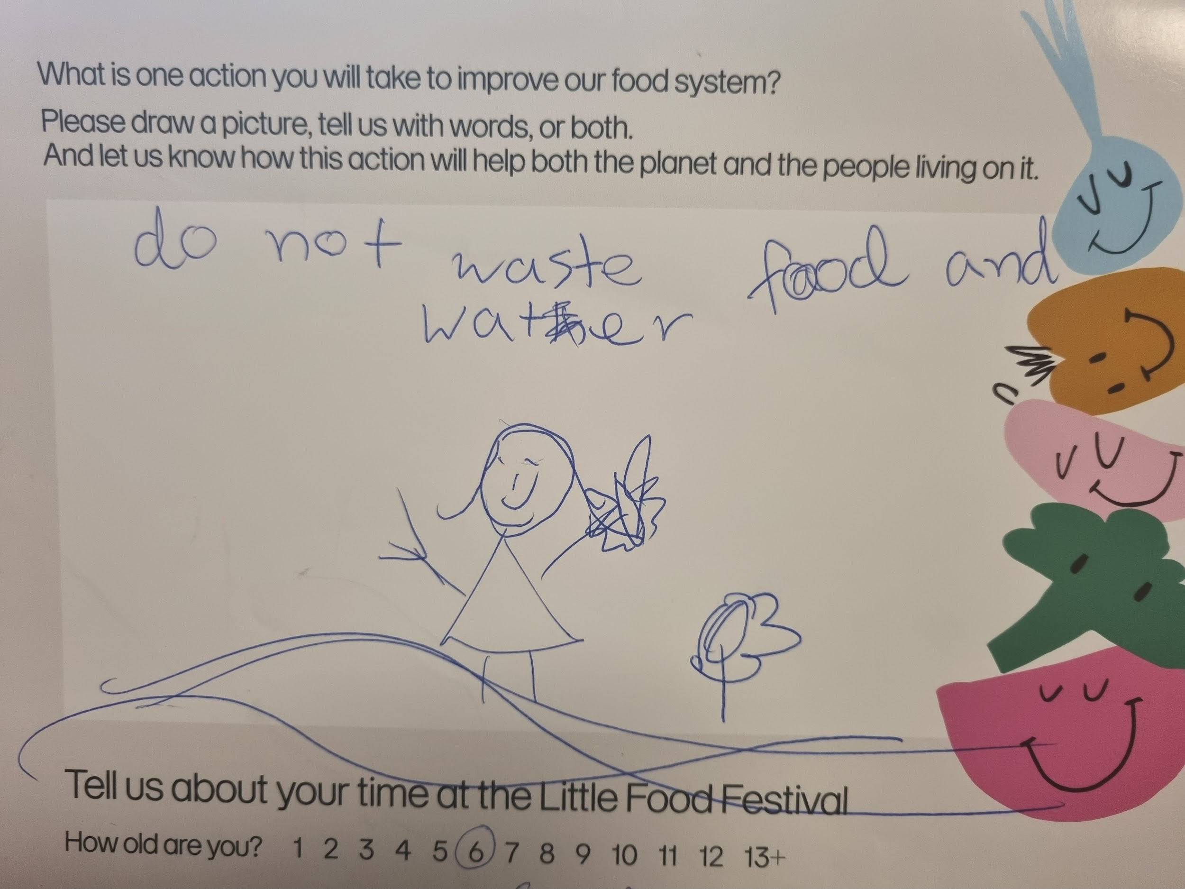
Example 1 | Written description | Girl holding a butterfly in the middle, there is a flower on her right side.
Example 1 | Description of interpretation | From the illustration, the child probably enjoys nature and flowers, which could represent their appreciation of nature, since there are insects and plants, it could also symbolise biodiversity in the ecosystem. From the phrase ‘do not waste food and water’, it could mean an understanding of conservation and importance of resources, which demonstrates their awareness of the value of food and water, and how their waste can impact environmental health.
Example 1 | Codewords | - Appreciation of nature  - Conservation awareness  - Awareness of environmental impact  - Understanding of biodiversity
Example 2 | Illustration | 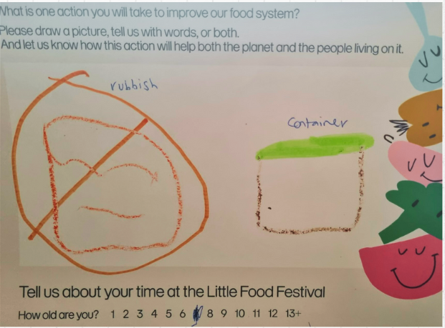
Example 2 | Written description | On the left, there is a big cross on a box (rubbish); on the right, there is another box with a green cover (container).
Example 2 | Description of interpretation | This could be interpreted as an action to bring containers from home for takeaway, instead of using plastic containers or food packaging, which could suggest the understanding of less food packaging for environmental health. It could also be interpreted as composting, as compost bins in Australia have green lids.
Example 2 | Codewords | - Less food packaging  - Avoid landfills  - Trash reduction  - Compost
Example 3 | Illustration | 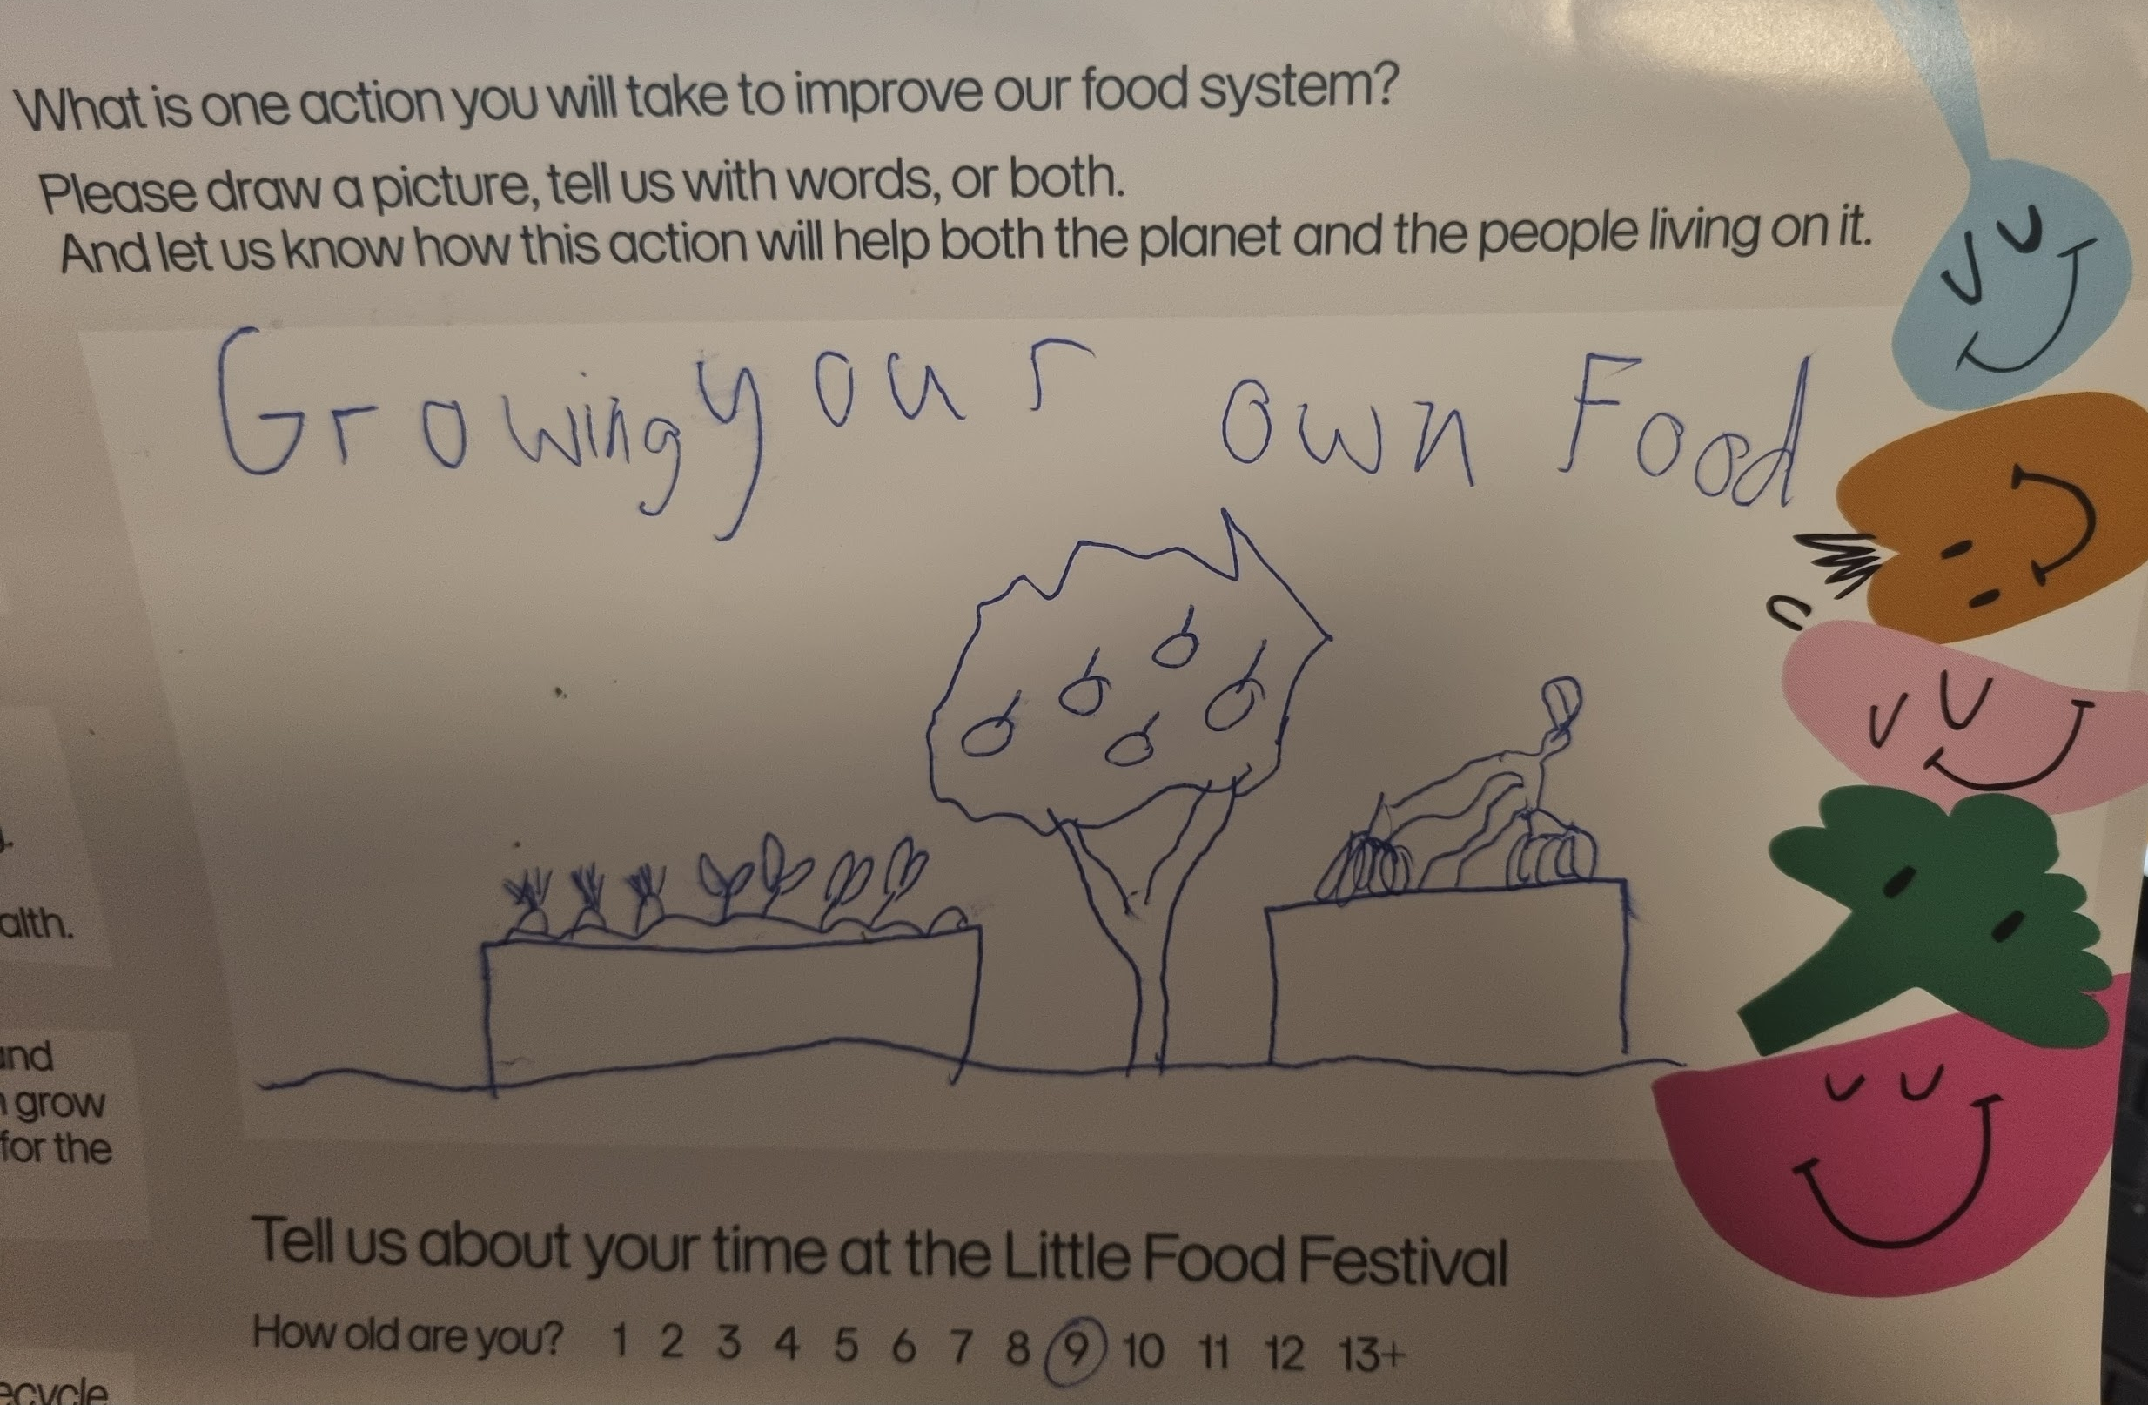
Example 3 | Written description | Seedlings planted on soil on the left; Fruit/apple tree in the middle; a different-looking plant on the right.
Example 3 | Description of interpretation | Growing a variety of food/edible plants in the garden, which could represent the importance of biodiversity in sustainable agricultural practices.
Example 3 | Codewords | - Gardening  - Biodiversity
Example 4 | Illustration | 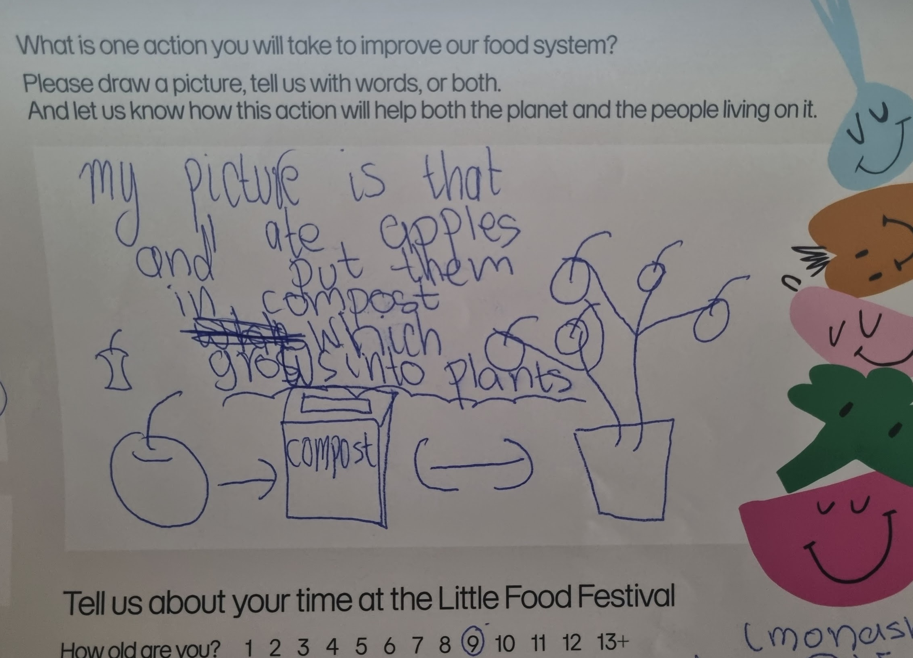
Example 4 | Written description | An apple core that has been eaten (separated by a one-way arrow) thrown into a compost bin (separated by a two-way arrow) then grown into an apple tree.
Example 4 | Description of interpretation | The drawing represents an action of composting and reducing food wastage that would instead be thrown into landfill. The two-way arrow could suggest the process is cyclical and ongoing. The apple breaks down in the compost bin and eventually becomes a part of the soil, which helps a new apple tree to grow. It reflects the understanding of the individual that composting is a sustainable practice to reduce waste and supports the growth of new plants, which shows the concept of a circular food system. This child seems to understand the basic idea of reusing 'waste' as a valuable resource that feeds back into our food system to nurture new life.
Example 4 | Codewords | - Composting  - Understanding of circular food system  - Understanding of life cycle  - Food waste reduction  - Avoid landfills
Example 5 | Illustration | 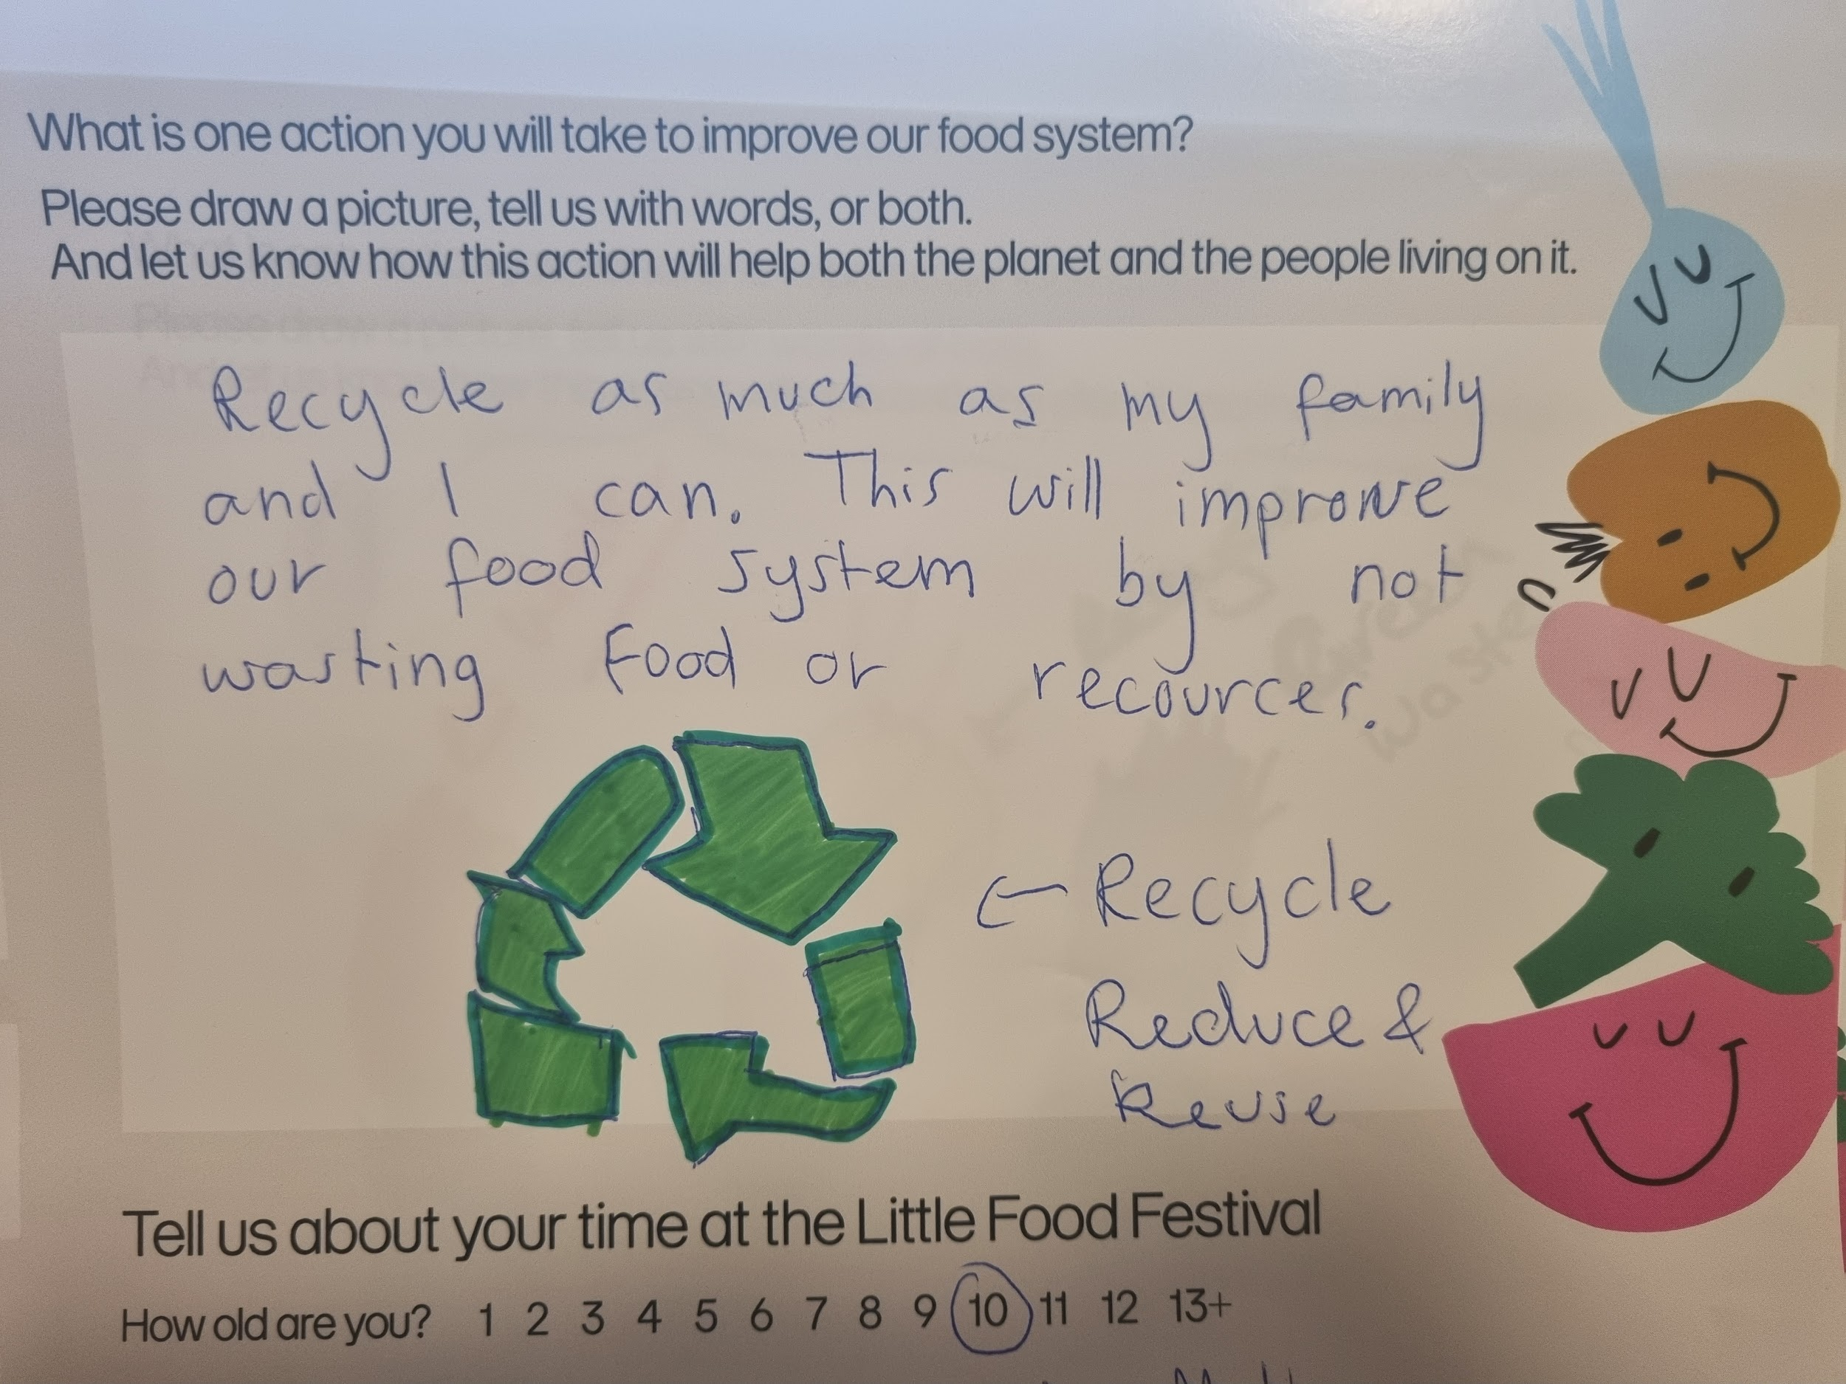
Example 5 | Written description | Drawing of the recycle, reduce, and reuse sign.
Example 5 | Description of interpretation | Reducing waste by reusing and recycling items, maybe composting as well. Reducing the volume of waste going into landfills. The phrase "recycling as much as my family and I can" suggested a determined and collective approach to reduce waste, no matter if it's food or other resources, this meant that the child showed their determination in protecting environmental health and also the desire to influence their family members.
Example 5 | Codewords | - Reusing  - Recycling  - Composting  - Avoiding landfills  - Waste management  - Determination approach  - Collective action  - Environmental health  - Influencing others
Example 6 | Illustration | 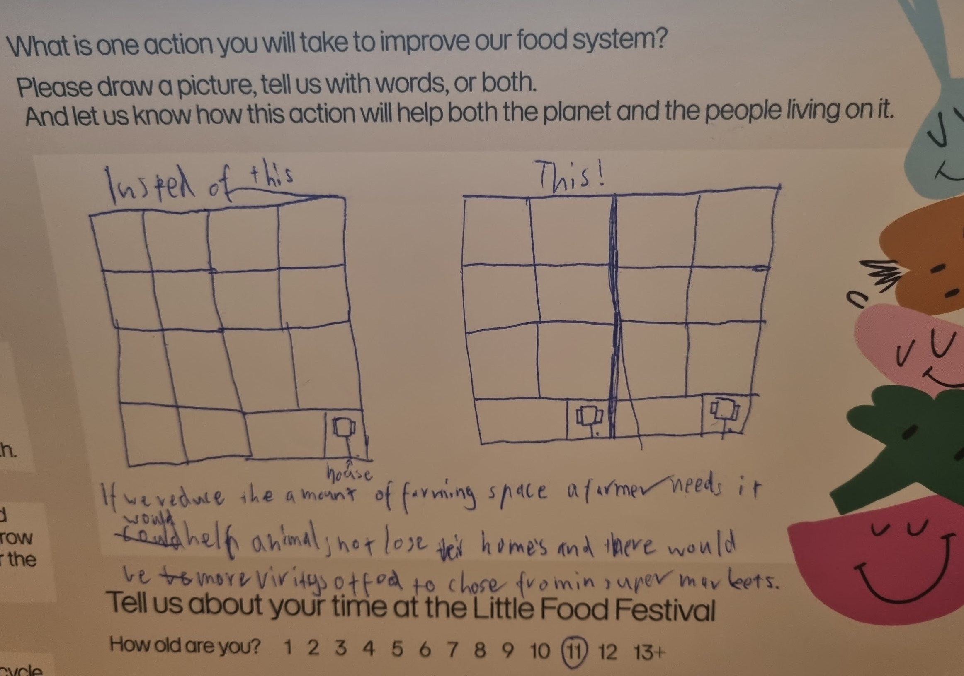
Example 6 | Written description | On the left, there is a land divided into 16 squares with one house on the bottom right; on the right, there is a land with 16 squares as well, but instead of 1 house, there are 2 houses sharing the land.
Example 6 | Description of interpretation | Increasing biodiversity in agricultural practices; Reducing deforestation and protecting animal habitation. Efficient farming could lead to greater variety of food in supermarkets.
Example 6 | Codewords | - Efficient agricultural practices  - Preserve animal habitation  - Increase biodiversity

