Supplementary Information
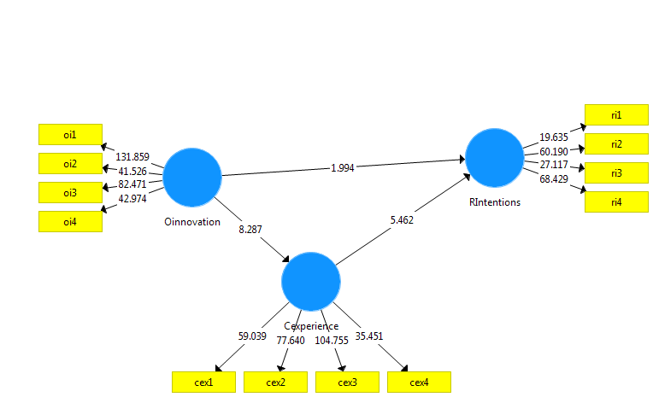
Figure S1: Results of Standard Bootstrapping Procedure
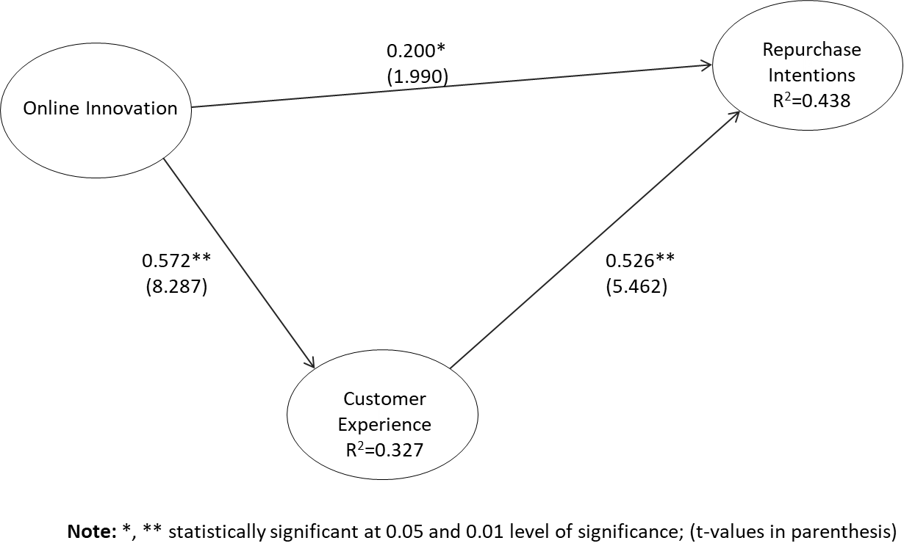
Figure S2: The Final Research Model

Table A1: Country of Origin
COO | Frequency | Percent
Bahamas | 1 | 0.6
Belgium | 1 | 0.6
Benin | 3 | 1.8
Brazil | 1 | 0.6
Cameroon | 1 | 0.6
Canada | 2 | 1.2
China | 9 | 5.4
Congo | 1 | 0.6
Cote De Voire | 1 | 0.6
Denmark | 1 | 0.6
Ethiopia | 2 | 1.2
Germany | 7 | 4.2
Ghana | 8 | 4.8
Holland | 2 | 1.2
India | 10 | 6
Ireland | 3 | 1.8
Japan | 3 | 1.8
Lebanon | 2 | 1.2
Liberia | 3 | 1.8
Malaysia | 3 | 1.8
Mexico | 1 | 0.6
Nigeria | 34 | 20.4
Oman | 1 | 0.6
Portugal | 1 | 0.6
Rwanda | 1 | 0.6
Senegal | 4 | 2.4
South Africa | 5 | 3
Thailand | 2 | 1.2
Togo | 4 | 2.4
Uganda | 1 | 0.6
UK | 10 | 6
USA | 20 | 12
No Response | 19 | 11.4
Total | 167 | 100

