Supplementary Files for Review

Survey Questionnaire
We are a research team from the University of Tabuk conducting a study titled "Technology Integration and its Role in Promoting Green Sustainable Campuses in Saudi Arabia." This survey aims to explore how advanced technologies—including Smart Building Technologies, Internet of Things Systems, Data Analytics for Resource Management, and Automation in Facilities—contribute to achieving sustainability in Saudi universities. We are particularly interested in understanding the role of Technology Adoption and Digital Infrastructure in promoting environmentally sustainable practices. Your honest responses will provide valuable insights into developing effective strategies for sustainable campus management. All responses will be kept strictly confidential and will be used solely for academic research purposes. Your input is essential in supporting efforts toward sustainability in higher education and aligning with Saudi Vision 2030. Thank you for your time and valuable participation.
Demographic Information
Please select the most appropriate option:
D1. Gender:
- Male
- Female
D2. Age:
- 18-24 years
- 25-34 years
- 35-44 years
- 45-54 years
- 55 years and above
D3. Position:
- Academic Staff
- Administrative Staff
- Student
D4. Educational Qualification:
- Bachelor’s Degree
- Master’s Degree
- Doctorate (PhD)
- Other
D5. Faculty:
- Science and Engineering
- Business and Management
- Social Sciences and Humanities
- Medicine and Health Sciences
- Other
D6. Transportation Mode (For commuting to campus):
- Public Transportation
- Private Car
- Bicycle
- Walking
- Carpooling
- Other
D7. Have you attended any sustainability or environmental workshops/courses?
- Yes
- No

Section B: Survey Questionnaire

Smart Building Technologies (SBT)
SBT1. Our campus incorporates advanced building technologies to optimize energy efficiency.
- Strongly Disagree
- Disagree
- Moderate
- Agree
- Strongly Agree
SBT2. Smart building systems are effectively integrated into campus facilities.
- Strongly Disagree
- Disagree
- Moderate
- Agree
- Strongly Agree
SBT3. Automated systems in campus buildings ensure optimal lighting and temperature control.
- Strongly Disagree
- Disagree
- Moderate
- Agree
- Strongly Agree
SBT4. The campus uses sensor-based technologies to monitor building performance.
- Strongly Disagree
- Disagree
- Moderate
- Agree
- Strongly Agree
SBT5. Smart buildings on campus contribute significantly to environmental sustainability.
- Strongly Disagree
- Disagree
- Moderate
- Agree
- Strongly Agree
Internet of Things Systems (IOTS)
IOTS1. IoT systems are widely used on campus to enhance resource management.
- Strongly Disagree
- Disagree
- Moderate
- Agree
- Strongly Agree
IOTS2. The integration of IoT systems supports campus sustainability goals.
- Strongly Disagree
- Disagree
- Moderate
- Agree
- Strongly Agree
IOTS3. IoT devices on campus improve the efficiency of facilities and services.
- Strongly Disagree
- Disagree
- Moderate
- Agree
- Strongly Agree
IOTS4. The campus leverages IoT systems for real-time monitoring of resources.
- Strongly Disagree
- Disagree
- Moderate
- Agree
- Strongly Agree
IOTS5. IoT systems enable effective data sharing and analysis for sustainability initiatives.
- Strongly Disagree
- Disagree
- Moderate
- Agree
- Strongly Agree

Data Analytics for Resource Management (DARM)
DARM1. Data analytics are used to optimize the allocation of campus resources.
- Strongly Disagree
- Disagree
- Moderate
- Agree
- Strongly Agree
DARM2. Advanced analytics systems contribute to effective decision-making for sustainability.
- Strongly Disagree
- Disagree
- Moderate
- Agree
- Strongly Agree
DARM3. The campus uses data-driven insights to enhance resource management.
- Strongly Disagree
- Disagree
- Moderate
- Agree
- Strongly Agree
DARM4. Big data tools are implemented to monitor and evaluate sustainability performance.
- Strongly Disagree
- Disagree
- Moderate
- Agree
- Strongly Agree
DARM5. Analytics help the campus predict and address resource challenges effectively.
- Strongly Disagree
- Disagree
- Moderate
- Agree
- Strongly Agree

Automation in Facilities (AF)
AF1. Automated systems are implemented for efficient campus operations.
- Strongly Disagree
- Disagree
- Moderate
- Agree
- Strongly Agree
AF2. Campus facilities rely on automation for effective waste and resource management.
- Strongly Disagree
- Disagree
- Moderate
- Agree
- Strongly Agree
AF3. Automation improves the operational efficiency of campus infrastructure.
- Strongly Disagree
- Disagree
- Moderate
- Agree
- Strongly Agree
AF4. Automated maintenance systems reduce resource wastage.
- Strongly Disagree
- Disagree
- Moderate
- Agree
- Strongly Agree
AF5. Facility automation enhances sustainability practices on campus.
- Strongly Disagree
- Disagree
- Moderate
- Agree
- Strongly Agree

Technology Adoption (TA)
TA1. The campus readily adopts new technologies to improve sustainability.
- Strongly Disagree
- Disagree
- Moderate
- Agree
- Strongly Agree
TA2. Technology adoption is prioritized to enhance campus operations.
- Strongly Disagree
- Disagree
- Moderate
- Agree
- Strongly Agree
TA3. Stakeholders support the implementation of advanced technologies on campus.
- Strongly Disagree
- Disagree
- Moderate
- Agree
- Strongly Agree
TA4. The adoption of innovative technologies aligns with campus sustainability objectives.
- Strongly Disagree
- Disagree
- Moderate
- Agree
- Strongly Agree
TA5. There is a positive attitude toward integrating new technologies across campus facilities.
- Strongly Disagree
- Disagree
- Moderate
- Agree
- Strongly Agree

Digital Infrastructure (DI)
DI1. The campus has a robust digital infrastructure to support sustainability initiatives.
- Strongly Disagree
- Disagree
- Moderate
- Agree
- Strongly Agree
DI2. Digital tools and platforms are effectively utilized for resource management.
- Strongly Disagree
- Disagree
- Moderate
- Agree
- Strongly Agree
DI3. The campus invests in digital infrastructure to enhance operational efficiency.
- Strongly Disagree
- Disagree
- Moderate
- Agree
- Strongly Agree
DI4. Digital infrastructure plays a key role in achieving campus sustainability goals.
- Strongly Disagree
- Disagree
- Moderate
- Agree
- Strongly Agree
DI5. Advanced digital systems ensure the seamless integration of technology on campus.
- Strongly Disagree
- Disagree
- Moderate
- Agree
- Strongly Agree

Green Sustainable Campus (GSC)
GSC1. The campus demonstrates a strong commitment to environmental sustainability.
- Strongly Disagree
- Disagree
- Moderate
- Agree
- Strongly Agree
GSC2. Green practices are evident in various campus operations and activities.
- Strongly Disagree
- Disagree
- Moderate
- Agree
- Strongly Agree
GSC3. Campus infrastructure supports sustainable development goals.
- Strongly Disagree
- Disagree
- Moderate
- Agree
- Strongly Agree
GSC4. Efforts are made to minimize the environmental impact of campus operations.
- Strongly Disagree
- Disagree
- Moderate
- Agree
- Strongly Agree
GSC5. Sustainability initiatives on campus are aligned with global environmental standards.
- Strongly Disagree
- Disagree
- Moderate
- Agree
- Strongly Agree

Table 3: Discriminant validity- Fornell Larcker
The off-diagonal values are the correlations between latent variables, and the diagonal is the square root of AVE.
Table 5: Assessment of the structural model

Moderation Results Explanation
Figure 4 provides a clear visual representation of how DI moderates the relationship between SBT and GSC. It illustrates that the impact of SBT on GSC is more pronounced when DI levels are higher, and less significant at lower DI levels. To further investigate this interaction, separate path analyses were conducted for high DI (1 standard deviation above the mean) and low DI (1 standard deviation below the mean). These analyses, as depicted in Figure 4, aim to clarify how the SBT-GSC relationship varies based on different DI levels. The results show a stronger SBT-GSC relationship at higher DI levels, indicated by a higher beta coefficient, while the relationship weakens at lower DI levels, reflected by a lower beta coefficient. These findings emphasize the important role DI plays in influencing the weaken of the relationship between SBT and GSC.

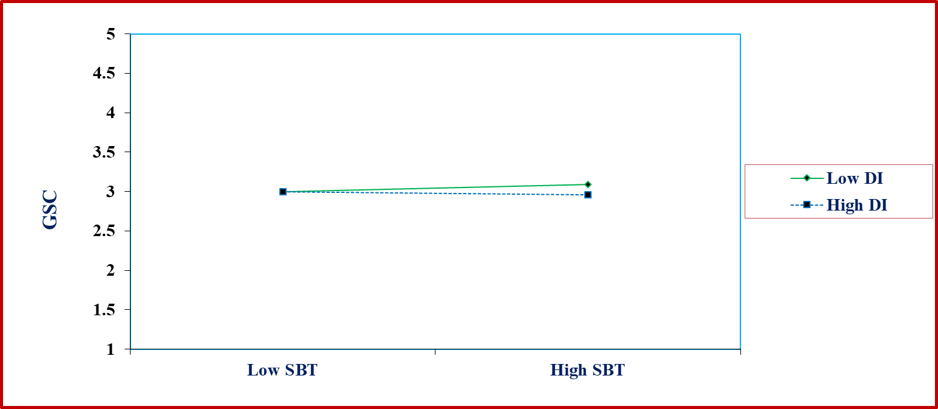
Figure 4: Interactive Effect of DI in between SBT and GSC
Figure 5 provides a clear visual representation of how DI moderates the relationship between DARM and GSC. It illustrates that the impact of DARM on GSC is more pronounced when DI levels are higher, and less significant at lower DI levels. To further investigate this interaction, separate path analyses were conducted for high DI (1 standard deviation above the mean) and low DI (1 standard deviation below the mean). These analyses, as depicted in Figure 4, aim to clarify how the DARM-GSC relationship varies based on different DI levels. The results show a stronger DARM-GSC relationship at higher DI levels, indicated by a higher beta coefficient, while the relationship weakens at lower DI levels, reflected by a lower beta coefficient. These findings emphasize the important role DI plays in influencing the strengthen of the relationship between DARM and GSC.
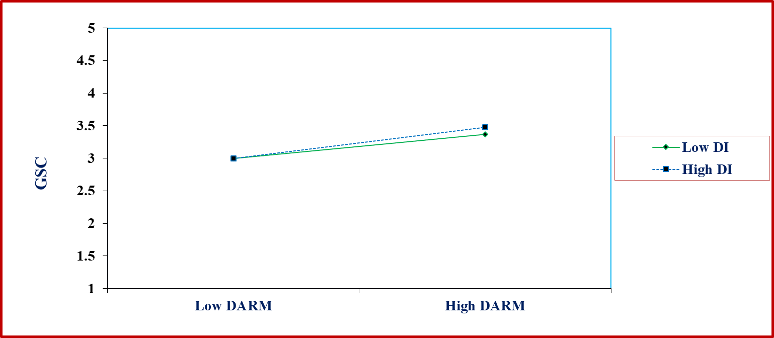
Figure 5: Interactive Effect of DI in between DARM and GSC

Figure 6 provides a clear visual representation of how DI moderates the relationship between AF and GSC. It illustrates that the impact of AF on GSC is more pronounced when DI levels are higher, and less significant at lower DI levels. To further investigate this interaction, separate path analyses were conducted for high DI (1 standard deviation above the mean) and low DI (1 standard deviation below the mean). These analyses, as depicted in Figure 4, aim to clarify how the AF-GSC relationship varies based on different DI levels. The results show a stronger AF-GSC relationship at higher DI levels, indicated by a higher beta coefficient, while the relationship weakens at lower DI levels, reflected by a lower beta coefficient. These findings emphasize the important role DI plays in influencing the strengthen of the relationship between AF and GSC.
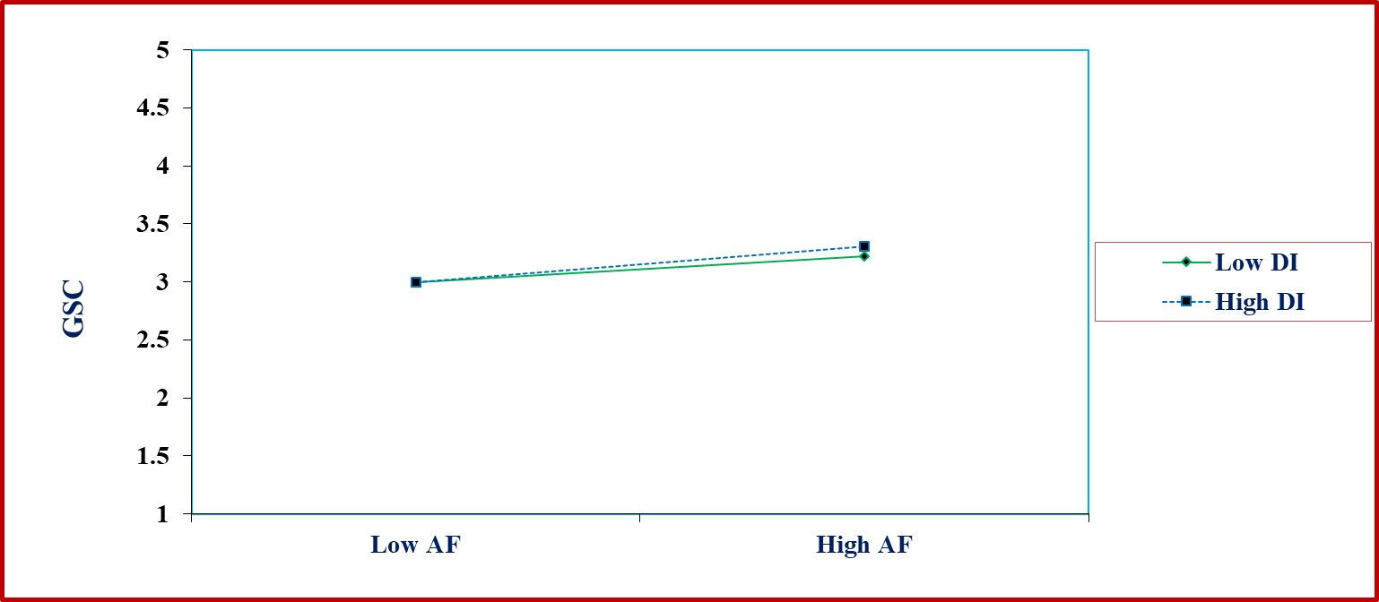
Figure 6: Interactive Effect of DI in between AF and GSC

