Supplementary material
Appendix 2: text-and-pictures condition
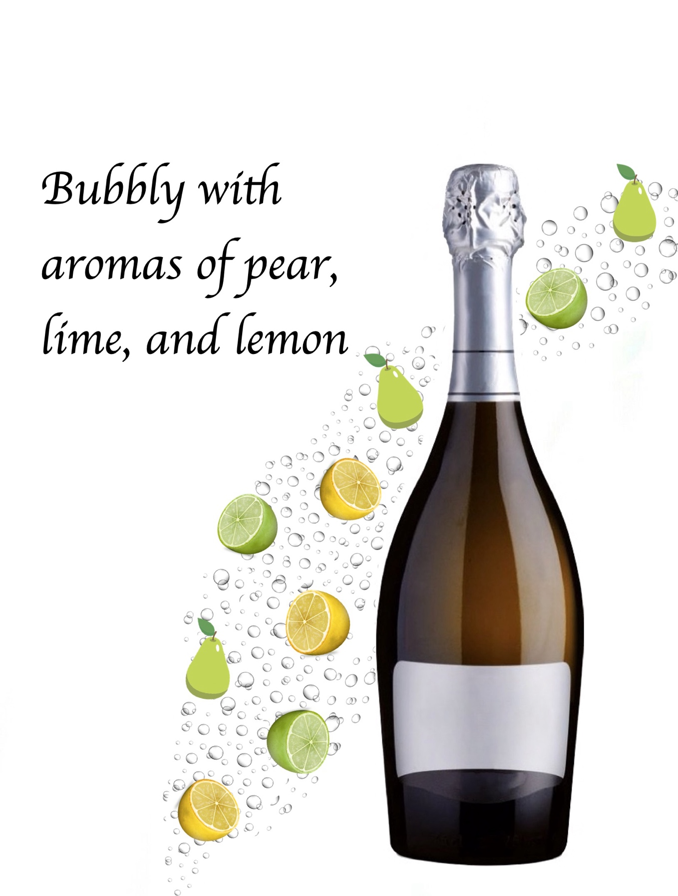
Source: Developed by authors

