Supplementary information.

Supplementary Table 1. Demographic characteristics
Demographic characteristics |  | Employee |  |  | Supervisor

Age
 | 18~25 | 136 | 49% |  | 1 | 2%
 | 26~30 | 33 | 12% |  | 10 | 17%
 | 31~40 | 53 | 19% |  | 27 | 47%
 | 41~50 | 36 | 13% |  | 18 | 31%
 | 51~60 | 14 | 5% |  | 1 | 2%
 | 60 or above | 3 | 1% |  | 1 | 2%

Gender
 | Male | 102 | 37% |  | 21 | 36%
 | Female | 173 | 63% |  | 37 | 64%

Education
 | Lower than high school | 23 | 8% |  | 2 | 3%
 | High school | 68 | 25% |  | 11 | 19%
 | 2-year college | 106 | 39% |  | 28 | 48%
 | Undergraduate | 75 | 27% |  | 15 | 26%
 | Graduate or above | 3 | 1% |  | 2 | 3%

Work nature
 | Full time | 163 | 59% |  | 52 | 90%
 | Contract | 41 | 15% |  | 5 | 9%
 | Intern | 63 | 23% |  | 1 | 2%

Income
 | Below RMB 3000 | 100 | 36% |  | 0 | 0%
 | RMB 3001~5000 | 110 | 40% |  | 20 | 34%
 | RMB 5001-8000 | 51 | 19% |  | 11 | 19%
 | RMB 8001-15000 | 9 | 3% |  | 14 | 24%
 | RMB 15001-50000 | 4 | 1% |  | 13 | 22%

Organizational tenure
 | Under 1 year | 122 | 44% |  | 11 | 19%
 | 1-2 years | 40 | 15% |  | 4 | 7%
 | 2-5 years | 47 | 17% |  | 14 | 24%
 | Over 5 years | 66 | 24% |  | 29 | 50%
N = 275 (employees), 58 (leaders). Source: Developed by authors

Supplementary Table S2. Items, factor loading, and factor structure illustration.

 |  |  |  | Std. loading | SE
Employee’s level: Leader empathy* (Second-order factor) (Liu, 2017); CR = 0.95, AVE = 0.86
 |  | Empathic concern; CR = 0.93; AVE = 0.77 |  | 0.90 | 0.03
 |  |  | 1. My leader can tell when I’m feeling down | 0.90 | 0.03
 |  |  | 2. My leader can tell when I’m showing dislike | 0.89 | 0.03
 |  |  | 3. My leader notices my body language or other nonverbal cues to understand what I’m thinking | 0.92 | 0.02
 |  |  | 5.My leader can tell when I’m feeling scared | 0.81 | 0.03
 |  | Perspective-taking; CR = 0.93, AVE = 0.64 |  | 1.01 | 0.01
 |  |  | 6. My leader can easily tell whether I’m really listening to them. | 0.84 | 0.03
 |  |  | 7. Before making decisions, my leader tries to look at everyone’s point of view in a discussion. | 0.80 | 0.05
 |  |  | 8. Sometimes my leader imagines what things look like from my perspective to better understand them. | 0.83 | 0.03
 |  |  | 9. My ideas are easily recognized and accepted by my leader. | 0.75 | 0.04
 |  |  | 10. Before criticizing others, my leader thinks, “If I were in their situation, how would I feel?” | 0.72 | 0.06
 |  |  | 11. My leader understands the reasons behind what I do. | 0.87 | 0.03
 |  |  | 12. My leader can sense when something at work doesn’t feel right. | 0.78 | 0.05
 |  | Emotional responsivity; CR = 0.92, AVE = 0.70 |  | 0.87 | 0.03
 |  |  | 14. My leader offers help when I feel helpless at work. | 0.83 | 0.05
 |  |  | 15. When I’m treated unfairly, my leader shows sympathy toward me. | 0.85 | 0.03
 |  |  | 16. My leader allows me to solve work problems in my own way. | 0.77 | 0.05
 |  |  | 17. When I don’t look well, my leader cares about what’s going on with me. | 0.89 | 0.02
 |  |  | 18. My leader does everything possible to make it easier for me to do my job. | 0.84 | 0.05
Employee's level: LMX scale (Graen and Uhl-Bien, 1995); RLMX calculation (Henderson et al., 2008); CR = 0.83, AVE = 0.67
 | How would you characterize your working relationship with your leader? |  |  | 0.80 | 0.06
 | What are the chances that your leader would use his/her power to help you solve problems in your work? |  |  | 0.69 | 0.06
 | How well does your leader recognize your potential? |  |  | 0.91 | 0.02
 | How well does your leader understand your job problems and needs? |  |  | 0.85 | 0.04
 | Do you usually know how satisfied your leader is with what you do? |  |  | 0.84 | 0.04
 | What are the chances that your leader would “bail you out” at his/ her expense? |  |  | 0.78 | 0.04
 | I have enough confidence in my leader that I would defend and justify his/her decision if he/she were not present to do so? |  |  | 0.86 | 0.02

Employee’s level: UPB (Umphress et al., 2010); CR = 0.96, AVE = 0.82
 | If it would help my hotel, I would misrepresent the truth to make my hotel look good. | 0.93 | 0.02
 | If it would help my hotel, I would exaggerate the truth about my company’s products or services to customers and others. | 0.90 | 0.02
 | If it would benefit my hotel, I would withhold negative information about my hotel or its products and services from custoemers/ others. | 0.92 | 0.02
 | If my hotel needed me to, I would give a good recommendation on the behalf of an incompetent employee in the hope that the person will become another hotel’s problem instead of my own. | 0.92 | 0.02
 | If my hotel needed me to, I would withhold issuing a refund to a customer or other accidentally overcharged. | 0.86 | 0.02
 | If needed, I would conceal information from the public that could be damaging to my hotel. | 0.91 | 0.02
Leader’s level: Leader’s work meaningfulness (Steger et al., 2012); CR = 0.91, AVE = 0.51
 | I have found a meaningful career | 0.79 | 0.11
 | I view my work as contributing to my personal growth. | 0.72 | 0.14
 | My work really makes a difference to the world. | 0.62 | 0.10
 | I understand how my work contributes to my life’s meaning. | 0.76 | 0.10
 | I have a good sense of what makes my job meaningful. | 0.76 | 0.10
 | I know my work makes a positive difference in the work | 0.61 | 0.14
 | My work helps me better understand myself. | 0.73 | 0.10
 | I have discovered work that has a satisfying purpose. | 0.72 | 0.08
 | My work helps me make sense of the world around me. | 0.74 | 0.07
 | The work I do serves a greater purpose. | 0.70 | 0.11
Note: * The scale was originally proposed and used in Chinese. The authors translated it into English for the purpose of this table. Source: Developed by authors
Supplementary Figure 1. Visual illustration of factor structure.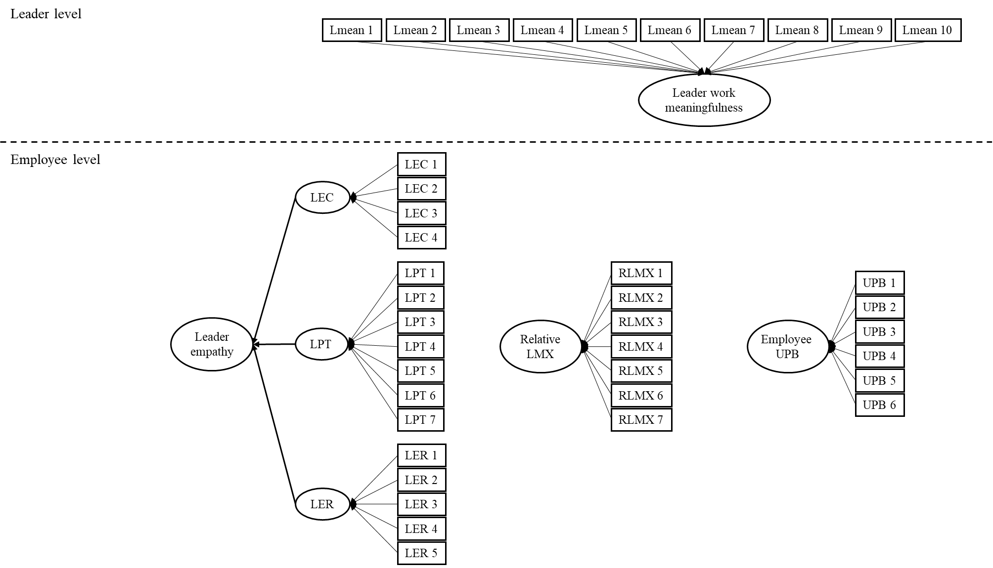
LEC = Leader empathy – Empathic concern; LPT = Leader empathy – Perspective taking; LER = Leader empathy – Emotional responsibity; The thicker arrow represents the second-order loadings. Source: Developed by authors

