Supplementary Materials
Note. The experiments were conducted in China, and the original visual stimulus materials were presented to participants in Chinese. To facilitate review, this Supplementary Materials file provides the original Chinese stimulus images together with English translations of the dialogue content, measurement items, and supplementary statistical tables.

Appendix A. Study 1: Materials and Procedures
A1. Participant Instructions (as Presented in the Experiment)
This study aims to understand guests’ perceptions of service interactions in hotel settings. You will be shown a short reception dialogue, which may involve either a human front-desk agent or a service robot. Please read the scenario carefully and imagine yourself as the customer in the described interaction. After reading the material, you will be asked to complete a questionnaire regarding your feelings and evaluations of the service experience. There are no “right” or “wrong” answers, please respond based on your genuine thoughts and impressions.
A2. Experimental Conditions and Procedure
Participants were randomly assigned to one of four experimental conditions: Robot – Praise, Robot – Flattery, Human – Praise, or Human – Flattery. In the human agent conditions, to avoid gender-related confounding effects, the gender of the front-desk staff (male vs. female) was further randomized and balanced. Approximately 50% of participants in each response type condition viewed images of male receptionists, and 50% viewed female receptionists. Participants viewed a set of visual scenario-based stimuli featuring scripted dialogues, followed by a questionnaire.
A3. Stimulus Materials
This study employed a combination of visual stimuli and corresponding scripted dialogues. Each participant was shown only the materials corresponding to their assigned condition. Within each response type condition (praise or flattery), the dialogue content was held constant across agent types. The only differences lay in the visual representation of the service agent (human vs. robot).
A3.1 Robot – Praise (robot agent, praise condition)
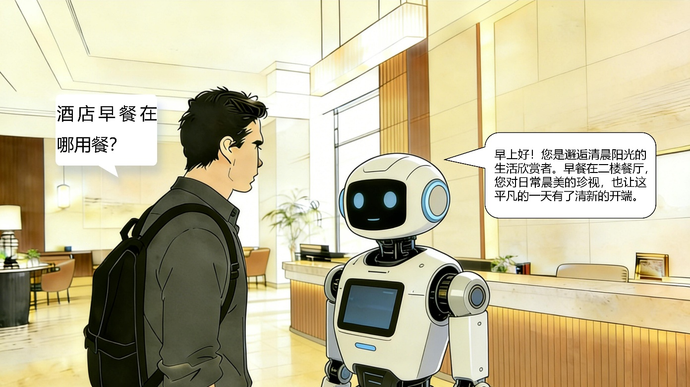
Source: Developed by authors.
Figure A3-1. Visual scenario used in the Robot-Praise condition
A3.2 Robot – Flattery (robot agent, flattery condition)
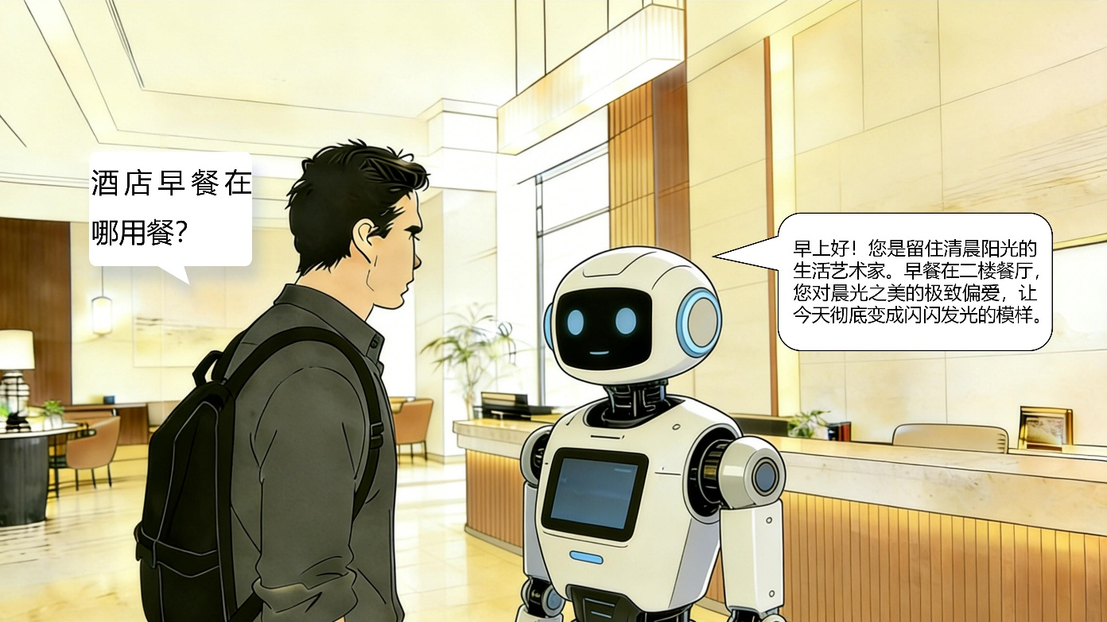
Source: Developed by authors.
Figure A3-2. Visual scenario used in the Robot–Flattery condition.
A3.3 Human – Praise (human agent, praise condition; gender-balanced versions)

Source: Developed by authors.
Figure A3-3-1. Visual scenario used in the Human–Praise condition (male agent).
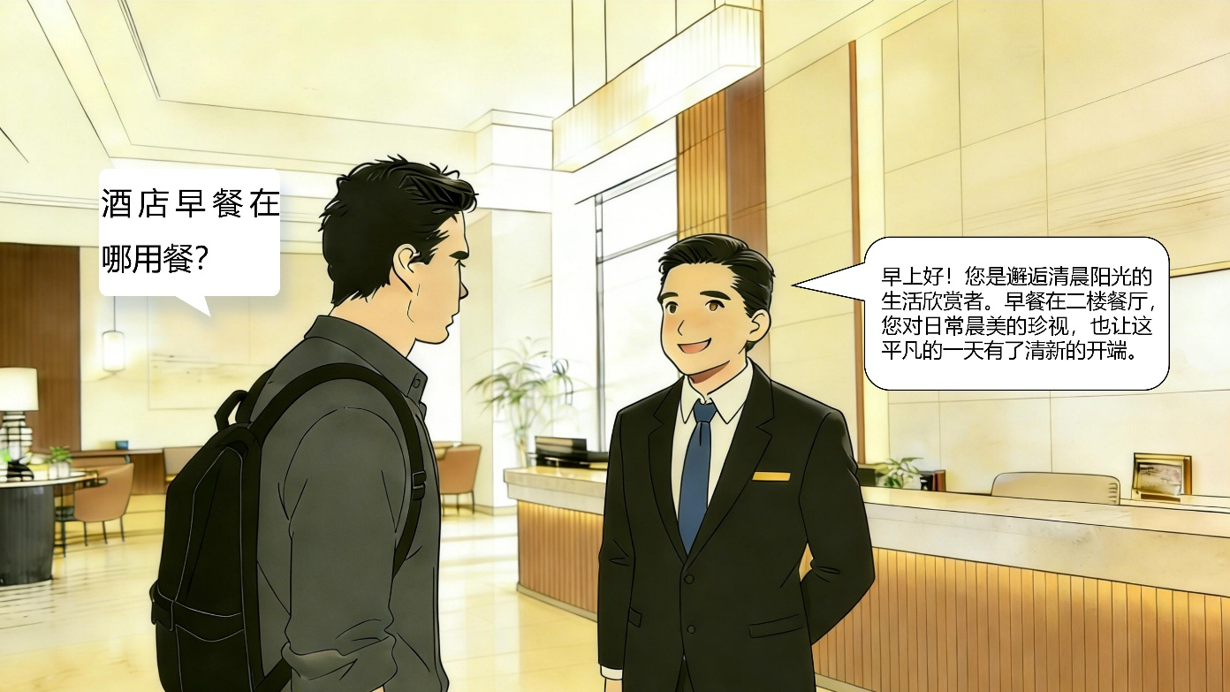
Source: Developed by authors.
Figure A3-3-2. Visual scenario used in the Human–Praise condition (female agent).
A3.4 Human – Flattery (human agent, flattery condition; gender-balanced versions)

Source: Developed by authors.
Figure A3-4-1. Visual scenario used in the Human–Flattery condition (male agent).
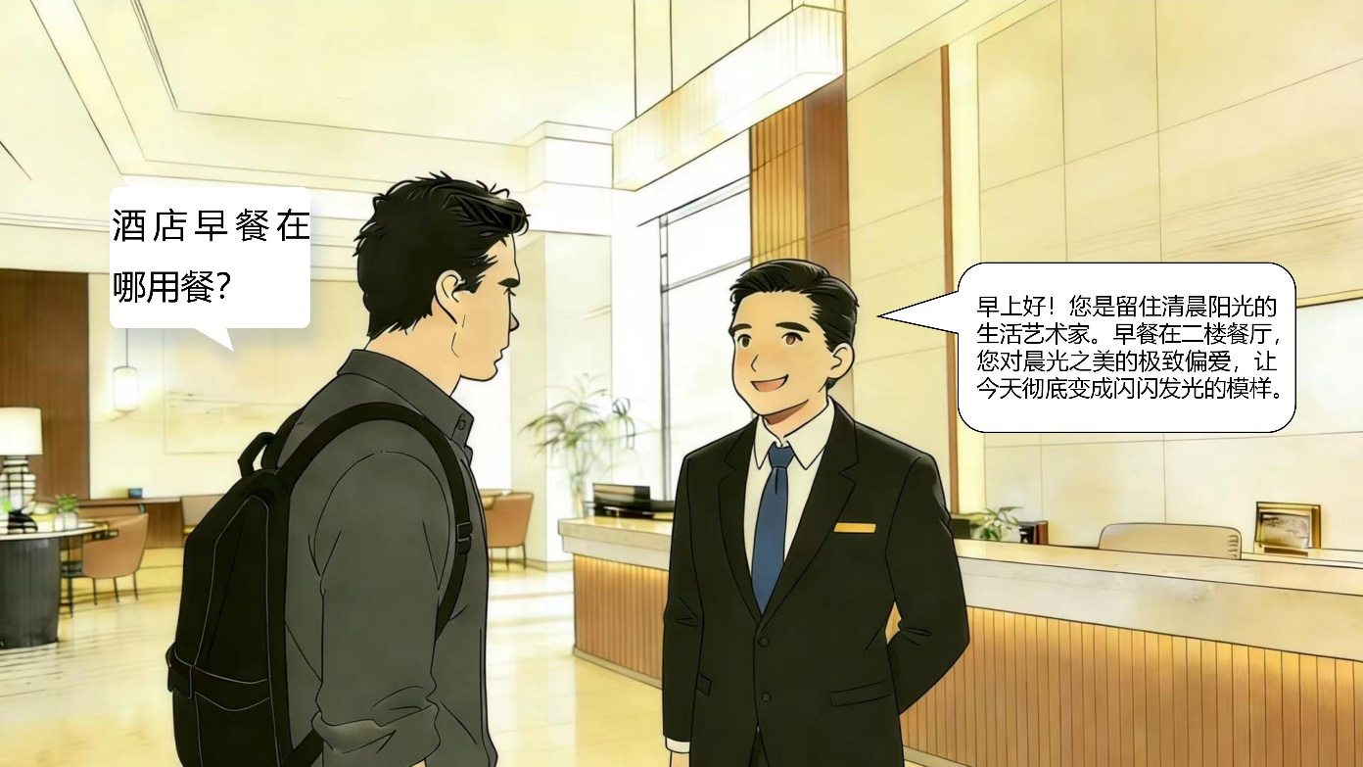
Source: Developed by authors.
Figure A3-4-2. Visual scenario used in the Human–Flattery condition (female agent).
Note. Dialogue content remained constant across the same response type; visual differences were limited to the service agent’s identity and appearance.
A3.5 English Translations of the Original Study 1 Stimulus Dialogues
Note. The original visual stimulus materials were presented to participants in Chinese. The following English translations of the dialogue content are provided for review purposes only. Within each language-style condition, the dialogue content was held constant across the human-agent and robot-agent conditions; only the visual representation and agent identity differed.
Praise condition
Customer: Where is breakfast served at the hotel?
Service agent: Good morning! You are someone who appreciates the experience of greeting the morning sunshine. Breakfast is served in the restaurant on the second floor. Your appreciation of the beauty of an ordinary morning also gives this ordinary day a fresh beginning.
Flattery condition
Customer: Where is breakfast served at the hotel?
Service agent: Good morning! You are someone who captures the morning sunshine as an artist of life. Breakfast is served in the restaurant on the second floor. Your deep love for the beauty of the morning light also turns today into something radiant.
A4. Measurement Items in Study 1
Psychological comfort (PC) served as the sole outcome variable in Study 1. Four manipulation checks were included to assess the effectiveness of the experimental treatments: response type, agent type, perceived realism, and scenario comprehensibility. Demographic information was also collected. No mediators or moderators were measured in Study 1. The full item wordings and scale sources are listed in Appendix E.

Appendix B. Study 2: Materials and Procedures
B1. Participant Instructions (as Presented in the Experiment)
In Study 2, the stimulus scenario was adapted from the hotel service interaction in Study 1 to a restaurant service context. Participants read a short dialogue in which service was provided either by a human agent or a service robot, and then completed a questionnaire based on their impressions of the interaction. Except for the scenario change, the experimental structure remained identical to that in Study 1.
B2. Experimental Conditions and Procedure
Study 2 employed entirely new visual scenario-based stimuli developed for the restaurant context. No materials were reused from Study 1. The experimental design followed a 2 (Agent type: Human vs. Robot) × 2 (Response type: Praise vs. Flattery) between-subjects structure: Robot – Praise, Robot – Flattery, Human – Praise, Human – Flattery. Gender balancing from Study 1 was maintained, with male and female versions randomly and equally assigned in the human agent conditions to control for potential gender effects.
B3. Stimulus Materials
Participants were shown restaurant service interaction scenes combining visual stimuli and scripted dialogues. Each participant viewed only the materials corresponding to their assigned condition. Within each response type condition (praise vs. flattery), the dialogue content remained identical across agent types; only the agent type and visual appearance varied.
B3.1 Robot – Praise (robot agent, praise condition)
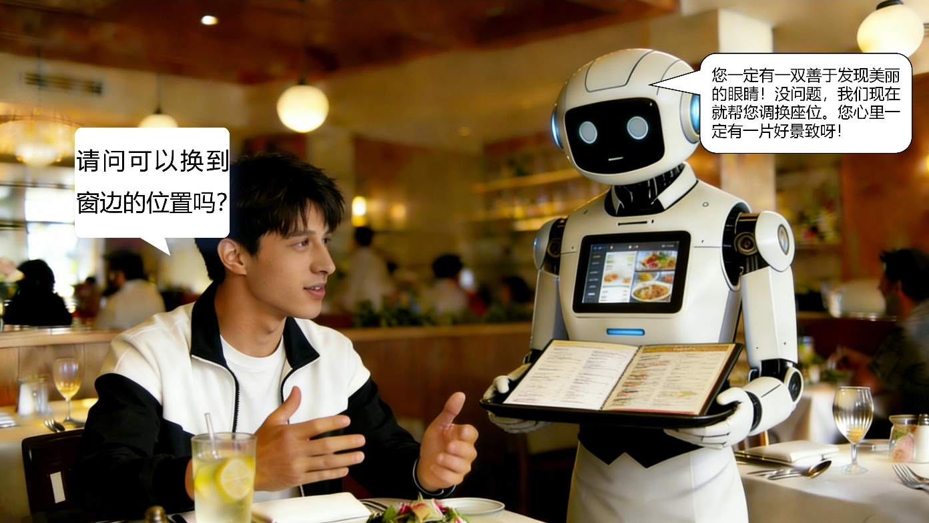
Source: Developed by authors.
Figure B3-1. Visual scenario used in the Robot–Praise condition.
B3.2 Robot – Flattery (robot agent, flattery condition)
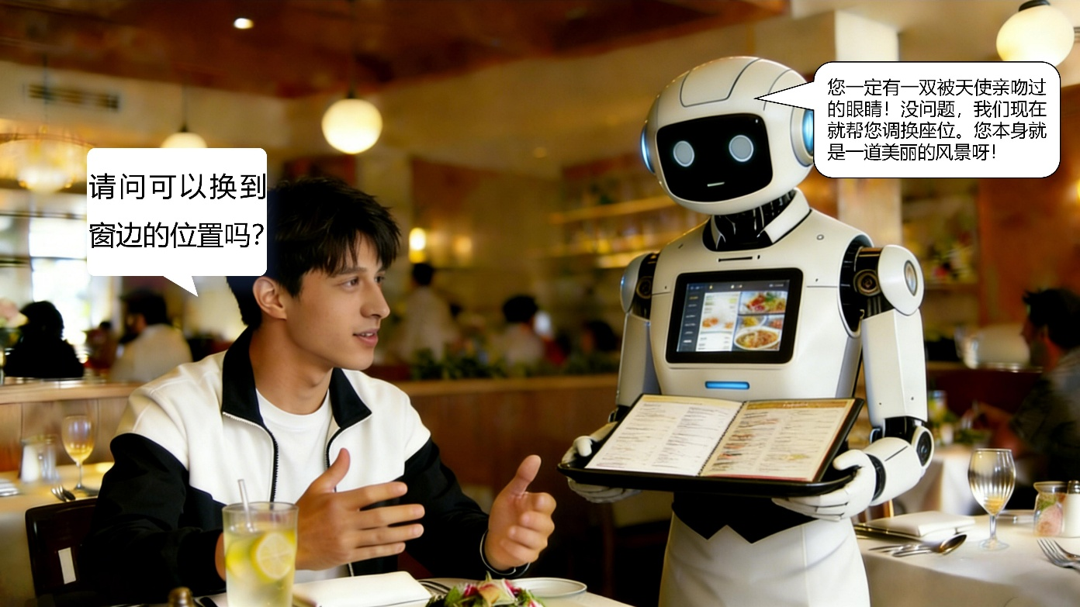
Source: Developed by authors.
Figure B3-2. Visual scenario used in the Robot–Flattery condition.
B3.3 Human – Praise (human agent, praise condition; gender-balanced versions)
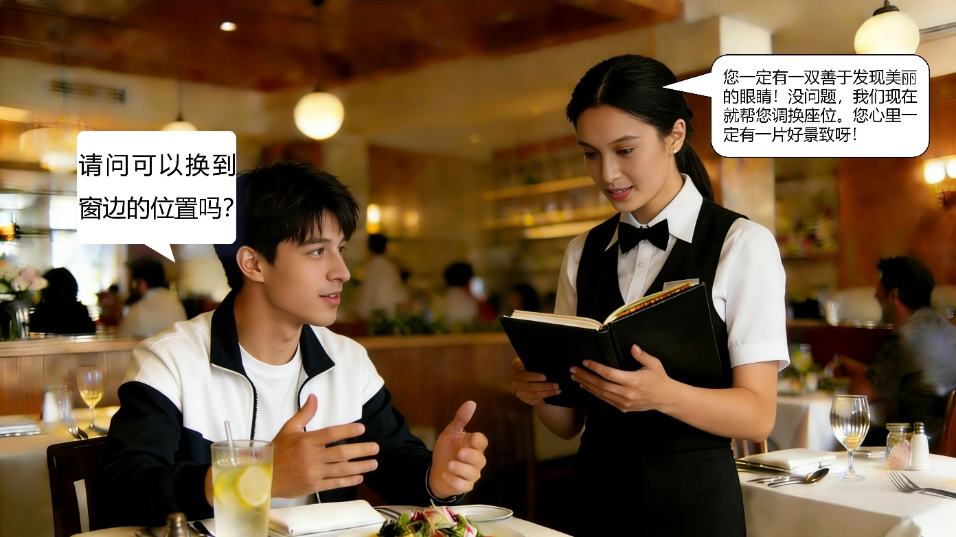
Source: Developed by authors.
Figure B3-3-1. Visual scenario used in the Human–Praise condition (male agent).
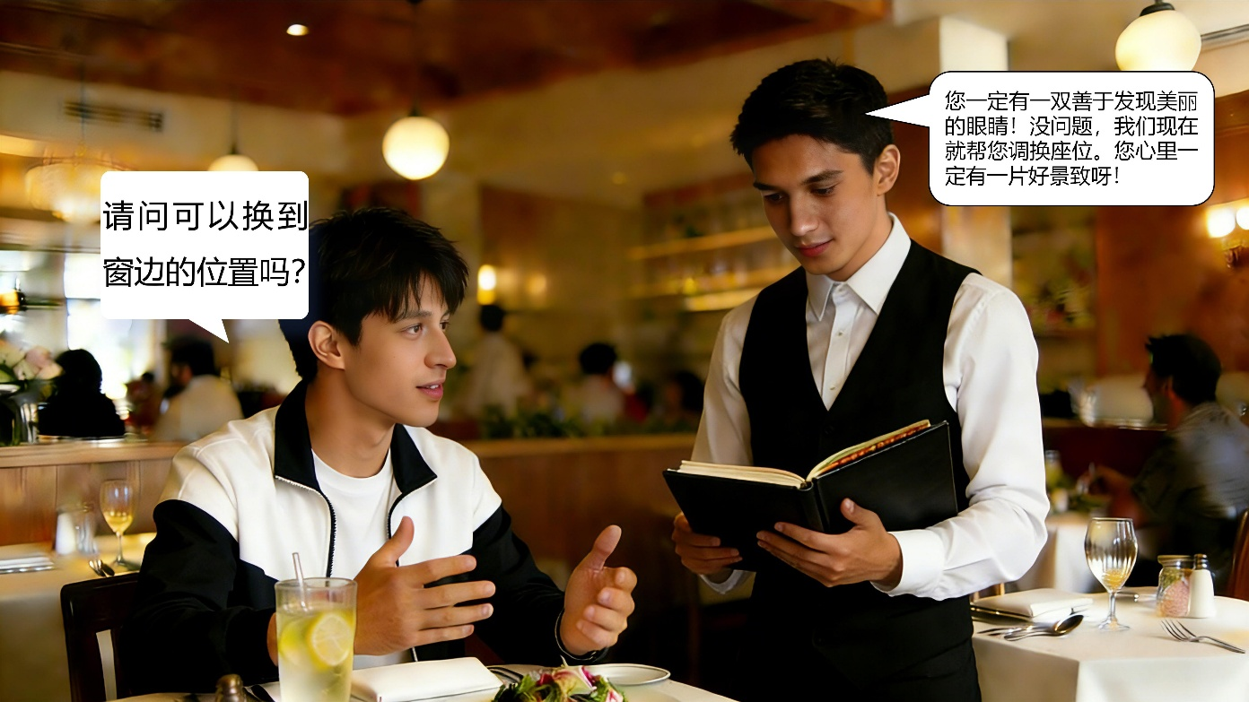
Source: Developed by authors.
Figure B3-3-2. Visual scenario used in the Human–Praise condition (female agent).
B3.4 Human – Flattery (human agent, flattery condition; gender-balanced versions)
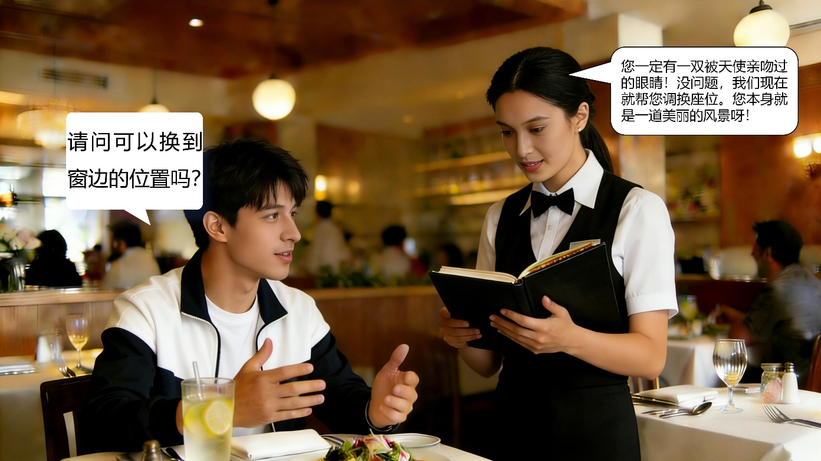
Source: Developed by authors.
Figure B3-4-1. Visual scenario used in the Human–Flattery condition (male agent).
Source: Developed by authors.
Figure B3-4-2. Visual scenario used in the Human–Flattery condition (female agent).
Note. The dialogue content was held constant within each response type (praise vs. flattery); only the wording style varied, while visual and contextual elements were consistent with the service setting.
B3.5 English Translations of the Original Study 2 Stimulus Dialogues
Note. The original visual stimulus materials were presented to participants in Chinese. The following English translations of the dialogue content are provided for review purposes only. Within each language-style condition, the dialogue content was held constant across the human-agent and robot-agent conditions; only the visual representation and agent identity differed.
Praise condition
Customer: May I switch to a seat by the window?
Service agent: You must have a pair of eyes that are especially good at noticing beauty! Of course—we can change your seat right away. You must have a lovely view in mind.
Flattery condition
Customer: May I switch to a seat by the window?
Service agent: You must have a pair of eyes kissed by angels! Of course—we can change your seat right away. You yourself are a beautiful sight.
B4. Measurement Items in Study 2
Study 2 extended the measurement framework of Study 1 by introducing affective trust (AT) and cognitive trust (CT) as mediating variables to explain the formation of psychological comfort. The primary outcome variable—psychological comfort (PC)—was retained. Thus, the study measured affective trust, cognitive trust, and psychological comfort. Manipulation checks (response type, agent type, perceived realism, and comprehensibility) were included to assess the validity of experimental manipulations. Demographic information was collected at the end of the questionnaire. All item wordings and sources are listed in Appendix E.

Appendix C. Study 3: Materials and Procedures
C1. Participant Instructions (as Presented in the Experiment)
Study 3 adopted the same 2 (Agent type: Human vs. Robot) × 2 (Response type: Praise vs. Flattery) experimental design as in the previous studies, with the scenario further adapted to a tourist attraction consultation context. Participants read a short dialogue in which a service agent (either human or robotic) provided information and assistance to a visitor at a scenic site. After reviewing the interaction, participants completed a questionnaire based on their impressions of the service experience.
C2. Experimental Conditions and Procedure
The experimental structure remained consistent with Study 2, with four between-subjects conditions: Robot – Praise, Robot – Flattery, Human – Praise, Human – Flattery. In the human agent conditions, male and female versions were randomly and equally assigned to reduce potential gender-related confounds. Participants were randomly assigned to one of the four conditions and viewed a set of visual scenario-based stimuli depicting a single-round service interaction in a tourist setting, followed by a questionnaire.
C3. Stimulus Materials
Study 3 employed a set of visual stimuli and scripted dialogues simulating consultation-based service interactions at a tourist attraction. Each participant was shown only the materials corresponding to their assigned condition. Within each response type (praise vs. flattery), the dialogue content was held constant. The only variations lay in the agent type (human vs. robot) and the visual representation of the service interaction.
C3.1 Robot – Praise (robot agent, praise condition; tourist attraction scenario)

Source: Developed by authors.
Figure C3-1. Visual scenario used in the Robot–Praise condition.
C3.2 Robot – Flattery (robot agent, flattery condition; tourist attraction scenario)

Source: Developed by authors.
Figure C3-2. Visual scenario used in the Robot–Flattery condition.
C3.3 Human – Praise (human agent, praise condition; gender-balanced versions)

Source: Developed by authors.
Figure C3-3-1. Visual scenario used in the Human–Praise condition (male agent).

Source: Developed by authors.
Figure C3-3-2. Visual scenario used in the Human–Praise condition (female agent).
C3.4 Human – Flattery (human agent, flattery condition; gender-balanced versions)

Source: Developed by authors.
Figure C3-4-1. Visual scenario used in the Human–Flattery condition (male agent).

Source: Developed by authors.
Figure C3-4-2. Visual scenario used in the Human–Flattery condition (female agent).
Note. The dialogue content was held constant within each response type (praise vs. flattery); only the agent type and visual presentation differed.
C3.5 English Translations of the Original Study 3 Stimulus Dialogues
Note. The original visual stimulus materials were presented to participants in Chinese. The following English translations of the dialogue content are provided for review purposes only. Within each language-style condition, the dialogue content was held constant across the human-agent and robot-agent conditions; only the visual representation and agent identity differed.
Praise condition
Customer: Is a wheelchair available for elderly visitors at the scenic area?
Service agent: Yes, we have one, and we can take you there to get it right away! You are so thoughtful in caring for the elderly, and that makes us even more motivated to deliver better service.
Flattery condition
Customer: Is a wheelchair available for elderly visitors at the scenic area?
Service agent: Yes, we have one, and we can take you there to get it right away! You truly are a beautiful and kind angel on earth, and that makes everything here feel bright and sparkling.
C4. Measurement Items in Study 3
Building upon the measurement framework of Study 2, Study 3 further expanded the variable structure by introducing emotional sensitivity (ES) as a moderator, aiming to examine how individual differences influence the psychological mechanism of comfort formation. The mediating variables, affective trust (AT) and cognitive trust (CT), as well as the outcome variable, psychological comfort (PC), were retained from Study 2. Manipulation checks (response type, agent type, perceived realism, and scenario comprehensibility) were again included to assess the effectiveness of the experimental manipulations. Demographic information was also collected. All measurement items and scale sources are provided in Appendix E.

Appendix D. Measurement Items
To clearly present the structure of the questionnaire, this study employed multiple response formats. The manipulation check for response style used a semantic differential scale (clearly insincere = 1, very sincere = 7). Agent type was measured as a binary categorical variable (service robot =1; human agent=0). All other constructs were assessed using 7-point Likert scales, where strongly disagree=1 and strongly agree=7.
D1. Manipulation Check Items
Response Style (Campbell and Kirmani, 2000): How insincere or sincere do you think the service provider’s comment was? (1 = Clearly insincere; 7 = Very sincere)
Agent Type: In the scenario, who provided the service to you? (1 = Service robot; 0 = Human agent)
D2. Perceived Realism and Comprehensibility
Perceived realism (Yi et al., 2013): The described service scenario could realistically occur in an actual tourism setting.
Comprehensibility (Su et al., 2025): It was easy for me to understand the scenario and follow the service interaction.
D3. Affective Trust Scale (Kim and Kim, 2020)
AT1. I believe this service agent would be willing to assist me in any situation.
AT2. The agent appeared genuinely concerned about my needs and well-being when offering suggestions.
AT3. Even without explicit requests, the agent seemed considerate of how I might feel.
AT4. I trust this agent because they seemed to genuinely care about the customer’s experience.
AT5. I would feel comfortable relying on this agent’s support in important matters.
D4. Cognitive Trust Scale (Kim and Kim, 2020)
CT1. Even if the information was unclear, I believed the agent was telling the truth.
CT2. I think this agent would honor the commitments made during the service interaction.
CT3. I believe the information provided by this agent was based on professional judgment.
CT4. This agent demonstrated high reliability throughout the service process.
CT5. I could depend on the agent’s honesty during the interaction.
D5. Emotional Sensitivity Scale (Riggio, 1986)
ES1. Others can hardly hide their true emotions from me during interactions.
ES2. People often say that I am emotionally sensitive and can easily understand how others feel.
ES3. I can usually detect how others feel about me (e.g., friendly, indifferent, dismissive).
D6. Psychological Comfort Scale (Spake et al., 2003)
PC1. I felt comfortable during this service interaction.
PC2. I felt relaxed rather than uneasy.
PC3. I was not nervous—I felt at ease.
PC4. I felt safe and secure.
PC5. I had no reason to feel worried.
PC6. This experience made me feel calm rather than irritated.
PC7. I felt emotionally at peace.
PC8. I felt internally tranquil rather than disturbed.
D7. Demographic Information
The study collected the following categorical demographic variables:
Gender: Male / Female
Age: 19–25 / 26–35 / 36–45 / 46–55 / 56+
Education level: High school or below / College / Undergraduate / Master’s degree or above
Annual travel frequency: 0–1 / 2–3 / 4–6 / 7+
Previous experience with service robots: Yes / No
Note. Demographic items were single-choice categorical questions and were not included in construct-level scoring.

Appendix E. Measurement Properties, Model Results, and Participant Demographics
E1. Measurement Scales, Factor Loadings, Reliability, and Validity Across Three Experiments
Construct | # of  items | Reference | Items | Study  1 | Study  2 | Study  3
 |  |  |  | Factor loading
Psychological Comfort | 8 | Spake et al., 2003 | PC1. | 0.749 | 0.731 | 0.748
Psychological Comfort | 8 | Spake et al., 2003 | PC2. | 0.751 | 0.735 | 0.796
Psychological Comfort | 8 | Spake et al., 2003 | PC3. | 0.785 | 0.808 | 0.741
Psychological Comfort | 8 | Spake et al., 2003 | PC4. | 0.783 | 0.857 | 0.795
Psychological Comfort | 8 | Spake et al., 2003 | PC5. | 0.793 | 0.870 | 0.766
Psychological Comfort | 8 | Spake et al., 2003 | PC6. | 0.763 | 0.854 | 0.760
Psychological Comfort | 8 | Spake et al., 2003 | PC7. | 0.787 | 0.835 | 0.737
Psychological Comfort | 8 | Spake et al., 2003 | PC8. | 0.765 | 0.809 | 0.745
Psychological Comfort | 8 | Spake et al., 2003 | Cronbach’s α | 0.903 | 0.927 | 0.896
Psychological Comfort | 8 | Spake et al., 2003 | CR | 0.922 | 0.940 | 0.917
Psychological Comfort | 8 | Spake et al., 2003 | AVE | 0.596 | 0.662 | 0.580
Affective Trust | 5 | Kim & Kim, 2020 | AT1. |  | 0.813 | 0.843
Affective Trust | 5 | Kim & Kim, 2020 | AT2. |  | 0.806 | 0.824
Affective Trust | 5 | Kim & Kim, 2020 | AT3. |  | 0.847 | 0.842
Affective Trust | 5 | Kim & Kim, 2020 | AT4. |  | 0.867 | 0.838
Affective Trust | 5 | Kim & Kim, 2020 | AT5. |  | 0.869 | 0.823
Affective Trust | 5 | Kim & Kim, 2020 | Cronbach’s α |  | 0.896 | 0.890
Affective Trust | 5 | Kim & Kim, 2020 | CR |  | 0.923 | 0.920
Affective Trust | 5 | Kim & Kim, 2020 | AVE |  | 0.707 | 0.696
Cognitive Trust | 5 | Kim & Kim, 2020 | CT1. |  | 0.780 | 0.822
Cognitive Trust | 5 | Kim & Kim, 2020 | CT2. |  | 0.772 | 0.822
Cognitive Trust | 5 | Kim & Kim, 2020 | CT3. |  | 0.818 | 0.822
Cognitive Trust | 5 | Kim & Kim, 2020 | CT4. |  | 0.808 | 0.838
Cognitive Trust | 5 | Kim & Kim, 2020 | CT5. |  | 0.843 | 0.818
Cognitive Trust | 5 | Kim & Kim, 2020 | Cronbach’s α |  | 0.863 | 0.882
Cognitive Trust | 5 | Kim & Kim, 2020 | CR |  | 0.902 | 0.914
Cognitive Trust | 5 | Kim & Kim, 2020 | AVE |  | 0.647 | 0.680
Emotional Sensitivity | 3 | Riggio, 1986 | ES1. |  |  | 0.874
Emotional Sensitivity | 3 | Riggio, 1986 | ES2. |  |  | 0.879
Emotional Sensitivity | 3 | Riggio, 1986 | ES3. |  |  | 0.873
Emotional Sensitivity | 3 | Riggio, 1986 | Cronbach’s α |  |  | 0.846
Emotional Sensitivity | 3 | Riggio, 1986 | CR |  |  | 0.908
Emotional Sensitivity | 3 | Riggio, 1986 | AVE |  |  | 0.766
Source: Developed by authors.
Note. Item codes (e.g., PC1, AT2) refer to full scale items listed in Appendix D. Abbreviated labels are used here to optimize visual clarity.
E2. Mediation Analysis Results (PROCESS Model 4; H2a–H2d)
Table E2. Mediation Effects of Affective Trust and Cognitive Trust (PROCESS Model 4, Bootstrap = 5,000)
Path No. | Condition | Mediator | Indirect Effect | SE | 95% CI | Direct Effect | SE | p
H2a | Human agent | Affective Trust | −0.7284 | 0.1671 | [−1.0688, −0.4159] | −2.2738 | 0.1776 | < .001
H2b | Human agent | Cognitive Trust | −0.5057 | 0.129 | [−0.7546, −0.2518] | −2.4965 | 0.1532 | < .001
H2c | Robot agent | Affective Trust | 0.0560 | 0.0179 | [0.0228, 0.0926] | 0.1418 | 0.0361 | < .001
H2d | Robot agent | Cognitive Trust | 0.0593 | 0.0205 | [0.0196, 0.1017] | 0.1385 | 0.0369 | < .001
Source: Developed by authors.
Notes. Bootstrap confidence intervals are based on 5,000 resamples. Indirect effects are considered significant when the 95% CI does not include zero (Hayes, 2022). Path numbering corresponds directly to Section 4.3.3 in the main text.
E3. Moderated Mediation Analysis Results (PROCESS Model 7; H3a–H3d)
Table E3. Conditional Indirect Effects (Moderated Mediation Paths H3a–H3d): flattery (vs. praise) → Trust (AT/CT) → Psychological Comfort under Varying Emotional Sensitivity Levels
Condition / Path | Emotional Sensitivity | Conditional Indirect | Boot SE | 95% CI
Human agent (Robot = 0)
H3a: flattery (vs. praise) × Emotional sensitivity → Affective trust → Psychological comfort | Low (−1 SD) | −0.1681 | 0.0528 | [−0.2833, −0.0752]
 | Medium (Mean) | −0.2458 | 0.066 | [−0.3846, −0.1238]
 | High (+1 SD) | −0.3234 | 0.0936 | [−0.5218, −0.1569]
H3b: flattery (vs. praise) × Emotional sensitivity → Cognitive trust → Psychological comfort | Low (−1 SD) | −0.1135 | 0.0456 | [−0.2100, −0.0347]
 | Medium (Mean) | −0.1565 | 0.0509 | [−0.2630, −0.0625]
 | High (+1 SD) | −0.1994 | 0.0661 | [−0.3361, −0.0781]
Robot agent (Robot = 1)
H3c: flattery (vs. praise) × Emotional sensitivity → Affective trust → Psychological comfort | Low (−1 SD) | 0.1386 | 0.0538 | [0.0456, 0.2558]
 | Medium (Mean) | 0.2720 | 0.0653 | [0.1551, 0.4098]
 | High (+1 SD) | 0.4054 | 0.1003 | [0.2227, 0.6163]
H3d: flattery (vs. praise) × Emotional sensitivity → Cognitive trust → Psychological comfort | Low (−1 SD) | 0.1642 | 0.0555 | [0.0692, 0.2881]
 | Medium (Mean) | 0.2193 | 0.0594 | [0.1125, 0.3437]
 | High (+1 SD) | 0.2745 | 0.0761 | [0.1376, 0.4350]
Source: Developed by authors.
Notes. Conditional indirect effects are reported separately for the Human agent (Robot = 0) and Robot agent (Robot = 1) conditions at low (−1 SD), medium (Mean), and high (+1 SD) levels of emotional sensitivity.
E4. Index of Moderated Mediation
Table E4. Index of Moderated Mediation for Emotional Sensitivity
Condition | Index | Boot SE | 95% CI
Human agent (Robot=0) | −0.0737 | 0.0357 | [−0.1543, −0.0155]
Robot agent (Robot=1) | 0.1146 | 0.0404 | [0.0447, 0.2029]
Source: Developed by authors.
Notes. Significance is determined based on whether the 95% CI excludes zero. A significant index indicates moderated mediation.
E5. Demographic Characteristics of Participants
Table E5. Demographic Characteristics of Participants Across Studies
Variable | Category | Study1(n=398) | Percentage (%) | Study2(n=415) | Percentage (%) | study3(n=416) | Percentage (%)
Gender | Male | 201 | 50.50 | 184 | 44.34 | 184 | 44.23
Gender | Female | 197 | 49.50 | 231 | 55.66 | 232 | 55.77
Age group (years) | 19–25 | 84 | 21.11 | 96 | 23.13 | 49 | 11.78
Age group (years) | 26–35 | 73 | 18.34 | 111 | 26.75 | 181 | 43.51
Age group (years) | 36–45 | 77 | 19.35 | 112 | 26.99 | 156 | 37.50
Age group (years) | 46–55 | 82 | 20.60 | 78 | 18.80 | 25 | 6.01
Age group (years) | ≥56 | 82 | 20.60 | 18 | 4.34 | 5 | 1.20
Educational attainment | High school or below | 100 | 25.13 | 93 | 22.41 | 33 | 7.93
Educational attainment | Junior college /Vocational | 116 | 29.15 | 92 | 22.17 | 101 | 24.28
Educational attainment | Bachelor’s | 99 | 24.87 | 110 | 26.51 | 207 | 49.76
Educational attainment | Master’s or above | 83 | 20.85 | 120 | 28.92 | 75 | 18.03
Travel frequency (per year) | 0–1 time | 105 | 26.38 | 52 | 12.53 | 40 | 9.62
Travel frequency (per year) | 2–3 times | 101 | 25.38 | 132 | 31.81 | 101 | 24.28
Travel frequency (per year) | 4–6 times | 85 | 21.36 | 124 | 29.88 | 122 | 29.33
Travel frequency (per year) | ≥7 times | 107 | 26.88 | 107 | 25.78 | 153 | 36.78
Experience with service robots | Yes | 196 | 49.25 | 224 | 53.98 | 254 | 61.06
Experience with service robots | No | 202 | 50.75 | 191 | 46.02 | 162 | 38.94
Total |  | 398 | 100.00 | 415 | 100.00 | 416 | 100.00
Source: Developed by authors.

Reference
Campbell, M. C. and Kirmani, A. (2000). Consumers' use of persuasion knowledge: The effects of accessibility and cognitive capacity on perceptions of an influence agent. Journal of Consumer Research, 27(1), 69-83.
Kim, M. and Kim, J. (2020). The influence of authenticity of online reviews on trust formation among travelers. Journal of Travel Research, 59(5), 763-776.
Riggio, R. E. (1986). Assessment of basic social skills. Journal of Personality and Social Psychology, 51(3), 649.
Spake, D. F., Beatty, S. E., Brockman, B. K. and Crutchfield, T. N. (2003). Consumer comfort in service relationships: Measurement and importance. Journal of Service Research, 5(4), 316-332.
Su, L., Chen, H. and Lin, Z. (2025). Igniting creativity through travel: The roles of interest, cognitive flexibility, and destination information presentation style. Tourism Management, 111, 105228.
Yi, Y., Gong, T. and Lee, H. (2013). The impact of other customers on customer citizenship behavior. Psychology & Marketing, 30(4), 341-356.

