Online Supplementary Material
Study 1
General information
Even in the best collaborations, it is possible that people get into conflicts with others or disagree with how things should be done... Think of a conflict (i.e., strong disagreement on an important issue) you have had (or you still have) with another person at your work over the last 6 months.
The conflict should preferably be work-related, and it should be between you and a colleague, your supervisor/manager, or a subordinate employee (i.e., someone who holds an inferior position than yours). The conflict/disagreement that you think of, must be a conflict that required some sort of negotiation between you and the other person (e.g., you had to discuss about it and come up with possible solutions). Please focus on this very conflict while filling in this questionnaire…
In the following page, we are requesting answers regarding the specifics of the conflict. The conflict, I will focus on while answering the questions to follow, involves me and a subordinate employee/ colleague/ my supervisor/ other (please indicate).
Measures
Relative Power
(Van Kleef et al., 2006)
In this conflict (e.g., while discussing or arguing about this issue)…
- Who do you think had the strongest position?
- Who do you feel had most influence?
- Who do you feel had the most power?
- Who do you think had the best basis to negotiate?
- Who do you feel had the best negotiation position?
- Who do you feel was most in control of the situation?
- Who do you feel was the most powerful person?
- Who do you think was most dependent on the other?
- Who do you feel needed the other most?
(1 = definitely the other person, 7 = definitely myself)

Creativity
Organizational Encouragement subscale of the KEYS scale (Amabile, 1995; Amabile et al., 1996)*
While discussing possible solutions to this disagreement/conflict:
- I solved the problem at hand by thinking creatively (out-of-the-box).
- I felt free to think of new ideas on how to deal with the conflict/disagreement at hand.
- I was free to develop creative ideas on how to solve the issue at hand.
- I could “take risks” (come up with unusual ideas) when thinking of possible solutions to this disagreement/conflict.
- I was free to think of creative solutions to the conflict/disagreement at hand.
- I could come up with creative ideas on how to deal with this issue.
- I was free to express unusual ideas on how to solve the conflict or disagreement at hand without the fear of being called stupid.
- I felt recognized for coming up with creative ideas when trying to find a solution to the disagreement at hand.
- I felt rewarded for thinking of creative ideas when trying to solve this conflict/disagreement.
- I had a free flow of ideas.
(1= not at all great, 7= to a great extent)
©1987, 2009 Teresa M. Amabile, Ph.D. and Center for Creative Leadership. All Rights Reserved.
*Items from KEYS are reprinted, for research purposes only, with the permission of Teresa M. Amabile, Ph.D. We adjusted the original items of the Organizational Encouragement subscale to the specifics of this study after acquiring written permission.
Study 2
Instructions and topics
Imagine that you are working for a company and it’s time to plan your summer holiday absence!
Holiday policy: In your company, the holiday period is between 1st of July and 15th of September while the duration of employees' holidays ranges between 9 and 14 days (14 days in a row is the maximum one can get).
Your problem:
Topic 1: The problem is that both you and a colleague of yours would like to go on holiday exactly at the same period, namely during the 1st and 2nd week of July. This is a problem because your boss cannot approve your leave even if it slightly overlaps with the leave of another colleague.
Topic 2: Moreover, both you and your colleague wish to take a leave for 14 days at once. However, your boss cannot grant 14 days of holidays to both of you simultaneously as this would cause delays in several projects. You can only take 14 days of holidays if your colleague accepts to take fewer days off. Otherwise, you will have to take fewer days off.
In the following step, you are invited to negotiate with your colleague and see whether you can reach an agreement.
You reach an agreement only if both of you agree a) on the exact period of your summer holidays and b) on the exact duration of your holidays.
Manipulations
High Power. Important to know before you start: In the unfortunate event that you do not reach an agreement with your colleague, your boss will have to decide for the both of you.
Your boss is willing to prioritize your request over your colleague's on the basis that you have a large family and you cannot be very flexible regarding holidays. In that case, neither your colleague nor you will get a leave exactly when you want it and for your preferred duration.
Thus, even though your boss's decision will be to some extent adjusted to your preferences, which is a big advantage for you, you might be better off if you try to reach an agreement with your colleague.
Low Power. Important to know before you start: In the unfortunate event that you do not reach an agreement with your colleague, your boss will have to decide for the both of you.
Your boss is willing to prioritize your colleague's request over yours on the basis that your colleague has a large family and is rather inflexible regarding holidays. In that case, neither your colleague nor you will get a leave exactly when you want it and for your preferred duration.
However, your boss's decision will be to some extent adjusted to your colleague's preferences. This is a big disadvantage for you. Therefore, you might be better off if you try to reach an agreement with your colleague.

High Creativity. We believe it is important for you to first brainstorm and think of many possible ideas before discussing the issues with your counterparts.
The issue is: 'Both me and my colleague want to have holidays a) during the same period (1st and 2nd week of July), and b) for as long as possible (14 days in a row). This is not possible for both of us.' Please think of many possible ideas on how to resolve both topics of disagreement (time and duration of absence) and write your ideas down. For this: Try to come up with as many ideas, solutions, or suggestions as you can think of. This increases the chances that you think of creative ideas to solve both issues. Aim to think out-of-the-box: try to come up with new, wild or seemingly unfeasible ideas. Such original ideas are actually very helpful to solve conflicts! No idea is too strange or weird at this point, let all your ideas flow to come to new ideas. Do not criticize your own ideas. Try to combine your ideas and build on them to come to new ones. Keep in mind that what you write will not be sent to your colleague.
You have up to 6 minutes for this task. After 6 minutes, you are automatically referred to the next page. After 5 minutes, the 'next' button will appear and you can manually proceed to the next page, where you will chat with your colleague. During the chat, you’ll be able to see the ideas you’ve written down.
Low Creativity. Please try to come up with one possible solution concerning the disagreement with your colleague on both topics (time and duration of holidays) and write it down below.
After you are done with this task, we would like to ask you to do something different: Please, think of as many American food-chains as possible that exist in Europe and type the names of the food-chains in the same box with your proposed solution (the names of the food chains should follow your proposed solution). Keep in mind that what you write will not be sent to your colleague.
You have up to 6 minutes for this. After 6 minutes, you are automatically referred to the next page. After 5 minutes, the 'next' button will appear and you can manually proceed to the next page, if you want to, you will chat with your colleague.

Payoff Schedule. In real life it is not always possible to implement our ideas or proposed solutions. Instead, we are often presented with fixed alternatives and we are invited to choose among them. Therefore, to simulate this real-life issue, we will now present you with certain options, that you can see in the payoff schedule below. Imagine that these are the alternatives that your boss proposes. You have to discuss with your colleague and agree on one single option per topic!
Instructions on how to use the payoff schedule: 1) Each option of the payoff slip corresponds to earned points. Your goal is to earn as many points as possible, while arriving at a consensus on both topics. 2) The points in your colleague's payoff schedule might differ from yours, however it is still possible to find options that fulfill both colleagues’ wishes. Essentially, you will first discuss the options with your colleague and agree on one of them. After that, you are asked to enter the number from the payoff schedule that corresponds to the option that you and your colleague jointly selected.
After 3 minutes in the chat, you are automatically referred to the next page. Please take some time to read the payoff schedule very carefully so that you know how many points each alternative per topic might give you.
High Power payoff schedule and allocation of points.

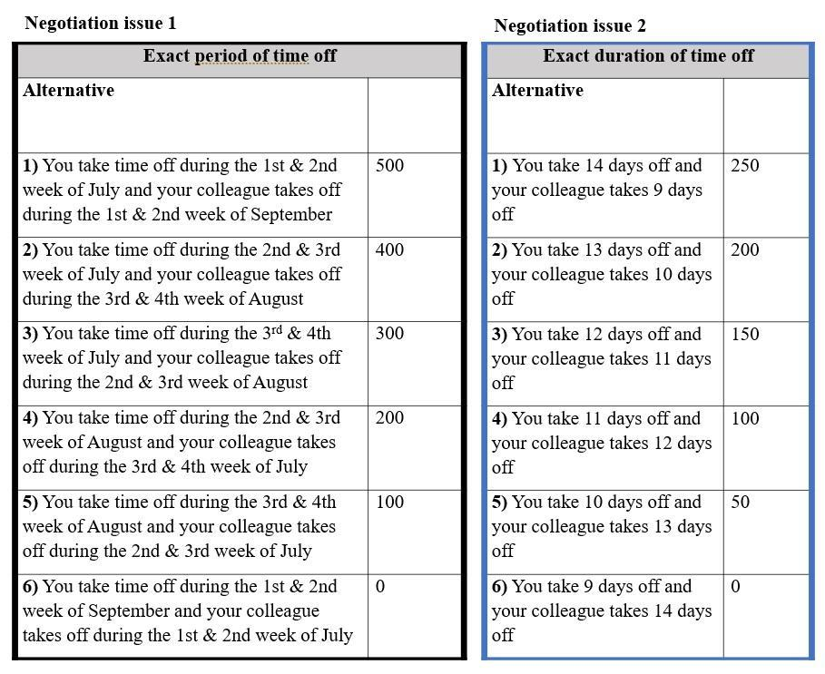
Issue 1 Issue 2

Low Power payoff schedule and allocation of points.
Issue 1 Issue 2
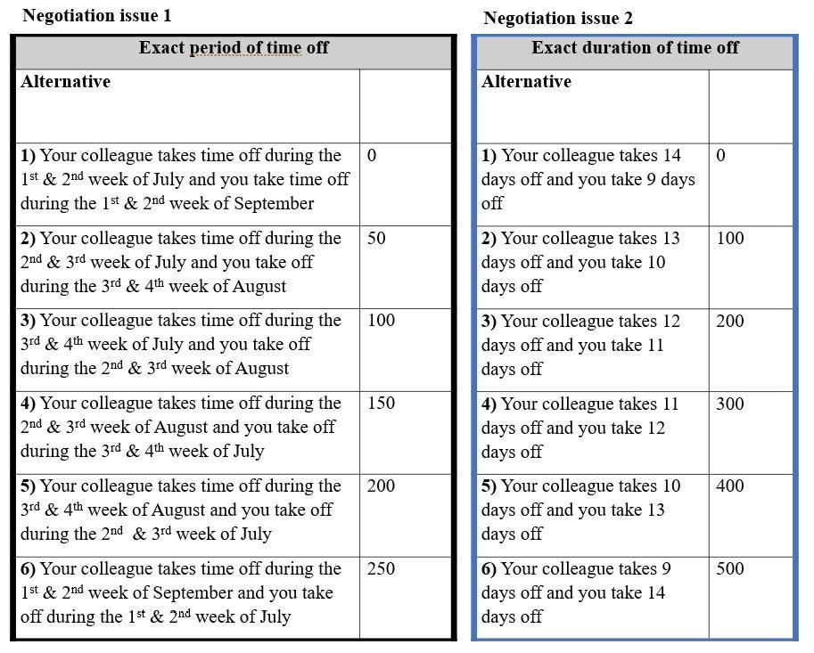
Manipulation Checks
Power
Based on my boss’s intentions about how to deal with the holiday issue
- I was in an advantageous position compared to my colleague
- I was in a better position than my colleague
- My colleague was in a better position than me
- My colleague was in a disadvantaged position compared to me
(1 = totally disagree, 7 = totally agree)
Creativity
During this conflict…
- I was encouraged to think creatively.
- I was encouraged to combine the solutions that I generated with the solutions that my colleague proposed to me.
- I was encouraged to come up with even strange and unusual ideas while thinking of possible solutions.
- I was encouraged to think “out of the box” while generating ideas for possible solutions.
(1 = not at all true, 7 = completely true)

Guidelines for raters:
Evaluate each idea on originality, that is, on how novel and unique the idea is,
and assign to it one of the following originality scores:
- not at all original – idea is identical to, or virtually the same as an idea that already exists, or that is frequently mentioned
- slightly original – idea is only a slight change to a common, existing idea (it's not fundamentally different, but has a somewhat new twist or angle)
- moderately original – idea is a clear change to an existing idea (although the existing idea can be easily recognized) and adds some really original aspects to it (for example, takes a surprising perspective)
- original – idea is somewhat similar to existing ideas, but in a completely new way or context
- very original – idea is completely novel and unique, it has no discernible qualities of pre-existing ideas

Evaluate each idea on effectiveness, that is, on how well you think the idea will
solve the problem.
When you ask yourself the question “Will it solve the problem / Will it work?”,
it may be helpful to consider the effectiveness of an idea in terms of its potential “broadness”:
“Will it solve the entire problem, or only part(s) of the problem?”[broadness of domain(s)]
“Will it have only a short-term effect, or a long-term effect?” [broadness of time-frame]

An idea that will solve all aspects of a problem and with a long-lasting effect would be considered to be more effective than an idea that will only solve part of the problem or that will only have a short-term effect.

Based on these considerations, please assign each idea one of the following effectiveness scores:
- not at all effective – idea does not solve the problem at all.
- slightly effective – idea only solves the problem to a small extent.
- moderately effective – idea sufficiently solves the problem.
- effective – idea solves the problem quite well.
- very effective – idea is the ideal solution to the problem.

