Table S1
Multilevel Polynomial Regression Model Predicting Individual Creativity for Finance and Insurance, Service, and Public Enterprises
 | Individual creativity
 | Model 1 | Model 2 | Model 3 | Model 4 | Model 5
Step 1. Control
Gender (member) | -.34* (.15) | -.35* (.15) | -.33* (.16) | -.41** (.15) | -.43* (.19)
Age (member) | .00 (.01) | .00 (.01) | .00 (.01) | .01 (.01) | .01 (.01)
Education (member) | .31*** (.08) | .27** (.08) | .24* (.10) | .26** (.09) | .26** (.09)
Team tenure (member) | -.03 (.02) | -.03 (.02) | -.02 (.02) | -.02 (.02) | -.02 (.02)
Step 2. Main effect
Relationship conflict (leader) |  | -.59*** (.15) | -.64*** (.17)
Relationship conflict (member) |  | .01 (.15) | .00 (.16)
Relationship conflict² (leader) |  |  | -.07 (.26)
Relationship conflict (leader) * Relationship conflict (member) |  |  | -.46** (.18)
Relationship conflict² (member) |  |  | -.05 (.09)
Task conflict (leader) |  |  |  | -.37 (.21) | -.30 (.21)
Task conflict (member) |  |  |  | .16 (.23) | .16 (.20)
Task conflict² (leader) |  |  |  |  | -.33 (.18)
Task conflict (leader) * Task conflict (member) |  |  |  |  | -.05 (.36)
Task conflict² (member) |  |  |  |  | -.04 (.15)
Congruence line
Slope (a₁) |  |  | -.64*** |  | -.15
Curvature (a₂) |  |  | -.58* |  | -.53
Incongruence line
Slope (a₃) |  |  | .64* |  | .46*
Curvature (a₄) |  |  | .34 |  | -.32
Note. N = 63.
* p < .05. ** p < .01. *** p < .001. Unstandardized regression coefficients are shown.

Table S2
Multilevel Polynomial Regression Model Predicting Individual Creativity for Manufacturing and Others
 | Individual creativity
 | Model 1 | Model 2 | Model 3 | Model 4 | Model 5
Step 1. Control
Gender (member) | -.05 (.15) | -.03 (.16) | -.02 (.16) | -.06 (.16) | -.08 (.15)
Age (member) | -.02 (.01) | -.01 (.01) | -.01 (.01) | -.02 (.01) | -.02 (.01)
Education (member) | .01 (13) | .01 (.12) | -.01 (.12) | .04 (.13) | .01 (.12)
Team tenure (member) | -.04 (.04) | -.03 (.04) | -.02 (.04) | -.04 (.04) | -.04 (.04)
Step 2. Main effect
Relationship conflict (leader) |  | -.29** (.09) | -.37** (.13)
Relationship conflict (member) |  | .01 (.07) | -.02 (.06)
Relationship conflict² (leader) |  |  | .19 (.17)
Relationship conflict (leader) * Relationship conflict (member) |  |  | .10(.12)
Relationship conflict² (member) |  |  | .01 (.10)
Task conflict (leader) |  |  |  | -.20 (.17) | -.15 (.14)
Task conflict (member) |  |  |  | -.02 (.13) | -.02 (.12)
Task conflict² (leader) |  |  |  |  | -.21 (.22)
Task conflict (leader) * Task conflict (member) |  |  |  |  | .29 (.22)
Task conflict² (member) |  |  |  |  | .07 (.17)
Congruence line
Slope (a₁) |  |  | -.39* |  | -.17
Curvature (a₂) |  |  | .31 |  | .14
Incongruence line
Slope (a₃) |  |  | .35** |  | .13
Curvature (a₄) |  |  | .10 |  | -.43
Note. N = 90.
* p < .05. ** p < .01. *** p < .001. Unstandardized regression coefficients are shown.

Figure S1
Response Surface Analysis for Vertical Asymmetry in Relationship Conflict and Individual Creativity for Finance and Insurance, Service, and Public Enterprises
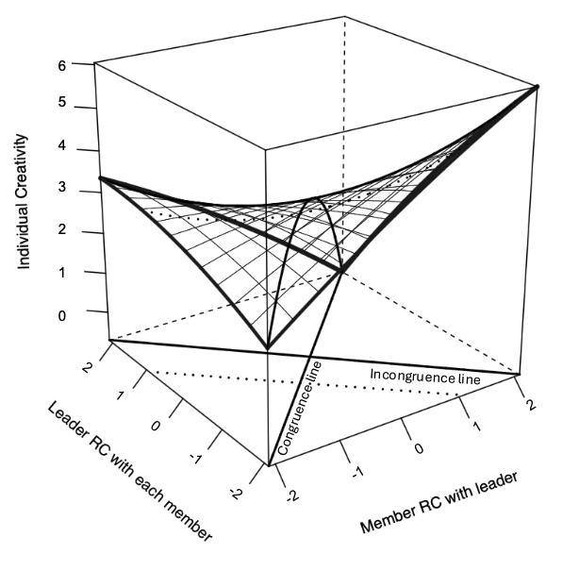
Note. RC = relationship conflict.
Figure S2
Response Surface Analysis for Vertical Asymmetry in Task Conflict and Individual Creativity for Finance and Insurance, Service, and Public Enterprises
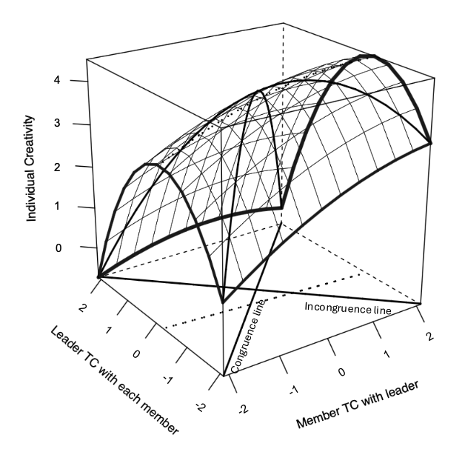
Note. TC = task conflict.
Figure S3
Response Surface Analysis for Vertical Asymmetry in Relationship Conflict and Individual Creativity for Manufacturing and Others
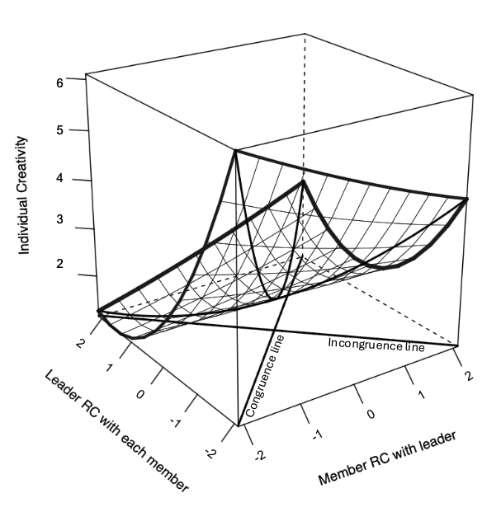
Note. RC = relationship conflict.

Figure S4
Response Surface Analysis for Vertical Asymmetry in Task Conflict and Individual Creativity for Manufacturing and Others
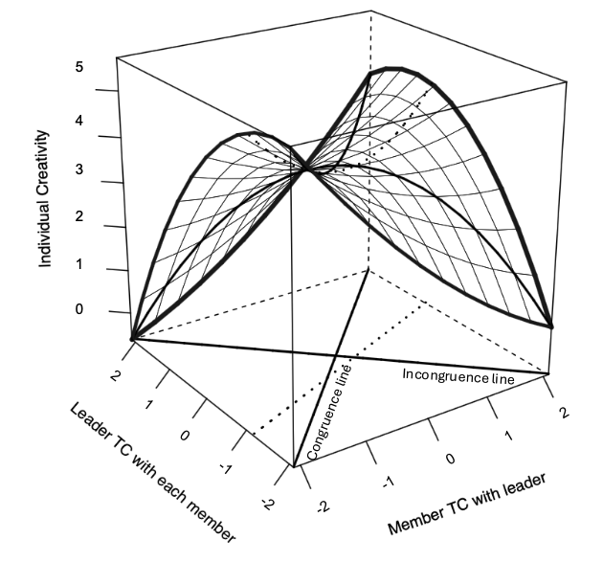
Note. TC = task conflict.

Table S3
Multilevel Polynomial Regression Model Predicting Team Creativity for Finance and Insurance, Service, and Public Enterprises
 | Team creativity
 | Model 1 | Model 2 | Model 3 | Model 4 | Model 5
Step 1. Control
Team size | .75 (.63) | .30 (.66) | .18 (.74) | .65 (.59) | .27 (.63)
Gender (leader) | .43 (.45) | .45 (.44) | .31 (.46) | .14 (.47) | .02 (.53)
Gender (member) | -.82 (.75) | .21 (.90) | .71 (1.12) | -.25 (.86) | .12 (.94)
Team tenure (leader) | .00 (.04) | -.01 (.04) | -.01 (.04) | .02 (.04) | .02 (.04)
Team tenure (member) | -.04 (.08) | .04 (.09) | .05 (.11) | -.01 (.08) | .03 (.08)
Step 2. Main effect
Relationship conflict (leader) |  | -.51 (.30) | -.77 (.38)
Relationship conflict (member) |  | .28 (.35) | .29 (.41)
Relationship conflict² (leader) |  |  | -.10 (.34)
Relationship conflict (leader) * Relationship conflict (member) |  |  | -.82 (.68)
Relationship conflict² (member) |  |  | .67 (.71)
Task conflict (leader) |  |  |  | -.37 (.34) | -.18 (.44)
Task conflict (member) |  |  |  | .72* (.31) | .50 (.32)
Task conflict² (leader) |  |  |  |  | .74 (.43)
Task conflict (leader) * Task conflict (member) |  |  |  |  | -.79 (.99)
Task conflict² (member) |  |  |  |  | -.44 (.60)
Congruence line
Slope (a₁) |  |  | -.47 |  | .33
Curvature (a₂) |  |  | -.25 |  | -.45
Incongruence line
Slope (a₃) |  |  | 1.06 |  | .68
Curvature (a₄) |  |  | 1.39 |  | 1.13
R² | .12 | .33 | .48 | .39 | .57
adj. R² | -.15 | -.01 | .00 | .09 | .17
Note. N = 22.
* p < .05. ** p < .01. *** p < .001. Unstandardized regression coefficients are shown

Table S4
Multilevel Polynomial Regression Model Predicting Team Creativity for Manufacturing and Others
 | Team creativity
 | Model 1 | Model 2 | Model 3 | Model 4 | Model 5
Step 1. Control
Team size | .16 (.37) | .52 (.36) | .34 (.39) | .41 (.38) | .42 (.42)
Gender (leader) | .38 (.33) | .22 (.31) | .35 (.33) | .21 (.31) | .20 (.34)
Gender (member) | -.26 (.42) | -.38 (.38) | -.43 (.40) | -.17 (.38) | -.21 (.41)
Team tenure (leader) | -.06 (.04) | -.03 (.04) | -.03 (.04) | -.07* (.03) | -.07 (.04)
Team tenure (member) | .01 (.06) | -.03 (.06) | -.01 (.06) | -.01 (.06) | -.01 (.06)
Step 2. Main effect
Relationship conflict (leader) |  | -.38* (.13) | -.36* (.16)
Relationship conflict (member) |  | .01 (.15) | -.05 (.17)
Relationship conflict² (leader) |  |  | .02 (.12)
Relationship conflict (leader) * Relationship conflict (member) |  |  | -.02 (.17)
Relationship conflict² (member) |  |  | .32 (.23)
Task conflict (leader) |  |  |  | -.21 (.17) | -.18 (.18)
Task conflict (member) |  |  |  | .40* (.18) | .39 (.19)
Task conflict² (leader) |  |  |  |  | .14 (.25)
Task conflict (leader) * Task conflict (member) |  |  |  |  | .06 (.39)
Task conflict² (member) |  |  |  |  | .14 (.37)
Congruence line
Slope (a₁) |  |  | -.41 |  | .21
Curvature (a₂) |  |  | .32 |  | .34
Incongruence line
Slope (a₃) |  |  | .31 |  | .57*
Curvature (a₄) |  |  | .37 |  | .22
R² | .23 | .45 | .51 | .45 | .46
adj. R² | .06 | .26 | .23 | .25 | .14
Note. N = 31.
* p < .05. ** p < .01. *** p < .001. Unstandardized regression coefficients are shown.

Figure S5
Response Surface Analysis for Vertical Asymmetry in Relationship Conflict and Team Creativity for Finance and Insurance, Service, and Public Enterprises
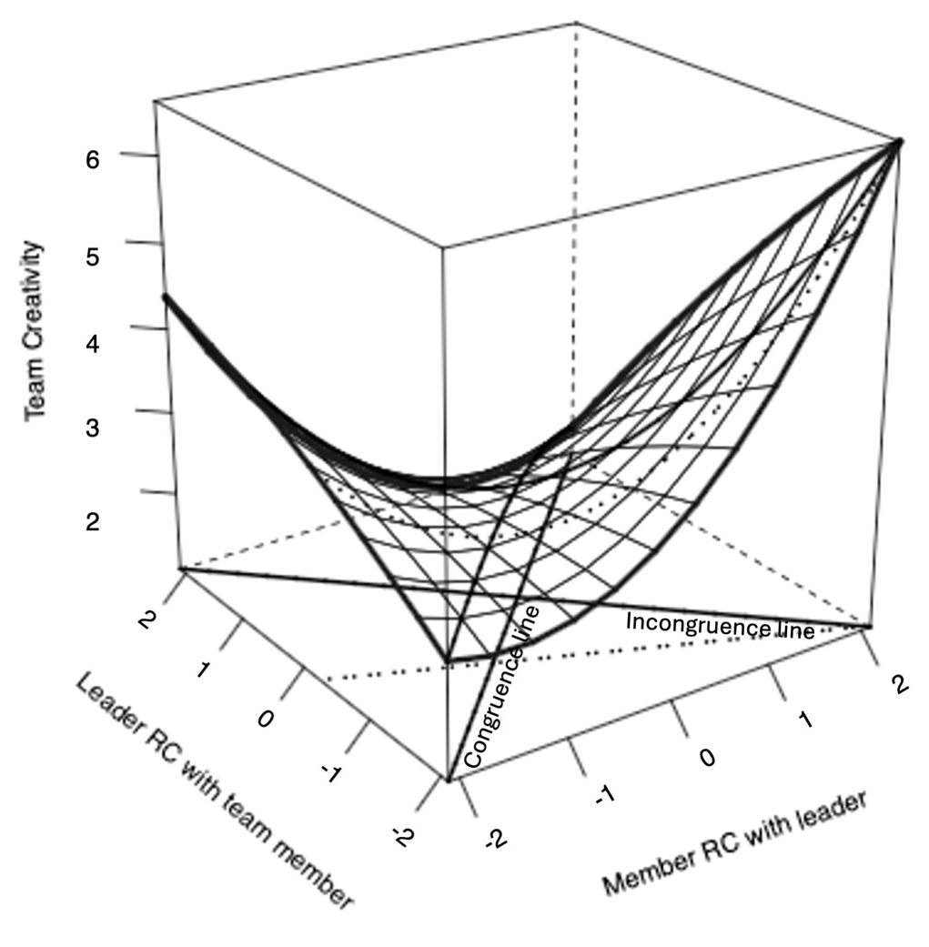
Note. RC = relationship conflict.
Figure S6
Response Surface Analysis for Vertical Asymmetry in Task Conflict and Team Creativity for Finance and Insurance, Service, and Public Enterprises
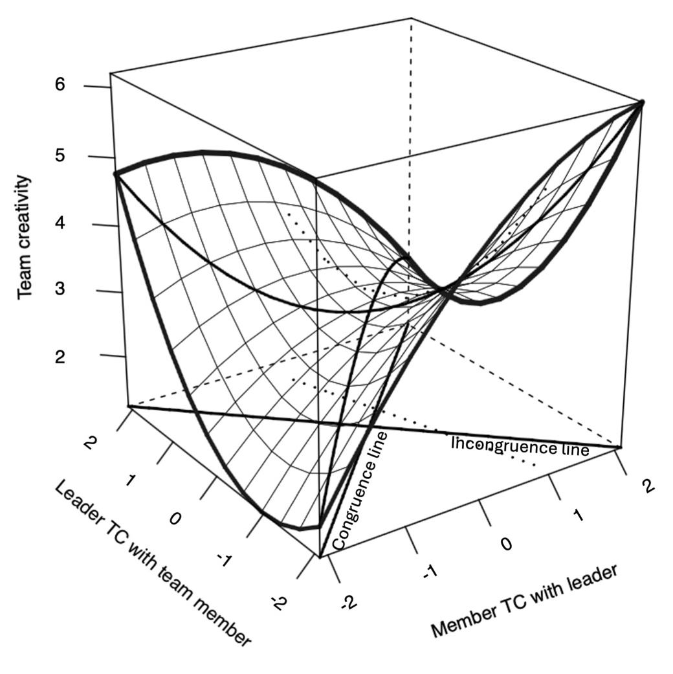
Note. TC = task conflict.
Figure S7
Response Surface Analysis for Vertical Asymmetry in Relationship Conflict and Team Creativity for Manufacturing and Others
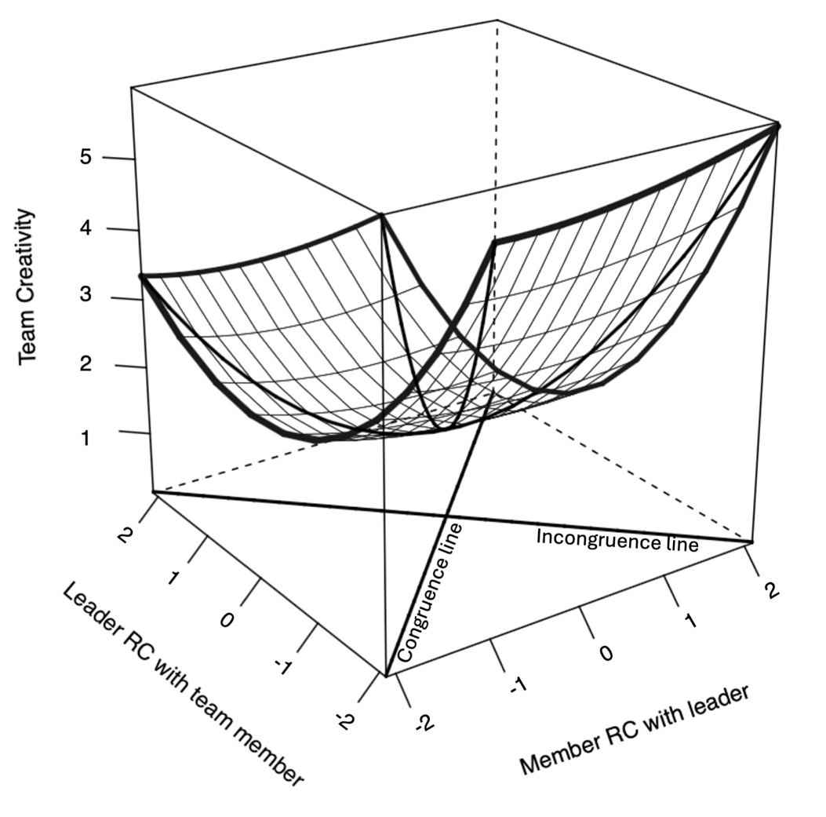
Note. RC = relationship conflict.

Figure S8
Response Surface Analysis for Vertical Asymmetry in Task Conflict and Team Creativity for Manufacturing and Others
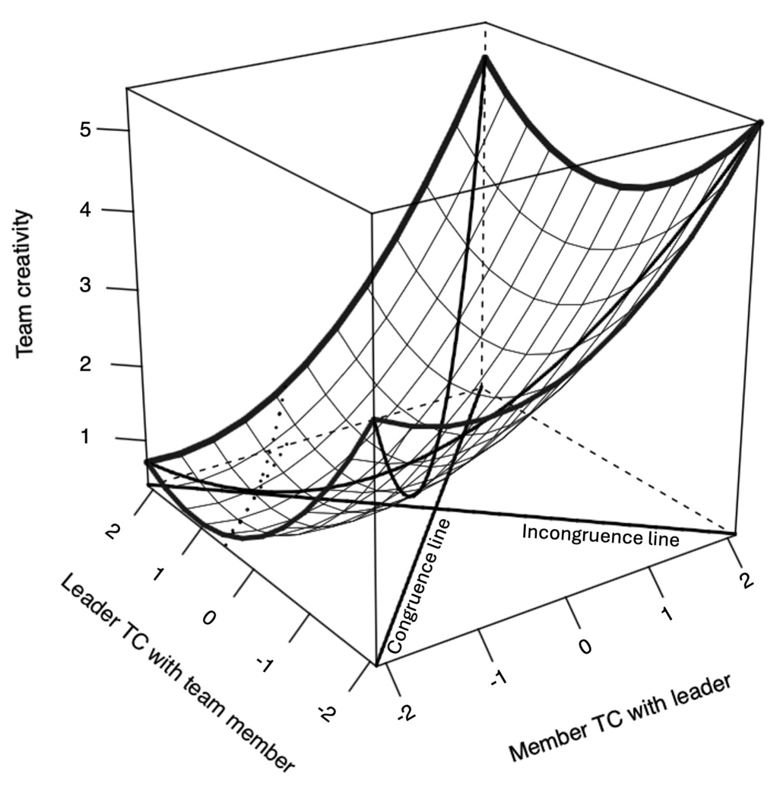
Note. TC = task conflict.

Table S5
Multilevel Polynomial Regression Model Predicting Individual Creativity Controlling Industry
 | Individual creativity
 | Model 1 | Model 2 | Model 3 | Model 4 | Model 5
Step 1. Control
Gender (member) | -.17 (.11) | -.15 (.11) | -.16 (.11) | -.19 (.10) | -.18 (.10)
Age (member) | -.01 (.01) | -.01 (.01) | -.01 (.01) | -.01 (.01) | -.01 (.01)
Education (member) | .27** (.08) | .21** (.07) | .20** (.07) | .22** (.07) | .20** (.07)
Team tenure (member) | -.02 (.02) | -.02 (.02) | -.02 (.02) | -.01 (.02) | -.02 (.02)
Industry (finance and insurance) | .13 (.17) | .10 (.17) | .11 (.17) | .12 (.16) | .09 (.16)
Industry (public enterprises) | .21 (.16) | .19 (.16) | .18 (.17) | .21 (.02) | .07 (.11)
Step 2. Main effect
Relationship conflict (leader) |  | -.39*** (.09) | -.41*** (.10)
Relationship conflict (member) |  | .01 (.08) | -.01 (.08)
Relationship conflict² (leader) |  |  | .10 (.15)
Relationship conflict (leader) * Relationship conflict (member) |  |  | -.01 (.09)
Relationship conflict² (member) |  |  | .03 (.07)
Task conflict (leader) |  |  |  | -.30 (.11) | -.24* (.11)
Task conflict (member) |  |  |  | .08 (.11) | .07 (.11)
Task conflict² (leader) |  |  |  |  | -.22 (.12)
Task conflict (leader) * Task conflict (member) |  |  |  |  | .20 (.18)
Task conflict² (member) |  |  |  |  | .09 (.14)
Congruence line
Slope (a₁) |  |  | -.42** |  | -.18
Curvature (a₂) |  |  | .12 |  | .07
Incongruence line
Slope (a₃) |  |  | .40** |  | .31*
Curvature (a₄) |  |  | .14 |  | -.34
Note. N = 153.
* p < .05. ** p < .01. *** p < .001. Unstandardized regression coefficients are shown.

Table S6
Multilevel Polynomial Regression Model Predicting Team Creativity Controlling Industry
 | Team creativity
 | Model 1 | Model 2 | Model 3 | Model 4 | Model 5
Step 1. Control
Team size | .43 (.34) | .52 (.31) | .42 (.31) | .65* (.31) | .64* (.31)
Gender (leader) | .38 (.27) | .40 (.26) | .42 (.25) | .25 (.25) | .24 (.25)
Gender (member) | -.50 (.35) | -.48 (.33) | -.47 (.32) | -.44 (.31) | -.43 (.32)
Team tenure (leader) | -.02 (.03) | -.02(.02) | -.01 (.02) | -.02 (.02) | -.02 (.02)
Team tenure (member) | -.01 (.05) | -.01 (.04) | -.01 (.04) | -.01 (.04) | -.01 (.04)
Industry (finance and insurance) | -.27 (.30) | -.26 (.28) | -.21 (.28) | -.22 (.27) | -.23 (.27)
Industry (public enterprises) | -.09 (.32) | -.19 (.30) | -.10 (.30) | .14 (.30) | .24 (.30)
Step 2. Main effect
Relationship conflict (leader) |  | -.32** (.11) | -.35** (.12)
Relationship conflict (member) |  | .10 (.15) | .02 (.15)
Relationship conflict² (leader) |  |  | .00 (.11)
Relationship conflict (leader) * Relationship conflict (member) |  |  | -.07 (.18)
Relationship conflict² (member) |  |  | .49* (.22)
Task conflict (leader) |  |  |  | -.22 (.14) | -.15 (.14)
Task conflict (member) |  |  |  | .51** (.16) | .49** (.16)
Task conflict² (leader) |  |  |  |  | .31 (.17)
Task conflict (leader) * Task conflict (member) |  |  |  |  | -.19 (.29)
Task conflict² (member) |  |  |  |  | .00 (.26)
Congruence line
Slope (a₁) |  |  | -.33 |  | .34
Curvature (a₂) |  |  | .42 |  | .12
Incongruence line
Slope (a₃) |  |  | .36 |  | .64**
Curvature (a₄) |  |  | .57* |  | .50
R² | .14 | .30 | .39 | .35 | .42
adj. R² | -.01 | .14 | .20 | .21 | .24
Note. N = 53.
* p < .05. ** p < .01. *** p < .001. Unstandardized regression coefficients are shown
Figure S9
Response Surface Analysis for Vertical Asymmetry in Relationship Conflict and Individual Creativity Controlling Industry
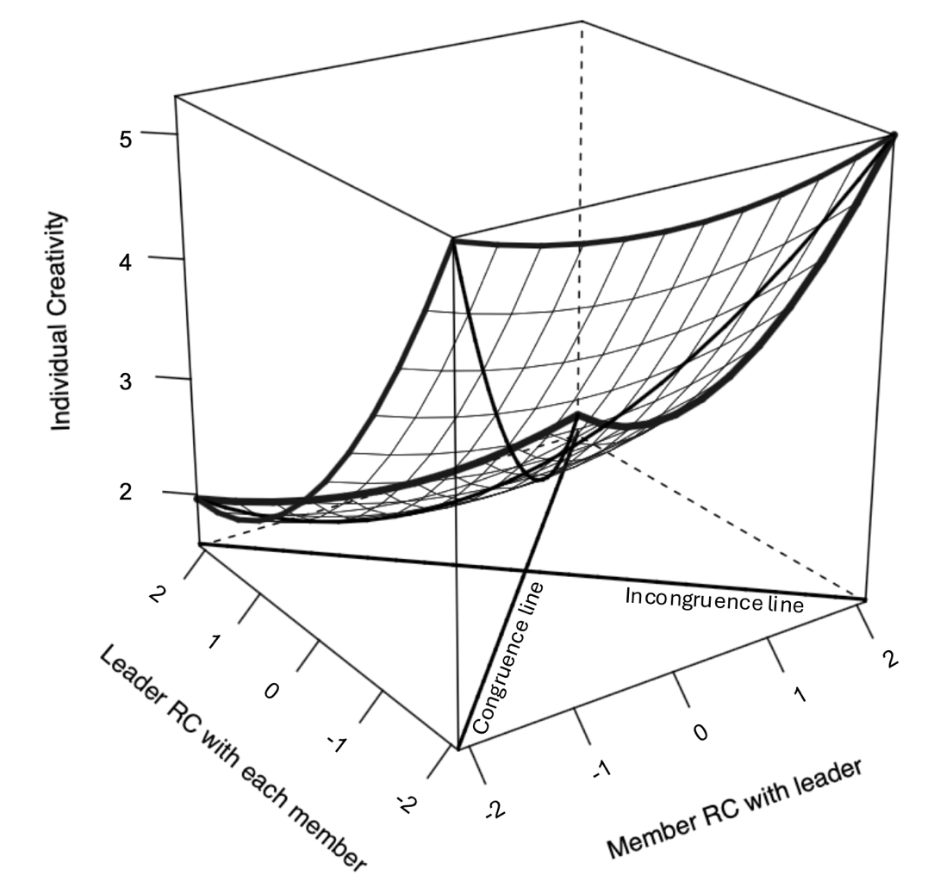
Note. RC = relationship conflict.

Figure S10
Response Surface Analysis for Vertical Asymmetry in Task Conflict and Individual Creativity Controlling Industry
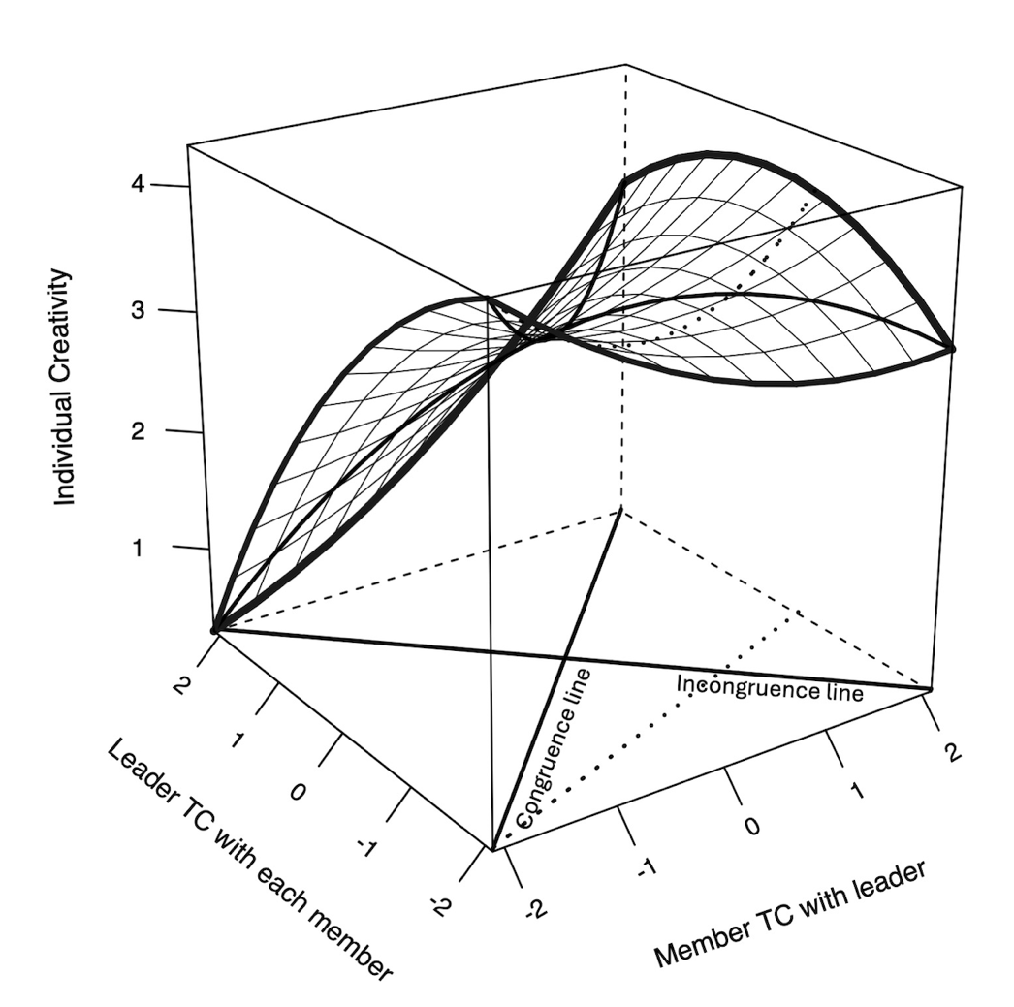
Note. TC = task conflict.

Figure S11
Response Surface Analysis for Vertical Asymmetry in Relationship Conflict and Team Creativity Controlling Industry
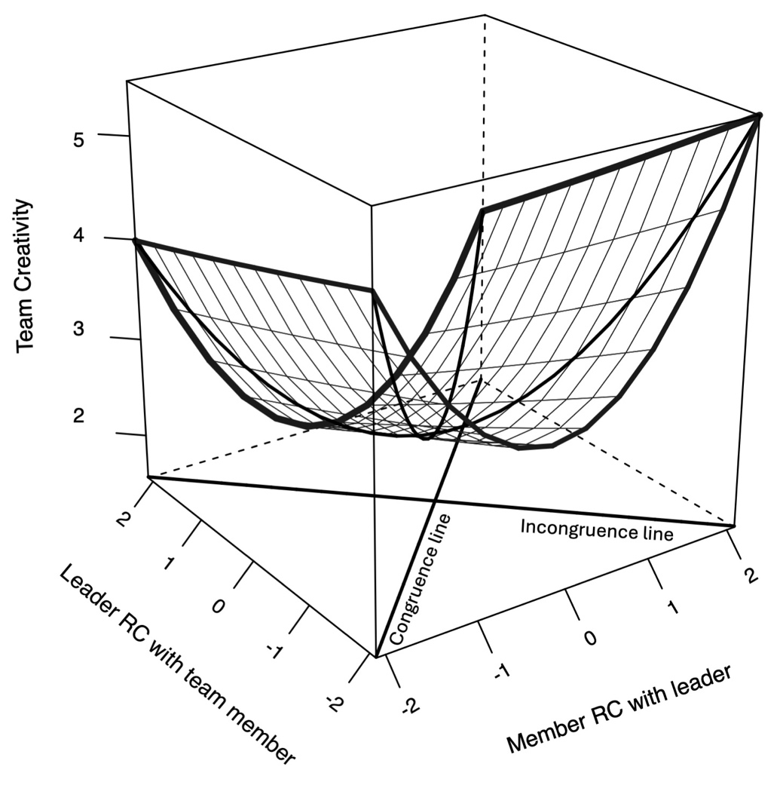
Note. RC = relationship conflict.

Figure S12
Response Surface Analysis for Vertical Asymmetry in Task Conflict and Team Creativity Controlling Industry
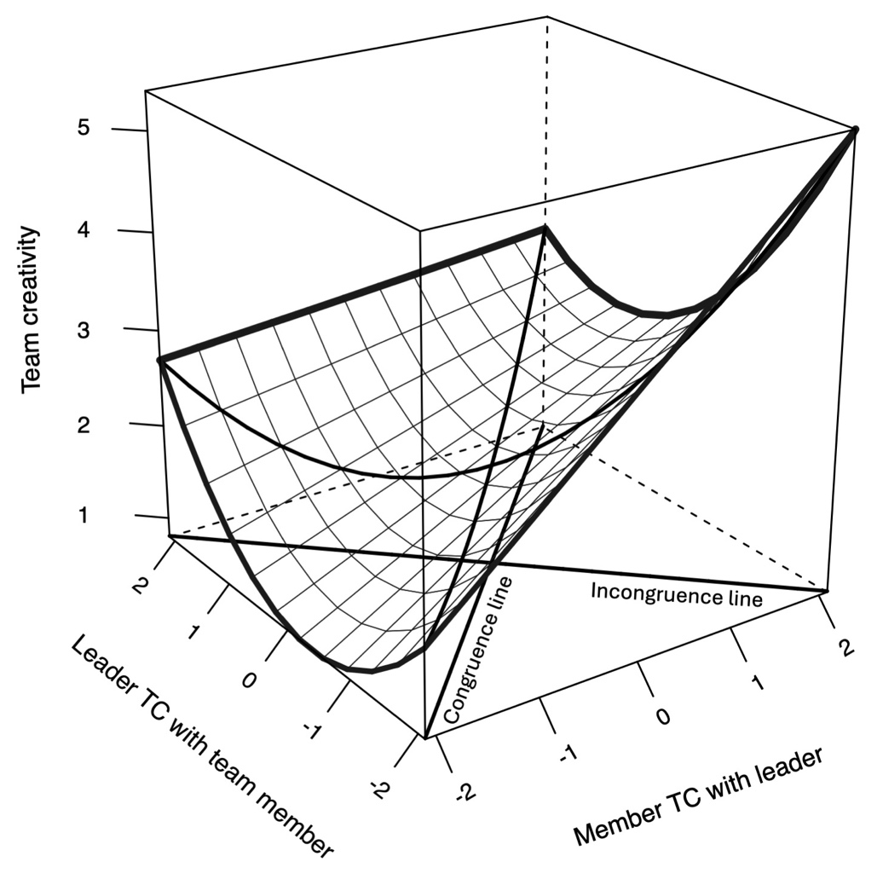
Note. TC = task conflict.

Table S7
Multilevel Polynomial Regression Model Predicting Individual Creativity
 | Individual creativity
 | Model 1 | Model 2 | Model 3
Step 1. Control
Gender (member) | -.13 (.10) | -.14 (.10) | -.12 (.10)
Age (member) | -.01 (.01) | -.01 (.01) | .00 (.01)
Education (member) | .18** (.06) | .18** (.06) | .15** (.06)
Team tenure (member) | -.01 (.02) | -.02 (.02) | -.02 (.02)
Step 2. Main effect
Relationship conflict (leader) | -.30*** (.08) | -.33** (.09) | -.29*** (.06)
Relationship conflict (member) | -.03 (.07) | -.05 (.07) | .04 (.05)
Relationship conflict² (leader) |  | .09 (.14)
Relationship conflict (leader) * Relationship conflict (member) |  | -.01 (.08)
Relationship conflict² (member) |  | .03 (.07)
Task conflict (leader) | -.18 (.10) | - .17 (.11) | -.15 (.11)
Task conflict (member) | .09 (.10) | .09 (.11) | .03 (.11)
Task conflict² (leader) |  |  | -.18 (.12)
Task conflict (leader) * Task conflict (member) |  |  | .17 (.15)
Task conflict² (member) |  |  | .02 (.13)
Congruence line
Slope (a₁) |  | -.37** | -.11
Curvature (a₂) |  | .11 | .01
Incongruence line
Slope (a₃) |  | .28* | .18
Curvature (a₄) |  | .13 | -.33
Note. N = 153.
* p < .05. ** p < .01. *** p < .001. Unstandardized regression coefficients are shown.

Table S8
Multilevel Polynomial Regression Model Predicting Team Creativity
 | Team creativity
 | Model 1 | Model 2 | Model 3
Step 1. Control
Team size | .53 (.28) | .43 (.29) | .48 (.27)
Gender (leader) | .26 (.21) | .30 (.21) | .29 (.21)
Gender (member) | -.39 (.30) | -.37 (.29) | -.37 (.29)
Team tenure (leader) | -.01 (.02) | -.01 (.02) | .00 (.02)
Team tenure (member) | .00 (.04) | .01 (.04) | .01 (.04)
Step 2. Main effect
Relationship conflict (leader) | -.28 (.14) | -.30 (.15) | -.33* (.13)
Relationship conflict (member) | -.21 (.16) | -.26 (.17) | -.25 (.16)
Relationship conflict² (leader) |  | .03 (.10)
Relationship conflict (leader) * Relationship conflict (member) |  | -.03 (.16)
Relationship conflict² (member) |  | .41 (.21)
Task conflict (leader) | .02 (.18) | -.01 (.18) | .15 (.18)
Task conflict (member) | .58** (.19) | .52** (.19) | .55** (.18)
Task conflict² (leader) |  |  | .34* (.15)
Task conflict (leader) * Task conflict (member) |  |  | -.27 (.26)
Task conflict² (member) |  |  | -.04 (.23)
Congruence line
Slope (a₁) |  | -.56* | .70**
Curvature (a₂) |  | .42 | .03
Incongruence line
Slope (a₃) |  | .05 | .41
Curvature (a₄) |  | .47 | .56
R² | .43 | .49 | .53
adj. R² | .30 | .32 | .37
Note. N = 53.
* p < .05. ** p < .01. *** p < .001. Unstandardized regression coefficients are shown.

Figure S13
Response Surface Analysis for Vertical Asymmetry in Relationship Conflict and Individual Creativity
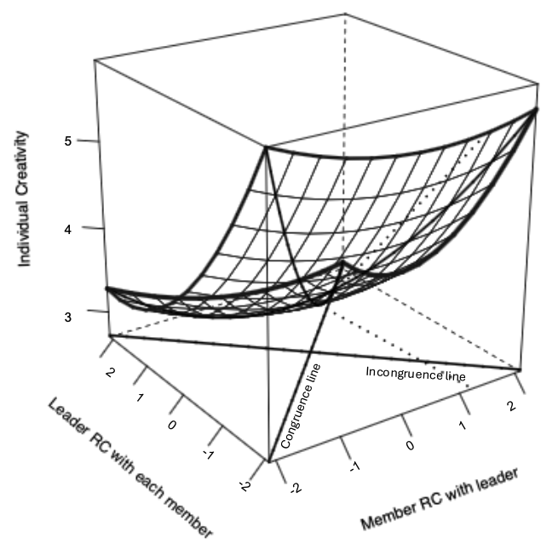
Note. RC = relationship conflict.

Figure S14
Response Surface Analysis for Vertical Asymmetry in Task Conflict and Individual Creativity
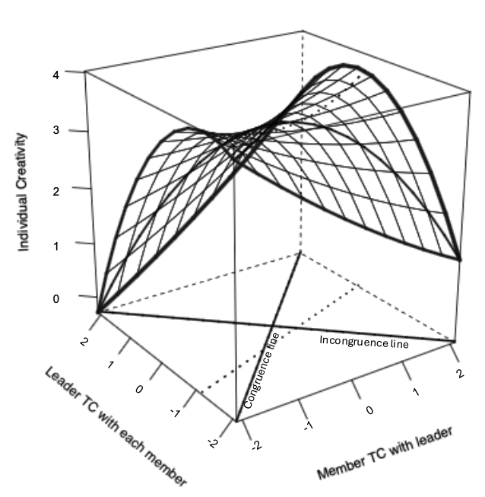
Note. TC = task conflict.

Figure S15
Response Surface Analysis for Vertical Asymmetry in Relationship Conflict and Team Creativity
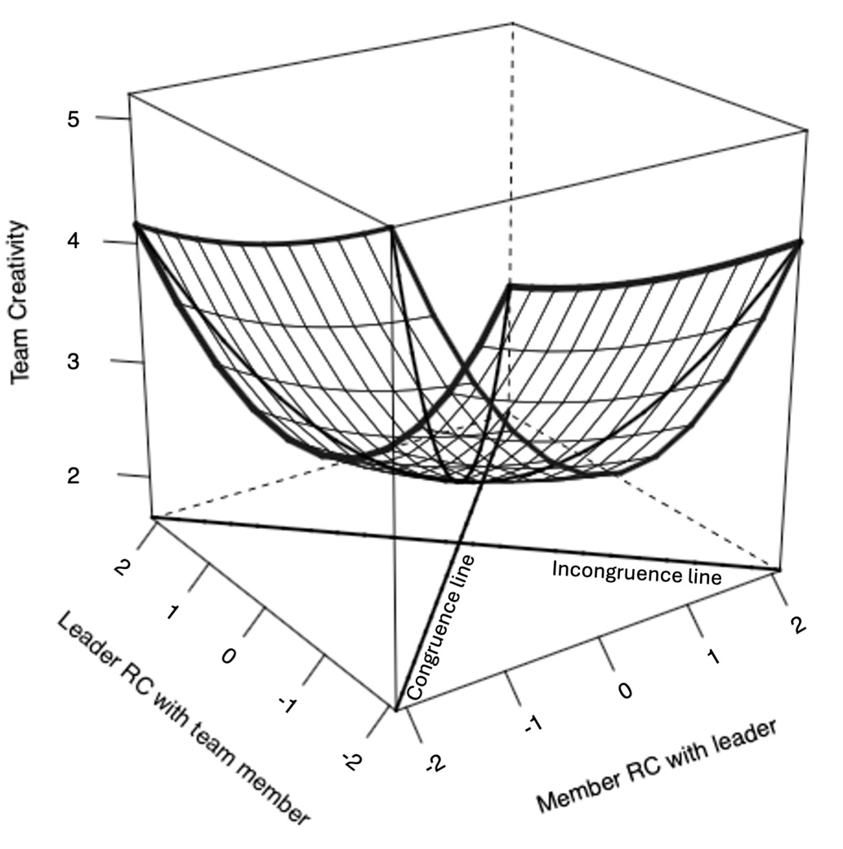
Note. RC = relationship conflict.

Figure S16
Response Surface Analysis for Vertical Asymmetry in Task Conflict and Team Creativity
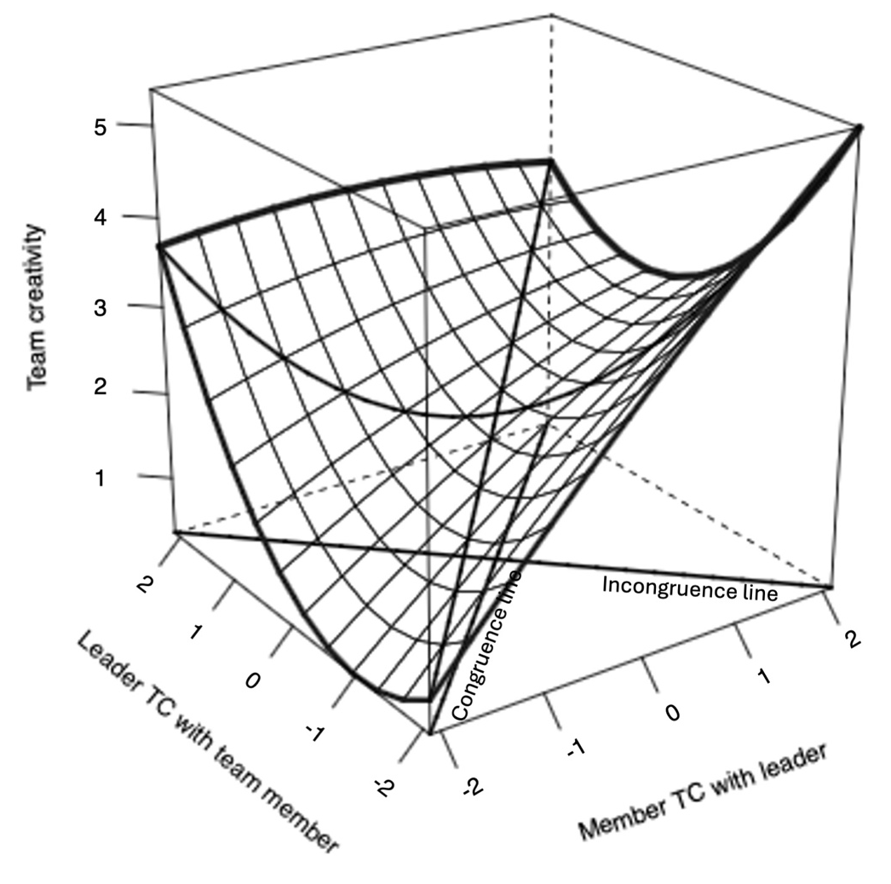
Note. TC = task conflict.

Table S9
Multilevel Polynomial Regression Model Predicting Task Conflict at the Individual Level
 | Task conflict (Leader) |  |  | Task conflict (Member)
 | Model 1 | Model 2 | Model 3 | Model 4 | Model 5 | Model 6
Step 1. Control
Gender (member) | -.17 (.15) | -.18 (.15) | -.17 (.14) | -.02 (.14) | -.26 (.14) | -.28* (.13)
Age (member) | -.01 (.01) | -.02 (.01) | -.02 (.01) | -.03** (.01) | -.03** (.01) | -.03** (.01)
Education (member) | .08 (.08) | .09 (.07) | .09 (.07) | .17 (.09) | .14 (.8) | .14 (.08)
Team tenure (member) | .00 (.02) | -.01 (.02) | .00 (.02) | -.04 (.02) | -.03 (.02) | -.04* (.02)
Step 2. Main effect
Relationship conflict (leader) |  | .47** (.14) | .41** (.13) |  | -.08 (.10) | -.02 (.13)
Relationship conflict (member) |  | .00 (.07) | .06 (.08) |  | .41*** (.10) | .34** (.10)
Relationship conflict² (leader) |  |  | .11 (.16) |  |  | -.08 (.15)
Relationship conflict (leader) * Relationship conflict (member) |  |  | .04 (.15) |  |  | -.05 (.12)
Relationship conflict² (member) |  |  | -.19 (.10) |  |  | .25** (.09)
Congruence line
Slope (a₁) |  |  | .47** |  |  | .32
Curvature (a₂) |  |  | -.04 |  |  | .12
Incongruence line
Slope (a₃) |  |  | -.36* |  |  | .35*
Curvature (a₄) |  |  | -.01 |  |  | .21
Note. N = 153.
* p < .05. ** p < .01. *** p < .001. Unstandardized regression coefficients are shown.

Table S10
Multilevel Polynomial Regression Model Predicting Task Conflict at the Team Level
 | Task conflict (Leader) |  |  | Task conflict (Member)
 | Model 1 | Model 2 | Model 3 | Model 4 | Model 5 | Model 6
Step 1. Control
Team size | .72* (.32) | .52 (.27) | .50 (.26) | .04 (.28) | .06 (.23) | .04 (.23)
Gender (leader) | -.42 (.21) | -.42* (.17) | -.41* (.17) | .10 (.18) | .12 (.14) | .12 (.15)
Gender (member) | .07 (.31) | .03 (.26) | .02 (.25) | -.36 (.27) | -.37 (.22) | -.36 (.22)
Team tenure (leader) | .01 (.03) | .00 (.02) | -.01 (.02) | -.01 (.02) | -.01 (.02) | -.01 (.02)
Team tenure (member) | -.06 (.05) | -.05 (.04) | -.06 (.04) | -.02 (.04) | -.03 (.03) | -.03 (.03)
Step 2. Main effect
Relationship conflict (leader) |  | .49*** (.10) | .56*** (.10) |  | -.08 (.08) | -.05 (.09)
Relationship conflict (member) |  | -.04 (.12) | -.10 (.12) |  | .55*** (.10) | .53*** (.11)
Relationship conflict² (leader) |  |  | -.18 (.09) |  |  | -.08 (.08)
Relationship conflict (leader) * Relationship conflict (member) |  |  | .05 (.15) |  |  | -.07 (.13)
Relationship conflict² (member) |  |  | .30 (.19) |  |  | .17 (.17)
Congruence line
Slope (a₁) |  |  | .46** |  |  | .47**
Curvature (a₂) |  |  | .16 |  |  | .01
Incongruence line
Slope (a₃) |  |  | -.65*** |  |  | .58***
Curvature (a₄) |  |  | .07 |  |  | .16
R² | .18 | .48 | .55 | .05 | .43 | .46
adj. R² | .09 | .40 | .44 | -.05 | .34 | .33
Note. N = 53.
* p < .05. ** p < .01. *** p < .001. Unstandardized regression coefficients are shown.

Figure S17
Response Surface Analysis for Vertical Asymmetry in Relationship Conflict and Leader rated Task Conflict in Individual Level
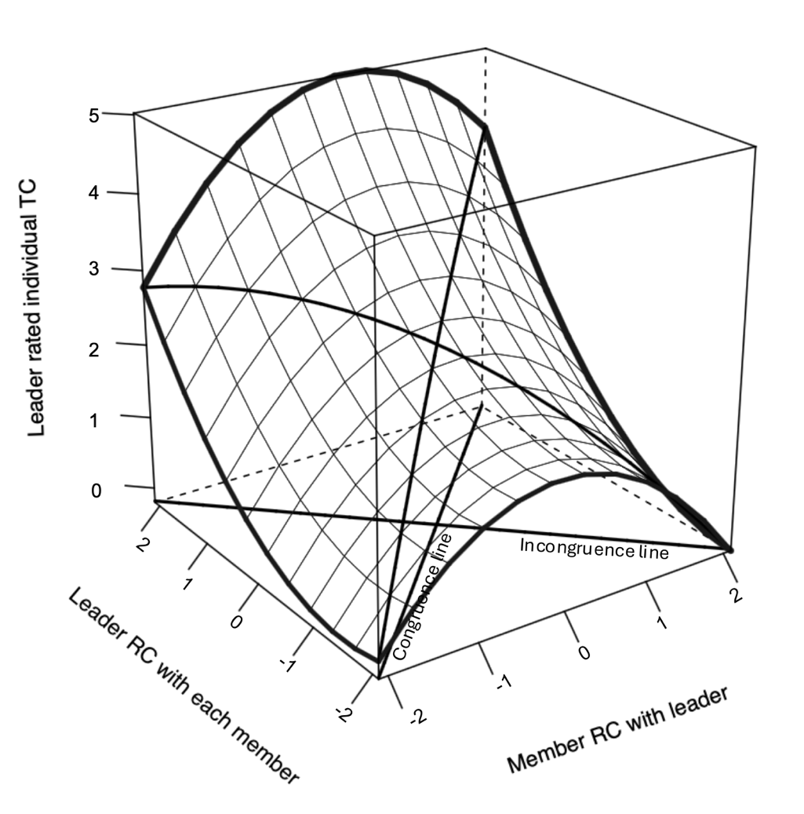
Note. RC = relationship conflict; TC = task conflict.

Figure S18
Response Surface Analysis for Vertical Asymmetry in Relationship Conflict and Member rated Task Conflict in Individual Level
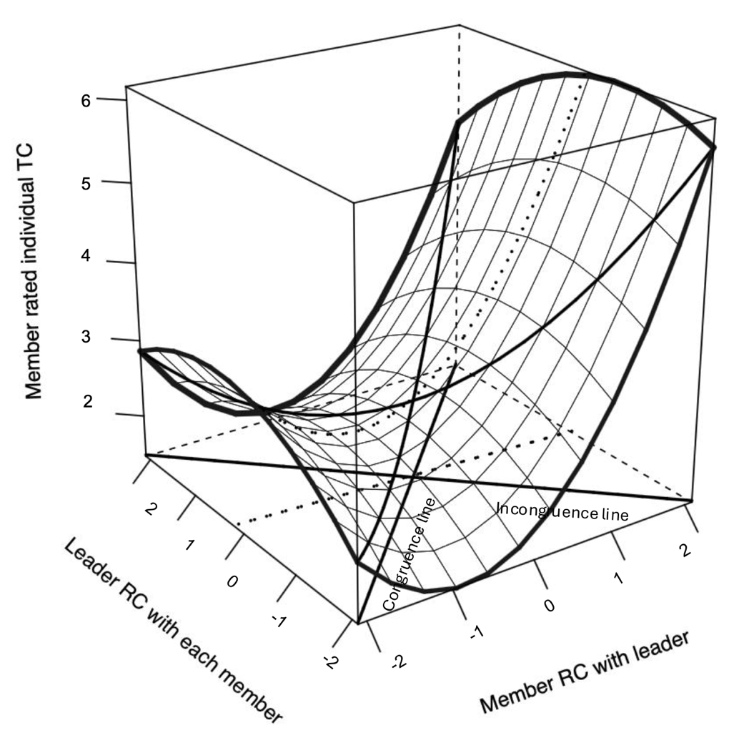
Note. RC = relationship conflict; TC = task conflict.

Figure S19
Response Surface Analysis for Vertical Asymmetry in Relationship Conflict and Leader rated Task Conflict in Team Level
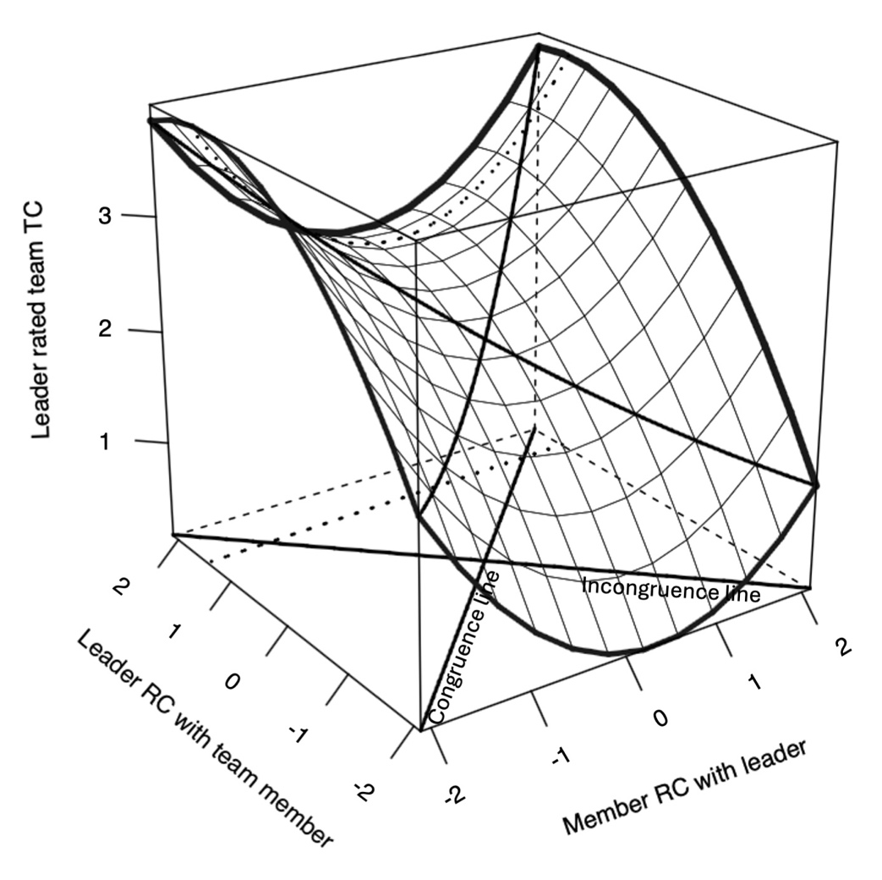
Note. RC = relationship conflict; TC = task conflict.

Figure S20
Response Surface Analysis for Vertical Asymmetry in Relationship Conflict and Member rated Task Conflict in Team Level
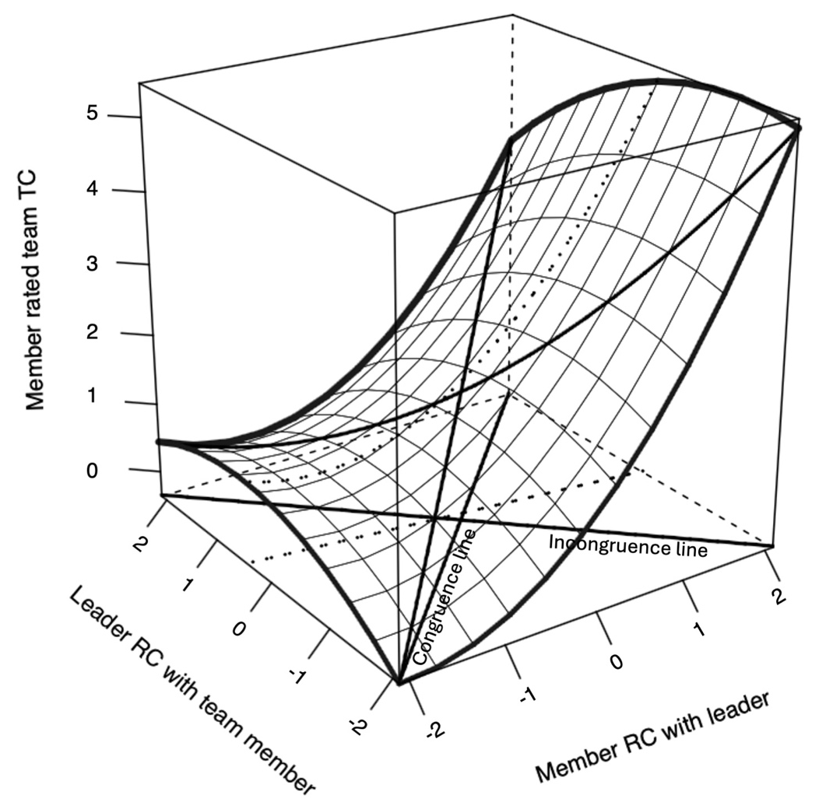
Note. RC = relationship conflict; TC = task conflict.

Table S11
VIF Predicting Team Creativity
 | Team creativity
 | Model 1 | Model 2 | Model 3 | Model 4 | Model 5
Step 1. Control
Team size | 1.24 | 1.27 | 1.35 | 1.36 | 1.43
Gender (leader) | 1.44 | 1.47 | 1.52 | 1.63 | 1.77
Gender (member) | 1.60 | 1.63 | 1.64 | 1.61 | 1.70
Team tenure (leader) | 1.18 | 1.19 | 1.20 | 1.18 | 1.19
Team tenure (member) | 1.13 | 1.13 | 1.24 | 1.17 | 1.19
Step 2. Main effect
Relationship conflict (leader) |  | 1.04 | 1.28
Relationship conflict (member) |  | 1.03 | 1.16
Relationship conflict² (leader) |  |  | 1.35
Relationship conflict (leader) * Relationship conflict (member) |  |  | 1.09
Relationship conflict² (member) |  |  | 1.25
Task conflict (leader) |  |  |  | 1.26 | 1.33
Task conflict (member) |  |  |  | 1.02 | 1.03
Task conflict² (leader) |  |  |  |  | 1.22
Task conflict (leader) * Task conflict (member) |  |  |  |  | 1.23
Task conflict² (member) |  |  |  |  | 1.19
Note. N = 53.
* p < .05. ** p < .01. *** p < .001. Unstandardized regression coefficients are shown

Table S12
Corner Point Values for Vertical Asymmetry in Relationship Conflict and Individual Creativity
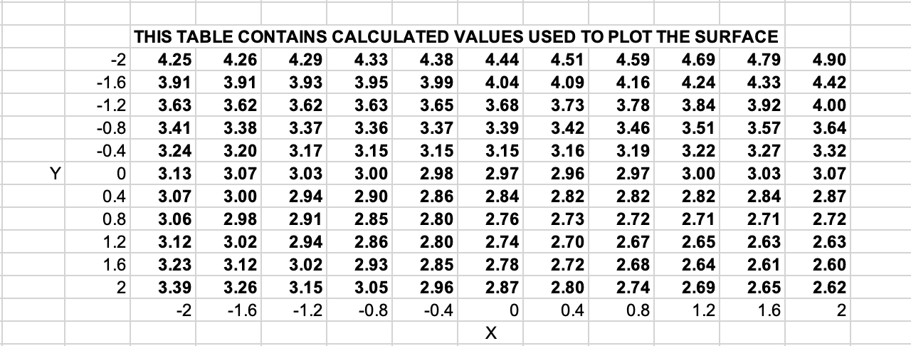

Table S13
Corner Point Values for Vertical Asymmetry in Relationship Conflict and Team Creativity
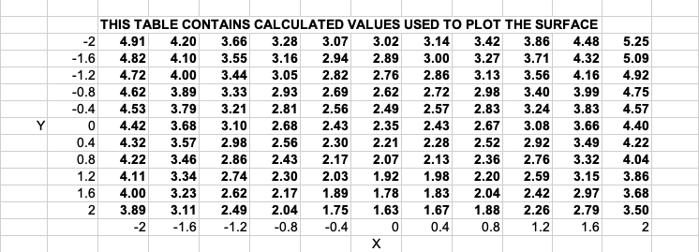

Figure S21
G*Power for Individual Level Analysis
