Appendix
APPENDIX 1: Logit model results
Table A1.1 Marginal effects (logit) of equation 1: Family firms and Non-Family Firms
 | Internal R&D | External R&D | External knowledge | New to Firm Product (NtF) | Process innovation | New to market Product (NtM)
Family firm | 0.0126** | 0.0104*** | 0.0152*** | 0.0391*** | 0.0204*** | 0.0348***
 | (0.00534) | (0.00397) | (0.00454) | (0.00603) | (0.00496) | (0.00535)
National market | 0.0963*** | 0.0484*** | 0.0489*** | 0.0697*** | 0.0480*** | 0.0593***
 | (0.00589) | (0.00468) | (0.00501) | (0.00628) | (0.00534) | (0.00564)
International market | 0.111*** | 0.0651*** | 0.0736*** | 0.0477*** | 0.0577*** | 0.0376***
 | (0.0109) | (0.00798) | (0.00936) | (0.0132) | (0.0102) | (0.0116)
Level of competition | -0.0147*** | -0.00653*** | -0.0107*** | -0.0247*** | -0.0150*** | -0.0213***
 | (0.00212) | (0.00158) | (0.00183) | (0.00245) | (0.00203) | (0.00217)
Competition*family firms | 0.000750 | 0.000182 | 0.00585** | -0.00737** | 0.00217 | -0.00284
 | (0.00309) | (0.00228) | (0.00262) | (0.00349) | (0.00283) | (0.00306)
Internationalization | 0.000535*** | 9.06e-05 | 5.35e-05 | 0.000704*** | 0.000290** | 0.000353**
 | (0.000136) | (9.61e-05) | (0.000117) | (0.000167) | (0.000127) | (0.000145)
Foreign involvement(foreign) | -0.000140 | 2.56e-06 | 0.000270*** | 0.000299** | 0.000128 | 0.000273***
 | (0.000106) | (7.12e-05) | (8.23e-05) | (0.000124) | (9.42e-05) | (0.000105)
Firm size | 0.0383*** | 0.0285*** | 0.0251*** | 0.0214*** | 0.0200*** | 0.0183***
 | (0.00195) | (0.00146) | (0.00167) | (0.00230) | (0.00185) | (0.00200)
Firm age | -0.00457 | -0.00573** | -0.00883*** | -0.00253 | -0.00498 | 0.00256
 | (0.00378) | (0.00280) | (0.00320) | (0.00426) | (0.00347) | (0.00376)
Manufacture | 0.128*** | 0.0427*** | 0.0571*** | 0.220*** | 0.172*** | 0.138***
 | (0.0230) | (0.0159) | (0.0199) | (0.0319) | (0.0367) | (0.0268)
Service | 0.115*** | 0.0463*** | 0.0974*** | 0.194*** | 0.156*** | 0.113***
 | (0.0234) | (0.0163) | (0.0202) | (0.0324) | (0.0369) | (0.0273)
Retail | 0.0794*** | 0.0425** | 0.0820*** | 0.196*** | 0.158*** | 0.118***
 | (0.0240) | (0.0166) | (0.0205) | (0.0327) | (0.0371) | (0.0275)
Observations | 20,995 | 20,995 | 20,995 | 20,995 | 20,995 | 20,995
LR chi2(18) | 2240.22 | 1238.65 | 1226.23 | 2358.00 | 1609.37 | 1620.88
Prob > chi2 | 0.0000 | 0.0000 | 0.0000 | 0.0000 | 0.0000 | 0.0000
Log likelihood | -8551.7761 | -5307.3864 | -6656.8483 | -10325.031 | -7466.9257 | -8482.8601
Notes:
(1) The model controls for location size effects and country dummies but they are not reported.
(2) ***significant at 1%; **significant at 5%; *significant at 10%.
(3) Reference category is construction

Table A1.2 Logit model results for family management and innovation
 | Internal R&D | External R&D | External knowledge | New to Firm Product (NtF) | Process innovation | New to market Product (NtM)
Family management dummy(25%-49%) | 0.14  (0.16) | 0.04  (0.21) | -0.08  (0.19) | 0.03  (0.14) | 0.09  (0.16) | 0.12  (0.15)
Family management dummy(50%-74%) | 0.00  (0.10) | 0.09  (0.13) | -0.03  (0.12) | -0.20**  (0.09) | -0.25**  (0.11) | -0.17*  (0.10)
Family management dummy(75%-100%) | -0.10  (0.08) | 0.01  (0.11) | 0.01  (0.09) | -0.12*  (0.07) | -0.20**  (0.08) | -0.10  (0.08)
National market | 0.86***  (0.07) | 0.79***  (0.10) | 0.56***  (0.08) | 0.35***  (0.05) | 0.44***  (0.07) | 0.37***  (0.06)
International market | 0.86***  (0.12) | 1.14***  (0.16) | 0.95***  (0.14) | 0.29***  (0.11) | 0.80***  (0.12) | 0.30***  (0.12)
Level of competition | -0.11***  (0.02) | -0.10***  (0.02) | -0.05***  (0.02) | -0.21***  (0.02) | -0.13***  (0.02) | -0.20***  (0.02)
Internationalization | 0.01***  (0.00) | 0.00  (0.00) | -0.00  (0.00) | 0.00**  (0.00) | -0.00  (0.00) | 0.00  (0.00)
Location in capital or city with pop > 1 m | -0.43**  (0.17) | -1.04***  (0.20) | -0.25  (0.20) | 0.55***  (0.17) | 0.83***  (0.24) | 0.44**  (0.20)
Location in city with pop. 250 k–1 m | -0.45***  (0.17) | -0.93***  (0.20) | -0.39*  (0.20) | 0.30*  (0.17) | 0.62***  (0.24) | 0.34*  (0.20)
Location in city with pop. 50–250 k | -0.54***  (0.17) | -0.95***  (0.20) | -0.10  (0.20) | 0.38**  (0.18) | 0.70***  (0.24) | 0.36*  (0.20)
Location in city with Pop < 50 k | -0.07  (0.17) | -0.54***  (0.20) | 0.13  (0.20) | 0.80***  (0.18) | 0.63***  (0.24) | 0.73***  (0.20)
Foreign involvement(foreign) | -0.00  (0.00) | -0.00  (0.00) | 0.00  (0.00) | 0.00  (0.00) | 0.00  (0.00) | 0.00  (0.00)
Firm size | 0.31***  (0.02) | 0.41***  (0.03) | 0.26***  (0.03) | 0.13***  (0.02) | 0.18***  (0.03) | 0.14***  (0.02)
Firm age | 0.02  (0.04) | -0.07  (0.06) | -0.01  (0.05) | -0.06  (0.04) | -0.07  (0.05) | -0.03  (0.04)
Manufacture | 0.60*  (0.32) | 0.39  (0.43) | 0.68  (0.43) | 1.63***  (0.39) | 2.80***  (1.01) | 1.83***  (0.51)
Service | 0.46  (0.33) | 0.45  (0.44) | 1.12***  (0.43) | 1.47***  (0.39) | 2.63***  (1.01) | 1.63***  (0.51)
Retail | 0.20  (0.33) | 0.44  (0.44) | 0.93**  (0.43) | 1.45***  (0.39) | 2.53***  (1.01) | 1.60***  (0.52)
Emerging country | -1.13***  (0.09) | -0.83***  (0.13) | -0.90***  (0.11) | -1.10***  (0.08) | -0.99***  (0.10) | -1.04***  (0.09)
Advanced country | -0.35***  (0.07) | -0.13  (0.09) | 0.02  (0.08) | -0.08  (0.06) | -0.07  (0.07) | -0.26***  (0.06)
_cons | -2.63***  (0.40) | -3.28***  (0.52) | -3.63***  (0.51) | -2.53***  (0.45) | -5.07***  (1.05) | -3.26***  (0.57)
Observations | 9633 | 9633 | 9633 | 9633 | 9633 | 9633
LR chi2 | 1084.74 | 602.88 | 490.18 | 898.65 | 627.93 | 609.82
Prob> chi2 | 0.0000 | 0.0000 | 0.0000 | 0.0000 | 0.0000 | 0.0000
Log likelihood | -4015.2921 | -2524.1317 | -3287.5869 | -5231.8773 | -3869.1243 | -4355.1958
Notes:
(1) The model controls for location size effects and country dummies but they are not reported.
(2) ***significant at 1%; **significant at 5%; *significant at 10%.
(3) Reference category is construction
(4) Reference category is family management dummy (0-24%)

APPENDIX 2: Correlation test of the variables used in this study
Table A2.1 and A2.2 show the correlation matrix for the variables included in our analysis.
Table A2.1 Correlation test of the variables used in this study
 | New to Firm Product (NtF) | New to market Product (NtM) | process innovation | Internal R&D | External R&D | External knowledge | Family firm | Family management | Local market | National market | International market | Level of competition
New to Firm Product (NtF) | 1
New to market Product (NtM) | 0.79 | 1
process innovation | 0.366 | 0.339 | 1
Intern R&D | 0.319 | 0.301 | 0.272 | 1
External R&D | 0.209 | 0.201 | 0.208 | 0.485 | 1
External knowledge | 0.272 | 0.253 | 0.273 | 0.376 | 0.33 | 1
Family firm | 0.083 | 0.064 | 0.059 | 0.018 | 0.014 | 0.026 | 1
Family management | 0.056 | 0.042 | 0.03 | -0.007 | -0.003 | 0.01 | 0.838 | 1
Local market | -0.136 | -0.121 | -0.12 | -0.195 | -0.136 | -0.12 | -0.012 | 0.02 | 1
National market | 0.069 | 0.07 | 0.045 | 0.097 | 0.061 | 0.058 | -0.032 | -0.03 | -0.796 | 1
International market | 0.105 | 0.077 | 0.117 | 0.154 | 0.117 | 0.097 | 0.069 | 16 | -0.32 | -0.318 | 1
Level of competition | -0.169 | -0.146 | -0.119 | -0.104 | -0.069 | -0.075 | -0.076 | -0.063 | 0.04 | -0.02 | -0.033 | 1
Internationalization | 0.119 | 0.089 | 0.116 | 0.161 | 0.115 | 0.089 | 0.055 | 0.001 | -0.302 | -0.175 | 0.748 | -0.061
Location in capital or city with pop > 1 m | 0.101 | 0.061 | 0.089 | 0.037 | 0.009 | 0.018 | 0.165 | 0.155 | -0.049 | -0.033 | 0.127 | -0.156
Location in city with pop. 250 k–1 m | -0.011 | -0.002 | 0.007 | -0.008 | -0.07 | -0.015** | 0.041 | 0.027 | 0.019 | -0.048 | 0.045 | -0.028
Location in city with pop. 50–250 k | -0.023 | -0.013 | -0.003 | -0.037 | -0.020 | 0.004 | 0.003 | 0.004 | 0.041 | -0.000 | -0.065 | 0.032
Location in city with Pop < 50 k | -0.055 | -0.036 | -0.079 | 0.001 | 0.005 | -0.005 | -0.198 | -0.174 | 0.001 | 0.064 | -0.103 | 0.120
Foreign involvement(foreign) | 0.076 | 0.067 | 0.074 | 0.073 | 0.070 | 0.086 | -0.063 | -0.111 | -0.152 | -0.002 | 0.241 | -0.069
Firm size | 0.121 | 0.113 | 0.128 | 0.209 | 0.189 | 0.148 | -0.096 | -0.142 | -0.287 | 0.120 | 0.262 | -0.107
Firm age | 0.031 | 0.030 | 0.030 | 0.045 | 0.036 | 0.014 | 0.098 | 0.083 | -0.123 | 0.068 | 0.087 | -0.061
Manufacture | 0.062 | 0.058 | 0.051 | 0.087 | 0.038 | -0.020 | -0.042 | -0.048 | -0.191 | 0.074 | 0.183 | -0.048
Service | -0.013 | -0.019 | -0.010 | -0.011 | -0.004 | 0.050 | 0.021 | 0.015 | 0.058 | -0.013 | -0.070 | 0.011
Retail | -0.001 | -0.005 | -0.007 | -0.055 | -0.017 | 0.007 | 0.089 | 0.094 | 0.146 | -0.067 | -0.123 | -0.024
Emerging country | -0.231 | -0.181 | -0.182 | -0.159 | -0.100 | -0.137 | -0.191 | -0.143 | 0.086 | -0.009 | -0.121 | 0.173
Advanced country | 0.101 | 0.049 | 0.093 | 0.033 | 0.031 | 0.048 | 0.295 | 0.257 | -0.100 | 0.000 | 0.155 | -0.174
Developing country | 0.136 | 0.130 | 0.097 | 0.122 | 0.069 | 0.090 | -0.053 | -0.069 | -0.002 | 0.008 | -0.009 | -0.026

Table A2.2 Correlation test of the variables used in this study
 | Internationalization | Location in capital or city with pop > 1 m | Location in city with pop. 250 k–1 m | Location in city with pop. 50–250 k | Location in city with Pop < 50 k | Foreign involvement(foreign) | Firm size | Firm age | Manufacture | Service | Retail | Emerging country | Advanced country | Developing country
Internationalization | 1
Location in capital or city with pop > 1 m | 0.139 | 1
Location in city with pop. 250 k–1 m | 0.018 | -0.315 | 1
Location in city with pop. 50–250 k | -0.064 | -0.313 | -0.271 | 1
Location in city with Pop < 50 k | -0.096 | -0.377 | -0.326 | -0.324 | 1
Foreign involvement(foreign) | 0.283 | 0.045 | -0.003 | -0.003 | -0.036 | 1
Firm size | 0.302 | 0.016 | -0.017 | 0.009 | 0.010 | 0.225 | 1
Firm age | 0.101 | 0.072 | -0.001 | -0.024 | -0.037 | -0.018 | 0.226 | 1
Manufacture | 0.203 | 0.033 | -0.12 | -0.023 | -0.010 | 0.054 | 0.173 | 0.065 | 1
Service | -0.090 | -0.011 | 0.014 | 0.008 | -0.024 | -0.010 | -0.092 | -0.073 | -0.618 | 1
Retail | -0.128 | 0.043 | 0.003 | 0.021 | -0.073 | -0.038 | -0.106 | 0.001 | -0.487 | -0.246 | 1
Emerging country | -0.096 | -0.186 | -0.127 | 0.012 | 0.328 | -0.078 | -0.013 | 0.016 | 0.085 | -0.125 | -0.165 | 1
Advanced country | 0.140 | 0.286 | 0.002 | -0.040 | -0.219 | 0.072 | 0.016 | 0.158 | -0.046 | 0.057 | 0.061 | -0.332 | 1
Developing country | -0.020 | -0.051 | 0.117 | 0.020 | -0.134 | 0.016 | -0.001 | -0.139 | -0.043 | 0.072 | 0.105 | -0.673 | -0.474 | 1

APPENDIX 3: Interaction effect in Model 1 (External knowledge)
As mentioned in equation 1 in the main text, this study uses interaction terms to verify the effect of market competition on the innovative behavior of family firms and non-family firms (H4). According to the results of the probit model (Table 2) and the coefficients of the interaction term, the competitive environment is related to the acquisition of external knowledge and for product innovation by family firms. relative to non-family member firms. However, Norton et al. (2004) highlighted that caution was required when computing marginal effects for interaction terms in non -linear models. To obtain correct estimates of the marginal effects of changes in the two interacting variables, this study ran the Stata code "INTEFF" developed by Norton et al. (2004).
Table A3.1 reports the corrected mean interaction effects, standard errors and t-statistics for the estimated partial effects for external knowledge. The results confirm that the average interaction effect is positive. Similarly, the plot of all interaction effects on the predicted probability of external knowledge acquisition (Figure A3.1) shows that the marginal effects are positive for all individuals. However, despite the interaction coefficient having the expected positive sign, Figure A3.2 shows that there is no significant effect for this interaction term: all observations are scattered on the zero line.

Table A3.1: Descriptive statistics of interaction effects, standard errors, and Z-statistics
Variable | Obs | Mean | Std. Dev. | Min | Max
_probit_ie | 20,995 | .0046248 | .0026727 | .0001835 | .0123673
_probit_se | 20,995 | .0132916 | .0118772 | .0006806 | .0651535
_probit_z | 20,995 | .3943309 | .0993053 | .0436671 | .5630172

Figure A3.1: Interaction effects after Probit
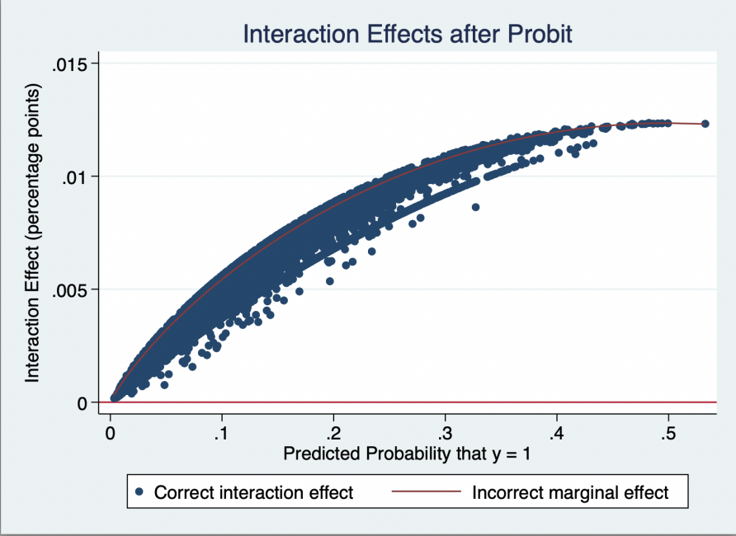

Figure A3.2: Z-statistics of interaction effects after Probit
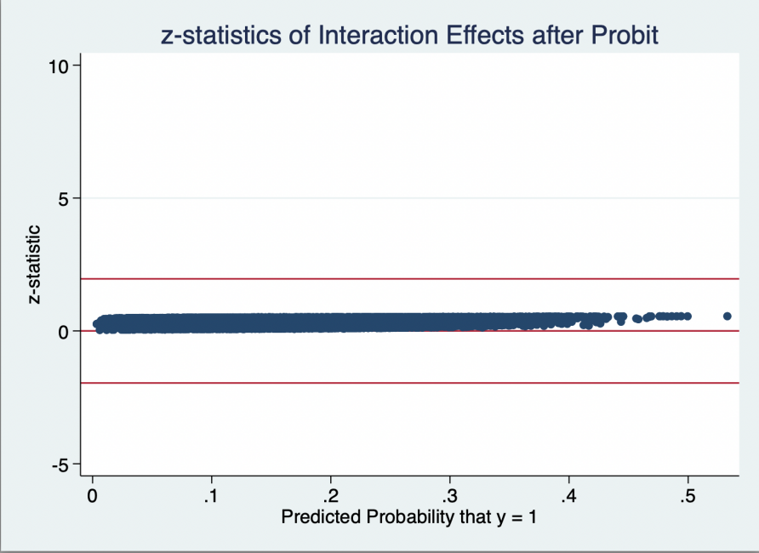

We follow the same method for the NtF product innovation estimation. Table A3.2 reports the corrected mean interaction effects, standard errors and t-statistics for the estimated partial effects. The results confirm that the average interaction effect is negative (first row). Similarly, the plot of all interaction effects on the predicted probability of external knowledge acquisition indicates (Figure A3.3) that the corrected marginal effects are negative for all individuals. However, their statistical significance is present only in rare cases as shown in Figure A3.4 producing negligible evidence in support of hypothesis 6.

Table A3.2: Descriptive statistics of interaction effects, standard errors, and Z-statistics
Variable | Obs | Mean | Std. Dev. | Min | Max
_probit_ie | 20,995 | -.0108714 | .0031777 | -.0150935 | -.0012754
_probit_se | 20,995 | .0155537 | .0095491 | .0008197 | ..0892343
_probit_z | 20,995 | -.8214748 | .2234647 | -3.233015 | -.0740238

Figure A3.3: Interaction effects after Probit
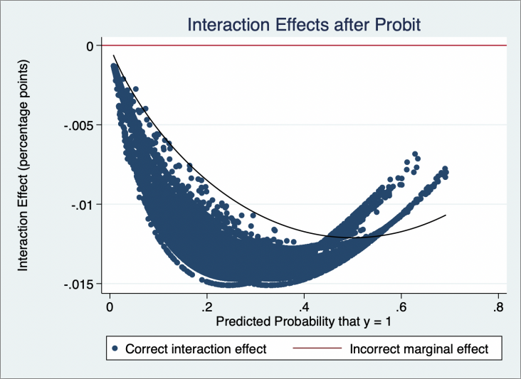

Figure A3.4: Z-statistics of interaction effects after Probit
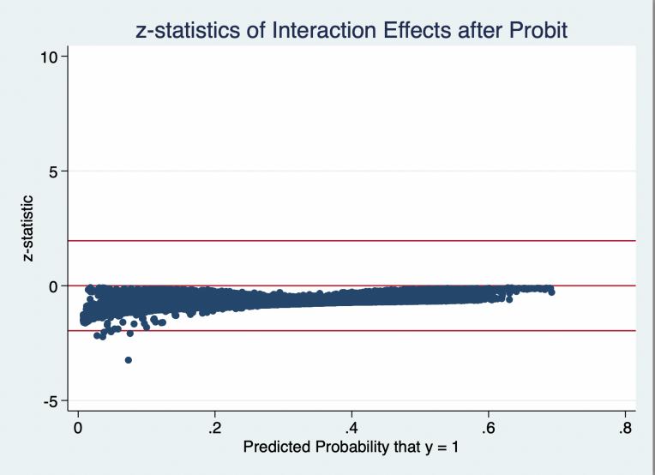

APPENDIX 4: Interaction effect in Model 2
This study also sets up other interaction items (interaction2=competition *family_management_dummy2,interaction3=competition*family_management_dummy3, interaction4= competition *family_management_dummy4). Hence, The impact of external stimuli on innovation activities under varying degrees of family management is further analyzed. As mentioned in the main text, when the proportion of family members in the management team is 50%-74%, competition promotes a greater likelihood of family firms to engage in internal RD, external rd, external knowledge. when the proportion of family members in the management team is 75%-100%, competition promotes a greater likelihood of family firms to when the proportion of family members in the management team is 75%-100%, competition promotes a greater likelihood of family firms to engage in internal RD, external RD, new to firm product innovation and process innovation. Therefore, the marginal effects of interaction terms are further estimated, as shown below. For the interaction terms in Model2, there is a significant coefficient appears for each model. Moreover, the plot of Z-statistics chart shows that nearly all interaction effects are statistically significant in each model.

Interaction effect in probit Model (New to firm product innovation).

Table A4.1 Descriptive statistics of interaction effects, standard errors, and Z-statistics
Variable | Obs | Mean | Std. Dev. | Min | Max
_probit_ie | 9,633 | .0167507 | .0051216 | -.0009023 | .0237144
_probit_se | 9,633 | .0079518 | .00274 | .0006514 | .0117684
_probit_z | 9,633 | 2.143124 | .1674254 | -.4706695 | 2.747003

Figure A4.1: Interaction effects after Probit
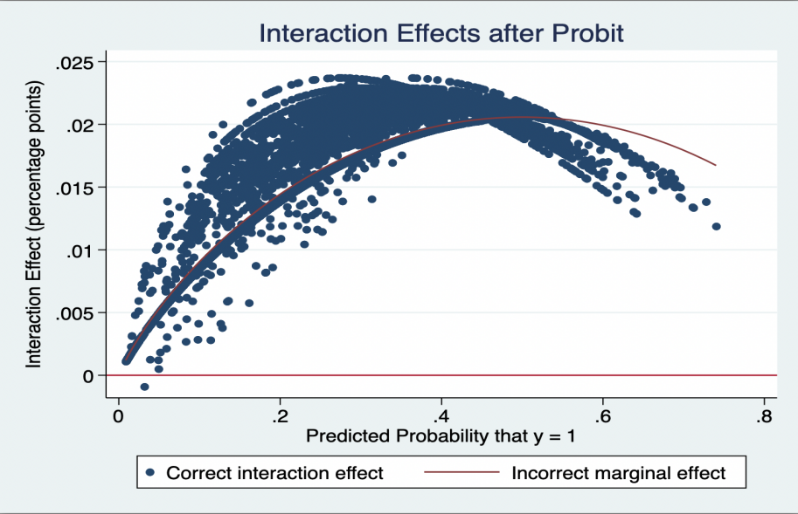
Figure A4.2: Z-statistics of interaction effects after Probit
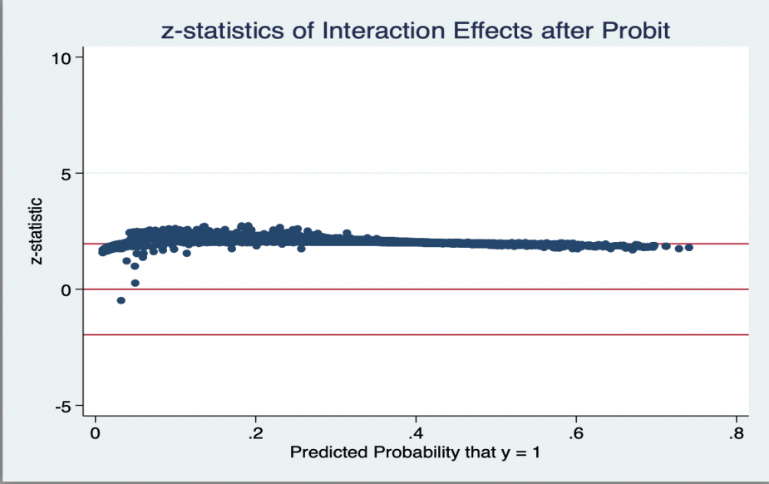
Interaction effect in probit Model (Process innovation)
Table A4.2 Descriptive statistics of interaction effects, standard errors, and Z-statistics
Variable | Obs | Mean | Std. Dev. | Min | Max
_probit_ie | 9,633 | .0213387 | .0091695 | .0001886 | .0366699
_probit_se | 9,633 | .0068678 | .0031222 | .0002207 | .0117684
_probit_z | 9,633 | 3.115931 | .435892 | .8547512 | 2.747003

Figure A4.3: Interaction effects after Probit
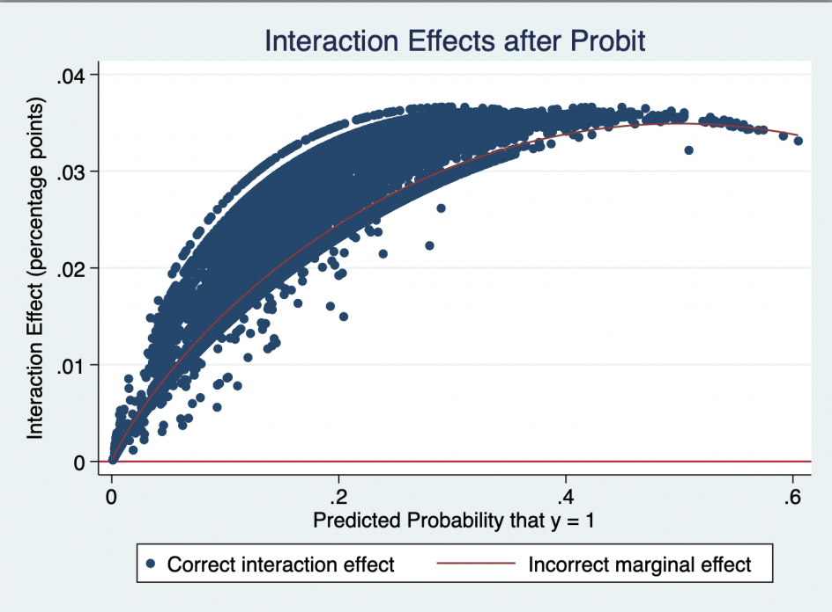

Figure A4.4: Z-statistics of interaction effects after Probit
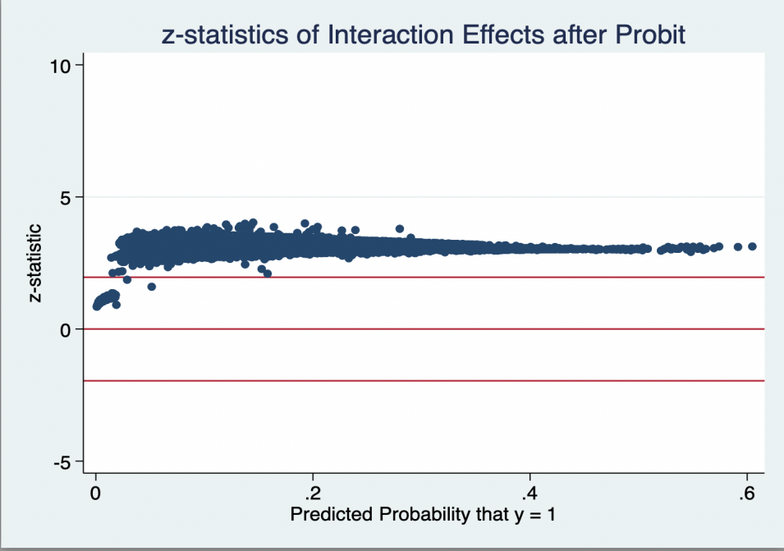

Interaction effect in probit Model (Internal R&D spending )
competition*family management dummy(50%-74%)
Table A4.3 Descriptive statistics of interaction effects, standard errors, and Z-statistics
Variable | Obs | Mean | Std. Dev. | Min | Max
_probit_ie | 9,633 | .0239716 | .0115044 | .0012537 | .0423923
_probit_se | 9,633 | .0087463 | .0039362 | .0007536 | .014906
_probit_z | 9,633 | 2.68539 | .270849 | .5575991 | 3.281423

Figure A4.5: Interaction effects after Probit
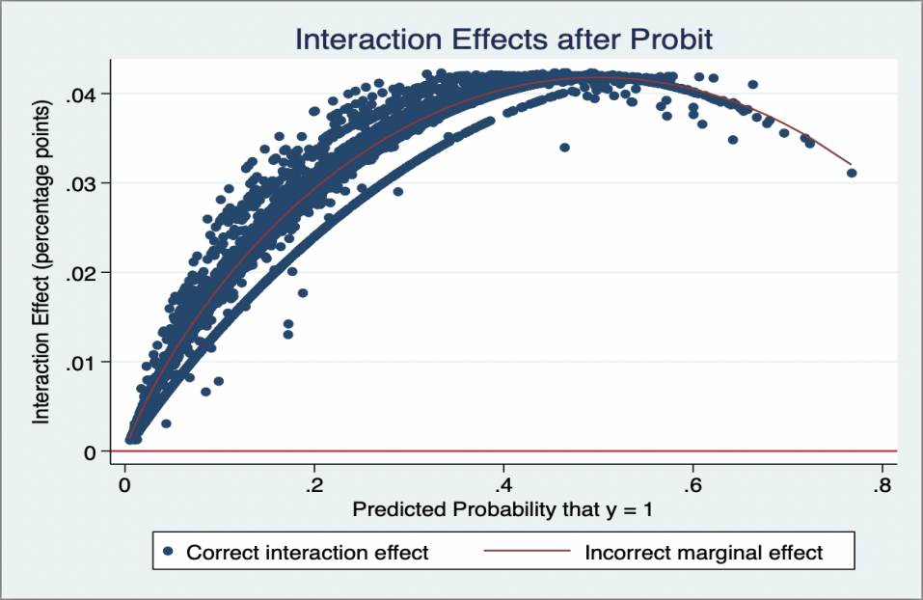
Figure A4.5: Z-statistics of interaction effects after Probit
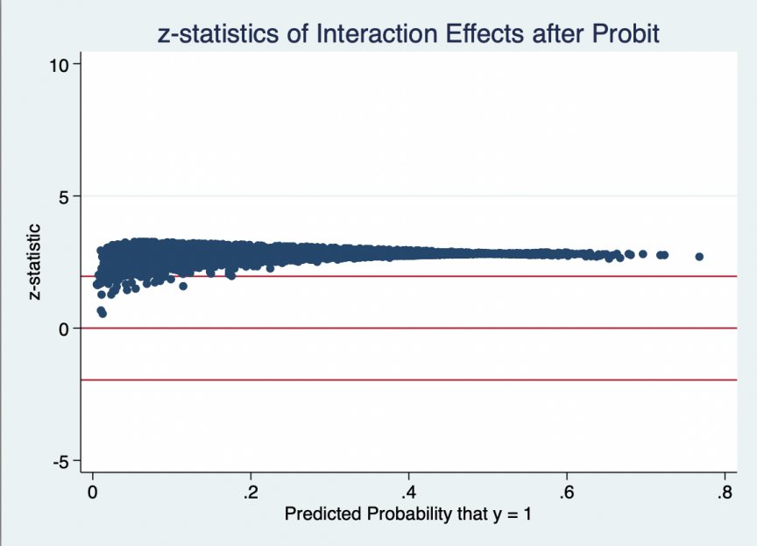

competition*family management dummy(75%-100%)
Table A4.4 Descriptive statistics of interaction effects, standard errors, and Z-statistics
Variable | Obs | Mean | Std. Dev. | Min | Max
_probit_ie | 9,633 | .0177768 | .00841 | .0000337 | .0308674
_probit_se | 9,633 | .0068693 | .0033291 | .0003484 | .0122023
_probit_z | 9,633 | 2.608373 | .193162 | .0380984 | 3.211761

Figure A4.6: Interaction effects after Probit
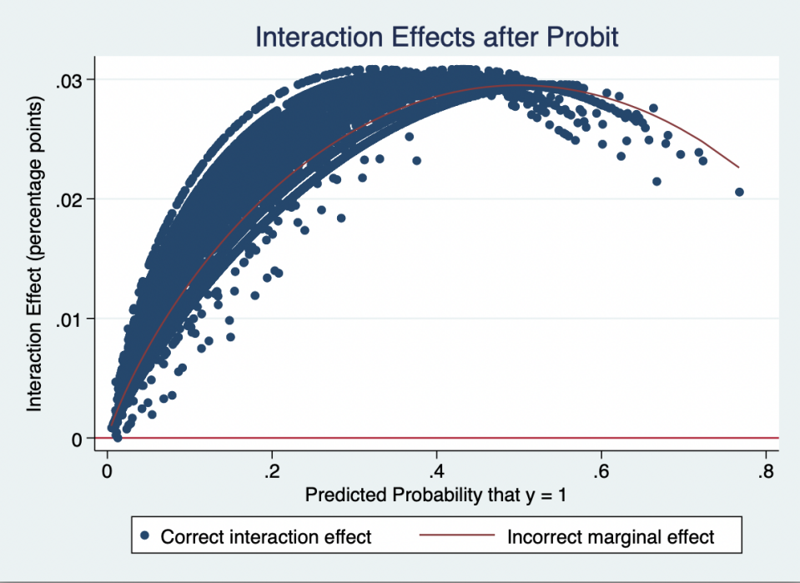

Figure A4.7: Z-statistics of interaction effects after Probit
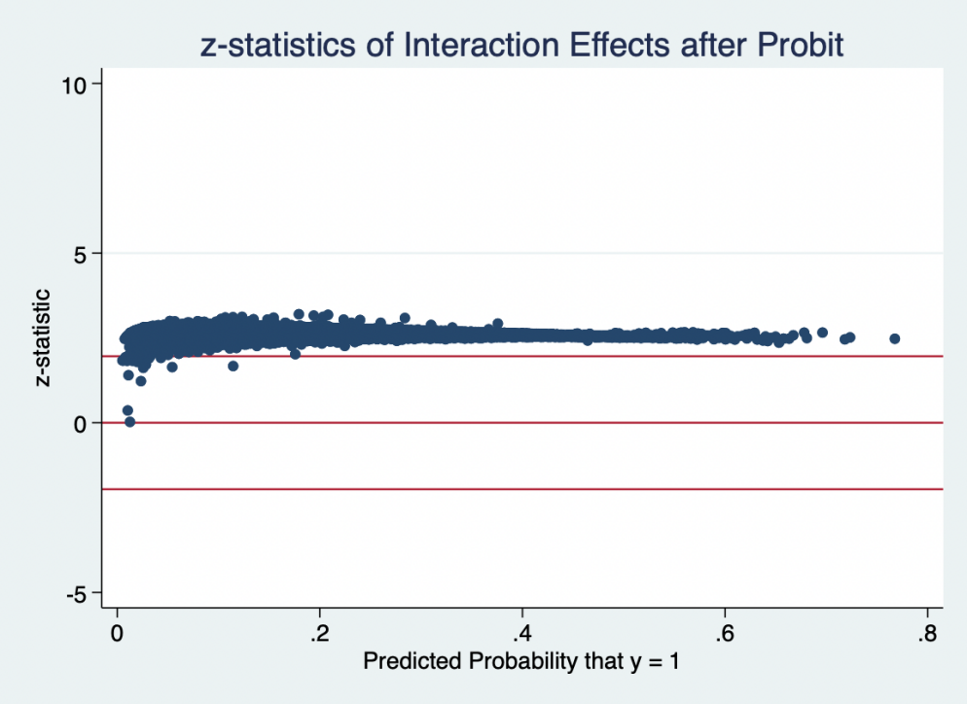

Interaction effect in probit Model (external R&D)
competition*family management dummy(50%-74%)
Table A4.5 Descriptive statistics of interaction effects, standard errors, and Z-statistics
Variable | Obs | Mean | Std. Dev. | Min | Max
_probit_ie | 9,633 | .0182588 | .0117367 | .0007713 | .0522382
_probit_se | 9,633 | .0069592 | .004032 | .0005659 | .0179812
_probit_z | 9,633 | 2.535388 | .4012689 | .6360414 | 3.343109

Figure A4.8: Interaction effects after Probit
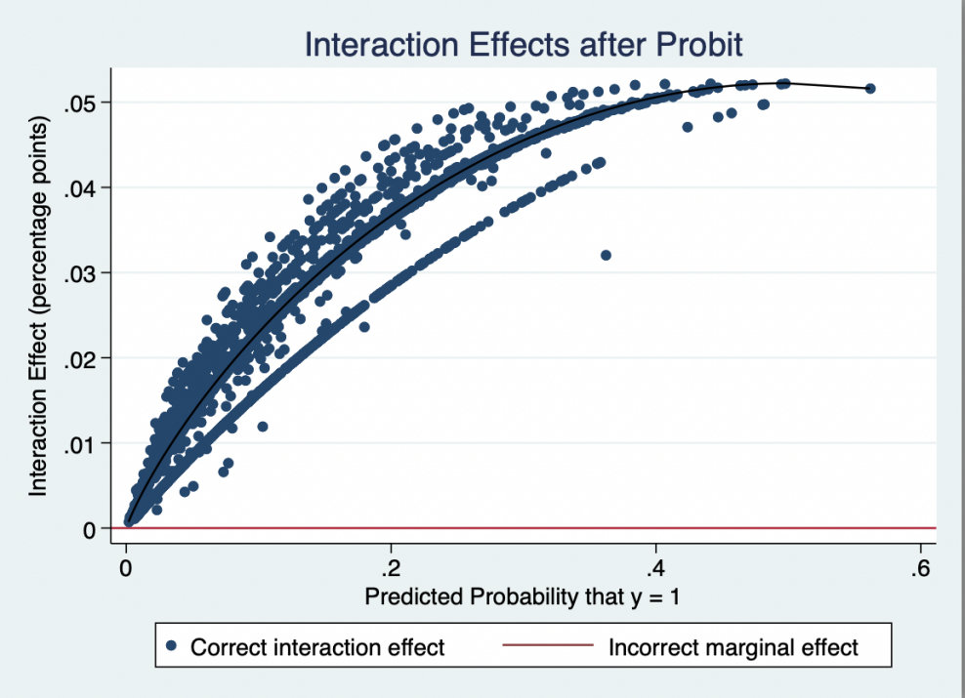

Figure A4.9: Z-statistics of interaction effects after Probit
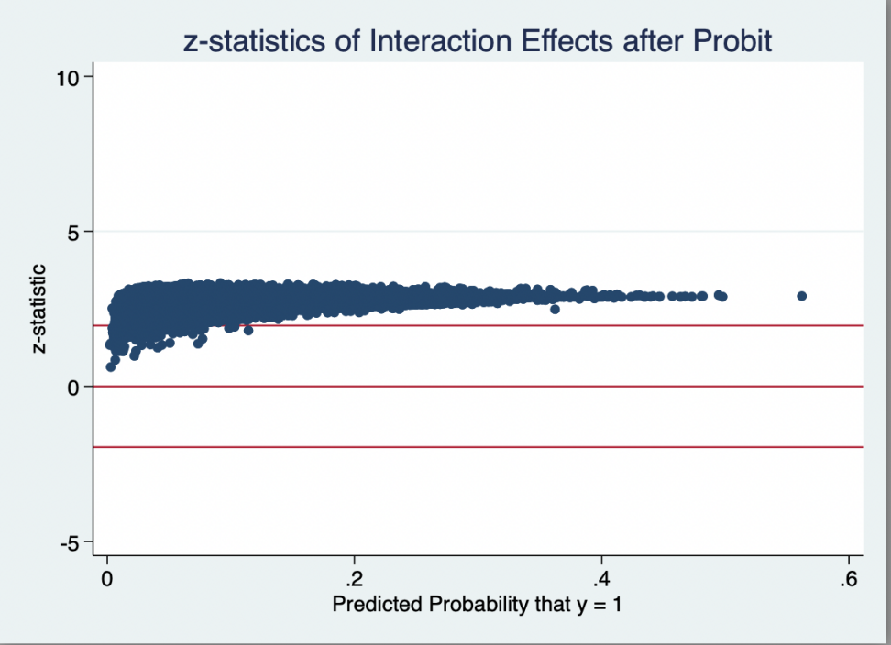

competition*family management dummy(50%-74%)
Table A4.6 Descriptive statistics of interaction effects, standard errors, and Z-statistics
Variable | Obs | Mean | Std. Dev. | Min | Max
_probit_ie | 9,633 | .0103546 | .0074011 | -.0003693 | .0313545
_probit_se | 9,633 | .0051093 | .0035437 | .0002351 | .0147233
_probit_z | 9,633 | 1.988651 | .1873794 | -.9702636 | 2.440699

Figure A4.10: Interaction effects after Probit
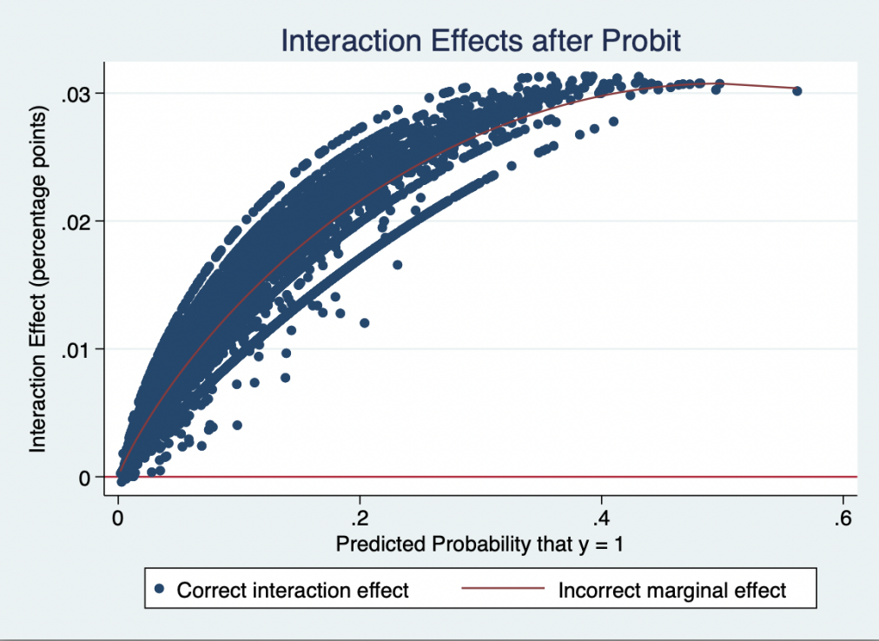

Figure A4.11: Z-statistics of interaction effects after Probit
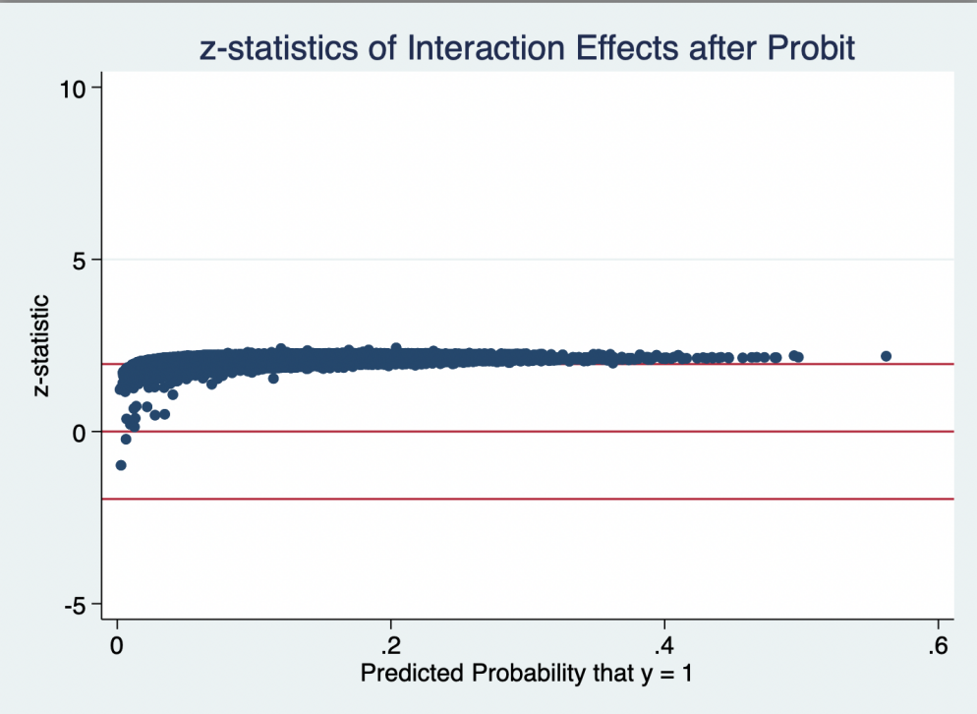

Interaction effect in probit Model (external knowledge)
Table A4.7 Descriptive statistics of interaction effects, standard errors, and Z-statistics
Variable | Obs | Mean | Std. Dev. | Min | Max
_probit_ie | 9,633 | .0159697 | .0069974 | .0012204 | .0340732
_probit_se | 9,633 | .0078132 | .0033008 | .000847 | .0161718
_probit_z | 9,633 | 2.027095 | .1706176 | 1.364043 | 2.416608

Figure A4.12: Interaction effects after Probit
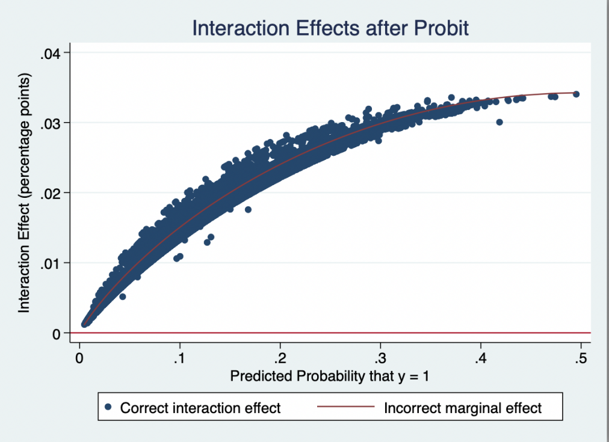

Figure A4.13: Z-statistics of interaction effects after Probit
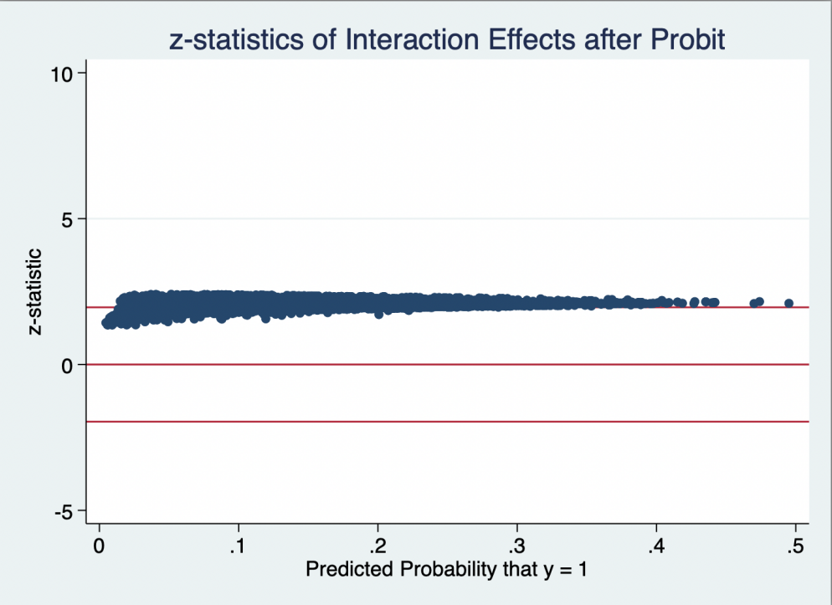

APPENDIX 5: Robust check for equation 1 and equation 2
A5.1: Robust check for equation 1

As a robustness check, we applied a multivariate probit model to examine for potential dependence across the error terms of equation one as unobserved firm characteristics may influence the adoption of each innovation decision simultaneously. This study uses the Mvprobit framework developed based on the Geweke-Hajivassiliour-Keane (GHK) algorithm (Cappellari and Jenkins, 2003). The results of these analyses are included in Table A5.1. The results suggest that controlling for this dependence matters as the Prob>chi = 0.000. However, the results are very similar to the results presented in the main paper, suggesting that controlling for unobserved firm characteristics in this case produces negligible differences in the results.

Table A5.1 MVprobit estimator on innovation in family firms
 | Internal R&D | External R&D | External knowledge | New to Firm Product (NtF) | Process innovation | New to market Product (NtM)
Family firm | 0.05  (0.04) | 0.08**  (0.04) | 0.09**  (0.04) | 0.15***  (0.04) | 0.12**  (0.05) | 0.16***  (0.05)
National market | 0.41***  (0.04) | 0.32***  (0.04) | 0.27***  (0.04) | 0.25***  (0.04) | 0.24***  (0.03) | 0.25***  (0.04)
International market | 0.47***  (0.08) | 0.43***  (0.08) | 0.40***  (0.09) | 0.17**  (0.07) | 0.29***  (0.07) | 0.16**  (0.08)
Level of competition | -0.06***  (0.02) | -0.05***  (0.01) | -0.06***  (0.01) | -0.09***  (0.02) | -0.08***  (0.02) | -0.09***  (0.02)
Internationalization | 0.00***  (0.00) | 0.00  (0.00) | 0.00  (0.00) | 0.00***  (0.00) | 0.00**  (0.00) | 0.00**  (0.00)
Location in capital or city with pop > 1 m | 0.01  (0.35) | -0.33  (0.35) | 0.16  (0.29) | 0.58***  (0.17) | 0.64***  (0.15) | 0.49***  (0.17)
Location in city with pop. 250 k–1 m | -0.06  (0.35) | -0.31  (0.35) | 0.09  (0.29) | 0.39**  (0.16) | 0.51***  (0.14) | 0.37**  (0.16)
Location in city with pop. 50–250 k | -0.08  (0.35) | -0.34  (0.36) | 0.21  (0.29) | 0.45***  (0.17) | 0.54***  (0.15) | 0.41**  (0.17)
Location in city with Pop < 50 k | 0.17  (0.35) | -0.13  (0.35) | 0.33  (0.30) | 0.58***  (0.16) | 0.49***  (0.15) | 0.52***  (0.16)
Foreign involvement(foreign) | -0.00  (0.00) | -0.00  (0.00) | 0.00**  (0.00) | 0.00*  (0.00) | 0.00  (0.00) | 0.00*  (0.00)
Firm size | 0.17***  (0.01) | 0.21***  (0.01) | 0.15***  (0.01) | 0.08***  (0.01) | 0.10***  (0.01) | 0.08***  (0.01)
Firm age | -0.02  (0.03) | -0.06**  (0.02) | -0.06**  (0.03) | -0.01  (0.02) | -0.03  (0.03) | 0.01  (0.02)
Manufacture | 0.47***  (0.10) | 0.23**  (0.11) | 0.22*  (0.13) | 0.64***  (0.16) | 0.62***  (0.17) | 0.50***  (0.15)
Service | 0.42***  (0.10) | 0.26**  (0.11) | 0.47***  (0.13) | 0.56***  (0.17) | 0.55***  (0.17) | 0.39**  (0.16)
Retail | 0.27***  (0.10) | 0.22*  (0.12) | 0.37***  (0.14) | 0.56***  (0.17) | 0.56***  (0.17) | 0.42***  (0.16)
Emerging country | -0.60***  (0.10) | -0.45***  (0.07) | -0.52***  (0.10) | -0.73***  (0.09) | -0.67***  (0.11) | -0.66***  (0.09)
Advanced country | -0.19**  (0.09) | -0.06  (0.08) | -0.03  (0.09) | -0.10  (0.11) | -0.04  (0.12) | -0.18**  (0.09)
Competition*family firms | -0.00  (0.02) | -0.00  (0.02) | 0.03*  (0.02) | -0.03  (0.02) | 0.01  (0.02) | -0.01  (0.02)
_cons | -2.03***  (0.36) | -2.12***  (0.38) | -2.19***  (0.30) | -2.09***  (0.22) | -2.58***  (0.22) | -2.28***  (0.22)
N=20995
chi2(15) = 17464.4
Prob > chi2 = 0.0000
Notes:
(1) The model controls for location size effects and country dummies but they are not reported.
(2) Marginal effects are reported in the table. ***significant at 1%; **significant at 5%; *significant at 10%.
(3) Reference category is construction

A5.2: Robust check for equation 2

Following a similar procedure as to that outlined in Appendix A5.1, to obtain robust results and ensure the validity of the previous evidence on the impact of family management on innovation, an MVprobit model was also applied to equation (2) of the paper. The results of these analyses are listed in Table A5.2. Again the results suggest that controlling for unobserved factors that may impact the innovation decisions of family firms is necessary condition where Prob>chi2 =0 .000. However, the results are negligible when compared to the probit results in Table 3 of the paper.
Table A5.2 MVprobit estimator for family management on innovation
 | Internal R&D | External R&D | External knowledge | New to Firm Product (NtF) | Process innovation | New to market Product (NtM)
Family management dummy(25%-40%) | 0.06  (0.22) | -0.03  (0.26) | -0.38  (0.25) | -0.20  (0.18) | -0.14  (0.20) | -0.11  (0.20)
Family management dummy(50%-74%) | -0.29*  (0.16) | -0.37**  (0.18) | -0.28*  (0.16) | -0.24*  (0.13) | -0.10  (0.13) | -0.15  (0.13)
Family management dummy(75%-100%) | -0.26**  (0.11) | -0.27**  (0.13) | -0.09  (0.13) | -0.18*  (0.11) | -0.35***  (0.09) | -0.02  (0.10)
National market | 0.45***  (0.04) | 0.36***  (0.05) | 0.27***  (0.05) | 0.21***  (0.05) | 0.22***  (0.04) | 0.19***  (0.05)
International market | 0.45***  (0.11) | 0.53***  (0.11) | 0.47***  (0.11) | 0.15  (0.09) | 0.43***  (0.10) | 0.14  (0.10)
Level of competition | -0.13***  (0.04) | -0.14***  (0.04) | -0.07**  (0.03) | -0.16***  (0.03) | -0.14***  (0.03) | -0.12***  (0.03)
Internationalization | 0.00***  (0.00) | 0.00  (0.00) | -0.00  (0.00) | 0.00**  (0.00) | -0.00  (0.00) | 0.00  (0.00)
Location in capital or city with pop > 1 m | -0.27  (0.28) | -0.56*  (0.31) | -0.12  (0.28) | 0.30*  (0.18) | 0.41***  (0.12) | 0.25  (0.22)
Location in city with pop. 250 k–1 m | -0.27  (0.29) | -0.49  (0.32) | -0.18  (0.27) | 0.16  (0.16) | 0.31***  (0.12) | 0.20  (0.21)
Location in city with pop. 50–250 k | -0.32  (0.29) | -0.49  (0.33) | -0.03  (0.28) | 0.20  (0.17) | 0.34***  (0.13) | 0.22  (0.22)
Location in city with Pop < 50 k | -0.08  (0.29) | -0.31  (0.32) | 0.07  (0.28) | 0.43***  (0.16) | 0.28**  (0.13) | 0.40**  (0.20)
Foreign involvement(foreign) | -0.00  (0.00) | -0.00  (0.00) | 0.00  (0.00) | 0.00  (0.00) | 0.00  (0.00) | 0.00  (0.00)
Firm size | 0.17***  (0.01) | 0.21***  (0.02) | 0.14***  (0.02) | 0.08***  (0.02) | 0.10***  (0.02) | 0.08***  (0.02)
Firm age | 0.01  (0.03) | -0.03  (0.03) | -0.00  (0.03) | -0.03  (0.03) | -0.03  (0.03) | 0.00  (0.03)
Manufacture | 0.22**  (0.11) | 0.09  (0.20) | 0.26  (0.22) | 0.74***  (0.17) | 1.06**  (0.42) | 0.79***  (0.15)
Service | 0.15  (0.12) | 0.12  (0.20) | 0.51**  (0.23) | 0.66***  (0.17) | 0.97**  (0.42) | 0.69***  (0.15)
Retail | 0.00  (0.12) | 0.10  (0.21) | 0.39*  (0.23) | 0.65***  (0.17) | 0.92**  (0.42) | 0.67***  (0.15)
Emerging country | -0.63***  (0.10) | -0.42***  (0.09) | -0.44***  (0.11) | -0.63***  (0.11) | -0.53***  (0.12) | -0.59***  (0.10)
Advanced country | -0.19**  (0.09) | -0.05  (0.09) | 0.03  (0.09) | -0.04  (0.11) | -0.04  (0.11) | -0.13  (0.09)
Competition*family management dummy(25%-40%) | 0.02  (0.06) | 0.02  (0.08) | 0.12  (0.07) | 0.07  (0.06) | 0.07  (0.06) | 0.07  (0.06)
Competition * family management dummy(50%-74%) | 0.10**  (0.05) | 0.14***  (0.05) | 0.09*  (0.05) | 0.04  (0.04) | -0.01  (0.04) | 0.03  (0.04)
Competition*family management dummy(75%-100%) | 0.07*  (0.04) | 0.09**  (0.04) | 0.03  (0.04) | 0.04  (0.04) | 0.09***  (0.03) | 0.00  (0.03)
_cons | -1.20***  (0.35) | -1.41***  (0.42) | -1.83***  (0.35) | -1.20***  (0.27) | -2.18***  (0.45) | -1.74***  (0.29)
N= 9633
chi2(15) = 8384.62
Prob > chi2 = 0.0000
Notes:
(1) The model controls for location size effects and country dummies but they are not reported.
(2) ***significant at 1%; **significant at 5%; *significant at 10%.
(3) Reference category is construction
(4) Reference category is family management dummy (0-24%)

APPENDIX 6: Country list and number of observation by country used in analysis
Table A6.1: Country list and Observations
Developed Country | Emerging Country | Developing Country
Croatia (404) | Egypt (3075) | Albania (377)
Cyprus (240) | Hungary(805) | Armenia (546)
Czech Republic(502) | Poland (1369) | Azerbaijan (225)
Estonia (360) | Russia (1323) | Bosnia (362)
Italy (760) | Turkey(1663) | Bulgaria (772)
Latvia(359) |  | Georgia (581)
Lithuania(358) |  | Jordan (601)
Portugal(1062) |  | Kazakhstan(1446)
Slovakia(429) |  | Kosovo(271)
Slovenia (409) |  | Kyrgyz Republic (360)
 |  | Lebanon(532)
 |  | Moldova(360)
 |  | Mongolia(360)
 |  | Montenegro (150)
 |  | Morocco(667)
 |  | North Macedonia(360)
 |  | Romania(814)
 |  | Serbia(361)
 |  | Tajikistan(352)
 |  | Tunisia(615)
 |  | Turkish Cypriot Community (120)
 |  | Ukraine (1337)
 |  | Uzbekinstan (1239)

References
Cappellari, L. and Jenkins, S.P. (2003), “Multivariate Probit Regression using Simulated Maximum Likelihood”, The Stata Journal, SAGE Publications, Vol. 3 No. 3, pp. 278–294, doi: 10.1177%2F1536867X0300300305.

Norton, E.C., Wang, H. and Ai, C. (2004), “Computing Interaction Effects and Standard Errors in Logit and Probit Models”, The Stata Journal, SAGE Publications, Vol. 4 No. 2, pp. 154–167, doi: 10.1177%2F1536867X0400400206.

