Appendix (supplementary materials for online publication only)

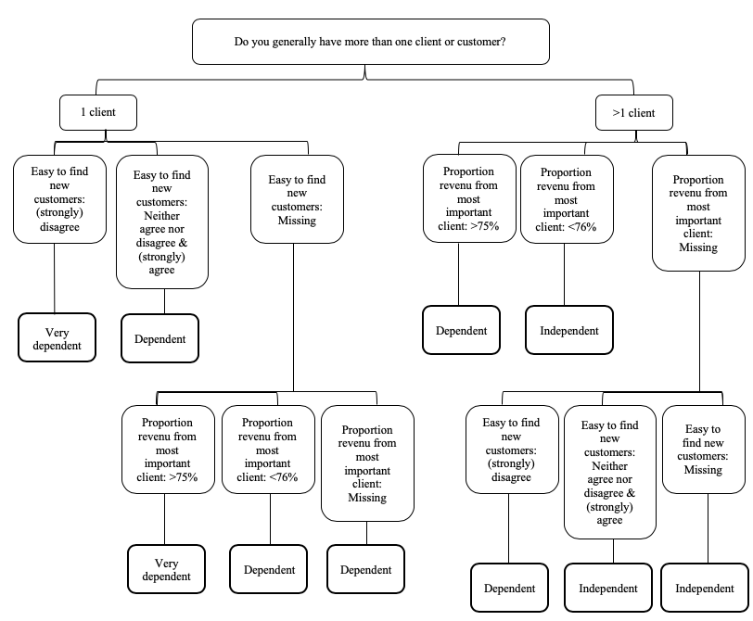
Figure A.1. Construction of the economically dependent self-employment indicator, existing of three categories (very dependent, dependent, independent) (De Moortel & Vanroelen, 2017). For the purpose of this paper, the indicator was collapsed into ‘Dependent’ (very dependent & dependent) and ‘Independent’ (independent).

Table A.1. Sample-based variance covariance matrix
 | 1 | 2 | 3 | 4 | 5 | 6 | 7 | 8 | 9 | 10 | 11 | 12 | 13 | 14 | 15 | 16 | 17 | 18
1. Vigour (high) | .052
2. Dedication (high) | .036 | .071
3. Absorption (high) | .025 | .029 | .053
4. Able to choose order of tasks | .005 | .009 | .007 | .115
5. Able to choose methods of work | .006 | .010 | .007 | .072 | .112
6. Able to choose speed of work | .005 | .007 | .007 | .063 | .066 | .100
7. Job involves meeting standards | .012 | .017 | .013 | .010 | .008 | .009 | .226
8. Job involves assessing yourself | .013 | .017 | .014 | .017 | .017 | .016 | .075 | .164
9. Job involves problem solving | .010 | .013 | .013 | .019 | .024 | .020 | .045 | .055 | .121
10. Job involves complex tasks | .012 | .024 | .017 | .014 | .015 | .017 | .065 | .045 | .046 | .249
11. Job involves learning things | .025 | .039 | .027 | .018 | .019 | .018 | .062 | .053 | .048 | .105 | .237
12. Recognition (high) | .027 | .034 | .021 | .011 | .009 | .007 | .015 | .016 | .010 | .016 | .027 | .092
13. Appropriate pay (high) | .024 | .030 | .016 | .002 | .003 | .002 | .011 | .008 | .004 | .013 | .018 | .053 | .114
14. Dependent self-employment | -.013 | -.020 | -.007 | -.015 | -.018 | -.017 | -.033 | -.035 | -.024 | -.033 | -.041 | -.015 | -.013 | .241
15. Necessity self-employment | -.021 | -.034 | -.012 | -.006 | -.006 | -.004 | -.015 | -.015 | -.012 | -.028 | -.041 | -.033 | -.038 | .031 | .220
16. Male | .003 | -.002 | .001 | -.003 | -.001 | -.003 | .021 | .007 | .015 | .025 | .010 | -.003 | .002 | -.007 | -.018 | .242
17. Age | -.285 | -.138 | .048 | .166 | .065 | -.036 | -.706 | -.265 | -.102 | -.516 | -1.042 | -.186 | -.233 | .729 | -.217 | .157 | 189.44
18. High education | .012 | .023 | .008 | .005 | .008 | .004 | .013 | .016 | .012 | .039 | .050 | .020 | .019 | -.027 | -.033 | -.015 | -.497 | .180
Notes; Vigour = “Full of energy at work (0-1)”; Dedication = “Enthusiastic about job (0-1)”; Absorption = “Time flies when working (0-1)”; Order tasks = “Able to choose order of tasks”; Methods of work = “Able to choose methods of work”; Speed of work = “Able to choose speed of work”; Recognition = “Receiving the recognition, they deserve for work (0-1)”; Appropriate pay = “Considering efforts and achievements, getting paid appropriately (0-1)”; Meeting standards = “Job involves meeting precise quality standards”; Assessing yourself = “Job involves assessing yourself the quality of your own work”; Problem solving = “Job involves solving unforeseen problems”; Complex tasks=” Job involves complex tasks”; Learning things = “Job involves learning new things”; Necessity = “Reasons for becoming self-employed is because of no other alternatives for work”; Dependent = “Economically dependent”

Table A.2. Sensitivity analyses: Unstandardized and standardized regression estimates of a structural model of work engagement, conditions in self-employment and intrinsic job resources – Estimation method: Full Information Maximum Likelihood, weighted with Eurofound’s design weights, no bootstrapped standard errors.
 | Skill discretion |  | Rewards |  | Autonomy |  | Work engagement
 | B  (95% CI) | β  (95% CI) | B  (95% CI) | β  (95% CI) | B  (95% CI) | β  (95% CI) | B  (95% CI) | β  (95% CI)
Direct effects
Dependent | -.163***  (-.194; -.132) | -.331***  (-.387; -.276) | -.045***  (-.072; -.018) | -.089***  (-.144; -.034) | -.099***  (-.130; -.068) | -.169***  (-.221; -.118) | -.001  (-.020; .017) | -.004  (-.055; .047)
Necessity | -.062***  (-.093; -.032) | -.119***  (-.177; -.061) | -.141***  (-.172; -.109) | -.260***  (-.322; -.198) | .017  (-.013; .046) | .027  (-.020; .074) | -.041***  (-.062; -.020) | -.105***  (-.160; -.049)
Skill discretion |  |  |  |  |  |  | .158***  (.098; .218) | .213***  (.130; .296)
Rewards |  |  |  |  |  |  | .411***  (.344; .478) | .570***  (.463; .676)
Autonomy |  |  |  |  |  |  | -.002  (-.036; .031) | -.003  (-.057; .050)
Indirect effects
Total indirect effect dependency |  |  |  |  |  |  | -.044***  (-.059; -.029) | -.121***  (-.165; -.076)
Skill discretion |  |  |  |  |  |  | -.026***  (-.036; -.016) | -.071***  (-.100; -.041)
Rewards |  |  |  |  |  |  | -.019***  (-.030; -.007) | -.051***  (-.083; -.018)
Autonomy |  |  |  |  |  |  | .001  (-.003; .004) | .001  (-.009; .010)
Total indirect effect necessity |  |  |  |  |  |  | -.068***  (-.085; -.050) | -.174***  (-.224; -.124)
Skill discretion |  |  |  |  |  |  | -.010***  (-.016; -.004) | -.025***  (-.042; -.009)
Rewards |  |  |  |  |  |  | -.058***  (-.075; -.041) | -.148***  (-.195; -.102)
Autonomy |  |  |  |  |  |  | .001  (-.001; .001) | .001  (-.002; .001)
Total effects
Dependent |  |  |  |  |  |  | -.046***  (-.063; -.028) | -.125***  (-.178; -.071)
Necessity |  |  |  |  |  |  | -.108***  (-.131; -.086) | -.278***  (-.345; -.212)
6th EWCS (2015); Weighted with Eurofound’s design weights (w5); p-values: * p<0.05; ** p<0.01; *** p<0.001; N observations: 5.463; Fit statistics: $χ^{2}$/ (d.f.) = 453.54 (105), CFI = .95, TLI = .93, RMSEA = .04. Unst. = Unstandardized estimates; St. = Standardized estimates; (CI) = Confidence Interval. The model allowed for correlations between all mediating factors (e.g., rewards, skill discretion, and autonomy) as well as between economic dependency and necessity. There are also correlations between socio-demographic variables (gender, age, and education) and the variables in the model) (results not shown).

