Supplementary Material

Supplementary table I.
COPSOQ II work demands subscales and items (Demands at work)
Subscale | Item ID | Item
Quantitative demands | QD1 | Is your workload unevenly distributed so it piles up?
Quantitative demands | QD2 | How often do you not have time to complete all your work tasks?
Quantitative demands | QD3 | Do you get behind with your work?
Quantitative demands | QD4 | Do you have enough time for your work tasks?
Work pace | WP1 | Do you have to work very fast?
Work pace | WP2 | Do you work at a high pace throughout the day?
Work pace | WP3 | Is it necessary to keep working at a high pace?
Cognitive demands | CD1 | Do you have to keep your eyes on lots of things while you work?
Cognitive demands | CD2 | Does your work require that you remember a lot of things?
Cognitive demands | CD3 | Does your work demand that you are good at coming up with new ideas?
Cognitive demands | CD4 | Does your work require you to make difficult decisions?
Emotional demands | ED1 | Does your work put you in emotionally disturbing situations?
Emotional demands | ED2 | Do you have to relate to other people’s personal problems as part of your work?
Emotional demands | ED3 | Is your work emotionally demanding?
Emotional demands | ED4 | Do you get emotionally involved in your work?
Demands for hiding emotions | HE1 | Are you required to treat everyone equally, even if you do not feel like it?
Demands for hiding emotions | HE2 | Does your work require that you hide your feelings?
Demands for hiding emotions | HE3 | Are you required to be kind and open towards everyone regardless of how they behave towards you?
Note. Items adapted from COPSOQ II (Pejtersen, Kristensen, Borg, & Bjorner, 2010). Response options: 5 = Always, 4 = Often, 3 = Sometimes, 2 = Seldom, 1 = Never/Hardly ever. Subscale scores were computed as the mean of the items within each subscale; where applicable, items were reverse-coded so that higher scores indicate higher levels of the construct.
Supplementary table II.
COPSOQ II health and well-being subscales and items (Burnout, Stress, and Somatic stress)
Subscale | Item ID | Item
Burnout | BO1 | How often have you felt worn out?
Burnout | BO2 | How often have you been physically exhausted?
Burnout | BO3 | How often have you been emotionally exhausted?
Burnout | BO4 | How often have you felt tired?
Stress | ST1 | How often have you had problems relaxing?
Stress | ST2 | How often have you been irritable?
Stress | ST3 | How often have you been tense?
Stress | ST4 | How often have you been stressed?
Somatic stress | SO1 | How often have you had stomach ache?
Somatic stress | SO2 | How often have you had a headache?
Somatic stress | SO3 | How often have you had palpitations?
Somatic stress | SO4 | How often have you had tension in various muscles?
Note. Items reflect COPSOQ II health and well-being content. Instruction: “During the past month:”. Response options: 1 = All the time, 2 = Mostly, 3 = Some of the time, 4 = Rarely, 5 = Never. Subscale scores were computed as the mean of the items within each subscale; where applicable, items were reverse-coded so that higher scores indicate higher levels of the construct.

Supplementary table III.
Brief Music in Mood Regulation scale (B-MMR) strategies and items
Strategy | Items
Entertainment (Happy mood maintenance) | 1. I usually put background music on to make the atmosphere more pleasant.  2. When I’m busy around the house and no one else is around, I like to have some music in the background.  3. I listen to music to make cleaning and doing other housework more pleasant.
Revival (Relaxation and new energy) | 1. I listen to music to perk up after a rough day.  2. When I’m exhausted, I listen to music to perk up.  3. When I’m tired out, I rest by listening to music.
Strong sensation (Intense emotion induction) | 1. Music has offered me magnificent experiences.  2. I want to feel the music in my whole body.  3. I feel fantastic putting my soul fully into the music.
Diversion (Distraction from worries and stress) | 1. For me, music is a way to forget about my worries.  2. When stressful thoughts keep going round and round in my head, I start to listen to music to get them off my mind.  3. When I feel bad, I try to get myself in a better mood by engaging in some nice, music-related activity.
Discharge (Release and venting of negative emotion) | 1. When I’m really angry, I feel like listening to some angry music.  2. When everything feels bad, it helps me to listen to music that expresses my bad feelings.  3. When I’m angry with someone, I listen to music that expresses my anger.
Mental work (Contemplation and reappraisal of emotional experience) | 1. Music helps me to understand different feelings in myself.  2. Music has helped me to work through hard experiences.  3. When I’m distressed by something, music helps me to clarify my feelings.
Solace (Emotional validation and support when feeling down) | 1. When everything feels bad, music understands and comforts me.  2. When I’m feeling sad, listening to music comforts me.  3. I listen to music to find solace when worries overwhelm me.
Note. The Brief Music in Mood Regulation scale (Saarikallio, 2012) includes three items for each regulatory strategy. Responses were recorded on a 5-point Likert scale ranging from “Strongly disagree” to “Strongly agree”. Strategy scores were computed as the mean of the three items within each strategy.

Supplementary table IV.
Pearson Correlations
Gender |  | Demands for hiding emotions
Male
 | Entertainment | -.11
 | Revival | -.21*
 | Strong sensation | -.18
 | Diversion | -.18
 | Discharge | -.22*
 | Mental work | -.19
 | Solace | -.18
Female
 | Entertainment | .16*
 | Revival | .09
 | Strong sensation | .10
 | Diversion | .10
 | Discharge | .10
 | Mental work | .18**
 | Solace | .21**
**p < .01.
*p < .05.
Note. Pairwise deletion has been used in the computation.

Supplementary table V.
Pearson Correlations
 | Work pace
Entertainment | .02
Revival | .00
Strong sensation | .07
Diversion | .05
Discharge | .07
Mental work | .06
Solace | .03
Note. Pairwise deletion has been used in the computation.

Supplementary table VI.
Pearson Correlations
 | Quantitative demands
Entertainment | .00
Revival | -.03
Strong sensation | .08
Diversion | .06
Discharge | .09
Mental work | .06
Solace | .10
Note. Pairwise deletion has been used in the computation.

Supplementary table VII.
Pearson Correlations
 | Cognitive demands
Entertainment | .00
Revival | -.02
Strong sensation | .08
Diversion | .05
Discharge | .02
Mental work | .05
Solace | .08
Note. Pairwise deletion has been used in the computation.

Supplementary table VIII.
Pearson Correlations
 | Demands for hiding emotions
Entertainment | .07
Revival | -.01
Strong sensation | .01
Diversion | .01
Discharge | .00
Mental work | .06
Solace | .10
Note. Pairwise deletion has been used in the computation.

Supplementary table IX.
Spearman’s Correlations

 | 1 | 2 | 3 | 4 | 5 | 6 | 7 | 8 | 9
1. MMR composite | -
2. Emotional demands | .21** | -
3. Demands for hiding emotions | .06 | .29** | -
4. Quantitative demands | .04 | .35** | .17** | -
5. Cognitive demands | .01 | .47** | .35** | .36** | -
6. Work pace | .03 | .36** | .21** | .58** | .53** | -
7. Perceived stress | .08 | .25** | .21** | .42** | .28** | .42** | -
8. Somatic stress | .22** | .35** | .21** | .34** | .23** | .30** | .55** | -
9. Burnout symptoms | .11 | .34** | .22** | .49** | .33** | .47** | .73** | .54** | -
**p < .01.
Note. Pairwise deletion has been used in the computation.

Supplementary figure I.
P-P Plot for model with B-MMR composite score as a dependent variable
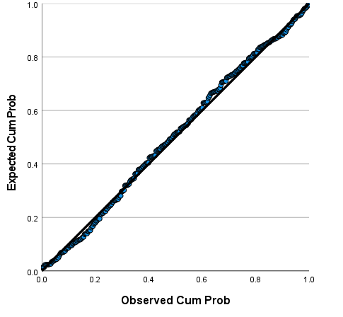
Supplementary figure II.
P-P Plot for model with Mental Work as a dependent variable

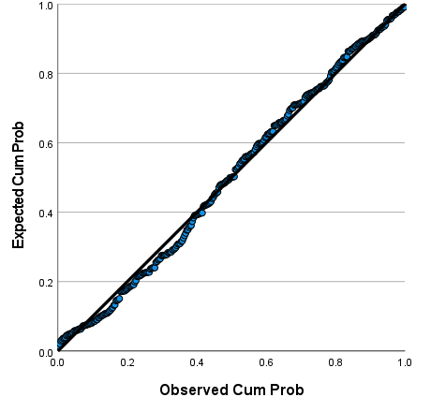
Supplementary figure III.
P-P Plot for model with Solace as a dependent variable
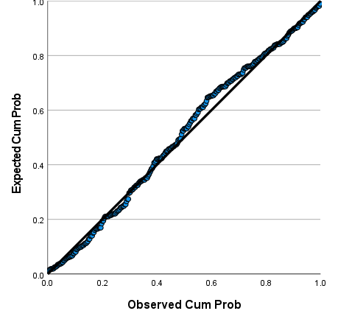
Supplementary figure IV.
P-P Plot for model with Discharge as a dependent variable
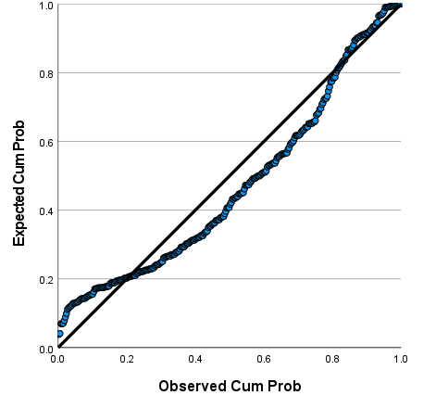
Supplementary figure V.
P-P Plot for model with Revival as a dependent variable
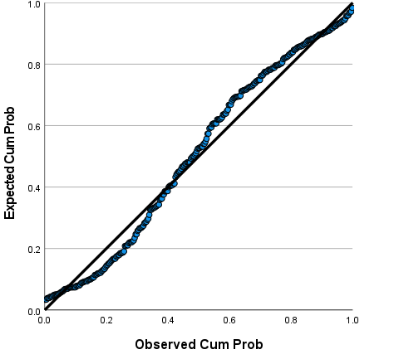
Supplementary figure VI.
P-P Plot for model with Entertainment as a dependent variable
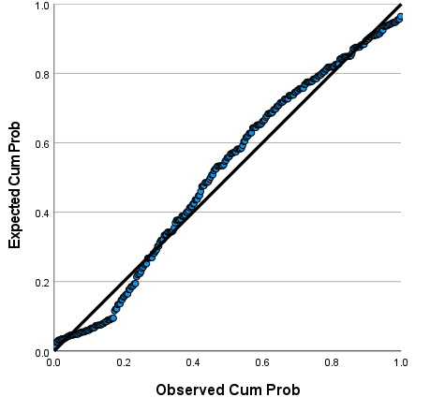
Supplementary figure VII.
P-P Plot for model with Strong Sensation as a dependent variable
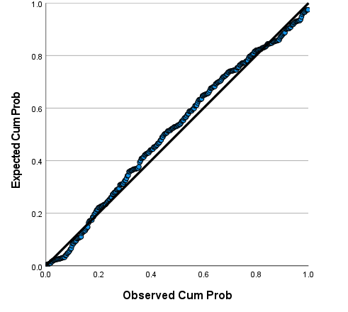
Supplementary figure VIII.
P-P Plot for model with Diversion as a dependent variable
