APPENDIX A
Table A1. Primary identified drivers of IR 4.0 adoption (Authors' own work)
S/N | Drivers Name | Brief Description
D1 | Business model innovation | Innovative approach in present business model aligning with the features of IR 4.0 technologies can boost proper technological inclusion
D2 | Government schemes | Government schemes like financial incentives, economic benefits and favorable policy implementation can play vital role for IR 4.0 technologies inclusion
D3 | Data security | Cyber data security system is a key requirement for integrated IR 4.0 technologies adoption
D4 | Coherent strategic plan | Effective organizational strategic planning can assist in proper IR 4.0 technological infusion in present manufacturing system
D5 | Financial Performance | Organizational financial support is required in every step of IR 4.0 technologies adaptation in present manufacturing system
D6 | Entrepreneurial management ability (EMA) | For proper incorporation and maintenance of IR 4.0 technologies, organizations must capture the optimum level of managerial and technical support
D7 | Stakeholder collaboration | Industrial stakeholders’ collaboration can contribute to the overall automated manufacturing systems by inclusion of IR 4.0 technologies
D8 | Readiness Assessment | Present readiness measurements of the industries can make sure proper IR 4.0 technologies infusion and maintenance
D9 | Smart supply chain management | Modernization in present industrial supply chain management can contribute to effective technical assistance
D10 | Smart quality monitoring | Smart quality monitoring system can help to properly utilizing the modern features of IR4.0 technologies
D11 | New digital technologies | Present automated and modernized systems can boost IR 4.0 technologies inclusion even in more effective and faster way
D12 | Customer integration in design and production | Customer perception of product design and production may guide favorable technologies adoption
D13 | Organizational awareness and monitoring | IR 4.0 technologies are new technical features and these require proper organizational awareness and perfect monitoring facilities from both management and employees

Table A2. Primary identified barriers to IR 4.0 adoption (Authors' own work)
S/N | Barriers Name | Brief Description
B1 | Inadequate knowledge of IR 4.0 concept | Lack of sufficient knowledge of current management personnel and employees about IR 4.0 technologies may hinder proper technological adaptation
B2 | Employee resistance to change | In many industries employees are reluctant to adapt with new technological changes
B3 | Organizational constraints | Lack of organizational support can be an issue of high concern for successful IR 4.0 technologies inclusion
B4 | Lack of collaboration | Absence of collaboration among the industry stakeholders may play as obstacle for IR 4.0 adaptation
B5 | Entrepreneurial technical inability | Without proper technical capabilities IR 4.0 technologies implementation and maintenance is not feasible
B6 | Insufficient digital & physical infrastructure | Lack of digital and physical infrastructure lead to ineffective IR 4.0 technologies adoption and proper maintenance
B7 | Lack of skilled workforce | Insufficient skills related to IR 4.0 technologies among manufacturing workers may steer to ineffective maintenance
B8 | Inadequate training for digital competencies | Absence of training facilities regarding modern technological features may create complexity in proper operation and maintenance of IR 4.0 technologies
B9 | Non-availability of technical standards and new technology accreditation | Absence of technical standards and accreditation facility may hinder innovation and adoption of new technologies in manufacturing firms
B10 | Cultural and regional obstacles | IR 4.0 technologies adaptation may face complexity due to cultural and regional differences between cities and countries
B11 | Ambiguity about digital investments | Industry stakeholders may feel ambiguous about digital investments for proper implementation of IR 4.0 technologies
B12 | Lack of digital legislation | Absence of effective digital or cyber laws may create cyber security issues for database management in cloud computing
B13 | High initial investment cost | Full phase of IR 4.0 technologies adoption requires high initial investment that may play as a burden for many small and medium sized textile and apparel industries

Table A3. Summary of the Experts’ profiles (Authors' own work)
Expert Details |  |  | Number of Experts | Percentage
Experts who participated in relevancy checking of the drivers and barriers
Experts (23) | Designation | Assistant General Manager | 2 | 8.70%
Experts (23) | Designation | Manager | 3 | 13.04%
Experts (23) | Designation | Senior Executive | 4 | 17.39%
Experts (23) | Designation | Executive | 5 | 21.74%
Experts (23) | Designation | Associate Professor | 2 | 8.70%
Experts (23) | Designation | Assistant Professor | 3 | 13.04%
Experts (23) | Designation | Lecturer | 4 | 17.39%
Experts (23) | Expertise Domain | Supply Chain Management | 3 | 13.04%
Experts (23) | Expertise Domain | Industrial Engineering | 4 | 17.39%
Experts (23) | Expertise Domain | Training and Development | 4 | 17.39%
Experts (23) | Expertise Domain | Industrial Management | 3 | 13.04%
Experts (23) | Expertise Domain | Textile Engineering | 9 | 39.13%
Experts (23) | Experience | 5 to 10 Years | 6 | 26.09%
Experts (23) | Experience | 10 to 15 Years | 9 | 39.13%
Experts (23) | Experience | Above 15 Years | 8 | 34.78%
Experts (23) | Organization Type | Textile Industry | 5 | 21.74%
Experts (23) | Organization Type | Apparel Industry | 5 | 21.74%
Experts (23) | Organization Type | Fashion Buying House | 4 | 17.39%
Experts (23) | Organization Type | Textile University | 9 | 39.13%

Table A3. Summary of the Experts’ profiles (continued) (Authors' own work)
Expert Details |  |  | Number of Experts | Percentage
Experts who participated in priority assignment (Pareto Analysis) among the most relevant drivers and barriers
Experts (17) | Designation | Assistant General Manager | 1 | 5.88%
Experts (17) | Designation | Manager | 2 | 11.76%
Experts (17) | Designation | Senior Executive | 3 | 17.65%
Experts (17) | Designation | Executive | 3 | 17.65%
Experts (17) | Designation | Associate Professor | 1 | 5.88%
Experts (17) | Designation | Assistant Professor | 3 | 17.65%
Experts (17) | Designation | Lecturer | 4 | 23.53%
Experts (17) | Expertise Domain | Supply Chain Management | 3 | 17.65%
Experts (17) | Expertise Domain | Industrial Engineering | 3 | 17.65%
Experts (17) | Expertise Domain | Training and Development | 2 | 11.76%
Experts (17) | Expertise Domain | Industrial Management | 3 | 17.65%
Experts (17) | Expertise Domain | Textile Engineering | 6 | 35.29%
Experts (17) | Experience | 5 to 10 Years | 5 | 29.41%
Experts (17) | Experience | 10 to 15 Years | 7 | 41.18%
Experts (17) | Experience | Above 15 Years | 5 | 29.41%
Experts (17) | Organization Type | Textile Industry | 4 | 23.53%
Experts (17) | Organization Type | Apparel Industry | 4 | 23.53%
Experts (17) | Organization Type | Fashion Buying House | 3 | 17.65%
Experts (17) | Organization Type | Textile University | 6 | 35.29%

Table A3. Summary of the Experts’ profiles (continued) (Authors' own work)
Expert Details |  |  | Number of Experts | Percentage
Experts who participated in developing the ISM model and assigning DEMATEL rating among the finally identified drivers and barriers
Experts (10) | Designation | Assistant General Manager | 1 | 10.00%
Experts (10) | Designation | Manager | 1 | 10.00%
Experts (10) | Designation | Senior Executive | 1 | 10.00%
Experts (10) | Designation | Executive | 2 | 20.00%
Experts (10) | Designation | Associate Professor | 1 | 10.00%
Experts (10) | Designation | Assistant Professor | 2 | 20.00%
Experts (10) | Designation | Lecturer | 2 | 20.00%
Experts (10) | Expertise Domain | Supply Chain Management | 2 | 20.00%
Experts (10) | Expertise Domain | Industrial Engineering | 2 | 20.00%
Experts (10) | Expertise Domain | Training and Development | 1 | 10.00%
Experts (10) | Expertise Domain | Industrial Management | 3 | 30.00%
Experts (10) | Expertise Domain | Textile Engineering | 2 | 20.00%
Experts (10) | Experience | 5 to 10 Years | 3 | 30.00%
Experts (10) | Experience | 10 to 15 Years | 4 | 40.00%
Experts (10) | Experience | Above 15 Years | 3 | 30.00%
Experts (10) | Organization Type | Textile Industry | 3 | 30.00%
Experts (10) | Organization Type | Apparel Industry | 3 | 30.00%
Experts (10) | Organization Type | Fashion Buying House | 2 | 20.00%
Experts (10) | Organization Type | Textile University | 2 | 20.00%

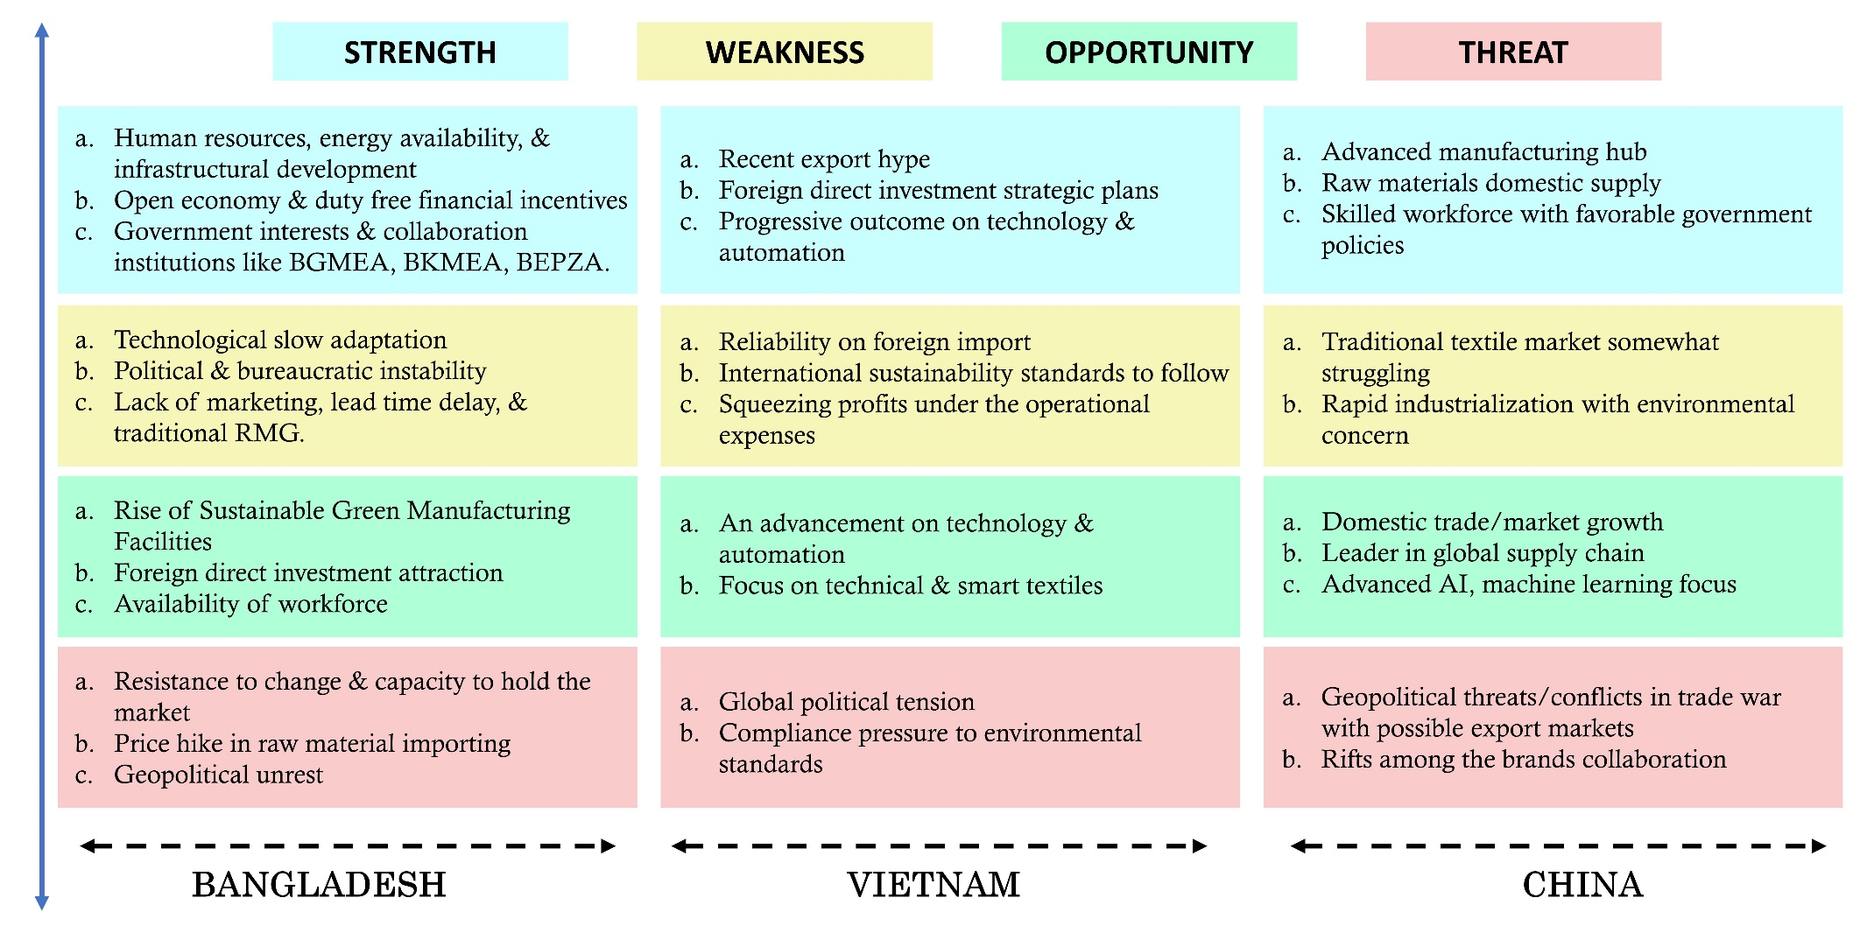

Figure A1. SWOT analysis of the T&A industries of three countries. (Authors' own work)

Figure A2. Driver’s Pareto chart (Authors' own work)

Figure A3. Barrier’s Pareto Chart (Authors' own work)
Table A4. SSIM of the drivers and barriers (Authors' own work)
Drivers |  | D13 | D11 | D10 | D9 | D7 | D6 | D4 | D2
Drivers | D2 |  | V | O | V | V | V | V | V
Drivers | D4 |  |  | A | V | X | O | A | V
Drivers | D6 |  |  |  | O | X | V | A | V
Drivers | D7 |  |  |  |  | A | O | O | V
Drivers | D9 |  |  |  |  |  | V | A | V
Drivers | D10 |  |  |  |  |  |  | A | X
Drivers | D11 |  |  |  |  |  |  |  | V
Drivers | D13
Barriers |  | B13 | B11 | B9 | B8 | B7 | B6 | B5 | B3 | B2
Barriers | B2 |  | A | A | V | V | V | A | V | V
Barriers | B3 |  |  | X | V | O | V | A | V | V
Barriers | B5 |  |  |  | V | O | O | V | V | V
Barriers | B6 |  |  |  |  | A | V | A | X | V
Barriers | B7 |  |  |  |  |  | V | A | V | V
Barriers | B8 |  |  |  |  |  |  | A | O | V
Barriers | B9 |  |  |  |  |  |  |  | V | V
Barriers | B11 |  |  |  |  |  |  |  |  | V
Barriers | B13

Table A5. Initial Reachability matrices of drivers and barriers (Authors' own work)
Drivers |  | D2 | D4 | D6 | D7 | D9 | D10 | D11 | D13 | Driving Power
Drivers | D2 | 1 | 1 | 0 | 1 | 1 | 1 | 1 | 1 | 7
Drivers | D4 | 0 | 1 | 0 | 1 | 1 | 0 | 0 | 1 | 4
Drivers | D6 | 0 | 1 | 1 | 0 | 1 | 1 | 0 | 1 | 5
Drivers | D7 | 0 | 0 | 0 | 1 | 0 | 0 | 0 | 1 | 2
Drivers | D9 | 0 | 1 | 1 | 1 | 1 | 1 | 0 | 1 | 6
Drivers | D10 | 0 | 0 | 0 | 0 | 0 | 1 | 0 | 1 | 2
Drivers | D11 | 0 | 1 | 1 | 0 | 1 | 1 | 1 | 1 | 6
Drivers | D13 | 0 | 0 | 0 | 0 | 0 | 1 | 0 | 1 | 2
Drivers | Dependence Power | 1 | 5 | 3 | 4 | 5 | 6 | 2 | 8
Barriers |  | B2 | B3 | B5 | B6 | B7 | B8 | B9 | B11 | B13 | Driving Power
Barriers | B2 | 1 | 0 | 0 | 1 | 1 | 1 | 0 | 1 | 1 | 6
Barriers | B3 | 1 | 1 | 1 | 1 | 0 | 1 | 0 | 1 | 1 | 7
Barriers | B5 | 1 | 1 | 1 | 1 | 0 | 0 | 1 | 1 | 1 | 7
Barriers | B6 | 0 | 0 | 0 | 1 | 0 | 1 | 0 | 1 | 1 | 4
Barriers | B7 | 0 | 0 | 0 | 1 | 1 | 1 | 0 | 1 | 1 | 5
Barriers | B8 | 0 | 0 | 0 | 0 | 0 | 1 | 0 | 0 | 1 | 2
Barriers | B9 | 1 | 1 | 0 | 1 | 1 | 1 | 1 | 1 | 1 | 8
Barriers | B11 | 0 | 0 | 0 | 1 | 0 | 0 | 0 | 1 | 1 | 3
Barriers | B13 | 0 | 0 | 0 | 0 | 0 | 0 | 0 | 0 | 1 | 1
Barriers | Dependence Power | 4 | 3 | 2 | 7 | 3 | 6 | 2 | 7 | 9

Table A6. Final reachability matrices of drivers and barriers (Authors' own work)
Drivers |  | D2 | D4 | D6 | D7 | D9 | D10 | D11 | D13 | Driving Power
Drivers | D2 | 1 | 1 | 1* | 1 | 1 | 1 | 1 | 1 | 8
Drivers | D4 | 0 | 1 | 1* | 1 | 1 | 1* | 0 | 1 | 6
Drivers | D6 | 0 | 1 | 1 | 1* | 1 | 1 | 0 | 1 | 6
Drivers | D7 | 0 | 0 | 0 | 1 | 0 | 1* | 0 | 1 | 3
Drivers | D9 | 0 | 1 | 1 | 1 | 1 | 1 | 0 | 1 | 6
Drivers | D10 | 0 | 0 | 0 | 0 | 0 | 1 | 0 | 1 | 2
Drivers | D11 | 0 | 1 | 1 | 1* | 1 | 1 | 1 | 1 | 7
Drivers | D13 | 0 | 0 | 0 | 0 | 0 | 1 | 0 | 1 | 2
Drivers | Dependence Power | 1 | 5 | 5 | 6 | 5 | 8 | 2 | 8
Barriers |  | B2 | B3 | B5 | B6 | B7 | B8 | B9 | B11 | B13 | Driving Power
Barriers | B2 | 1 | 0 | 0 | 1 | 1 | 1 | 0 | 1 | 1 | 6
Barriers | B3 | 1 | 1 | 1 | 1 | 1* | 1 | 1* | 1 | 1 | 9
Barriers | B5 | 1 | 1 | 1 | 1 | 1* | 1* | 1 | 1 | 1 | 9
Barriers | B6 | 0 | 0 | 0 | 1 | 0 | 1 | 0 | 1 | 1 | 4
Barriers | B7 | 0 | 0 | 0 | 1 | 1 | 1 | 0 | 1 | 1 | 5
Barriers | B8 | 0 | 0 | 0 | 0 | 0 | 0 | 1 | 0 | 1 | 2
Barriers | B9 | 1 | 1 | 1* | 1 | 1 | 1 | 1 | 1 | 1 | 9
Barriers | B11 | 0 | 0 | 0 | 1 | 0 | 1* | 0 | 1 | 1 | 4
Barriers | B13 | 0 | 0 | 0 | 0 | 0 | 0 | 0 | 0 | 1 | 1
Barriers | Dependence Power | 4 | 3 | 3 | 7 | 5 | 8 | 3 | 7 | 9

Table A7. Level partitioning of the drivers and barriers (Authors' own work)
 |  | Reachability Set R(Mi) | Antecedent Set A(Ni) | Intersection Set R(Mi)∩A(Ni) | Level
Drivers | D2 | D2 | D2 | D2 | 5
Drivers | D4 | D4, D6, D9 | D2, D4, D6, D9, D11 | D4, D6, D9 | 3
Drivers | D6 | D4, D6, D9 | D2, D4, D6, D9, D11 | D4, D6, D9 | 3
Drivers | D7 | D7 | D2, D4, D6, D7, D9, D11 | D7 | 2
Drivers | D9 | D4, D6, D9 | D2, D4, D6, D9, D11 | D4, D6, D9 | 3
Drivers | D10 | D10, D13 | D2, D4, D6, D7, D9, D10, D11, D13 | D10, D13 | 1
Drivers | D11 | D11 | D2, D11 | D11 | 4
Drivers | D13 | D10, D13 | D2, D4, D6, D7, D9, D10, D11, D13 | D10, D13 | 1
Barriers | B2 | B2 | B2, B3, B5, B9 | B2 | 5
Barriers | B3 | B3, B5, B9 | B3, B5, B9 | B3, B5, B9 | 6
Barriers | B5 | B3, B5, B9 | B3, B5, B9 | B3, B5, B9 | 6
Barriers | B6 | B6, B11 | B2, B3, B5, B6, B7, B9, B11 | B6, B11 | 3
Barriers | B7 | B7 | B2, B3, B5, B7, B9 | B7 | 4
Barriers | B8 | B8 | B2, B3, B5, B6, B7, B, B9, B11 | B8 | 2
Barriers | B9 | B3, B5, B9 | B3, B5, B9 | B3, B5, B9 | 6
Barriers | B11 | B6, B11 | B2, B3, B5, B6, B7, B9, B11 | B6, B11 | 3
Barriers | B13 | B13 | B2, B3, B5, B6, B7, B8, B9, B11, B13 | B13 | 1

APPENDIX B
Table B1. Average rating matrices of the drivers and barriers for DEMATEL analysis (Authors' own work)
Drivers |  | D2 | D4 | D6 | D7 | D9 | D10 | D11 | D13
Drivers | D2 | 0 | 2 | 3 | 3 | 2 | 1 | 2 | 1
Drivers | D4 | 0 | 0 | 3 | 2 | 3 | 2 | 3 | 3
Drivers | D6 | 1 | 3 | 0 | 2 | 2 | 3 | 2 | 2
Drivers | D7 | 1 | 3 | 3 | 0 | 2 | 1 | 2 | 3
Drivers | D9 | 0 | 2 | 3 | 2 | 0 | 3 | 2 | 3
Drivers | D10 | 1 | 2 | 3 | 2 | 3 | 0 | 1 | 3
Drivers | D11 | 3 | 3 | 3 | 2 | 3 | 3 | 0 | 3
Drivers | D13 | 0 | 3 | 3 | 2 | 1 | 2 | 2 | 0
Barriers |  | B2 | B3 | B5 | B6 | B7 | B8 | B9 | B11 | B13
Barriers | B2 | 0 | 2 | 3 | 2 | 2 | 3 | 3 | 1 | 1
Barriers | B3 | 2 | 0 | 3 | 2 | 3 | 2 | 2 | 3 | 3
Barriers | B5 | 2 | 2 | 0 | 3 | 2 | 1 | 3 | 1 | 0
Barriers | B6 | 2 | 3 | 3 | 0 | 2 | 2 | 3 | 1 | 1
Barriers | B7 | 3 | 3 | 2 | 1 | 0 | 3 | 1 | 1 | 0
Barriers | B8 | 3 | 2 | 2 | 2 | 3 | 0 | 3 | 1 | 1
Barriers | B9 | 3 | 2 | 2 | 2 | 3 | 3 | 0 | 2 | 2
Barriers | B11 | 2 | 3 | 3 | 3 | 1 | 2 | 2 | 0 | 3
Barriers | B13 | 0 | 3 | 2 | 3 | 2 | 2 | 2 | 3 | 0

Table B2. Direct relationship matrix of the drivers and barriers (Authors' own work)
Drivers |  | D2 | D4 | D6 | D7 | D9 | D10 | D11 | D13
Drivers | D2 | 0.000 | 0.105 | 0.158 | 0.158 | 0.105 | 0.053 | 0.105 | 0.053
Drivers | D4 | 0.000 | 0.000 | 0.158 | 0.105 | 0.158 | 0.105 | 0.158 | 0.158
Drivers | D6 | 0.053 | 0.158 | 0.000 | 0.105 | 0.105 | 0.158 | 0.105 | 0.105
Drivers | D7 | 0.053 | 0.158 | 0.158 | 0.000 | 0.105 | 0.053 | 0.105 | 0.158
Drivers | D9 | 0.000 | 0.105 | 0.158 | 0.105 | 0.000 | 0.158 | 0.105 | 0.158
Drivers | D10 | 0.053 | 0.105 | 0.158 | 0.105 | 0.158 | 0.000 | 0.053 | 0.158
Drivers | D11 | 0.158 | 0.158 | 0.158 | 0.105 | 0.105 | 0.158 | 0.000 | 0.158
Drivers | D13 | 0.000 | 0.158 | 0.158 | 0.105 | 0.053 | 0.105 | 0.105 | 0.000
Barriers |  | B2 | B3 | B5 | B6 | B7 | B8 | B9 | B11 | B13
Barriers | B2 | 0.000 | 0.095 | 0.143 | 0.095 | 0.095 | 0.143 | 0.143 | 0.048 | 0.048
Barriers | B3 | 0.095 | 0.048 | 0.143 | 0.095 | 0.143 | 0.095 | 0.095 | 0.143 | 0.143
Barriers | B5 | 0.095 | 0.095 | 0.000 | 0.143 | 0.095 | 0.048 | 0.143 | 0.048 | 0.000
Barriers | B6 | 0.095 | 0.143 | 0.143 | 0.000 | 0.095 | 0.095 | 0.143 | 0.048 | 0.048
Barriers | B7 | 0.143 | 0.143 | 0.095 | 0.048 | 0.000 | 0.143 | 0.048 | 0.048 | 0.000
Barriers | B8 | 0.143 | 0.095 | 0.095 | 0.095 | 0.143 | 0.000 | 0.143 | 0.048 | 0.048
Barriers | B9 | 0.143 | 0.095 | 0.095 | 0.095 | 0.143 | 0.143 | 0.000 | 0.095 | 0.095
Barriers | B11 | 0.095 | 0.143 | 0.143 | 0.143 | 0.048 | 0.095 | 0.095 | 0.000 | 0.143
Barriers | B13 | 0.000 | 0.143 | 0.095 | 0.143 | 0.095 | 0.095 | 0.095 | 0.143 | 0.000

Table B3. Total relationship matrices of the drivers and barriers (Authors' own work)
Drivers |  | D2 | D4 | D6 | D7 | D9 | D10 | D11 | D13
Drivers | D2 | 0.158 | 0.560 | 0.655 | 0.513 | 0.481 | 0.454 | 0.462 | 0.520
Drivers | D4 | 0.181 | 0.527 | 0.723 | 0.513 | 0.572 | 0.560 | 0.551 | 0.673
Drivers | D6 | 0.213 | 0.628 | 0.551 | 0.490 | 0.508 | 0.567 | 0.483 | 0.597
Drivers | D7 | 0.211 | 0.631 | 0.685 | 0.393 | 0.501 | 0.482 | 0.485 | 0.635
Drivers | D9 | 0.167 | 0.586 | 0.684 | 0.486 | 0.407 | 0.569 | 0.478 | 0.638
Drivers | D10 | 0.204 | 0.578 | 0.677 | 0.482 | 0.538 | 0.423 | 0.432 | 0.627
Drivers | D11 | 0.341 | 0.739 | 0.812 | 0.583 | 0.598 | 0.660 | 0.475 | 0.744
Drivers | D13 | 0.151 | 0.576 | 0.624 | 0.443 | 0.417 | 0.478 | 0.440 | 0.445
Barriers |  | B2 | B3 | B5 | B6 | B7 | B8 | B9 | B11 | B13
Barriers | B2 | 0.433 | 0.572 | 0.598 | 0.505 | 0.533 | 0.558 | 0.585 | 0.354 | 0.307
Barriers | B3 | 0.604 | 0.642 | 0.706 | 0.604 | 0.664 | 0.612 | 0.641 | 0.513 | 0.455
Barriers | B5 | 0.455 | 0.500 | 0.403 | 0.478 | 0.463 | 0.415 | 0.513 | 0.306 | 0.228
Barriers | B6 | 0.521 | 0.618 | 0.604 | 0.422 | 0.537 | 0.522 | 0.587 | 0.361 | 0.313
Barriers | B7 | 0.494 | 0.538 | 0.489 | 0.398 | 0.377 | 0.493 | 0.435 | 0.306 | 0.228
Barriers | B8 | 0.559 | 0.574 | 0.560 | 0.502 | 0.571 | 0.436 | 0.581 | 0.354 | 0.307
Barriers | B9 | 0.601 | 0.628 | 0.611 | 0.550 | 0.616 | 0.607 | 0.505 | 0.429 | 0.378
Barriers | B11 | 0.559 | 0.679 | 0.661 | 0.605 | 0.544 | 0.568 | 0.603 | 0.356 | 0.431
Barriers | B13 | 0.441 | 0.633 | 0.573 | 0.560 | 0.537 | 0.524 | 0.551 | 0.451 | 0.280

Table B4. Degree of effect matrices of the drivers and barriers (Authors' own work)
Drivers |  | D2 | D4 | D6 | D7 | D9 | D10 | D11 | D13
Drivers | D2 | 0.0000 | 0.5598 | 0.6549 | 0.5126 | 0.0000 | 0.0000 | 0.0000 | 0.5199
Drivers | D4 | 0.0000 | 0.5267 | 0.7228 | 0.5134 | 0.5721 | 0.5596 | 0.5509 | 0.6734
Drivers | D6 | 0.0000 | 0.6284 | 0.5506 | 0.0000 | 0.0000 | 0.5673 | 0.0000 | 0.5971
Drivers | D7 | 0.0000 | 0.6307 | 0.6850 | 0.0000 | 0.0000 | 0.0000 | 0.0000 | 0.6346
Drivers | D9 | 0.0000 | 0.5864 | 0.6838 | 0.0000 | 0.0000 | 0.5688 | 0.0000 | 0.6375
Drivers | D10 | 0.0000 | 0.5782 | 0.6767 | 0.0000 | 0.5380 | 0.0000 | 0.0000 | 0.6273
Drivers | D11 | 0.0000 | 0.7391 | 0.8118 | 0.5832 | 0.5982 | 0.6603 | 0.0000 | 0.7439
Drivers | D13 | 0.0000 | 0.5762 | 0.6237 | 0.0000 | 0.0000 | 0.0000 | 0.0000 | 0.0000
Barriers |  | B2 | B3 | B5 | B6 | B7 | B8 | B9 | B11 | B13
Barriers | B2 | 0.0000 | 0.5721 | 0.5979 | 0.5049 | 0.5325 | 0.5582 | 0.5847 | 0.0000 | 0.0000
Barriers | B3 | 0.6038 | 0.6417 | 0.7063 | 0.6040 | 0.6637 | 0.6124 | 0.6411 | 0.5126 | 0.0000
Barriers | B5 | 0.0000 | 0.0000 | 0.0000 | 0.0000 | 0.0000 | 0.0000 | 0.5134 | 0.0000 | 0.0000
Barriers | B6 | 0.5215 | 0.6185 | 0.6042 | 0.0000 | 0.5366 | 0.5224 | 0.5873 | 0.0000 | 0.0000
Barriers | B7 | 0.0000 | 0.5375 | 0.0000 | 0.0000 | 0.0000 | 0.0000 | 0.0000 | 0.0000 | 0.0000
Barriers | B8 | 0.5592 | 0.5736 | 0.5598 | 0.0000 | 0.5706 | 0.0000 | 0.5815 | 0.0000 | 0.0000
Barriers | B9 | 0.6009 | 0.6283 | 0.6112 | 0.5501 | 0.6157 | 0.6069 | 0.5045 | 0.0000 | 0.0000
Barriers | B11 | 0.5592 | 0.6793 | 0.6613 | 0.6049 | 0.5436 | 0.5676 | 0.6026 | 0.0000 | 0.0000
Barriers | B13 | 0.0000 | 0.6332 | 0.5734 | 0.5595 | 0.5373 | 0.5243 | 0.5506 | 0.0000 | 0.0000

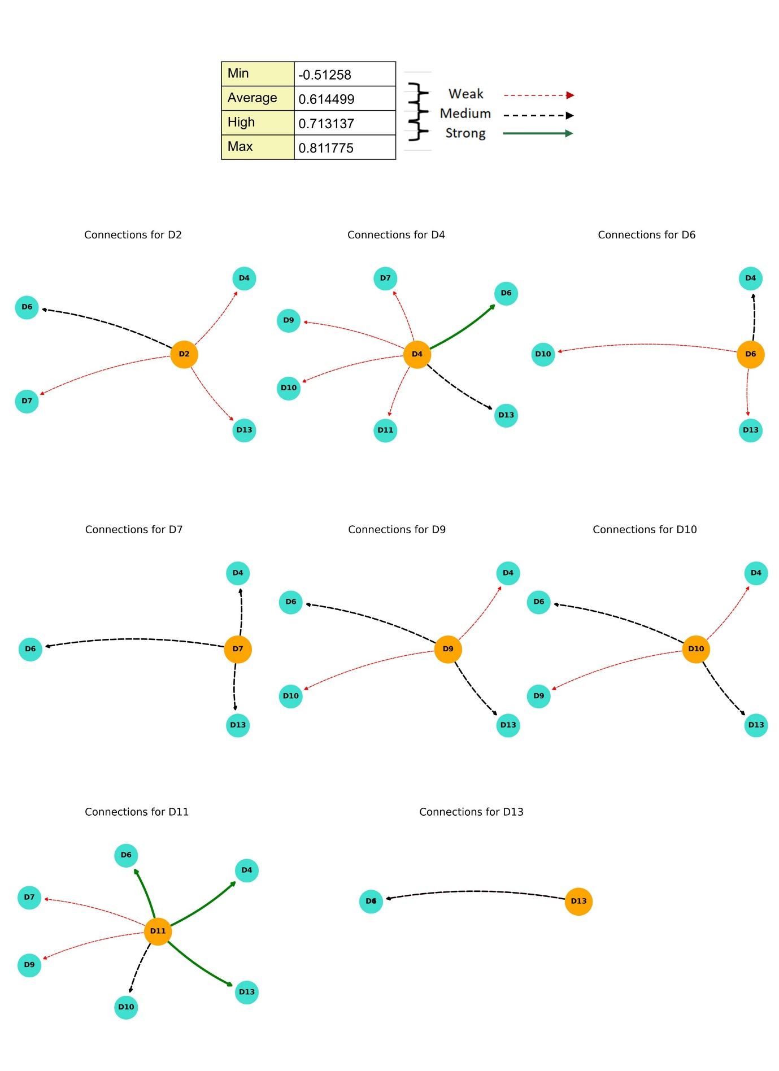

Figure B1: Degree of effect and connections among the drivers (Authors' own work
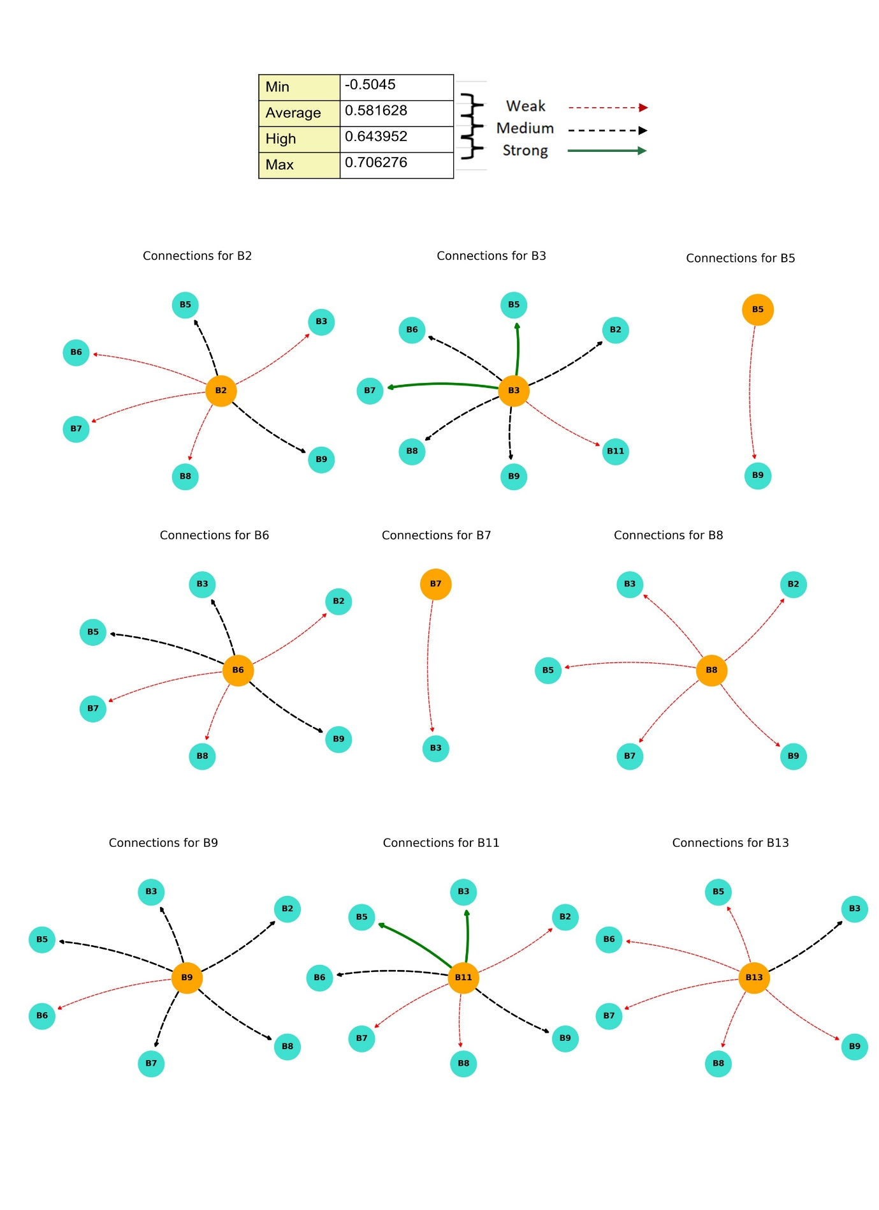
Figure B2: Degree of effect and connections among the barriers (Authors' own work)

Table B5. Weight given to experts in sensitivity analysis (Authors' own work)
 | Run 1 | Run 2 | Run 3 | Run 4
Expert 1 | 0.4 | 0.2 | 0.2 | 0.2
Expert 2 | 0.2 | 0.4 | 0.2 | 0.2
Expert 3 | 0.2 | 0.2 | 0.4 | 0.2
Expert 4 | 0.2 | 0.2 | 0.2 | 0.4

Table B6. Sensitivity analysis for drivers (Authors' own work)
Investigation Run 1 |  |  |  |  |  | Investigation Run 2 |  |  |  |  | Investigation Run 3 |  |  |  |  | Investigation Run 4
Drivers | R+C | Rank | R-C | Rank |  | R+C | Rank | R-C | Rank |  | R+C | Rank | R-C | Rank |  | R+C | Rank | R-C | Rank
D2 | 5.841 | 8 | 2.185 | 1 |  | 5.421 | 8 | 2.345 | 1 |  | 5.217 | 8 | 2.785 | 1 |  | 5.740 | 8 | 2.231 | 1
D4 | 9.224 | 2 | -0.521 | 6 |  | 9.125 | 2 | -0.547 | 6 |  | 9.524 | 2 | -0.524 | 6 |  | 9.321 | 2 | -0.533 | 6
D6 | 9.321 | 1 | -1.333 | 8 |  | 9.332 | 1 | -1.254 | 8 |  | 9.324 | 1 | -1.385 | 8 |  | 9.254 | 1 | -1.382 | 8
D7 | 7.428 | 7 | 0.129 | 3 |  | 7.425 | 7 | 0.147 | 3 |  | 7.854 | 7 | 0.144 | 3 |  | 7.854 | 7 | 0.125 | 3
D9 | 8.125 | 6 | -0.004 | 4 |  | 8.125 | 6 | -0.021 | 4 |  | 8.124 | 6 | -0.025 | 4 |  | 8.278 | 6 | -0.033 | 4
D10 | 8.221 | 5 | -0.211 | 5 |  | 8.214 | 5 | -0.288 | 5 |  | 8.254 | 5 | -0.237 | 5 |  | 8.354 | 5 | -0.288 | 5
D11 | 8.795 | 3 | 1.114 | 2 |  | 8.621 | 3 | 1.254 | 2 |  | 8.624 | 3 | 1.321 | 2 |  | 8.932 | 3 | 1.399 | 2
D13 | 8.415 | 4 | -1.331 | 7 |  | 8.325 | 4 | -1.325 | 7 |  | 8.325 | 4 | -1.377 | 7 |  | 8.625 | 4 | -1.355 | 7
R+C | D6>D4>D11>D13>D10>D9>D7>D2 |  |  |  |  | D6>D4>D11>D13>D10>D9>D7>D2 |  |  |  |  | D6>D4>D11>D13>D10>D9>D7>D2 |  |  |  |  | D6>D4>D11>D13>D10>D9>D7>D2
Cause | D2, D11, D7 |  |  |  |  | D2, D11, D7 |  |  |  |  | D2, D11, D7 |  |  |  |  | D2, D11, D7
Effect | D9, D10, D4, D13, D6 |  |  |  |  | D9, D10, D4, D13, D6 |  |  |  |  | D9, D10, D4, D13, D6 |  |  |  |  | D9, D10, D4, D13, D6

Table B7. Sensitivity analysis for barriers (Authors' own work)
Investigation Run 1 |  |  |  |  |  | Investigation Run 2 |  |  |  |  | Investigation Run 3 |  |  |  |  | Investigation Run 4
Barriers | R+C | Rank | R-C | Rank |  | R+C | Rank | R-C | Rank |  | R+C | Rank | R-C | Rank |  | R+C | Rank | R-C | Rank
B2 | 9.024 | 5 | -0.278 | 6 |  | 9.001 | 5 | -0.285 | 6 |  | 9.148 | 5 | -0.298 | 6 |  | 9.214 | 5 | -0.254 | 6
B3 | 10.725 | 1 | 0.098 | 3 |  | 10.524 | 1 | 0.088 | 3 |  | 11.052 | 1 | 0.085 | 3 |  | 10.978 | 1 | 0.076 | 3
B5 | 8.944 | 6 | -1.287 | 9 |  | 8.971 | 6 | -1.385 | 9 |  | 8.894 | 6 | -1.987 | 9 |  | 8.845 | 6 | -1.428 | 9
B6 | 9.125 | 4 | -0.129 | 5 |  | 9.129 | 4 | -0.189 | 5 |  | 9.241 | 4 | -0.146 | 5 |  | 9.349 | 4 | -0.125 | 5
B7 | 8.524 | 7 | -1.028 | 8 |  | 8.577 | 7 | -1.087 | 8 |  | 8.574 | 7 | -1.874 | 8 |  | 8.324 | 7 | -1.324 | 8
B8 | 9.174 | 3 | -0.299 | 7 |  | 9.144 | 3 | -0.299 | 7 |  | 9.524 | 3 | -0.358 | 7 |  | 9.624 | 3 | -0.287 | 7
B9 | 9.946 | 2 | -0.084 | 4 |  | 9.937 | 2 | -0.085 | 4 |  | 9.864 | 2 | -0.084 | 4 |  | 9.875 | 2 | -0.081 | 4
B11 | 8.427 | 8 | 1.637 | 2 |  | 8.477 | 8 | 1.867 | 2 |  | 8.328 | 8 | 1.678 | 2 |  | 8.265 | 8 | 1.528 | 2
B13 | 7.014 | 9 | 1.897 | 1 |  | 6.975 | 9 | 1.985 | 1 |  | 7.347 | 9 | 1.824 | 1 |  | 7.249 | 9 | 1.675 | 1
R+C | B3>B9>B8>B6>B2>B5>B7>B11>B13 |  |  |  |  | B3>B9>B8>B6>B2>B5>B7>B11>B13 |  |  |  |  | B3>B9>B8>B6>B2>B5>B7>B11>B13 |  |  |  |  | B3>B9>B8>B6>B2>B5>B7>B11>B13
Cause | B13, B11, B3 |  |  |  |  | B13, B11, B3 |  |  |  |  | B13, B11, B3 |  |  |  |  | B13, B11, B3
Effect | B9, B6, B2, B8, B7, B5 |  |  |  |  | B9, B6, B2, B8, B7, B5 |  |  |  |  | B9, B6, B2, B8, B7, B5 |  |  |  |  | B9, B6, B2, B8, B7, B5

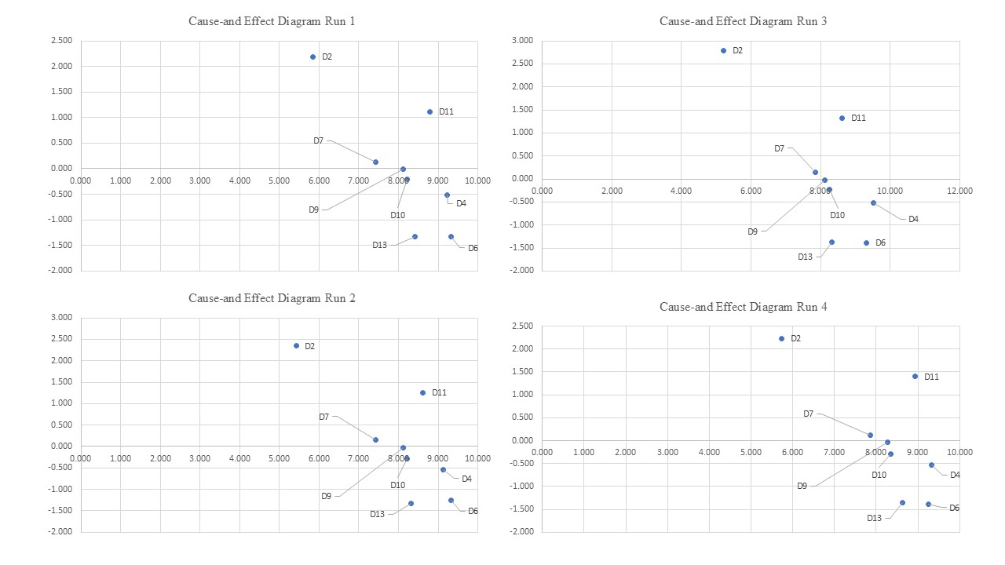
Figure B3: Cause and effect diagram of drivers for investigation runs (Authors' own work)

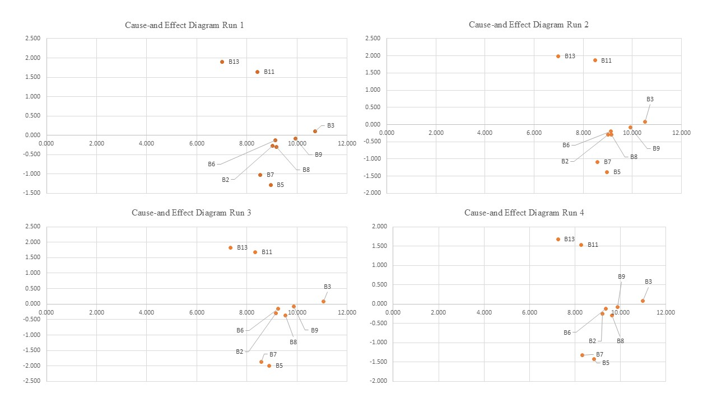
Figure B4: Cause and effect diagram of barriers for investigation runs (Authors' own work)

