Appendix A. Unconstrained model and constrained model
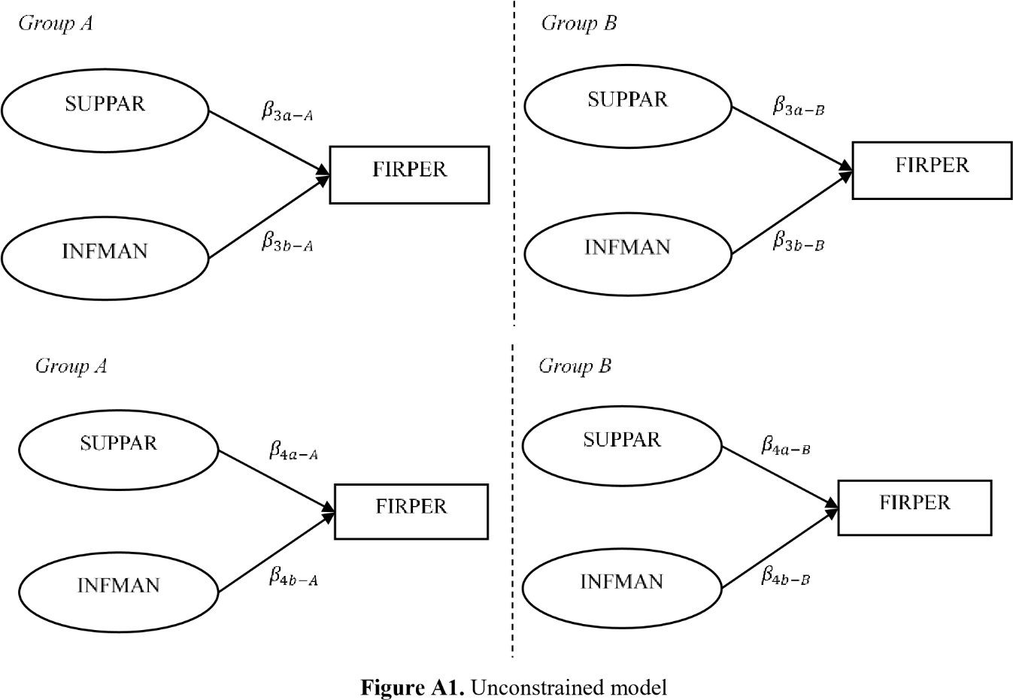

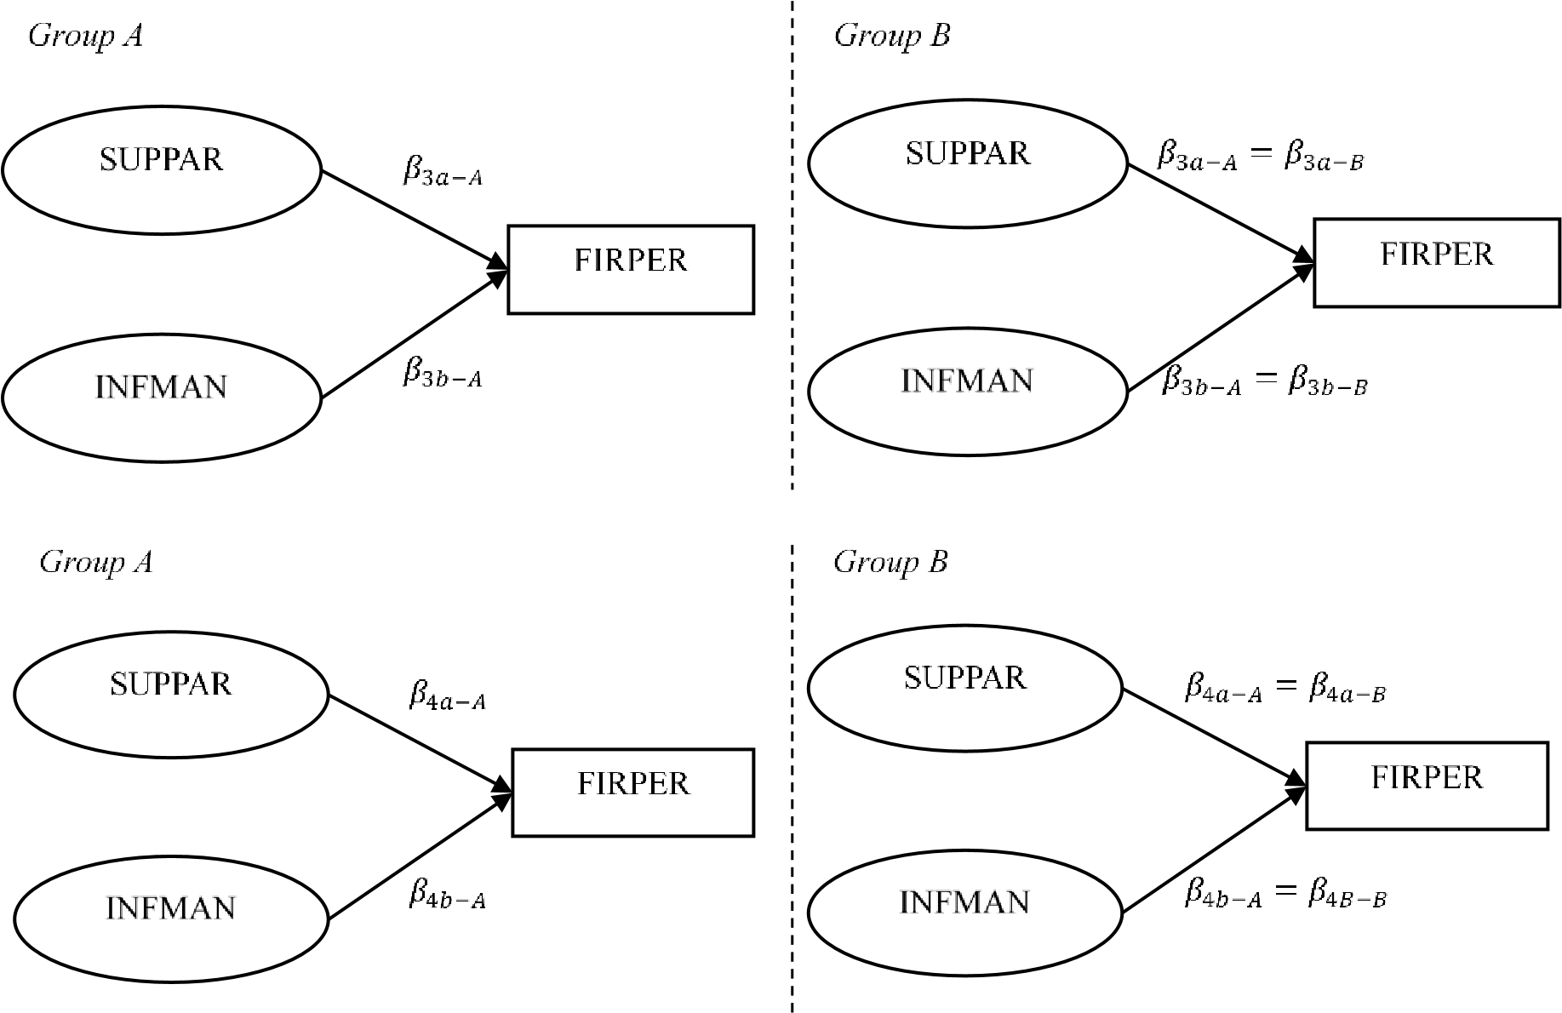
Figure A2. Constrained model
Appendix B. Reliability indices of constructs in the model
Construct | No. of Item | Mean of  Standardised  Regression | Cronbach's Alpha | Composite  Reliability | Percentage of  Variance Extracted
Supply chain partnership barrier | 5 | 0.829 | 0.917 | 0.919 | 0.696
Information management barrier | 5 | 0.800 | 0.898 | 0.901 | 0.648
Sensing capability | 4 | 0.839 | 0.905 | 0.905 | 0.704
Responding capability | 7 | 0.781 | 0.916 | 0.917 | 0.611
Firm performance | 6 | 0.906 | 0.965 | 0.965 | 0.820

Appendix C. Results of structural model estimation
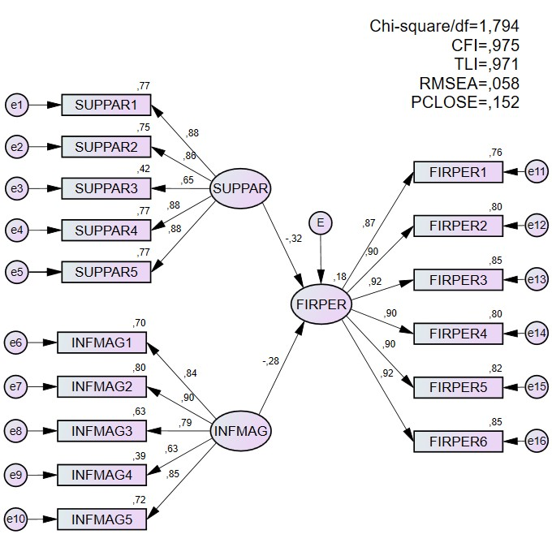

Appendix D. Hypothesis testing results and comparison with previous studies

Hypothesised Relationship |  | Standardised Coefficient (β) | SE | CR | p-value | Result | Comparison with previous studies
H1 | Supply chain partnership barrier → Firm performance | -0,316 | 0,072 | -4.844 | *** | Supported | - Berger et al. (2018)  - Jadhav et al. (2014)  - Manzouri et al. (2013)
H2 | Information management  barrier → Firm performance | -0.283 | 0.078 | -4.315 | *** | Supported | - Takeda-Berger et al. (2021)  - Jadhav et al. (2014)  - Jharkharia & Shankar (2005)

Appendix E. Moderating effects of sensing capability on the hypothesised relationship

 | Chi-Square | df | p-Value | TLI | CFI | RMSEA | Chi-  Square/df | Result
H3a: Supply chain partnership barrier → Firm performance
Constrained model | 323.055 | 205 | 0.000 | 0.953 | 0.960 | 0.050 | 1.576 | Support
Unconstrained model | 318.475 | 204 | 0.000 | 0.954 | 0.961 | 0.049 | 1.561
Significant discrepancy | 4.580 | 1 | 0.032 | 0.001 | 0.001 | 0.001 | 0.015
H3b: Information management barrier → Firm performance
Constrained model | 323.819 | 205 | 0.000 | 0.952 | 0.959 | 0.050 | 1.580 | Support
Unconstrained model | 318.475 | 204 | 0.000 | 0.954 | 0.961 | 0.049 | 1.561
Significant discrepancy 5.344 1.00 0.021 0.002 0.002 0.001 0.019

Appendix F. Unstandardized estimation on moderating effect of sensing capability

Unconstrained model

Constrained model

Low sensing capability

High sensing capability

m SE CR p m SE CR p m SE CR p
H3a | Supply chain partnership barrier → Firm performance | -.719 | .090 | -8.01 | *** | -.435 | .089 | -4.91 | *** | -.582 | .064 | -9.080 | ***
H3b | Information management barrier → Firm performance | -.369 | .098 | -3.76 | *** | -.066 | .075 | -.890 | .373 | -.171 | .060 | -2.843 | .004

Appendix G. Moderating effects of responding capability on the hypothesised relationship

Chi-Square df p-Value |  |  |  | TLI | CFI | RMSEA | Chi-  Square/df | Result
H4a: Supply chain partnership barrier → Firm performance
Constrained model | 333.944 | 205 | 0.000 | 0.952 | 0.959 | 0.052 | 1.629 | Support
Unconstrained model | 328.370 | 204 | 0.000 | 0.954 | 0.961 | 0.051 | 1.610
Significant discrepancy | 5.574 | 1 | 0.018 | 0.002 | 0.002 | 0.001 | 0.019
H4b: Information management barrier → Firm performance
Constrained model | 332.396 | 205 | 0.000 | 0.953 | 0.960 | 0.052 | 1.621 | Support
Unconstrained model | 328.370 | 204 | 0.000 | 0.954 | 0.961 | 0.051 | 1.610
Significant discrepancy | 4.026 | 1 | 0.045 | 0.001 | 0.001 | 0.001 | 0.011

Appendix H. Unstandardized estimation on moderating effect of responding capability
 |  | Unconstrained model |  |  |  |  |  |  |  | Constrained model
 |  | Low responding capability |  |  |  | High responding capability
 |  | m | SE | CR | p | m | SE | CR | p | m | SE | CR | p
H4a | Supply chain partnership barrier → Firm performance | -.734 | .088 | -8.37 | *** | -.367 | .121 | -3.02 | .003 | -.613 | .070 | -8.800 | ***
H4b | Information management barrier → Firm performance | -.542 | .099 | -5.45 | *** | -.238 | .105 | -2.26 | .024 | -.399 | .072 | -5.570 | ***

