Title
An Exploration into Reductionistic and Holistic Perspectives of Supply Chain Practitioners using Systems Thinking: A Mixed-Methods Study

- Appendices
Appendix 1: Pre-Interview Questions
Section | Question # | Sub-Section | Definition | Explanation | Question
Stakeholders | 1 | Aligned  (Unitary) | When stakeholders are aligned, they share common interests, values, and beliefs. They actively participate in decision-making, ensuring unanimous agreement on the actions taken. This collective alignment among stakeholders leads to streamlined and effective outcomes. | Aligned stakeholders are synchronised in their approach, working in unison to achieve prompt and favourable results. Their collaboration ensures progress and the timely accomplishment of goals. | Given the above definition, metaphor, and explanation, please determine how Aligned do you perceive the following stakeholders to be.
Stakeholders | 2 | Diverse | The stakeholders share fundamental interests but have different values and beliefs. | Diverse stakeholders are regarded as having common interests. For example, diverse stakeholders may work in the same organisation or be part of the same Supply Chain. Thus, they share the organisation's common interest in remaining in business, so the collective group has a job. However, they are very focused on their interests and what they regard as necessary, which is different to what you may regard as important. Progress is slower because there is a need to work through the differing perspectives and priorities held by groups in the organisation or the Supply Chain. | Given the above definition, metaphor, and explanation, please determine how Diverse do you perceive the following stakeholders to be.
Stakeholders | 3 | Coercive | There are a few common interests among the stakeholders. If they could express them, they would hold conflicting values and beliefs. Generally, compromise is impossible, as a dominant stakeholder wields the most power and resorts to various forms of coercion to ensure their desires are met. Outcomes are predominantly slanted towards the interests of the controlling group. | Stakeholders regarded as Coercive generally have the most power and are more likely to get their way. Stakeholders around the controlling group are usually accountable to the group with the most power and influence upon an outcome. If those in less powerful or dominant positions do not align with the Coercive group's request, these groups are likely to suffer. This could be the Supplier who is beholden to the Customer's decision, for whom the Supplier is critically dependent, or one part of the organisation that always gets its way, while other teams, departments, or divisions must satisfy the dominant firm's requirements, despite the negative consequences they will encounter. | Given the above definition, metaphor, and explanation, please determine how Coercive do you perceive the following stakeholders to be.
Systems | 4 | Uncomplex | Uncomplex systems are controlled by those who know everything there is to know about the operation. | If the process is not performed according to the specifications, no diagnosis is needed, as the fix is immediate. | Given the above definition, metaphor, and explanation, please determine if the following stakeholders operate in Uncomplex system.
Systems | 5 | Uncomplicated | Uncomplicated systems are those characterised by those overseeing as knowing all regarding the operation of the components. | Should the process not be performed according to the specifications, a primary diagnosis is needed, with the intervention quickly following the clarity of the solution required. | Given the above definition, metaphor, and explanation, please determine if the following stakeholders operate in the Uncomplicated system.
Systems | 6 | Basic | A few components are controlled in a tightly controlled and structured system. | The input-transformation-output methods are straightforward, and external conditions or influences do not impact the components. A more thorough diagnosis is required to determine the process in which the fault occurred. However, rectification is quick because the problem's cause and effect are apparent. | Given the above definition, metaphor, and explanation, please determine if the following stakeholders operate in the Basic system.
Systems | 7 | Simple | A few components or subsystems are involved in a small number of highly organised interactions. | A Simple system undergoes minimal changes over time, and its components are relatively unaffected by the independent actions of their parts or by external influences. | Given the above definition, metaphor, and explanation, please determine if the following stakeholders operate in the Simple system.
Systems | 8 | Complicated | Complicated Systems can be defined as having a number of components or Subsystems that are organised in a manner that gives the system order, albeit highly dependent on others and thus verging on instability. | Given the lack of control, these contexts contain the ‘known-unknowns’ where it is not always or immediately clear what the cause-and-effect relationships are, given the span of the system's stakeholders. | Given the above definition, metaphor, and explanation, please determine if the following can be regarded as a Complicated system.
Systems | 9 | Complex | Complex Systems can be characterised as having many components or Subsystems involved in many loosely structured interactions, with outcomes that are not predetermined. In complex contexts, we are confronted by “unknown unknowns.” | There is constant flux, and nothing is predictable. A more experimental approach is required, opening up discussion and encouraging diversity until favourable “attractors” begin to emerge. | Given the above definition, metaphor, and explanation, please determine if the following can be regarded as a Complex system:
Paradigms | 10 | Decomposition | Breaking down the System into parts | How can the parts that comprise the System or process be broken down and analysed separately? We are concerned with breaking down the parts of our process from other departments or organisations external to our firm. Individual elements of the organisation or Supply Chain are rewarded for maximising their performance, which can come at the expense of related organisations or departments. In the first instance, the preference is to separate the parts and understand them in isolation. | Given the above definition and explanation, please determine whether the following stakeholders, in the first instance, apply a Decomposition paradigm when seeking to solve problems or make improvements.
Paradigms | 11 | Simplification | Seeking simple solutions to problems or opportunities | We are concerned with applying simple methods and processes to understand problems or opportunities. When doing this, we focus on our department or organisation first. We attempt to use the same approach to solve the problem as we have before, knowing that, while effective in some cases, it may not be the best fit in others.  In the first instance, we aim to solve the problem quickly using methods we know, rather than more complex, dynamic processes we have yet to understand. | Given the above definition and explanation, please determine whether the following stakeholders, in the first instance, apply a Simplification paradigm when seeking to solve problems or make improvements.
Paradigms | 12 | Optimisation | How can the part under study be optimised independently of related parts? | We are concerned with optimising a single part of the organisation or Supply Chain, with improvements that focus on improving that part without immediate regard for the related stakeholders.  It's important to understand that optimising one part of the Supply Chain could potentially cost corresponding stakeholders, leading to significant negative consequences. | Given the above definition and explanation, please determine if the following stakeholders, in the first instance, apply a paradigm of Optimisation when seeking to solve problems or make improvements.
Holism | 13 | Functionalism | Ensuring that everything in the system functions well to promote efficiency, adaptation, and survival. | Our primary focus is on efficiency. We aim to standardise operations and reduce inventories. This streamlines our processes, ensuring consistency and reliability and instilling confidence in our strategy. We aim to treat the Supply Chain as a well-oiled machine with tight specifications.  This approach, primarily guided by the focal firm, focuses on greater efficiency and on ensuring precision and reliability in our operations. A Functionalist Supply Chain, built on stability and control, has limitations. It may struggle to handle complications, complexity, or chaos effectively. | Given the above definition and explanation, please determine whether the following stakeholders, in the first instance, apply a Functionalist paradigm when seeking to solve problems or make improvements.
Holism | 14 | Interpretivism | Exploring collective purposes through integrating the perspectives of those in organisations and pursuing decisions based on participative involvement that gain the commitment of key stakeholders. | We are concerned with effectiveness (doing the right things) and efficiency (doing things right) …, albeit not at the expense of those who comprise the Supply Chain: “How can we leverage the insights of those in the Supply Chain to ensure the right thing is done… How can we reach a compromise that considers the perspective of others for the betterment of the entire Supply Chain?”  The foundation of our approach is an Interpretive Supply Chain, which underscores the importance of understanding the system and of the collective effectively navigating complex situations. The orientation is to view the Supply Chain as a collection of organisations with individuals with differing perspectives and viewpoints who may sometimes be in conflict. | Given the above definition and explanation, please determine whether the following stakeholders, in the first instance, apply an Interpretivist paradigm when seeking to solve problems or make improvements.
Holism | 15 | Emancipation | Concerning oneself with emancipating oppressed individuals and groups in organisations and society. Critical of the status quo and wants to encourage a radical reformation of, or revolution in, the current social order. | Our utmost concern is the urgent emancipation of the Supply Chain, particularly those who are oppressed and suffering due to the actions of certain actors.  The question we must address is: “How can we eliminate slavery and oppression from our Supply Chains?" This is the central focus, even at the expense of cost minimisation. All entities within the Supply Chain must align with the imperative of emancipation, or they will inevitably clash with this overarching goal. An Emancipatory Supply Chain is predicated on freeing the System of oppression and bringing about equality between the oppressed and the oppressors. Our mission is crystal clear: to emancipate the Supply Chain, free those oppressed, and bring about radical change. This transformation will lead to a Supply Chain that is more equitable and empowered, paving the way for a brighter, more promising future for all stakeholders. | Given the above definition and explanation, please determine if the following stakeholders, in the first instance, apply a paradigm of Emancipation when seeking to solve problems or make improvements.
Holism | 16 | Post-Modernism | Opposition to the ‘modernist’ rationality that it sees as present in all the other three paradigms. Open challenge and ridicule what it regards as its ‘totalising’ attempts to explain how organisations function comprehensively. | We are deeply concerned with deconstructing efficiency and challenging power structures: “We are here to overthrow the existing ways of managing our Logistics and Supply Chain operations… We must urgently challenge those in power and prioritise the environmental and social concerns before all else! The time for action is now!"  A Post-Modern Supply Chain is transfixed by radical change, reforming the System of oppression and bringing about a transformative way of operating, emphasising the challenge to existing narratives! The orientation is to debunk the grand narratives of maximising efficiency and effectiveness across the Supply Chain, rather than promoting the marginalised and oppressed. Power must be taken from those who have it! | Given the above definition and explanation, please determine whether the following stakeholders, in the first instance, apply a Post-Modern paradigm when seeking to solve problems or make improvements.
Source: Authors’ own work
Appendix 2: Conceptual Diagnostic Instrument
Section | Sub-Sections | Composition(#) | Scale | Representative Question | Survey Example
Stakeholders | Unitary  Diverse  Coercive | 3* / 21** | Five-Point unipolar Likert scale | “Given the above definition, metaphor and explanation, please determine how Diverse you perceive the following stakeholders to be…” | 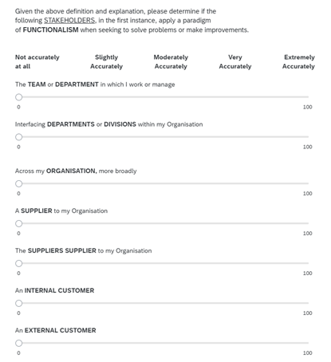
Systems | Uncomplex  Uncomplicated  Basic  Simple  Complicated  Complex | 6/ 42 | Five-Point unipolar Likert scale | “Given the above definition, metaphor and explanation, please determine if the following can be regarded as Complicated systems…”
Paradigms | Decomposition  Simplification  Optimisation  Functionalism  Interpretivism  Emancipation  Post-Modernism | 7/ 49 | Five-Point unipolar Likert scale | “Given the above definition and explanation, please determine if the following stakeholders, in the first instance, apply a paradigm of Functionalism when seeking to solve problems or make improvements…”
NOTE:
#: There were single conceptual questions (per *), with multiple ratings (per **), i.e., 1 question was asked in a Matrix format with 7 positions.
Source: Authors’ own work

Appendix 3: Interview Questions
Section | Representative Question
Stakeholders | Reviewing your positions regarding stakeholders, I can see that you have… (insert the participant's Survey result).
Stakeholders | Can you expand on these results to better understand your stakeholder interactions?
Systems | Reviewing your positions on situations or systems (based on the highest results), I can see that you have… (insert the participant's result from the Survey).
Systems | Can you expand on these results to better understand the types of Systems or situations (per the highest result) you operate within, and your perspectives towards the stakeholders you have allocated?
Paradigms | Reviewing your positions regarding paradigms (based on the highest results), I can see that you align with the… (insert participant's highest result from the Survey) paradigm, followed by the (2nd-highest result) paradigm.
Paradigms | Why do you think you associate with the paradigm of (insert paradigm with the highest result), followed by (insert paradigm with the 2nd highest result)?
Paradigms | Do you see the need to consider operating from the paradigms of (insert the 3rd and 4th highest paradigms)?
Paradigms | What do you see as the positives or negatives of operating in the paradigms as (insert the top two highest paradigms)?
Paradigms | If you sought to operate more in the paradigm of (insert paradigm that is above the highest one associated with, e.g., Interpretive over Functionalistic), what do you see as the challenge of doing so?
Paradigms | Do you see the need to operate across multiple paradigms, and if so, why would that be?
Paradigms | If you have operated across multiple paradigms, can you share examples of situations or scenarios in which this has occurred?
Paradigms | What do you see as influencing your paradigmatic perspective when managing the Supply Chain?
Paradigms | Do you need to adjust your paradigmatic perspective based on organisational factors, such as the type of organisational culture or business priorities, in comparison to your values, beliefs, and ethos?
Paradigms | Given these conflicting aspects, i.e., between your preferred paradigmatic perspective and that required by the organisation, how do you reconcile this?
Paradigms | Have you left a job or wanted to leave one due to a conflicting paradigmatic position, i.e., the organisation vs. your paradigmatic perspective?
Paradigms | How does your paradigmatic perspective inform how you devise strategies or solve problems?
Source: Authors’ own work

Appendix 4: Participant Profile Mapped to the Spectrum of the Whole
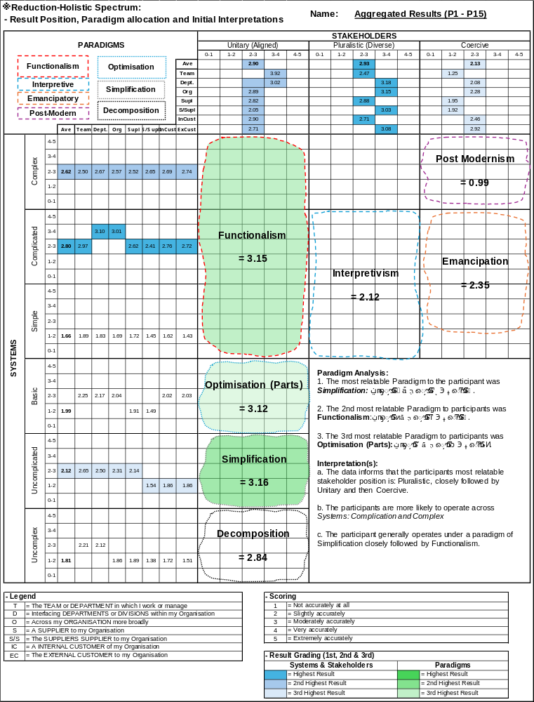
Source: Authors’ own work

Appendix 5: Reconciliation of Questionnaire & Interviews
Element |  | Sub-Element | Questionnaire (1) |  | Interview (2) |  | Change (3) | Representative Quotes (4)
 |  | Sub-Element | Result | Position | Result | Position | Change (3) | Representative Quotes (4)
Stakeholders | Pluralistic |  | 2.93 | 1 | 1.52 | 2 | ↓ (-1) | P4: "The stakeholders' position is: We need this right now; in the form we want it in; they don't have an understanding or appreciation of what it takes to assemble to make it happen."  P15: "We might have the same goal; however, we have very different approaches about how we will go about getting the outcome.  P9: "As a Supply Chain function, we have very dominant and controlling internal stakeholders."
Stakeholders | Unitary |  | 2.90 | 2 | 0.65 | 3 | ↓ (-1)
Stakeholders | Coercive |  | 2.13 | 3 | 2.83 | 1 | ↑ (+2)
Systems | Uncomplicated |  | 2.12 | 3 | 1.09 | 4 | ↓ (-1) | P3: "When you break the job down, the Procurement and Supply Chain function is a fairly basic, repeatable, and controlled process until things go wrong."  P5: "That's probably why I landed on basic, it's a well-oiled machine, goods are coming in, they are processed, and then they go out, in essence, there isn't much more to it than that."  P6: "Regarding Basic, I would say that day-to-day we have a fairly stable organisation and Supply Chain."
Systems | Basic |  | 1.99 | 4 | 1.30 | 3 | ↑ (+1)
Systems | Uncomplex |  | 1.81 | 5 | 0.22 | 6 | ↓ (-1)
Systems | Complicated |  | 2.80 | 1 | 2.00 | 2 | ↓ (-1) | P13: "An example of when a complicated system becomes complex is the new US tariffs, all of a sudden the costs and prices change which are outside of our control, and something that we didn’t think about, and then all of a sudden we need to figure out how to manage this situation, particularly to minimise the impact."  P4: "...the known unknowns have become a lot more prevalent and pronounced, where it is getting challenging to predict when these things are going to occur, or the fact that they are happening more regularly these days."
Systems | Complex |  | 2.62 | 2 | 2.11 | 1 | ↑ (+1)
Systems | Simple |  | 1.66 | 6 | 0.89 | 5 | ↓ (-1)
Paradigms | Simplification |  | 3.16 | 1 | 2.38 | 2 | ↓ (-1) | P2: "I always try to find the simplest way to get the best outcome…. how can we simplify our processes and approaches, improve the relationship with the Supplier, and shorten that Supply Chain?"  P14: "I am more attracted to the Simplification paradigm because it helps me to understand what's going on, and be able to solve a problem quickly, when it arises....When there is a lack of control and understanding of what's going on, managing the Supply Chain gets difficult and complex; that's why it's better to have simple approaches."
Paradigms | Optimisation (Parts) |  | 3.12 | 3 | 2.13 | 3 | ↔
Paradigms | Decomposition |  | 2.84 | 4 | 0.50 | 6 | ↓ (-2)
Paradigms | Functionalism |  | 3.15 | 2 | 2.65 | 1 | ↓ (-1) | P13: "I’m oriented to functionalism as Logistics is all about efficiency…., it’s about maximising the logistics and transport networks, ensuring I get the best bang for my buck."  P8: "The customer wants their products delivered in full on time, all the time, without question; therefore, how can you improve efficiency within the Supply Chain to make this happen?"  P4: "Are we being as efficient as possible, have we removed all the waste in the system to be lean, minimise inventories to ensure we are maximising profitability?"
Paradigms | Emancipation |  | 2.35 | 5 | 0.88 | 5 | ↔
Paradigms | Interpretivism |  | 2.12 | 6 | 1.47 | 4 | ↑ (+2)
Paradigms | Post-Modernism |  | 0.99 | 7 | 0.29 | 7 | ↔
Note: (1) The elements are rank ordered according to the questionnaire results, i.e., the highest returned result out of five. (2) These positions are derived from Interviews, from the number of times a reference was made to one of these sub-elements, with a percentage derived, i.e., Sub-Element divided by the Element. (3) This is the net change between the position returned from the questionnaire and the interview. (4) The quotes are derived from the interviews with participants, with some level of filtering to remove elements that may overtly identify the participant.
Source: Authors’ own work
  - Appendix 6: Influences on the Paradigmatic Perspective (Thematic Analysis)
Theme | Sub-Theme | Interpretation | Representative Quotes
Shift  (44 | 30%) (1) | Organisational Factors  (23 | 15%) | An approach, or reverence for, the Supply Chain can negatively affect the practitioner's propensity to shift from one paradigm to another and progress to a higher order of thinking, given the imperative of short-term outcomes. | P13: “The business still expects the same results from us (Supply Chain), even though we have gone from a Complicated to a Complex System arrangement, however, they are (the organisation) are still thinking we can get the same result, e.g., cost, or responsiveness, but they won't invest in developing the Supply Chain Team, beyond the transactional level, i.e., getting to being more strategic.”  P4: “…the stakeholder, who has the pressure from their customer, needs a solution right now, and their lack of understanding places pressure to be aligned on what actually can occur, and how quickly this could happen.”
Shift  (44 | 30%) (1) | Supply Chain Type  (18 | 12%) | Regulation or characteristics (i.e., cost) inform the type; there is a necessity to conform to the requirements, and a challenge arises if the practitioner seeks transcendence. | P9: “Given the nature of the customers, and the customers' customers, there is a need to be very reactive to a range of problems that you probably know will occur; however, you don't know when they will appear.”  P7: “We need to have a total understanding of our suppliers, their products, processes, certifications, everything, due to the sensitivity of the product, and the negative impact upon people if you get it wrong.”
Disposition  (44 | 30%) | Static  (23 | 15%) | Practitioners, or their stakeholders, view the Supply Chain as fixed in extant positions, which can be classified as preferring existing ways of working, suggesting rigidity. | P9: “The tendency is to work with suppliers that we've always worked with because we know they can deliver the parts in time to meet the target. This tends to build a dominant mindset in the supplier, making it really hard to change.”  P15: “We feel like we need to influence our internal customers continually. Perhaps this is due to the lack of process and frameworks that we can call upon to demonstrate that this is the approach we need to take…. We are virtually trying to convince them that this is the best way to do it.”
Disposition  (44 | 30%) | Dynamic  (21 | 14%) | As the opposite of Static, Dynamic reflects a more positive, outwardly focused disposition in both practitioners and stakeholders, characterised by a willingness to transcend the fixed positions they face. | P13: “An example of when a complicated system becomes complex is the new US tariffs, all of a sudden the prices change which are outside of our control, and something that we didn’t think about, and then all of a sudden we need to figure out how to manage this situation, particularly to minimise the impact upon us.”  P4: “Our ability to deal with these issues externally, e.g., the availability of some products, means that we need to switch to a type of product that is reflective of this. If the product were more standardised, i.e., as per a regulatory requirement or a sophisticated engineering type, we would not be able to cope as well as we do.”
Approaches  (32 | 21%) | Hard  (20 | 13%) | The preference is for process and technology to control the Supply Chain, aiming to achieve stability. There are either regulatory requirements or more deeply rooted ways of working. | P3: “We still need to optimise our part of the process. We need to ensure that we achieve our goals. After securing the supply of the product, we still need to ensure we achieve a fair price to realise our profitability targets.”  P7: “Due to the high level of regulation in our industry, reflected in the product requirements, we can't have a situation of a known-unknown or an unknown's unknown.”
Approaches  (32 | 21%) | Soft  (12 | 8%) | The practitioner prioritises relationships within the Supply Chain, either equivalent to or superseding the process, because of a reverence for people. | P15: “Some parts of the organisation might be ok to sacrifice the supplier; however, I know we need to maintain the relationship, and it’s also the right thing to do.”  P4: “The only way to get them (the Supplier) back onside is through the building of relationships, and having an appreciation for everyone, and the collective understanding of the pressures that we are facing…”
NOTE: (1) These numbers represent the times this Theme and Sub-Theme were identified during the Thematic analysis, alongside the percentages that reflect the position of the Theme/ Sub-Theme as a total of all the elements identified during the study of the Interview
Source: Authors’ own work

