Appendix A
The detailed results that follow for each of the four boundary object capacity options draw upon the qualitative data gathered through survey, interview and MCM activities to describe Participant’s scoring outcomes and the codification strategy rationales articulated by Participants in support of their scoring decisions. Rationale articulations from individual participants have been thematically-grouped as ‘rationale themes’, describing the ‘reasons’ Participants have given to explain their scoring decisions; in this context ‘codification strategy rationale’ and ‘scoring rationale’ are equivalent and interchangeable.
A.1 Option 1 of 4: Common language and syntax
The common language and syntax option explores the first of the four Boundary Object Capacity Schema capacities, introducing Participants to six key characteristics: language and syntax; concreteness; standardisation; modularity; accessibility and required tools; and, synchronisation, versioning and indexing.
A.1.1 Option 1 scoring
This option was scored well, receiving the second most optimistic mean scoring overall and the highest optimistic mean score for five of the ten criteria, including ‘enables sharing and application by others’, ‘enables application by project team’, ‘enables global, broad and systemwide adoption’, ‘supports comprehensive explanation and context’ and ‘demonstrated validation, evidencing and method’. Consistent with the strength of this optimistic scoring, this option also received the second lowest pessimistic mean score overall.
A.1.2 Option 1 rationale themes by project type
The codification strategy rationale themes articulated by Participants in relation to common language and syntax scoring are summarised in Figure 11 below, including the total number of rationale theme references by project type.
Figure 11 – Common language and syntax rationale themes
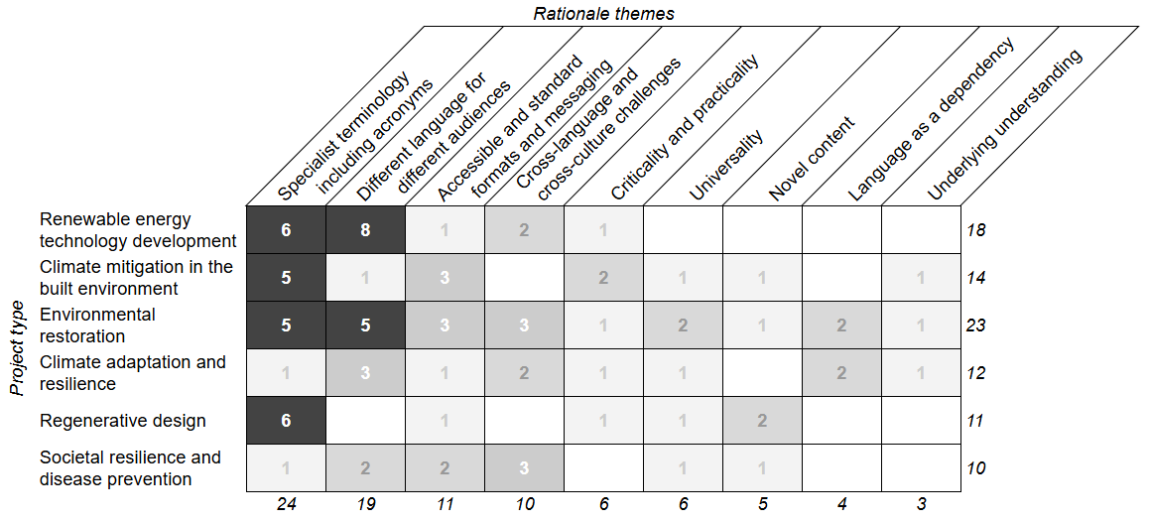
Of the nine rationale themes identified, the most frequently raised were (a) ‘specialist terminology including acronyms’, (b) ‘different language for different audiences’, (c) ‘accessible and standard formats and messaging’ and (d) ‘cross-language and cross-culture challenges’ with corresponding remarks including:
Per (a): “you might say it ‘improves value’ … and if you've got a definition of value as ‘economic value’, and they're like, oh, well, I'm looking for ‘social value’, I'm looking for ‘environmental value’, then maybe the outcome that you've described isn't actually what I'm seeking, even though at first read, it seems like it was” (C12)
Per (b): “when I do those things, I'm writing them for a person in the energy industry, so I would use the languages and structures … you know, someone that basically understands how the energy industry works …. (let’s) use my mother in law as a benchmark for an ordinary person in the street … (she) would be completely baffled by it, I would say, but that's okay. Because if I wrote it for her, the people in the energy industry would get very bored after about the two hundredth page of trying to explain that sort of stuff” (C2)
Per (c): “it's important to standardise it, so then moving forward … learnings are captured in the same way … there might be issues along the way, if everyone's trying to capture in a slightly different way” (C8)
Per (d): “when you're dealing with incredibly smart people, but in another country, which is not adjacent ... there can be quite a few differences ... so when we're dealing with long complex legal type documents, agreements, there can be challenges in interpreting that in the same way” (C27)
Two of the themes were referenced by every project type (‘specialist terminology including acronyms’ and ‘accessible and standard formats and messaging’) while two themes were referenced by ≤50% of project types (‘language as a dependency’ and ‘underlying understanding’).
A.2 Option 2 of 4: Interpretative and translation
The interpretative and translation option explores the second of the four Boundary Object Capacity Schema capacities, introducing Participants to thirteen key characteristics: Declared capture approach; authorship; declared specialist knowledge; context; summary information; narratives and storytelling; quotations; recommended actions; abstracted insights; annotations; engaging format; illustrations and graphics; and, related artefacts.
A.2.1 Option 2 scoring
This option was scored most strongly, receiving the most optimistic mean scoring overall and the highest optimistic mean score for six of the ten criteria, including ‘describes specific characteristics, actions and solutions’, ‘describes benefits, value, vision, criticality and key question outcomes’, ‘describes why unexpected, surprising, not obvious information and questions’, ‘supports continuous improvement, avoiding mistake repetition’, ‘describes new, novel information’ and ‘demonstrated validation, evidencing and method’. Consistent with this optimistic scoring, this option also received the lowest pessimistic mean scoring overall.
A.2.2 Option 2 rationale themes by project type
The codification strategy rationale themes articulated by Participants in relation to interpretative and translation scoring are summarised in Figure 12 below.
Figure 12 – Interpretative and translation rationale themes
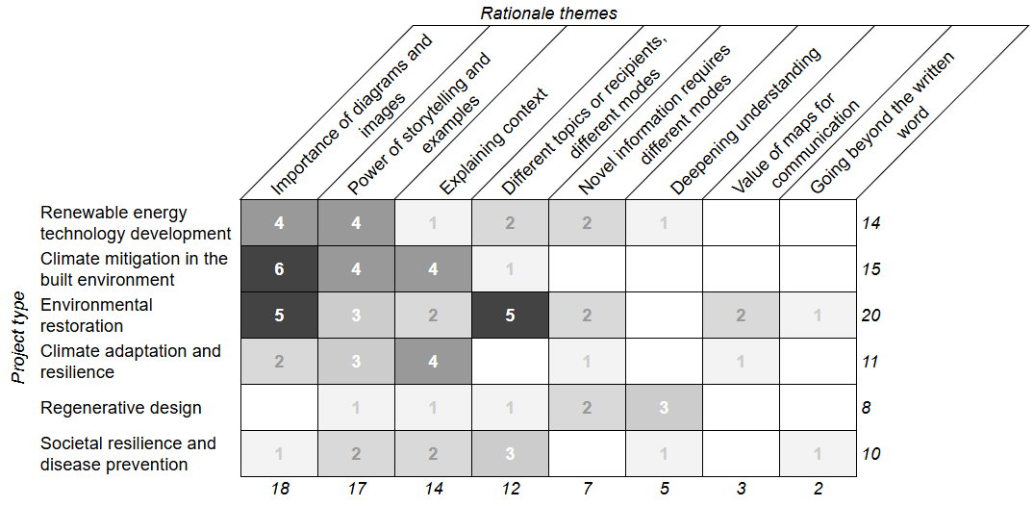
Of the eight rationale themes identified, the most frequently raised were (a) ‘importance of diagrams and images’, (b) ‘power of storytelling and examples’, (c) ‘explaining context’ and (d) ‘different topics or recipients, different modes’ with corresponding remarks including:
Per (a): (we use) “all these big words … people outside of the discipline get a bit lost. So then I use drawings … Venn diagrams … what does ‘transition’ mean, and what does ‘transformation’ mean, and what's in the intersection of the two and what's outside of the two … so diagramming helped a lot to explain the definition” (C16)
Per (b): “I think the storytelling aspect … gives you that opportunity to find the motivator of the different groups of people and get them to understand something really well” (C19)
Per (c): “sustainable development, done well, is about ... the backstory … how did it happen, was it deliberate, was it serendipitous ... why did you do it, why did you undertake that and what motivated you?” (C23)
Per (d): “if you're talking about sustainability back at the community level … songs and stories might be just as powerful as the new policies” (C28)
Two of the themes were referenced by every project type (‘power of storytelling and examples’ and ‘explaining context’) while three themes were referenced by ≤50% of project types (‘deepening understanding’, ‘value of maps for communication’ and ‘going beyond the written word’).
A.3 Option 3 of 4: Transformation to new knowledge
The transformation to new knowledge option explores the third of the four Boundary Object Capacity Schema capacities, introducing Participants to eight key characteristics: Alteration; up-to-dateness; traceability; new knowledge and learnings; enabling practice engagement; enabling negotiation; malleability; and, accommodating multiple purposes.
A.3.1 Option 3 scoring
This option was scored less well, ranking as the third most optimistic mean score overall and not receiving a ‘most optimistic’ score for any of the ten criteria. This option received the second most pessimistic mean score overall and the most pessimistic mean score for five of the ten criteria, including ‘enables application by project team’, ‘describes why unexpected, surprising, not obvious information and questions’, ‘supports continuous improvement, avoiding mistake repetition’, ‘supports comprehensive explanation and context’ and ‘demonstrated validation, evidencing and method’.
A.3.2 Option 3 rationale themes by project type
The codification strategy rationale themes articulated by Participants in relation to transformation to new knowledge scoring are summarised in Figure 13 below.
Figure 13 – Transformation to new knowledge rationale themes
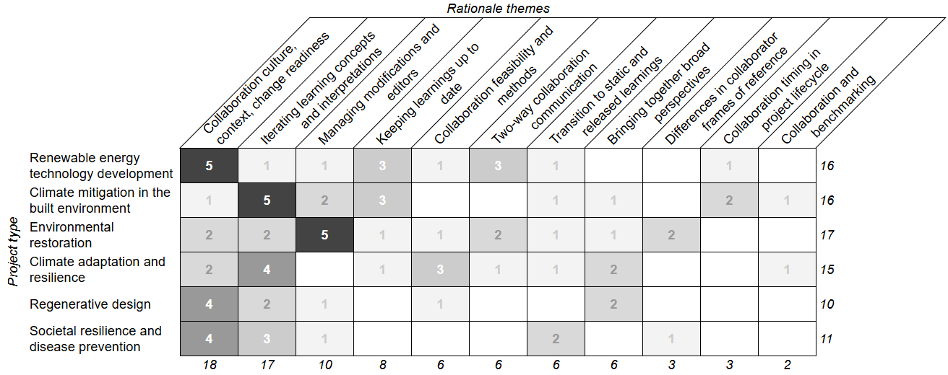
Of the eleven rationale themes identified, the most frequently raised were (a) ‘collaboration culture, context, change readiness’, (b) ‘iterating learning concepts and interpretations’ and (c) ‘managing modifications and editors’ with corresponding remarks including:
Per (a): “when you're trying to develop a business out of faith, you sort of have to keep certain information for yourself … because … IP, or … know how … that's your competitive advantage in the end. So although you want it to be disseminated so that people know what you're doing … and we can work together on it … you still want to keep part of the recipe for yourself” (C6)
Per (b): “we’re actually running an assessment … on the exit, we ran a focus group session … so we've been able to say, okay, ‘that part of the process was awful, everybody hated it, it was a waste of their time’ … so we've been able to sort of like redesign … that part of the process with other communities” (C21)
Per (c): “it needs to be able to be tracked (to avoid) … people just going willy nilly and just making changes … and then … I find in this project that sometimes people maybe lose sight of the bigger picture, and they start getting down into just, you know, maybe losing focus, and at that point … maybe take the comment and say ‘look, this is where we're straying from the goals’” (C14)
Two of the themes were referenced by every project type (‘collaboration culture, context, change readiness’ and ‘iterating learning concepts and interpretations’) while four of the themes were referenced by ≤50% of project types (‘two-way collaboration communication’, ‘differences in collaborator frames of reference’, ‘collaboration timing in project lifecycle’ and ‘collaborating and benchmarking’).
A.4 Option 4 of 4: Temporal orientation
The temporal orientation option explores the final Boundary Object Capacity Schema capacity, introducing Participants to three key characteristics: Timeline alignment; timeframe conception; and, organisation temporality.
A.4.1 Option 4 scoring
This option was scored the least well, receiving the least optimistic mean score overall. A single ‘most optimistic’ score was received by this option (as a tied result) for the ‘demonstrated validation, evidencing and method’ criteria. This option also received the most pessimistic mean scoring overall and the most pessimistic mean score for five of the ten criteria, including ‘describes specific characteristics, actions and solutions’, ‘enables sharing and application by others’, ‘describes benefits, value, vision, criticality and key question outcomes’, ‘enables global, broad and systemwide adoption’ and ‘describes new, novel information’.
A.4.2 Option 4 rationale themes by project type
The codification strategy rationale themes articulated by Participants in relation to temporal orientation scoring are summarised in Figure 14 below.
Figure 14 – Temporal orientation rationale themes
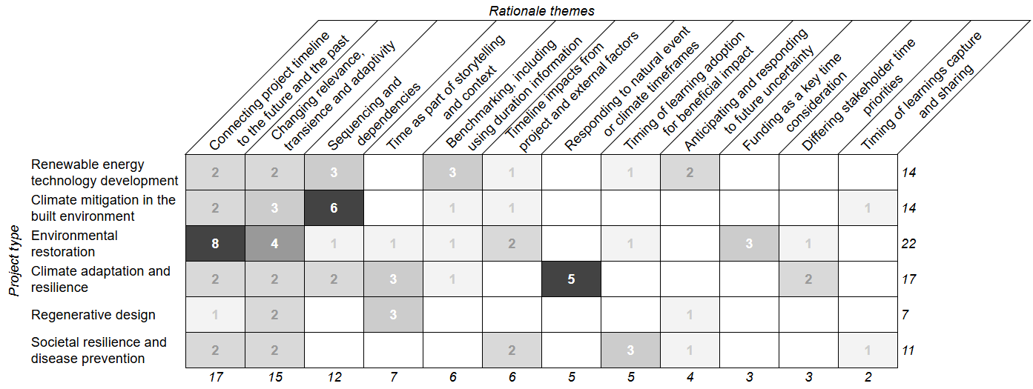
Of the twelve rationale themes identified, the most frequently raised were (a) ‘connecting project timeline to the future and the past’, (b) ‘changing relevance, transience and adaptivity’ and (c) ‘sequencing and dependencies’ with corresponding remarks including:
Per (a): “within the process of regenerative development … we looked backwards, 280,000 years’ ago, maybe a few million, we look at the geology … and then we looked at the timeframes, what are the major things that happened, where is it now, where do we want to be in 50 years’ time, what do we want our grandchildren to see from this?” (C25)
Per (b): “information … becomes more distant and more stale as time passes” (C17)
Per (c): “so many things within construction, are about doing the right thing at the right time … so I think to be able to go and pass on learning … you need to give the context of when was the right time to take action, how long do we take, did it save time … all of those kinds of things … time is really, really important” (C7)
Two of the themes were referenced by every project type (‘connecting project timeline to the future and the past’ and ‘changing relevance, transience and adaptivity’) while seven of the themes were referenced by ≤50% of project types (‘time as part of storytelling and context’, ‘responding to natural event or climate timeframes’, ‘timing of learning adoption for beneficial impact’, ‘anticipating and responding to future uncertainty’, ‘funding as a key time consideration’, ‘differing stakeholder time priorities’ and ‘timing of learnings capture and sharing’).

