Supplementary File 1. Research context
The healthcare sector for people with intellectual disabilities is one of the healthcare settings in the Netherlands where a workforce shortage is prominently evident. Almost 8,600 job vacancies were open in 2023, a 6.2% increase compared to 2022 (VGN, 2023a), and healthcare organizations report that their vacancies are difficult to fill. The absenteeism rate is also steadily increasing, from 7.7% in Q3 of 2022 to 8.3% in Q4 of 2023 (VGN, 2023a). In addition, about 18,000 out of 187,000 professionals caring for people with intellectual disabilities left the setting in 2023 (VGN, 2023a), and the majority of healthcare organizations for people with an intellectual disability face staff shortages in addition to financial losses (VGN, 2023c). To deal with these staff shortages, healthcare organizations feel the need to hire self-employed individuals. In the individual disability care setting, 5,680 self-employed individuals are actively hired, composing ~3% of the overall healthcare professionals employed in this setting (VGN, 2023a). The number of self-employed individuals has steadily increased over the years. Figure SF1 shows the projection of workforce shortages in Dutch intellectual disability care: a projected shortage of 8,400 employees in 2024, increasing to 13,000 in 2028, and skyrocketing to 23,000 by 2033 (CBS, 2024; Figure SF1).

Figure SF1. Projected workforce shortages in Dutch intellectual disability care 2024-2033. Data retrieved from Centraal Bureau voor de Statistiek (CBS). Available at: https://dashboards.cbs.nl/v4/AZWDashboard/
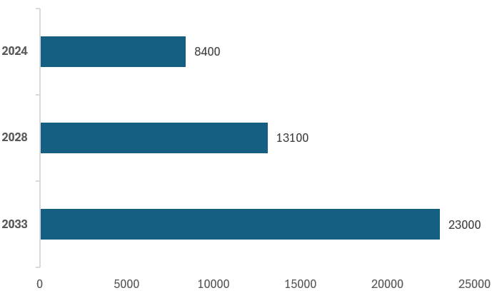
Source(s): Created by authors

Due to increased competition for labor and employee turnover in the healthcare sector for people with intellectual disabilities, healthcare organizations are experiencing both quantitative (in terms of number of healthcare professionals (VGN, 2023b)) and qualitative (in terms of level and skills) frictions in their staffing. Work pressure on incumbent healthcare professionals thus rises, resulting in increased attrition and intention to leave, and effectively creating a vicious circle (CBS, 2024; Regio+, 2024). Figure SF2 provides an overview of demand, supply, and fulfilled demand of healthcare professionals in Dutch intellectual disability care over 2023-2033, highlighting the huge gap between demand and supply of healthcare professionals (CBS, 2024).

Figure SF2. Demand, supply, and fulfilled demand of healthcare professionals in Dutch intellectual disability care 2023-2033. Data retrieved from Centraal Bureau voor de Statistiek (CBS). Available at: https://dashboards.cbs.nl/v4/AZWDashboard/

Source(s): Created by authors

The shortage of healthcare professionals and frequent staff changes also harm the relationship between professionals and clients, which is essential to clients’ quality of support and quality of life. In addition to the ‘standard’ problems arising from high turnover, such as time and resources taken to recruit, train, and supervise new staff, services for people with intellectual disabilities need to consider additional issues that may occur when vacancy and turnover rates are high. Relationships with staff can be quite important for people with intellectual disabilities. When staff leaves there is a negative emotional impact on people with intellectual disabilities that is associated with increases in challenging behavior.
References
Centraal Bureau voor de Statistiek (CBS). (2024), “Dashboard Arbeidsmarkt Zorg en Welzijn”. Retrieved from https://dashboards.cbs.nl/v4/AZWDashboard/
Vereniging Gehandicaptenzorg Nederland (VGN). (2023a), “Kengetallen Medewerkers in de gehandicaptenzorg”. Retrieved from https://www.vgn.nl/system/files/2023-07/Kengetallen%20Arbeidsmarkt%20GHZ%20-%205%20juli%202023.pdf
Vereniging Gehandicaptenzorg Nederland (VGN). (2023b), “Arbeidsmarkt gehandicaptenzorg: een situatieschets”. Retrieved from https://www.vgn.nl/achtergrond/arbeidsmarkt-gehandicaptenzorg-een-situatieschets
Vereniging Gehandicaptenzorg Nederland (VGN). (2023c), “Financiële problemen gehandicaptenzorg”. Retrieved from https://www.vgn.nl/financiele-problemen-gehandicaptenzorg
Regio+. (2024), “Arbeidsmarktinformatie”. Retrieved from https://regioplus.nl/oplossingsrichtingen/arbeidsmarktinformatie/

