Impact Pathways: Improving Medicine Access Through
Cross-National Stockpiling Online Appendix

A World café workshop
Set-up. We performed a three-round world-café workshop. The workshop consisted of three consecutive rounds of conversation, approximately 30 minutes each, followed by a plenary summary of overall conclusions. Each round corresponded with two unique questions. In rounds two and three, we first summarized the answers to the questions discussed in the previous round(s), allowed participants to react and provide additional answers, and subsequently started the discussion on that round’s questions. See below for the questions we discussed. The three rounds were hosted by two members of the author team, who also provided the summaries of the previous rounds and the plenary summary. As is common for world-café workshops [Löhr et al., 2020], participants provided their answers by writing them on sticky notes. In total, we collected 56 sticky notes, which formed the source for the quotes in the paper.
Data analysis. We analyzed the quotes along three dimensions:
- The perceived need for some form of cross-national stockpiles (in the context of this workshop: coordination of stocks at the EU-level).
- The perceived relevance of open questions listed in our three impact pathways.
- Open questions not yet covered by the impact pathways.
This analysis confirmed 1) and 2): There was uniform agreement on the need for some form of cross-national stockpiling, and the relevance of none of our pathways was questioned (we explicitly discussed our pathways regarding the need for better evidence on cost-effectiveness, the stockpiling archetype, the scope and quantities, product form, and fair financing and allocation mechanisms). Our analysis also led to an additional question regarding the impact of various perceived barriers on the cost-effectiveness of stockpiling, which we embedded in pathway 1.
Participants. The workshop attracted 38 participants. Two represented hospital organizations. Two represented policy makers. Two represented pharmacy associations. Four represented the pharmaceutical industry (wholesalers and manufacturers). Three represented organizations involved in drug shortage management. Fifteen were academics working at various business schools and involved in research on drug shortages. Ten were academics working at other schools and involved in research on drug shortages.

Questions discussed during the workshop.
- Round 1 — In your view, should countries be adopting minimum stock obligations at all? Why? Pointers: Think about feasibility of implementation, cost/price impacts, impact on shortages, impacts on market attractiveness...
- Round 1 — Are minimum stock obligations only an intermediate solution or are they there to stay? Why?
Pointers: Think about feasibility of implementation, cost/price impacts, impact on shortages, impacts on market attractiveness...
- Round 2 – In your view, how feasible is it to differentiate minimum stock obligations across different categories of medicines? E.g., to have 2, 4, or 6 categories with a different minimum stock level per category? What are the pros and cons?
Pointers: Think about feasibility of implementation and monitoring, cost/price impacts, impact on shortages, impacts on market attractiveness...
- Round 2 – For which categories of medicines should a relatively high minimum stock level be considered? For which categories should a relatively low minimum stock level be considered? Why?
Pointers: Think about feasibility of implementation, cost impacts, impact on shortages, impacts on market attractiveness...
- Round 3 – In your view, should countries be coordinating their minimum stock obligations? Why? And should they expand mechanisms to facilitate swift stock transfers to countries with a shortage? Why?
Pointers: Think about the feasibility of implementation and monitoring, cost/price impacts, impact on shortages, impacts on market attractiveness...
- Round 3 – Should the EU step up efforts to ensure minimum stock levels at the EU level? How? Pointers: Think of 1) whether this should come in the form of an EU-level minimum stock obligation and stock monitoring, 2) whether this should come in the form of EU-held stocks, 3) whether this should be for APIs, white label stock, or finished products. Think about feasibility of implementation, cost impacts, impact on shortages, impacts on market attractiveness....

B Data cleaning
Historical data is lacking as the majority of countries report active shortages only. Therefore, there is no common ground to examine co-occurrence over time. We therefore select one specific date to compare active shortages across countries: May 15th, 2021.
The twelve shortage catalogs differ significantly in terms of the time frame over which shortages are included. Some report both past and currently active shortages, some only register currently active shortages, and others do not clearly distinguish between the two since (consistent) registration of (expected) end dates is lacking. Besides active and inactive shortages, we therefore introduce a category of presumably active shortages:
- Active shortages. All shortages that have a start date before May 15, 2021, and an expected end date in the future (after May 15, 2021).
- Presumably active shortages. All shortages that took place later than January 1st, 2020, but do not mention an (expected) end date.
- Inactive shortages. Shortages that started and ended before May 15, 2021, or those that started before January 1st, 2020, but do not mention an end date.
We chose May 15th, 2021 as the reference point for comparing shortages because this was when all data was retrieved from the national shortage catalogs. We chose the date January 1st, 2020 (i.e., 16.5 months before May 15th, 2021) as a conservative cut-off point from which we presume a shortage without an end date to be active. Shortage registers from countries reporting strictly active shortages show that shortages rarely last longer than 16.5 months [BfArM, 2021, AEMPS, 2021, Lakemedelsverket, 2021]. We use this cut-off point conservatively because it supports the robustness of our key conclusion: that there is little co-occurrence of shortages, even when all those shortages are assumed active.

C Comparability of datasets on shortages
Before comparing national shortages across countries, it is important to assess the comparability of the shortage catalogs of the twelve different countries. We compare the countries along the four dimensions proposed by Troein et al. [2020]: (1) the key term, (2) the classification criteria, (3) the scope, and (4) the owner of notification.
- The key term used to describe the concept ‘shortage’. Alternatives to the word ‘shortage’ include ‘supply problem’ or ‘disruption’.
- The classification criteria to label a shortage as such. The criteria can differ even when countries use a similar or the same key term [Troein et al., 2020]. For example, the European Medicines Agency (EMA) defines a shortage as a situation where supply does not meet demand, whereas some countries define it as a situation where supply is disrupted.
- The scope is the level at which a shortage must occur (e.g., national or regional) to be labeled as such.
- The owner of notification is the entity responsible for monitoring and reporting shortages. For example, EMA standards define a marketing authorization holder (MAH) as the responsible entity. However, in some countries pharmacies are responsible for registering shortages [Troein et al., 2020].
Our analysis revealed that countries differ along yet another dimension:
- The time-to-trigger for a shortage is the amount of time the criteria must be met before it is labeled as a shortage.
Table 1 depicts the comparability of the 12 countries in this study. It shows a country’s flag for a given dimension if the country aligns with the benchmark for that dimension. We use the EMA definition (dimensions 1-3), reporting standards (dimension 4), and 14 days (dimension 5; this is the most common time-to-trigger) as benchmarks.
Table 1: Alignment of shortage definition elements (flag = country aligns with benchmark). Source: Created by author team
Key element shortage definition | Aligned countries | Percentage
1. Key term |  | 50%
2. Shortage classification criteria |  | 58%
3. Scope |  | 83%
4. Owner of notification |  | 83%
5. Time-to-trigger |  | 42%
The key insight is that none of the countries aligns 100% with the benchmark. As we argue in Appendix D, misalignment of shortage definitions in terms of the key term, shortage classification criteria, scope, and the owner of notification likely leads to an overestimation of the amount of overlap. This supports the robustness of our key conclusion: even under such overestimation there is little co-occurrence of shortages. Misalignment in terms of time-to-trigger may lead to a slight underestimation.

D Alignment of shortage definitions
In what follows, we discuss implications for the comparability of datasets.
Key term (1). Only half the countries refer to the items included in their catalogs as “shortages”. The other half refers to events or conditions that could potentially lead to shortages. Examples include “limited ability to sell” (Austria), “temporary unavailability” (Belgium), “supply issues” (Denmark), “supply disruptions” (France), “supply bottlenecks” (Germany), and “supply problems” (Spain). Including potential shortages that do not become actual shortages in our analysis will yield a conservative estimate of the amount of overlap and help assess the robustness of our main conclusion.
Shortage classification criteria (2). The EMA defines a shortage as a situation in which supply is not able to meet demand. Six out of 12 countries use the same criterion. Five out of 12 countries do not consider the demand side (i.e., they emphasize supply issues only), which may lead to the inclusion of potential shortages and, hence, a conservative estimation of overlap. For example, France classifies situations when a pharmacist is unable to stock medicines as a shortage, and Hungary does so when an MAH is unable to supply. Among the countries considered, Denmark is the only country that uses stricter criteria than the EMA by requiring that the supply issue should have “serious consequences” or be “potentially life-threatening”.
Scope (3). Two out of 12 countries include regional shortages in their catalogs, while the EMA definition covers national shortages only. Two countries explicitly mention that they only include national shortages. The remaining countries do not specify the scope. Given that almost all shortages occur at a national level (HMA, n.d.), we assume that the majority of the reported shortages are at that level and that those countries comply “de facto” with the EMA in this perspective. Given that our analysis considers the overlap of national shortages across countries the fact that the catalogs may include sub-national shortages can lead to over-reporting and a conservative estimation of overlap.
Owner of notification (4). In 83% of the investigated countries, the MAH is responsible for monitoring and reporting medicine shortages and supply disruptions. Only France and the Netherlands have reporting mechanisms in which the pharmacist is responsible for shortage reporting. MAHs have been argued to be risk averse while reporting shortages, since there are no consequences for reporting shortages that have no real impact in practice. However they do have a real impact. MAHs are often held financially and legally liable. This may again induce an overestimation of the overlap in shortages across countries.
Time-to-trigger (5). In 42% of the countries (e.g., Germany and Norway), a shortage/disruption should last at least fourteen days to be included in the shortage catalog. Other countries use 72 hours (France) and three weeks (Sweden) as the “time-to-trigger”. Austria has more granular criteria: an “unavailability” should be reported when it lasts at least two weeks, and a situation of “limited availability” when it lasts at least four weeks [Bundesgesetzblatt, 2020]. The remaining countries do not specify the minimum duration of a shortage/disruption. The implication is that some short shortages/disruptions may not have been entered into the catalog of some countries, potentially leading to an underestimation. However, given that short shortages are rare (The European Commission, 2021 estimates the average duration at 137 days), the bias induced by this can be assumed small.

E Co-occurrence of shortages per ATC 1st level category
A key question for decision-makers is whether certain types of medicines have a relatively high or low risk of a multi-country shortage. Figure 1 presents the absolute number of multi-country shortages per country and per ATC 1st level category (i.e., letter A, B, ..., V) at our reference date: May 15th, 2021. In line with previous studies, most multi-country shortages occur in categories N (Nervous system), J (Anti-infectives), and C (Cardiovascular system). However, those categories also contain the largest number of ATC 5th level categories. Figure 2 depicts the proportion of ATC 5th level categories with a shortage, showing that multi-country shortages are most prone to occur in category G: Genito-urinary system and sex hormones. The figure also shows that multi-country shortages are rare for categories D, H, P, R, S, and V. Pooled stockpiling appears particularly attractive for those categories (in comparison to national stockpiling).
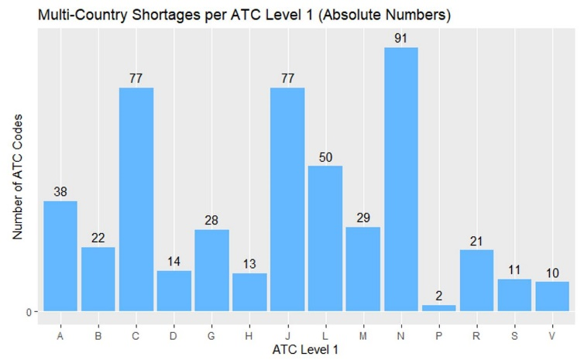
Figure 1: Number of ATC 5th level categories with a multi-country shortage. Source: Created by author team.

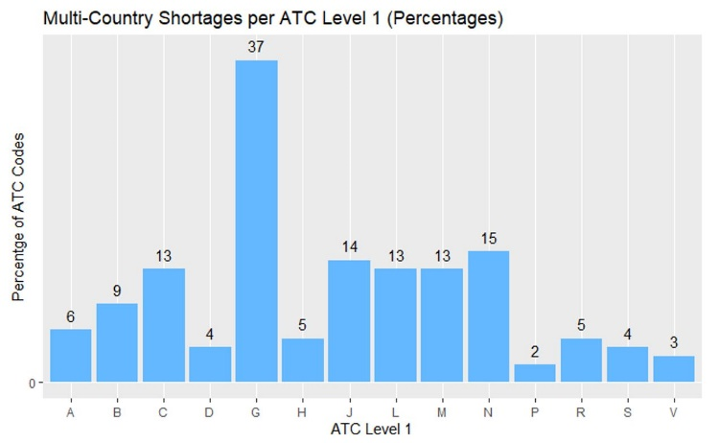
Figure 2: Proportion of ATC 5th level categories with a multi-country shortage. Source: Created by author team.

References
AEMPS. Problemas de suministro de medicamentos, 2021. Retrieved from: https://www.aemps.go b.es/acciones-informativas/boletines-de-la-aemps/problemas-de-suministro-de-medic amentos/ (Accessed: May 23rd, 2021).
BfArM. Lieferengpässe, 2021. Retrieved from: https://www.bfarm.de/DE/Arzneimittel/Arzneim ittelzulassung/Arzneimittelinformationen/Lieferengpaesse/_functions/Filtersuche_Fo rmular.html?nn=11296612 (Accessed: May 14th, 2021).
Bundesgesetzblatt. Verordnung des bundesministers für soziales, gesundheit, pflege und konsumentenschutz über die sicherstellung der arzneimittelversorgung, 2020. Retrieved from: https://www. ris.bka.gv.at/Dokumente/BgblAuth/BGBLA_2020_II_30/BGBLA_2020_II_30.html (Accessed: June 22th, 2021).
Lakemedelsverket. Restsituationer, 2021. Retrieved from: https://www.lakemedelsverket.se/sv /behandling-och-forskrivning/forskrivning/restsituationer (Accessed: May 14th, 2021).
Katharina Löhr, Michael Weinhardt, and Stefan Sieber. The “world café” as a participatory method for collecting qualitative data. International Journal of Qualitative Methods, 19:1609406920916976, 2020.
P. Troein, M. Newton, A. Wasik, C. Coucoravas, and K. Scott. Reporting of medicine shortages in Europe. Technical report, IQVIA, 2020.

It is important to note that category G contains relatively few 5th level categories, and that the proportion in shortage may vary significantly over time.

