ONLINE SUPPLEMENTARY MATERIALS
Vignette Description
Organization: WholePalm
Sector: Palm oil wholesaler
You have been an account manager at WholePalm for 3 years. WholePalm is a medium sized palm oil wholesaler who contracts with consumer food goods manufacturers. WholePalm is a middle-party who purchases refined palm oil from a supplier and sells it to manufacturers (your customer).
Contract
WholePalm has recently secured a new customer, Foodz Inc. The contract amount is for 10,000 metric tons (mt) of refined palm oil at 1,650 €/mt. Additionally, Foodz Inc has started imposing serious economic sanctions to their first-tier supply contracts (including WholePalm) in response to increasing consumer pressure to address upstream supplier sustainability risks. Palm oil production involves social risks which can have serious human and economic consequences to all parties in the supply chain. If a social issue is exposed in connection to one of your suppliers, WholePalm will have to pay a 2.5 million euro penalty to Foodz Inc.
Product Information
One of your key suppliers in Malaysia, who sources from multiple growers, has sent you a binding offer of 10,000 metric tons for two different palm product options.
Option 1: mass balance, where both uncertified and certified sustainable palm fruit is mixed at the refinery. In mass balance, palm oil is untraceable to specific growers but addresses some social concerns. This option costs WholePalm 1,400 €/mt.
Option 2: certified, where certified sustainable palm fruit is separated at the refinery and supplied. With certified, palm oil is traceable to specific growers. This provides social transparency in palm production and carries a price premium of 125 €/mt, costing WholePalm 1,525 €/mt.
Sustainability and Risks
Your customer, Foodz Inc, wants to mitigate supply risks while keeping costs to a minimum. Palm oil is a cheap commodity with tight competition, and while end consumer preferences have shifted away from conventionally unsustainable palm oil, the market demand doesn’t currently support the cost of fully certified sustainable palm oil trade (hence mass balance being industry standard). Certified palm plantations follow guidelines (set by the global certification agency for palm oil) to uphold standard labor conditions, reducing social risks to a negligible amount. This helps protect from common issues in production.

SIS Manipulated Condition: For example, a recent Associated Press report found that workers across 24 large plantations regularly were underpaid or withheld wages from employees for months at a time. Many of the interviewed employees were immigrant contract workers, and therefore were unable to lodge formal complaints without fear of reprisal.

It is estimated that in mass balance, 50% (RPA Manipulated Condition: 40-60%) of supplying palm plantations engage in unethical labor practices.
The following table provides the summary of cost, risk and expected profit values.
Contract Options Summary
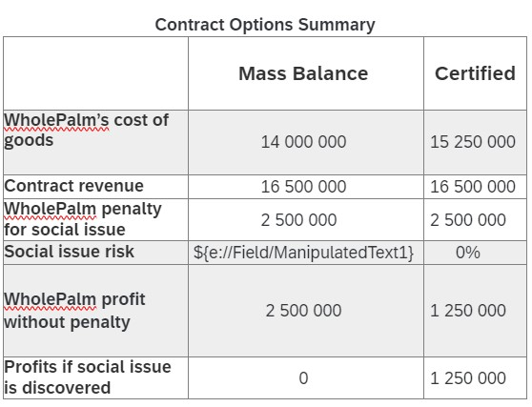
(Source: Authors’ own work)
Product Decision (binary variable)
Given Foodz Inc.'s interests, your costs, profit and risks, you must make the final product choice for WholePalm. You choose to purchase:
- Certified
- Mass Balance
*The order of options ‘Certified’ and ‘Mass Balance’ being shown to participants were randomized.
Pilot Study: Student sample description
The complete sample of students who passed all of the comprehension and checks related to their manipulation was 170 students (out of 196), consisting of 84 identifying females and 86 identifying males. 4 students preferred not to answer this gender question and were left out due to insufficient data points to analyze separately. 122 were Finnish and included international students from 21 other countries. The average age was 25 with little relevant work experience. The majority (86%) were business master’s students, but the experiment also took place halfway through the course, making all participants knowledgeable enough about the topic.

No significant differences between classroom data collected in 2022 and 2023 were found, nor was there a significant difference between online and in class participation (both years, both participation options were available to students, but regardless of participation mode, all students completed the experiment at the same time during a hybrid class). Therefore, the analysis could be done on the combined data set.

The risk preferences of students were determined in an exercise completed before the main experiment. Financial and social risk domains from DOSPERT (Blais, 2006) were measured on a Likert 5 item scale and given values of 0-4, the average of which determined the value of everyone’s risk preferences per domain. The closer to zero, the more risk tolerant participants were. DOSPERT is one way to establish differences in baseline risk preferences across different domains, in our case, financial and social (Weber, 2002). This was collected as a pre-experiment exercise so as not to induce demand effects afterwards (Eckerd et al., 2021). These would later be used as controls to see whether these measures of risk perceptions and behavior effect product choices.
Reflecting losses and gains, participants would only receive i) 1 point if they chose mass balance and the risk was realized, ii) 2 points if they chose the certified option (in which case there was no risk to be realized) or iii) 3 points if they chose mass balance and the risk was not realized. The final risk outcome was randomly generated based on given probability of issue occurrence. Because of the ethical constraints when using students as participants, no post-experiment questions were asked about gender related aspects that may have explained any difference in risk preferences based on gender roles and expectations.

Table A. SC student sample: OLS Regressions of Choice with Heteroskedastic Standard Errors
Variables | Model A1 |  | Model A2
Variables | β coefficients  (std. errors) | 95% CI | β coefficients  (std. errors) | 95% CI
Intercept | 0.895 **** (0.03) | [0.85, 0.94] | 1.006 **** (0.19) | [0.63, 1.38]
RPA | -0.005 (0.05) | [-0.10, 0.09] | 0.000 (0.05) | [-0.10, 0.10]
SIS | 0.040 (0.05) | [-0.06, 0.14] | 0.049 (0.05) | [-0.05, 0.15]
Gender | 0.103 (0.05) ** | [0.00, 0.20] | 0.102 (0.05) ** | [0.00, 0.20]
RPA* SIS | 0.131 (0.10) | [-0.07, 0.33] | 0.137 (0.10) | [-0.07, 0.34]
RPA * Gender | 0.138 (0.10) | [-0.06, 0.34] | 0.119 (0.10) | [-0.08, 0.31]
SIS * Gender | -0.007 (0.10) | [-0.21, 0.19] | 0.016 (0.10) | [-0.18, 0.21]
RPA * SIS * Gender | -0.232 (0.20) | [-0.63, 0.16] | -0.223 (0.20) | [-0.61, 0.17]
Social risk taking (DOSPERT) |  |  | -0.084 ** (0.04) | [-0.16, -0.01]
Other controls¹ |  |  | included  (not significant)
Sample size | 170 |  | 170
R-squared | 0.0671 |  | 0.110
F-statistic | 1.664 |  | 1.482
*p-value < .10.; **p-value < .05.; ***p-value < .01; ****p-value < .001
¹ business studies; age; financial DOSPERT domain; time; level of study
Regression of treatment condition on choice (mass balance or certified product) with females being coded as ‘1’ for the gender

(Source: Authors’ own work)

