Unlocking Online Product Returns Behaviour: The Influence of Product Attributes on Customer Interaction Styles

Online Appendix A. Intrinsic and extrinsic product attributes’ description and expected relationships (Source: Authors own creation)
Product attribute |  | Description and their importance to customer satisfaction and behaviour study
Search intrinsic attributes | Primary and secondary features | Features involve the number, complexity and uniqueness of the characteristics that distinguish among product models (Brucks et al., 2000). Primary features refer to the essential purpose and operational aspects, encompassing technical considerations, and functional attributes. Secondary features refer to complementary features supporting the basic functions and making the product more appealing. The prevalence of multifunctional products makes this attribute an important factor influencing customers behaviour (Decker and Trusov, 2010; Tirunillai and Tellis, 2014).
Search intrinsic attributes | Physical appearance | Physical appearance refers to the product’s exterior, aesthetic design (e.g., appearance, colour, shape, and size). Patrick and Hagtvedt (2011) studied the aesthetic incongruity concept in which customers often seek aesthetic harmony when placing a product in its spatial and contextual surroundings. Any incongruity (e.g., unmatched colours) would cause remorseful emotion, influencing their behaviour.
Experience intrinsic attributes | Performance | Performance attribute refers to the product’s effectiveness in fulfilling its intended function (Brucks et al., 2000). Anderson (1973) posited that how customers perceive product performance is explainable through the assimilation-contrast theory. If the gap between initial expectations and actual performance fits into the assimilation zone, customers may generate downward counterfactual thoughts which alternatives are worse than the actual performance to mitigate dissatisfaction (Wang et al., 2011). However, if a substantial dissatisfaction exists, falling into the contrast zone, customers may emerge with upward counterfactual thoughts which alternatives are better than actual performance making them feel remorseful.
Experience intrinsic attributes | Durability | This attribute measures the product lifetime which is the amount of use the consumer gets from a product before it deteriorates (Garvin, 1987). According to the emotion duration bias theory, customers’ expected product durability can form their affective forecasts, that is, they tend to anticipate a longer product lifespan than intended (Wood and Bettman, 2007). If product end of life occurs due to normal “wear and tear” reason, customers maintain positive emotions. When customers experience the product’s shorter-than-expected lifespan, their positive emotion terminates abruptly, and they could quickly emerge dissatisfaction.
Experience intrinsic attributes | Reliability | Reliability refers to the probability of a product breakdown during its normal life cycle (Garvin, 1987). A reliability issue includes malfunctioning out of the box or after the first few uses. From the lens of product defect severity, customers may experience intensive irritation if the product fails shortly after purchase, leading them to perceive a lack of usefulness (Klutke et al., 2003).
Experience intrinsic attributes | Ease of use | Ease of use refers to customer experience on how easily they can use a product or service. Based on technology acceptance model (Davis, 1989), this attribute is one of the keys searching and buying criteria. If a product is not user friendly, customers will perceive less usefulness and subsequently arouse a negative attitude.
Extrinsic attributes | Product information mismatch | Product information mismatch refers to how the discrepancy of information perceived by customers between the pre-purchase stage (i.e., provide by sellers) and post-purchase stage (i.e., perceive through actual product experience) (Martínez-López et al., 2022). In practice, most sellers are aware that customers cannot physically inspect the product in online market, which leads to the information asymmetry (Fan et al., 2020). They usually exaggerate/distort the actual information to boost sales such as using digital photo manipulation. This false advertisement can be counterproductive as customers may emerge scepticism if the information is surreal.
Extrinsic attributes | After-sales services | After-sales services refer to customer experience on the seller’s supports during post-sales (e.g., helpdesk, instruction, communication). SERVQUAL model is usually used to study customers’ perception on after-sales service quality (Parasuraman et al., 1988). Any failure in this model will lead to a dissatisfaction, subsequently reducing loyalty, and retention (Sousa and Voss, 2009).
Extrinsic attributes | Warranty | Warranty refers to the guaranteed services offering that the defective product can be troubleshot by manufacturers or a warranty company (Brucks et al., 2000; Garvin, 1987). Customers typically turn to warranty services when they encounter product issues that they are unable to resolve, considering warranty as their last resort before returning. If customers experience warranty service failure, they are more likely to express dissatisfaction and anger.
Extrinsic attributes | Logistics service quality | Logistics service quality attribute refers to the fulfilment stage of the product including packaging of the product, delivery, etc. This attribute is for business to create competitive advantage (Nandankar et al., 2023). Since customers have high expectation towards logistics services quality, any inaccurate, poor condition products due to the poor logistics service will force them to seek for corrections from sellers (Mentzer et al., 2001).

Online Appendix B. Variable extraction and validation

Online Appendix B1. Unstructured and structured data cleaning process
Textual data exhibits a significant degree of unstructured information. Consequently, specific pre-processing methods are employed to eliminate any noises within each review. The methods utilised in this study consists of:
- Identify and replace all contractions (e.g., “we’re” to “we are”) and slang words (e.g., rll?y to really, asap to as soon as possible);
- Eliminate punctuation marks, symbols and non-alphabetic characters;
- Convert uppercase words to lowercase;
- Utilise TextBlob for spell checking (Lorla, 2020);
- Implement our custom program for detecting negative expressions, such as converting “not return” to “NOTreturn”. This step is paramount important to find the negative expression precisely;
- Remove English stopwords – words with frequent occurrences but lacking unique informational value;
- Tokenise sentences and lemmatise words – transform each word in a sentence to its base form and break words into tokens. This process has been demonstrated to enhance the comprehensibility of topic modelling methods (Vanhala et al., 2020);
- Construct bigram and trigram models – combine two or three words likely to appear together as phrases to improve the meaningfulness of the topic models;
According to our metadata, several features contain missing values – specifically, 25% for price, 4.7% for sales rank, and 0.01% for product image. To maintain data integrity and avoid sampling bias, we opted not to remove these entries as their other features are still valuable. Instead, we employed iterative imputation techniques, leveraging ML methods to estimate the missing values based on patterns observed in the other features (Buck, 1960; Buuren and Groothuis-Oudshoorn, 2011).

Online Appendix B2. Product attributes labelling
Table B2.1. Product quality attributes labelling (Source: Authors own creation)
LDA topic | Examples of keywords and phrases | Representative reviews and topic dominance percentage | Assigned attribute
0 | Stop_work_week, stop_charge, suddenly_stop, notlast_long, month, day, time, week, it do not last, it take weeks, it last months, few months, few weeks, battery life, month of use | - I purchased from this seller a few years ago and the battery worked just fine. Over time the battery life deteriorated and now it only holds charge for about 45 minutes… (97.92%)  - Worked fine for a little over a month and just after my return window closed it stopped working out of nowhere… (97.82%)  - I bought this for my adult son in December of 2016. It worked great for a while. then one day, June of 2017, only 6 months later, it just quit working… (97.82%) | Durability | Intrinsic
1 | Mbps, signal_strength, work, well, use, try, lose connection, drop connection, have range, line of sight | - … all that said I am unsatisfied with the Wi-Fi signal, not to the point of returning/throwing it out and getting something better, but to the point of major disappointment. The router is located centrally in our small, single story, 950 sq. ft house, yet signal at the corners of the house, the garage, and outside is unreliable at best, mostly non-existent… (98.82%)  - … the router installed easy and when I run a speed test now I am seeing 119/23 mbps on the xfinity speed test page, but my webpages are loading extremely slower than the netgear router did and that was only capable of handling 25mbps… (98.57%)  - Well, it does work...but going through the extender will cost you most of your throughput speed… (98.33%) | Performance | Intrinsic
2 | Use_hub, scroll_wheel, trackpad, space_bar, skin, letter, use, usb port, hard drive, key on keyboard, key, card | - … Even though transfer attempts crashed, reader still got quite warm. (it is also weird to put the SD card into the USB end, but that is not a fault). Returning (96.84%)  - Could not boot PC, board was showing error code 55 for no memory. After dropping to a single stick of ram and testing each slot found that the first and second slots for ram were dead… (96.73%)  - This was great until someone at work lost the USB key that ... (96.73%) | Primary features | Intrinsic
3 | Audio quality, it make noise, it have bass, quality of sound, sound, sound_quality, notsound, noise_cancellation | - These are literally the worst headphones I have ever had in my entire life and I have had many. They sound really really really bad… (98.33%)  - …Sound quality was good, did not like quite as much as the dt880… (98.3%)  - I was so bummed about the quality of this speaker that I returned it. It is a great speaker for on the go, however l was looking for clear, loud sound with a lot of bass… (96.73%) | Performance | Intrinsic
4 | It do notwork, they have issues, it have flaw, notwork for, issue with, they have defect, it manufacture defect, defective unit, work, Barely_hear, cheap_material, notconnection, | - Very soon after purchasing, the wire begins to separate from the connector… (95.83%)  - …All of us who had to replace this this power supply, did so due to the first one failing. So, I cannot really give it high praise. (94.6%)  - if I did not have to replace the little suction cups upon arrival I would have given it a better rating. (94.27%) | Reliability | Intrinsic
5 | Case, cover, fabric, screen protector, case donot fit, bottom of case, part of case, look, cover, crack, fit, nice, it do notfit | - … The case itself is not any good since it holds down the power button. when I initially put this on my iPod, my iPod wanted to turn off… (97.92%)  - I loved the design of the case but for whatever reason the bottom part kept coming off. the case was also heavy, something I did not think about when I was purchasing it… (97.45%)  - I expected a cover similar to those sold by Apple which have a magnetic clasp and cover only the screen-side of the iPad. This was not that… (97.04%) | Secondary features (primary features of electronics accessories) | Intrinsic
6 | Picture quality, image quality, dead pixels, problems with side/middle/center of screen, good, quality, image, highly_disappointed | - Bad and aged menu that for some is impossible to navigate, the white is not pure on this monitor and has a noticeable portion of yellow with it, the display is dim and is a struggle to look like an actual led screen, the text is noticeably blurry and even with sharpness at 100%, it is still blurry… (98.27%)  - Not a bad lens for the money but I found the photos not quite as sharp as I hoped… (98.27%)  - I loved the auto set feature, but the screen does not dim enough. the lowest dim setting is still too bright, next setting is off… (96.47%) | Performance | Intrinsic
7 | Notfit_properly, it do notfit, zipper_break, hurt_ear, mm, bag, big, small, look, fit, it donot fit, big for tablet, size of | - Really well made, but way too small. I have a sleeve for my laptop (because this bag offers no padding) and it is impossible to fit in here. even without the sleeve, this bag offers little to no room for additional items… (97.71%)  - It is a nice looking bag, and the color is awesome!, but I decided the 1 x11 was too small (it looks more like a purse at that size). So, I am trying a couple of others sizes larger, … (97.04%)  - These are horrible quality. The metal pressed unevenly and with creases and there are straps coming out of the metal piece. This is honestly one of the poorest quality things I have ever bought off Amazon… (96.33%) | Secondary features (primary features of electronics accessories) | Intrinsic
8 | Virtually, they change information, confusing misleading emails, wrong size, product description, notwork out, notwork with, description of product, dell tablet notcompatible, compatible product | - Apparently not made by Motorolla and was unable to get a proper cradle charger. Ordered 4 from online, model numbers listed as proper chargers but were not the right ones. Returned radios and wrong chargers. wasted time and effort. (96.18%)  - Ordered this product but it was not compatible with my iPhone 6, which I had purchased it for… (95.63%)  - Do not buy this. Reasons: 1. Item description is inaccurate: the item description on amazon says this is a 5v 1.5a adapter. what I received is a 6.2v 1a adapter (see attached picture). 2. item is not legible for return. (95.63%) | Product information mismatch | Extrinsic
9 | Protection_plan, square_trade, cobra, warranty, repair, call, they send replacement, it have warranty, customer service, year warranty, new one, proof of purchase | - Buyer beware - contacted Samsung about start up issues while under warranty and they refused to cover repair… (97.52%)  - WD doesn’t allow me to RMA the disk despite it failing the smart test and has many bad sectors. the states that this is "out-of-region". and I cannot return it. why then does amazon allow me to buy and ship it out of us! WD is very inflexible with its warranty and now I am stuck with a 6-month-old disk with no RMA… (96.18%)  - HD failed after 6 months, tried to return/warranty from manufacturer. Information would not take. Looks like this will be a complete loss of money. Keep in mind warranty will only be Amazon 30 days (95.63%) | Warranty | Extrinsic
10 | Alert, map, pay_attention, nothelpful, platform, totally_useless, skill, try, app, support, software, say, it take hours, customer service, tech support, set up, instructions for, lack of support, etc. | - Upon my return called Garmin and was told that i needed to update the maps even though the unit was brand new. Tried to update the maps and it started with the north American maps, and it showed 1 hour and 8 minutes to go. Three hours later showed 1 hour and 11 minutes to go. I canceled the updating and returned the unit. (98.47%)  - … Also, the tech support is horrendous. I sent an email in and never got a confirmation reply that they got my support request. and it took 3 days for someone to reply to me and the response was one sentence and not a very helpful sentence at that. I have now sent it back to whence it came. (97.3%)  - This comes with a one sentence instruction to plug it in, and it works. of course -- no software, no instructions, and no way to figure out how the heck to operate it. The silicon power website is not much help. they have downloads - not of anything you need -- and no documentation of what to do, or how to do it. I am sure somebody figured this thing out -- but I have no idea what to do, and consider it worthless -- because of that. returning it immediately. (97.21%) | After-sales services | Extrinsic
11 | Dimension, hardplastic, stain, box, look, original packaging, whole package, packing expect shipment, who fulfil order, wrong parts, wrong thing, packing prime envelop, brown packing box, etc. | - While I am sure this filter, if received in new condition would be fine, mine however, clearly came in used condition. and I purchased a new filter. Scratches that exposed the metal/ plastic around the threads. this will be returned. (96.47%)  - Gosh, quite the mini light. do not know that I will find these to be very useful. read descriptions closely. this is a very small light. You would need to be very close to your subject/ comes with a decent carry pouch. returning lights, incorrect item shipped. (96.01%)  - Delivered slightly damaged. It looks like they have a small 3mm part of the plastic that is slightly melted. this is obviously a concern from a life expectancy perspective. will be returning them. (94.61%) | Logistics service quality | Extrinsic
The performance attribute appears in topic 1, 3 and 6. Notably, we found that topic 5 and 7 mainly discussed about the sizing and design of electronics accessories such as cases, cover, screen protectors, laptop bag, and ear bud. The sizing and design of electronics accessories are the primary features of these products as they determine its main function. However, electronics accessories can be considered as the secondary features since they supplement for the main electronics such as tablets, laptops, or earphone. Therefore, we also label them as secondary features of electronics. The remaining intrinsic attributes refer mainly to electronics. In terms of extrinsic attributes, they can be universally used for both electronics and electronics accessories. For example, SquareTrade is a warranty provider providing protection plans for both electronics and their accessories. The probability distribution of performance and secondary features is merged by aggregating the probability values of similar topics. There are two reviewed product attributes – ease of use and physical appearance which are not mentioned by customers in our dataset.

Online Appendix B3. Output variable data training and validation
The machine labelling process is presented as below (Source: Authors own creation):
Step | Description
- Returned-related sentence isolation | Since the key indicator for labelling lays on the action words surrounding the return-related keywords (e.g., I have returned, I went to the RMA process), we isolate the sentences containing defined return-related keywords in section 1.2.
- Certainty detection | The first filtering layer is certainty-uncertainty (hedge) detection using a BERTweet base model trained on the corpus of the CONLL-2010 shared task (Farkas et al., 2010; Nguyen et al., 2020). The trained model[] proved to have a high accuracy (96.8%) in detecting hedges in a sentence.  The aim of this step is to identify whether a “return” action is certain. A sentence is considered “certain” if it does not contain such uncertain words (e.g., may, might, would, should, likely, probable). For the full list of cases, please refer to the original paper Farkas et al. (2010). If a return-related sentence is detected as uncertain (e.g., I might return this item), we can classify the sentence as non-assertive OPRB.
- Past event detection | The second filtering layer is past event detection. We follow the procedure from Consoli et al. (2022) to check whether a sentence describe an event in the past. We use NLTK Python package to compile the patterns for past tenses such as past indefinite, past perfect, present perfect etc. and match with the returned-related sentences (Bird et al., 2009). If a sentence is not in the past, we can classify the sentence as non-assertive OPRB.
- Negation detection | The third filtering layer is negation detection. The aim of this step is to detect if a return-related keyword associate with any negation context (e.g., I did not return, returns is not allowed).  Chapman et al. (2001) developed a Python-based negation detection algorithm embedded, called negspaCy. The algorithm allows to detect negated words associate with a specific keyword (i.e., named entity) in 4 main patterns: (1) pseudo negations – negation phrases are ambiguous, false triggers or double negatives such as “not able to be”, “not necessarily”; (2) preceding negations – negation words that placed before the return-related keywords; (3) following negations – negation words that placed after the return-related keywords; and (4) termination – negation words separate two parts of a sentence such as “but”.  If a return-related sentence is negated, we can classify the sentence as non-assertive OPRB.
After obtaining the three machine-generated signals for assertive OPRB, we set up a conditional algorithm to generate the overall machine label. If a return-related sentence unanimously describes a certain, affirmative past event, we denote it as assertive OPRB (Figure B3.1). Since a review might have multiple returned-related sentences, we group it back to review level with class 1 having at least 1 sentence satisfied the three machine-general signals. This is because having one sentence showing the past actual OPRB is sufficient to indicate class 1 in a review.
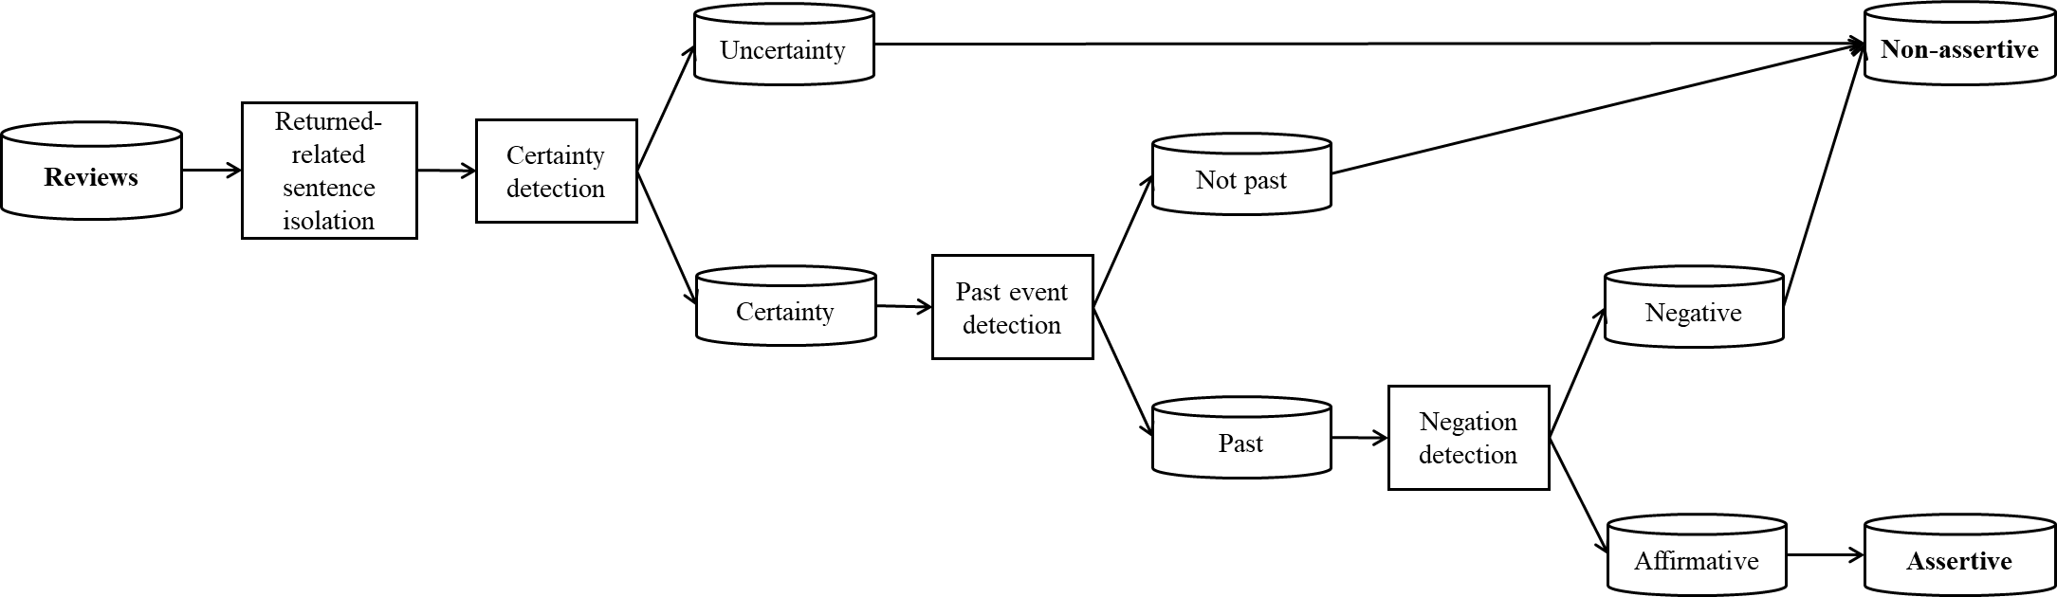
Figure B3.1. Labelling assertive vs. non-assertive OPRB using machine-generated algorithms (Source: Authors own creation)
- Set of predictors
Table B3.1. The predictors used for training and evaluating (semi-)supervised learning models (Source: Authors own creation)
Predictor | Description and Measure
Review Rating | Review rating is proven to have a direct impact on customers product returns (Minnema et al., 2016). This predictor consists of three values – 1, 2 and 3 since we only collect 1-3 stars reviews.
Review Sentiment | Since only negative reviews are retained, review rating may have an insignificant effect on assertive OPRB. Review sentiment may have more classification power because a negative review may contain both negative and positive emotions of customers. Customer sentiment has been investigated having an influence on sales performance (Li et al., 2019). To extract review sentiment, we apply a deep learning-based sentiment analysis on each review (Barbieri et al., 2020). This analysis results in three sentiment scores – positive, negative, and neutral ranging from the least (0) to the most (1).
Review Length | Mudambi & Schuff (2010) suggested that an in-depth information can be unveiled when customers express their opinion excessively, thus it can indicate the usefulness of a review. For review length, we first split a review into a list of words and simply count the number of words in that review.
Review Image | Review image provides additional visual information which supplements for customer evaluation on products (Cheng & Ho, 2015). If any review attaches with images, it will be denoted as 1, otherwise 0.
Seasonal effect | Seasonal and trend effects are proven to have direct impacts on PR volume (Cui et al., 2020). Follow the approach from Cui et al. (2020), we extract the seasonal effect through the review month (January to December) and the trend effect through 22 periods (i.e., 22 months) from the first review to the last review in the dataset.
Trend effect
Bag of Words (BoW) | BoW is a common method to represent a text document. It provides a granular view of word choice in writing return-related reviews. Previous studies have employed BoW in detecting some behaviours such as fake or spamming review (Birim et al., 2022; Ligthart et al., 2021). Since the number of features extracted from BoW rely on the number of unique vocabularies of the whole corpus, the BoW may be displayed as a sparse matrix from a large number of documents which will consume substantial computation resources and time. Therefore, we select the 1000 optimal words that contribute to the (non)-assertive OPRB classification using the SelectKBest technique[], as suggested by Ligthart et al. (2021). We test the classification performance of BoW with two most common techniques – Countvectorizer and Tfidfvectorizer on a default logistics regression because of its training time efficiency. As a result, Countvectorizer achieve a higher overall accuracy than Tfidfvectorizer (0.79 > 0.76). Therefore, we select Countvectorizer with 1000 optimal words as the BoW for the training stage.
Feature Similarity | Feature similarity is the measurement of the extent in which reviews match with the product description from sellers. This provides a meaningful context and indicates the data relevancy of customers discussion towards product features (Zheng et al., 2013). Feature similarity of each review is measured by taking the cosine similarity between two vectors of a review and its description embedded by the discussed BoW technique.
Product Image | An initial perception on product image before purchase is proven to have a direct impact on PR volume (Dzyabura et al., 2018). Therefore, we include this as a binary predictor which is 1 if the product page does have a product photo and 0, otherwise
Certainty detection | We include four machine-generated signals as described previously since they are constructed in an independent setting and proved to have a substantial agreement with human-generated label.
Past event detection
Negation detection
Machine-generated label
- ML models
We train and evaluate on five SL models: logistics regression (LR), decision tree (DT), random forest (RF), gradient boosting (GB), support vector machine (SVM). The parameters of each ML algorithm are optimized using hyperparameter tuning and a stratified 10-fold cross-validation (with 70% training set and 30% testing set) for a fair comparison and avoiding sampling bias issues[]. We adopt four common metrics – Accuracy (Acc), F1, True Positive Rate (TPR) and True Negative Rate (TNR) to evaluate the classification performance of the selected predictors on the testing sets. The optimal ML models will be fed forward to the SSL training in the next step.
Two most popular SSL methods are self-training (ST) and its extension – co-training (CT). Their training process consists of six main steps: Step (1) keeps the 10% labels while masking the labels of remaining 90% in the training set; Step (2) requires a SL model as a base estimator to fit into the 10% labelled dataset; Step (3) utilizes the trained estimator to generate the probabilities of class 0 and 1; Step (4) labels the masked dataset instances with highest probabilities (i.e., highest confidence) in each class; Step (5) adds new labels (i.e., pseudo labels) combined with the initial 10% labelled data; Step (6) retrains the base model on the newly combined labelled data. The process iteratively runs until no new labels are added. This approach enables SSL models to learn from a limited dataset and classify well on a large unlabelled dataset. Both ST[] and CT[] follow the same procedure, however, instead of one-view considered by ST, CT adopts a two-view approach. The selection of subset predictors is based on BoW and the remaining predictors. The approach is proven to be effective in increasing the model accuracy (Ligthart et al., 2021) since BoW can be used to benchmark with other predictors (Birim et al., 2022). For the details of ST and CT, please refer to Birim et al. (2022) and Ligthart et al. (2021).
The whole training and evaluating process is illustrated in Figure B3.1.
- Results
We ensure all ML models are optimised with the most appropriate parameters for the data using hyperparameter tuning (Table B3.2). Since GB yields the highest accuracy among 5 SL models, we use GB as a base estimator for ST, CT with one view (CT1V) and CT with two views (CT2V). As a result, CT1V outperforms the other models in terms of accuracy and F1 scores. We further calculate p-values and mean differences using the T-test analysis to check the significance of the performance between CT1V and the other models. If p-value of a pair ≤ 0.01, the difference between the two members in the pair is considered as significant. As shown in Table B3.3, the p-values between CT1V and other models on accuracy and F1 scores are lower than 0.01, which reaffirms the significant improvement of CT1V in detecting assertive vs. non-assertive OPRB.
We also examine the performance of Class 1 and Class 0 individually. Regarding Class 1 (Figure B3.2), CT1V has overly high TPR scores (0.91-0.95) and is superior in compared with the others by looking its mean difference (Table B3.3). In terms of class 0 (Figure B3.2), CT1V has good TNR scores (0.85-0.90) and is still superior in compared with the others by looking its mean difference except CT2V. However, CT2V has a lower ability to classify the positive class which is important to identify the customers’ reason for assertive and non-assertive OPRB.
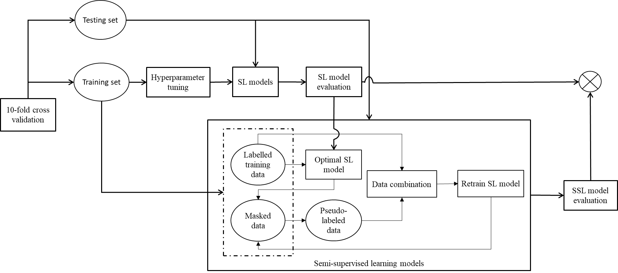
Figure B3.1. The process of training and evaluating SL and SSL models (Source: Authors own creation)
Table B3.2. Main optimised parameters of machine learning algorithms used for the training (Source: Authors own creation)
Model | Parameters
LR | C=1.0, class_weight=balanced, dual=False, fit_intercept=True, intercept_scaling=1, l1_ratio=None, max_iter=1, multi_class=auto, n_jobs=-1, penalty=l1, random_state=7187, solver=liblinear, tol=0.1, verbose=100, warm_start=False
SVM | C=49.7483, break_ties=False, cache_size=200, coef0=0.0, decision_function_shape=ovr, degree=3, gamma=scale, kernel=rbf, max_iter=-1, probability=True, random_state=None, shrinking=True, tol=0.001, verbose=False
DT | ccp_alpha=0.0, class_weight=balanced, criterion=gini, max_depth=35, max_features=0.9180, max_leaf_nodes=None, min_impurity_decrease=1.252e-08, min_samples_leaf=4, min_samples_split=9, min_weight_fraction_leaf=0.0, random_state=7187, splitter='best'
GB | boosting_type=gbdt, colsample_bytree=1.0, importance_type=split, learning_rate=0.1, max_depth=-1, min_child_samples=20, min_child_weight=0.001, min_split_gain=0.0, n_estimators=100, n_jobs=-1, num_leaves=31, objective=None, random_state=5600, reg_alpha=0.0, reg_lambda=0.0, subsample=1.0, subsample_for_bin=200000, subsample_freq=0
RF | bootstrap=True, ccp_alpha=0.0, class_weight=None, criterion=gini, max_depth=None, max_features=sqrt, max_leaf_nodes=None, max_samples=None, min_impurity_decrease=0.0, min_samples_leaf=1, min_samples_split=2, min_weight_fraction_leaf=0.0, n_estimators=100, n_jobs=-1, oob_score=False, random_state=7187, verbose=0, warm_start=False
NN | activation=relu, alpha=0.0001, batch_size=auto, beta_1=0.9, beta_2=0.999, early_stopping=False, epsilon=1e-08, hidden_layer_sizes=(100,), learning_rate=constant, learning_rate_init=0.001, max_fun=15000, max_iter=500, momentum=0.9, n_iter_no_change=10, nesterovs_momentum=True, power_t=0.5, random_state=344, shuffle=True, solver=adam, tol=0.0001, validation_fraction=0.1, verbose=False, warm_start=False
ST | base_estimator=optimal GB, criterion=k_best, k_best=50, max_iter=10, verbose=True
CT | estimator1=optimal GB, estimator2=optimal GB, random_state=97, num_iter=100, unlabeled_pool_size=18,878

Table B3.3. T-test analysis between CT1V and other ML models (Source: Authors own creation)
CT1V |  | LR | SVM | DT | GB | RF | SGB | CT2V
Acc | Mean diff | 16.37 | 17.52 | 23.37 | 6.58 | 13.76 | 25.02 | 5.79
Acc | p-value | 2.04e-23* | 7.67e-25* | 3.35e-31* | 1.47e-08* | 6.26e-20* | 9.13e-33* | 2.96e-07*
F1 | Mean diff | 15.93 | 18.14 | 23.60 | 6.51 | 14.63 | 24.66 | 8.06
F1 | p-value | 7.46e-23* | 1.38e-25* | 2.00e-31* | 1.93e-08* | 3.97e-21* | 1.97e-32* | 4.83e-11*
TPR | Mean diff | 6.53 | 11.98 | 14.11 | 3.07 | 13.75 | 15.03 | 20.19
TPR | p-value | 1.78e-08* | 2.53e-17* | 2.04e-20* | 0.003* | 6.55e-20* | 1.17e-21* | 6.47e-28*
TNR | Mean diff | 14.77 | 12.02 | 15.65 | 5.68 | 4.71 | 15.85 | -10.24
TNR | p-value | 2.51e-21* | 2.16e-17* | 1.77e-22* | 4.56e-07* | 1.57e-05* | 9.55e-23* | 1.25e-14*
*: p-value <= 0.01

Online Appendix B4. The description of permutation test
The rationale of the test:
- Step 1: The dataset is split into two folds and each variable will be tested individually. The selected variable will be used to fit into a ML model using one-fold and the trained model will be used to generate the accuracy in the other fold. The AUC score is called as the original AUC (AUC⁰) illustrated by dash lines in the result graphs.
- Step 2: The technique generates a null distribution (the grey distribution) by calculating the AUC scores (AUC^{p}) of the ML classifier on 100 different permutations of the dataset, where input variables remain the same, but the values of output variable undergo different permutations. This is the distribution for the null hypothesis which states there is no dependency between the input variables and the output variable.
- Step 3: In order to reject the null hypothesis (which means there is a significant dependency between the selected variable and the output variable), the Acc⁰ - Acc^{p} has to be significantly larger than 0. The significance can be confirmed through an empirical p-value ≤ 0.01.

Online Appendix C. Results

Online Appendix C1. Goodness of fit for different splits of training and testing set (Source: Authors own creation)
 |  |  | LR |  | SVM |  | DT |  | GB |  | RF
 |  |  | Training | Testing | Training | Testing | Training | Testing | Training | Testing | Training | Testing
F1 | 60:40 | Mean | 0.5548 | 0.5449 | 0.5755 | 0.5747 | 0.8510 | 0.5152 | 0.5943 | 0.5548 | 0.9995 | 0.5546
F1 | 60:40 | Std. | 0.0005 | 0.0039 | 0.0008 | 0.0049 | 0.0033 | 0.0060 | 0.0016 | 0.0050 | 0.0000 | 0.0059
F1 | 70:30 | Mean | 0.5406 | 0.5386 | 0.5765 | 0.5757 | 0.8514 | 0.5174 | 0.5885 | 0.5523 | 0.9994 | 0.5565
F1 | 70:30 | Std. | 0.0010 | 0.0047 | 0.0007 | 0.0045 | 0.0048 | 0.0048 | 0.0012 | 0.0055 | 0.0000 | 0.0036
F1 | 80:20 | Mean | 0.5430 | 0.5416 | 0.5774 | 0.5767 | 0.8516 | 0.5171 | 0.5851 | 0.5536 | 0.9995 | 0.5559
F1 | 80:20 | Std. | 0.0009 | 0.0046 | 0.0011 | 0.0039 | 0.0041 | 0.0046 | 0.0013 | 0.0043 | 0.0000 | 0.0042
F1 | 90:10 | Mean | 0.5422 | 0.5414 | 0.5767 | 0.5761 | 0.8520 | 0.5197 | 0.5814 | 0.5547 | 0.9993 | 0.5594
F1 | 90:10 | Std. | 0.5420 | 0.0043 | 0.0005 | 0.0031 | 0.0028 | 0.0041 | 0.0013 | 0.0054 | 0.0000 | 0.0031
AUC | 60:40 | Mean | 0.5433 | 0.5568 | 0.5577 | 0.5563 | 0.9476 | 0.5376 | 0.6627 | 0.6090 | 1.0000 | 0.5968
AUC | 60:40 | Std. | 0.0011 | 0.0044 | 0.0005 | 0.0049 | 0.0017 | 0.0051 | 0.0009 | 0.0046 | 0.0000 | 0.0046
AUC | 70:30 | Mean | 0.5544 | 0.5548 | 0.5590 | 0.5577 | 0.9478 | 0.5399 | 0.6560 | 0.6070 | 1.0000 | 0.6017
AUC | 70:30 | Std. | 0.0005 | 0.0051 | 0.0005 | 0.0055 | 0.0026 | 0.0046 | 0.0007 | 0.0051 | 0.0000 | 0.0037
AUC | 80:20 | Mean | 0.5542 | 0.5551 | 0.5575 | 0.5565 | 0.9478 | 0.5391 | 0.6508 | 0.6096 | 1.0000 | 0.6024
AUC | 80:20 | Std. | 0.5538 | 0.0045 | 0.0004 | 0.0043 | 0.0021 | 0.0040 | 0.0007 | 0.0042 | 0.0000 | 0.0033
AUC | 90:10 | Mean | 0.5559 | 0.5547 | 0.5589 | 0.5581 | 0.9479 | 0.5414 | 0.6475 | 0.6092 | 1.0000 | 0.6055
AUC | 90:10 | Std. | 0.0004 | 0.0039 | 0.0004 | 0.0037 | 0.0015 | 0.0044 | 0.0007 | 0.0043 | 0.0000 | 0.0031

Online Appendix C2. 1D PDP for weakly important variables (Source: Authors own creation)
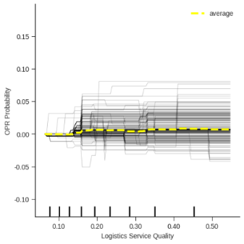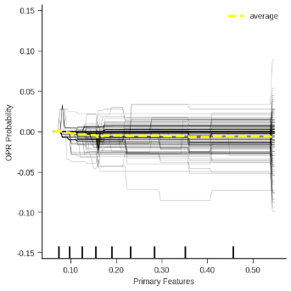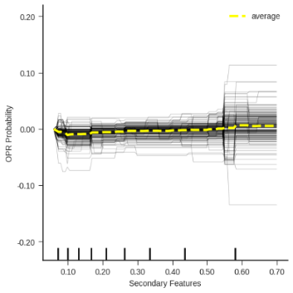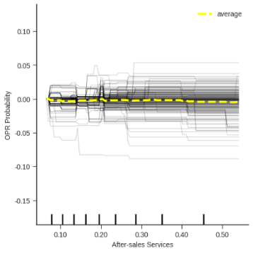

Online Appendix C3. Robustness check (Source: Authors own creation)
Test 1 – Using electronics reviews in different time periods
AUC = 0.5294; F1 = 0.6267
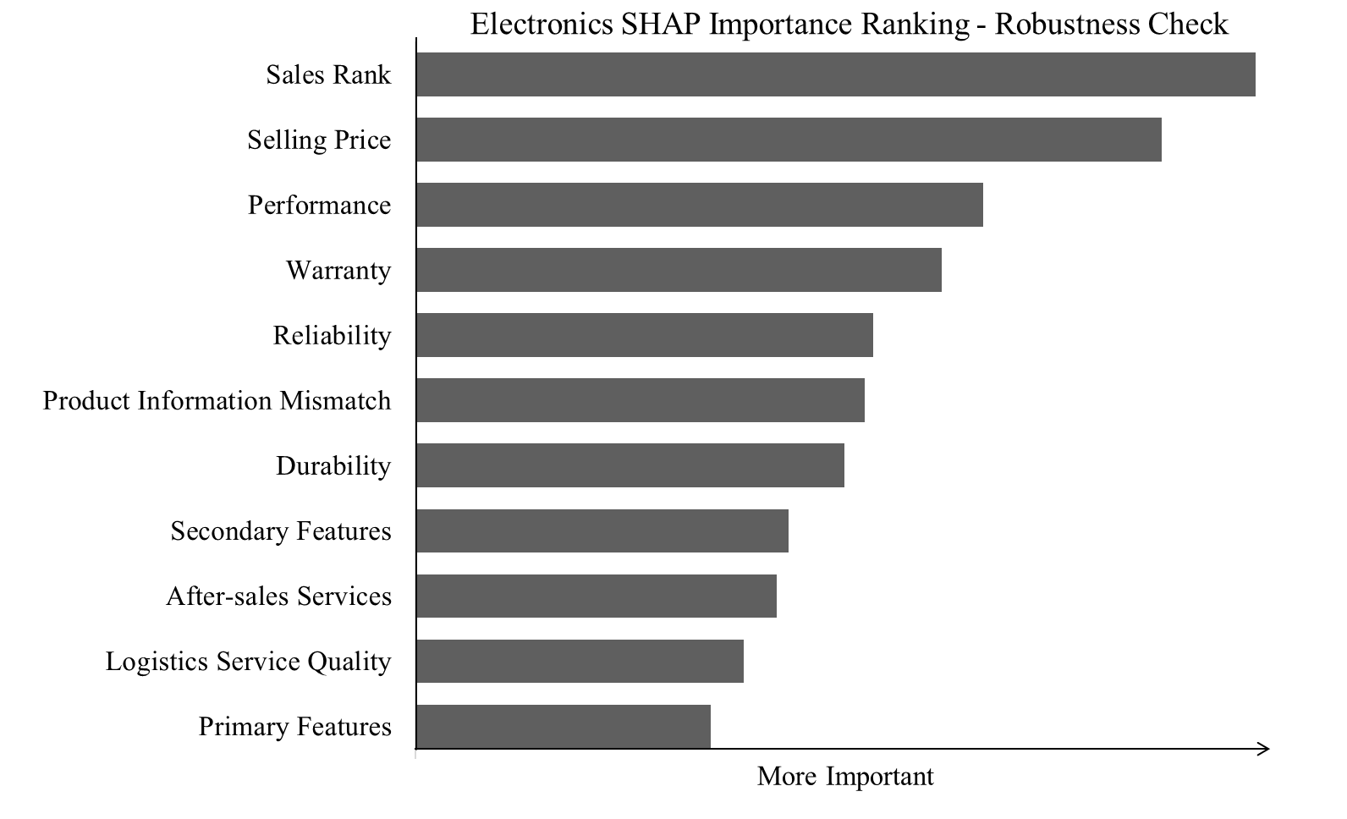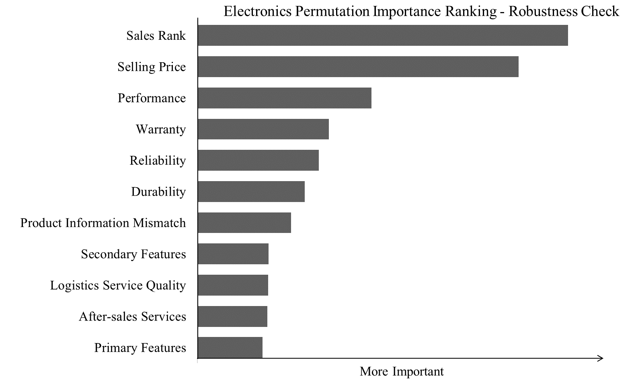
Test 2 – Using reviews for fashion items in same time periods
AUC = 0.5696; F1 = 0.4578
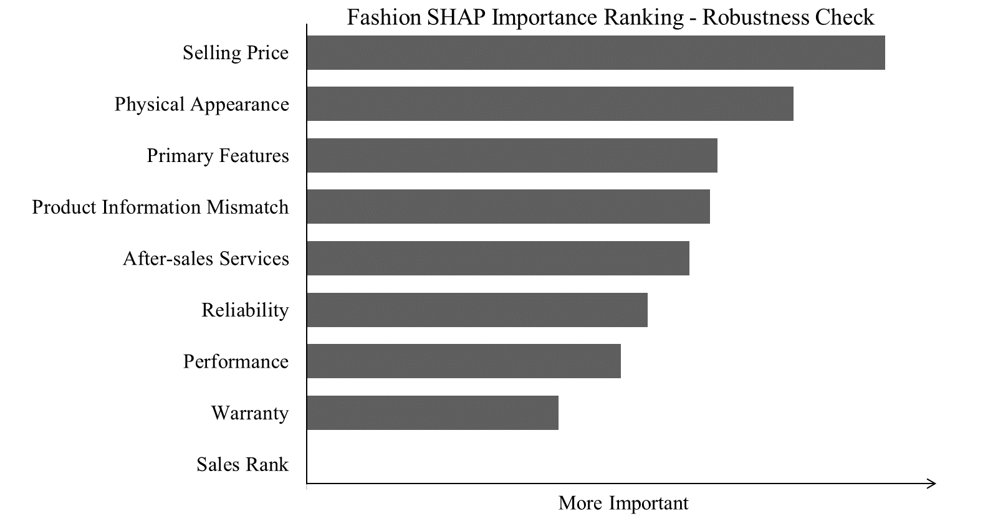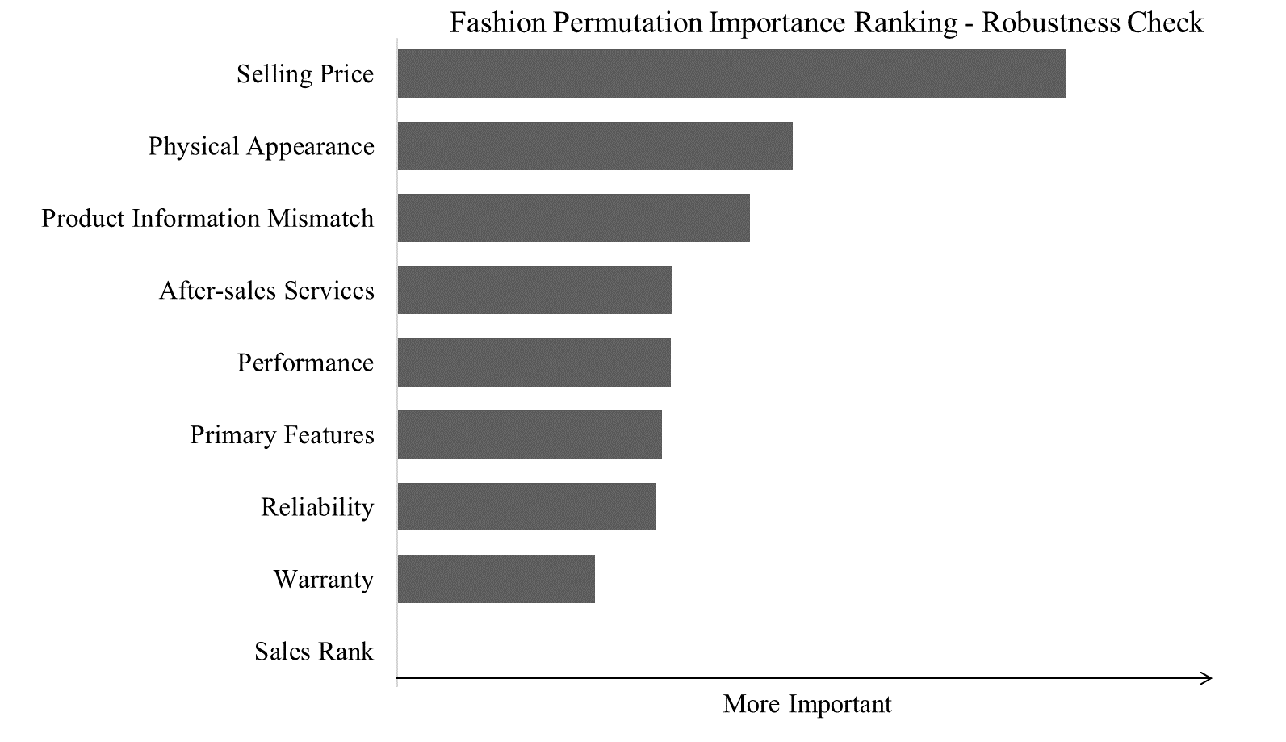
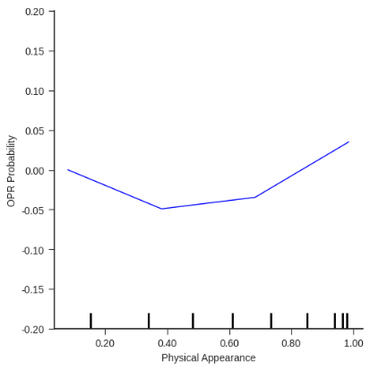
Test 3 - Using reviews for grocery items in different time periods
AUC = 0.522; F1 = 0.296
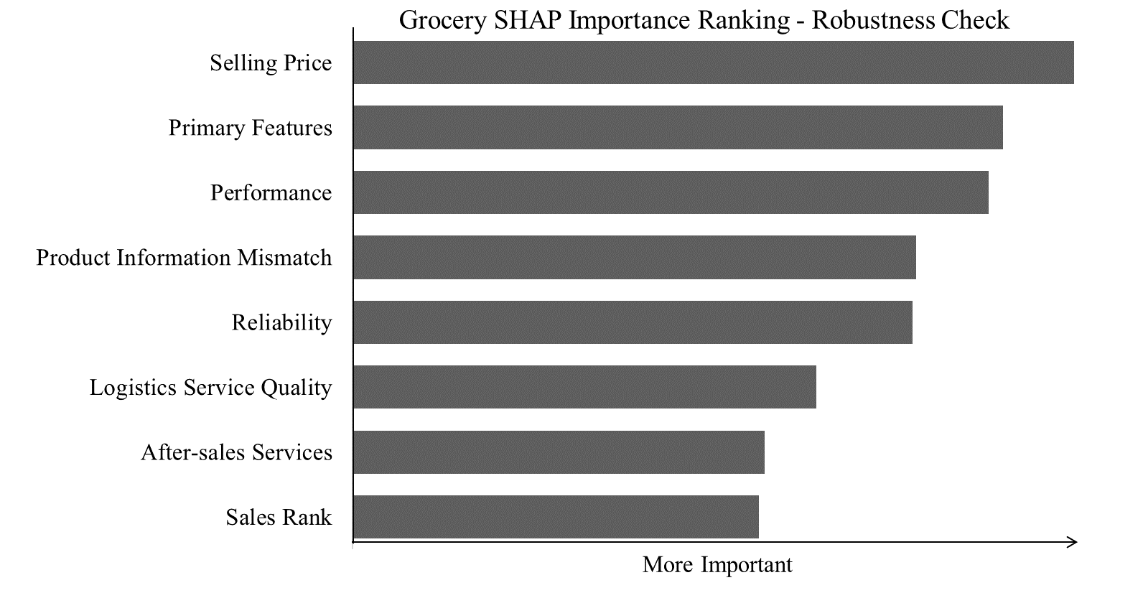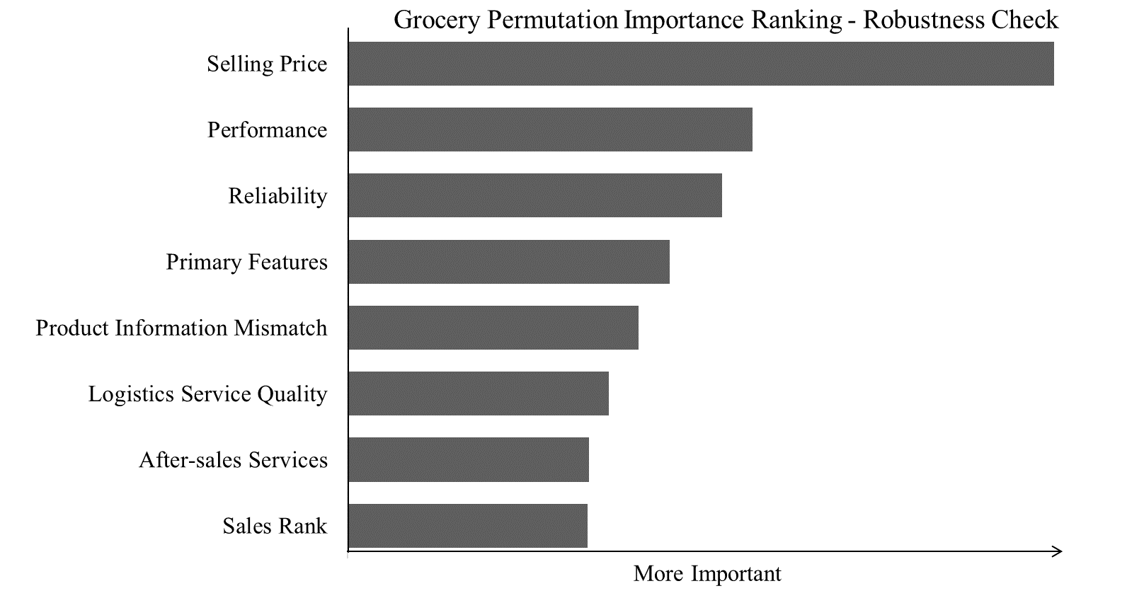
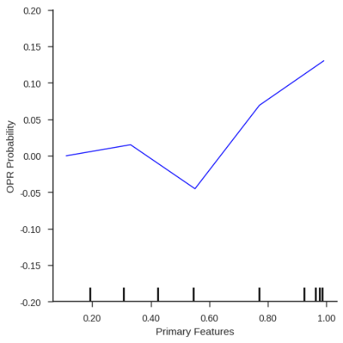
References
Anderson, R.E. (1973), “Consumer Dissatisfaction: The Effect of Disconfirmed Expectancy on Perceived Product Performance”, Journal of Marketing Research, Vol. 10 No. 1, p. 38, doi: 10.2307/3149407.
Barbieri, F., Camacho-Collados, J., Espinosa Anke, L. and Neves, L. (2020), “TweetEval: Unified Benchmark and Comparative Evaluation for Tweet Classification”, Findings of the Association for Computational Linguistics: EMNLP 2020, Association for Computational Linguistics, Stroudsburg, PA, USA, pp. 1644–1650, doi: 10.18653/v1/2020.findings-emnlp.148.
Bird, S., Klein, E. and Loper, E. (2009), Natural Language Processing with Python, O’Reilly, O’Reilly Media, Inc.
Birim, Ş.Ö., Kazancoglu, I., Kumar Mangla, S., Kahraman, A., Kumar, S. and Kazancoglu, Y. (2022), “Detecting fake reviews through topic modelling”, Journal of Business Research, Vol. 149, doi: 10.1016/j.jbusres.2022.05.081.
Brucks, M., Zeithaml, V.A. and Naylor, G. (2000), “Price and brand name as indicators of quality dimensions for consumer durables”, Journal of the Academy of Marketing Science, Vol. 28 No. 3, doi: 10.1177/0092070300283005.
Buck, S.F. (1960), “A Method of Estimation of Missing Values in Multivariate Data Suitable for Use with an Electronic Computer”, Journal of the Royal Statistical Society Series B: Statistical Methodology, John Wiley & Sons, Ltd, Vol. 22 No. 2, pp. 302–306, doi: 10.1111/j.2517-6161.1960.tb00375.x.
Buuren, S. van and Groothuis-Oudshoorn, K. (2011), “Multivariate Imputation by Chained Equations in R”, Journal of Statistical Software, Vol. 45 No. 3, pp. 1–67, doi: 10.18637/jss.v045.i03.
Chapman, W.W., Bridewell, W., Hanbury, P., Cooper, G.F. and Buchanan, B.G. (2001), “A Simple Algorithm for Identifying Negated Findings and Diseases in Discharge Summaries”, Journal of Biomedical Informatics, Vol. 34 No. 5, pp. 301–310, doi: 10.1006/jbin.2001.1029.
Cheng, Y.H. and Ho, H.Y. (2015), “Social influence’s impact on reader perceptions of online reviews”, Journal of Business Research, Elsevier, Vol. 68 No. 4, pp. 883–887, doi: 10.1016/J.JBUSRES.2014.11.046.
Consoli, S., Barbaglia, L. and Manzan, S. (2022), “Fine-grained, aspect-based sentiment analysis on economic and financial lexicon”, Knowledge-Based Systems, Elsevier, Vol. 247, p. 108781, doi: 10.1016/J.KNOSYS.2022.108781.
Cui, H., Rajagopalan, S. and Ward, A.R. (2020), “Predicting product return volume using machine learning methods”, European Journal of Operational Research, Vol. 281 No. 3, pp. 612–627, doi: 10.1016/j.ejor.2019.05.046.
Davis, F.D. (1989), “Perceived Usefulness, Perceived Ease of Use, and User Acceptance of Information Technology”, MIS Quarterly, Vol. 13 No. 3, p. 319, doi: 10.2307/249008.
Decker, R. and Trusov, M. (2010), “Estimating aggregate consumer preferences from online product reviews”, International Journal of Research in Marketing, North-Holland, Vol. 27 No. 4, pp. 293–307, doi: 10.1016/j.ijresmar.2010.09.001.
Dzyabura, D., El Kihal, S. and Ibragimov, M. (2018), “Leveraging the Power of Images in Predicting Product Return Rates”, SSRN Electronic Journal, doi: 10.2139/ssrn.3209307.
Fan, Y., Stevenson, M. and Li, F. (2020), “Supplier-initiating risk management behaviour and supply-side resilience: the effects of interpersonal relationships and dependence asymmetry in buyer-supplier relationships”, International Journal of Operations and Production Management, Vol. 40 No. 7–8, doi: 10.1108/IJOPM-06-2019-0497.
Farkas, R., Vincze, V., Móra, G., Csirik, J. and Szarvas, G. (2010), “The CoNLL-2010 Shared Task: Learning to Detect Hedges and their Scope in Natural Language Text”, CoNLL 2010 - 14th Conference on Computational Natural Language Learning: Shared Task, Proceedings.
Garvin, D.A. (1987), “Competing on the eight dimensions of quality”, Harvard Business Review, pp. 101–109.
Klutke, G.A., Kiessler, P.C. and Wortman, M.A. (2003), “A critical look at the bathtub curve”, IEEE Transactions on Reliability, Vol. 52 No. 1, doi: 10.1109/TR.2002.804492.
Li, X., Wu, C. and Mai, F. (2019), “The effect of online reviews on product sales: A joint sentiment-topic analysis”, Information and Management, Vol. 56 No. 2, doi: 10.1016/j.im.2018.04.007.
Ligthart, A., Catal, C. and Tekinerdogan, B. (2021), “Analyzing the effectiveness of semi-supervised learning approaches for opinion spam classification”, Applied Soft Computing, Elsevier, Vol. 101, p. 107023, doi: 10.1016/j.asoc.2020.107023.
Lorla, S. (2020), “TextBlob Documentation”, TextBlob.
Martínez-López, F.J., Li, Y., Feng, C., Liu, H. and Sansó-Mata, M. (2022), “‘What I’ve received doesn’t match what I saw online’: Effects of purchase-risk notices on reducing online returns”, Information & Management, North-Holland, Vol. 59 No. 8, p. 103720, doi: 10.1016/J.IM.2022.103720.
Mentzer, J.T., Flint, D.J. and Hult, G.T.M. (2001), “Logistics Service Quality as a Segment-Customized Process”, Journal of Marketing, SAGE PublicationsSage CA: Los Angeles, CA, Vol. 65 No. 4, pp. 82–104, doi: 10.1509/jmkg.65.4.82.18390.
Minnema, A., Bijmolt, T.H.A., Gensler, S. and Wiesel, T. (2016), “To Keep or Not to Keep: Effects of Online Customer Reviews on Product Returns”, Journal of Retailing, JAI, Vol. 92 No. 3, pp. 253–267, doi: 10.1016/j.jretai.2016.03.001.
Mudambi, S.M. and Schuff, D. (2010), “What makes a helpful online review? A study of customer reviews on amazon.com”, MIS Quarterly: Management Information Systems, doi: 10.2307/20721420.
Nandankar, S., Sachan, A., Adhikari, A. and Mukherjee, A. (2023), “Developing and validating e-marketplace service quality model in B2G e-commerce settings: a mixed-methods approach”, International Journal of Operations and Production Management, Vol. 43 No. 12, doi: 10.1108/IJOPM-05-2022-0333.
Nguyen, D.Q., Vu, T. and Tuan Nguyen, A. (2020), “BERTweet: A pre-trained language model for English Tweets”, Proceedings of the 2020 Conference on Empirical Methods in Natural Language Processing: System Demonstrations, Association for Computational Linguistics, Stroudsburg, PA, USA, pp. 9–14, doi: 10.18653/v1/2020.emnlp-demos.2.
Parasuraman, A., Zeithaml, V.A. and Berry, L.L. (1988), “SERVQUAL : A Multiple-Item Scale for Measuring Consumer Perception of Service Quality”, Journal of Retailing, Vol. 64 No. 1.
Patrick, V.M. and Hagtvedt, H. (2011), “Aesthetic Incongruity Resolution”, Journal of Marketing Research, American Marketing Association, Vol. 48 No. 2, pp. 393–402, doi: 10.1509/jmkr.48.2.393.
Sousa, R. and Voss, C.A. (2009), “The effects of service failures and recovery on customer loyalty in e‐services”, International Journal of Operations & Production Management, Vol. 29 No. 8, pp. 834–864, doi: 10.1108/01443570910977715.
Tirunillai, S. and Tellis, G.J. (2014), “Mining marketing meaning from online chatter: Strategic brand analysis of big data using latent dirichlet allocation”, Journal of Marketing Research, Vol. 51 No. 4, pp. 463–479, doi: 10.1509/jmr.12.0106.
Vanhala, M., Lu, C., Peltonen, J., Sundqvist, S., Nummenmaa, J. and Järvelin, K. (2020), “The usage of large data sets in online consumer behaviour: A bibliometric and computational text-mining–driven analysis of previous research”, Journal of Business Research, Elsevier, Vol. 106, pp. 46–59, doi: 10.1016/J.JBUSRES.2019.09.009.
Wang, K.Y., Liang, M. and Peracchio, L.A. (2011), “Strategies to offset dissatisfactory product performance: The role of post-purchase marketing”, Journal of Business Research, Elsevier, Vol. 64 No. 8, pp. 809–815, doi: 10.1016/J.JBUSRES.2010.10.006.
Wood, S.L. and Bettman, J.R. (2007), “Predicting happiness: How normative feeling rules influence (and even reverse) durability bias”, Journal of Consumer Psychology, Vol. 17 No. 3, doi: 10.1016/S1057-7408(07)70028-1.
Zheng, X., Zhu, S. and Lin, Z. (2013), “Capturing the essence of word-of-mouth for social commerce: Assessing the quality of online e-commerce reviews by a semi-supervised approach”, Decision Support Systems, Vol. 56 No. 1, doi: 10.1016/j.dss.2013.06.002.

[] The model is trained and shared publicly on the well-known model hub – Hugging Face via https://huggingface.co/ChrisLiewJY/BERTweet-Hedge
[] We apply SelectKBest method from the well-known Python ML package – scikit learn: https://scikit-learn.org/stable/modules/generated/sklearn.feature_selection.SelectKBest.html
[] The hyperparameter tuning and cross validation is implemented using Optuna method in PyCaret package: https://pycaret.gitbook.io/docs/
[] The implementation of self-training is applied by using sklearn package: https://scikit-learn.org/stable/modules/generated/sklearn.semi_supervised.SelfTrainingClassifier.html
[] The implementation of co-training is applied by using mvlearn package: https://mvlearn.github.io/references/semi_supervised.html#cotraining-classifier

