Supplementary Materials
Table S1. Agenda of the Group Model Building workshop
Activity | Duration | Activity Description
Introduction and problem formulation | 15 min | Welcome the participants, introduce tools, make them comfortable with technology. Ice breaker: what are the expectations for the day?
Hopes and fears | 25 min | Participants are divided into breakout rooms of 3-4 participants, where they first individually think about their hopes and fears for the challenge, then they cluster them together and have some time for individual voting. When the participants come back to the main room, they have time for a brief discussion of key takeaways.
Break | 5 min
Orientation to system thinking | 10 min | Introduction to system thinking and system dynamics modelling.
Variable elicitation | 25 min | Participants are divided into breakout rooms (not same as before, 3-4 participants in each room), where they first individually write down the relevant variables in the problem, then they cluster them together and have some time for individual voting. When the participants come back to the main room, they have time for a brief discussion of the most voted variables.
Break | 5 min
Graphs over time | 30 min | The purpose is to get the expert groups’ view on the system behavior for a set of “extreme” technological developments. Each group discusses and documents their reasoning on the causal effects in the system. Then, they draw the outcome on TKM and some other relevant variable (e.g. cost, fleet size, penetration rate, emissions).
Break | 5 min
Identify causal links | 50 min | Participants are divided first into groups of 3-4 people, where they create a causal loop diagram, identifying hypothesized causal relationships between variables. In these larger groups, they discuss the diagrams created and try to combine them. When the participants come back to the main room, they have time to explain one diagram per group.
Closing | 10 min

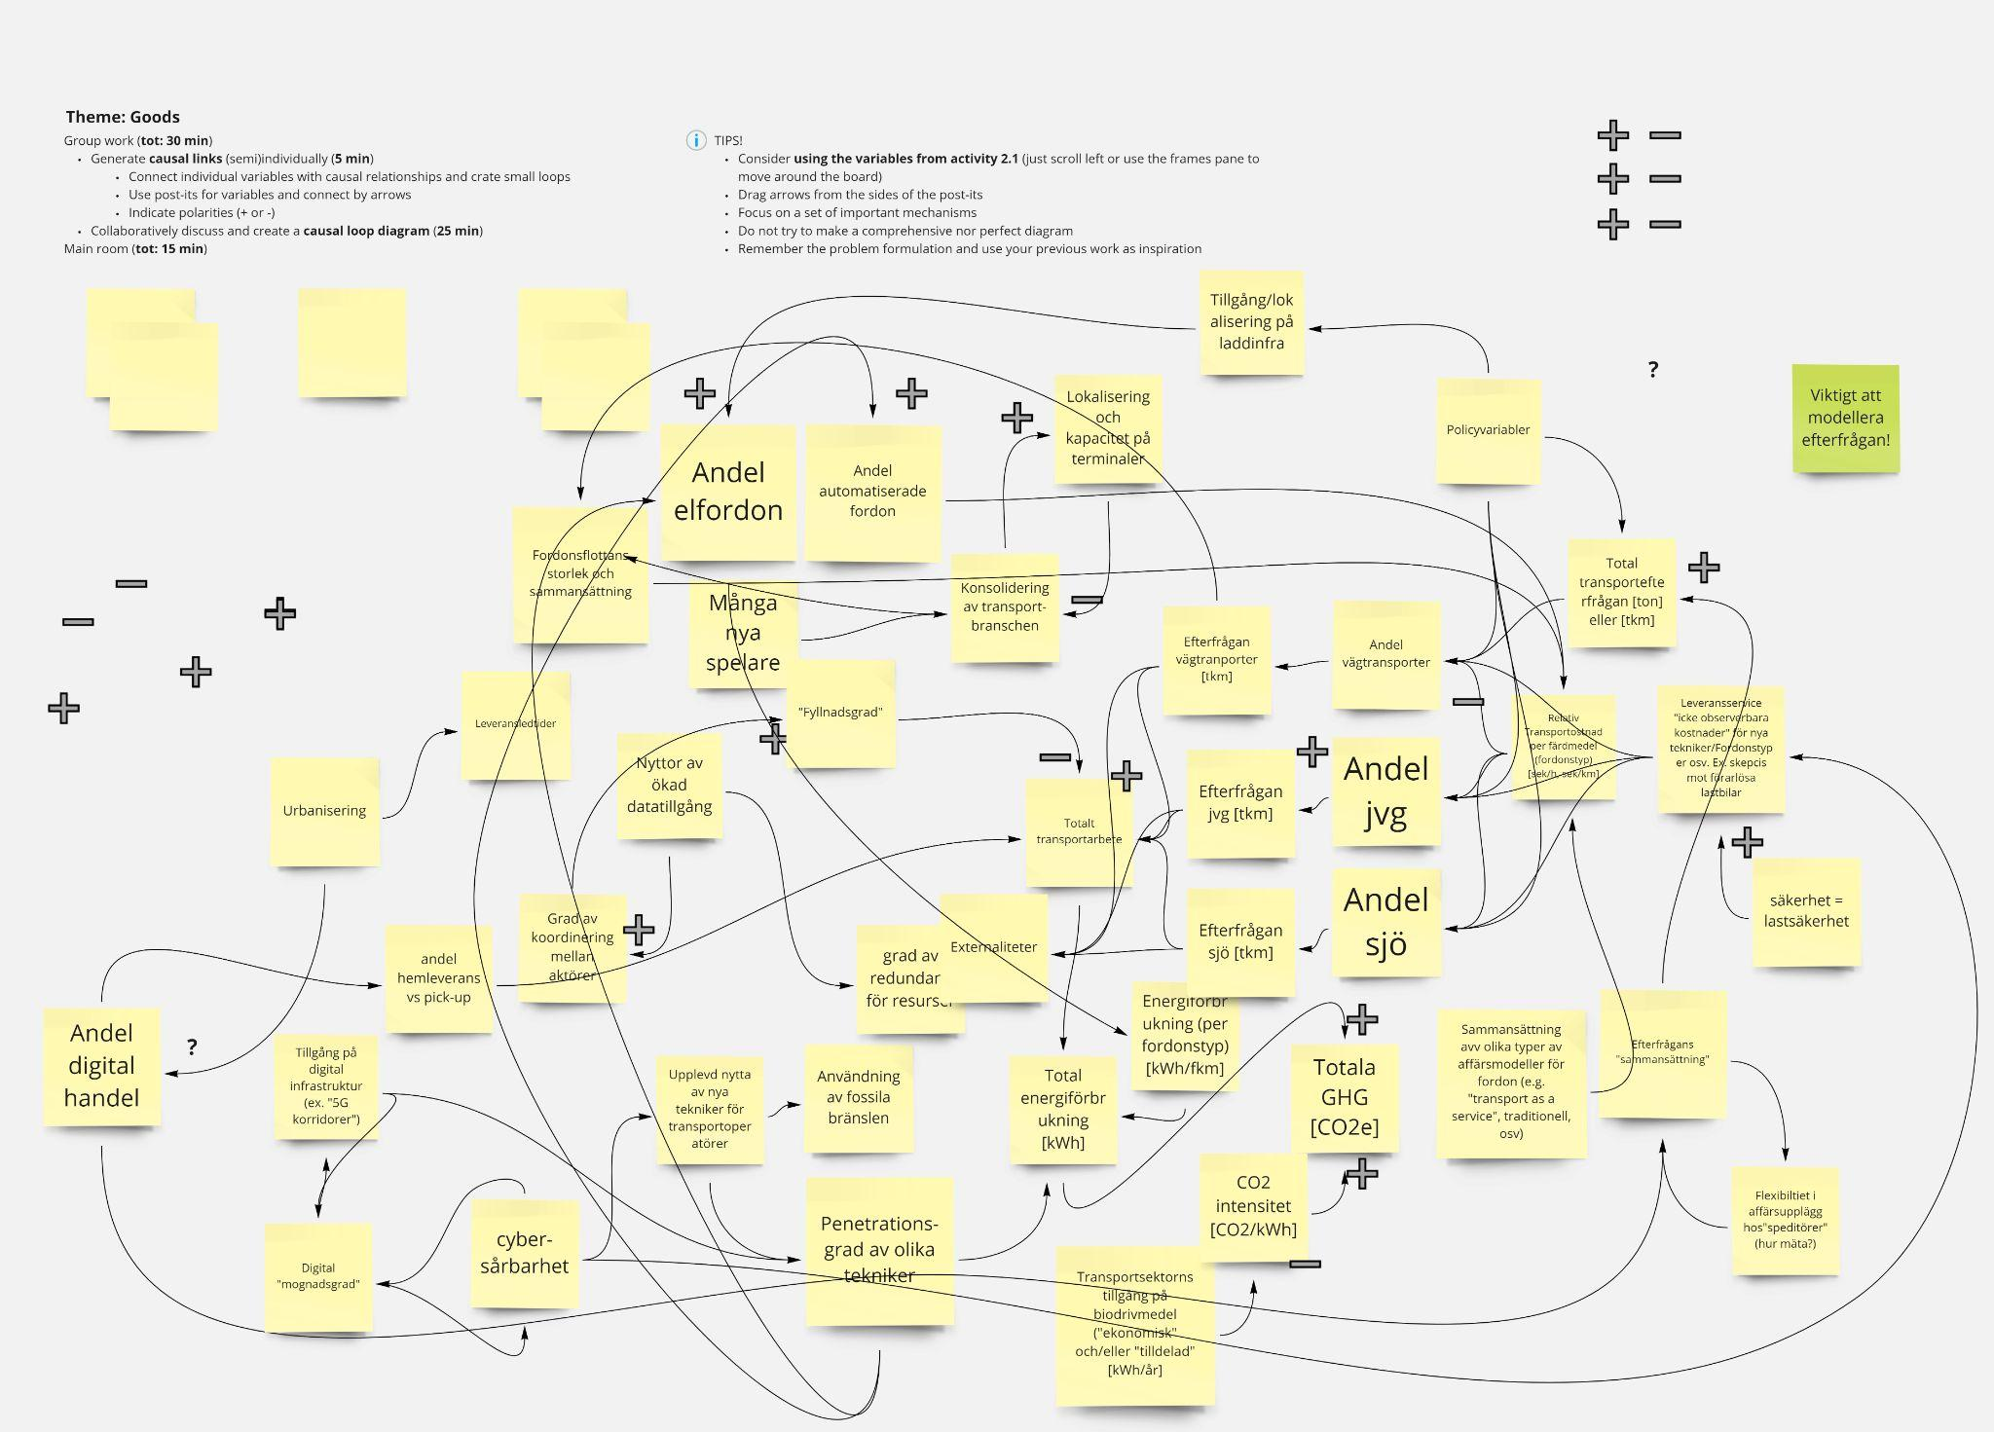
Figure S1. An example output from the Group Model Building workshop

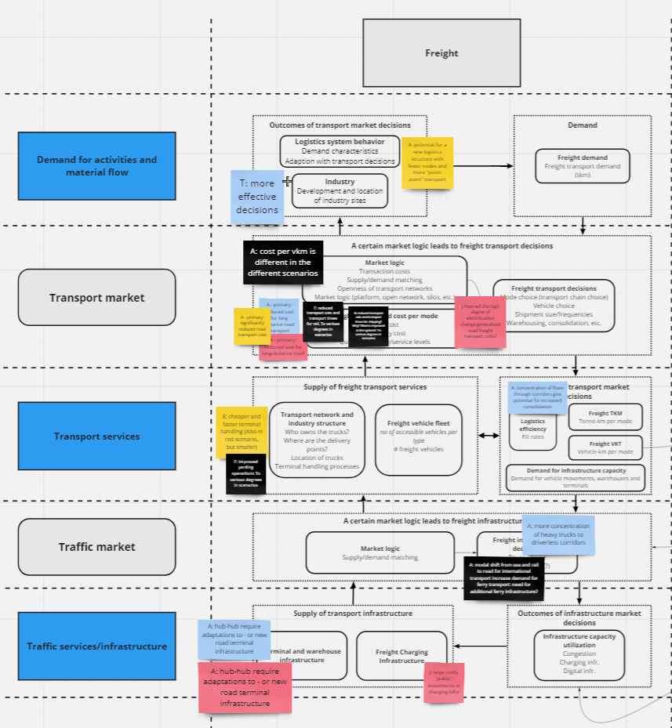
Figure S2. An example output from first impact analysis workshop

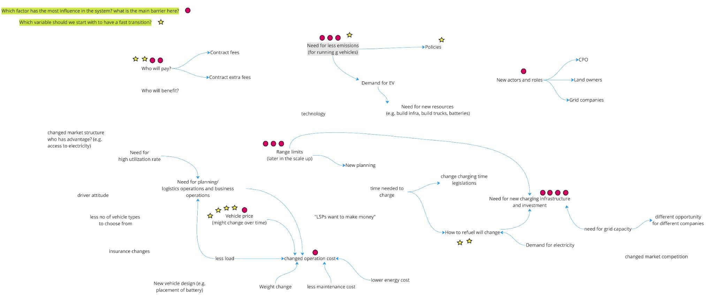
Figure S3. An example output from second impact analysis workshop

Table S2. The direct and induced impacts of electrification on the road freight transport system, along with potential policy interventions, were identified during the workshops with experts. Directions are denoted by: “+” for positive/increase, “−” for negative/decrease, and “?” for uncertain/limited evidence or no clear direction for change. Refer to Figure 2 for the positions of impacts and policy interventions. Many of the impacts have also previously been identified in the literature, and in those cases, references are provided.
No. | Possible impact of electrification | Direction | Comments | Sources
 | Direct Impact
D1 | Vehicle purchase cost | + | E-trucks, including batteries, are expected to be more expensive than their diesel counterparts. | Basma et al., 2021;  Noll et al., 2022;  Parviziomran and Bergqvist, 2023)
D2 | Vehicle operation cost (fuel per km & maintenance) | - | E-trucks are anticipated to have lower vehicle operational costs, including fuel per kilometre and maintenance. | Basma et al., 2021;  Noll et al., 2022;  Parviziomran and Bergqvist, 2023)
D3 | Demand for charging infra. expansion and fuel change | + | To operate e-trucks, a new charging network and electricity in the transport sector are necessary. | Alp et al., 2022;  Gutierrez and Huge-Brodin, 2022
D4 | Carbon intensity and emissions | - | E-trucks have lower tailpipe emissions. Note that in the early stages of electrification adoption, emissions may rise due to emissions from infrastructure construction. | Gustafsson et al., 2021;  Nicolaides et al., 2019;  Tamba et al., 2022
D5 | Refuelling/recharging time | + | Recharging times for e-trucks are longer and more frequent compared to refuelling times for diesel trucks. | Ahmadi, 2019;  Link and Plötz, 2022;  Taefi, 2016
D6 | Payload capacity | - | The weight of the battery reduces the payload capacity of e-trucks in weight-constrained applications. | Magnusson and Berggren, 2018;  Morganti and Browne, 2018
 | Induced Impact
I1 | Route choice (optimal) | - | Detours might be needed to access charging points. | Ewert et al., 2021;  Raeesi and Zografos, 2022
I2 | Transport planning (complexity) | + | Charging planning leads to greater complexity in transport planning by fleet managers. | Al-Hanahi et al., 2022;  Kin et al., 2021;  Zhang et al., 2020
I3 | Utilisation of vehicle | ? | High purchase costs and reduced load capacity require higher e-truck utilisation rates for compensation. However, the time spent searching for a charging spot and waiting at stations may decrease the utilisation rate. Additionally, reduced noise emissions enable nighttime e-truck deliveries, potentially boosting their utilisation rates. | Gillström et al., 2023;  Gutierrez and Huge-Brodin, 2022
I4 | Mode split (shift to road) | ? | Adopting e-trucks might reduce total ownership costs, shifting from rail and marine transport to trucks for greater flexibility, profitability, and customer satisfaction.
I5 | Traffic and logistics flexibility | - | Traffic flexibility is limited due to the complexities of charging and transport planning. Moreover, logistics flexibility is constrained by reduced load capacity. | Kin et al., 2021
I6 | Congestion | + | Increased detours, charging queues and additional trips (due to reduced payload capacity), can lead to more congestion in the system. | Alp et al., 2022
I7 | Vehicle ownership | - | High purchase costs and uncertainty about residual value may lead to a shift to financial or operational leasing business models, and reduced vehicle ownership. | Link and Plötz, 2022;  Noll et al., 2022
I8 | Vehicle type choice (e.g. weight, fuel type) | ? | In the initial phase of e-truck adoption, there are fewer options available to choose from. | Gillström et al., 2023
I9 | Business models of freight companies (complexity) | + | Freight companies will need to adjust their business models to accommodate e-trucks and complex charging planning, potentially requiring new income streams and new collaborations and partnerships. | Gillström et al., 2023
I10 | Shipment frequencies | + | Reduced payload might lead to decreased average shipment size and increased shipment frequencies.
I11 | Contract circumstance | ? | Contracts between transport buyers and freight companies should have longer durations to enable freight companies to make investments in e-trucks. Who should bear the additional costs incurred during the first phase of adoption: the shipper, the freight company, or the customer?
I12 | Logistics operation cost (monetary and time costs) | + | Logistics operation costs may increase due to:  i) reduced load capacity, resulting in more frequent shipments. ii) longer charging times, leading to less productive driving time. iii) potential detours to reach charging points | Alp et al., 2022;  Gutierrez and Huge-Brodin, 2022
I13 | Freight transport demand (ton-km) | ? | The impact of electrification on freight transport demand (induced demand) is uncertain, mainly because the total cost effect is uncertain.
I14 | Location of nodes (supply chain and transportation layers) | ? | Strategic location decisions for nodes in both the supply chain and transportation layers should consider accessibility to the grid and electricity network. Moreover, these nodes should be equipped with multiple charging infrastructures. | Jahn et al., 2021;  Londoño and Granada-Echeverri, 2019
I15 | Structural decisions and behaviour (supply chain and transportation layers) | ? | In addition to national and global emission targets, many companies, in both transport buyers and freight companies, set their internal emission goals, motivating the transition to e-trucks. These emission goals are defined mostly by transport buyers, which are larger companies with more financial resources compared to smaller, low-margin freight companies. | İmre et al., 2021;  Dahlgren and Ammenberg, 2022;  Gillström et al., 2024
 | Policy intervention
P1 | Vehicle purchase cost |  | Government incentives to reduce e-truck purchase costs.
P2 | Price of fuel (electricity, diesel) |  | Government policies involve subsidising electricity prices to reduce the operational costs of e-trucks and taxing diesel fuel to make e-trucks more attractive.
P3 | Energy supply and transmission infrastructure |  | Government investment in constructing renewable electricity power plants and upgrading the electricity grid network
P4 | Freight refuelling/ charging infrastructure |  | Government incentives for charging station construction.
P5 | Truck manufacturing and battery technology |  | Government investment in supporting innovations within e-trucks and battery technologies
P6 | Emission goals |  | Governments, both at the national and international levels, are setting emission goals to motivate the adoption of fossil-free transport.
P7 | Awareness of green trends and climate change |  | Investment in programmes aimed at educating customers, freight companies, and shippers about climate change and the importance of considering the climate impact of their activities

Table S3. Explaining the dynamics of variables in different loops of the CLD model of e-truck attractiveness. R for reinforcing loops and B for balancing loops. Green arrows for the same direction impact and red arrows for the opposite direction impact.
Loop name | R / B | Dynamics of variables
"Awareness" | R1 | E-truck market share → awareness of technology → Attractiveness of e-truck → E-truck market share
"Access to charging" | B1 | E-truck market share → Electricity and charging demand → Market gap of charging infra. → Attractiveness of e-truck → E-truck market share
"Investment in charging" | B2 | Market gap of charging infra.→ Willingness to invest in charging infra. → Charging Infrastructure → Market gap of charging infra.
"Green mindset" | B3 | GHG emissions from transport → emission gap → Green mindset of transport companies → Willingness to put in extra effort for achieving fossil-free transportation → Attractiveness of e-truck→ E-truck market share → GHG emissions from transport
"Price of electricity" | B4 | Attractiveness of e-truck → E-truck market share → Electricity and charging demand → Electric power demand → Price of electricity → E-truck total cost of ownership → Attractiveness of e-truck
"Learning by doing" | R2 | Attractiveness of e-truck → E-truck market share → R&D spending on e-trucks → E-truck production improvements → E-truck purchase cost → E-truck total cost of ownership → Attractiveness of e-truck
"Complexity of planning " | B5 | Attractiveness of e-truck → E-truck market share → Electricity and charging demand → Market gap of charging infra. → Losses due to planning complexity → E-truck total cost of ownership → Attractiveness of e-truck
"Business development" | B6 | Losses due to planning complexity → Pressure to invest in planning and business development → Applying planning tools (adapting business model) → Losses due to planning complexity
"Demand price balance" | B7 | Transport price→ Transport demand → Transport price
"Demand rebound effect" | R3 | GHG emissions from transport → Emission gap → Governmental subsidies → E-truck purchase cost → E-truck total cost of ownership → Transport price → Transport demand → GHG emissions from transport
"Reaching climate goals 1" | B8 | Attractiveness of e-truck → E-truck market share → GHG emissions from transport → Governmental subsidies → E-truck purchase cost→ E-truck total cost of ownership → Attractiveness of e-truck
"Reaching climate goals 2" | B9 | Attractiveness of e-truck → E-truck market share → GHG emissions from transport → Governmental subsidies → Electric power supply → Price of electricity → E-truck total cost of ownership → Attractiveness of e-truck
"Reaching climate goals 3" | B10 | Attractiveness of e-truck → E-truck market share → GHG emissions from transport → Governmental subsidies → Charging Infrastructure → Market gap of charging infra. → Attractiveness of e-truck
"Reaching climate goals 4" | B11 | Attractiveness of e-truck → E-truck market share → GHG emissions from transport → Governmental subsidies → Price of electricity → E-truck total cost of ownership → Attractiveness of e-truck

Table S4. Explaining the dynamics of variables in different loops of the CLD model of trade-off between truck battery size vs. fast charging infrastructure. R for reinforcing loops and B for balancing loops. Green arrows for the same direction impact and red arrows for the opposite direction impact.
Loop name | R / B | Dynamics of variables
"Demand price balance" | B1 | Transport price → Transport demand → Transport price
"Transport cost effect" | B2 | Transport Cost → Transport price → Transport demand → Numbers of trips to fulfil a demand → Transport Cost
"Congestion effect" | B3 | Transport Cost → Transport price → Transport demand → Numbers of trips to fulfil a demand→ Vehicle mileage→ Congestion→ Transport time → Transport Cost
"Road expansion" | B4 | Congestion → Pressure to invest in infra → Road infrastructure → Congestion
"Investment in  charging stations" | B5 | Market gap of charging infrastructure → Willingness to invest in charging infra → Number of charging infrastructure → Market gap of charging infrastructure
"Trust of widespread charging stations" | R1 | Battery size → Vehicle Range → Demand for charging station (fast chargers) → Market gap of charging infrastructure → Willingness to invest in charging infra → Number of charging infrastructure → trust on widespread charging networks (long-term) → Battery size

References of the Supplementary Materials
Ahmadi, P., 2019. Environmental impacts and behavioral drivers of deep decarbonization for transportation through electric vehicles. J. Clean. Prod. 225, 1209–1219. https://doi.org/10.1016/j.jclepro.2019.03.334
Al-Hanahi, B., Ahmad, I., Habibi, D., Masoum, M.A.S., 2022. Smart charging strategies for heavy electric vehicles. eTransportation 13, 100182. https://doi.org/10.1016/j.etran.2022.100182
Alp, O., Tan, T., Udenio, M., 2022. Transitioning to sustainable freight transportation by integrating fleet replacement and charging infrastructure decisions. Omega 109, 102595. https://doi.org/10.1016/j.omega.2022.102595
Basma, H., Saboori, A., Rodríguez, F., 2021. Total cost of ownership for tractor-trailers in Europe: Battery electric versus diesel. ICCT: Berlin, Germany.
Dahlgren, S., Ammenberg, J., 2022. Environmental Considerations Regarding Freight Transport among Buyers of Transport Services in Sweden. Sustainability 14, 11244. https://doi.org/10.3390/su141811244
Ewert, R., Martins-Turner, K., Thaller, C., Nagel, K., 2021. Using a Route-based and Vehicle Type specific Range Constraint for Improving Vehicle Routing Problems with Electric Vehicles. Transp. Res. Procedia 52, 517–524. https://doi.org/10.1016/j.trpro.2021.01.061
Gillström, H., Björklund, M., Stahre, F., Abrahamsson, M., 2023. Critical factors in logistics service providers business model for electrified freight. Presented at the NOFOMA, Helsinki, Finland, 15-16 June, 2023.
Gillström, H., Jobrant, M., Sallnäs, U., 2024. Towards building an understanding of electrification of logistics systems – A literature review and a research agenda. Clean. Logist. Supply Chain 10, 100134. https://doi.org/10.1016/j.clscn.2023.100134
Gustafsson, M., Svensson, N., Eklund, M., Dahl Öberg, J., Vehabovic, A., 2021. Well-to-wheel greenhouse gas emissions of heavy-duty transports: Influence of electricity carbon intensity. Transp. Res. Part Transp. Environ. 93, 102757. https://doi.org/10.1016/j.trd.2021.102757
Gutierrez, J., Huge-Brodin, M., 2022. The adoption of Battery Electric vehicles. Challenges from the perspective of commercial vehicle manufacturers. 34th Nofoma conference, Reykjavik, June 2022.
İmre, Ş., Çelebi, D., Koca, F., 2021. Understanding barriers and enablers of electric vehicles in urban freight transport: Addressing stakeholder needs in Turkey. Sustain. Cities Soc. 68, 102794. https://doi.org/10.1016/j.scs.2021.102794
Jahn, R.M., Syré, A., Grahle, A., Martins-Turner, K., Göhlich, D., 2021. Methodology for Determining Charging Strategies for Freight Traffic Vehicles based on Traffic Simulation Results. Procedia Comput. Sci. 184, 656–661. https://doi.org/10.1016/j.procs.2021.03.082
Kin, B., Hopman, M., Quak, H., 2021. Different Charging Strategies for Electric Vehicle Fleets in Urban Freight Transport. Sustainability 13, 13080. https://doi.org/10.3390/su132313080
Link, S., Plötz, P., 2022. Technical Feasibility of Heavy-Duty Battery-Electric Trucks for Urban and Regional Delivery in Germany—A Real-World Case Study. World Electr. Veh. J. 13, 161. https://doi.org/10.3390/wevj13090161
Londoño, A., Granada-Echeverri, M., 2019. Optimal placement of freight electric vehicles charging stations and their impact on the power distribution network. Int. J. Ind. Eng. Comput. 10, 535–556.
Magnusson, T., Berggren, C., 2018. Competing innovation systems and the need for redeployment in sustainability transitions. Technol. Forecast. Soc. Change 126, 217–230. https://doi.org/10.1016/j.techfore.2017.08.014
Morganti, E., Browne, M., 2018. Technical and operational obstacles to the adoption of electric vans in France and the UK: An operator perspective. Transp. Policy 63, 90–97. https://doi.org/10.1016/j.tranpol.2017.12.010
Nicolaides, D., Cebon, D., Miles, J., 2019. An Urban Charging Infrastructure for Electric Road Freight Operations: A Case Study for Cambridge UK. IEEE Syst. J. 13, 2057–2068. https://doi.org/10.1109/JSYST.2018.2864693
Noll, B., del Val, S., Schmidt, T.S., Steffen, B., 2022. Analyzing the competitiveness of low-carbon drive-technologies in road-freight: A total cost of ownership analysis in Europe. Appl. Energy 306, 118079. https://doi.org/10.1016/j.apenergy.2021.118079
Parviziomran, E., Bergqvist, R., 2023. A cost analysis of decarbonizing the heavy-duty road transport sector. Transp. Res. Part Transp. Environ. 120, 103751. https://doi.org/10.1016/j.trd.2023.103751
Raeesi, R., Zografos, K.G., 2022. Coordinated routing of electric commercial vehicles with intra-route recharging and en-route battery swapping. Eur. J. Oper. Res. 301, 82–109. https://doi.org/10.1016/j.ejor.2021.09.037
Taefi, T.T., 2016. Viability of electric vehicles in combined day and night delivery: a total cost of ownership example in Germany. Eur. J. Transp. Infrastruct. Res. https://doi.org/10.18757/EJTIR.2016.16.4.3160
Tamba, M., Krause, J., Weitzel, M., Ioan, R., Duboz, L., Grosso, M., Vandyck, T., 2022. Economy-wide impacts of road transport electrification in the EU. Technol. Forecast. Soc. Change 182, 121803. https://doi.org/10.1016/j.techfore.2022.121803
Zhang, H., Sheppard, C.J.R., Lipman, T.E., Moura, S.J., 2020. Joint Fleet Sizing and Charging System Planning for Autonomous Electric Vehicles. IEEE Trans. Intell. Transp. Syst. 21, 4725–4738. https://doi.org/10.1109/TITS.2019.2946152

