Appendix

Measuring neurobiological responses in practice: a proof-of-concept
We proposed three areas of added value by measuring neurobiological responses in practice: identifying mechanisms underlying workers’ performance, complementing self-reports with implicit response measurement and enabling continuous, real-time data collection. To explore these three areas, we conducted a pilot study at an industrial facility. In this setting, participants engaged in an assembly task, as shown in Figure A1. First, we explored the value of assessing implicit biological responses in relation to explicit self-reports. We specifically examined arousal, defined as a rapid visceral response previously measured through both self-reports (Mehrabian and Russell, 1974) and cardiac responses (Immanuel et al., 2023). Second, our pilot study investigated the potential added value of uncovering mechanisms underlying worker performance by evaluating whether cortical responses could act as mediators in a sequential process. Third, we evaluated the feasibility of real-time, continuous data collection by recording both cardiac and cortical data throughout the experiment. We focused on assessing signal quality to determine the suitability of wearable biosensors, confirming the suitability of Electrocardiogram (ECG) and Electroencephalogram (EEG) measures for continuous recording in a typical operational environment.
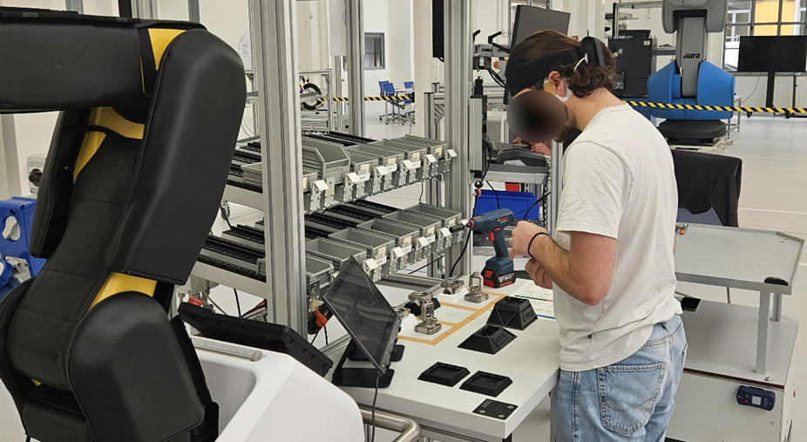
Figure A1. Experimental setting. Source: Authors’ own elaboration

Research design
We conducted a pilot study at an industrial facility affiliated with a leading Italian university. This facility replicates a realistic factory working environment to ensure ecological validity, meaning that findings can be generalised to real-world operational settings. In this setting, participants engaged in an assembly task at a workstation resembling a factory bench, where they assembled physical products in the shape of valves. These products were selected for their general relevance in operations contexts, as they involved multiple steps, including bolting and tightening, as shown in Figures A4 and A5. The assembly station (Figure A2) included various components: a workbench with containers for assembly parts (A), a screwdriver (B), a screen displaying experimental instructions (C), the main parts of three valves (D), and written instructions for assembly (E). Completed valves were then placed on a table adjacent to the workbench.

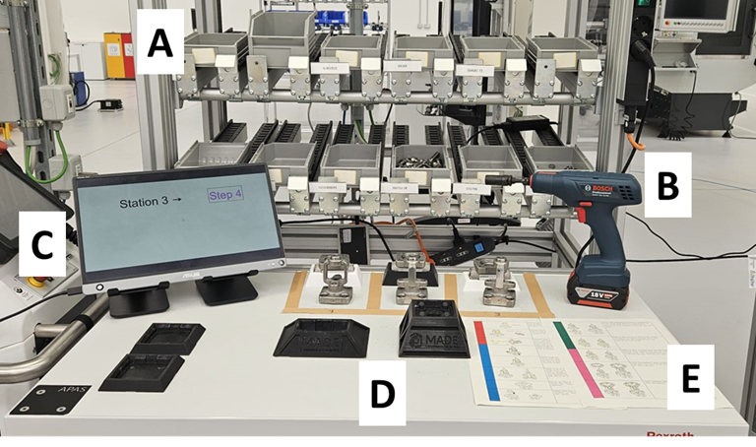Figure A2. Assembly station. Source: Authors’ own elaboration

Our research design employed a within-subject manipulation, differentiating between two task sequences: a Simple Task Sequence (S) and a Complex Task Sequence (C). In the S-condition, participants assembled valves sequentially, completing all steps for one valve before moving to the next. Conversely, the C-condition required participants to assemble valves in a scrambled order of steps and valves, as indicated by the screen. The sequence of steps was maintained in order, ensuring for instance that step 4 could not precede step 3. This manipulation aimed to test neurobiological responses to varying complexities in the assembly sequence, focusing on cardiac and cortical responses due to the ease of recording these via wireless wearable biosensors (see section 3.3). We monitored the error rate in assembly (i.e., deviations from the instruction manual) as a measure of operational performance.

Participants
We recorded data from twelve participants (6 F; M_{age} = 25.33 years, SD = 3.99), aligning with similar studies on neurophysiological responses during standing and movement activities (Scanlon et al., 2021). Participants reported no neurological or cardiovascular disorders and had normal or corrected-to-normal vision.

Instrumentation and measures
We employed a Polar H10 chest belt (Polar Electro, Finland) to record cardiac (ECG) signal at a sampling rate of 1000 Hz. The ECG signal was processed using Kubios HRV version 2.2 to perform Heart Rate Variability (HRV) analysis. From the ECG signal, the sequence of RR intervals was extracted from the recording device. An RR interval refers to the time interval between two successive R-peaks in the heart’s electrical cycle, reflecting heart rate variability. Raw data was first inspected visually and then pre-processed using a 0.15s threshold-based artifact correction. In this process, artifacts and ectopic beats were corrected by comparing each RR interval to a local average, removing movement-related artifacts and signal noise. We calculated the number of RR intervals corrected and the percentage of artifacts removed for each task sequence completed by a participant. Observations from any analysis window shorter than five minutes were discarded, in line with HRV processing guidelines (Malik et al., 1996). The processed signal was used to calculate the Standard Deviation of all RR intervals (SDNN), which was extracted for each block and adjusted against baseline levels by subtracting the average values recorded during the baseline period. SDNN is commonly employed to assess arousal through cardiac responses, and it is generally inversely related to arousal (Immanuel et al., 2023).
Cortical signals were recorded using the cEEGrid system, which features 20 Ag/AgCl electrodes affixed with an adhesive sticker and connected to an amplifier transmitting signals via Bluetooth to the recording laptop at a sampling rate of 250 Hz. Both ECG and EEG data were recorded and synchronised using iMotions (9.3). EEG analysis was subsequently conducted in Matlab (version: 23.2.0.2459199). Data was re-referenced to the electrode opposite to the reference and bandpass filtered between 0.1 Hz and 30 Hz. Bad channels were detected using the clean_rawdata function for EEGLAB (Delorme and Makeig, 2004). Data was then cut to 1 second epochs and we used the pop_jointprob function to identify bad epochs. Data was then transformed into frequency space using a Fast Fourier Transformation (FFT). We averaged the resulting spectra and identified peaks in the alpha frequency band (8-12Hz). Alpha peak values were z-transformed across experimental blocks for normalization.
We assessed individual responses after each block through explicit self-reports on 7-point Likert scales. These included a 4-item construct investigating Fluency of Performance (Rheinberg et al., 2003), a 3-item construct investigating Arousal (Mehrabian and Russell, 1974), and a single item investigating Cognitive Workload (Gualtieri et al., 2022). Lastly, assembly errors were assessed by a researcher who inspected each completed valve, comparing each step against the provided visual instructions.

Experimental protocol
Participants were welcomed to the experimental site where they were briefed on the study procedures and provided written informed consent. To prepare for data collection, an ECG chest belt was fitted to ensure proper skin contact, and EEG electrodes were applied. The preparation for EEG involved cleaning the areas around each ear with abrasive gel and alcohol, followed by drying and placing an adhesive electrode grid around the ears. The impedance of each electrode was checked and adjusted to below 10kΩ. Before starting the experimental tasks, participants underwent a three-minute resting period to record baseline cardiac and cortical responses. Next, participants underwent a training phase where they assembled three test valves and received feedback on any errors they made. Following this, they began the main task, assembling three valves across four blocks in a within-subject design. The blocks were split into the two conditions, C and S, with two blocks for each. The sequence of the blocks was quasi-randomised to prevent any condition from appearing consecutively. After each block, participants completed self-reports. With the fourth block completed, participants had a second resting period for three minutes. This second resting period enables the recording of post-task baseline data which allows a comparison with the first resting state before the experiment. The procedure was developed in line with the principles of the Helsinki Declaration.

Results
The assembly task displayed adequate variation in terms of completion times, ranging from 32 minutes and 29 seconds to 49 minutes and 20 seconds, with an average of 40 minutes. Error rates were also well distributed across the four blocks among participants (M = 4.1, SD = 4.9; min = 0; max = 18). As anticipated, the blocks under the C (vs S) condition were perceived as more challenging, confirmed by a manipulation check on perceived cognitive workload (t(23) = -3.607, p < .001). Significant differences were observed in self-reported arousal (t(23) = -2.378, p = .013), while differences in self-reported fluency were not significant (t(23) = -.819, p = .211). Physiological measurements revealed statistically significant differences in cortical alpha activity (t(23) = -2.413, p = .012), where the C condition resulted in only marginally higher physiological arousal (t(23) = -1.539, p = .069) across the two conditions.
In our evaluation of the three proposed areas of added value, we first assessed the utility of measuring implicit processes through biological responses by comparing self-reported arousal with physiological measures. Self-reported and physiological arousal were not significantly correlated (r = .156, p = .153), aligning with previous literature that indicates self-reported metrics do not always linearly relate to physiological responses (Epel et al., 2018). Subsequently, we conducted three linear regression models to examine the contributions of explicit and implicit responses to error rates. Our analysis initially tested the effects of self-reported arousal (model 1) and physiological arousal (model 2) as separate independent variables. We then analysed both variables together in model 3 to determine their combined effect. The results indicated that both explicit and implicit responses were related to error rates, supporting the hypothesis that arousal levels are related to assembly mistakes, aligning with prior empirical studies (Bruccoleri et al., 2014). Interestingly, when the predictive contributions of both models were compared, implicit responses provided a stronger significant contribution to predicting error rates, thus suggesting that implicit processes measured through cardiac data may provide added value over explicit responses in understanding error rates. Table A1 reports the full results. Overall, these results support the hypothesis that physiological responses can be effective in measuring implicit responses that are linked to operational outcomes.

Table A1. Regression analysis comparing the contribution of Self-reported and physiological arousal
To explore the added value of identifying mechanisms underlying worker performance, we employed Hayes’ PROCESS macro. We ran model 6 with two mediators in PROCESS v4.1 with 10,000 bootstrap samples. We included the workplace manipulation as the independent variable; cortical activity and perceived self-reported fluency as sequential mediators; and error rate as the dependent variable. A significant indirect effect was observed (indirect effect = - 0.601, BootSE = 0.491, 95% BCBCI [-1.868, -0.004]). Both mediators displayed significant effects. Specifically, condition C increased the cortical activity during the task (b = 0.487, SE = 0.182, t = 2.678, p = .010), which subsequently improved perceived fluency (b = 0.583, SE = 0.222, t = 2.638, p = .012), leading to reduced error rates (b = -2.116, SE = 0.73, t = -2.899, p = .006). No other significant effects were noted. These findings validate a mediation process where task sequence complexity affects physiological responses, which then influence self-reported and ultimately operational performance. The related path model is shown in Figure A3. Although the results are preliminary and the interpretation of physiological responses requires careful consideration, they support the hypothesis that physiological responses can effectively serve as mediating variables to explain the mechanisms underlying workers' performance.

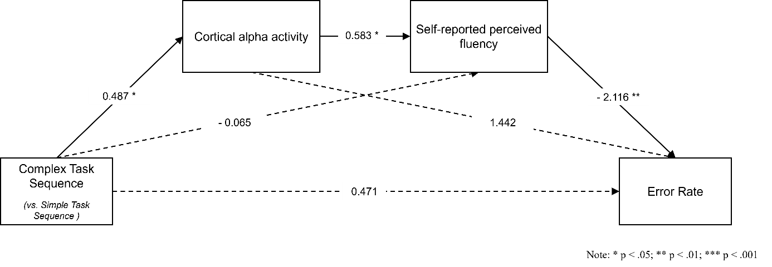
Figure A3. Path model testing the effects of task sequency complexity on error rate. Source: Authors’ own elaboration

Third, the study explored the feasibility of real-time, continuous monitoring of cardiac and cortical data during the session. We evaluated the consistency of signal quality for both cardiac and cortical measurements, alongside any discomfort reported by participants. Regarding cardiac signals, the average of RR intervals corrected per block was 13.5 (SD = 27.6) and the average percentage corrected per participant was 1.42%. Only three blocks from the same individual exhibited significant noise, yielding less than five continuous minutes of usable data, and were consequently excluded from the analysis. These results align well with, and even surpass, previous findings on cardiac signal quality in standing and motion conditions (Gilgen-Ammann et al., 2019), confirming the feasibility of real-time, continuous monitoring of cardiac responses. Regarding cortical signals, an average of 3.46 channels were identified as bad across participants (SD=1.70). Four participants had to be excluded from analysis due to insufficient data quality based on exclusion criteria. From the remaining participants, 93.15% of the data was used on average for further analysis (SD=3.09). 93.49% of the remaining sequences across participants contained alpha peaks (SD=7.08) usable for analysis. The percentage of acceptable data is in line with previous investigations using EEG in a standing position with simple tasks (Kerick et al., 2009; Scanlon et al., 2021). We conclude that mobile EEG is suitable for continuous recording of cortical activity. Although this pilot study was confined to a single setting, the results support the hypothesis that neurobiological responses can be continuously measured during operational tasks lasting more than 30 minutes.

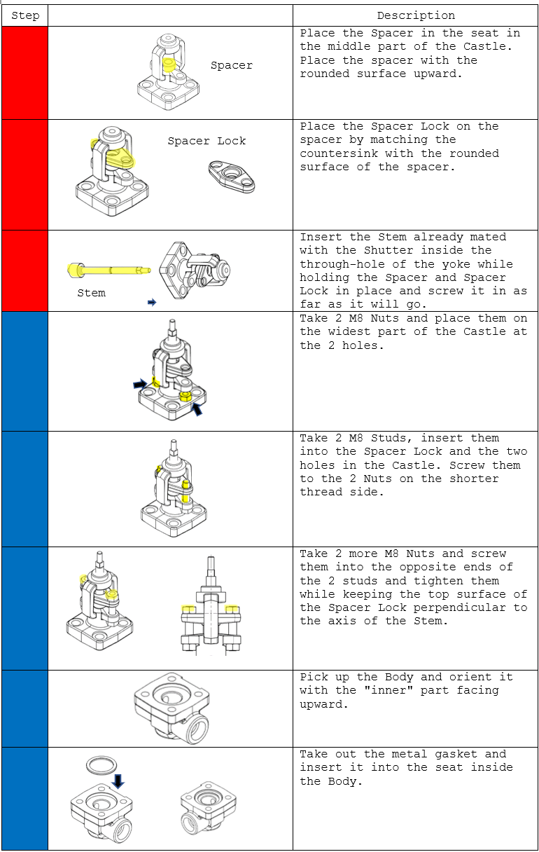
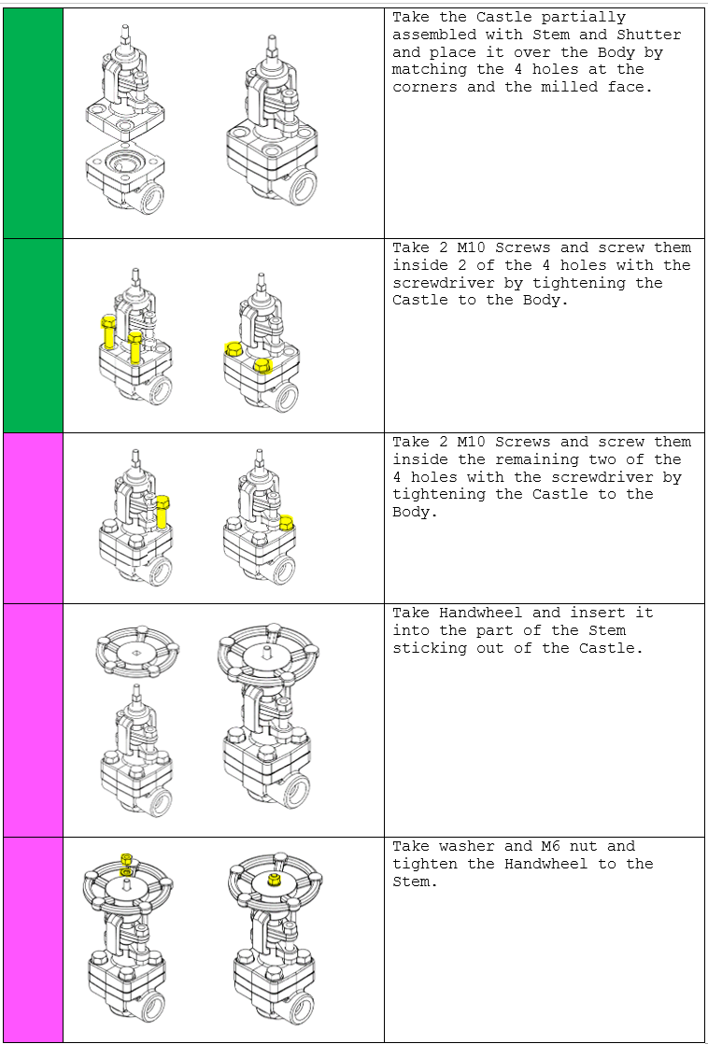
Figure A4. Assembly steps and instructions for each valve. Source: Authors’ own elaboration

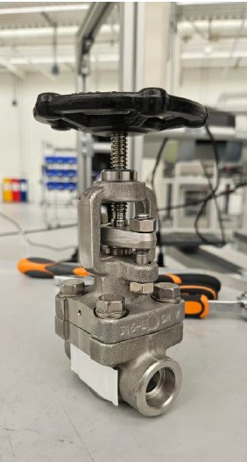
Figure A5. Assembly product in shape of a valve. Source: Authors’ own elaboration

References for online appendix
Bruccoleri, M., Cannella, S., and La Porta, G. (2014), “Inventory record inaccuracy in supply chains: the role of workers’ behavior”. International Journal of Physical Distribution and Logistics Management, Vol. 44 No. 10, pp. 796-819. https://doi.org/10.1108/IJPDLM-09-2013-0240.
Delorme, A., and Makeig, S. (2004). “EEGLAB: an open source toolbox for analysis of single-trial EEG dynamics including independent component analysis”, Journal of Neuroscience Methods, Vol. 134 No. 1, pp. 9-21. https://doi.org/10.1016/j.jneumeth.2003.10.009.
Epel, E., Crosswell, A., Mayer, S., Prather, A., Slavich, G., Puterman, E., and Mendes, W. (2018), “More than a feeling: A unified view of stress measurement for population science”, Frontiers in Neuroendocrinology, Vol. 49, pp. 146-169. https://doi.org/10.1016/j.yfrne.2018.03.001.
Gilgen-Ammann, R., Schweizer, T., & Wyss, T. (2019), “RR interval signal quality of a heart rate monitor and an ECG Holter at rest and during exercise”. European journal of applied physiology, Vol. 119 No. 7, pp. 1525-1532. https://doi.org/10.1007/s00421-019-04142-5.
Gualtieri, L., Fraboni, F., De Marchi, M. and Rauch, E. (2022), "Development and evaluation of design guidelines for cognitive ergonomics in human-robot collaborative assembly systems", Applied Ergonomics, Vol. 104. https://doi.org/10.1016/j.apergo.2022.103807.
Kerick, S., Oie, K., and McDowell, K. (2009), “Assessment of EEG signal quality in motion environments”, Aberdeen Proving Ground: US Research Laboratory, No.: ARLTN-355.
Immanuel, S., Teferra, M., Baumert, M., and Bidargaddi, N. (2023), “Heart rate variability for evaluating psychological stress changes in healthy adults: a scoping review”, Neuropsychobiology, Vol. 82 No. 4, pp. 187-202. https://doi.org/10.1159/000530376.
Malik, M., Bigger, J.T., Camm, A.J., Kleiger, R.E., Malliani, A., Moss, A.J. and Schwartz, P.J. (1996), "Heart rate variability: Standards of measurement, physiological interpretation, and clinical use", European Heart Journal, Vol. 17 No. 3, pp. 354-381. https://doi.org/10.1093/oxfordjournals.eurheartj.a014868.
Mehrabian, A. and Russell, J.A. (1974), An Approach to Environmental Psychology, MIT Press.
Rheinberg, F., Vollmeyer, R. and Engeser, S. (2003), "Flow Short Scale APA PsycTests".
Scanlon, J., Jacobsen, N., Maack, M., and Debener, S. (2021), “Does the electrode amplification style matter? A comparison of active and passive EEG system configurations during standing and walking”, European Journal of Neuroscience, Vol. 54 No. 12, pp. 8381-8395. https://doi.org/10.1111/ejn.15037.

