Supplementary file of manuscript:
Managing Sustainability Tensions Under Disruptive Conditions: The Role of Cumulative Operations and Network Capabilities
- Survey questionnaire




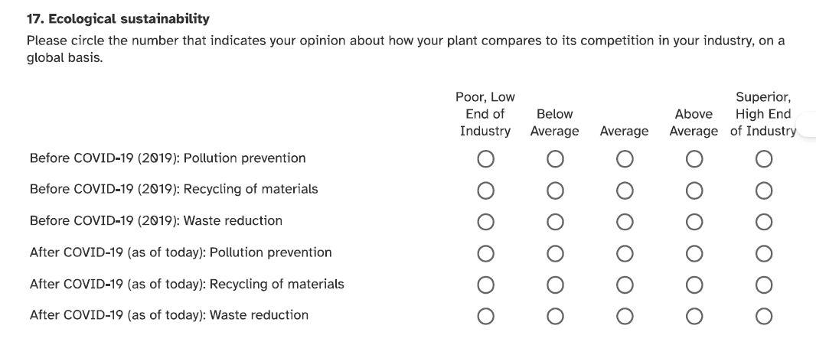


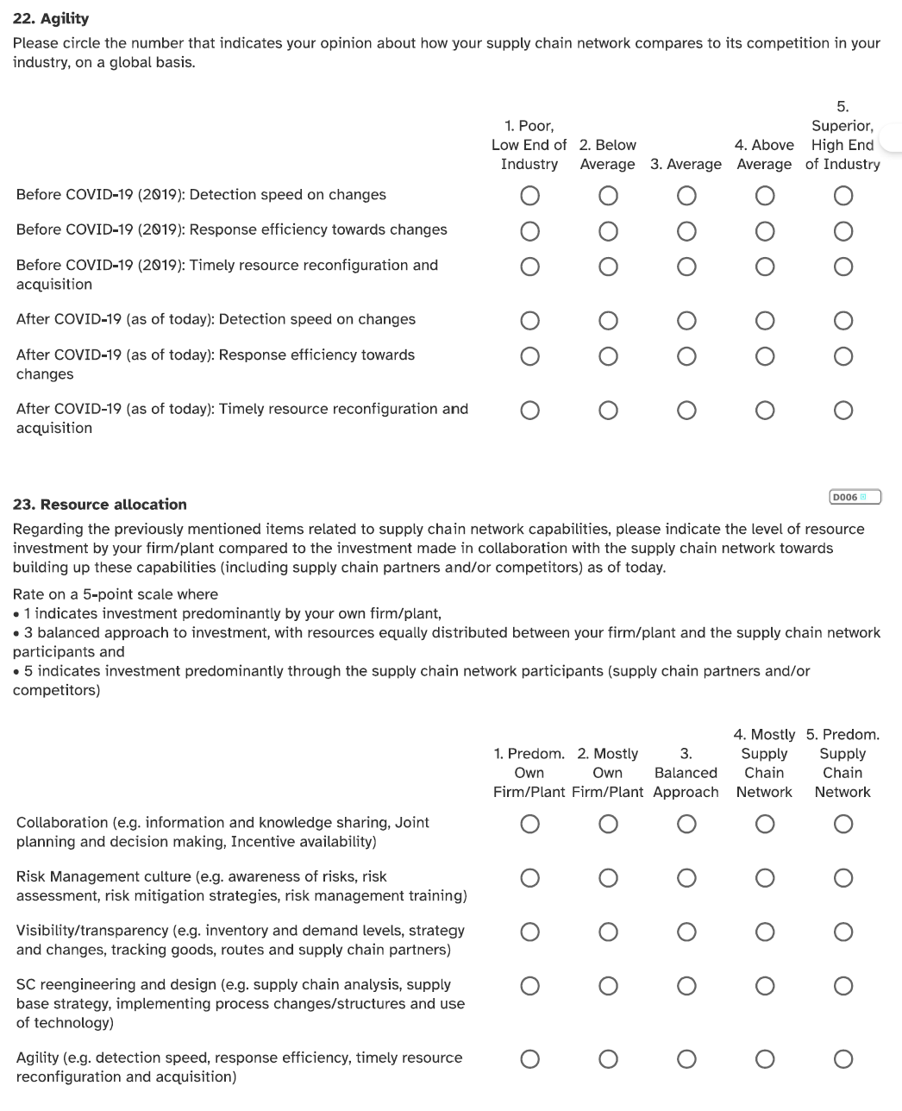

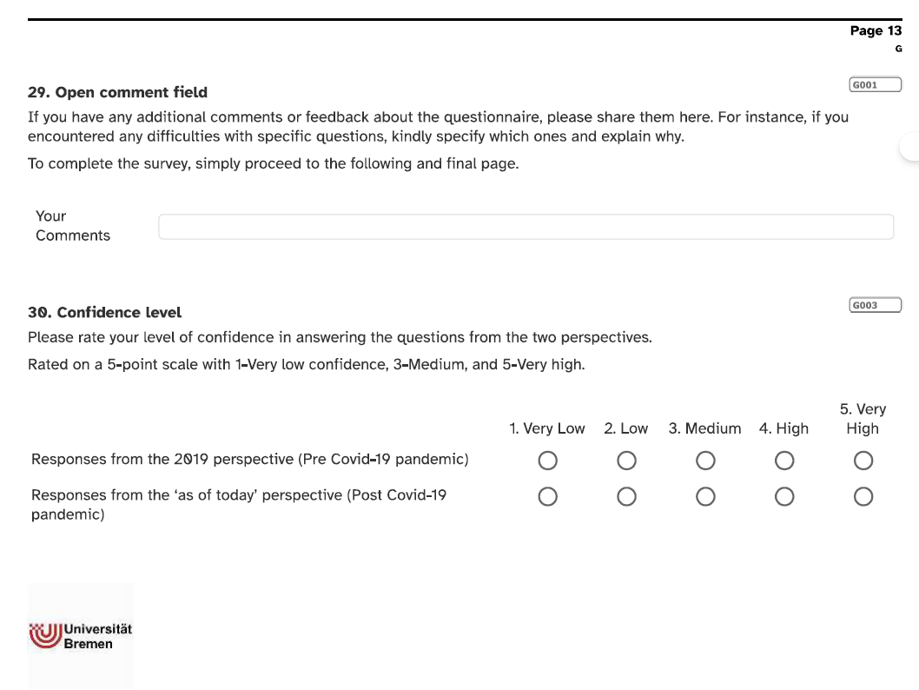

- Results
B.1 PLS-SEM
Table B.I Discriminant validity - HTMT criterion
 | Post HILF | Pre HILF | Post HILF | Pre HILF | Post HILF | Pre HILF | Post HILF | Pre HILF | Post HILF | Pre HILF
OC measurement model
Constructs | OCC |  | OCD |  | OCSE |  | OCF |  | OCQ
OCD | 0.751 | 0.688
OCSE | 0.910 / 0.880* | 0.825 / 0.796* | 0.754 / 0.739* | 0.771 / 0.707*
OCF | 0.758 | 0.696 | 0.895 | 0.779 | 0.679 / 0.660* | 0.693 / 0.644*
OCQ | 0.397 | 0.388 | 0.586 | 0.517 | 0.400 / 0.378* | 0.317 / 0.297* | 0.441 | 0.361
OCSS | 0.911 / 0.785* | 0.916 / 0.674* | 0.761 / 0.622* | 0.705 / 0.509* | 0.952 / 0.803* | 0.915 / 0.677* | 0.800 / 0.708* | 0.694 / 0.521* | 0.455 / 0.389* | 0.371 / 0.317*
NC measurement model
Constructs | NCA |  | NCC |  | NCRM |  | NCR
NCC | 0.747 / 0.749* | 0.566 / 0.560*
NCRM | 0.779 / 0.776* | 0.695 / 0.664* | 0.936 / 0.894* | 0.874 / 0.796*
NCR | 0.938 / 0.888* | 0.903 / 0.808* | 0.774 / 0.742* | 0.752 / 0.692* | 0.844 / 0.776* | 0.792 / 0.706*
NCV | 0.848 / 0.876* | 0.778 / 0.757* | 0.797 | 0.745 | 0.907 / 0.876* | 0.832 / 0.799* | 0.928 / 0.880* | 0.901 / 0.848*
Note: Thick font shows values with potential issues; ¹ Note OC: HTMT criterion without OCQ1. Thick font shows values with potential issues. *values after delating OCSS2 and OCSE3; ² Note NC: *values after delating NCR3, NCR4, NCRM3, NCRM4, NCA3

Table B.II Cross loadings
Post HILF |  |  |  |  |  |  |  | Pre HILF
OC measurement items
 | OCC | OCD | OCSE | OCF | OCQ | OCSS |  | OCC | OCD | OCSE | OCF | OCQ | OCSS
C1 | 0.799 | 0.569 | 0.727 | 0.596 | 0.330 | 0.738 |  | 0.840 | 0.573 | 0.719 | 0.564 | 0.336 | 0.792
C2 | 0.897 | 0.728 | 0.768 | 0.696 | 0.353 | 0.803 |  | 0.906 | 0.655 | 0.737 | 0.660 | 0.388 | 0.804
C3 | 0.809 | 0.586 | 0.788 | 0.607 | 0.313 | 0.743 |  | 0.875 | 0.575 | 0.713 | 0.606 | 0.294 | 0.806
D1 | 0.622 | 0.823 | 0.630 | 0.752 | 0.460 | 0.653 |  | 0.639 | 0.928 | 0.734 | 0.708 | 0.498 | 0.648
D2 | 0.596 | 0.793 | 0.588 | 0.694 | 0.486 | 0.576 |  | 0.579 | 0.841 | 0.629 | 0.668 | 0.415 | 0.600
E1 | 0.816 | 0.625 | 0.910 | 0.561 | 0.308 | 0.866 |  | 0.731 | 0.621 | 0.883 | 0.561 | 0.242 | 0.810
E2 | 0.749 | 0.691 | 0.869 | 0.614 | 0.366 | 0.827 |  | 0.613 | 0.575 | 0.772 | 0.527 | 0.259 | 0.708
E3 | 0.874 | 0.709 | 0.905 | 0.646 | 0.401 | 0.862 |  | 0.701 | 0.717 | 0.820 | 0.630 | 0.285 | 0.752
F1 | 0.671 | 0.801 | 0.575 | 0.891 | 0.381 | 0.689 |  | 0.671 | 0.674 | 0.629 | 0.910 | 0.281 | 0.584
F2 | 0.677 | 0.805 | 0.624 | 0.897 | 0.397 | 0.703 |  | 0.549 | 0.675 | 0.596 | 0.831 | 0.340 | 0.584
F3 | 0.642 | 0.740 | 0.580 | 0.835 | 0.378 | 0.706 |  | 0.633 | 0.716 | 0.617 | 0.914 | 0.339 | 0.676
Q2 | 0.397 | 0.585 | 0.400 | 0.441 | 1.000 | 0.455 |  | 0.389 | 0.517 | 0.316 | 0.360 | 1.000 | 0.370
S1 | 0.784 | 0.623 | 0.809 | 0.707 | 0.389 | 0.855 |  | 0.674 | 0.508 | 0.694 | 0.521 | 0.317 | 0.746
S2 | 0.761 | 0.669 | 0.805 | 0.648 | 0.383 | 0.841 |  | 0.710 | 0.556 | 0.693 | 0.529 | 0.244 | 0.766
NC measurement items
 | NCA | NCC | NCRM | NCR | NCV |  |  | NCA | NCC | NCRM | NCR | NCV
A1 | 0.935 | 0.700 | 0.728 | 0.878 | 0.804 |  |  | 0.896 | 0.541 | 0.656 | 0.810 | 0.703
A2 | 0.951 | 0.707 | 0.764 | 0.892 | 0.841 |  |  | 0.865 | 0.531 | 0.619 | 0.782 | 0.709
A3 | 0.898 | 0.672 | 0.677 | 0.843 | 0.715 |  |  | 0.959 | 0.501 | 0.619 | 0.867 | 0.709
CO1 | 0.591 | 0.824 | 0.771 | 0.636 | 0.648 |  |  | 0.244 | 0.509 | 0.448 | 0.374 | 0.338
CO2 | 0.632 | 0.863 | 0.808 | 0.658 | 0.686 |  |  | 0.472 | 0.827 | 0.728 | 0.628 | 0.664
CO3 | 0.669 | 0.845 | 0.792 | 0.666 | 0.686 |  |  | 0.473 | 0.753 | 0.663 | 0.578 | 0.565
RM1 | 0.709 | 0.845 | 0.899 | 0.752 | 0.812 |  |  | 0.617 | 0.794 | 0.899 | 0.693 | 0.744
RM2 | 0.671 | 0.786 | 0.854 | 0.747 | 0.787 |  |  | 0.624 | 0.707 | 0.850 | 0.702 | 0.743
RM3 | 0.724 | 0.884 | 0.951 | 0.786 | 0.868 |  |  | 0.645 | 0.823 | 0.932 | 0.739 | 0.771
RM4 | 0.714 | 0.865 | 0.907 | 0.759 | 0.807 |  |  | 0.555 | 0.766 | 0.832 | 0.646 | 0.661
SCR1 | 0.863 | 0.704 | 0.750 | 0.918 | 0.850 |  |  | 0.757 | 0.594 | 0.666 | 0.850 | 0.778
SCR2 | 0.767 | 0.678 | 0.742 | 0.835 | 0.790 |  |  | 0.778 | 0.649 | 0.672 | 0.838 | 0.734
SCR3 | 0.868 | 0.693 | 0.761 | 0.919 | 0.846 |  |  | 0.853 | 0.690 | 0.737 | 0.937 | 0.838
SCR4 | 0.884 | 0.717 | 0.787 | 0.934 | 0.858 |  |  | 0.768 | 0.713 | 0.687 | 0.865 | 0.795
V1 | 0.778 | 0.733 | 0.835 | 0.852 | 0.920 |  |  | 0.620 | 0.678 | 0.747 | 0.761 | 0.870
V2 | 0.800 | 0.762 | 0.840 | 0.856 | 0.925 |  |  | 0.681 | 0.666 | 0.730 | 0.781 | 0.872
V3 | 0.769 | 0.710 | 0.832 | 0.855 | 0.920 |  |  | 0.770 | 0.680 | 0.739 | 0.858 | 0.923
Note: Thick font shows values with potential issues

Table B. III Significance and relevance of structural relationships (direct and indirect effects) OC Model
Post HILF
Direct effects | Original sample (O) | Sample mean (M) | Standard deviation (STDEV) | T statistics (|O/STDEV|) | P values
Delivery -> Cost efficiency | 0.679 | 0.680 | 0.049 | 13.840 | 0.000
Delivery -> Ecological sustainability | 0.597 | 0.598 | 0.054 | 11.016 | 0.000
Delivery -> Social sustainability | 0.533 | 0.535 | 0.050 | 10.698 | 0.000
Flexibility -> Ecological sustainability | 0.667 | 0.667 | 0.050 | 13.427 | 0.000
Flexibility -> Social sustainability | 0.596 | 0.596 | 0.048 | 12.527 | 0.000
Quality -> Cost efficiency | 0.397 | 0.400 | 0.058 | 6.853 | 0.000
Quality -> Ecological sustainability | 0.349 | 0.352 | 0.056 | 6.290 | 0.000
Quality -> Flexibility | 0.524 | 0.527 | 0.068 | 7.733 | 0.000
Quality -> Social sustainability | 0.312 | 0.315 | 0.049 | 6.305 | 0.000
Specific indirect effect | Original sample (O) | Sample mean (M) | Standard deviation (STDEV) | T statistics (|O/STDEV|) | P values
Flexibility -> Cost efficiency -> Ecological sustainability | 0.667 | 0.667 | 0.050 | 13.427 | 0.000
Quality -> Delivery -> Flexibility -> Cost efficiency | 0.397 | 0.400 | 0.058 | 6.853 | 0.000
Quality -> Delivery -> Flexibility | 0.524 | 0.527 | 0.068 | 7.733 | 0.000
Delivery -> Flexibility -> Cost efficiency -> Social sustainability | 0.533 | 0.535 | 0.050 | 10.698 | 0.000
Flexibility -> Cost efficiency -> Social sustainability | 0.596 | 0.596 | 0.048 | 12.527 | 0.000
Quality -> Delivery -> Flexibility -> Cost efficiency -> Social sustainability | 0.312 | 0.315 | 0.049 | 6.305 | 0.000
Quality -> Delivery -> Flexibility -> Cost efficiency -> Ecological sustainability | 0.349 | 0.352 | 0.056 | 6.290 | 0.000
Delivery -> Flexibility -> Cost efficiency -> Ecological sustainability | 0.597 | 0.598 | 0.054 | 11.016 | 0.000
Delivery -> Flexibility -> Cost efficiency | 0.679 | 0.680 | 0.049 | 13.840 | 0.000
Pre HILF
Direct effects | Original sample (O) | Sample mean (M) | Standard deviation (STDEV) | T statistics (|O/STDEV|) | P values
Delivery -> Cost efficiency | 0.542 | 0.543 | 0.061 | 8.947 | 0.000
Delivery -> Ecological sustainability | 0.430 | 0.431 | 0.057 | 7.533 | 0.000
Delivery -> Social sustainability | 0.366 | 0.365 | 0.052 | 7.094 | 0.000
Flexibility -> Ecological sustainability | 0.554 | 0.553 | 0.054 | 10.282 | 0.000
Flexibility -> Social sustainability | 0.471 | 0.469 | 0.051 | 9.194 | 0.000
Quality -> Cost efficiency | 0.281 | 0.281 | 0.051 | 5.462 | 0.000
Quality -> Ecological sustainability | 0.222 | 0.223 | 0.045 | 4.951 | 0.000
Quality -> Flexibility | 0.402 | 0.402 | 0.058 | 6.869 | 0.000
Quality -> Social sustainability | 0.189 | 0.189 | 0.038 | 4.914 | 0.000
Specific indirect effect | Original sample (O) | Sample mean (M) | Standard deviation (STDEV) | T statistics (|O/STDEV|) | P values
Flexibility -> Cost efficiency -> Ecological sustainability | 0.554 | 0.553 | 0.054 | 10.282 | 0.000
Quality -> Delivery -> Flexibility -> Cost efficiency | 0.281 | 0.281 | 0.051 | 5.462 | 0.000
Quality -> Delivery -> Flexibility | 0.402 | 0.402 | 0.058 | 6.869 | 0.000
Delivery -> Flexibility -> Cost efficiency -> Social sustainability | 0.366 | 0.365 | 0.052 | 7.094 | 0.000
Flexibility -> Cost efficiency -> Social sustainability | 0.471 | 0.469 | 0.051 | 9.194 | 0.000
Quality -> Delivery -> Flexibility -> Cost efficiency -> Social sustainability | 0.189 | 0.189 | 0.038 | 4.914 | 0.000
Quality -> Delivery -> Flexibility -> Cost efficiency -> Ecological sustainability | 0.222 | 0.223 | 0.045 | 4.951 | 0.000
Delivery -> Flexibility -> Cost efficiency -> Ecological sustainability | 0.430 | 0.431 | 0.057 | 7.533 | 0.000
Delivery -> Flexibility -> Cost efficiency | 0.542 | 0.543 | 0.061 | 8.947 | 0.000

Table B. IV Operations capability models explanatory power
OC Model
Post HILF
 | R-square | R-square adjusted
Cost efficiency | 0.576 | 0.572
Delivery | 0.342 | 0.337
Ecological sustainability | 0.774 | 0.772
Flexibility | 0.801 | 0.799
Social sustainability | 0.616 | 0.613
Pre HILF
 | R-square | R-square adjusted
Cost efficiency | 0.488 | 0.484
Delivery | 0.268 | 0.262
Ecological sustainability | 0.628 | 0.626
Flexibility | 0.603 | 0.600
Social sustainability | 0.455 | 0.451
Note: Thick font shows values with potential issues

Table B.V Operations capability models predictive power
OC Model
Post HILF
 | Q²predict | PLS-SEM_RMSE | PLS-SEM_MAE | LM_RMSE | LM_MAE
C1 | 0.098 | 0.840 | 0.687 | 0.841 | 0.681
C2 | 0.109 | 0.818 | 0.690 | 0.815 | 0.679
C3 | 0.088 | 0.819 | 0.658 | 0.822 | 0.669
D1 | 0.205 | 0.716 | 0.579 | 0.717 | 0.582
D2 | 0.231 | 0.654 | 0.503 | 0.655 | 0.502
E1 | 0.080 | 0.730 | 0.555 | 0.728 | 0.576
E2 | 0.102 | 0.868 | 0.698 | 0.857 | 0.699
F1 | 0.142 | 0.755 | 0.563 | 0.756 | 0.565
F2 | 0.151 | 0.812 | 0.664 | 0.815 | 0.663
F3 | 0.139 | 0.768 | 0.637 | 0.770 | 0.640
S1 | 0.112 | 0.852 | 0.706 | 0.839 | 0.702
Pre HILF
 | Q²predict | PLS-SEM_RMSE | PLS-SEM_MAE | LM_RMSE | LM_MAE
C1 | 0.092 | 0.819 | 0.677 | 0.813 | 0.665
C2 | 0.112 | 0.829 | 0.652 | 0.814 | 0.607
C3 | 0.075 | 0.820 | 0.666 | 0.819 | 0.673
D1 | 0.240 | 0.798 | 0.656 | 0.798 | 0.657
D2 | 0.165 | 0.881 | 0.718 | 0.881 | 0.719
E1 | 0.047 | 0.705 | 0.513 | 0.704 | 0.532
E2 | 0.051 | 0.631 | 0.535 | 0.629 | 0.525
F1 | 0.073 | 0.874 | 0.710 | 0.876 | 0.705
F2 | 0.109 | 0.854 | 0.679 | 0.856 | 0.676
F3 | 0.109 | 0.826 | 0.701 | 0.829 | 0.704
S1 | 0.067 | 0.710 | 0.506 | 0.702 | 0.540

Table B.VI Robustness checks operations capability model
 | OC Model
Nonlinear Effects | Significant quadratic terms:  - Flexibility -> Cost Efficiency (P < 0.01)  - Cost Efficiency -> Social Sustainability (P < 0.01)  - Other QE paths not significant
Endogeneity (Gaussian Copula) | No significant endogenous issues for:  - Quality -> Delivery  - Delivery -> Flexibility  Significant for:  - Social Sustainability -> Ecological Sustainability (P < 0.01)
Unobserved Heterogeneity (FIMIX-PLS) | Model with 3 segments best fit:  - BIC = 1479.352, CAIC = 1511.352  - Segment 3: Most pronounced paths under high uncertainty

B.2 Chi-square test for H1a, b and H 2a, b
Table B.VII Observed versus expected frequencies in relation to H1a, b and H2a, b
H1a: There is a relationship between the adherence to the traditional sand cone (TSC) sequence and trade-offs among ecological sustainability (OCSE) or social sustainability (OCSS). |  |  |  |  |  | H2a: There is a correlation between the level of network capabilities (NC) and trade-offs among ecological sustainability (OCSE) or social sustainability (OCSS).
Observed frequencies |  |  |  |  |  | Observed frequencies
 |  | Trade-offs among OCSE or OCSS |  |  |  |  |  | Trade-offs among OCSE or OCSS
 |  | no | yes | Total |  |  |  | no | yes | Total
Adherence to the TSC sequence | yes | 93 | 1 | 94 |  | Level of NC | H | 68 | 2 | 70
 | no | 25 | 16 | 41 |  |  | L | 50 | 15 | 65
 | Total | 118 | 17 | 135 |  |  | Total | 118 | 17 | 135
Expected frequencies for perfectly independent variables |  |  |  |  |  | Expected frequencies for independent variables
 |  | Trade-offs among OCSE or OCSS |  |  |  |  |  | Trade-offs among COCSE or COCSS
 |  | no | yes | Total |  |  |  | no | yes | Total
Adherence to the TSC sequence | yes | 82,16 | 11,84 | 94 |  | Level of NC | H | 61,19 | 8,81 | 70
 | no | 35,84 | 5,16 | 41 |  |  | L | 56,81 | 8,19 | 65
 | Total | 118 | 17 | 135 |  |  | Total | 118 | 17 | 135
H1b: There is a relationship between the adherence to the traditional sand cone (TSC) sequence and building or preserving ecological sustainability (OCSE) or social sustainability (OCSS). |  |  |  |  |  | H2b: There is a relationship between the level of network capabilities (NC) and building or preserving ecological sustainability (OCSE) or social sustainability (OCSS).
Observed frequencies |  |  |  |  |  | Observed frequencies
 |  | Building / preserving OCSE or OCSS |  |  |  |  |  | Building / preserving OCSE or OCSS
 |  | yes | no | Total |  |  |  | yes | no | Total
Adherence to the TSC sequence | yes | 47 | 47 | 94 |  | Level of NC | H | 59 | 11 | 70
 | no | 19 | 22 | 41 |  |  | L | 7 | 58 | 65
 | Total | 66 | 69 | 135 |  |  | Total | 66 | 69 | 135
Expected frequencies for perfectly independent variables |  |  |  |  |  | Expected frequencies for independent variables
 |  | Building / preserving OCSE or COCSS |  |  |  |  |  | Building / preserving OCSE or COCSS
 |  | yes | no | Total |  |  |  | yes | no | Total
Adherence to the TSC sequence | yes | 45,96 | 48,04 | 94 |  | Level of NC | H | 34,22 | 35,78 | 70
 | no | 20,04 | 20,96 | 41 |  |  | L | 31,78 | 33,22 | 65
 | Total | 66 | 69 | 135 |  |  | Total | 66 | 69 | 135
B.3 Network capability sequence and additional control tests
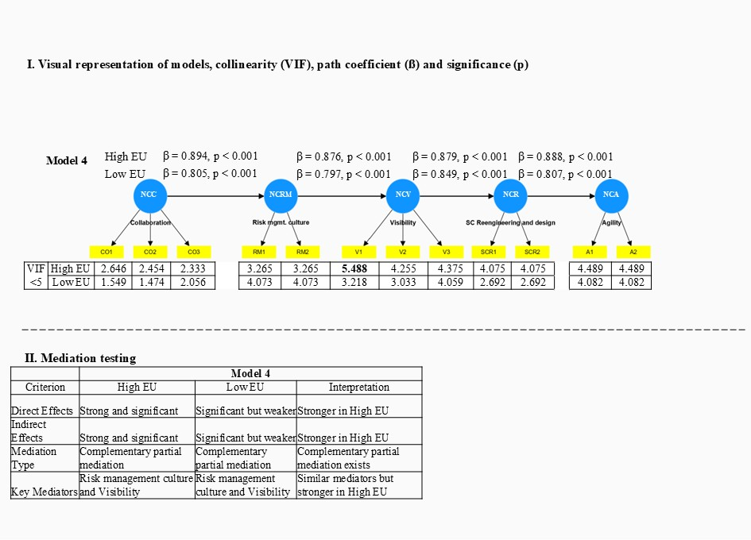
Figure B.1 Results summary of structural model evaluation – network capability model , including mediation testing

Table B. VIII Significance and relevance of structural relationships (direct and indirect effects) network capability model
High EU
Direct effects | Original sample (O) | Sample mean (M) | Standard deviation (STDEV) | T statistics (|O/STDEV|) | P values
Collaboration -> Agility | 0.611 | 0.610 | 0.048 | 12.652 | 0.000
Collaboration -> SC Reengineering and design | 0.688 | 0.688 | 0.048 | 14.418 | 0.000
Collaboration -> Visibility | 0.783 | 0.784 | 0.046 | 16.898 | 0.000
Risk Mgmt. Culture -> Agility | 0.683 | 0.682 | 0.045 | 15.088 | 0.000
Risk Mgmt. Culture -> SC Reengineering and design | 0.770 | 0.768 | 0.041 | 18.625 | 0.000
Visibility -> Agility | 0.780 | 0.779 | 0.040 | 19.291 | 0.000
Specific indirect effect | Original sample (O) | Sample mean (M) | Standard deviation (STDEV) | T statistics (|O/STDEV|) | P values
Collaboration -> Risk Mgmt. Culture -> Visibility -> SC Reengineering and design -> Agility | 0.611 | 0.610 | 0.048 | 12.652 | 0.000
Risk Mgmt. Culture -> Visibility -> SC Reengineering and design -> Agility | 0.683 | 0.682 | 0.045 | 15.088 | 0.000
Visibility -> SC Reengineering and design -> Agility | 0.780 | 0.779 | 0.040 | 19.291 | 0.000
Low EU
Direct effects | Original sample (O) | Sample mean (M) | Standard deviation (STDEV) | T statistics (|O/STDEV|) | P values
Collaboration -> Agility | 0.440 | 0.440 | 0.051 | 8.548 | 0.000
Collaboration -> SC Reengineering and design | 0.544 | 0.545 | 0.052 | 10.448 | 0.000
Collaboration -> Visibility | 0.641 | 0.643 | 0.050 | 12.836 | 0.000
Risk Mgmt. Culture -> Agility | 0.546 | 0.545 | 0.054 | 10.062 | 0.000
Risk Mgmt. Culture -> SC Reengineering and design | 0.676 | 0.675 | 0.049 | 13.769 | 0.000
Visibility -> Agility | 0.685 | 0.684 | 0.055 | 12.414 | 0.000
Specific indirect effect | Original sample (O) | Sample mean (M) | Standard deviation (STDEV) | T statistics (|O/STDEV|) | P values
Collaboration -> Risk Mgmt. Culture -> Visibility -> SC Reengineering and design -> Agility | 0.440 | 0.440 | 0.051 | 8.548 | 0.000
Risk Mgmt. Culture -> Visibility -> SC Reengineering and design -> Agility | 0.546 | 0.545 | 0.054 | 10.062 | 0.000
Visibility -> SC Reengineering and design -> Agility | 0.685 | 0.684 | 0.055 | 12.414 | 0.000

Table B.IX Network capability models explanatory power
NC Model
High EU
 | R-square | R-square adjusted
Agility | 0.788 | 0.786
Risk Mgmt. Culture | 0.799 | 0.797
SC Reengineering and design | 0.772 | 0.770
Visibility | 0.767 | 0.765
Low EU
 | R-square | R-square adjusted
Agility | 0.652 | 0.649
Risk Mgmt. Culture | 0.648 | 0.645
SC Reengineering and design | 0.721 | 0.719
Visibility | 0.635 | 0.632

Table B.X Network capability models predictive power
NC Model
High EU
 | Q²predict | PLS-SEM_RMSE | PLS-SEM_MAE | LM_RMSE | LM_MAE
A1 | 0.379 | 0.884 | 0.718 | 0.854 | 0.693
A2 | 0.386 | 0.862 | 0.674 | 0.834 | 0.660
RM1 | 0.626 | 0.512 | 0.421 | 0.515 | 0.424
RM2 | 0.540 | 0.576 | 0.460 | 0.578 | 0.456
SCR1 | 0.415 | 0.774 | 0.641 | 0.774 | 0.636
SCR2 | 0.388 | 0.862 | 0.741 | 0.865 | 0.734
V1 | 0.467 | 0.697 | 0.555 | 0.704 | 0.554
V2 | 0.499 | 0.740 | 0.594 | 0.734 | 0.581
V3 | 0.439 | 0.804 | 0.655 | 0.817 | 0.656
Low EU
 | Q²predict | PLS-SEM_RMSE | PLS-SEM_MAE | LM_RMSE | LM_MAE
A1 | 0.186 | 0.799 | 0.662 | 0.771 | 0.625
A2 | 0.181 | 0.730 | 0.615 | 0.713 | 0.601
RM1 | 0.485 | 0.634 | 0.517 | 0.626 | 0.518
RM2 | 0.384 | 0.707 | 0.541 | 0.696 | 0.562
SCR1 | 0.248 | 0.806 | 0.670 | 0.793 | 0.664
SCR2 | 0.283 | 0.784 | 0.673 | 0.770 | 0.648
V1 | 0.342 | 0.599 | 0.449 | 0.588 | 0.470
V2 | 0.331 | 0.775 | 0.616 | 0.751 | 0.562
V3 | 0.344 | 0.728 | 0.597 | 0.715 | 0.562

Table B.XI Robustness checks network capability model
 | NC model
Nonlinear Effects | Significant quadratic terms:  - SC Reengineering and Design -> Agility (P < 0.05)  - Other QE paths not significant
Endogeneity (Gaussian Copula) | No significant endogenous issues for:  - Collaboration -> Risk Management Culture  Significant for:  - Visibility -> SC Reengineering and Design (P < 0.05)
Unobserved Heterogeneity (FIMIX-PLS) | Model with 3 segments best fit:  - BIC = 1000.441, CAIC = 1026.441  - Segment 2: More balanced paths across capability levels

Table B.XII Sequence testing network capability model
Evaluated sequences NC* |  |  |  |  | No. of plants |  | Sequence progression according H3
NCC | NCRM | NCV | NCR | NCA | Low EU | High EU | Sequence progression according H3
L | L | L | L | H | 8 | 2 | No
L | L | L | H | L | 1 | 0 | No
L | L | L | H | H | 2 | 0 | No
L | L | H | H | L | 0 | 1 | No
L | L | H | H | H | 1 | 1 | No
L | H | L | L | H | 1 | 0 | No
L | H | L | H | L | 0 | 1 | No
L | H | H | H | H | 0 | 1 | No
H | L | L | L | L | 6 | 18 | Possible
H | L | L | L | H | 7 | 2 | No
H | L | L | H | H | 5 | 2 | No
H | L | H | L | H | 1 | 0 | No
H | L | H | H | L | 0 | 1 | No
H | L | H | H | H | 7 | 1 | No
H | H | L | L | L | 5 | 6 | Possible
H | H | L | L | H | 4 | 1 | No
H | H | L | H | L | 1 | 1 | No
H | H | L | H | H | 7 | 2 | No
H | H | H | L | L | 0 | 7 | Possible
H | H | H | L | H | 15 | 3 | No
H | H | H | H | L | 0 | 10 | Possible
H | H | H | H | H | 47 | 55 | Possible
L | L | L | L | L | 17 | 20 | Possible
Percentage of plants following sequence H3 |  |  |  |  | 56% | 86%
Note**: The following sequence were not listed due to missing observations in the data set: LLHLL, LLHLH, LHLLL, LHLHH, LHHLL, LHHLH, LHHHL, HLLHL, HLHLL
In addition, we have conducted two additional control tests: a. the adherence to the network capability (NC) sequence (in low environmental uncertainty) and high level of network capabilities; b. the high level of network capabilities (in high environmental uncertainty) and shared resource allocation in building these capabilities. Related to the first point the Chi² test revealed a statistically significant correlation between high level of NCs and the adherence to the NC sequence, with χ²(1) = 4.49, p = 0.034, Cramér's V = 0.18 (Table B.XI). Related to the second point the Spearman correlation test showed that there is a statistically significant and strong correlation between high level of NCs and the collaborative allocation of resources within the network, with r(133) = 0.88 and p < 0.001.
Table B.XIII Observed versus expected frequencies in relation to adherence to the network capability (NC) sequence and high level of network capabilities
Observed frequencies
 |  | Adherence to the NC sequence
 |  | yes | no | Total
Level of NC | H | 45 | 25 | 70
Level of NC | L | 30 | 35 | 65
 | Total | 75 | 60 | 135
Expected frequencies for perfectly independent variables
 |  | Adherence to the NC sequence
 |  | yes | no | Total
Level of NC | H | 38,89 | 31,11 | 70
Level of NC | L | 36,11 | 28,89 | 65
 | Total | 75 | 60 | 135

B.4 Model comparison to evaluate the extended Sand Cone sequence

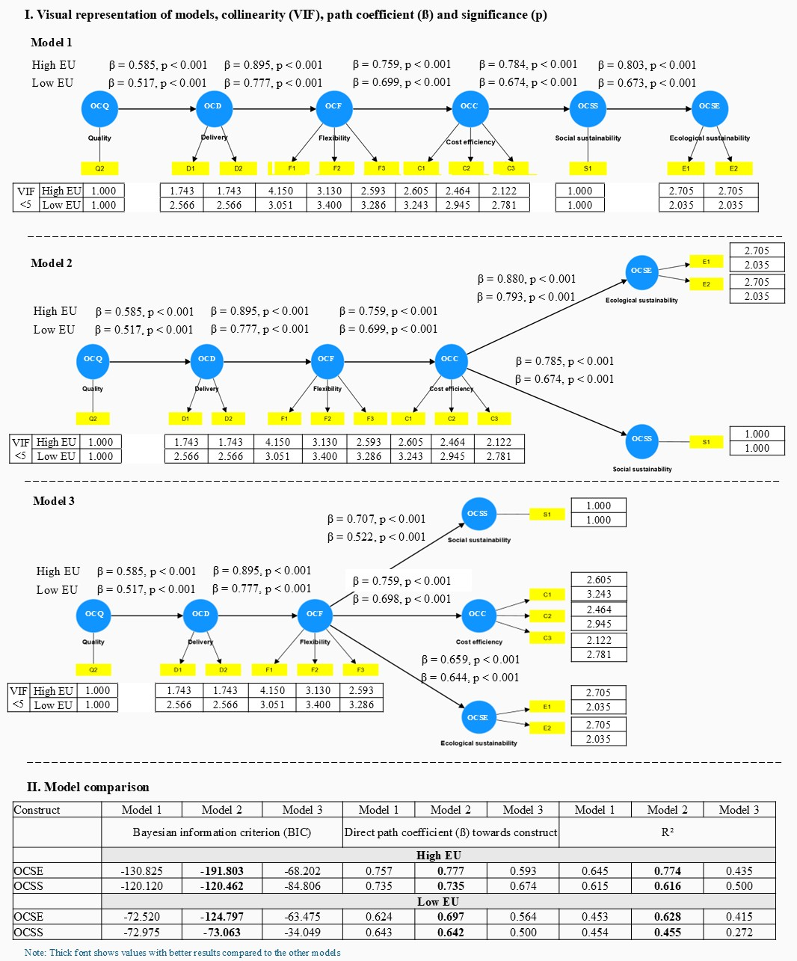
Figure B.2 Results summary of model comparison

