Appendix A– Experimental Scenarios

SCENARIO | CHANNEL | RETURNS POLICY | PRODUCT TYPE
1 | Offline | Lenient | New
2 | Offline | Lenient | Remanufactured
3 | Offline | Restricted | New
4 | Offline | Restricted | Remanufactured
5 | Online | Lenient | New
6 | Online | Lenient | Remanufactured
7 | Online | Restricted | New
8 | Online | Restricted | Remanufactured

You have been planning to buy the new ACE 32WT tablet for yourself. ACE is a leading brand in the tablet market, and sells the most innovative and high quality tablets.

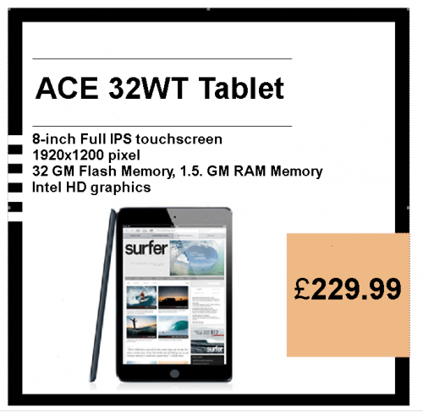

- Experimental scenario in the offline/lenient/new condition
You visit your favorite physical retail store (which is a 30 minute round-trip drive from your house) to buy the new ACE 32WT tablet for yourself. If you are going to buy it from your favorite physical retail store, you will have 30 days to return the tablet and you will get 100 percent of your money back or, as an alternative, you can exchange your tablet immediately with another tablet. In addition, for returnable merchandise, you don’t have to explain anything or fill out any forms - they accept it, no questions asked. Their policy says that even items bought on sale can be returned for a full refund or replacement.

- Experimental scenario in the offline/lenient/remanufactured
You visit your favorite physical retail store (which is a 30 minute round-trip drive from your house) to buy a remanufactured* version of the ACE 32WT tablet for yourself. If you are going to buy it from your favorite physical retail store, you will have 30 days to return the tablet and you will get 100 percent of your money back or, as an alternative, you can exchange your tablet immediately with another tablet. In addition, for returnable merchandise, you don’t have to explain anything or fill out any forms - they accept it, no questions asked. Their policy says that even items bought on sale can be returned for a full refund or replacement.

- Experimental scenario in the offline/restricted/new condition
You visit your favorite physical retail store (which is a 30 minute round-trip drive from your house) to buy the new ACE 32WT tablet for yourself. If you are going to buy it from your favorite physical retail store, you will have 7 days to return the tablet and you will get a coupon back in the form of a store credit or, if you want to change your tablet with another one you will have to wait around two weeks. In order to get a refund, you have to show the original receipt and explain why you are returning the tablet, and fill out a form giving your name and personal details (email, phone number etc.). The policy underlines also that you need to take back the packaging in a good condition. The policy says that if you buy something on sale, it cannot be returned for any reason.

- Experimental scenario in the offline/restricted/remanufactured
You visit your favorite physical retail store (which is a 30 minute round-trip drive from your house) to buy a remanufactured* version of the ACE 32WT tablet for yourself. If you are going to buy it from your favorite physical retail store, you will have 7 days to return the tablet and you will get a coupon back in the form of a store credit or, if you want to change your tablet with another one you will have to wait around two weeks. In order to get a refund, you have to show the original receipt and explain why you are returning the tablet, and fill out a form giving your name and personal details (email, phone number etc.). The policy underlines also that you need to take back the packaging in a good condition. The policy says that if you buy something on sale, it cannot be returned for any reason.

- Experimental scenario in the online/lenient/new condition
You visit your favorite online retail website to buy the new ACE 32WT tablet for yourself. If you are going to buy it from your favorite online retail website, you will have 30 days to return the tablet and you will get 100 percent of your money back or, as an alternative, you can exchange your tablet immediately with another tablet. In addition, for returnable merchandise, you don’t have to explain anything or fill out any forms - they accept it, no questions asked. Their policy says that even items bought on sale can be returned for a full refund or replacement.

- Experimental scenario in the online/lenient/remanufactured
You visit your favorite online retail website to buy a remanufactured* version of the ACE 32WT tablet for yourself. If you are going to buy it from your favorite online retail website, you will have 30 days to return the tablet and you will get 100 percent of your money back or, as an alternative, you can exchange your tablet immediately with another tablet. In addition, for returnable merchandise, you don’t have to explain anything or fill out any forms - they accept it, no questions asked. Their policy says that even items bought on sale can be returned for a full refund or replacement.

- Experimental scenario in the online/restricted/new condition
You visit your favorite online retail website to buy the new ACE 32WT tablet for yourself. If you are going to buy it from your favorite online retail website, you will have 7 days to return the tablet and you will get a coupon back in the form of a store credit or, if you want to change your tablet with another one you will have to wait around two weeks. In order to get a refund, you have to show the original receipt and explain why you are returning the tablet, and fill out a form giving your name and personal details (email, phone number etc.). The policy underlines also that you need to take back the packaging in a good condition. The policy says that if you buy something on sale, it cannot be returned for any reason.

- Experimental scenario in the online/restricted/remanufactured
You visit your favorite online retail website to buy a remanufactured* version of the ACE 32WT tablet for yourself. If you are going to buy it from your favorite online retail website, you will have 7 days to return the tablet and you will get a coupon back in the form of a store credit or, if you want to change your tablet with another one you will have to wait around two weeks. In order to get a refund, you have to show the original receipt and explain why you are returning the tablet, and fill out a form giving your name and personal details (email, phone number etc.). The policy underlines also that you need to take back the packaging in a good condition. The policy says that if you buy something on sale, it cannot be returned for any reason.

* If needed, please find here the following definition of a remanufactured product: “A remanufactured product is one that has gone through the process of disassembling, cleaning, inspecting, repairing, replacing, and reassembling the components of a part or product to like-new condition. Such product is a returned item that is fully tested and inspected by highly trained technicians and restored to original factory specifications. According to EU law (Directive, 1999/44/EC Article 7.1), refurbished products must come with a one-year warranty. In general, refurbished products are priced 30% lower than the new product."

