Supplementary Material 1: List of Documents
# | Title of the document (Translated into English) | Year of publishing
1 | Area quality program Blankenburgverbinding | 2015
2 | Blankenburgverbinding: Contract and tender procedure | 2016
3 | Joint ambition: Market vision | 2016
4 | Government structure vision: Accessibility in the Rotterdam region and the New Western Bank connection- Social Cost Benefit Analysis (SCBA) | 2013
5 | Information about future blankenburgverbinding: Better accessibility of Rotterdam region | 2015
6 | Information about future blankenburgverbinding: Environmental impact report (MER) | 2015
7 | Route Decision/ EIA Blankenburgverbinding | 2016
8 | Government structure vision: Accessibility in the Rotterdam region and the New Western Bank connection- Regional Economic Effects Study (REES) | 2013
9 | Government structure vision: Accessibility in the Rotterdam region and the New Western Bank connection- Plan-MER MIRT exploration; Rotterdam region and port: sustainability accessible | 2013
10 | Government structure vision: Accessibility in the Rotterdam region  and the New Western Bank Connection  Plan-MER New Western Bank Connection report C: Visual  report on participation in variant development | 2013

Supplementary Material 2: Location map of the “A24 Blankenburgverbinding” project and
events across the project lifecycle
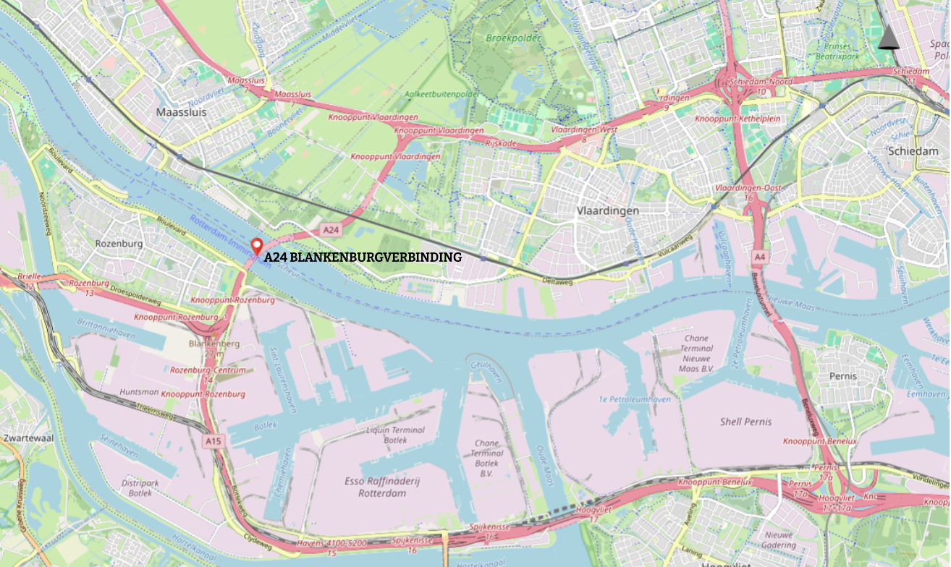
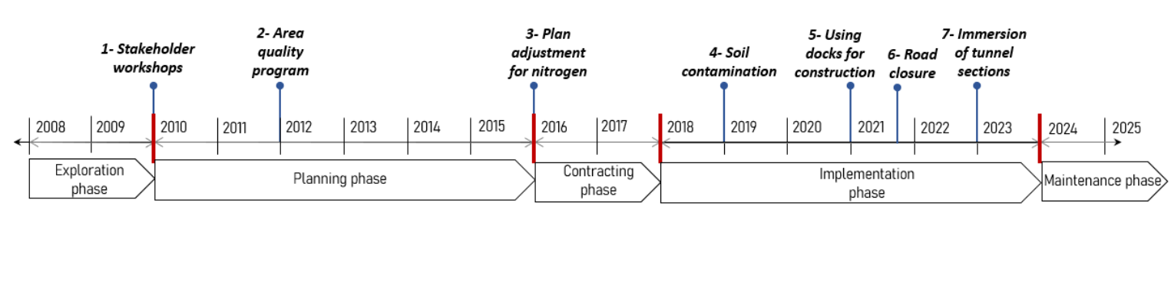

Supplementary Material 3: Interview details
Interviewee | Date | Duration in minutes | Role in the project | Location of interview | Events discussed
I1 | 01.11.2023 | 101 | Project director | Project site | E1, E2, E3, E7
I2 | 01.12.2023 | 42 | Contractor side- project manager | Project site | E4, E5, E7
I3 | 29.11.2023 | 74 | Stakeholder manager | Rotterdam | E1, E2, E3, E5, E6
I4 | 27.11.2023 | 53 | Project controller | Rotterdam | E5
I5 | 1.12.2023 | 62 | Ministry employee | Den Haag | E4, E5
I6 | 29.09.2023 | 43 | Contract manager | Groningen | E1
I7 | 29.11.2023 | 60 | Contract manager | Project site | E3, E4, E7
I8 | 14.12.2023 | 48 | Municipality official | Vlaardingen | E4, E6
I9 | 13.12.2023 | 42 | Top management | Utrecht | E3, E7

Supplementary Material 4: Interview guide
Section 1: General Information
1. | For how long were you involved in the project?
2. | Was the management style of the IPM team cooperatively or contractually governed?
3. | What was the general project atmosphere?  (Prompt: Both parties tended to be very responsive to maintain the cooperative relationship.  Problems that arose in the course of this project were treated by both parties as a joint responsibility  The partners in this project did not mind owing each other a favour. Disagreements were resolved to the mutual satisfaction of both parties.  In this project, it was expected that any information that could help the project partner would be provided to them.  Project partners were expected to keep each other informed of events or changes that could affect the other party.)
4. | Was response to events occurring due to proactively (opportunity during tendering, early client requirements, opportunity during design, opportunity during production) or reactively (issues during implementation, realisation to have an integrated area development)?
Section 2: Collaboration
5. | 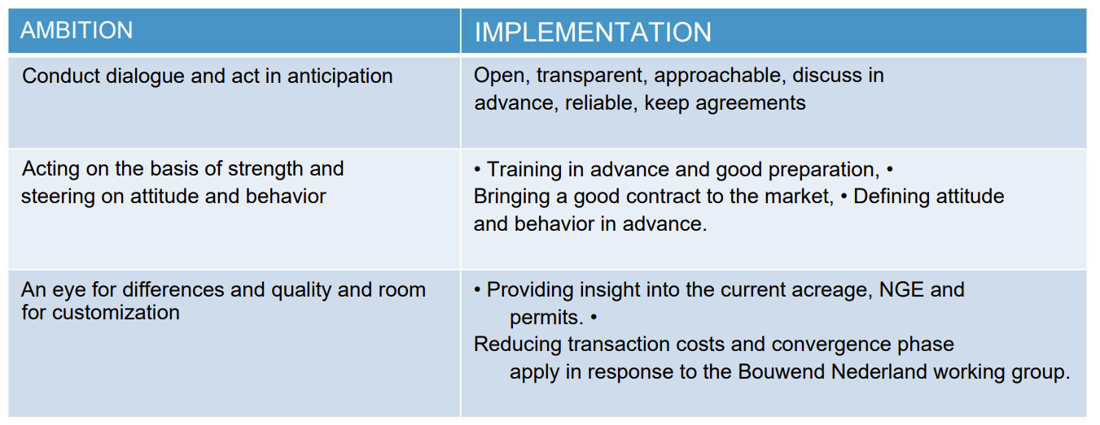  Did the project live up to this ambition? Did all parties work together on this?
6. | Was the focus on project management (minimal information is provided to the stakeholder environment about the project's progress, the emphasis is on making progress by speeding up processes, solutions for problems are sought in the project organization so as to promote the project interest, management persists on achieving pre-determined goals regardless of changing circumstances, and communication to the stakeholder environment takes a DAD-strategy (decide, announce, and defend)) or process management (the project is accessible to interested parties, the emphasis is on creating or maintaining support for the project, solutions are sought together with external stakeholders, management is receptive and flexible to changing circumstances, and communication takes a dialogue, decide, and deliver strategy)? (at the planning, contracting, and implementation phases)
7. | How did you foster collaboration?  (Prompt: encourage collaboration among team members and departments, form any external partnerships or collaborations)
8. | In your opinion, do you think that good relationships built during the planning phase have contributed to the implementation phase?
Section 4: Boundary spanning
9. | How did you contribute to accomplishing these ambitions?
10. | Did you experience problems when engaging in information exchange between the various parties? What did you do to overcome this problem?
11. | Did you experience any problems when engaging in relationship building and maintaining activities? What did you do to overcome this problem?
12. | Did you experience any problems when engaging in coordination and negotiation activities? What did you do to overcome this problem?
13. | Did you experience any problems when engaging in mediation and facilitation activities? What did you do to overcome this problem?
14. | Would you say that trust has been observed as a critical factor in this project?
Section 5: Closing questions
15. | Would you recommend any key lessons learned and recommendations for enhancing collaborative quality in future partnerships?
16. | Would you like to add further information about the collaborative quality in this project or in general?
Supplementary Material 5: List of newspaper articles
# | Publisher | Date of publishing | Author | Title (translated into English)
1 | RWE Resources News | 12-09-2024 | - | Ballast Nedam takes center stage in Europe's construction industry with a focus on building sustainable living environments
2 | BN De Stem.nl | 06-04-2023 | Daan de Hulster | Second tunnel section of Blankenburg connection later sunk due to leakage during first job
3 | Provincial Zeeland Courant | 08-03-2024 | GERT ONNINK | The super tunnel near Rotterdam almost ready
4 | AD/Rotterdams Dagblad | 16-09-2023 | DAAN DE HULSTER | An important moment in the run-up to the new tunnel
5 | BN De Stem.nl | 14-07-2023 | Gert Onnink | The Holland Tunnel is almost finished and the construction of the Blankenburg connection is on schedule despite setbacks
6 | AD/Algemeen Dagblad.nl | 01-08-2023 | Daan de Hulster | Tunnel builders want to generate energy, but solar panels are not wanted: 'Affects the landscape'
7 | AD/Algemeen Dagblad.nl | 18-08-2023 | Stéphan Reket | Vlaardingen has a new recreation area, thanks to a tunnel 'that nobody wanted'
8 | AD/Rotterdams Dagblad | 12-03-2022 | Gert Onnink | Blankenburgtunnel reaches its lowest point: -28 meters
9 | Co-construction | 12-05-2022 | - | Cheetah drags part of Maasdelta tunnel to Botlek 'parking lot'
10 | PZC.nl | 04-05-2022 | Gert Onnink | This tunnel is so important that the port of Rotterdam has to close for it
11 | De Vlaardinger | 18-10-2021 | - | South neighborhood Vlaardingen closed to through traffic for ten weeks
12 | Co-construction | 02-03-2021 | - | In the deep construction pit, help from Archimedes is never far away
13 | FD.nl | 13-09-2019 | Vasco van der Boon | Cabinet breaks nitrogen impasse with calculation tool
14 | The Financial Daily | 16-10-2019 | Arend Clahsen | Construction of Holland Tunnel begins, despite concerns about soil regulations
15 | The Financial Daily | 14-06-2019 | - | Critical statement on nitrogen disrupts infrastructure plans
16 | De Persgroep | 29-05-2019 | EMIEL HAKKENE | Thousands of permits possibly illegal
17 | AD/Algemeen Dagblad.nl | 25-04-2019 | Eric Oosterom | Traffic congestion due to discovery of asbestos during construction of Blankenburg connection
18 | Co-construction | 26-07-2018 | - | Construction of controversial Blankenburg tunnel allowed to continue by Council of State
19 | FD.nl | 18-07-2018 | From the editor | Blankenburg tunnel can now really be built
20 | ENP Newswire | 19-12-2017 | - | DEME Group - The Directorate-General for Public Works and Water Management and Ballast Nedam DEME and Macquarie Capital sign contract on A24 Blankenburg connection
21 | The Botlek 1 | 30-09-2015 | - | Schulz-van Haegen seals construction of Blankenburg tunnel
22 | AD/The Hague Courant | 01-08-2018 | Eric Oosterom | 'New' puddle plaster on the wound
23 | Co-construction | 30-05-2015 | Ingrid Koenen | 'Three applicants is enough'
24 | AD/Rotterdams Dagblad | 08-08-2015 | Pieter Maessen | Serve sweet and sour at the same time

Supplementary Material 6: Elaboration of Table 2
 | Event | Description | Response | Boundary spanning Activities (BSA) | Critical Success Factor (CSF) | Synergetic momentum
Planning Phase (2012- 2024) | Event 1:  Stakeholder workshop  (2010) | Opposition from the municipality, farmers, and NGOs leading to protests against the project. | In response, the IPM team designed workshops to facilitate open communication with the stakeholders. | Relational Activities:  – Intensive interaction with differentiated groups of stakeholders like local residents, the Port of Rotterdam, nearby municipality employees, and various specialist (traffic engineers, landscape architects, civil engineers, and ecologists) (I1). “ We had three groups. We had the governmental organizations, we also had the non-profit organizations and we had the residents” (I1). “We had a traffic engineer, we had architects, we had landscape engineers, we had civil engineers, we had an ecologist... a broad diversity of specialists” (I1)  – To maintain constant stakeholder engagement and accurately identify underlying issues, as expressed concerns may sometimes differ from the actual problems (I1, I6).  – Maintaining ongoing engagement with various stakeholder groups, including professional stakeholders, is essential not only during challenges but also when operations are running smoothly (I3). “We made a strategy for that and also worked out the rules of participation and the rules of collaboration. We worked in a tight time sheet so we did a lot of in a short time. Sometimes people think that's not possible but it is possible if you know what your question is of participation what your rules are? Where can people participate on or and what is not negotiable.” (I3)  Mediation and Facilitation:  – Organized structured stakeholder workshops with clear time frames, rules of participation and pre-defined discussion topics (I1, I3). “And we said to those people: you are going to join us for six months, one afternoon and one evening a week. What you get: you get specialists, we match specialists to you. We link information to you. At the same time, you get insight into how such a design process works”. (I1)  Information exchange and knowledge sharing:  – Tailored communication inviting local knowledge to improve project design (I1, I6). | Mutual Trust:  – Having the adaptive room to incorporate stakeholder suggestions demonstrated a commitment to their perspectives, fostering trust in the decision-making process (I6, I3, I1). “I think well, the trust you built in your planning phase should be a basis for this construction phase.” (I6).  Open communication:  – Early, transparent dialogue building confidence among stakeholders (I3). “ we still are in contact with the different stakeholder groups, also the professional stakeholders and even though we don't have that much maybe to talk about, but it's important to not only to fight each other when it's not going well. Also to talk to each other when it's going fine and because then it's more easy to find each other when it goes wrong.” (I3)  Leadership and conflict resolution:  – Effective facilitation turned protests into constructive discussion (I3).  –The IPM team lead effectively transferred collective experiences from the planning to the implementation phase while serving as a critical liaison between internal and external stakeholders (I3). “Not everybody has that type of skills and also how Helen is organizing this and also managing this project is unique and also very important of how things go. She is very important in that and that's why it's also I think great that she's also still on board in this phase because also of the memory of the past, because I've been away for a few years in the contracting phase. I was working for the port of Rotterdam for four years and I came back in 2020. Just before COVID. And there was a new team also within the stakeholder team. And then I noticed that why things are the way they are because of the past, people don't know that anymore and you cannot also not read it. So we have a big archive” (I3). | Open dialogue and co-design:  Stakeholder protests about the tunnel were converted into concrete wishes through intensive early interaction, open dialogue, and adaptive project capacity, leading to design changes (second tunnel, lower junction) and growing trust.  “Local municipalities and of course farmers, they didn't like the tunnel being there. But the decision to build the tunnel was made and the protests evolved to wishes. If we have to accept that that the tunnel is going to be there, then we want this and this so. The project started with protests, but during the planning phase, it evolved into can you do a little bit of nature, can you lower this here and there this kind of things?”(I6)  “we also said that when you are participating , the way to the courts is always open for you, so we will not hold it against you that you were involved with in this project. But we want to learn from your point of view, your knowledge of the area to make the project better. so that's how also the design of the highway is made because of the wishes and ideas of the different participants, so that's why also because they were firm in their ideas, the second tunnel came, but also the the junction in the A 20 and the new A 24 is a low junction that's also to keep it as much as possible out of sight.” (I3)
Planning Phase (2012- 2024) | Event 2:  Area quality program  (2012) | Many ideas arose to enhance area quality, requiring prioritization of 30 sub-projects for an Area Quality Program. | Through the intensive discussions with top management, residents and local authorities from nearby municipalities of Rozenburg and Vlaardingen, the IPM team was able to gather support and investments for the Area Quality Program. | Mediation and Facilitation:  – Used an interactive prioritization “game” (allocating 25 symbolic balls) to help residents decide on project order (I1, I3).  – Through mediation of the IPM team, stakeholders with contradicting interests were able to adapt and negotiate solutions rather than cast aside the projects (I3). “We came up with a little game we gave them 25 little balls. That was symbol of the 25,000,000 and we also gave the project. So this project is 3 balls and that project is 5 balls. So if you have to make a decision together, what projects would you see realized 1st and then were able to do it together. So that was also a nice result. But in the end the regional municipalities also wanted to invest so they also put in 25,000,000 and then all the projects could be realized and that's now the current quality program. New waterland. It's a nice result and the municipalities are still working together to realize that that's not always that easy, because now you see in time situations are changing. Budgets are now more tight, so we then they'd have to make new choices, but because they are in collaboration situation already for a long time, they are able to go with the change and talk about it.”(I3) | Open communication:  – Transparent discussion about resource limits and benefits fostered consensus (I1, I3). “We should not do that, come up with a plan. We have to facilitate it, but they have to come up with a plan. You get more support; you get cooperation because they have to get to work themselves. It will only cost you 25 million.” (I1)  Top management support:  – Strategic support was secured by engaging top management in discussions and conducting further consultations, which strengthened their understanding of community needs and priorities (I1). “Your project team knows very clearly that they have your support when they have to address the Rijkswaterstaat organization about: hey, guys, a little more spark and a little less tick. And that the contractor knows, hey, I have to focus on the stakeholder side, I have to do something about that. How would you describe the relationship between your project team and your contractor? How do they work?” (I1) | Regional co‑investment and long‑term collaboration:  Regional governments, citizens and NGOs co-prioritised 30 quality projects using a “25 balls = 25 million” game, which led municipalities to add their own 25 million and maintain an ongoing collaborative New Waterland programme despite changing budgets.  “In the end the regional municipalities also wanted to invest so they also put in 25,000,000 and then all the projects could be realized and that's now the current quality program.” (I3)
Planning Phase (2012- 2024) | Event 3:  Plan adjustment for nitrogen emissions (2016) | An environmental lawsuit over nitrogen emissions from the new infrastructure risked significant project delays. | The IPM team anticipated this issue and took proactive steps to develop a concrete plan of action to compensate nitrogen emissions. | Coordination and negotiation activities:  – Proactively changed the route and negotiated with landowners for nature compensation (I1, I3 I7).  – Suspended the process temporarily to allow for comprehensive stakeholder briefings (I1). “At that time, we asked the Council of States to suspend the entire process for six weeks, and in six weeks' time we decided to change the route. We negotiated with all stakeholders who had land that was suitable for nature compensation, and we simply put in a completely new nature compensation plan”(I1) | Top management support:  – The IPM team instilled confidence in upper management to take the risk of initiating contracting before the project's verdict, preventing further delays that would have resulted from awaiting the decision (I9). “So quick decision making is always important for a project. If you have a team, the luxury of a professional team and they can make it themselves, then it means that you don't have to go up and down the entire hierarchy. It takes much too long. If you go to the Minister and back. So for a successful project, it's important to have the opportunity to make decisions when it's necessary. ” (I9) | Proactive anticipation of nitrogen risks:  The project team proactively created a nitrogen-compensation sub‑project (grassland nature reserve) and updated plans before court rulings, avoiding delays and gaining several years of time.  “I think it was very proactive and took all the necessary steps. It also made it possible and we won a couple of years of time with that because all the procedure is taking a lot of time. Also I think the project manager is proactive with her team”(I9).  “We did a very different approach and it worked. Actually you could use the model. Or you could just take real concrete measures outside and we saw the storm coming about the nitrogen discussion. And then we as a project said that in a few months we make a sub project to compensate for nitrogen emissions in our project. ”(I7).
Implementation Phase (2018- 2024) | Event 4:  Soil Contamination  (2018) | Discovery of significant soil contamination (including asbestos) during excavation threatened project schedule continuity. | Although contractually client's responsibility, the contractors proactively addressed the issue, anticipating a resolution to follow. In addition, prior agreements made with the municipality had to be renegotiated for deciding soil disposal locations, resident compensation, and road condition monitoring. | Coordination and negotiation activities:  – Leveraged established trust to quickly mobilize a solution without initially discussing cost disputes (I2).  “ Encountered huge pollution, and instead of discussing whose contractual problem it is... how we're going to solve, we said, OK, we're going to solve it and in the end RWS will give financial compensation for that and we do our best to clean it out and to not to disturb the schedule. So instead of first discussing how to solve it, we solved it and financially also” (I2) | Common goal and shared vision:  – The recognition that project progress took precedence over individual interests facilitated the effective resolution of issues without major obstacles (I8) (I5).  “ we made agreements about the location where the land will go, about compensation for the residents, monitoring of the road, whether the road went well or not. Yes, we always worked it out in the end. ” (I8)  “ Every time there were big issues that the project itself could not handle- exogenous, it is called, then they came to me, and we were discussing and preparing a request for the policy people and the Minister. Could you agree with a certain proposal? Yeah, mostly there was a request for extra budget involved or change of the scope of the project a little bit. ”(I5) | Joint problem‑solving under pressure:  When unexpected soil pollution, truck traffic issues and budget shortages emerged, parties focused on solving them together (compensation, new land locations, extra funding) instead of blaming, relying on trust to keep schedule and project going.  “We had a moment when contaminated soil had to be removed which was not foreseen, a lot of truck movements that could do nothing but drive through the city that we had agreed on was that that was not the agreement. And even there we actually have good ones, in the end they come up with a problem of which they say there is really no other way and then I am also sensitive to that, if there is no other way then yes but no tunnel no it doesn't work that way. So, then you have to look at how do you work it out together?”(I8).  “Encountered huge pollution, and instead of discussing whose contractual problem it is... how we're going to solve, we said, OK, we're going to solve it and in the end RWS will give financial compensation for that and we do our best to clean it out and to not to disturb the schedule. So instead of first discussing how to solve it, we solved it and financially also. ”(I2).
Implementation Phase (2018- 2024) | Event 5:  Using docks for construction  (2021) | COVID-19 triggered material shortages and delays, necessitating a shift to off-site construction for tunnel elements. | To counter delays, the tunnel elements were planned to be built off-site at the Damen Verolme dry dock, allowing simultaneous construction activities. | Relational Activities:  – Engage top management and key stakeholders in discussions to revise and adapt the plan for better resource utilization (I5).  Mediation and Facilitation:  – Engage in out-of-the-box thinking to deal with time and space constraints (I2, I4, I5).  “ When you had a corona and there were delays and they were thinking, OK, how can we solve the delay that we face? Yeah, there was a plan how to build it and the order in which to build. And then contractual, it was also agreed on how to do it. And then they said, listen, we can win some time if we do it differently, but OK, you take the risk because you change things. But it was a kind of out-of-the-box thinking that was not building the tunnel parts at the spot itself. Where you go, they first wanted to build it over there. But then at the end they decided, together with the colleagues of BAAK, the contractor. They decided if we do not build it on the spot but on different place in the dock, then we can already do work here. And otherwise when we're building the tunnel compartment, we first have to finish it, then take it away and only then we can start building over there.” (I5) | Commitment to win-win philosophy:  – The successful outcome was facilitated by the collective desire of all parties involved, ensuring that the interests of each stakeholder were addressed, which contributed to achieving desired outcome (I3).  Leadership and conflict resolution:  – The IPM team lead effectively communicated to all stakeholders that mutual dependence is essential, emphasizing the importance of maintaining strong relations (I5).  Top management support:  – While changing contractual agreements carries inherent risks, the IPM team demonstrated increased efficiency through this approach, which ultimately convinced the ministry that it was the correct course of action (I5).  “ To change the agreements that were made earlier, it took extra risk for us at RWS ministry part, but also the contractor. And in the end, that's also an important thing, which Helene also will mention I guess you both need each other. So within the ministry, RWS , bestuurstaf, policy making, there you need eachother to have decision making in a good way. But you also have relation with the contractor and the contractor needs the opdrachtgever. And there is not one opdrachtgever, it's a chain. It's a whole chain.” (15) | “Best for project” by using the dock:  RWS, policy, and contractor accepted extra risk and worked around contract rules to use an available ship dock for tunnel elements, enabled by tight collaboration, a “what’s best for the project” mindset, and alignment across a long client chain.  “To change the agreements that were made earlier, it took extra risk for us at RWS ministry part, but also the contractor. And in the end, that's also an important thing, you both need each other. So within the ministry, RWS, policy making, there you need each other to have decision making in a good way. ”(I5).  “And then they started negotiations with that building dock and also the contractor came to RWS to discuss would it be a good idea? And then we work together to make that idea possible and it was made possible to work more parallel, because otherwise we have to work in parts in series and now the tunnel part get could be made on a different place nearby, but at a different place. And other activities could also go further. At the same time, but it was also possible because all the parties wanted it, and so advantage of doing made sure all the interests of the different parties were served. So that was helpful. ”(I3).
Implementation Phase (2018- 2024) | Event 6:  Road closure  (2021) | A local road closure for material transport threatened local businesses and community access. | The IPM team, leveraging strong relations built through stakeholder workshops, discussed the issue with the local community and developed a plan, which was to conduct campaigns to promote local businesses. | Relational Activities:  – Used established stakeholder relationships to reframe the situation (I3).  Mediation and Facilitation:  – Developed a creative campaign (promotional signs, vouchers, community photos) to mitigate negative impacts (I3, I8). “we saw at one point that the road, the southern neighborhood, had to be closed for a while. Which is not surprising because here you are going to build the tunnel, but you there you have a golf course and some entrepreneurs, a lot of leisure economy, etc. yes, they became less and less accessible and of course protested saying, yes this can't happen, I won't be reachable anymore. What they did then, very creative I think, was started a campaign with those people about “come to the south neighbourhood”, so they have big signs with attention for the south neighbourhood, people from the golf course on the photo with a builder of the Blankenburg connection and say how great it is. Vouchers handed out to staff to eat at the restaurant. And in that way, actually, those entrepreneurs there, because they asked me can I close that road, and I said if you come out of that with those entrepreneurs, you can close the road from me. As a result, they finally manage to celebrate a big festive moment that the road closed, that I thought what is happening here? Are we all celebrating that the road is closing?? That's pretty crazy but very creative.” (I8) | Common goal and shared vision:  – Focused on turning disruption into an opportunity for community engagement, ensuring mutual benefit (I8).  “ focus on stakeholder management, when I see how the project team of the Blankenburg connection does that, I think that is an fine example for a lot of projects, yes. The time, energy, attention they give to their environment” (I8) | Creative mitigation for local businesses:  To allow an unplanned 10‑week local road closure, the team co‑created a promotional campaign with affected retailers using joint branding, visibility, and festive actions so access problems turned into relationship‑building.  “we had to shut down the local road for 10 weeks and that was not one of the things we agreed with the municipality of Vlaardingen. We had agreed to never shut down local road. But also to prevent delay, it helped that we had a good relationship. So they said OK, but the local retailers in that area also should agree on it. And so, I came up with a campaign. We made the campaign with the builders, they were photographed with a local project of one of the retailers. There were 10 or 11 retailers… it was also a connection with the building people who were there making that work. ”(I3).
Implementation Phase (2018- 2024) | Event 7:  Immersion of second tunnel element  (2023) | A cable break during tunnel sinking caused damage and risked significant delays. | Although this issue primarily fell under the contractor's responsibility, both public and private stakeholders collaborated to explore all possible scenarios and develop effective solutions. | Relational Activities:  – Supporting one another during challenging times while avoiding transfer of risks between parties (I1).  Coordination and negotiation activities:  – Activated pre-scenario planning measures for rapid response (I9).  – Coordinated a joint public–private problem-solving effort focused on solutions rather than assigning blame (I2). “we hit problems a couple of months ago with the second tunnel element that we had to sink. I believe that they thought of all the scenarios that were possible and for all the scenarios they had everything in place to show that the two or three days that they actually will take place, that there was no chance of missing something. No, I think it was very proactive. They thought of every scenario.” (I9) | Mutual Trust:  – Understanding that all the stakeholders are dependent on each other and trust one another to do what is best for the project (I1)  Common goal and shared vision:  – Public and private partners are able to think of the good of the project keeping their differences aside when a problem arises (I1)  Leadership and conflict resolution:  – Having a keen attitude to understand what are the ongoing problems and discuss as a team to find solution (I1)  “Because you can see that it costs a lot financially and that the reaction of my management is: make it clear that he is blundering and not us. At the same time, if I do that, then I'll just lose my partner. Because in good times it's okay to fight each other, but in bad times you stand next to each other and help.” (I1) | Dealing with technical challenges (tunnel immersion):  During major immersion problems with the second tunnel element, client and contractor treated it as a shared challenge rather than a blame issue, with the client offering help despite internal pressure, thereby protecting the partnership and project.  “We really encountered the problem within the immersion and it took us five months to solve it and it could go both ways in that sense that this was our problem. It was our responsibility and we had to solve it. The client could have said what are you doing and how you're going to solve it, and now you're bringing me into problems because we're going to be late and etcetera, etcetera. So you messed up and tell me how you're going to solve it. There was nothing in that direction. So they came to us and said we are very sorry that it went that way, how can we help? Yes, that is a much better, much better way to approach this, yeah.”(I2)

