Supplementary Material

SM1 - Operationalization of conditions and outcome (Authors’ own work)
Social phenomena are empirically distributed in ways that produce limited diversity, which is therefore not merely a methodological artifact of QCA but a reflection of this underlying distribution: given the causal constraints that shape social reality, certain combinations of conditions occur systematically and repeatedly, while other logically possible combinations are rarely observed in empirical cases. This empirical unevenness directly produces logical remainders, configurations that are logically conceivable but for which no empirical instances exist in the data. What the research design can do is limit its extent and manage its consequences transparently. Accordingly, we first ensured an adequate case-to-condition ratio, which reduces the proportion of unobserved configurations and improves the interpretability of the truth table. Mello (2021) recommends a minimum of 16 cases for 4 conditions, while Mattke et al. (2022) suggest a conditions-to-cases proportion close to 0.20; both recommendations are met here. In addition, as we need to take account of limited diversity, we analyzed the intermediate solutions as main results.
In QCA, membership scores are assigned to each case for each condition and outcome through a process called calibration. We implemented a manual calibration approach (Mello, 2021), assigning scores case-by-case based on a prior theoretical definition of the target set, consistent coding rules, and external criteria grounded in the empirical and institutional context of Italian municipal unions. Fuzzy-set membership scores resulted in a four-value categorization (0, 0.33, 0.67, 1), a common approach in fsQCA (Tóth et al., 2017): 0 indicates a case fully out of the set, 0.33 more out than in, 0.67 more in than out, and 1 fully in the set. Raw data were transformed into these calibrated values based on the survey administered to the 24 unions of municipalities, validated through confirmatory focus groups, and triangulated with a document analysis of the unions' 2022-2024 Integrated Plan of Activities and Organization (PIAO) to address potential subjectivity in survey responses. Internal consistency of the multi-item conditions was assessed using Cronbach's alpha; given the exploratory nature of the study and the use of two-item measures, the reliability coefficients were considered acceptable for fsQCA purposes (Eisinga et al., 2013).
Condition 1: Political leadership.
Political leadership (X1) captured the active role of the political apex in the integrated planning process. The specific criteria for membership calibration are shown in the SM1.1.
Criteria for set membership calibration of the condition political leadership (X1).
X1 — Political leadership
Survey item:
“Did the political leadership play an active role in the integrated planning process?”
Response scale: 0–3 (0 = absent; 3 = full). Internal consistency: Cronbach’s α = 0.624.
Condition X1: Political leadership
Operationalization of the condition: General level of support provided by political leaders in the introduction and operation of the strategic planning process.
Sources of evidence for data collection: semi-structured questionnaire, focus group discussion.
Set membership value | Qualitative description | Criteria for set membership calibration
1 | Fully in | Political leaders participated in the entire strategic planning process (value assigned = 3).
0.67 | More in than out | Political leaders participated in the most significant meetings of the strategic planning process (value assigned = 2).
0.33 | More out than in | Political leaders participated only at the start of the strategic planning process (value assigned = 1).
0 | Fully out | Political leaders did not participate in the strategic planning process (value assigned = 0).
Condition 2: Integrated planning.
Integrated planning (X2) captured the degree to which distinct planning and programming processes are connected within a unified strategic framework, together with the establishment of an integrated monitoring system across the PIAO subsections. The specific criteria for membership calibration are shown in the SM1.2. The survey instrument does not assume that an integrated planning process has occurred in every case; integration is treated as a measured condition (X2) rather than a precondition. The item captures the level of integration of planning and programming processes within a unified strategic framework as a continuous dimension, from full absence to full integration, so that unions in which integration had not taken place receive a low calibrated score and those with more developed integration a higher one. All 24 unions had nonetheless adopted a PIAO for the 2022–2024 cycle, as confirmed by the document analysis.
Criteria for set membership calibration of the condition integrated planning (X2).
X2 — Integrated planning
Survey items:
Q1. “Has the integration among the different planning and programming processes improved (e.g. activity programming, budgeting, human resource management, anti-corruption, digitalisation, etc.)?”
Q2. “Has the administration established an integrated monitoring system for the different PIAO subsections (public value, performance, corruption risks, organisational structure, agile work organisation, and the three-year workforce planning)?”
Response scale: 0–3 (0 = absent; 3 = full). Internal consistency: Cronbach’s α = 0.625.
Condition X2: Integrated planning
Operationalization of the condition: Integration level of the different planning and programming processes within a coherent strategic framework.
Sources of evidence for data collection: semi-structured questionnaire, focus group discussion.
Set membership value | Qualitative description | Criteria for set membership calibration
1 | Fully in | Full integration and complete monitoring. All planning processes are fully integrated and all PIAO subsections are monitored in an integrated way (Q1 and Q2 = 3).
0.67 | More in than out | Moderate integration and monitoring. Processes are largely coordinated and most PIAO subsections are monitored in an integrated way (average of Q1+Q2 between 1.5* and 2.5).
0.33 | More out than in | Initial/partial integration and monitoring. Some coordination exists between processes (ex-ante or ex-post) and at least the public value and performance subsections are monitored (average of Q1+Q2 between 0.5 and 1.5).
0 | Fully out | No integration, no monitoring. Absence of integration between planning processes and no integrated monitoring system in place (Q1 and Q2 = 0).
* In case of two questions yielding an intermediate average (1.50), the case is classified moderately integrated and monitored given that at least partial progress has been demonstrated on both dimensions.
Condition 3: Measurability.
Measurability (X3) captured the use of extra-organizational and multidimensional metrics (e.g. SDGs, EU objectives) to express public value objectives. The specific criteria for membership calibration are shown in the SM1.3.
Criteria for set membership calibration of the condition measurability (X3)
X3 — Measurability
Survey items:
Q1. “Do public value objectives also refer to non-self-referential elements, such as BES indicators, the SDGs, or NRRP objectives?”
Q2. “Are public value objectives supported by multiple types of indicators (economic-financial, social, environmental, etc.) to measure their impact?”
Response scale: 0–3 (0 = absent; 3 = full). Internal consistency: Cronbach’s α = 0.625.
Condition X3: Measurability
Operationalization of the condition: Usage of extra-organizational and multidimensional metrics to measure public value.
Sources of evidence for data collection: semi-structured questionnaire, focus group discussion.
Set membership value | Qualitative description | Criteria for set membership calibration
1 | Fully in | All objectives include external references, and every objective is supported by a full variety of indicator types (Q1 and Q2 = 3).
0.67 | More in than out | Most objectives include external references and are supported by multiple types of indicators (average of Q1+Q2 between 1.5* and 2.5).
0.33 | More out than in | Only a small portion of objectives include external references (BES, SDGs, NRRP) and/or are supported by a limited variety of indicator types (average of Q1+Q2 between 0.5 and 1.5).
0 | Fully out | Public value objectives do not reference non-self-referential elements and are not supported by multiple types of indicators (Q1 and Q2 = 0).
* In case of two questions yielding an intermediate average (1.50), the case is classified moderately integrated and monitored given that at least partial progress has been demonstrated on both dimensions.
Condition 4: Collaborative approach.
Collaborative approach (X4) captured stakeholder involvement in developing PIAO content and in evaluating objectives. The specific criteria for membership calibration are shown in the SM1.4.
Criteria for set membership calibration of the condition collaborative approach (X4).
X4 — Collaborative approach
Survey items:
Q1. “Does the PIAO include content (context analysis, objectives, indicators) developed in collaboration with stakeholders (e.g. other public administrations, service users)?”
Q2. “Does the PIAO provide for stakeholder involvement in the evaluation of objectives?”
Response scale: 0–3 (0 = absent; 3 = full). Internal consistency: Cronbach’s α = 0.770.
Condition X4: Collaborative approach
Operationalisation of the condition: Level of collaboration among stakeholders within the strategic planning process.
Sources of evidence for data collection: semi-structured questionnaire, focus group discussion.
Set membership value | Qualitative description | Criteria for set membership calibration
1 | Fully in | Stakeholders were fully involved in all PIAO content and in the evaluation of all objectives (Q1 and Q2 = 3).
0.67 | More in than out | Stakeholders were involved in most of the PIAO content and in the evaluation of most objectives (average of Q1+Q2 between 1.5* and 2.5).
0.33 | More out than in | Stakeholders were involved only minimally, either in a small part of the content or in the evaluation of a limited number of objectives (average of Q1+Q2 between 0.5 and 1.5).
0 | Fully out | Stakeholders were not involved in the development of PIAO content nor in the evaluation of objectives (Q1 and Q2 = 0).
* In case of two questions yielding an intermediate average (1.50), the case is classified moderately integrated and monitored given that at least partial progress has been demonstrated on both dimensions.
Outcome: public value orientation.
The public value orientation (Y) captured whether the integration of planning processes increased objectives aimed at creating public value and whether such objectives refer to relevant and verifiable impacts (outcomes). Respondents were not left to interpret these terms on their own: a short introductory section of the questionnaire defined "public value" and "public value objectives" as strategic objectives that (i) contribute to improving societal conditions for citizens and stakeholders and (ii) are framed as relevant and verifiable societal impacts (outcomes) rather than as activities, outputs, or internal processes. Respondents therefore assessed their PIAO objectives against a shared, theoretically anchored definition rather than their own interpretation of the concept. The specific criteria for membership calibration are shown in the SM1.5.
Criteria for set membership calibration of the outcome public value orientation (Y)
Y — Public value orientation (outcome)
Survey items:
Q1. “Has the integration of planning and programming processes led to a reconfiguration of performance objectives, with an increase in those aimed at creating public value?”
Q2. “Do public value objectives refer to the creation of relevant and verifiable impacts (outcomes)?”
Response scale: 0–3 (0 = absent; 3 = full).
Outcome Y: Public value orientation
Operationalization of the condition: The orientation of strategic planning towards the creation of public value.
Sources of evidence for data collection: semi-structured questionnaire, focus group discussion.
Set membership value | Qualitative description | Criteria for set membership calibration
1 | Fully in | All performance objectives contribute to public value, and all are formulated in terms of relevant and verifiable impacts (outcomes) (Q1 and Q2 = 3).
0.67 | More in than out | Most performance objectives contribute to public value creation, and most are formulated in terms of verifiable impacts (outcomes) (average of Q1+Q2 between 1.5* and 2.5).
0.33 | More out than in | Only a small portion of performance objectives contribute to public value, and only a few are formulated as outcome-based impacts (average of Q1+Q2 between 0.5 and 1.5).
0 | Fully out | Performance objectives have not been reoriented toward public value, and none are formulated in terms of verifiable outcomes (Q1 and Q2 = 0).
* In case of two questions yielding an intermediate average (1.50), the case is classified moderately integrated and monitored given that at least partial progress has been demonstrated on both dimensions.

References for SM1
Eisinga, R., Grotenhuis, M. T., & Pelzer, B. (2013). The reliability of a two-item scale: Pearson, Cronbach, or Spearman-Brown?. International journal of public health, 58(4), 637-642.
Mattke, J., Maier, C., Weitzel, T., Gerow, J. E., & Thatcher, J. B. (2022). Qualitative comparative analysis (QCA) in information systems research: Status quo, guidelines, and future directions. Communications of the association for information systems, 50(1), 8.
Mello, P. A. (2021). Qualitative comparative analysis: An introduction to research design and application. Georgetown University Press.
Tóth, Z., Henneberg, S. C., & Naudé, P. (2017). Addressing the ‘qualitative’ in fuzzy set qualitative comparative analysis: The generic membership evaluation template. Industrial Marketing Management, 63, 192-204.

SM2 – Data Matrix (Authors’ own work)

Since conditions and outcome derive from self-reported data, common method bias was assessed using the common latent factor method; the variance explained remained below the accepted threshold, suggesting no substantial bias. After calibration, fsQCA 4.0 (Thiem & Duşa, 2013) was used to identify the configurational paths presented below. Data matrix in the Appendix A6 shows the membership scores assigned to the selected conditions and outcomes.

ID | Case acronym | X1 | X2 | X3 | X4 | Y
1 | UTM | 1 | 0.67 | 0.67 | 0 | 0.33
2 | UMCOVL | 0.33 | 0.33 | 0.33 | 0 | 0.33
3 | ANCI | 0.33 | 0.33 | 0.33 | 0 | 0.33
4 | UCVE | 0.67 | 0.67 | 0.33 | 0.67 | 0.67
5 | UC_BASRE | 0.67 | 0.33 | 1 | 0.67 | 0.67
6 | MR | 1 | 0.33 | 0.33 | 0.33 | 1
7 | UC_VALMA | 0.67 | 0.33 | 0.67 | 0.33 | 0.33
8 | UCVS_03 | 0.67 | 0.33 | 0.33 | 0 | 0
9 | UTS_RE | 0.67 | 0.67 | 0.33 | 0.33 | 0.67
10 | UCLAM | 1 | 0.33 | 0.33 | 0 | 0.67
11 | UMDCM_0 | 0.67 | 0.67 | 0.33 | 0 | 0.33
12 | UDCTP_ | 0 | 0 | 1 | 0 | 0.33
13 | UC_VIGNO | 0.67 | 0 | 0 | 0 | 0
14 | UCGC | 0.67 | 0.67 | 0.67 | 0.67 | 1
15 | URM_040 | 0.67 | 0.67 | 0.33 | 0 | 0.33
16 | UDCTF_FE | 0 | 0 | 0 | 0 | 0
17 | UDCVS | 1 | 0.67 | 0.67 | 0.67 | 0.33
18 | UVDE_035 | 0.67 | 0.67 | 0.33 | 0 | 0.33
19 | UC_SORBA | 0.33 | 0.33 | 0 | 0.33 | 0
20 | UNRENGAL | 0.67 | 0.33 | 1 | 0.67 | 0.33
21 | UC_MOARN | 0.67 | 0.33 | 0.67 | 0.33 | 0.33
22 | UM_ACQUA | 0.33 | 0.33 | 0.33 | 0.33 | 0.33
23 | UDCVED | 0.67 | 0.33 | 0 | 0 | 0
24 | UDCF_036 | 0.67 | 0.67 | 0.67 | 0.33 | 0.67

SM2 - Composition of the selected unions of municipalities (Authors’ own work)

N. | UNIONS OF MUNICIPALITIES | MUNICIPALITIES
1 | UNIONE TERRA DI MEZZO | Bagnolo in Piano; Cadelbosco di Sopra; Castelnovo di Sotto
2 | UNIONE MONTANA COMUNI OLIMPICI VIA LATTEA | Cesana Torinese; Claviere; Pragelato; Sauze di Cesana; Sauze d'Oulx; Sestriere
3 | ASSOCIAZIONE NAZIONALE COMUNI ITALIANI | All municipalities
4 | UNIONE DEI COMUNI VALDOSTANI EVANÇON | Arnad; Ayas; Brusson; Challand-Saint-Anselme; Challand-Saint-Victor; Champdepraz; Émarèse; Issogne; Montjovet; Verrès
5 | UNIONE DEI COMUNI DELLA BASSA REGGIANA | Boretto; Brescello; Gualtieri; Guastalla; Luzzara; Novellara; Poviglio; Reggiolo
6 | UNITÉ DES COMMUNES VALDÔTAINES MONT-ROSE | Bard; Champorcher; Donnas; Fontainemore; Hône; Lillianes; Perloz; Pontboset; Pont-Saint-Martin
7 | UNIONE DI COMUNI VALMARECCHIA | Casteldelci; Maiolo; Montecopiolo; Novafeltria; Pennabilli; Poggio Torriana; San Leo; Sant'Agata Feltria; Santarcangelo di Romagna; Talamello; Verucchio
8 | UNIONE DEI COMUNI VALLI DEL RENO LAVINO E SAMOGGIA | Casalecchio di Reno; Monte San Pietro; Sasso Marconi; Valsamoggia; Zola Predosa
9 | UNIONE TRESINARO SECCHIA | Baiso; Casalgrande; Castellarano; Rubiera; Scandiano; Viano
10 | UNIONE DI COMUNI LOMBARDA "ADDA MARTESANA" | Bellinzago Lombardo; Liscate; Pozzuolo Martesana; Truccazzano
11 | UNIONE MONTANA DEI COMUNI DEL MUGELLO | Barberino di Mugello; Borgo San Lorenzo; Dicomano; Firenzuola; Marradi; Palazzuolo sul Senio; Scarperia e San Piero; Vicchio
12 | UNIONE DEI COMUNI TERRE DI PIANURA - EMILIA | Baricella; Granarolo dell'Emilia; Malalbergo; Minerbio
13 | U.C. TERRE DI CASTELLI | Castelnuovo Rangone; Castelvetro di Modena; Guiglia; Marano sul Panaro; Savignano sul Panaro; Spilamberto; Vignola; Zocca
14 | UNITÉ DES COMMUNES VALDÔTAINES GRAND-COMBIN | Allein; Bionaz; Doues; Étroubles; Gignod; Ollomont; Oyace; Roisan; Saint-Oyen; Saint-Rhémy-en-Bosses; Valpelline
15 | UNIONE RUBICONE E MARE | Borghi; Cesenatico; Gambettola; Gatteo; Longiano; Roncofreddo; San Mauro Pascoli; Savignano sul Rubicone; Sogliano al Rubicone
16 | UNIONE DEI COMUNI TERRE E FIUMI | Copparo; Riva del Po; Tresignana
17 | UNIONE DEI COMUNI VALLE DEL SAVIO | Bagno di Romagna; Cesena; Mercato Saraceno; Montiano; Sarsina; Verghereto
18 | UNIONE DEI COMUNI VAL D'ENZA | Bibbiano; Campegine; Canossa; Cavriago; Gattatico; Montecchio Emilia; San Polo d'Enza; Sant'Ilario d'Enza
19 | U.C. DEL SORBARA | Bastiglia; Bomporto; Castelfranco Emilia; Nonantola; Ravarino; San Cesario sul Panaro
20 | UNIONE RENO GALLIERA | Argelato; Bentivoglio; Castello d'Argile; Castel Maggiore; Galliera; Pieve di Cento; San Giorgio di Piano; San Pietro in Casale
21 | U.C. MODENESI AREA NORD | Camposanto; Cavezzo; Concordia sulla Secchia; Finale Emilia; Medolla; Mirandola; San Felice sul Panaro; San Possidonio; San Prospero sulla Secchia
22 | UNIONE DEI COMUNI DELLA ROMAGNA FORLIVESE-UNIONE MONTANA | Bertinoro; Castrocaro Terme e Terra del Sole; Civitella di Romagna; Dovadola; Forlimpopoli; Galeata; Meldola; Modigliana; Portico e San Benedetto; Predappio; Premilcuore; Rocca San Casciano; Santa Sofia; Tredozio
23 | UNIONI DEI COMUNI VALLI E DELIZIE | Argenta; Ostellato; Portomaggiore
24 | UNIONE DEI COMUNI DEL FRIGNANO | Fanano; Fiumalbo; Lama Mocogno; Montecreto; Pavullo nel Frignano; Pievepelago; Polinago; Riolunato; Serramazzoni; Sestola

Overall distribution of municipal unions in Italian regions based on 2026 government data. The regions indicated in the darkest color have the highest number of municipal unions (authors’ own work).

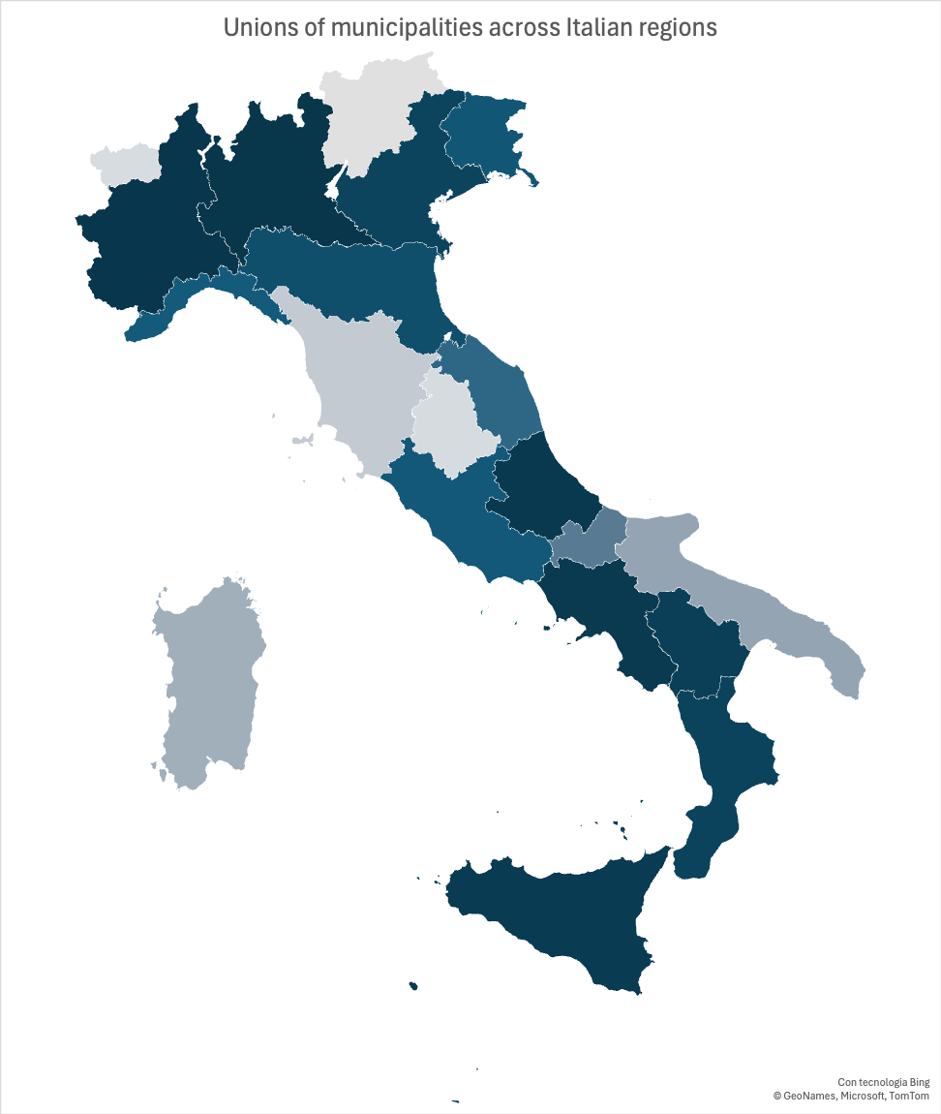

SM3 - Necessity analysis (Authors’ own work)

 | Presence of the outcome (Y) |  | Absence of the outcome (~Y)
Condition | Consistency | Coverage | Consistency | Coverage
Political leadership | 0.929109 | 0.588435 | 0.703880 | 0.703401
~ Political leadership | 0.531686 | 0.532258 | 0.588155 | 0.929032
Measurability | 0.784103 | 0.730731 | 0.542546 | 0.797798
~ Measurability | 0.783029 | 0.520343 | 0.816882 | 0.856531
Planning integration | 0.783029 | 0.684507 | 0.543227 | 0.749296
~ Planning integration | 0.713212 | 0.497378 | 0.771273 | 0.848689
Collaborative approach | 0.499463 | 0.821555 | 0.270933 | 0.703180
~ Collaborative approach | 0.819549 | 0.416030 | 0.931246 | 0.745911
Note: ~ (negation)

SM4 - Truth table (Authors’ own work)

X1 | X2 | X3 | X4 | number | Y | raw consistency | PRI consistency | SYM consistency
1 | 0 | 1 | 1 | 2 | 1 | 0.921114 | 0.746269 | 0.746269
1 | 1 | 1 | 1 | 2 | 1 | 0.921114 | 0.746269 | 0.746269
1 | 1 | 0 | 1 | 1 | 1 | 0.909341 | 0.75188 | 0.75188
1 | 1 | 1 | 0 | 2 | 1 | 0.903597 | 0.598802 | 0.598802
1 | 0 | 1 | 0 | 2 | 1 | 0.854676 | 0.395209 | 0.395209
1 | 0 | 0 | 1 | 1 | 1 | 0.831933 | 0.24812 | 0.33
1 | 1 | 0 | 0 | 4 | 0 | 0.736566 | 0.332226 | 0.332226
1 | 0 | 0 | 0 | 5 | 0 | 0.718072 | 0.36413 | 0.36413
0 | 0 | 1 | 0 | 5 | 0 | 0.518325 | 0.0822942 | 0.0822942
0 | 0 | 0 | 0 | 0 | R
0 | 1 | 0 | 0 | 0 | R
0 | 1 | 1 | 0 | 0 | R
0 | 0 | 0 | 1 | 0 | R
0 | 1 | 1 | 1 | 0 | R
0 | 1 | 1 | 1 | 0 | R
1 | 0 | 0 | 0 | 0 | R
Note: Logical remainders (R) represent configurations of conditions that were not observed among the cases analysed.

