Table of Supplementary Materials (SM)

SM A: Q-Methodology Reporting Checklist  SM B: Ethics Approvals  SM C: Glossary of terms used in Q methodology  SM D: Ready-made Concourse  SM E: Naturalistic Concourse  SM F: Concept-based curriculum and example content included in the Q-Set  SM G: Q-set Cards  SM H: Context and instructions for completing the Q-sort  SM I: Curriculum concepts participants (n=48) identified as missing from the Q-set  SM J: Curriculum concepts considered most difficult to rank by participants  SM K: Demographics of participants loaded against Viewpoint 1  SM L: Relative ranking of statements in Viewpoint 1  SM M: Composite Q sort for Viewpoint 1  SM N: Demographics of participants loaded against Viewpoint 2a and 2b  SM O: Relative ranking of statements in Viewpoint 2a and 2b  SM P: Composite Q sort for Viewpoint 2a and 2b  SM Q: Demographics of participants loaded against Viewpoint 3  SM R: Composite Q sort for Viewpoint 3  SM S: Relative ranking of statements in Viewpoint 3 | Page 2  Page 4  Page 5  Page 7  Page 12  Page 22  Page 28  Page 31  Page 35  Page 37  Page 38  Page 39  Page 40  Page 41  Page 42  Page 46  Page 48  Page 49  Page 51

Supplementary Material A: Q Methodology Reporting Checklist

This checklist, published by Dieteren et al (2023), was developed based on a systematic literature review to inform best-practice Q methodology.

Topic |  | Description | Page
1. | Study design
1.1 | Source(s) of the concourse | Describe how the concourse was developed (e.g., based on a review of the literature, interviews, newspapers, etc.). | 5
1.2 | Item sampling process | Describe how the item set was drawn from the concourse (e.g., whether a structured or unstructured approach was used) and motivate. | 5-6
1.3 | Type of items | Specify the type of items used (e.g., verbal statements, visual items). | 5-7
1.4 | Number of items | Report the number of items that participants are asked to rank. | 7
1.5 | Pilot study | Describe whether a pilot study was conducted and its aim and implications. | N/A
2. | Data collection
2.1 | Selection of participants | Describe how participants were sampled for the study (e.g., purposive, convenience) and motivate. | 3
2.2 | Number of participants | Report the number of participants in the study and motivate. | 3-9
2.3 | Mode of interview | Describe the interview mode (e.g., individual, (focus) group setting). | 8
2.4 | Type of interview | Describe the interview type (e.g., face-to-face, online, postal). | 8
2.5 | Ranking instruction | Describe how the participants were instructed to perform the ranking exercise (e.g., the ranking question, verbal or in writing, individual or group, pre-ranking of items into piles, and whether and how participants were, asked to explain their ranking of the statements). | 7
2.6 | Sorting grid | Describe the characteristics of the sorting grid (e.g., the condition of instruction, scale, shape and type of distribution). | 5-7
3. | Data analysis
3.1 | Factor analysis | Describe the factor extraction and rotation methods used. | 9
3.2 | Factor selection | Describe the criteria used for selecting the number of factors. | 9
3.3 | Bipolar factors | When relevant, report how bipolar factors were handled (e.g., negative loaders included or excluded from development of factor array, describe positive and negative pole, splitting of factor) and motivate. | 9
3.4 | Interpretation of the factors | Describe how the factors were interpreted (e.g., use of quantitative and qualitative data, characterizing and distinguishing statements). | 9
3.5 | Statistical software | Report which statistical software (including the package) that was used for analyzing the data. | 9
4. | Presentation of findings
4.1 | Factor solution | Report details about the factor solution (e.g., number of factors, Eigen value of factors, communalities of statements, explained variance, correlation between factors, factor loadings of participants for each factor, number of significant loaders for each factor). | 9,  11-17
4.2 | Factor arrays | Present the full factor array (e.g., statement positions as z-scores or position on the grid) for each of the extracted factor. | Supp
4.3 | Distinguishing and consensus statements | Specify the distinguishing statements for each factor as well as consensus statements between the factors, and their potential relevance. | 11-17
4.4 | Description of the factors | Provide a comprehensive narrative for each factor. | 11-17

Supplementary Material B: Institutional Ethics Approvals

Institution | Ethics Approval Number
Monash University  Melbourne, Australia | Monash University’s Human Research Ethics Committee (Project ID: 41791)
Acadia University  Wolfville, Canada | Acadia University Research Ethics Board (REB 24-15)
University of Plymouth | Faculty of Health Staff Research Ethics and Integrity Committee (Project ID 5012)
Toronto Metropolitan University | Toronto Metropolitan University Research Ethics Board (REB 2024-094)
University College Dublin | UCD Office of Research Ethics (LS-LR-24-140-Browne)
St. Francis Xavier University | STFX Research Ethics Board (ROMEO File #: 27114)

Supplementary Material C: Glossary of terms used in Q methodology

Key Terms
Concourse | A collection of all possible statements, viewpoints and opinions on a certain topic or subject of choice. (ref: https://doi.org/10.4135/9781483384412.n2)  This forms the foundation on which the different perspectives on the particular topic of the study are identified and deciphered.
Conditions of Instruction | Instructions presented to the participants to elicit their subjective opinion or viewpoint on the subject matter. e.g. “Sort this based on how relevant you think this is to … on a scale of -3 (least relevant) to +3 (most relevant).”
P-set | Also known as the participants, purposefully chosen to perform the Q-sort.  These participants often represent different viewpoints relevant to the study’s subject – and are crucial in the representation of the results.
Q-grid / Distribution Grid | A matrix or scoresheet, where participants rank their level of agreement with statements. The distribution of this scoresheet is pre-determined by the researcher, and typically and most commonly, is a forced distribution format.
Q-sampling | Statements picked out of the concourse that are then refined further, forming the collection of statements known as the Q-set.
Q-set / Q-samples | A set of statements, usually defined by the researcher based on the distribution of the Q-grid, used in the sorting phase for participants.
Q-sort | The process where a participant ranks or sorts a set of statements. Comprised of 4 main elements:  - Q-set Statements to be sorted by participants.  - Ranking of Statements into the Q-grid.  - Recording the Participants’ Inputs.  - Factor Analysis of the recorded input.
Factor Analyses Terms
Correlations | Degree of similarity between two Participants.  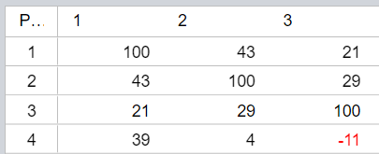  - Participant 1 and 2 share 43% similarity.  - Participant 3 and 4 share 11% similarity but in the opposite direction. (i.e. their Q-Grid is flipped).
Principal Component Analysis (PCA) | Takes these Correlations and puts them on a scatter plot.  This scatter plot then helps find the line of best fit between all the “similarities”. e.g. “Large” and “Enormous” refer to different degrees of “Big”, but it is still “Big”. PCA understands this is “Big” and recodes the shared similarity as “Big” to simplify the similarity.
PCA Terms
Bipolar Factor | When a factor consists of two opposing viewpoints – a positive and a negative. This usually occurs when participants rank the same statement on the opposite ends (i.e. -3 vs +3; or least likely vs most likely). (Webler, T., Danielson, S., & Tuler, S. (2009). Using Q method to reveal social perspectives in environmental research. Greenfield MA: Social and Environmental Research Institute. Page 31. Downloaded  from: http://www.seri-us.org/sites/default/files/Qprimer.pdf)  Example: In a study of “The best cheese for cooking vs snacking”, the factor – “Cheddar is the best cheese” can be bipolar – 1) Cheddar is the best cheese for cooking; and 2) Cheddar is the best cheese for snacking. The bipolar factor here is that both sides argue that Cheddar is best, but for different reasons. As compared to two different factors; a) Cheddar is the best for snacking; and b) Brie is the best for snacking.
Cumulative Explained Variance | The mean amount of difference between 2, 3, 4, 5, … participants required to make a flattened curve (r-shaped).
Eigenvalue (EV) | Degree of similarity of the shared viewpoint is between all participants sharing this viewpoint.
Explained Variance | Amount of difference between Participant A’s shared viewpoint with Participant B’s, and B’s and C’s, ...
Factor | One shared viewpoint, most common first.
Factor Loading | Indicative of how strongly a participant’s Q-sort aligns with an identified factor. This ranges from -1 to +1, with values closer to 0 indicating a weaker relationship between Q-sort and Factor.
Flagged Sorts | Refers to the Q-sorts that load significantly onto a single factor, making them representative of that factor. These are usually automatically flagged by the Q-methodology software based on specific criteria.  - Statistical significance (p < 0.05)  - Researcher determined – Researchers may set additional parameters for inclusion, depending on the study’s context and goals.  These flagged sorts are used in determining the Factor Array and Factor Interpretation thereafter.
Interpretation of results
Factor Array | Represents an illustration of how a factor’s Q-sort would appear.
Factor Interpretation | An analysis of the corresponding Factor Array to determine how a viewpoint can be described based on the factor.
Consensus Statement(s) | Statements that were ranked by participants similarly across all identified factors.
Distinguishing Statement(s) | Statements that were ranked by participants significantly differently across all identified factors.

Supplementary Material D: Ready-made Concourse

The purpose of developing the ‘Ready-made Concours’ is to draw upon what is already known about planetary health curricula for nutritionists and dietitians, to ensure the Q set is grounded in evidence.

As a research team, two research questions and approaches were used to guide this rapid review of the literature. One researcher (LC) led this literature review process, with decision-making support from the lead author (LB) throughout the process.

Research Question | Approach to identify relevant literature
What knowledge and skills do regulatory bodies expect nutritionists and dietitians to develop during their tertiary education? | - Two content analyses of the grey literature that examined:  - Documents governing competency standards/accreditation standards, and  - Other guiding documents, where those were not available, that articulated sustainable food systems-relevant knowledge and skills for dietitians.  - Review of interprofessional health expectations, frameworks and guidance from allied health professionals.
What knowledge and skills do experts in the field advise nutritionists and dietitians to develop during their tertiary education? | - Search terms: “nutrition” AND/OR “dietetic*” AND “education” AND “sustainable food systems” AND/OR “food systems”  - Key references known to the author team who have expertise in this area/familiar with the literature, review of reference lists to identify additional publications and using “discovery layer”/database “environment complete” and medline  - Inclusion criteria;  - relevance to tertiary education and training  - describing knowledge, skills and competencies for contributing to sustainable food systems  - Specific to dietitians and nutritionists (or allied health professionals)  - Specific to food systems professionals

Upon retrieval of the eligible literature, relevant statements were extracted and organised into the following categories;
- Affective statements - values, ethical and commitments
- Cognitive statements - knowledge of relevant concepts
- Applied knowledge of foods, dietary patterns, foodways that promote planetary health
- Skills required to apply the above

The following table outlines the identified 67 statements.
Table: Synthesis of statements gathered from the literature to advise which knowledge and skills are required for future nutritionists and dietitians to promote planetary health

Category | Proposed Concourse Statement
Affective Statements - values, ethical and commitments | Consideration of SFS is a moral and professional obligation
Affective Statements - values, ethical and commitments | Guided by Human Rights and the Human Right to Food
Affective Statements - values, ethical and commitments | Guided by accountability to maximize equity, cultural safety, social justice, and address power imbalances
Affective Statements - values, ethical and commitments | Guided by responsibility to protect and steward resources in an environmentally responsible way, that is in harmony with nature
Affective Statements - values, ethical and commitments | Aware of own values, and guided to identify values guiding SFS work
Affective Statements - values, ethical and commitments | Commitment to diversity in ways of knowing and doing
Affective Statements - values, ethical and commitments | Commitment to reconciliation and conflict resolution in SFS work
Affective Statements - values, ethical and commitments | Guided by a responsibility to fairness and ethical practice
Cognitive statements - knowledge of relevant concepts | Understand food supply chains and food systems (diverse ways of conceptualizing; complex interconnections; food environments)
Cognitive statements - knowledge of relevant concepts | Understand factors affecting food systems (globalization; food policy and regulations; power; country context; health messages and marketing; scale; ethics; institutions)
Cognitive statements - knowledge of relevant concepts | Understanding factors affecting sustainability of food systems (context specificity; principles of sustainability/general; sociocultural determinants of health; equity, social justice; food security; food sovereignty; animal welfare; nutrition and health; food acceptance and preferences; urgency and scale, need for mitigation and adaptation; biodiversity, food waste; climate variability; water use and quality; soil and plant health; production efficiency; livelihoods; affordability and access; local economy)
Cognitive statements - knowledge of relevant concepts | Understanding the relevance to nutrition and dietetics (interdependence between food systems sustainability and food and nutrition security; interdependence between health of the environment and human health, or planetary health; health impacts of health care and health systems; future focussed practice; finite resources)
Applied knowledge of foods, dietary patterns, foodways that promote planetary health | Knowledge of foods choices and alternatives that have lower environmental impacts
 | Knowledge of food practices that have lower environmental impacts (food waste, packaging, etc.)
Skills required to apply the above | Identify relevant food system stakeholders across disciplines and sectors
Skills required to apply the above | Communicate and collaborate with diverse food systems stakeholders to build inclusive relationships, partnerships or and/movements
Skills required to apply the above | Build collective capacity for addressing SFS within and through partnerships
 | Apply a transdisciplinary, collaborative approach to addressing SFS
 | Apply complex, systems thinking to assess food systems and understand SFS-relevant context
 | Identify evidence-based, high-leverage opportunities for systems change that will improve food and nutrition, and sustainability
 | Understand and balance system and organizational trade-offs, unintended consequences implicit in any actions
 | Provide leadership: activate, disrupt, inspire, support and advocate for food systems change that will support health and sustainability priorities
 | Maintain critical, reflective practice
 | Conduct and/or follow research, translate science/evidence into clear messages and practical solutions appropriate to target audience and settings
 | Work effectively in uncertainty: be adaptable and tolerant to myriad imperfect solutions
 | Embrace entrepreneurial approaches: tech-savvy, creative, curious, courageous
 | Leverage governance and accountability structures: understand, shape and use food policy (and relevant regulations and agreements) to support health, equity and sustainability priorities
 | Facilitate equitable access to health
 | Consider sustainability (environmental, social, longevity) of medical nutrition therapy plans, recommendations and interventions and integrate as appropriate
 | Maximize clinical efficiency (right care, right place, right time)
 | Design and develop surveillance systems for food and nutrition security at multiple levels
 | Design food menu with sustainability in mind
 | Influence production and distribution at scale for food security and sustainability
 | Design food product with sustainability in mind

Bibliography for above table

- Boak R, Palermo C, Beck EJ, Patch C, Pelly F, Wall C, et al. A qualitative exploration of the future of nutrition and dietetics in Australia and New Zealand: Implications for the workforce. Nutrition & Dietetics. 2022;79(4):427–37.
- Brekken CA, Peterson HH, King RP, Conner D. Writing a recipe for teaching sustainable food systems: Lessons from three university courses. Sustainability. 2018;10(6):1898.
- Burkhart S, Verdonck M, Ashford T, Maher J. Sustainability in Nutrition: Potential Guiding Statements for Education and Practice. Journal of Nutrition Education and Behavior. 2021 Aug;53(8):663–76.
- Campbell, C. G., & Feldpausch, G. (2023). Teaching nutrition and sustainable food systems: justification and an applied approach. Frontiers in Nutrition, 10, 1167180.
- Carino S, McCartan J, Barbour L. The Emerging Landscape for Sustainable Food System Education: Mapping Current Higher Education Opportunities for Australia’s Future Food and Nutrition Workforce. Journal of Hunger & Environmental Nutrition. 2020 Mar 3;15(2):273–94.
- Coucil of Deans of Health. (2023). Education for sustainable healthcare within UK pre-registration curricula for allied health professions (p. 75). https://www.councilofdeans.org.uk/wp-content/uploads/2023/12/ES-curricula-guidance-CoDH-version_SM-final-no-links.pdf
- Guzmán, C. A. F., Aguirre, A. A., Astle, B., Barros, E., Bayles, B., Chimbari, M., El-Abbadi, N., Evert, J., Hackett, F., Howard, C., Jennings, J., Krzyzek, A., LeClair, J., Maric, F., Martin, O., Osano, O., Patz, J., Potter, T., Redvers, N., … Zylstra, M. (2021). A framework to guide planetary health education. The Lancet Planetary Health, 5(5), e253–e255. https://doi.org/10.1016/S2542-5196(21)00110-8
- Harmon A, Lapp JL, Blair D et al. (2011) Teaching food system sustainability in dietetic programs: need, conceptualization, and practical approaches. J Hunger Environ Nutr 6, 114–124.
- Higgins M, Strother H, Burkhart S, Carlsson L, Meyer N, Spiker M, et al. Sustainable Food Systems and Diets in Dietetic Training Standards: An International Content Analysis. Journal of Human Nutrition & Dietetics. 2022(36(3)):957–66.
- Ingram, J., Ajates, R., Arnall, A., et al. (2020). A future workforce of food system analysts. Nature Food, 1, 9-10. DOI: 10.1038/s43016-019-0003-3
- Innes S, Shephard K, Furnari M et al. (2016) Greening the curriculum to foster environmental literacy in tertiary students studying human nutrition. J Hunger Environ Nutr. Published online: 23 December 2016. https://doi.org/10.1080/19320248.2016.1255693.
- Shaw, E., Walpole, S., McLean, M., Alvarez-Nieto, C., Barna, S., Bazin, K., Behrens, G., Chase, H., Duane, B., El Omrani, O., Elf, M., Faerron Guzmán, C. A., Falceto de Barros, E., Gibbs, T. J., Groome, J., Hackett, F., Harden, J., Hothersall, E. J., Hourihane, M., & Huss, N. M. (2021). AMEE Consensus Statement: Planetary health and education for sustainable healthcare. Medical Teacher, 43(3), 272–286. https://doi.org/10.1080/0142159X.2020.1860207
- Useche KCC, Palacio NR, Carlsson L. Sustainability and Food Systems Concepts in Dietetic Training Standards in Speaking Spanish Countries. Revista Española de Nutrición Humana y Dietética. 2023 Dec 4;27(4):315–24.
- Valley, W, Wittman H, Jordan N, Ahmed S, Galt R. An emerging signature pedagogy for sustainable food systems education. Renew Agric Food Syst. 2018 Oct;33(5):467–80.
- Wegener, J., Fong, D., & Rocha, C. (2018). Education, practical training and professional development for public health practitioners: A scoping review of the literature and insights for sustainable food system capacity-building. Public Health Nutrition, 1–10. https://doi.org/10.1017/S1368980017004207
- Wilkins, J. L. (2020). Nutrition education in the Anthropocene: Toward public and planetary health. Journal of Agriculture, Food Systems & Community Development, 9(3), 1–11. Environment Complete.

Supplementary Material E: Naturalistic Concourse

The purpose of developing the ‘Naturalistic Concourse’ is to draw upon key stakeholders and experts in the field to define what they believe nutritionists and dietitians should learn about to promote planetary health.

Online Survey Questions

Q1. Which country are you employed in? (short text field)

Q2. Where does your work primarily occur? (multiple choice, select as many as apply)
- In a metropolitan setting
- In a rural, remote or regional setting
- Other (short text field)

Q3. Please tell us more about where you work. Which of the following describes your current role? (long text field)
- If you are a Nutritionist or Dietitian, are you working in higher education, primary healthcare, public health, food and nutrition policy, directly with food system stakeholders such as primary food producers, food manufacturers and food retailers?
- If you are a Non-Nutritionist/Dietitian working with nutritionists/dietitians, are you working in the food system as a primary food producer, food manufacturer or food retailer, higher education, primary healthcare, public health, food and nutrition policy or other role?

Q4. How many years of experience have you had working in this, or a similar, setting?
- 0 - 2 years, 2-5 years, 5-10 years, 10-20 years, 20+ years

____
How can you contribute to our future workforce?
The EAT-Lancet Commission called for a ‘Great Food Transformation’ to ensure current and future generations can eat a healthy diet within the boundaries of our Earth’s natural systems. Nutritionists and dietitians work in roles at the intersection of diets and the bigger food system, and are therefore well-placed to contribute to this transformation.
What does this sustainable food system look like? “Dietitians-Nutritionists around the world envision sustainable food systems as ones that nourish all people, now and into the future, with sufficient, nutritious, affordable, tasty, diverse, and culturally appropriate food. Such food systems support people’s physical and mental health while respecting the integrity of ecological and social systems.” (International Confederation of Dietetic Associations)
Based on your own experience, what knowledge and skills do you think should be prioritised for future nutritionists and dietitians during their Tertiary/Higher education to adequately equip them to contribute to the Great Food Transformation?

Q5. Please describe here the specific topics, concepts or issues you would like to see prioritised by University educators as they prepare the future workforce of nutritionists and dietitians.

- Knowledge: Please describe here the specific topics, concepts or issues you would like to see prioritised
For example, sustainable development, social justice, planetary health, equity, climate change, biodiversity, healthy and sustainable dietary patterns. Write as little or as much detail as you prefer. If you feel you do not have enough experience with nutrition and dietetics, food system sustainability or education and training to comment, please state this.

- Skills-related: Please describe here the specific skills or competencies you would like to see nurtured in our future workforce.
For example, critical analysis, systems thinking, reflective practice, examination of world views, leadership and multidisciplinary teamwork. We are mindful that if you work in Higher Education you may be more likely to describe theoretical and academic skills here, whereas if you are working ‘in the field’, these will be more practical skills. We welcome the description of all types of relevant skills here. Write as little or as much detail as you prefer. If you feel you do not have enough experience with nutrition and dietetics, food system sustainability or education and training to comment, please state this.
___
Help us capture a diverse range of perspectives!
Please consider forwarding this survey to any networks or colleagues whose work intersects with the food system, and who may work with nutritionists and dietitians. For example, those working in food production, transport, manufacturing, marketing, retail, policy-development (in non-profits and at all levels of government), emergency food relief, waste management and food-related community development initiatives such as gardens and kitchens.
Thank you for contributing to the first stage of this multi-year, international co-design process!

The survey was sent to subscribers of these existing online forums and members of these networks known to the authorship team:
- eNewsletter for subscribers of the International Confederation of Dietetic Associations (ICDA) GROW Sustainability Toolkit (n = 420) and all ICDA member organisations (n = 50 countries)
- Mail-outs to ICDA member organisations (e.g., Dietitians Australia, British Dietetic Association)
- Email to nutrition and dietetic educators who attended a networking event in Dublin in 2023 (n ~ 50)
The recruitment text also included a prompt for snowball recruitment which encouraged participants to share the survey with nutrition and dietetic students, new graduates, educators and practitioners working in, or learning about, food systems.

Survey Responses

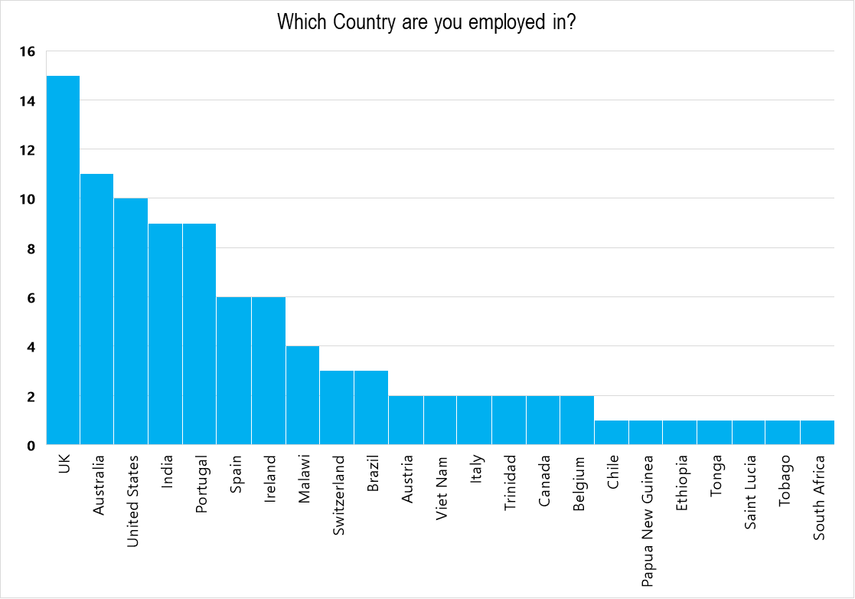

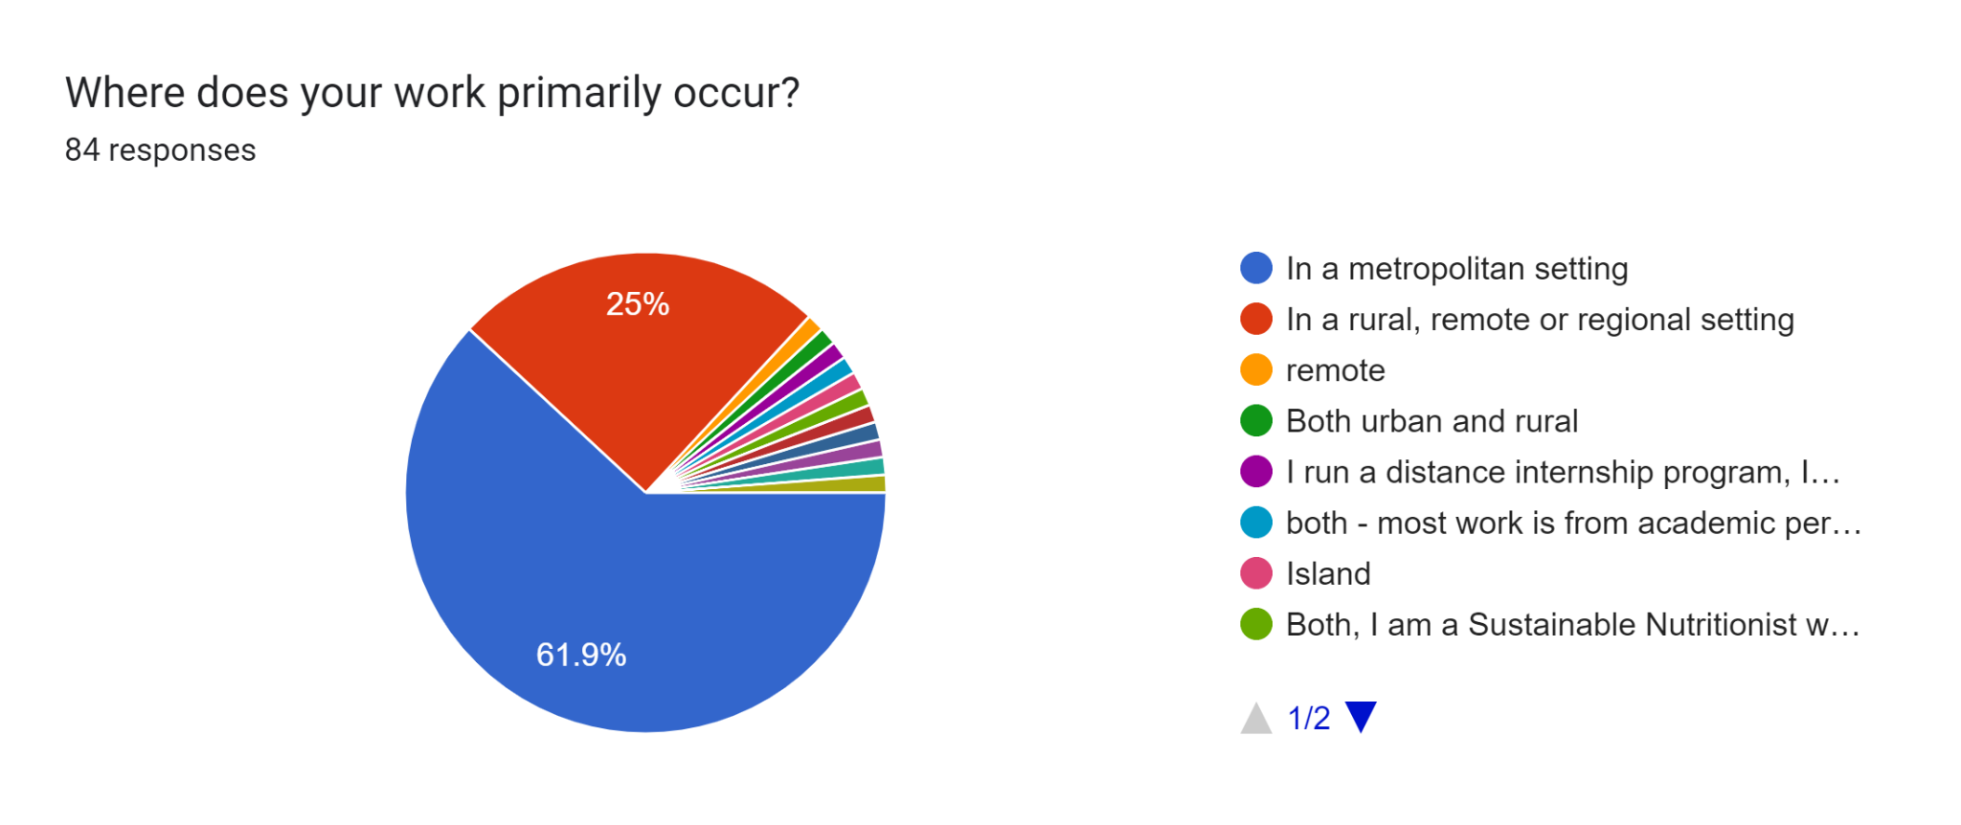
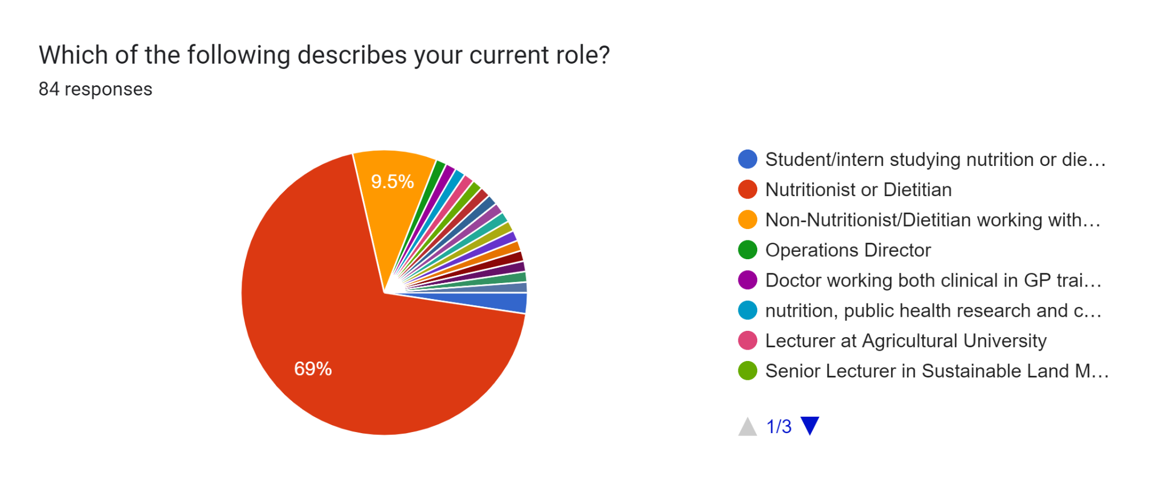
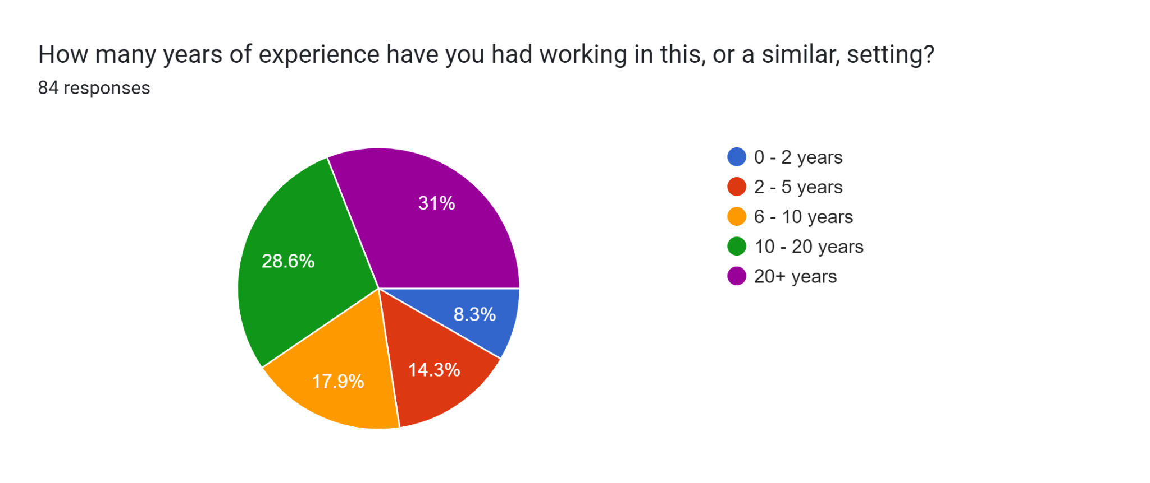

Regarding the responses to question 5 about the knowledge and skills, two researchers (JW & TF) analysed these responses initially by synthesising the raw data and categorising responses into the broad groupings outlined in the table below. Other researchers (LB, LC, TE, CP & SB) provided input throughout this process.

The following table outlines the proposed concourse statements (n = 118) identified from the synthesis of survey responses.

Table: Synthesis of survey responses about knowledge and skills required for future nutritionists and dietitians to promote planetary health

Knowledge or Skill | Broad Grouping | Proposed Concourse Statement
Knowledge | Applied knowledge of foods | Knowledge of foods and alternatives that have lower environmental impacts (e..g., plant-based diets, plant-based proteins)
Knowledge | Applied knowledge of foods | Knowledge of foods and alternatives that are affordable and have lower environmental impacts
Knowledge | Applied knowledge of foods | Knowledge of foods and alternatives that have lower environmental impacts (e.g., wild foods)
Knowledge | Applied knowledge of foods | Knowledge of foods and alternatives that have lower environmental impacts (e.g., sustainable-labelled foods))
Knowledge | Applied knowledge of foods | Knowledge of foods and alternatives that have lower environmental impacts (e.g., seasonal and local foods)
Knowledge | Applied knowledge of foods | Knowledge of food/foodways that support individuals and groups (e.g., indigenous foods)
Knowledge | Applied knowledge of foods | Knowledge of food practices that have lower environmental impacts (e.g., rational use of water, control of household waste for recycling)
Knowledge | Applied knowledge of foods | Knowledge of food practices that have lower environmental impacts (e.g., sustainable agriculture)
Knowledge | Applied knowledge of foods | Knowledge of food practices that have lower environmental impacts (e.g., permaculture)
Knowledge | Applied knowledge of foods | Knowledge of food practices that have lower environmental impacts (e.g., food waste reduction, recycling)
Knowledge | Applied knowledge of foods | Knowledge of foods/food species and alternatives that have lower environmental impacts OR Knowledge of the food species authentication process
Knowledge | Applied knowledge of foods | Understanding of the health impacts of plant-based diets
Knowledge | Factors affecting food systems | Understanding of factors affecting food systems (e.g., economics)
Knowledge | Factors affecting food systems | Knowledge of specific examples of food and nutrition policies (and relevance to sustainable food sytems)
Knowledge | Factors affecting food systems | Knowledge of political ecology including power asymmetries, social inequalities, capital accumulation and the relationship between local communities and global forces
Knowledge | Factors affecting food systems | Understanding of policy and policy frameworks related to food systems and sustainability
Knowledge | Factors affecting food systems | Understanding of ethics (and governance) as factors affecting food systems
Knowledge | Factors affecting food systems | Understanding of the sustainable development goals (SDGs) as a factor affecting food systems
Knowledge | Factors affecting food systems | Understanding of political processes and how to influence and affect change

Knowledge | Factors affecting sustainability of food systems | Understanding of animal welfare as a factor affecting the sustainability of food systems
Knowledge | Factors affecting sustainability of food systems | Understanding of soil health and biodiversity as factors affecting the sustainability of food systems
Knowledge | Factors affecting sustainability of food systems | Understanding of climate change as a factor affecting the sustainability of food systems
Knowledge | Factors affecting sustainability of food systems | Understanding of climate justice as a factor affecting the sustainability of food systems
Knowledge | Factors affecting sustainability of food systems | Understanding of equity and social justice as factors affecting the sustainability of food systems
Knowledge | Factors affecting sustainability of food systems | Understanding of food safety and hygiene as factors affecting the sustainability of food systems
Knowledge | Factors affecting sustainability of food systems | Understanding of food sovereignty as a factor affecting the sustainability of food systems
Knowledge | Factors affecting sustainability of food systems | Understanding that there is context specificity in the factors impacted by and impacting the sustainability of food systems
Knowledge | Factors affecting sustainability of food systems | Knowledge of sustainability assessment measures and methodologies (e.g., life cycle assessment, greenhouse gas emissions, methane emissions, food product analysis, value chain analysis, general metrics/measures)
Knowledge | Factors affecting sustainability of food systems | Understanding of sustainable diets and sustainable nutrition as factors affecting the sustainability of food systems
Knowledge | Factors affecting sustainability of food systems | Knowledge of the natural world, human interaction with the environment, and sustainable ways to deal with environmental problems
Knowledge | Factors affecting sustainability of food systems | Understanding of food waste as a factor affecting the sustainability of food systems
Knowledge | Factors affecting sustainability of food systems | Understanding of water use and water quality as factors affecting the sustainability of food systems
Knowledge | Factors affecting sustainability of food systems | Understanding of food security as a factor affecting the sustainability of food systems
Knowledge | Food supply chains and food systems | Understanding of food supply chains as part of more broad, complex, interconnected food systems
Knowledge | Food supply chains and food systems | Understanding of food production and manufacturing, and their impacts, as part of more broad, complex, interconnected food systems
Knowledge | Food supply chains and food systems | Understanding of the basics of healthy agriculture through an introduction to production systems (e.g., how soil is similar to human health)
Knowledge | Food supply chains and food systems | Understanding of the impact of food system drivers on social, economic and environmental domains
Knowledge | Food supply chains and food systems | Understanding of commercial determinants of global food supply
Knowledge | Food supply chains and food systems | Understanding of sustainable food environments

Knowledge | Knowledge of food systems and sustainability concepts | Understanding of the diverse ways of conceptualizing sustainable development (e.g., models) in the context of healthy and sustainable dietary patterns
Knowledge | Knowledge of food systems and sustainability concepts | Understanding diverse ways of conceptualizing food systems, including industrial food systems and sustainable food systems and their associated dietary patterns
Knowledge | Knowledge of food systems and sustainability concepts | Understanding of the diverse ways of conceptualizing healthy and sustainable dietary patterns (e.g., regional differences, meaning of sustainability in general and in different settings/areas of practice, difficulties defining a sustainable diet, unique strategies to strengthen food system sustainability, etc.)
Knowledge | Knowledge of food systems and sustainability concepts | Ability to use food systems as a framework to integrate new information on food systems components and actors (systems thinking)
Knowledge | Knowledge of food systems and sustainability concepts | Understanding of diverse ways of conceptualizing food systems, including Indigenous perspectives and other frameworks (e.g., local food systems)
Knowledge | Knowledge of food systems and sustainability concepts | Understanding of diverse ways of conceptualizing food systems, including Indigenous perspectives and other frameworks (e.g., regenerative food system)
Knowledge | Knowledge of food systems and sustainability concepts | Understanding of diverse ways of conceptualizing food systems, including Indigenous perspectives and other frameworks (e.g., nutritional ecology as a framework for thinking about issues affecting sustainability of food systems)
Knowledge | Knowledge of food systems and sustainability concepts | Understanding of diverse ways of conceptualizing food systems, including Indigenous perspectives and other frameworks (e.g., One Health)
Knowledge | Relevance to nutrition and dietetic practice | Understanding the what and how of food system transformation (the role of nutritionists and dietitians)
Knowledge | Relevance to nutrition and dietetic practice | Understanding of the environmental impact of individual and population dietary choices
Knowledge | Relevance to nutrition and dietetic practice | Understanding of population-level factors affecting food choice (e.g., nutrition recommendations)
Knowledge | Relevance to nutrition and dietetic practice | Understanding of social factors affecting food choice (e.g., social engagement with food)
Knowledge | Relevance to nutrition and dietetic practice | Understanding of advocacy as a tool to influence the sustainability of food systems
Knowledge | Relevance to nutrition and dietetic practice | Knowledge of best practices in supporting sustainable food sytems across nutrition and dietetic practice areas
Knowledge | Relevance to nutrition and dietetic practice | Understanding of individual-level factors affecting food choice (e.g., views on sustainability, convenience, affordability, preferences, food literacy, food skills)
Knowledge | Relevance to nutrition and dietetic practice | Knowledge of sustainable dietary recommendations and how to adapt for various populations/groups
Knowledge | Relevance to nutrition and dietetic practice | Knowledge of dietary assessment in the context of sustainable food systems
Knowledge | Relevance to nutrition and dietetic practice | Knowledge of health behaviour change theories (individual and population level)
Knowledge | Relevance to nutrition and dietetic practice | Understanding the value of conducting and/or pursuing evidence-based research, translating science/evidence into clear messages and practical solutions appropriate for the target audience and setting (e.g., implementation research).
Knowledge | Relevance to nutrition and dietetic practice | Understanding the value of applying a transdisciplinary and/or interprofessional collaborative approach to learning and addressing sustainable food systems
Knowledge | Relevance to nutrition and dietetic practice | Understanding the value and need to learn from experts (broadly defined) in the field (e.g., experts across the food system, at all levels, with diverse perspectives)
Knowledge | Relevance to nutrition and dietetic practice | Understanding of basic concepts and topics in food and nutrition and how these fit within the context of sustainable food systems
Knowledge | Relevance to nutrition and dietetic practice | Understanding of planetary health as a solutions-oriented, transdisciplinary field and social movement focused on analyzing and addressing the impacts of human disruptions to Earth’s natural systems on human health and all life on Earth and its relevance to nutrition and dietetic practice
Knowledge | Relevance to nutrition and dietetic practice | Understanding of the environmental, social, cultural, geographic, and economic factors that influence health and well-being
Knowledge | Relevance to nutrition and dietetic practice | Knowledge of public health interventions, including upstream approaches that can be applied in the context of sustainable food systems
Knowledge | Relevance to nutrition and dietetic practice | Understanding of the environmental, social, cultural, geographic, and economic factors that influence health and well-being
Knowledge | Relevance to nutrition and dietetic practice | Understanding the role of nutritionists/dietitians in facilitating the transition to healthier and more sustainable food systems (e.g., "overall empowerment ...[to] play a big role in mitigating climate change and this transition to a more sustainble future")
Knowledge | Relevance to nutrition and dietetic practice | Understanding of the evoloving nature of food systems and the need to adapt
Knowledge | Relevance to nutrition and dietetic practice | Knowledge of history and philosophy (epistemology) and the different ways of building knowledge
Knowledge | Relevance to nutrition and dietetic practice | Understanding of breastfeeding in the context of healthy and sustainable dietary patterns
Knowledge | Understanding food supply chains and food systems | Knowledge of production systems as a way to understand the basics of healthy agriculture (e.g., parallels between nature and human health, the concept of permaculture for healthy planet & people).
Knowledge | Understanding food supply chains and food systems | Understanding of emergency preparedness related to food systems
Skill | Application of resources | Demonstrate the application of artificial intelligence (as a tool for more sustainable food practices)
Skill | Application of resources | Apply modeling skills in sustainable food systems-relevant contexts
Skill | Application of resources | Use resource management and waste mitigation strategies (e.g., reducing food waste) to promote more sustainable practices
Skill | Application of resources | Use appropriate sustainability assessment measures and methodologies (e.g., life cycle assessment, GHG emissions)
Skill | Communication | Demonstrate advocacy skills (e.g., how to work within the political advocacy/lobbying space, identify partners, communicate with stakeholders and decision makers at local, regional and national levels)
Skill | Communication | Use communication skills (e.g., education) and techniques to provide clear, evidence-based scientific information to both specialists and non-specialist audiences
Skill | Communication | Use communication skills based on principles of a patient-centred approach in counselling
Skill | Communication | Educate others on food practices that have lower environmental impacts: e.g., rational use of water, controlling household waste for recycling, discussing climate change) (families, peers, patients)
Skill | Communication | Use communication skills (e.g., public speaking, debating) and techniques (e.g., media training) to communicate the scientific message/science to diverse audiences
Skill | Communication | Use communication skills (e.g., knowledge translation) to provide the scientific message/science to diverse audiences
Skill | Communication / Professional | Communicate, colloborate and engage with diverse food systems stakeholders to build inclusive relationships, partnerships and/or movements
Skill | Communication / Professional | Demonstrate conflict resolution skills (e.g., when navigating conflicts of interest within food system stakeholders)
Skill | Communication / Professional | Use facilitation skills with individuals and groups to understand and address food, nutrition and sustainbility-related issues
Skill | Communication / Professional | Use communication skills (e.g., negotiation) and techniques in sustainable food systems-relevant contexts
Skill | Communication / Professional | Use networking skills to engage with individuals and groups in sustainable food systems-relevant contexts
Skill | Food / Nutrition-related | Use food production and procurement skills and demonstrate to diverse audiences (in sustainable food systems-relevant contexts)
Skill | Food / Nutrition-related | Demonstrate food skills (e.g., growing, foraging for wild foods, preserving local seasonal food, permaculture, cooking) to prepare healthy and sustainable meals and demonstrate to diverse audiences
Skill | Professional | Apply behaviour change theory and techniques at the individual and population level
Skill | Professional | Apply co-creation and design think principles when working with others
Skill | Professional | Apply collaboration skills in working with individuals and groups
Skill | Professional | Apply conceptual thinking to understand and assess food systems and sustainable food systems-relevant context
Skill | Professional | Apply critical thinking and analysis skills to understand and assess food systems and sustainable food systems-relevant context
Skill | Professional | Demonstrate critical thinking and openness to multiple perspectives and ways of knowing within a sustainable food systems-relevant context
Skill | Professional | Demonstrate cultural competence relating to diverse food practices and when working with individuals and groups
Skill | Professional | Demonstrate emotional intelligence (e.g., people skills) in working with individuals and groups
Skill | Professional | Demonstrate leadership, team coordination and problem solving skills in working with individuals and groups
Skill | Professional | Apply organizational and management skills (e.g., leadership, commitment to meeting deadlines, project coordination, use of team participation strategies, strategic thinking, productivity evaluation, prioritizing and professional multitasking) (in sustainable food systems-relevant contexts)
Skill | Professional | Demonstrate leadership and influence (political processes, policies, health behaviours)
Skill | Professional | Use entrepreneurial skills (e.g., creativity, innovation) and approaches (e.g., tech-savvy, curiosity, courage) (in sustainable food systems-relevant contexts)
Skill | Professional | Consider different world views, perspectives, lenses, and learning opportunities and demonstrate openness to different ways of building knowledge (in sustainable food systems-relevant contexts)
Skill | Professional | Identify governance and accountability structures and understand, shape and use food policy (and relevant regulations and agreements) to support health, equity and sustainability priorities (in sustainable food systems-relevant contexts)
Skill | Professional | Use health system strengthening and nutrition financing in sustainable food systems-relevant contexts
Skill | Professional | Analyze menus with a sustainability perspective
Skill | Professional | Monitor and evaluate food and nutrition programs in sustainable food systems-relevant context
Skill | Professional | Demonstrate food and nutrition literacy (in sustainable food systems-relevant contexts)
Skill | Professional | Plan, formulate, implement and evaluate policies (in sustainable food systems-relevant contexts)
Skill | Professional | Apply knowledge and theory to diverse practice areas and settings (in sustainable food systems-relevant contexts)
Skill | Professional | Maintain critical, personal and professional reflective practice (e.g., mindfulness, making purposeful connections in nutrition and dietetic-related activities)
Skill | Professional | Apply systems thinking to assess food systems and understand sustainable food systems-relevant context
Skill | Professional | Apply systems thinking frameworks (e.g., intersectional framework, Individual plus Policy, System, and Environmental (I+PSE) Conceptual Framework) in sustainable food systems-relevant contexts
Skill | Professional | Use strategic influence and planning in sustainable food systems-relevant contexts
Skill | Professional | Demonstrate adaptability as a professional skill in nutrition and dietetics OR (Liesel's wording) Work effectively in uncertainty: be adaptable and tolerant to imperfect solutions
Skill | Professional | Apply a transdisciplinary/multidisciplinary and/or interprofessional collaborative approach to learning and addressing SFS
Skill | Research-related | Conduct, manage, and/or pursue evidence-based research and translate science/evidence into clear messages and practical solutions appropriate for the target audience and setting (e.g., big data management)
Skill | Research-related | Apply current and evidence-based approaches to inform decision-making and address food, nutrition, and sustainability-related issues
Skill | Research-related | Seek and appraise relevant data and information in order to make judgements on social, scientific or ethical issues (in sustainable food systems-relevant contexts)
Skill | Research-related | Conduct, manage, and/or pursue evidence-based research, and translate science/evidence into clear messages and practical solutions appropriate for the target audience and setting (e.g., implementation research)

Supplementary Material F: Concept-based curriculum and example content included in the Q-Set

ID | Concept and Definition | Example topics of knowledge or skills to be developed via curriculum
A | Ethical, Values-based Practice - moral principles and professional obligations to act for SFS. | The impact of values in guiding SFS work.  Animal welfare as a factor affecting food systems.
B | Social justice - addressing structural and historical injustices. | Equity and fairness including food access and cultural safety. Food system working conditions.
C | Responsible Stewardship of SFS - encouraging human activity that supports planetary health. | The role of nutrition and dietetic practice to protect and steward food system resources in an environmentally responsible way, safeguarding for future generations.
D | Respect for Diverse Knowledges & Cultures - understanding and respecting diverse ways of knowing and doing. | Understanding of the diverse ways of conceptualizing SFS including academic and non-academic sources. Cultural competence relating to diverse food practices.
E | Prioritising Indigenous Knowledge Systems - privileging First Nations Peoples' ways of knowing, being and doing in relation to the natural world. | Demonstrating a deep respect for Indigenous peoples as the custodians and expert stewards of the land, water-ways and our finely balanced ecosystem
F | Food Systems Literacy - understand food supply chains as part of more broad, complex, interconnected food systems | Trade policy, political processes, economics, and food safety as factors affecting the sustainability of food systems.
G | Global Economic & Political Context - how colonisation, globalisation, and industrialisation influence the food system. | Promoting 'big-picture thinking' by considering the country context, such as the influence of colonialism and industrial development.
H | Policy - use of governance structures to shape health, equity and sustainability priorities. | Political processes, how to influence and affect change. Develop and evaluate policies in SFS-relevant contexts.
I | Power - where does the power lie and how does this influence the food system? | Understanding how corporate power shapes the food system, including the commercial determinants of health.
J | Knowledge Translation - applying high quality evidence in communication to inform decision-making (individuals and groups). | Use and translate evidence-based research into clear messages and practical solutions appropriate for the target audience and setting.
K | Context Matters - geographical, practice, and setting differences in relation to sustainable food systems. | Defining and conceptualising what sustainability means in various contexts and prioritising actions accordingly.
L | Planetary Health - examining the relationship between human health and the natural ecosystems upon which it depends. | Principles of planetary health. Interdependence between health of the environment and human health. Role of nutrition and dietetic practice in safeguarding the future food system.
M | Determinants of Health - social, cultural, economic, environmental, political factors that influence health. | Increasing accessibility of foods with lower environmental impact. Address inequalities in health. Evaluation of food environments’ ability to promote dietary behaviours.
N | Food & Nutrition Security - access to a reliable, sufficient, affordable food and water supply that supports nutrition and health. | Community food security. Surveillance systems for food and nutrition security at multiple levels.
O | Food Sovereignty - the right to determine and define agricultural and food policy and food access. | Respecting cultural and productive diversity.  Food sovereignty as a factor affecting the sustainability of food systems.
P | Nutrition and Health - interdependence between SFS, food and nutrition security, and health outcomes. | Consider sustainability of medical nutrition therapy plans, recommendations and interventions.
Q | Urgency for Action - the need for bold actions to mitigate the impact of the industrial food system. | High-leverage opportunities for systems change that will improve food, nutrition, and sustainability.
R | Waste - waste-minimisation strategies across the supply chain. | Responsible food and consumption practices.  Resource management and waste mitigation strategies.
S | Ecological and Climate Literacy - understanding the principles of natural systems. | Responsible water and land use that protect natural systems and biodiversity.  Factors that impact climate variability.
T | Agricultural Practice - Food production systems and the basics of healthy agricultural practices. | Principles of soil health affecting food production.  Agricultural practices that have lower environmental impacts (e.g., sustainable agriculture, permaculture).
U | Dietary Patterns - food knowledge, skills, and behaviours that benefit human and planetary health. | Food practices that have lower environmental impacts and drive transformation towards more equitable, sustainable and health food systems.
V | Collaboration building inclusive relationships, partnerships and movements with stakeholders from diverse sectors | Identify relevant SFS stakeholders. Apply a transdisciplinary and/or interprofessional approach to engage diverse partners and address SFS challenges.
W | Systems-thinking - understanding the interconnections and interdependence in complex systems (e.g., natural, social, health, economic, and political). | Recognise context specificity, balancing trade-offs and unintended consequences implicit in SFS-related actions. Apply systems thinking frameworks in SFS-relevant contexts.
X | Leadership & Advocacy - take risks, disrupt the status quo, motivate others to advocate for food systems change that will support health and sustainability priorities. | Leadership and advocacy as tools to network, communicate, strategically influence and lobby in SFS-relevant contexts. Advanced problem-solving skills.
Y | Critical Thinking - address complex problems, question assumptions, analyse and evaluate multiple sources of information. | Seek and appraise relevant information, consider different world views and perspectives, demonstrate openness to different ways of building knowledge.
Z | Uncertainty Tolerance - ability to navigate decision-making and professional practice despite significant uncertainty regarding our future planetary health and food systems. | Demonstrate adaptability, work effectively in uncertainty and tolerance to imperfect solutions
AA | Innovation - ability to develop and respect ‘out of the box’ thinking to solve complex, systemic challenges. | Entrepreneurial approaches: tech-savvy, creative, curious, courageous solutions to SFS challenges.
BB | Food service - procuring, preparing, handling, packaging and delivering food in organisation contexts | Food procurement and menu design with sustainability and health in mind.
CC | Food industry - novel foods and innovation in product development (R&D) | Designing food products with sustainability in mind
DD | Monitoring and Assessment - systematic collection and analysis of data to assess impact and areas for improvement. | Appropriate sustainability assessment measures and methodologies (e.g., life cycle assessment, GHG emissions). Monitor and evaluate food and nutrition programs in sustainable food systems-relevant contexts.
EE | Drivers - socio ecological factors (individual, social, economic, commercial, environmental, policy) influencing food availability and access. | Behaviour change theories at the individual and population level. Food environment and individual factors that impact food choice.
FF | Scope & Responsibility - understanding the role and social responsibility of nutritionists/dietitians in relation to SFS. | Organisational factors (e.g., health systems, adequate resource/budget, clinical efficiencies) that support SFS. Good practices to support SFS across dietetic areas and settings.
GG | Emergency Preparedness - readiness to effectively respond to and mitigate the impacts of disasters or crises. | Effective and efficient emergency food relief strategies. Knowledge of procurement and logistics systems
HH | Reflective Practice - ability to reflect on one's experiences, thoughts and actions to cultivate self-awareness and continuous learning. | Recognising how our individual worldview shapes our perspectives and practice.
II | Capacity Development - Building capacity for change at an individual, community and workforce level | Determining baseline capacity and proposing evidence-based strategies to enhance existing capacities

Supplementary Material G: Q-Set Cards

The Q-Set contained 35 concept-based curriculum statements. Each set was printed with the concept name and a short description on the front, and an example of a specific content-based activity that could be facilitated within that concept.

Front of card: | Concept Name  Short description
Reverse of card: | Example content  An example of specific knowledge that could be taught as part of this concept

Printed deck of 35 double-sided cards:
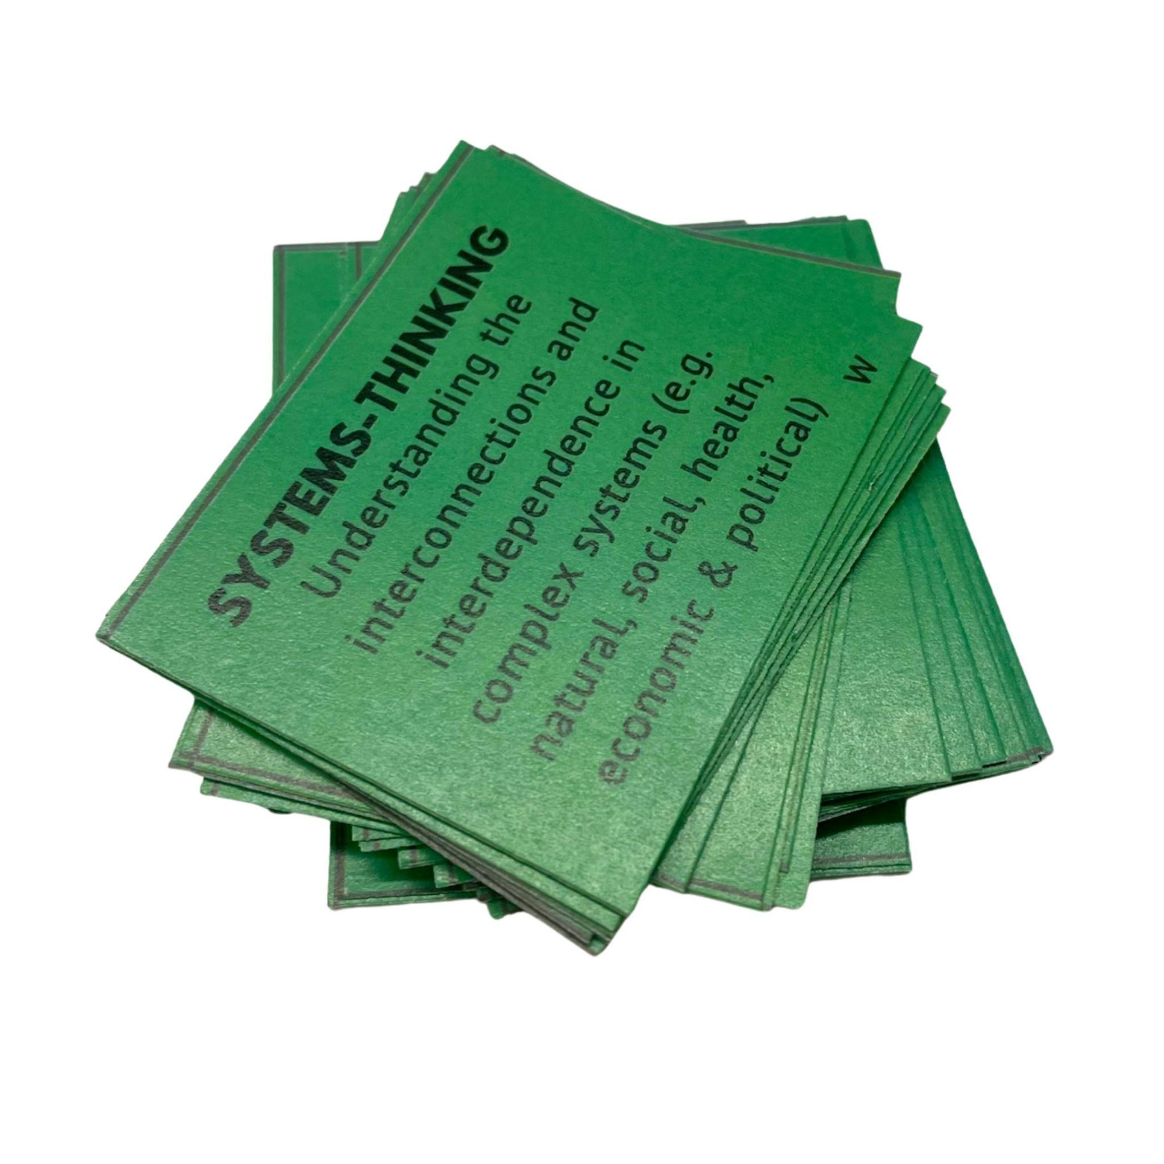

Concept Names and Descriptions (front of Q-set cards):
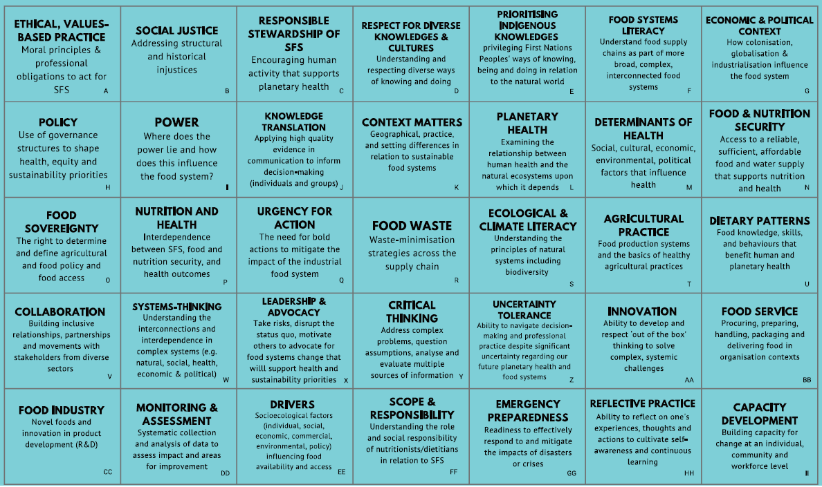
Content-based activity for each concept (reverse of Q-set cards):
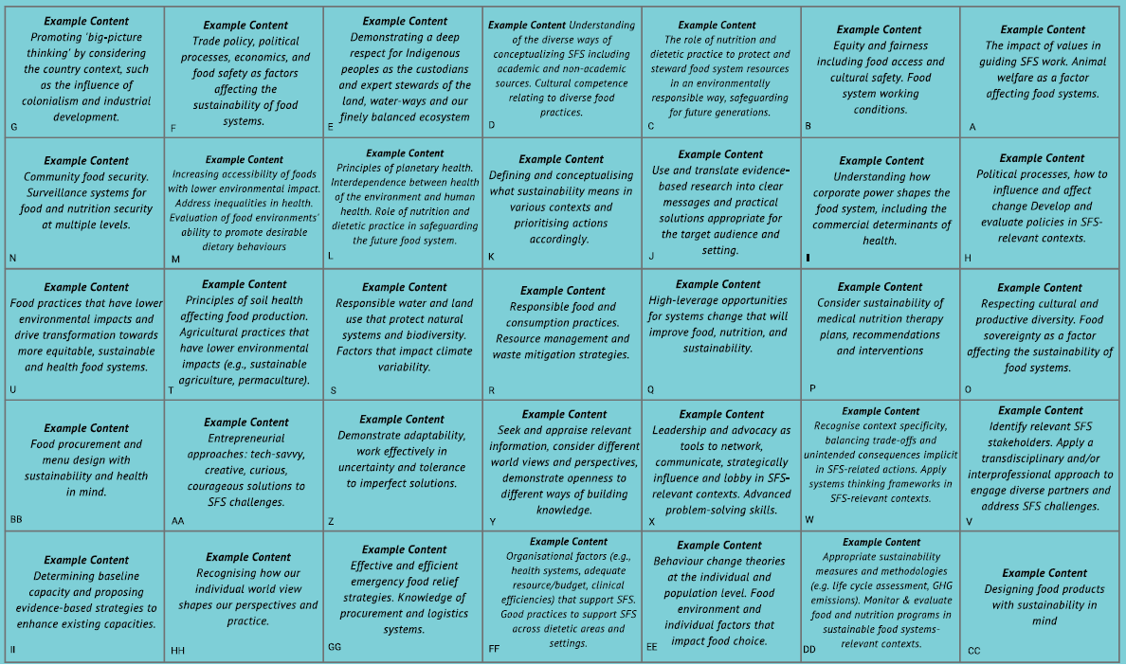

Supplementary Material H: Context and instructions for completing the Q-sort

The Q-sort was completed by participants attending a 90-minute workshop at the International Congress of Nutrition and Dietetics in Toronto (June, 2024). Participants were not required to pre-register for this workshop, and chose to attend based on this abstract available to them in the conference program:

Workshop Title:
Advancing Food Systems Education: Co-designing a Framework for Action

Background: Our global food system is contributing to climate change, the greatest threat to human health of our time. Nutritionists and dietitians all work within this food system, and are well-positioned to contribute to the transformation that is urgently required. However, our future workforce, and those involved in training them, require additional support to take evidence-based action. In 2023, nutritionists and dietitians from 11 countries (n=55) gathered in Dublin to explore what is known about Sustainable Food Systems (SFS) Education and discuss what is required to better equip our workforce. The need for a SFS Education Framework was identified as a key priority.

Aim: Upon completion of this workshop, participants (nutritionists and dietitians involved in teaching and practice, with an interest in planetary health outcomes), will be able to identify the essential elements of a fit-for-purpose SFS Education Framework that is both internationally relevant and anchored in practice.

Summary: This workshop will build upon previous work by initially showcasing what is known about SFS education globally in lightning presentations. Facilitators will then present a drafted SFS Education framework ready for critique and re-development by workshop participants using a series of hands-on, facilitated activities embodying the principles of co-design. At the end of the workshop, participants will be invited to pilot and evaluate the new framework in a range of geographically diverse settings to inform further refinement at ICND in 2028.

Discussion: This workshop will produce a SFS Education Framework that (i) reflects real-world opportunities to improve sustainability in diverse areas of practice, (ii) supports educators to design contextually-relevant and evidence-based curricula, and (iii) contributes to a future workforce who are equipped to contribute to food system transformation. These outcomes are already a priority area for ICDA and therefore are directly relevant to Nutrition and Dietetics Associations globally.

The workshop was facilitated by Dr Liza Barbour (Australia), Dr Sarah Browne (Ireland), Associate Professor Jessica Wegener (Canada), Associate Professor Liesel Carlsson (Canada), Associate Professor Clare Pettinger (United Kingdom) and Dr Tracy Everitt (Canada).

Learning objectives:
Upon completion of this workshop, participants will be able to:
- Identify topics and concepts that our future nutrition and dietetics workforce requires to contribute to food system transformation
- Contribute to the co-design of a fit-for-purpose SFS Education Framework (with SFS Educators and Practitioners for SFS Educators and Students) that is (i) internationally relevant, (ii) anchored in practice and (iii) fit-for-purpose (evidence-based, feasible for educators to implement and student-centred).

The workshop activities were facilitated according to this outline:

Time | Activity Description (Facilitator Initials)
10 mins | Welcome (LB)  - Purpose of workshop  - Ethics/consent  - Definitions and context for Planetary Health and Sustainable Food Systems
15 mins | What we already know about SFS Education in N&D  - Definitions and scope of practice for N&Ds (LC)  - What does SFS education look like in accredited nutrition and dietetics programs in select countries? (JW)  - The tertiary landscape is changing for the better: Australian mapping (LB)  - Sustainability in Canadian Dietetic Practice: Reported practice activities and knowledge/skills required (TE)  - Students are engaged with this topic and innovative approaches to our education are proving to be effective (CP)  - Dietetic educators globally are working together to progress this field of practice: Networking event in Dublin 2023 (SB)
10 mins | Co-Designing a SFS Education Framework (LB)  - Brief overview and rationale for Q methodology (short video)  - Embracing the principles of Co-Design  - Preparing the ‘naturalistic’ and ‘ready made’ concourse statements  - Orientation to the Q-Set and Q-Grid
45 mins | Q-sort Activity (LB)  Guided process through each of these steps (see slide deck for details):  - Create initial piles of cards: not relevant, neutral and very relevant  - Rank cards onto the Q-Grid  - Take a photo of your complete Q-Grid  - Submit photo for analysis  - Complete post-sort Questionnaire to reflect on decision-making process
10 mins | Next Steps (LB)  - Plans for Q-grid analysis to inform a drafted Curriculum Framework  - Invitation to contribute to piloting the framework (across diverse geographic locations) for future refinement at the next International Congress of Nutrition and Dietetics in 4 years

Participants were each given one deck of 35 palm-sized cards (the Q-set) before commencing the 5-step Q-sort:
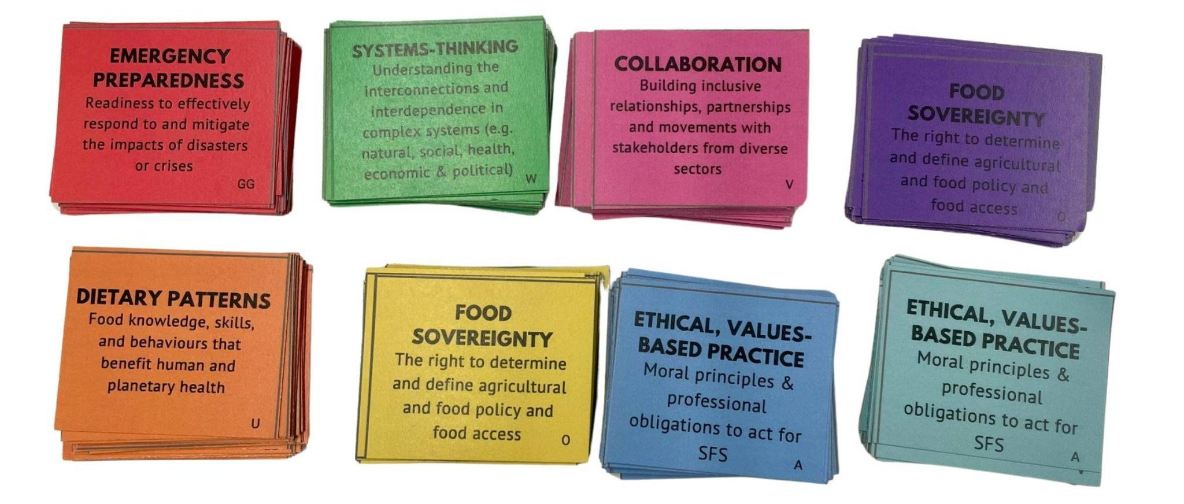

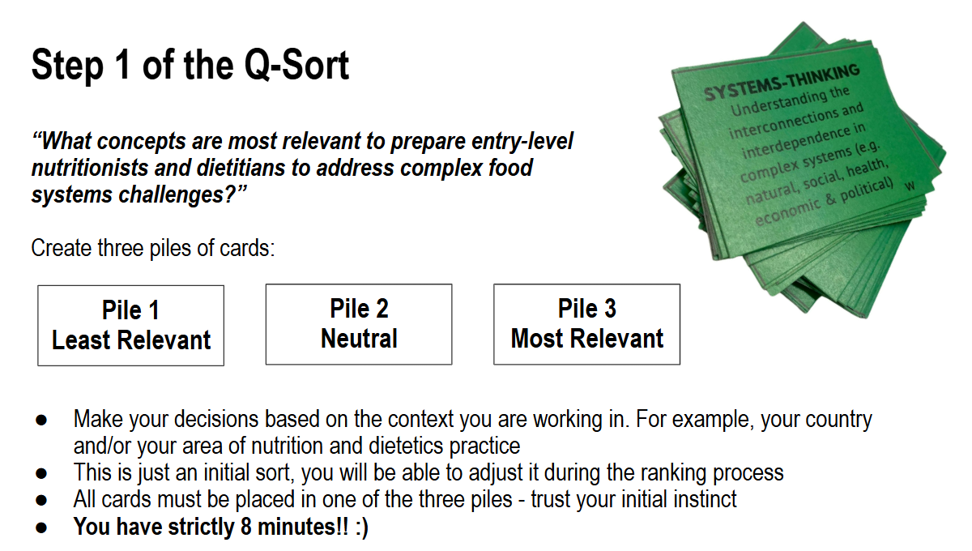

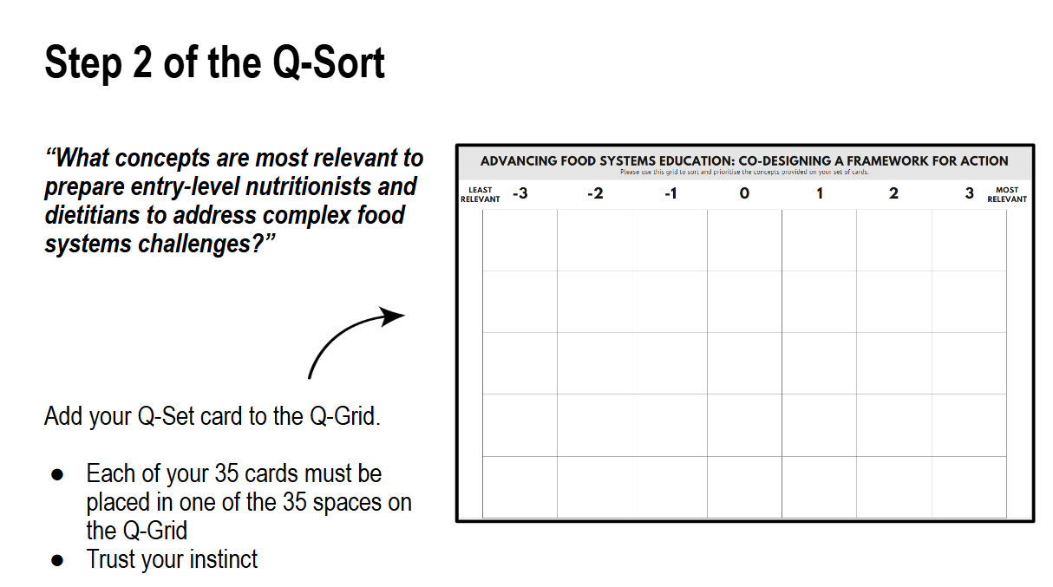

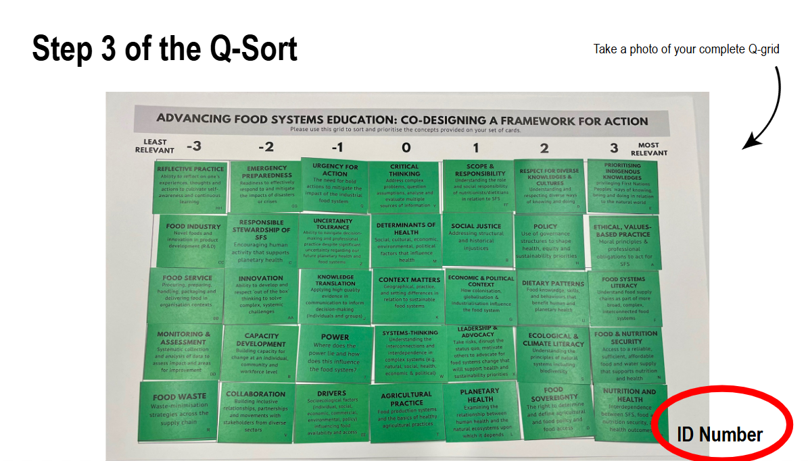

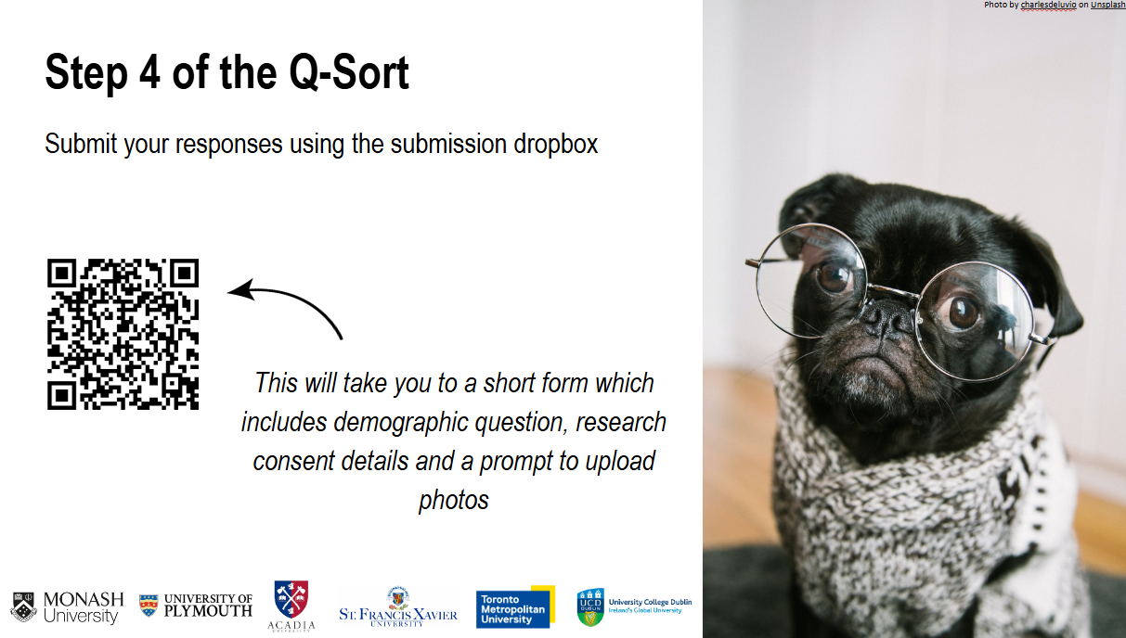

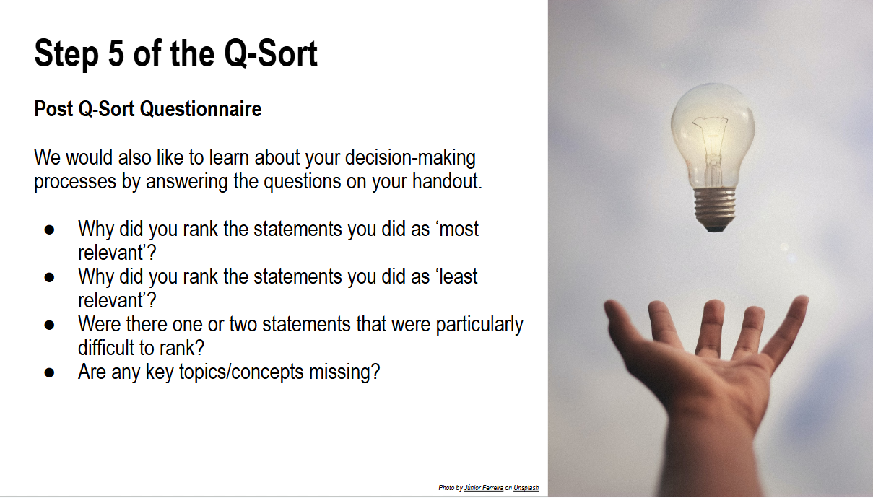

Supplementary Material I: Curriculum concepts participants (n=48) identified as missing from the Q-set

Curriculum concepts | Description | n (%)
Cultural consideration and responsiveness | The need to ensure adequate representation and input from a broad range of global viewpoints to understand SFS. | 4 (8.33)
Communication | The personal development of both written and verbal communication. | 4 (8.33)
Social equity | Addressing and mitigating inequities and injustice including justice dimensions. | 3 (6.25)
Governance | Refers to the way in which organisations or societies are managed and regulated. | 3 (6.25)
Practical skill development | Gaining hands-on experience to enhance food skills. | 2 (4.17)
Individual practices and personal responsibility | Individual and workplace practices, and emphasis on the role of personal responsibility in supporting sustainable food systems. | 2 (4.17)
Change management | Process of planning and establishing necessary steps for change within an organisation and to ensure successful implementation and are sustained overtime. | 2 (4.17)
Current food systems practices and impact | The need to understand current state of food system practices and how individual lifestyle choices directly affect planetary health. | 2 (4.17)
Trade-offs | Recognising sacrifices and costs, including environmental, health, economic and social trade-offs to achieve sustainable food systems. | 1 (2.08)
Ecological economics | Achieving sustainable food production and consumption while respecting ecological limits and conserving biodiversity. | 1 (2.08)
Evidence-based education | Importance of teaching food systems based on scientific evidence, rather than personal opinions. | 1 (2.08)
Natural systems and human interactions | Study of natural systems and explores how humans interact and diverge from the system. | 1 (2.08)
Grounded theory for behaviour change | Use of grounded theory methodology to understand and promote behaviour change related to sustainable food systems. | 1 (2.08)
Pedagogy | Address approaches used in the delivery of educational content. | 1 (2.08)
Supply chain management | Process of handling the entire production flow of goods, including procurement, manufacturing, transportation, storage, distribution. | 1 (2.08)
Globalisation | Understanding the increased interdependence among countries through international trade and technological advancements. | 1 (2.08)
Power dynamics | Need for equitable food system, highlighting issues of justice, democracy, and governance particularly in low- and middle-income countries (LMICs) | 1 (2.08)
Food processing and packaging | Importance of food processing and packaging within the food system and its impact on consumers and the environment. | 1 (2.08)
Adaptation | Addresses strategies and practices aimed at adapting to the impacts of changing climatic conditions or other environmental, economic, social challenges in terms of food production and security. | 1 (2.08)
Socioeconomic challenges | Address issues within food systems, including issues such as poverty, corruption, lack of education, and violence, impacting food security; particularly in underdeveloped countries. | 1 (2.08)
AI use | Focuses on the advancements in artificial intelligence (AI), for data analysis and innovations within food systems. | 1 (2.08)
Commercial food service industry | Commercial aspects of the food service industry, including restaurants and catering services. | 1 (2.08)
Life cycle assessment | Assess potential environmental impacts through the product's life cycle, from raw material acquisition to disposal. | 1 (2.08)
Knowledge generation | Creation and development of new knowledge through research within the food system. | 1 (2.08)
One health | Emphasises that the health of people is closely connected to the health of animals, plants, and shared environment. | 1 (2.08)
Poverty alleviation | Strategies or actions aimed at reducing the incidence and severity of poverty | 1 (2.08)

Supplementary Material J: Curriculum concepts considered most difficult to rank by participants (n = 48)

Concepts | Description | N (%) *
Prioritising Indigenous knowledges | Privileging First Nations Peoples' way of knowing, being and doing in relation to the natural world. | 8 (16.67)
Social justice | Addressing structural and historical injustices | 8 (16.67)
Planetary health | Examining the relationship between human health and the natural ecosystems upon which it depends. | 5 (10.42)
Policy | Use of governance structures to shape health, equity and sustainability priorities. | 5 (10.42)
Power | Where does the power lie and how does this influence the food system? | 5 (10.42)
Critical thinking | Address complex problems, question assumptions, analyse and evaluate multiple sources of information. | 5 (10.42)
Capacity development | Building capacity for change at an individual, community and workforce level. | 4 (8.33)
Reflective practice | Ability to reflect on one's experiences, thoughts and actions to cultivate self-awareness and continuous learning. | 4 (8.33)
Collaboration | Building inclusive relationships, partnerships and movements with stakeholders from diverse sectors. | 4 (8.33)
*Multiple statements could be discussed in responses.

Supplementary Material K: Demographics of participants loaded against Viewpoint 1

Partic-ipant | Country Income* | ND/  other | Metro/  rural | Area of practice | Expertise**
1 | United States (HIC) | Other | Rural | Education and research | 4
2 | Ireland (HIC) | ND | Both | Education and research | 3
3 | Canada (HIC) | ND | Both | Population and/or community health | 3
6 | Canada (HIC) | Other | Rural | Food products and industry | 4
7 | Canada (HIC) | Other | Rural | Food products and industry | 4
10 | Canada (HIC) | Other | Rural | Food and nutrition management | 2
12 | Canada (HIC) | Other | Metro | Population and/or community health  Education and research | 4
13 | Spain (HIC) | ND | Metro | Population and/or community health  Education and research | 4
14 | Mexico (MIC) | Other | Metro | Education and research  Private practice | 3
15 | USA (HIC) | ND | Metro | Food & Nutrition consultant | 3
18 | Spain (HIC) | ND | Metro | Population and/or community health  Education and research | 5
22 | USA (HIC) | ND | Metro | Education and research | 4
23 | USA (HIC) | ND | Metro | Education and research | 5
30 | Canada (HIC) | ND | Metro | Education and research | 3
32 | Canada (HIC) | ND | Metro | Food and nutrition management  Education and research  Food products and industry | 3
34 | Canada (HIC) | Both | Both | Software product management | 3
39 | Canada (HIC) | Other | Metro | Education and research  Food systems | 5
41 | Canada (HIC) | ND | Metro | Population and/or community health  Education and research | 3
42 | New Zealand (HIC) | ND | Metro | Education and research  Food Service | 4
43 | Ghana (MIC) | ND | Both | Population and/or community health  Clinical nutrition  Education and research | 3
45 | Canada (HIC) | Both | Metro | Research | 2
50 | Canada (HIC) | Other | Metro | Education and research | 4
51 | Canada (HIC) | Other | Rural | Population and/or community health | 4
ND = Registered Nutritionist or dietitian
*Rankings based on World Bank (2023) categories of low-income (LIC), middle income, (MIC, combined World Bank lower middle-income (LMIC) upper middle income (UMIC) categories) and high-income countries (HIC).
**Question item was measured with a 5-point Likert scale. 1 = low, 5 = high.

Supplementary Material L: Relative ranking of statements in Viewpoint 1

Highest Ranked Statements
Participant Number | Statements | Factor 1 | Cons/  Disting# | Factor 2a | Factor 2b | Factor 3
16 | Nutrition and health | 3 | D* | -1 | 0 | -2
6 | Food systems literacy | 3 |  | 2 | 2 | 1
14 | Food and nutrition security | 3 |  | 2 | 1 | -1
12 | Planetary health | 3 | D* | 2 | -1 | 2
21 | Dietary patterns | 3 |  | -1 | 3 | -1
Positive Statements Ranked Higher in Factor 1 Array than in Other Factor Arrays
Participant Number | Statements | Factor 1 | Cons/  Disting | Factor 2a | Factor 2b | Factor 3
32 | Scope and responsibility | 2 | D* | 0 | -3 | 1
31 | Drivers | 2 | D | 1 | -1 | 0
18 | Food waste | 1 |  | 1 | -1 | -3
20 | Agricultural practice | 0 |  | -1 | -1 | -3
Negative Statements Ranked Lower in Factor 1 Array than in Other Factor Arrays
Participant Number | Statements | Factor 1 | Cons/  Disting | Factor 2a | Factor 2b | Factor 3
22 | Collaboration | 0 |  | 0 | 2 | 3
3 | Responsible stewardship of SFS | -1 |  | 1 | 0 | 0
5 | Prioritising indigenous knowledges | -2 |  | 3 | 0 | 1
24 | Leadership and advocacy | -2 | D | 1 | 0 | 3
Lowest Ranked Statements
Participant Number | Statements | Factor 1 | Cons/  Disting | Factor 2a | Factor 2b | Factor 3
27 | Innovation | -3 |  | -3 | 1 | 0
30 | Monitoring and assessment | -3 |  | -2 | 2 | -1
26 | Uncertainty tolerance | -3 |  | -3 | -2 | -2
29 | Food industry | -3 | C* | -3 | -2 | -3
33 | Emergency preparedness | -3 |  | -2 | 1 | -3
#Cons/Disting = Consensus or Distinguishing Statement
* Indicates statistical significance (p<0.05)

Supplementary Material M: Composite Q sort for Viewpoint 1

This composite Q sort, created using Kade, supports the interpretation of Viewpoint 1. This figure presents the idealised Q Sort arrangement made by participants who supported this viewpoint based on the factor analysis.

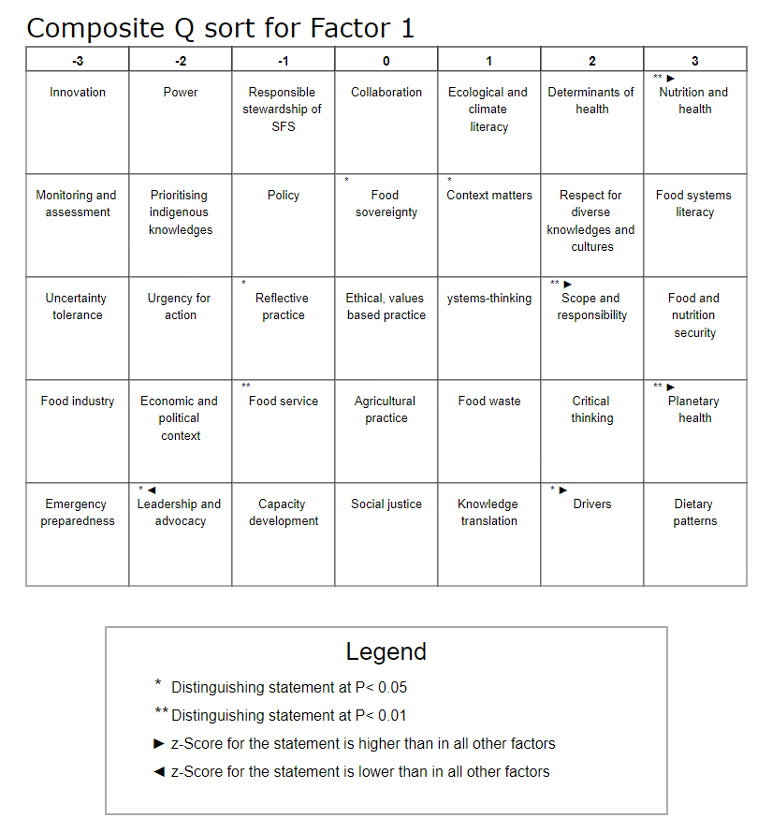

Supplementary Material N: Demographics of participants loaded against Viewpoint 2

Partic-ipant | Country Income* | ND/  other | Metro/  rural | Area of practice | Expertise**
9 | Canada (HIC) | Other | Metro | Education and research | 3
16 | Venezuela and the USA (HIC) | Other | Metro | Population and/or community health  Education and research | 4
19 | Canada (HIC) | ND | Both | Population and/or community health | 4
20 | Canada (HIC) | ND | Both | Population and/or community health | 4
24 | Canada (HIC) | ND | Rural | Population and/or community health | 3
29 | England (HIC) | Both | Metro | Population and/or community health  Education and research | 4
44 | Canada (HIC) | ND | Metro | Population and/or community health  Education and research | 4
46 | Canada (HIC) | ND | Rural | Population and/or community health | 4
33 | Canada (HIC) | ND | Rural | Public school food program manager | 3
ND = Registered Nutritionist or dietitian
*Rankings based on World Bank (2023)
**Question item was measured with a 5-point Likert scale. 1 = low, 5 = high

Please note: Participant 33 is highlighted as this participants’ Q-sort is opposite to the above views (bipolar) within Viewpoint 2.

Supplementary Material O: Relative ranking of statements in Viewpoint 2

Table: Relative ranking of statements in Viewpoint 2a
Highest Ranked Statements
Participant Number | Statements | Factor 2a | Cons/  Disting | Factor 1 | Factor 2b | Factor 3
15 | Food sovereignty | 3 | D* | 0 | -2 | -1
13 | Determinants of health | 3 |  | 2 | 2 | 1
5 | Prioritising indigenous knowledges | 3 | D* | -2 | 0 | 1
4 | Respect for diverse knowledges and cultures | 3 | C | 2 | 3 | 2
2 | Social justice | 3 | D | 0 | -2 | 2
Positive Statements Ranked Higher in Factor 2a Array than in Other Factor Arrays
Participant Number | Statements | Factor 2a | Cons/  Disting | Factor 1 | Factor 2b | Factor 3
7 | Economic and political context | 2 | D* | -2 | -3 | 0
19 | Ecological and climate literacy | 2 |  | 1 | -3 | -1
9 | Power | 1 |  | -2 | -3 | 1
18 | Food waste | 1 |  | 1 | -1 | -3
3 | Responsible stewardship of SFS | 1 |  | -1 | 0 | 0
8 | Policy | 0 | C | -1 | -2 | 0
17 | Urgency for action | 0 | D* | -2 | -3 | -2
Negative Statements Ranked Lower in Factor 2a Array than in Other Factor Arrays
Participant Number | Statements | Factor 2a | Cons/  Disting | Factor 1 | Factor 2b | Factor 3
22 | Collaboration | 0 |  | 0 | 2 | 3
21 | Dietary patterns | -1 |  | 3 | 3 | -1
23 | Systems-thinking | -1 |  | 1 | 0 | 3
10 | Knowledge translation | -2 | D* | 1 | 2 | 3
11 | Context matters | -2 |  | 1 | 3 | -2
25 | Critical thinking | -2 | D* | 2 | 3 | 3
Lowest Ranked Statements
Participant Number | Statements | Factor 2a | Cons/  Disting | Factor 1 | Factor 2b | Factor 3
27 | Innovation | -3 |  | -3 | 1 | 0
26 | Uncertainty tolerance | -3 |  | -3 | -2 | -2
28 | Food service | -3 | D | -1 | 3 | -3
29 | Food industry | -3 | C* | -3 | -2 | -3
34 | Reflective practice | -3 | D* | -1 | 1 | 2
#Cons/Disting = Consensus or Distinguishing Statement
* Indicates statistical significance (p<0.05)

Table: Relative ranking of statements in Viewpoint 2b

Highest Ranked Statements
Participant Number | Statements | Factor 2b | Cons/  Disting | Factor 1 | Factor 2a | Factor 3
4 | Respect for diverse knowledges and cultures | 3 | C | 2 | 3 | 2
11 | Context matters | 3 | D | 1 | -2 | -2
21 | Dietary patterns | 3 |  | 3 | -1 | -1
25 | Critical thinking | 3 |  | 2 | -2 | 3
28 | Food service | 3 | D* | -1 | -3 | -3
Positive Statements Ranked Higher in Factor 2b Array than in Other Factor Arrays
Participant Number | Statements | Factor 2b | Cons/  Disting | Factor 1 | Factor 2a | Factor 3
30 | Monitoring and assessment | 2 | D* | -3 | -2 | -1
27 | Innovation | 1 |  | -3 | -3 | 0
33 | Emergency preparedness | 1 | D* | -3 | -2 | -3
35 | Capacity development | 1 | D | -1 | -1 | -2
Negative Statements Ranked Lower in Factor 2b Array than in Other Factor Arrays
Participant Number | Statements | Factor 2b | Cons/  Disting | Factor 1 | Factor 2a | Factor 3
1 | Ethical, values-based practice | -1 |  | 0 | 0 | 2
12 | Planetary health | -1 | D | 3 | 2 | 2
31 | Drivers | -1 |  | 2 | 1 | 0
2 | Social justice | -2 |  | 0 | 3 | 2
8 | Policy | -2 | C | -1 | 0 | 0
15 | Food sovereignty | -2 |  | 0 | 3 | -1
Lowest Ranked Statements
Participant Number | Statements | Factor 2b | Cons/  Disting | Factor 1 | Factor 2a | Factor 3
7 | Economic and political context | -3 |  | -2 | 2 | 0
9 | Power | -3 |  | -2 | 1 | 1
17 | Urgency for action | -3 |  | -2 | 0 | -2
19 | Ecological and climate literacy | -3 | D | 1 | 2 | -1
32 | Scope and responsibility | -3 | D* | 2 | 0 | 1
#Cons/Disting = Consensus or Distinguishing Statement
* Indicates statistical significance (p<0.05)

Supplementary Material P: Composite Q sort for Viewpoint 2

These composite Q sorts, created using Kade, support the interpretation of Viewpoints 2a and 2b. These figures present the idealised Q Sort arrangement made by participants who supported each viewpoint based on the factor analysis.

Figure: Composite Q sort for Viewpoint 2a

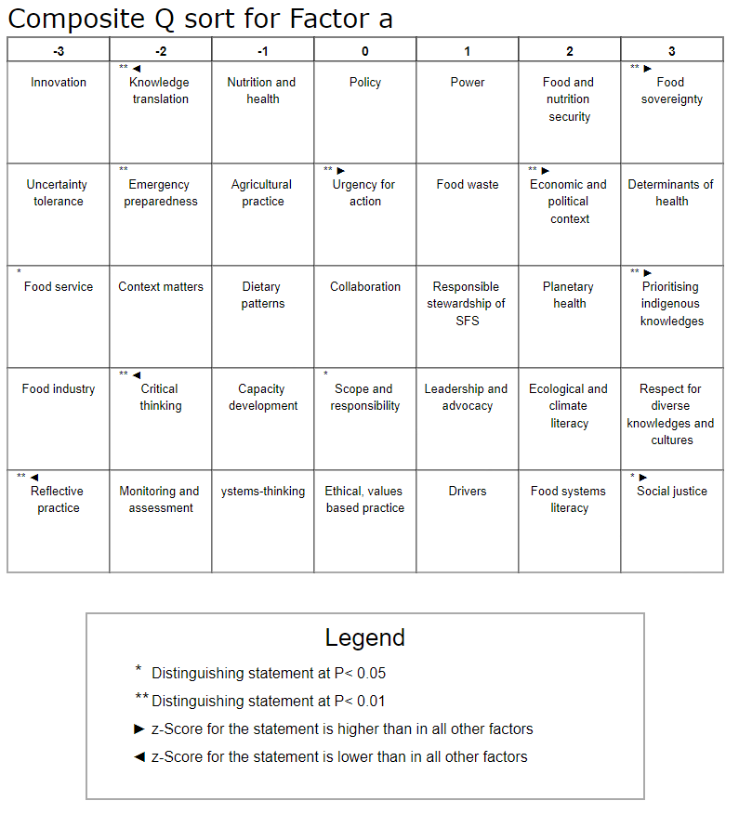

Figure: Composite Q sort for Viewpoint 2b

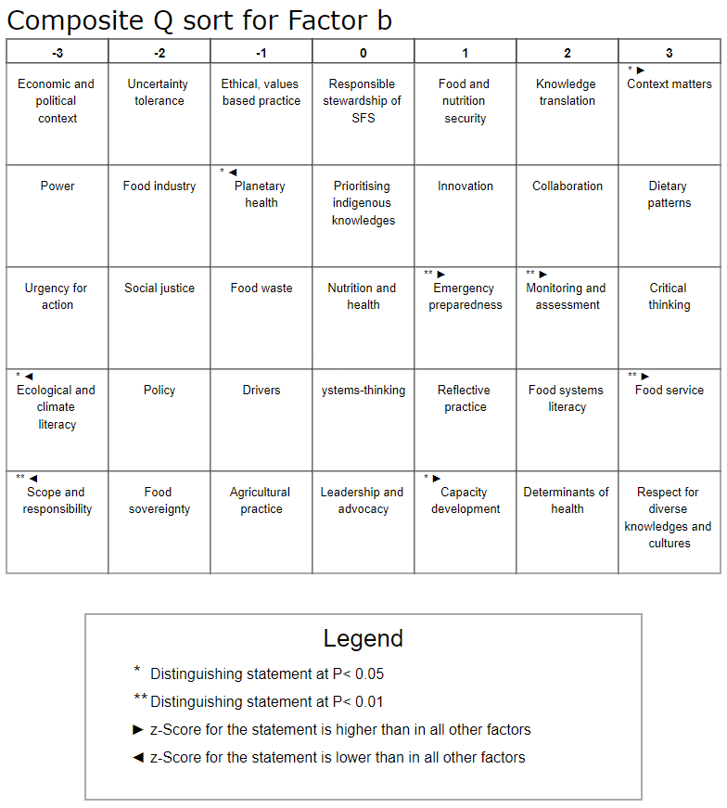
Supplementary Material Q: Demographics of participants loaded against Viewpoint 3

Partic- ipant | Country Income* | ND/other | Metro/  rural | Area of practice | Expertise**
4 | USA (HIC) | RD | Rural | Education and research | 5
5 | Canada (HIC) | RD | Metro | Population and/or community health | 3
8 | Canada (HIC) | Other | Metro | Population and/or community health  Education and research | 3
17 | Ireland (HIC) | RD | Metro | Education and research | 4
26 | Canada (HIC) | RD | Metro | Population and/or community health | 4
27 | Canada (HIC) | Other | Metro | Population and/or community health  Clinical nutrition  Education and research  Food products and industry | 4
28 | Canada (HIC) | Other | Metro | Education and research | 2
31 | Canada (HIC) | RD | Rural | Population and/or community health | 5
35 | Australia (HIC) | Other | Metro | Education and research | 4
37 | Canada (HIC) | RD | Both | Population and/or community health  Education and research | 4
47 | Canada (HIC) | RD | Metro | Population and/or community health  Food products and industry | 3
ND = Registered Nutritionist or dietitian
*Rankings based on World Bank (2023)
**Question item was measured with a 5-point Likert scale. 1 = low, 5 = high

Supplementary Material R: Relative ranking of statements in Viewpoint 3

Highest Ranked Statements
Participant Number | Statements | Factor 3 | Cons/  Disting | Factor 1 | Factor 2a | Factor 2b
23 | Systems-thinking | 3 | D* | 1 | -1 | 0
25 | Critical thinking | 3 |  | 2 | -2 | 3
22 | Collaboration | 3 |  | 0 | 0 | 2
24 | Leadership and advocacy | 3 | D | -2 | 1 | 0
10 | Knowledge translation | 3 |  | 1 | -2 | 2
Positive Statements Ranked Higher in Factor 3 Array than in Other Factor Arrays
Participant Number | Statements | Factor 3 | Cons/  Disting | Factor 1 | Factor 2a | Factor 2b
34 | Reflective practice | 2 |  | -1 | -3 | 1
1 | Ethical, values-based practice | 2 | D | 0 | 0 | -1
9 | Power | 1 |  | -2 | 1 | -3
8 | Policy | 0 | C | -1 | 0 | -2
Negative Statements Ranked Lower in Factor 3 Array than in Other Factor Arrays
Participant Number | Statements | Factor 3 | Cons/  Disting | Factor 1 | Factor 2a | Factor 2b
14 | Food and nutrition security | -1 |  | 3 | 2 | 1
21 | Dietary patterns | -1 |  | 3 | -1 | 3
16 | Nutrition and health | -2 |  | 3 | -1 | 0
11 | Context matters | -2 |  | 1 | -2 | 3
35 | Capacity development | -2 |  | -1 | -1 | 1
Lowest Ranked Statements
Participant Number | Statements | Factor 3 | Cons/  Disting | Factor 1 | Factor 2a | Factor 2b
20 | Agricultural practice | -3 |  | 0 | -1 | -1
18 | Food waste | -3 | D | 1 | 1 | -1
33 | Emergency preparedness | -3 |  | -3 | -2 | 1
29 | Food industry | -3 | C* | -3 | -3 | -2
28 | Food service | -3 | D | -1 | -3 | 3
#Cons/Disting = Consensus or Distinguishing Statement
* Indicates statistical significance (p<0.05)

Supplementary Material S: Composite Q sort for Viewpoint 3

This composite Q sort, created using Kade, supports the interpretation of Viewpoint 3. This figure presents the idealised Q Sort arrangement made by participants who supported this viewpoint based on the factor analysis.

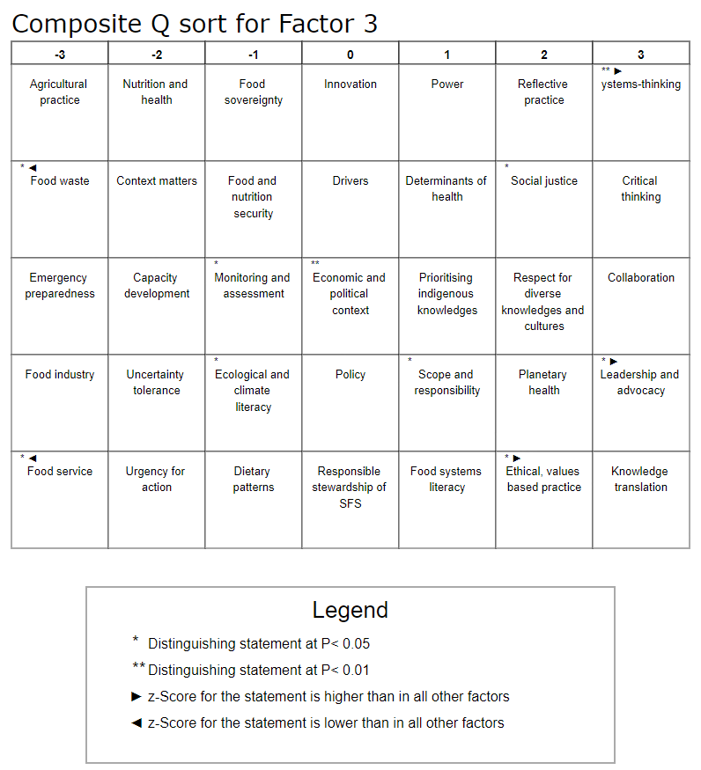

Dieteren, C.M., Patty, N.J., Reckers-Droog, V.T. and van Exel, J., 2023. Methodological choices in applications of Q methodology: A systematic literature review. Social Sciences & Humanities Open, 7(1), p.100404.

