Online Appendix of the article
“Unraveling the Path to Smart Manufacturing Advancement: Insights from Necessary Condition and Fuzzy-Set Qualitative Comparative Analyses”

Questionnaire

Section 1 – Company and respondents’ details
What is your role within the company?
How long have you been working in this role at your company?
- Up to 2 years
- 2-5 years
- More than 5 years
What is the size of your company?
- Less than 50 employees
- Between 50 and 249 employees
- More than 249 employees
In which industry does your company operate?
In which country is your company headquartered?

Section 2 – Smart Manufacturing (SM) advancement
Based on the definitions provided below, what are the capacities enabled by SM technologies in your lead plant for SM?

- Monitoring
- Control
- Optimization
- Autonomy
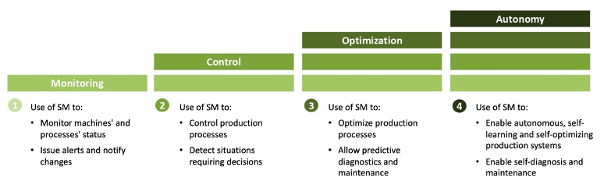

Section 3 – Technological and organizational factors impacting SM advancement
To what extent do the following statements apply to your lead plant for SM?
Please rate on a scale from 1 to 5, with 1 indicating low agreement and 5 very high agreement

- We have invested in our IT infrastructure (e.g., servers, datacenters)
- We always evaluate interoperability between old and new equipment
- We always consider scalability of SM solutions
- We have invested in digital competences training for employees
- We have defined a clear roadmap for SM implementation
- We scan the market for new SM solutions of value
- Our staff are fully informed about the goals of SM projects
- Our employees exchange best practices concerning use of SM
- Our top management strongly supports SM
- We have a culture of openness to external partnerships in the field of SM
- We have appointed dedicated roles to manage SM implementation
- We have cross-functional integration teams for SM projects
- We adopted agile organizational structures to fully exploit SM

