Appendix

This appendix contains supplementary material to accompany the manuscript titled:

“Caught in the Web: A Meta-analysis of Internet Addiction, Excessive Daytime Sleepiness and Depressive Symptoms in Adolescents”

List of Appendices

Appendix A: Literature Search and Screening
Appendix B: Included Studies
Appendix C: The Association between Internet Addiction and Depressive Symptoms
Appendix D: Two-stage Structural Equation Modeling (TSSEM)
Appendix E: Erroneous Path from Depressive Symptoms to Internet Addiction

List of Figures

Figure A.1. Flow chart of the literature search process (internet addiction and depressive symptoms)
Figure A.2. Flow chart of the literature search process (internet addiction and excessive daytime sleepiness)
Figure A.3. Flow chart of the literature search process (excessive daytime sleepiness and depressive symptoms)
Figure C.1. Funnel plot

List of Tables

Table A.1. Search strings
Table B.1. Characteristics of studies included in the meta-analysis
Table C.1. Summary effect size as a function of varying correlations between sampling errors
Table C.2. Moderator analyses (univariate) excluding potential outlier
Table C.3. Moderator analysis (multivariate) excluding potential outlier
Table D.1. Average correlation matrix (TSSEM)

Appendix A

Literature Search and Screening

Table A.1. Search strings

Database | Search terms
Internet addiction and depressive symptoms

Scopus | TITLE-ABS ((("cross sectional") AND (teen OR adolescent OR school)) AND (("internet addiction" OR "problematic internet use" OR "excessive internet use" OR "compulsive internet use" OR "pathological internet use") AND (depression OR "mental health")))
PubMed | ((“cross sectional”) AND (teen [tiab] OR adolescent [tiab] OR school [tiab])) AND ((“internet addiction” [tiab]OR “problematic internet use” [tiab] OR “excessive internet use” [tiab] OR “compulsive internet use” [tiab] OR “pathological internet use” [tiab]) AND (depression [tiab] OR “mental health” [tiab]))
Google Scholar | (("cross sectional") AND (teen OR adolescent OR school)) AND (("internet addiction" OR "problematic internet use" OR "excessive internet use" OR "compulsive internet use" OR "pathological internet use") AND (depression OR "mental health")
Past meta-analysis (Cai et al., 2023) | None
Internet addiction and excessive daytime sleepiness

Scopus | TITLE-ABS ((("cross sectional") AND (teen OR adolescent OR school)) AND (("internet addiction" OR "problematic internet use" OR "excessive internet use" OR "compulsive internet use" OR "pathological internet use") AND ("daytime sleep" OR daytime OR "Epworth Sleepiness Scale" OR ESS OR hypersomnia)))
PubMed | ((“cross sectional”) AND (teen [tiab] OR adolescent [tiab] OR school [tiab])) AND ((“internet addiction” [tiab]OR “problematic internet use” [tiab] OR “excessive internet use” [tiab]OR “compulsive internet use” [tiab] OR “pathological internet use” [tiab]) AND ("daytime sleep" [tiab] OR daytime [tiab] OR "Epworth Sleepiness Scale" [tiab] OR ESS [tiab] OR hypersomnia [tiab]))
Google Scholar | (("cross sectional") AND (teen OR adolescent OR school)) AND (("internet addiction" OR "problematic internet use" OR "excessive internet use" OR "compulsive internet use" OR "pathological internet use") AND ("daytime sleep" OR daytime OR "Epworth Sleepiness Scale" OR ESS OR hypersomnia)
Past meta-analysis (Alimoradi et al., 2019) | None
Excessive daytime sleepiness and depressive symptoms

Scopus | TITLE-ABS ((("cross sectional") AND (teen OR adolescent OR school)) AND ((depression OR "mental health") AND ("daytime sleep" OR daytime OR "Epworth Sleepiness Scale" OR ESS OR hypersomnia)))
PubMed | (("cross sectional") AND (teen [tiab] OR adolescent [tiab] OR school [tiab])) AND ((depression [tiab] OR "mental health" [tiab]) AND ("daytime sleep" [tiab] OR daytime [tiab] OR "Epworth Sleepiness Scale" [tiab] OR ESS [tiab] OR hypersomnia [tiab]))
Google Scholar | (("cross sectional") AND (teen OR adolescent OR school)) AND ((depression OR "mental health") AND ("daytime sleep" OR daytime OR "Epworth Sleepiness Scale" OR ESS OR hypersomnia)
Past meta-analysis (O'Callaghan et al., 2021) | None

Source: Authors’ own work.

Figure A.1. Flow chart of the literature search process (internet addiction and depressive symptoms)

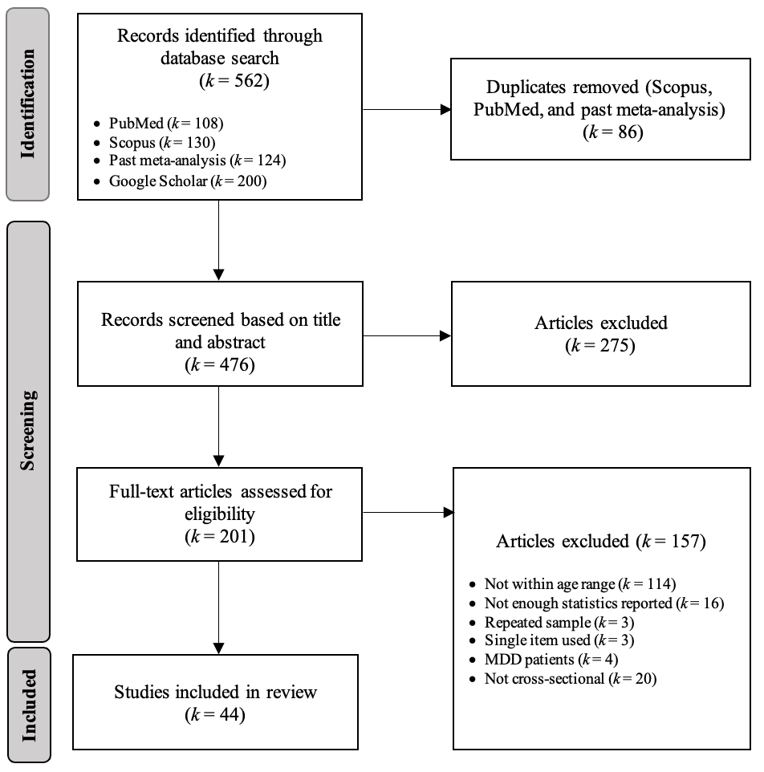

Source: Authors’ own work. Prisma Flow Diagram adopted from Moher et al. (2009) with modifications.

Figure A.2. Flow chart of the literature search process (internet addiction and excessive daytime sleepiness)

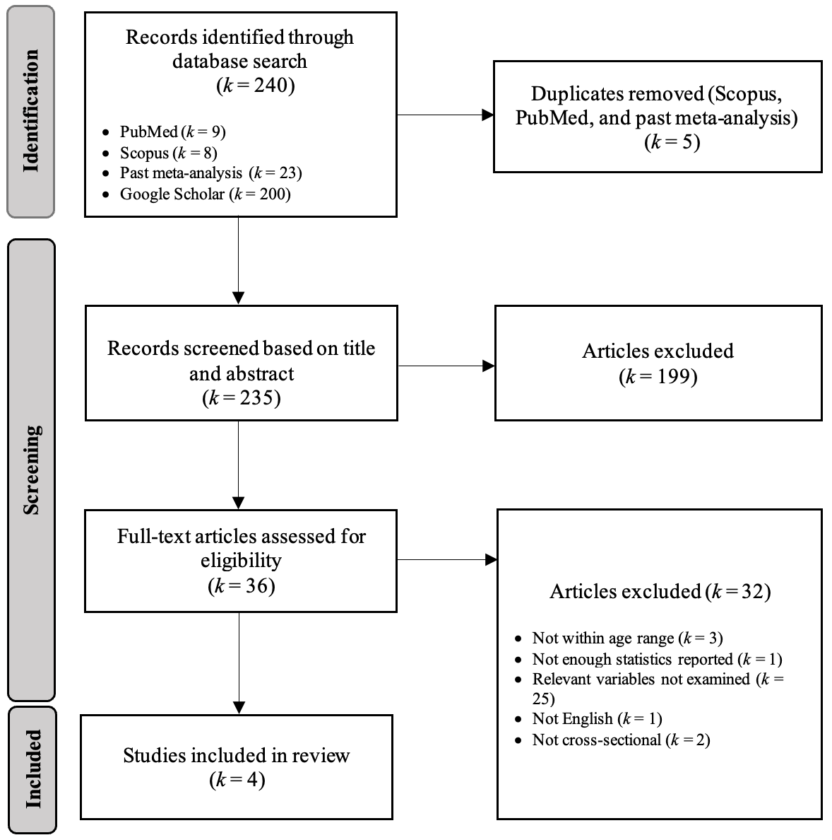

Source: Authors’ own work. Prisma Flow Diagram adopted from Moher et al. (2009) with modifications.

Figure A.3. Flow chart of the literature search process (excessive daytime sleepiness and depressive symptoms)

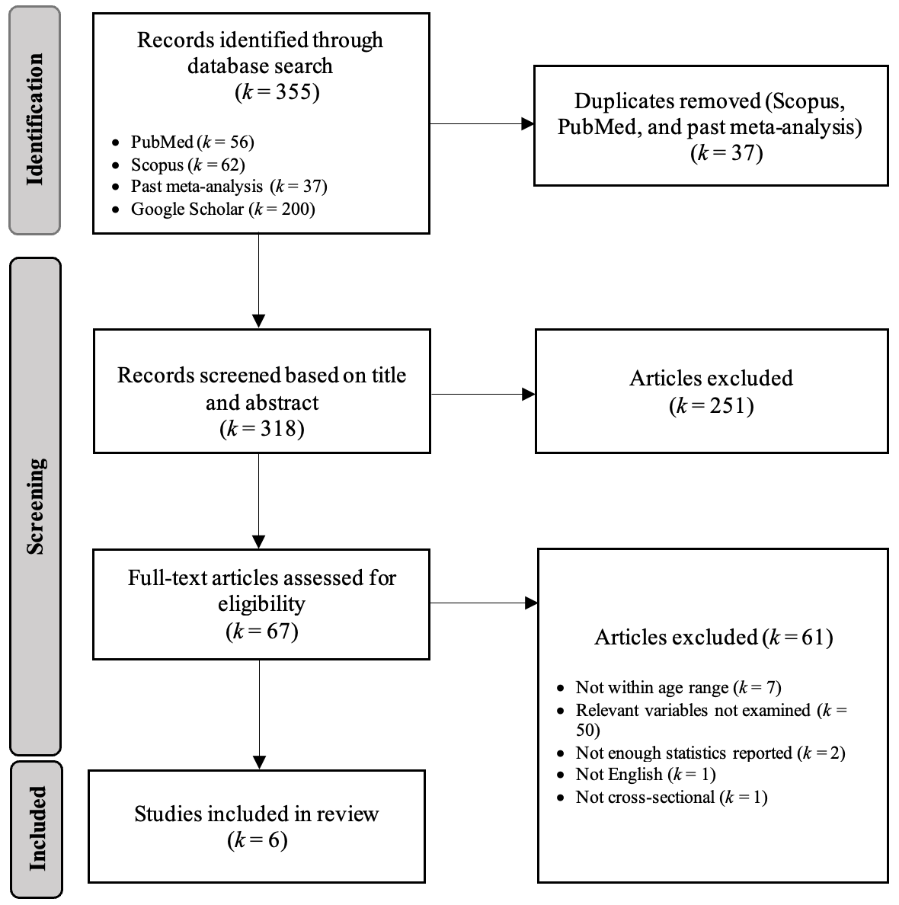

Source: Authors’ own work. Prisma Flow Diagram adopted from Moher et al. (2009) with modifications.

Appendix B

Included Studies

Table B.1. Characteristics of studies included in the meta-analysis

Study | N | Age range | % Female | Country | IV measures | DV measures
Internet addiction and depressive symptoms

Ibrahim et al. (2022) | 461 | 13-17 | 59.2 | Malaysia | YIAT | CDI-27
Aleebrahim et al. (2022) | 903 | 15-18 | 49.6 | Iran | YIAT | GHQ-28
Lee et al. (2018) | 1168 | 13-18 | 53.3 | Korea | YIAT | CESD-20
Gao et al. (2018) | 2259 | 12-19 | 53.6 | China | YIAT | DASS-21
Zhai et al. (2020) | 2758 | 10-19 | 53.9 | China | YIAT | CDI-10
Saikia et al. (2019) | 416 | 16-19 | 73.1 | India | YIAT | DASS-21
Tang et al. (2014) | 1076 | 11-19 | 45.9 | China | YIAT | SDS-20
Goel et al. (2013) | 987 | 16-18 | 68.9 | India | YIAT | DUKE-17
Chundawat et al. (2022) | 348 | 14-19 | 34.5 | India | YIAT | DASS-42
Liang et al. (2021) | 690 | 12-18 | 51.9 | China | YIAT | PHQ-9
Kim et al. (2006) (Independent sample) | 951 | 15-16 | 65.1 | Korea | YIAT | KDISC-MDD-SQ
Kim et al. (2006) (Independent sample) | 597 | 15-16 | 65.3 | Korea | YIAT | KDISC-MDD-SQ
Kim et al. (2006) (Independent sample) | 25 | 15-16 | 56.0 | Korea | YIAT | KDISC-MDD-SQ
Park et al. (2018) | 766 | 12-17 | 36.9 | Korea | YIAT | CDI-27
Guo et al. (2023) | 4091 | 11-19 | 51.1 | China | YIAT | SDS-20
Liu et al. (2022) | 4852 | 10-18 | 51.5 | China | CIAS-R-26 | SDS-20
Haddad et al. (2021) | 1103 | 13-17 | 58.4 | Lebanon | YIAT | ADRS-10
Veisani et al. (2020) | 362 | 13-18 | 50.0 | Iran | YIAT | GHQ-28
Andreous and Svoli (2013) | 384 | 15-18 | 54.4 | Greece | YIAT | ADRS-10
Bağatarhan and Siyez (2022) | 600 | 14-19 | 53.2 | Turkey | YIAT | CESD-R-10
Bozoglan et al. (2014) | 244 | 14-18 | 52.0 | Turkey | PIUS | BDI-21
Cao et al. (2021) | 2022 | 10-17 | 50.1 | China | YIAT | CESD-20
Cerruti et al. (2017) | 240 | 10-15 | 51.9 | Italy | YIAT | CDI-27
Chi et al. (2019) | 522 | 11-15 | 42.6 | China | YIAT | CESD-20
Columb et al. (2021) | 234 | 12-18 | 33.3 | Ireland | YIAT | CDI-27
Fathian Dastgerdi et al. (2020) | 721 | 10-15 | 48.0 | Iran | YIAT | GHQ-28
El Asam et al. (2019) | 1814 | 10-16 | 47.0 | United Kingdom | PIUQ | PHQ-9
Erceg et al. (2018) | 1320 | 11-18 | 57.0 | Croatia | CIUS | BDI-Y-20
Hernández et al. (2019) | 529 | 13-19 | 46.8 | Chile | YIAT | BDI-21
Kawabe et al. (2016) | 853 | 12-15 | 50.2 | Japan | YIAT | GHQ-30
Li et al. (2021) | 2848 | 12-17 | 50.6 | China | YIAT | CESD-10
Malak and Khalifeh (2018) | 800 | 12-18 | 50.0 | Jordan | YIAT | CESD-20
Nam et al. (2018) | 519 | 14 | 48.4 | South Korea | YIAT | BDI-21
Park et al. (2013) | 795 | 12-16 | 67.7 | South Korea | KS-scale | BDI-22
Sami et al. (2018) | 631 | 12-18 | 54.5 | Israel | YIAT | PHQ-A-9
Sesar et al. (2018) | 326 | 16-19 | 62.6 | Bosnia and Herzegovina | PIUQ | DASS-42
Tan et al. (2016) | 1661 | 12-18 | 48.2 | China | YIAT | CESD-10
Van Rooij et al. (2017) | 3945 | 12-15 | 50.0 | Netherlands | CIUS | DML-6
Wang et al. (2021) | 2211 | 10-16 | 50.8 | China | GPIU | CESD-20
Yadav et al. (2013) | 552 | 15-18 | 40.6 | India | YIAT | DASS-21
Yang et al. (2005) | 328 | 15-19 | 50.0 | Korea | YIAT | SCL-90_R
Yang et al. (2014) | 3507 | 14-17 | 48.1 | China | YIAT | CESD-20
Lai et al. (2015) (Independent sample) | 879 | 12-18 | 46.5 | China | YIAT | CESD-20
Lai et al. (2015) (Independent sample) | 839 | 12-18 | 62.3 | Hong Kong | YIAT | CESD-20
Lai et al. (2015) (Independent sample) | 744 | 12-18 | 51.1 | Japan | YIAT | CESD-20
Lai et al. (2015) (Independent sample) | 936 | 12-18 | 38.6 | South Korea | YIAT | CESD-20
Lai et al. (2015) (Independent sample) | 969 | 12-18 | 54.0 | Malaysia | YIAT | CESD-20
Lai et al. (2015) (Independent sample) | 999 | 12-18 | 61.5 | Philippines | YIAT | CESD-20
Chen et al. (2020) | 451 | 10.33-12.92 | 49.2 | Taiwan | YIAT | CESD-20
Lim et al. (2015) | 691 | 14-16 | 45.6 | South Korea | YIAT | BDI-21
Bener et al. (2016) | 1189 | 12-18 | 49.9 | Qatar | YIAT | BDI-21
Internet addiction and excessive daytime sleepiness

Tereshchenko et al. (2021) | 4615 | 12-18 | 53.8 | Russia | CIAS | PDSS
Ferreira et al. (2017) | 694 | Teenagers | 47.0 | Portugal | YIAT | PDSS
Park et al. (2018) | 766 | 12-17 | 36.9 | Korea | YIAT | ESS
Bener et al. (2016) | 1189 | 12-18 | 49.9 | Qatar | YIAT | ESS
Excessive daytime sleepiness and depressive symptoms

Ng et al. (2020) | 686 | 12-19 | 45.9 | Hong Kong | ESS | DASS-21
Chen et al. (2015) | 757 | 16-18 | 30.1 | Taiwan | ESS | BDI-II-21
Bahrami et al. (2021) | 940 | 12-18 | 100.0 | Iran | ESS | BDI-II-21
Yang et al. (2017) | 538 | 16-17 | 50.0 | Korea | ESS | BDI-II-21
Richardson et al. (2019) | 528 | 10-12 | 49.0 | Australia | PDSS | SMFQ-C-13
Lehto and Uusitalo‐Malmivaara (2014) | 438 | 11 | 50.8 | Finland | self-devised | CDI-25

Source: Authors’ own work.
Notes. YIAT = Young's Internet Addiction Test, CIAS = Chen Internet Addiction Scale, PIUS = Problematic Internet Use Scale, KS = Korean Internet Addiction Test, PIUQ = The Problematic Internet Use Questionnaire, CIUS = Compulsive Internet Use Scale, GPIU = Generalized Problematic Internet Use Scale, CDI = Children's Depression Inventory, GHQ = General Health Questionnaire, CESD = Center for Epidemiologic Studies Depression Scale, DASS = Depression, Anxiety and Stress Scale, SDS = Severity of Dependence Scale, PHQ = Patient Health Questionnaire, KDISC-MDD-SQ = Korean Diagnostic Interview Schedule for Children-Major Depression Disorder-Simple Questionnaire, ADRS = Adolescent Depression Rating Scale, BDI = Beck's Depression Inventory, DML = Depressive Mood List, SCL = Symptom Checklist, SMFQ = Short Mood and Feelings Questionnaire, ESS = Epworth Sleepiness Scale, PDSS = Pediatric Daytime Sleepiness Scale.

References

- Aleebrahim, F., Daneshvar, S. and Tarrahi, M. J. (2022), “The prevalence of internet addiction and its relationship with mental health among high school students in Bushehr, Iran (2018)”, International Journal of Preventive Medicine, Vol. 13
- Andreou, E. and Svoli, H. (2013), “The association between internet user characteristics and dimensions of internet addiction among Greek adolescents”, International Journal of Mental Health and Addiction, Vol. 11, pp. 139-148.
- Bağatarhan, T. and Siyez, D. M. (2022), “Rumination and internet addiction among adolescents: the mediating role of depression”, Child and Adolescent Social Work Journal, Vol. 39 No. 2, pp. 209-218.
- Bahrami, A., Salarbashi, D., Mohammad-Zadeh, M., Tayefi, M., Mirmoosavi, S. J., Ferns, G. A., Bahrami-Taghanaki, H. and Ghayour-Mobarhan, M. (2021), “Depression and aggression scores, reported sleep disorders status and their associated factors among adolescent girls in Northern Iran”, Current Psychology, Vol. 40, pp. 5064-5075.
- Bener, A., Al-Mahdi, H. S. and Bhugra, D. (2016), “Lifestyle factors and internet addiction among school children”, International Journal of Community & Family Medicine, Vol. 1, No. 118.
- Bozoglan, B., Demirer, V. and Sahin, I. (2014), “Problematic Internet use: Functions of use, cognitive absorption, and depression”, Computers in Human Behavior, Vol. 37, pp. 117-123.
- Cao, R., Gao, T., Ren, H., Hu, Y., Qin, Z., Liang, L. and Mei, S. (2021), “The relationship between bullying victimization and depression in adolescents: multiple mediating effects of internet addiction and sleep quality”, Psychology, Health & Medicine, Vol. 26 No. 5, pp. 555-565.
- Cerruti, R., Spensieri, V., Presaghi, F., Valastro, C., Fontana, A. and Guidetti, V. (2017), “An exploratory study on Internet addiction, somatic symptoms and emotional and behavioral functioning in school-aged adolescents”, Clinical Neuropsychiatry, Vol. 14 No. 6, pp. 374-383.
- Chen, H. C., Wang, J. Y., Lin, Y. L. and Yang, S. Y. (2020), “Association of internet addiction with family functionality, depression, self-efficacy and self-esteem among early adolescents”, International Journal of Environmental Research and Public Health, Vol. 17 No. 23.
- Chen, T. Y., Chou, Y. C., Tzeng, N. S., Chang, H. A., Kuo, S. C., Pan, P. Y., Yeh, Y.W., Yeh, C.B. and Mao, W. C. (2015), “Effects of a selective educational system on fatigue, sleep problems, daytime sleepiness, and depression among senior high school adolescents in Taiwan”, Neuropsychiatric Disease and Treatment, Vol. 11, pp. 741-750.
- Chi, X., Liu, X., Guo, T., Wu, M. and Chen, X. (2019), “Internet addiction and depression in chinese adolescents: a moderated mediation model”, Frontiers in Psychiatry, Vol. 10.
- Chundawat, D. S., Yadav, K. C., Mudgal, S. K., Yadav, Y., Gaur, R. and Malhotra, V. (2022), “A Study on Psychosomatic Problems Related to the Problematic Internet Use among Adolescents at Selected Schools of Aspur Block, Dungarpur, Rajasthan”, Mymensingh Medical Jouranl, Vol. 31 No. 2, pp. 539-546.
- Columb, D., Keegan, E., Griffiths, M. D. and O’Gara, C. (2021), “A descriptive pilot survey of behavioural addictions in an adolescent secondary school population in Ireland”, Irish Journal of Psychological Medicine, pp. 1-13
- El Asam, A., Samara, M. and Terry, P. (2019), “Problematic internet use and mental health among British children and adolescents”, Addictive Behaviors, Vol. 90, pp. 428-436.
- Erceg, T., Buljan Flander, G. and Brezinšćak, T. (2018), “The relationship between compulsive Internet use and symptoms of depression and anxiety in adolescence”, Alcoholism and psychiatry research: Journal on Psychiatric Research and Addictions, Vol. 54 No. 2, pp. 101-112.
- Fathian Dastgerdi, Z., Amidi Mazaheri, M., Jadidi, H., Zhaleh, M., Kaviani Tehrani, A., Ghasemi, M. and Khoshgoftar, M. (2020), “Prevalence of internet addiction and its association with general health status among high school students in Isfahan, Iran. International”, Journal of Pediatrics, Vol. 8 No. 1, pp. 10799-10806.
- Ferreira, C., Ferreira, H., Vieira, M. J., Costeira, M., Branco, L., Dias, Â. and Macedo, L. (2017), “Epidemiology of internet use by an adolescent population and its relation with sleep habits”, Acta Médica Portuguesa, Vol. 30 No. 7-8, pp. 524-533.
- Gao, T., Meng, X., Qin, Z., Zhang, H., Gao, J., Kong, Y., Hu, Y. and Mei, S. (2018), “Association between parental marital conflict and Internet addiction: A moderated mediation analysis”, Journal of Affective Disorders, Vol. 240, pp. 27-32.
- Goel, D., Subramanyam, A. and Kamath, R. (2013), “A study on the prevalence of internet addiction and its association with psychopathology in Indian adolescents”, Indian Journal of Psychiatry, Vol. 55 No. 2, pp. 140-143.
- Guo, Y. Y., Gu, J. J., Gaskin, J., Yin, X. Q., Zhang, Y. H. and Wang, J. L. (2023), “The association of childhood maltreatment with Internet addiction: the serial mediating effects of cognitive emotion regulation strategies and depression”, Child Abuse & Neglect, Vol. 140.
- Haddad, C., Malaeb, D., Sacre, H., Khalil, J. B., Khansa, W., Al Hajj, R., Kheir, N., Saade, S., Obeid, S. and Hallit, S. (2021), “Association of problematic internet use with depression, impulsivity, anger, aggression, and social anxiety: Results of a national study among Lebanese adolescents”, Pediatric Investigation, Vol. 5 No. 04, pp. 255-264.
- Hernández, C., Ottenberger, D. R., Moessner, M., Crosby, R. D. and Ditzen, B. (2019), “Depressed and swiping my problems for later: The moderation effect between procrastination and depressive symptomatology on internet addiction”, Computers in Human Behavior, Vol. 97, pp. 1-9.
- Ibrahim, M. F., Ismail, W. S. W., Jaafar, N. R. N., Mokhtaruddin, U. K. M., Ong, H. Y., Bakar, N. H. A. and Sahimi, H. M. S. (2022), “Depression and its association with self-esteem and lifestyle factors among school-going adolescents in Kuala Lumpur, Malaysia”, Frontiers in Psychiatry, Vol. 13.
- Kawabe, K., Horiuchi, F., Ochi, M., Oka, Y. and Ueno, S. I. (2016), “Internet addiction: Prevalence and relation with mental states in adolescents”, Psychiatry and Clinical Neurosciences, Vol. 70 No. 9, pp. 405-412.
- Kim, K., Ryu, E., Chon, M. Y., Yeun, E. J., Choi, S. Y., Seo, J. S. and Nam, B. W. (2006), “Internet addiction in Korean adolescents and its relation to depression and suicidal ideation: a questionnaire survey”, International Journal of Nursing Studies, Vol. 43 No. 2, pp. 185-192.
- Lai, C. M., Mak, K. K., Watanabe, H., Jeong, J., Kim, D., Bahar, N., Ramos, M., Chen, S.H. and Cheng, C. (2015), “The mediating role of Internet addiction in depression, social anxiety, and psychosocial well-being among adolescents in six Asian countries: a structural equation modelling approach”, Public Health, Vol. 129 No. 9, pp. 1224-1236.
- Lee, J. Y., Kim, S. Y., Bae, K. Y., Kim, J. M., Shin, I. S., Yoon, J. S. and Kim, S. W. (2018), “Prevalence and risk factors for problematic I nternet use among rural adolescents in Korea”, Asia‐Pacific Psychiatry, Vol. 10 No. 2.
- Lehto, J. E. and Uusitalo‐Malmivaara, L. (2014), “Sleep‐related factors: Associations with poor attention and depressive symptoms”, Child: Care, Health and Development, Vol. 40 No. 3, pp. 419-425.
- Li, X., Shek, D. T. and Shek, E. Y. (2021), “Offline victimization, psychological morbidity, and problematic online behavior among Chinese secondary school students”, International Journal of Environmental Research and Public Health, Vol. 18 No. 18.
- Liang, L., Zhu, M., Dai, J., Li, M. and Zheng, Y. (2021), “The mediating roles of emotional regulation on negative emotion and internet addiction among Chinese adolescents from a development perspective”, Frontiers in Psychiatry, Vol. 12.
- Lim, J. A., Gwak, A. R., Park, S. M., Kwon, J. G., Lee, J. Y., Jung, H. Y., Sohn, B.K., Kim, J.W. and Choi, J. S. (2015), “Are adolescents with internet addiction prone to aggressive behavior? The mediating effect of clinical comorbidities on the predictability of aggression in adolescents with internet addiction”, Cyberpsychology, Behavior, and Social Networking, Vol. 18 No. 5, pp. 260-267.
- Liu, S., Zou, S., Zhang, D., Wang, X. and Wu, X. (2022), “Problematic Internet use and academic engagement during the COVID-19 lockdown: The indirect effects of depression, anxiety, and insomnia in early, middle, and late adolescence”, Journal of Affective Disorders, Vol. 309, pp. 9-18.
- Malak, M. Z. and Khalifeh, A. H. (2018), “Anxiety and depression among school students in Jordan: Prevalence, risk factors, and predictors”, Perspectives in Psychiatric Care, Vol. 54 No. 2, pp. 242-250.
- Nam, C. R., Lee, D. H., Lee, J. Y., Choi, A. R., Chung, S. J., Kim, D. J., Bhang, S.Y., Kwon, J.H., Kweon, Y.S. and Choi, J. S. (2018), “The role of resilience in internet addiction among adolescents between sexes: a moderated mediation model”, Journal of Clinical Medicine, Vol. 7 No. 8.
- Ng, K. C., Wu, L. H., Lam, H. Y., Lam, L. K., Nip, P. Y., Ng, C. M., Leung, K.C. and Leung, S. F. (2020), “The relationships between mobile phone use and depressive symptoms, bodily pain, and daytime sleepiness in Hong Kong secondary school students”, Addictive Behaviors, Vol. 101.
- Park, M. H., Park, S., Jung, K. I., Kim, J. I., Cho, S. C. and Kim, B. N. (2018), “Moderating effects of depressive symptoms on the relationship between problematic use of the Internet and sleep problems in Korean adolescents”, BMC Psychiatry, Vol. 18 No. 1, pp. 1-8.
- Park, S., Hong, K. E. M., Park, E. J., Ha, K. S. and Yoo, H. J. (2013), “The association between problematic internet use and depression, suicidal ideation and bipolar disorder symptoms in Korean adolescents”, Australian & New Zealand Journal of Psychiatry, Vol. 47 No. 2, pp. 153-159.
- Richardson, C., Oar, E., Fardouly, J., Magson, N., Johnco, C., Forbes, M. and Rapee, R. (2019), “The moderating role of sleep in the relationship between social isolation and internalising problems in early adolescence”, Child Psychiatry & Human Development, Vol. 50, pp. 1011-1020.
- Saikia, A. M., Das, J., Barman, P. and Bharali, M. D. (2019), “Internet addiction and its relationships with depression, anxiety, and stress in urban adolescents of Kamrup District, Assam”, Journal of Family & Community Medicine, Vol. 26 No. 2, pp. 108-112.
- Sami, H., Danielle, L., Lihi, D. and Elena, S. (2018), “The effect of sleep disturbances and internet addiction on suicidal ideation among adolescents in the presence of depressive symptoms”, Psychiatry Research, Vol. 267, pp. 327-332.
- Sesar, K., Dodaj, A. and Jurišić, M. (2018), “Problematic Internet Use and Emotional States Among Secondary School Students”, Central European Journal of Pediatrics, Vol. 14 No. 2, pp. 211-223.
- Tan, Y., Chen, Y., Lu, Y. and Li, L. (2016), “Exploring associations between problematic internet use, depressive symptoms and sleep disturbance among southern Chinese adolescents”, International Journal of Environmental Research and Public Health, Vol. 13 No. 3.
- Tang, J., Zhang, Y., Li, Y., Liu, L., Liu, X., Zeng, H., Xiang, D., Li, C.S.R. and Lee, T. S. H. (2014), “Clinical characteristics and diagnostic confirmation of Internet addiction in secondary school students in Wuhan, China”, Psychiatry and Clinical Neurosciences, Vol. 68 No. 6, pp. 471-478.
- Tereshchenko, S., Kasparov, E., Smolnikova, M., Shubina, M., Gorbacheva, N. and Moskalenko, O. (2021), “Internet addiction and sleep problems among russian adolescents: a field school-based study”, International Journal of Environmental Research and Public Health, Vol. 18 No. 19.
- Van Rooij, A. J., Ferguson, C. J., Van de Mheen, D. and Schoenmakers, T. M. (2017), “Time to abandon Internet Addiction? Predicting problematic Internet, game, and social media use from psychosocial well-being and application use”, Clinical Neuropsychiatry, Vol. 14 No. 1, pp. 113-121.
- Veisani, Y., Jalilian, Z. and Mohamadian, F. (2020), “Relationship between internet addiction and mental health in adolescents”, Journal of Education and Health Promotion, Vol. 9.
- Wang, P., Wang, J., Yan, Y., Si, Y., Zhan, X. and Tian, Y. (2021), “Relationship between loneliness and depression among Chinese junior high school students: the serial mediating roles of internet gaming disorder, social network use, and generalized pathological internet use”, Frontiers in Psychology, Vol. 11.
- Yadav, P., Banwari, G., Parmar, C. and Maniar, R. (2013), “Internet addiction and its correlates among high school students: A preliminary study from Ahmedabad, India”, Asian Journal of Psychiatry, Vol. 6 No. 6, pp. 500-505.
- Yang, B., Choe, K., Park, Y. and Kang, Y. (2017), “Associations among daytime sleepiness, depression and suicidal ideation in Korean adolescents”, International Journal of Adolescent Medicine and Health, Vol. 31 No. 2, 20160161.
- Yang, C. K., Choe, B. M., Baity, M., Lee, J. H. and Cho, J. S. (2005), “SCL-90-R and 16PF profiles of senior high school students with excessive internet use”, The Canadian Journal of Psychiatry, Vol. 50 No. 7, pp. 407-414.
- Yang, L., Sun, L., Zhang, Z., Sun, Y., Wu, H. and Ye, D. (2014), “Internet addiction, adolescent depression, and the mediating role of life events: finding from a sample of Chinese adolescents”, International Journal of Psychology, Vol. 49 No. 5, pp. 342-347,
- Zhai, B., Li, D., Li, X., Liu, Y., Zhang, J., Sun, W. and Wang, Y. (2020), “Perceived school climate and problematic internet use among adolescents: Mediating roles of school belonging and depressive symptoms”, Addictive Behaviors, Vol. 110.

Appendix C

The Association between Internet Addiction and Depressive Symptoms

Sensitivity analysis. We probe the robustness of the derived summary effect size by including the study that measured depressive symptoms based on a single dichotomous item (yes or no) (Ha and Hwang, 2014). The CHE model yielded a significant and moderate association between internet addiction and depressive symptoms (r _{refitted} = 0.318 [% change = -1.85%], SE = 0.019, p < 0.001, CI₉₅ = 0.281, 0.355). The estimated heterogeneity remained significant (Q [54] = 3235.146, p < 0.001) and the estimated variance components were $τ_{Level 3}^{2}$ = 0.014 (between-study heterogeneity) and $τ_{Level 2}^{2}$ = 0.002 (within-study heterogeneity). The application of RVE to the working model yielded a similar inference (r _{refitted} = 0.318, SE = 0.019, p < 0.001, CI₉₅ = 0.280, 0.356).

Figure C.1. Funnel plot

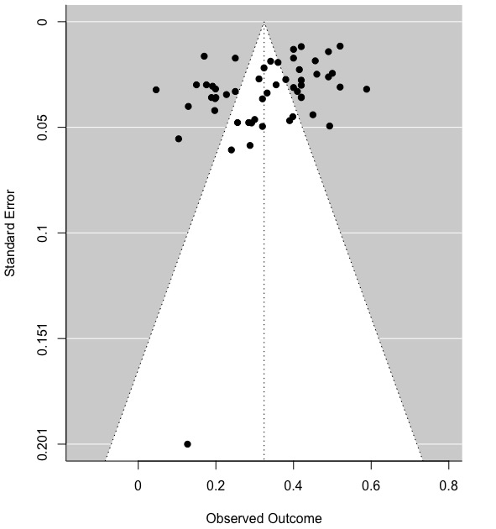

Source: Authors’ own work. Figure generated using the ‘metafor’ package (version 3.4-0; Viechtbauer, 2010) in R (version 4.2.1; R Core Team, 2022).

Table C.1. Summary effect size as a function of varying correlations between sampling errors

ρ | r | t | SE | p-value | CI₉₅
 |  |  |  |  | LB | UB
0 | 0.324 | 17.670 | 0.018 | 0.000 | 0.287 | 0.361
0.1 | 0.324 | 17.666 | 0.018 | 0.000 | 0.287 | 0.361
0.2 | 0.324 | 17.661 | 0.018 | 0.000 | 0.287 | 0.361
0.3 | 0.324 | 17.654 | 0.018 | 0.000 | 0.287 | 0.361
0.4 | 0.324 | 17.645 | 0.018 | 0.000 | 0.287 | 0.361
0.5 | 0.324 | 17.633 | 0.018 | 0.000 | 0.287 | 0.361
0.6 | 0.324 | 17.618 | 0.018 | 0.000 | 0.287 | 0.361
0.7 | 0.324 | 17.601 | 0.018 | 0.000 | 0.287 | 0.361
0.8 | 0.324 | 17.579 | 0.018 | 0.000 | 0.287 | 0.361
0.9 | 0.324 | 17.554 | 0.019 | 0.000 | 0.287 | 0.361

Source: Authors’ own work.

Table C.2. Moderator analyses (univariate) excluding potential outlier

Variables | Estimate | SE | t | p | CI₉₅ |  | k₁/k₂
 |  |  |  |  | LB | UB | k₁/k₂
$β$_{0 Internet freedom} | 0.339 | 0.029 | 11.841 | 0.000 | 0.277 | 0.401 | 31/35
$β$ _{Internet freedom} | -0.001 | 0.001 | -0.733 | 0.487 | -0.002 | 0.001 | 31/35
$β$_{0 Percentage of females} | 0.466 | 0.111 | 4.215 | 0.012 | 0.167 | 0.766 | 43/52
$β$ _{Percentage of females} | -0.003 | 0.002 | -1.325 | 0.256 | -0.009 | 0.003 | 43/52
$β$_{0 Study quality} | 0.447 | 0.119 | 3.738 | 0.002 | 0.193 | 0.701 | 43/52
$β$_{Study quality} | -0.067 | 0.061 | -1.098 | 0.288 | -0.196 | 0.062 | 43/52

Source: Authors’ own work.
Notes. LB = lower bound, UB = upper bound; k₁ = number of studies, k₂ = number of effect sizes; study quality coding: 1 = strong quality, 2 = moderate quality, 3 = weak quality. None of the included studies exceeded the suggested Cook’s distance threshold ($χ_{1;0.5}^{2}$ = 0.45) which would be indicative of an outlier. Thus, there was no objective reason to expect influential outliers. Nonetheless, to demonstrate the robustness of the fitted model, the study with the relatively large Cook’s distance of 0.105 (Saikia et al., 2019) was excluded and the model was refitted. Excluding the study (r _{excluded 1} = 0.588; Saikia et al., 2019) did not lead to a considerable change in the fitted model (r _{refitted 1} = 0.318 [1.76% change], SE = 0.018, p < 0.001, CI₉₅ = 0.283, 0.353) and the underlying heterogeneity remained significant (Q [51] = 1037.288, p < 0.001).

Table C.3. Moderator analysis (multivariate) excluding potential outlier

Variables | Estimate | SE | t | p | CI₉₅ |  | k₁/k₂
 |  |  |  |  | LB | UB | k₁/k₂
$β$₀ | 0.695 | 0.118 | 5.877 | 0.002 | 0.394 | 0.996 | 31/35
$β$_{1 Internet freedom} | 0.000 | 0.001 | -0.333 | 0.750 | -0.002 | 0.002 | 31/35
$β$_{2 Percentage of females} | -0.004 | 0.002 | -2.249 | 0.115 | -0.009 | 0.002 | 31/35
$β$_{3 Study quality} | -0.097 | 0.063 | -1.544 | 0.153 | -0.237 | 0.042 | 31/35

Source: Authors’ own work.
Notes. LB = lower bound, UB = upper bound; k₁ = number of studies, k₂ = number of effect sizes; study quality coding: 1 = strong quality, 2 = moderate quality, 3 = weak quality; test of moderators: F (3, 4.42) = 2.836, p = 0.159.

Appendix D

Two-stage Structural Equation Modeling (TSSEM)

The average correlation matrix was subjected to a path analysis to test the hypothesized mediation model (N = 68,312). The derived average correlation matrix is given in Table D1.
Based on the 95% likelihood-based confidence intervals, the estimated path coefficients from internet addiction to depressive symptoms (direct effect; β = 0.273, CI₉₅ = 0.220, 0.320), internet addiction to excessive daytime sleepiness (β = 0.227, CI₉₅ = 0.088, 0.366) and excessive daytime sleepiness to depressive symptoms (β = 0.246, CI₉₅ = 0.149, 0.340) were all statistically significant. Moreover, the estimated indirect effect was β = 0.056 (CI₉₅ = 0.024, 0.095). Thus, 16.98% of the association between internet addiction and depressive symptoms was mediated through excessive daytime sleepiness.

Table D.1. Average correlation matrix (TSSEM)

 | Internet addiction | Excessive daytime sleepiness | Depressive symptoms
Internet addiction | -
Excessive daytime sleepiness | 0.227 ** | -
Depressive symptoms | 0.329 *** | 0.308 *** | -

Source: Authors’ own work.
Notes. ** p < 0.01; *** p < 0.001.

Appendix E

Erroneous Path from Depressive Symptoms to Internet Addiction

To provide greater evidence of the specified mediation path from internet addiction to depressive symptoms via excessive daytime sleepiness, we considered an alternate path, one which is inconsistent with empirical and theoretical evidence. Specifically, we set depressive symptoms as the independent variable, internet addiction as the dependent variable, excessive daytime sleepiness as the mediating variable.

The estimated path coefficients from depressive symptoms to internet addiction (direct effect; β = 0.281, CI₉₅ = 0.209, 0.350) and depressive symptoms to excessive daytime sleepiness (β = 0.311, CI₉₅ = 0.215, 0.407) were statistically significant, while the path from excessive daytime sleepiness to internet addiction (β = 0139, CI₉₅ = -0.042, 0.317) was not significant. Moreover, the estimated indirect effect was not statistically significant β = 0.043 (CI₉₅ = -0.014, 0.104).

This document is an online appendix which is not intended for print publication.
This analysis is purely for demonstration purposes.

