Additional information

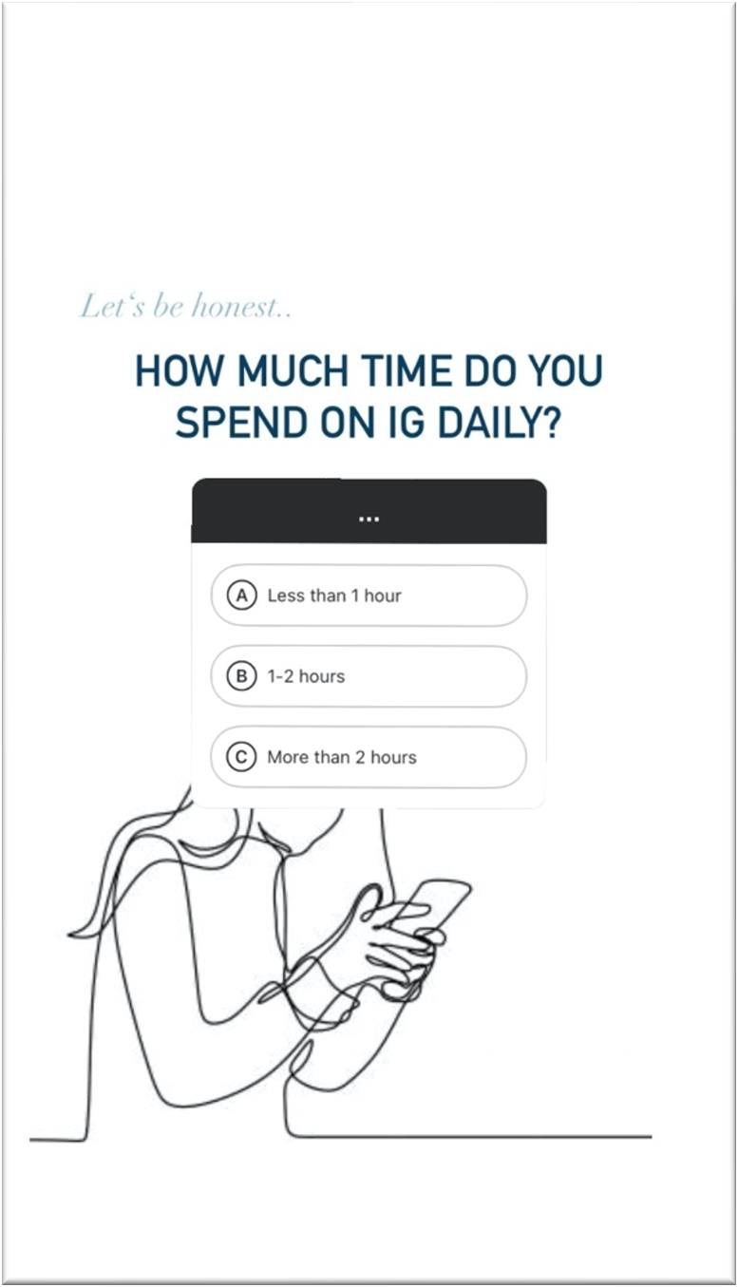
Instagram story for recruiting participants - judgmental sampling

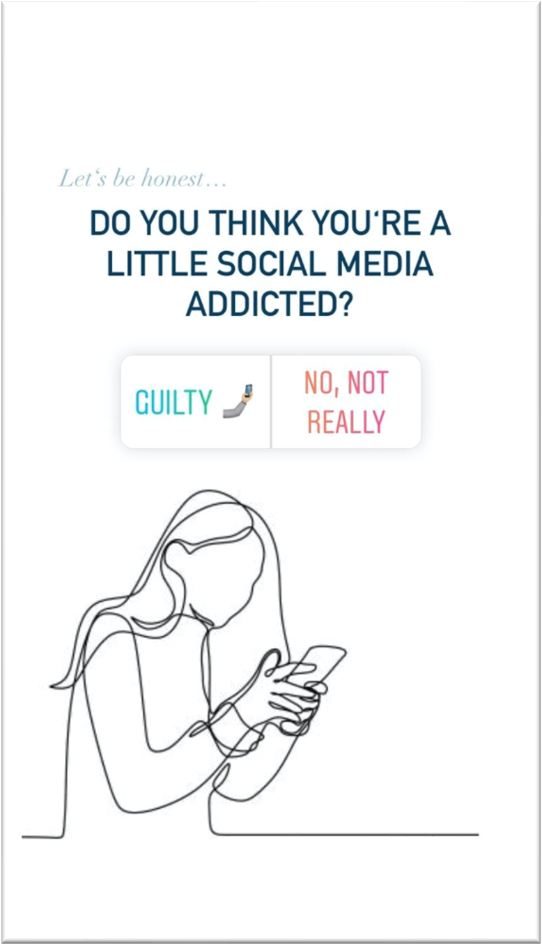
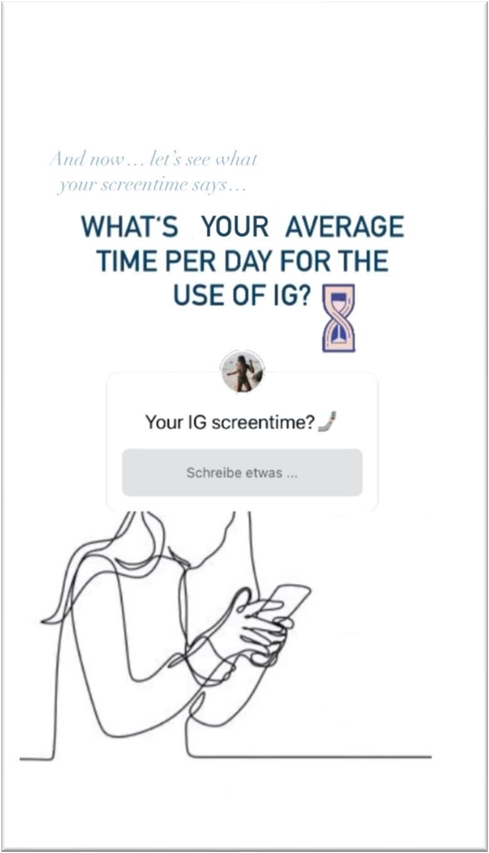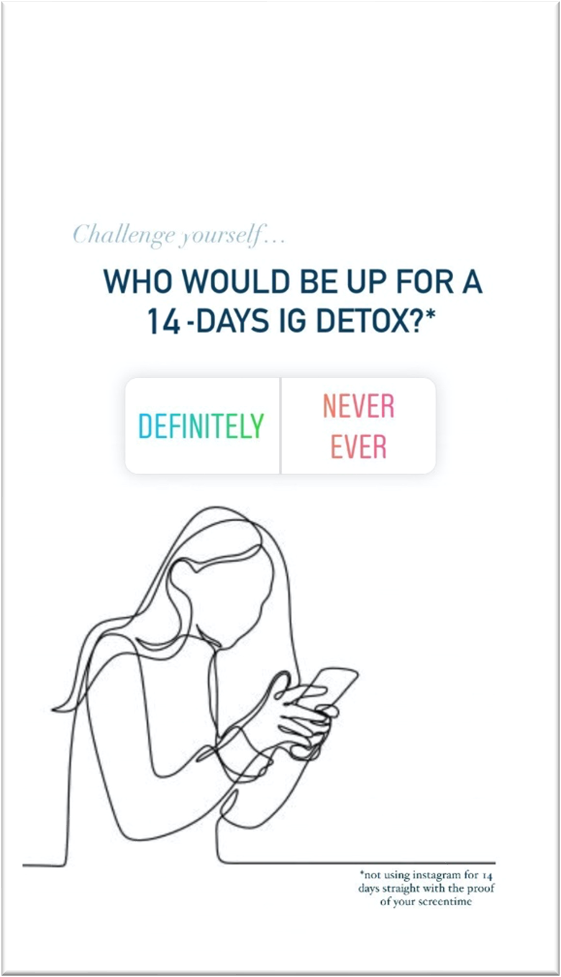

Focus group discussion guide

1. Introduction & Welcome
Explanation of the focus group process
Welcoming participants and informing about GDPR

Introducing of researchers

2. Introduction in the focus group round

2.1 Participants introducing themselves
Asking participants about age, profession, nationality, and place of residence

3. Discussion on Motivation
3.1 Motivation: Asking about participants motivation before the detox
3.2 Expectation: Asking about participants expectations before the detox
3.3 Wishes: Asking about participants wishes before the detox
3.4 Anxieties: Asking about participants anxieties before the detox

4. Screentime Check
4.1 Participants telling screentime
Asking participants about their screentime before the detox

5. Screentime Proof & Diary
Informing participants about study process
Asking participants of being honest if relapse occurs
Explaining about the timings for the screentime proofs
Telling participants to choose freely between uninstalling or keeping the app
Showing and explaining how the diary looks like

6. Thank you & Farewell

Instagram Detox Diary

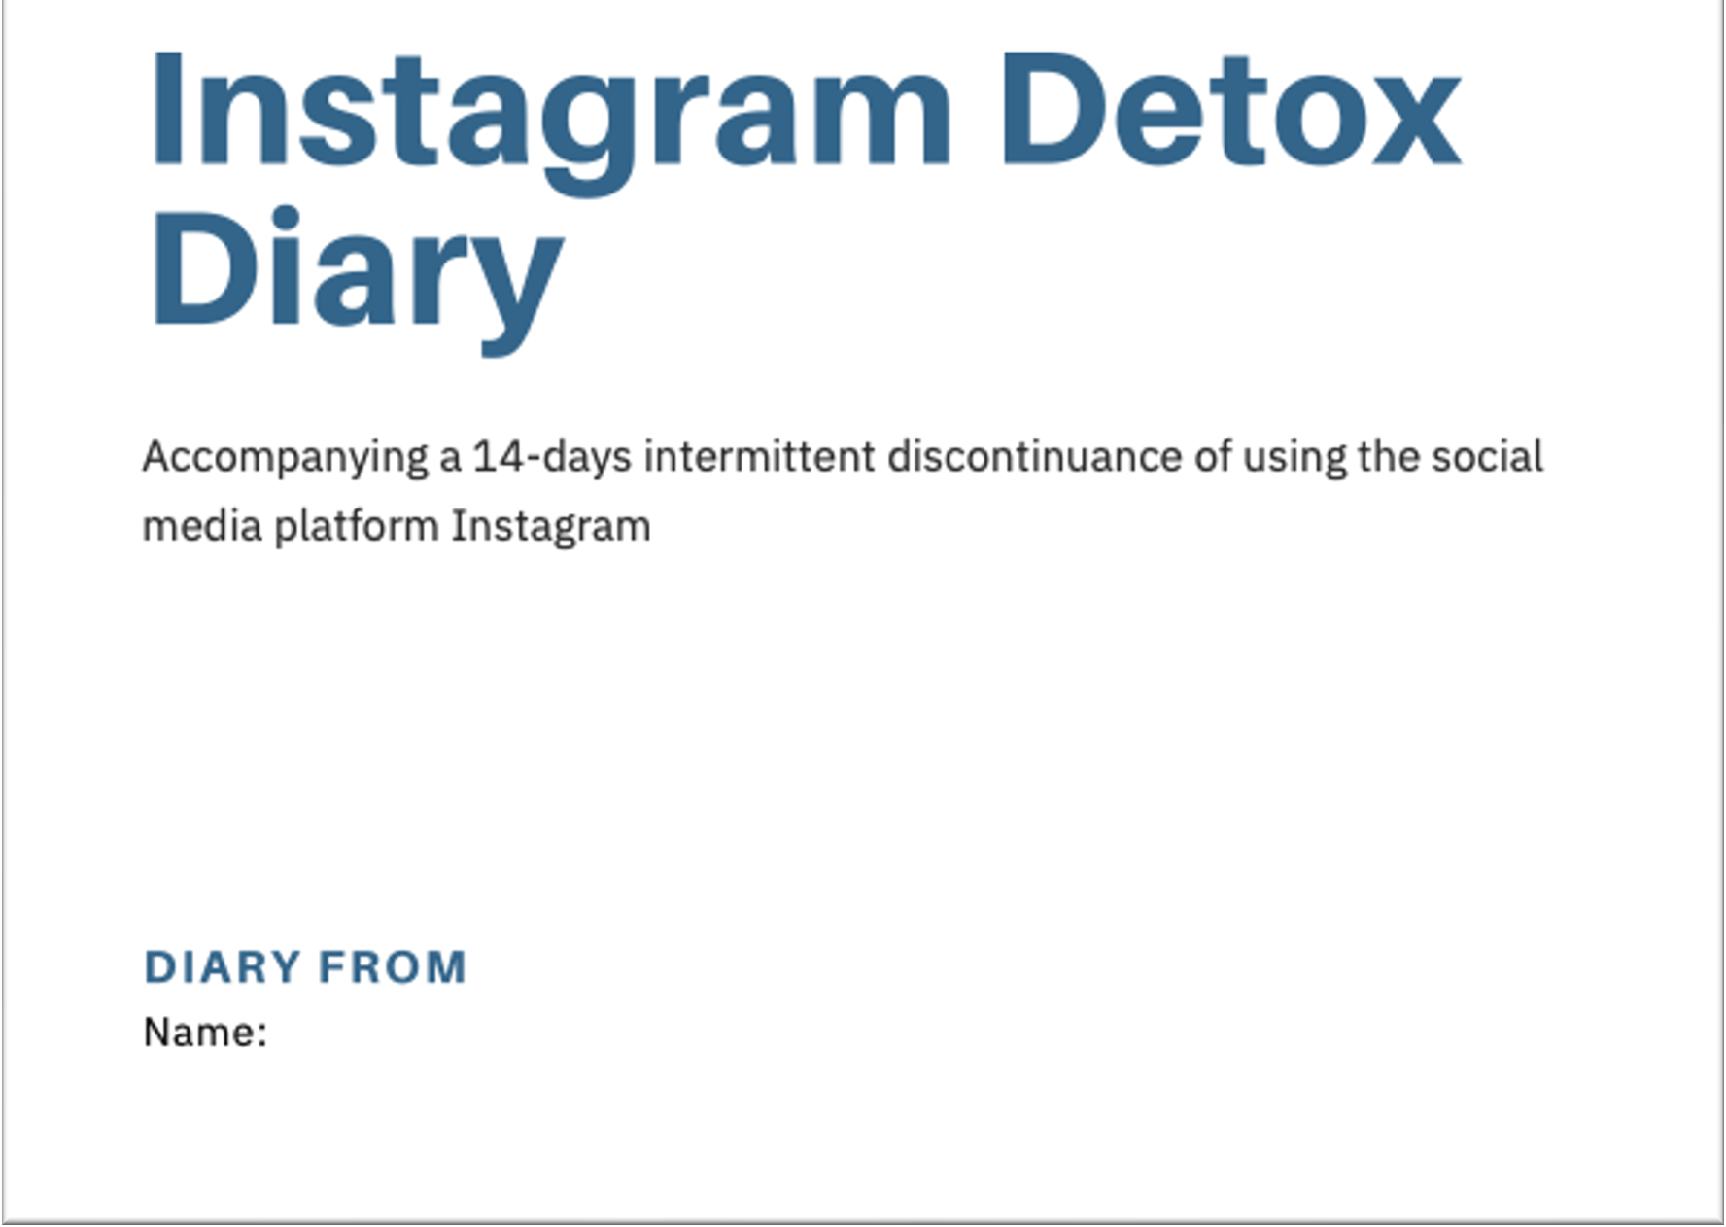
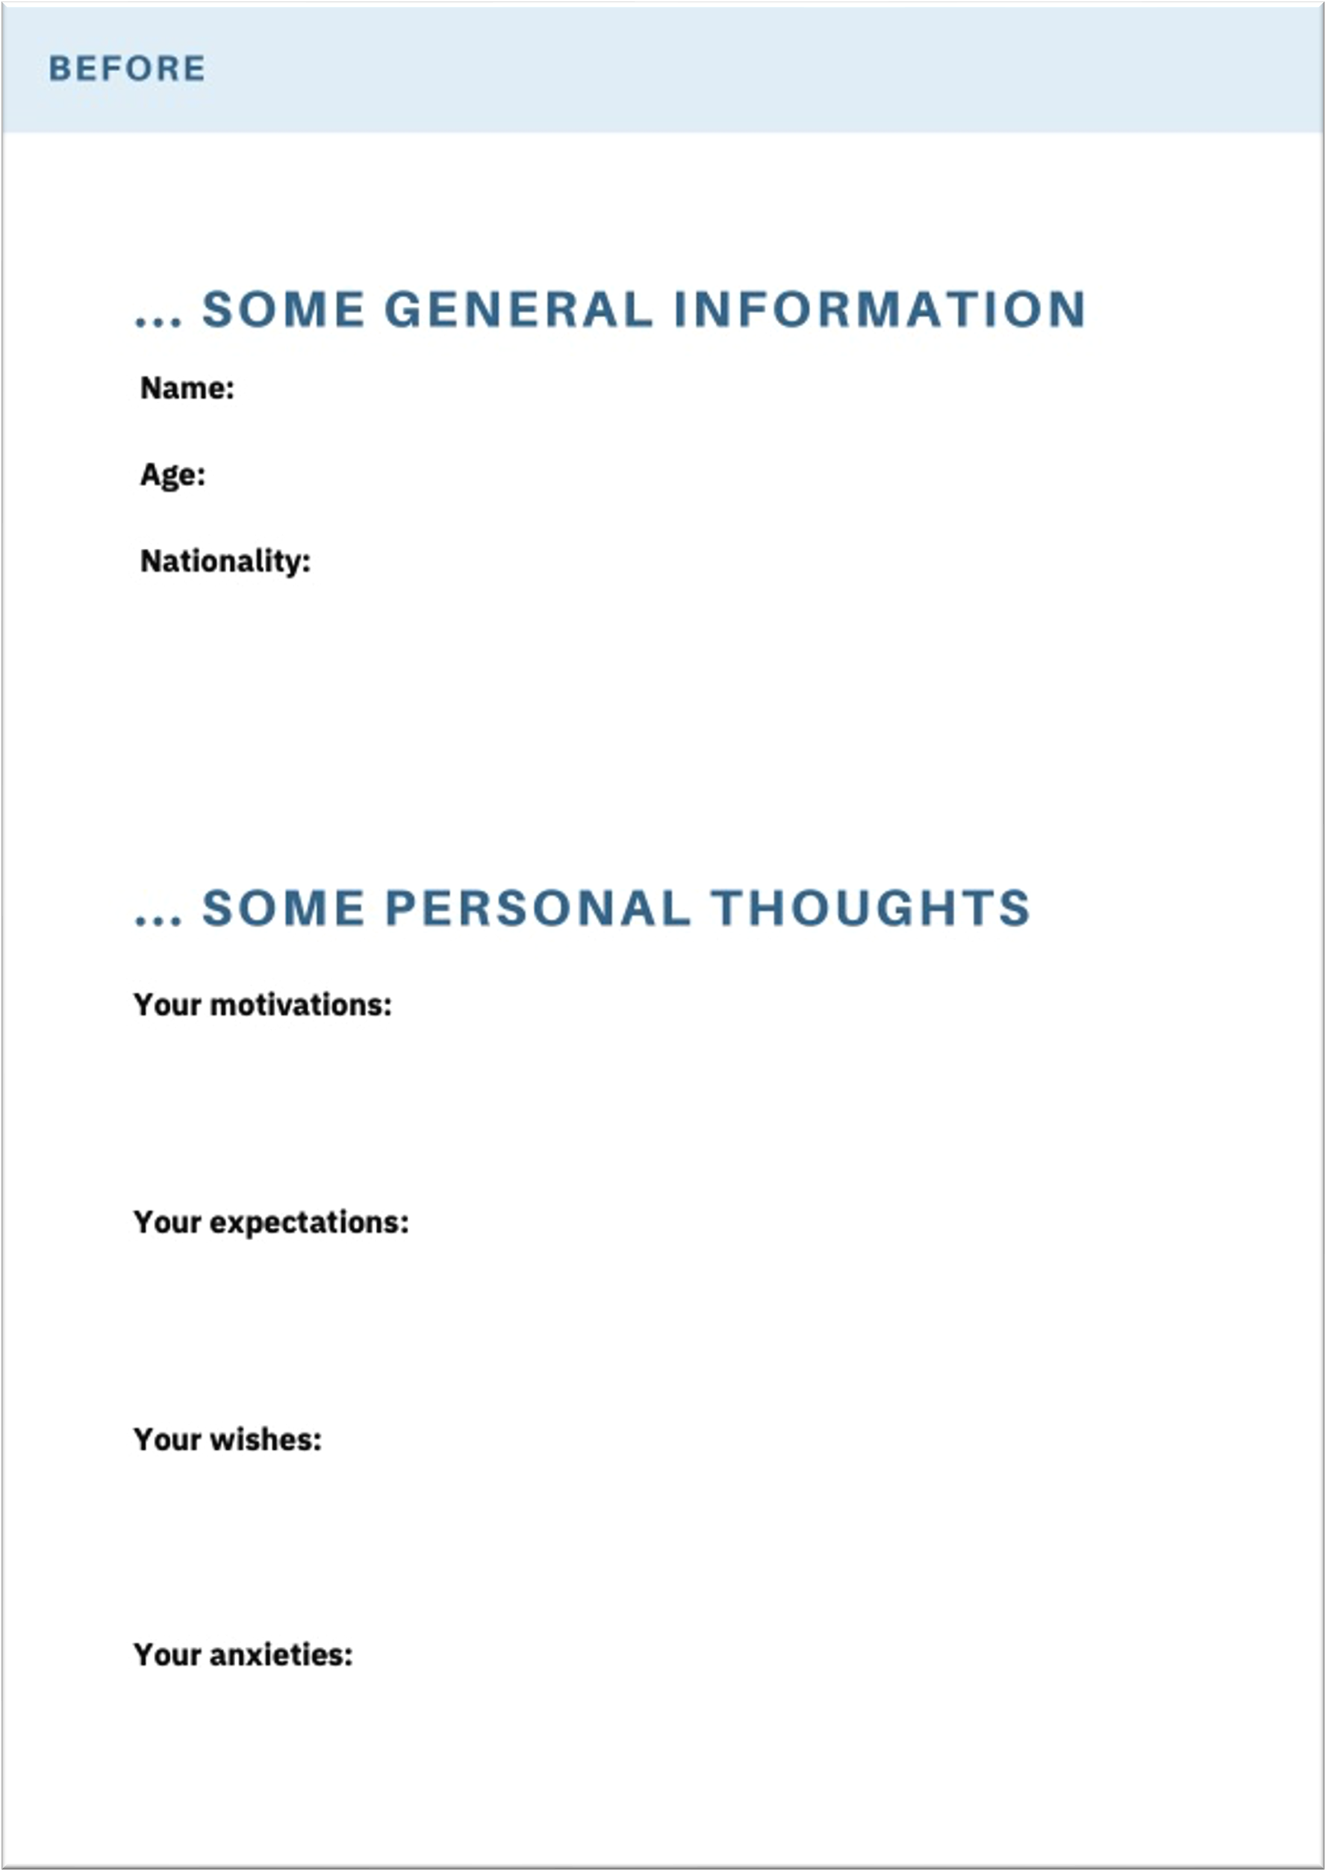

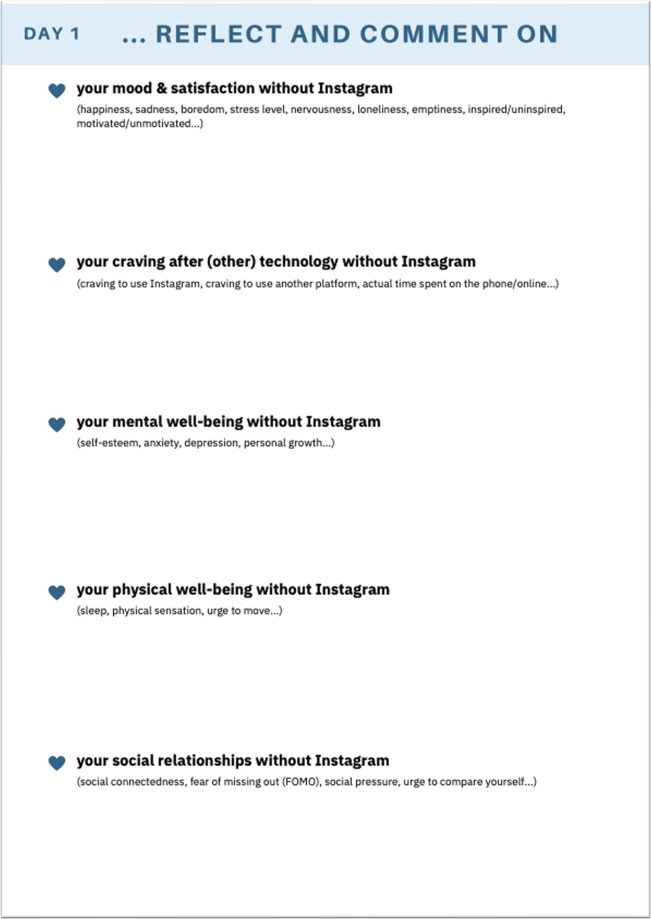
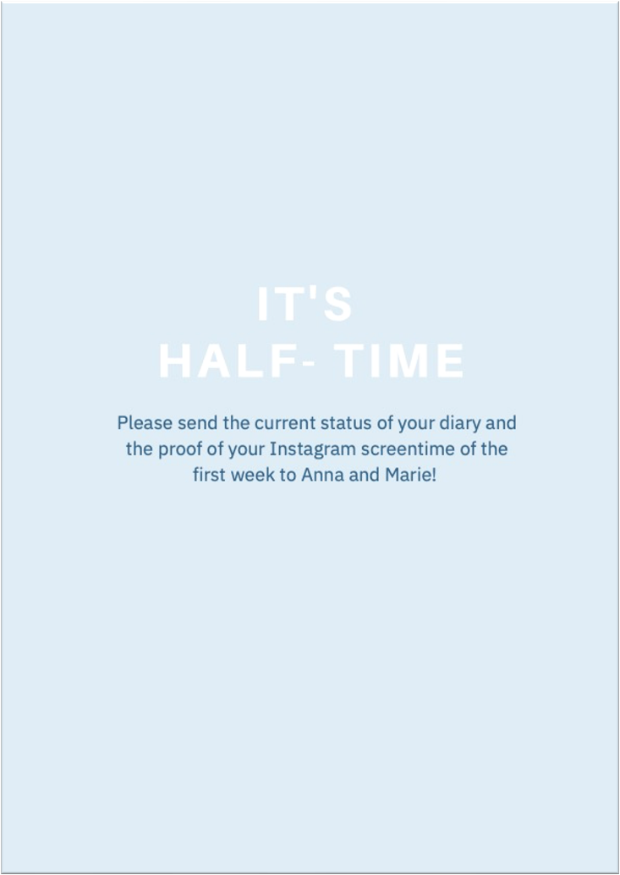

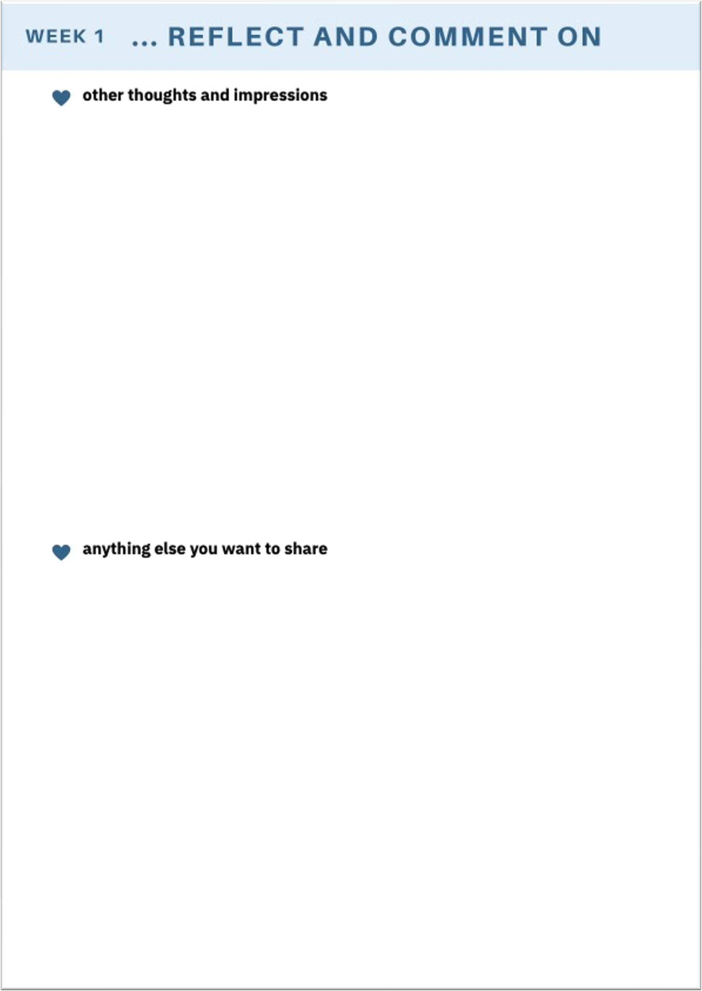

Interview guide

1. Introduction
Explanation of the interview process looking back to the 2 weeks of detox, can you briefly give us a recap of your experiences? What do you think about it?

2. Before the detox
Motivations, expectations, wishes, and anxieties reflected on in the diary
Individual questions based on diary answers for each category (motivations, expectations, wishes, anxieties)

3. During the detox
3.1 Mood & Satisfaction reflected on in the diary
Individual questions based on diary answers

3.2 Technological Craving reflected on in the diary
Individual questions based on diary answers

3.3 Mental Well-being reflected on in the diary
Individual questions based on diary answers

3.4 Physical Well-being reflected on in the diary
Individual questions based on diary answers

3.5 Social Relationships reflected on in the diary
Individual questions based on diary answers

4. Journey within the community
Journey experience as part of the research study group
As you did the Instagram detox together with 14 other people, how do you think this sense of community/group impacted your journey?
What role did the study frame and screen time proof play in your commitment and perseverance in the detox?

5. After the detox
Experiences on IG consumption after the detox
Since detox has been over for a week, how is your IG consumption now? Has there been any change?
Can you tell us about the time you spend on IG after the detox? Is it the same or different? How?
Can you tell me about the content and people you follow now after the detox? Is it the same or different? How?
Individual questions based on diary answers

6. Thank you & Farewell
Conclusion of the interview

