Table A1. Details of the Independent Variables
Category | Variables | Calculation
Bond specific variables | Duration | Modified duration extracted from DataStream
Bond specific variables | Residual maturity | The difference between trading date and redemption date
Bond specific variables | Trading volume | Change in trading volume
Market volatility variables | Stock market volatility | Historical volatility
Market volatility variables | Exchange market volatility | Historical volatility
Market volatility variables | Treasury bond yield volatility | Historical volatility
Macro-economic variables | Industrial production | Growth rate of Industrial production index
Macro-economic variables | Inflation | Growth rate of consumer price index
Macro-economic variables | Money supply | Change in M3
Global variables | Volatility index | Historical volatility of VIX obtained from Chicago board of exchange
Global variables | Ted spread | Eurodollar-Treasury spread from Federal Reserve Bank of St. Louis website
Global variables | WTIC | West Texas Intermediate crude oil price index from Federal Reserve Bank of St. Louis website
Note: The table shows the category of independent variables, the sub-variables included under each category and their computation.
Source: Authors' own creation
Table A2. Credit spread determinants
VARIABLES | 1 Year | 2 Years | 5 Years | 10 Years | 15 Years | 20 Years
Bond | -0.161*** | 0.0810*** | -0.449*** | 0.0241* | 0.0191 | 0.0293
 | (0.0245) | (0.0212) | (0.0183) | (0.0124) | (0.0296) | (0.106)
Market-Vol | 0.195*** | 0.495*** | 0.149*** | 0.0762*** | 0.160*** | 0.269***
 | (0.0202) | (0.0162) | (0.00732) | (0.0107) | (0.0270) | (0.0949)
Macro-Eco | -0.291*** | -0.234*** | -0.0471*** | -0.0593*** | -0.0707*** | 0.0670
 | (0.0129) | (0.0111) | (0.0109) | (0.0122) | (0.0273) | (0.131)
Global | 0.0290 | 0.0159 | 0.117*** | 0.0365*** | 0.0850*** | 0.0439
 | (0.0178) | (0.0137) | (0.0100) | (0.0113) | (0.0276) | (0.0979)
Observations | 21,054 | 47,539 | 38,292 | 6,808 | 1,119 | 513
R-squared | 0.036 | 0.029 | 0.063 | 0.016 | 0.051 | 0.016
Note: The table presents the regression analysis for all the six time maturity series of corporate bonds. Credit spread is the dependent variable. The independent variables present the first component obtained from principle component analysis on each category. The monthly data is collected over a sample period from January 2010 to June 2022.
Source: Authors' own creation
Table A3. Credit spread connectedness
Country | China | Korea | India | Malaysia | FROM
China | 55.93 | 17.79 | 11.56 | 14.72 | 44.07
Korea | 16.23 | 66.2 | 5.9 | 11.67 | 33.8
India | 13.31 | 7.69 | 70.47 | 8.53 | 29.53
Malaysia | 29.51 | 26.88 | 17.72 | 25.89 | 74.11
TO | 59.05 | 52.36 | 35.18 | 34.92 | 181.5
Inc.Own | 114.98 | 118.56 | 105.65 | 60.81 | TCI
NET | 14.98 | 18.56 | 5.65 | -39.19 | 45.38
Note: The diagonal values represent own country's contagion. TO indicates the total directional spill-overs from country j to all other countries i excluding own spill-overs. FROM presents the total directional spill-overs to country i from all other asset j. The net represents the difference between what a country receives (From) and what it transmits (To). The lower right corner cell of the table presents the total connectedness index in percentage terms.
Source: Authors' own creation

Figure A1. Total dynamic connectedness

Note: The graph presents the total dynamic connectedness index of credit spread across four countries from January 2010 to June 2022. The TCI is computed following the DCC-GARCH model.
Source: Authors' own creation
Figure A2. Total dynamic spillover of credit spreads to other countries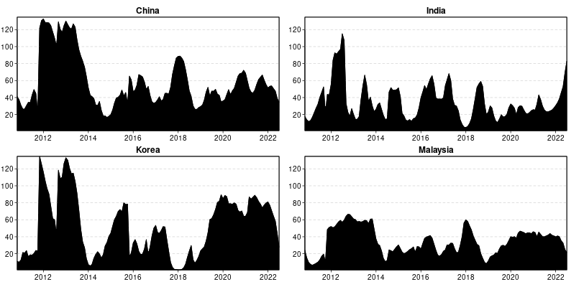
Note: The graph demonstrates the transmission of credit spread shocks by one country to others from January 2010 to June 2022.
Source: Authors' own creation
Figure A3. Total dynamic spillover of credit spreads from other countries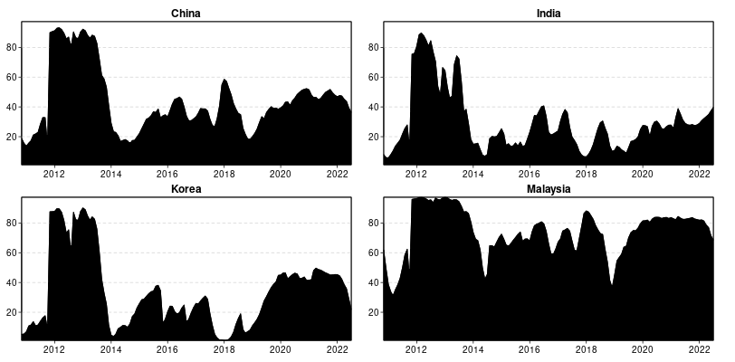
Note: The graph demonstrates the absorption of credit spread shocks by one country from other countries from January 2010 to June 2022.
Source: Authors' own creation

