Supplementary Online APPENDIX
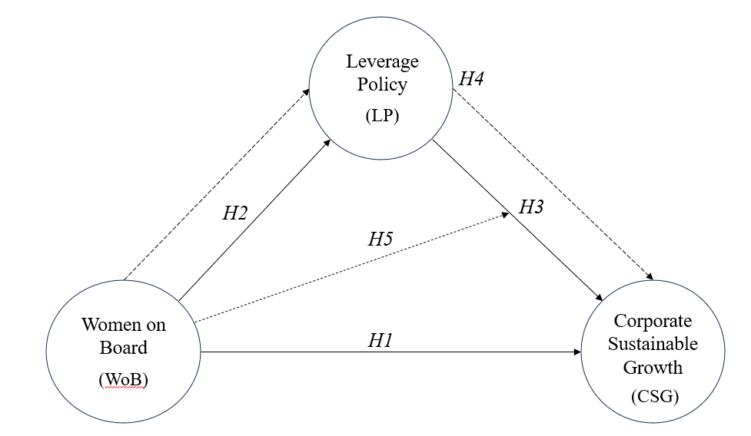
Figure A1. Moderated mediation research model
Source: Output of WarpPLS 8.0

Table A1. Descriptive Statistic
Variable | N | Mean | Max | Min | SD
WoB | 252 | 0.176 | 0.750 | 0.000 | 0.147
LP | 252 | 0.617 | 4.840 | 0.070 | 0.470
CSG | 252 | 15.073 | 145.090 | -57.280 | 22.635
Source: Output WarpPLS

Table A2. Measurement quality of the model’s constructs
Construct | Cronbach’s alpha | Composite Reliability (CR) | Average Variance Extracted (AVE)
WoB | 1.000 | 1.000 | 1.000
LP | 1.000 | 1.000 | 1.000
CSG | 1.000 | 1.000 | 1.000
Moderating Effect | 1.000 | 1.000 | 1.000
Source: Output WarpPLS

Table A3. Correlation among latent variables with square root of AVEs for assessing discriminant validity
Variable | WoB | LP | CSG | Moderating Effect
WoB | 1.000
LP | 0.145 | 1.000
CSG | 0.098 | 0.220 | 1.000
Moderating Effect | -0.064 | -0.050 | 0.178 | 1.000
Note: The diagonal value reported in italic is the square root of AVE
Source: output of WarpPLS 8.0

Table A4. Full collinearity VIFs for assessing discriminant validity
 | Block VIF to CSG | Full collinearity VIF
WoB | 1.024 | 1.032
LP | 1.024 | 1.075
CSP |  | 1.099
Moderating Effect | 1.000 | 1.047
Average | 1.016 | 1.063
Note: Both the AVIF and AFVIF be equal to or lower than 3.3
Source: output of WarpPLS 8.0

Table A5. Fit Model
 | Saturated Model | Estimated Model
SRMR | 0.075 | 0.079
Chi-Square | 336.570 | 342.466
Source: output of WarpPLS 8.0

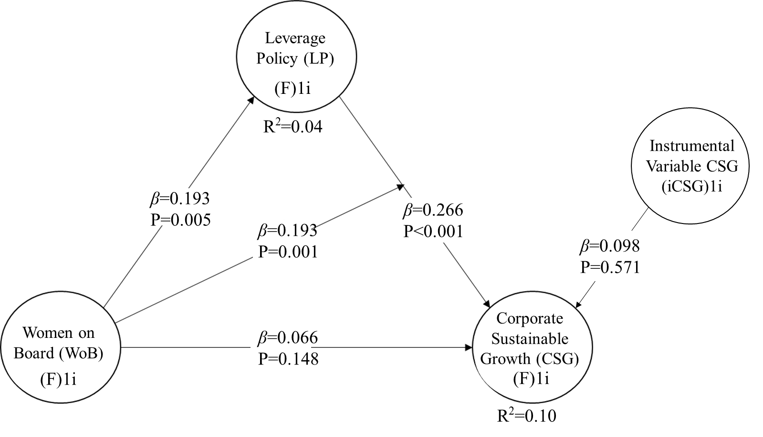

Figure A2. The results of hypothesis testing use the entire data
Source: Output of WarpPLS 8.0

Table A6. Significant testing result of the structural model path coefficient
 | Path Coefficient | Standard error (SE) | Effect Size (f) | Hypothesis Decision
Part A: Direct effect
WoB $→$ CSG (H1)
All sample | 0.066 | 0.063 | 0.007 | Rejected
Subs sample
only 1 Women on Board | -0.255** | 0.076 | 0.065 | Rejected
≥ 2 Women on Boards | 0.459** | 0.098 | 0.211 | Accepted
WoB $→$ LP (H2)
All sample | 0.193*** | 0.074 | 0.037 | Accepted
Subs sample
only 1 Women on Board | -0.149 | 0.088 | 0.028 | Rejected
≥ 2 Women on Boards | 0.164 | 0.107 | 0.031 | Rejected
LP $→$ CSG (H3)
All sample | 0.226*** | 0.059 | 0.054 | Accepted
Subs sample
only 1 Women on Board | 0.209* | 0.099 | 0.037 | Accepted
≥ 2 Women on Boards | 0.529** | 0.096 | 0.247 | Accepted
Part B: Indirect effect
WoB $→$ LP $→$ CSG (H4)
All sample | 0.044** | 0.020 | 0.004 | Accepted
Subs sample
only 1 Women on Board | -0.053* | 0.028 | 0.010 | Rejected
≥ 2 Women on Boards | 0.243** | 0.074 | 0.046 | Accepted
WoB x LP $→$ CSG (H5)
All sample | 0.193** | 0.063 | 0.038 | Accepted
Subs sample
only 1 Women on Board | 0.194* | 0.113 | 0.032 | Accepted
≥ 2 Women on Boards | 0.250** | 0.104 | 0.041 | Accepted
Determination coefficients (R²) and preictive relevance (Q²) of endogenous:
R² Leverage Policy = 0.04 Q² Leverage Policy = 0.042
R² Corporate Sustainable Growth = 0.10 Q² Corporate Sustainable Growth = 0.112
***,**, and * indicate significant at the 0.01, 0.05, and 0.10 levels respecttively.
Source: output of WarpPLS 8.0

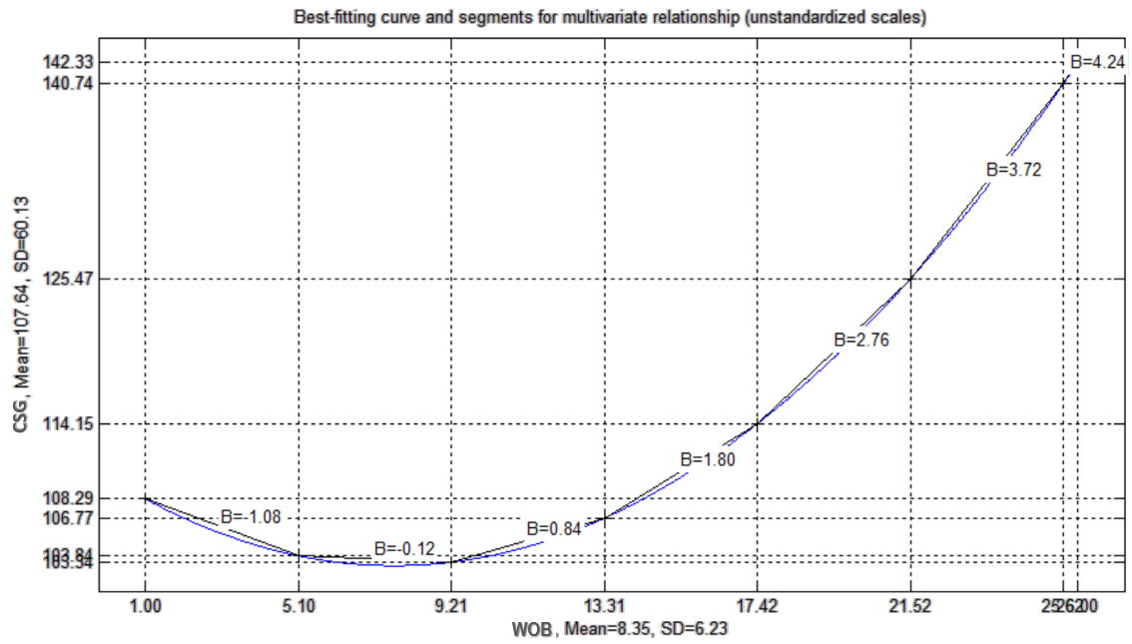
Figure A3. J-curve graph of the relationship between Women on Board and Corporate Sustainable Growth
Source: output of WarpPLS 8.0

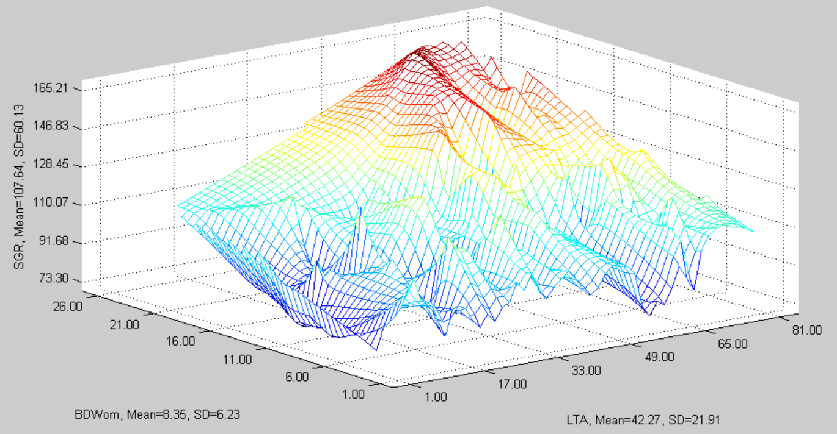

Figure A4 . Moderate Effect of Women on Board
(Source: output of WarpPLS 8.0)

