Supplementary Online Appendix

Figure A1: Green, Social and Sustainability (GSS) issuance (Amount issued, USDbn)
Source: The Climate Bonds Initiative (2022)

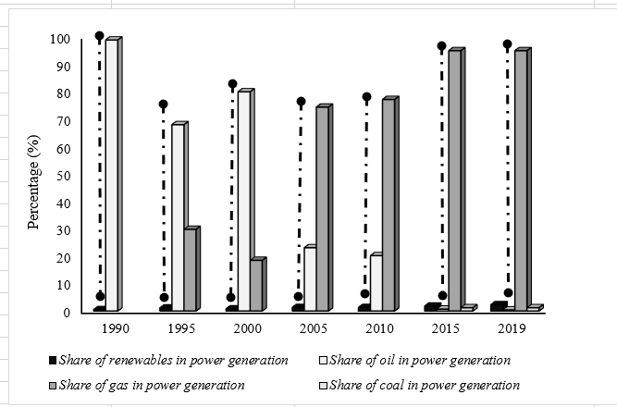
Figure A2: Share of renewables, oil, coal, and gas in power generation
Source: IEA (2022)
Note: The arrow line indicates the gap between the share of renewables and non-renewable.

Table A1: Green Finance Issuance in Singapore
Issuer | Green Finance Type Issued | Year | Nominal Value | Purpose
M+S | Green loan | 2020 | SGD1950 | Refinance the office and retail components of Marina One
City developments | Green loan | 2019 | SGD500 | Finance green development
City developments | Green bond | 2017 | SGD100 | Enhance energy and water efficiency
Capitaland | Green loan | 2020 | SGD400 | Finance of the development, investment and acquisition of certified green buildings.
DBS Group Holdings | Green Bond | 2017 | SGD685 | Provide financing for green assets such as green buildings
National University of Singapore | Green Bond | 2020 | USD300 | Finance green projects under the university’s new green finance framework
Source: Darrieux et al. (2020) & EuroCham (2022)

Table A2: Summary of past studies on green finance and renewable energy
Author(s) | Country | Approach |  | Finding |  | Does Singapore include it in the sample?
Zhang and Wang (2021) | China |  | Case Study |  | Positive impact |  | No
Shang et al. (2023) | China |  | Spatial Panel Dobbin Model |  | Positive impact (long-run)  No impact (short run) |  | No
Lee et al. (2023) | China |  | panel quantile regression model |  | Positive impact |  | No
Li and Umair (2023) | China |  | Panel cointegration and causality |  | Positive impact |  | No
Tang and Zhou (2023) | China |  | Spatial Panel Dobbin Model |  | Positive impact |  | No
Tolliver et al. (2020) | 66 countries |  | difference-in-differences analysis |  | Positive impact |  | No
Polzin and Sanders (2020) | Europe |  | demand and supply analysis |  | Positive impact |  | No
Liu et al. (2021) | the United States |  | time-invariant and time-varying copula |  | Positive impact |  | No
Rasoulinezhad and Taghizadeh-Hesary (2022) | Canada, Denmark, Hong Kong, Japan, New Zealand, Norway, Sweden, Switzerland, the UK, and the USA |  | Generalized Method of Moments (GMM) |  | Positive impact (long-run)  No impact (short run) |  | No
Alharbi et al. (2023) | 44 countries |  | Cross-sectional dependence and panel unit roots |  | Positive impact (short- and long-run) |  | Yes
Source: Created by authors

Table A3: Variables description
Variable Name | Definition | Source
REN | Share of renewable energy in total energy consumption | International Energy Agency (IEA)
CO2 | CO2 emissions (metric tons per capita) | World Data Bank
EU | Total final consumption (TFC) | International Energy Agency (IEA)
GE | Government Effectiveness | World Data Bank
RL | Rule of law | World Data Bank
OILPR | Crude Oil Price (Singapore Dollar per Barrel) | BP Statistical Review of World Energy
GDP | Gross Domestic Product per capita (constant 2010 US$) | World Data Bank
GF | Green Bonds Issuance (USD millions) | The Climate Bonds Initiative
Source: Created by authors

Table A4: Descriptive Analysis
 | InREN | lnGDP | lnOILPR | lnCO2 | lnEU | lnGE | lnRL | lnGF
Mean | 1.3041 | 11.3076 | 4.2717 | 2.1253 | 3.2069 | 0.8076 | 0.6159 | 5.9934
Maximum | 2.2231 | 11.3397 | 7.5242 | 3.1343 | 13.5946 | 0.8481 | 1.6314 | 6.7250
Minimum | 0.3855 | 6.2648 | 4.0382 | 2.1080 | 12.2531 | 0.7910 | 0.6017 | 3.0369
Std. Dev | 0.0780 | 0.0323 | 0.2121 | 0.0133 | 0.5531 | 0.0229 | 0.0144 | 0.7292
Skewness | 0.1347 | 0.2115 | 0.1678 | 1.2160 | 1.2461 | 1.3790 | 0.1896 | 0.4367
Kurtosis | 1.2592 | 1.5473 | 1.3893 | 2.9656 | 2.9021 | 2.1037 | 1.2393 | 1.7914
Source: Created by authors

Table A5: Correlation Analysis
 | InREN | lnGDP | lnOILPR | lnCO2 | lnEU | lnGE | lnRL | lnGF
lnREN | 1.0000
lnGDP | 0.0662 | 1.0000
lnOILPR | 0.0216 | 0.0615 | 1.0000
lnCO2 | 0.0124 | -0.0269 | -0.0575 | 1.0000
lnEU | 0.0359 | 0.0598 | 0.0426 | 0.0777 | 1.0000
lnGE | -0.0524 | 0.0262 | -0.0643 | -0.0513 | -0.0187 | 1.0000
lnRL | 0.0396 | 0.0493 | -0.0484 | -0.0791 | -0.0599 | 0.0448 | 1.0000
lnGF | 0.0396 | 0.0676 | -0.0242 | 0.0268 | -0.0484 | 0.0207 | 0.0265 | 1.0000
Source: Created by authors

Table A6: Ordinary Least Squares (OLS) Estimations (Dependent Variable: lnREN)
 | (1) | (2) | (3) | (4) | (5) | (6)
lnGF | 0.0740**  (2.10) | 0.0396**  (2.16) | 0.5597***  (3.33) | 0.1977*  (2.03) | 0.3991**  (2.13) | 0.2725**  (2.34)
lnGDP | 1.6721**  (2.21) | - | - | - | - | -
lnOILPR | - | 0.2382*  (1.91) | - | - | - | -
lnCO2 | - | - | 3.0658***  (2.11) | - | - | -
lnEU | - | - | - | 0.6669**  (2.11) | - | -
lnGE | - | - | - | - | 1.8607***  (2.57) | -
lnRL | - | - | - | - | - | 0.5266**  (2.15)
_cons | 5.6533**  (2.31) | 0.9831**  (2.19) | 8.5025***  (5.30) | 0.7180***  (2.69) | 0.6943**  (3.14) | 3.5967**  (2.27)
R² | 0.56 | 0.62 | 0.80 | 0.89 | 0.65 | 0.69
F | 9.28 | 3.70 | 4.57 | 3.17 | 2.20 | 2.61
Note: Asterisks *, **, and*** denote the 10%, 5%, and 1% levels of significance, respectively. Figures in ( ) stand for t-statistics.
Source: Created by authors

