Online Appendix
Appendix A: Figures and tables
Figure A1: Budgetary revenue size relative to GDP

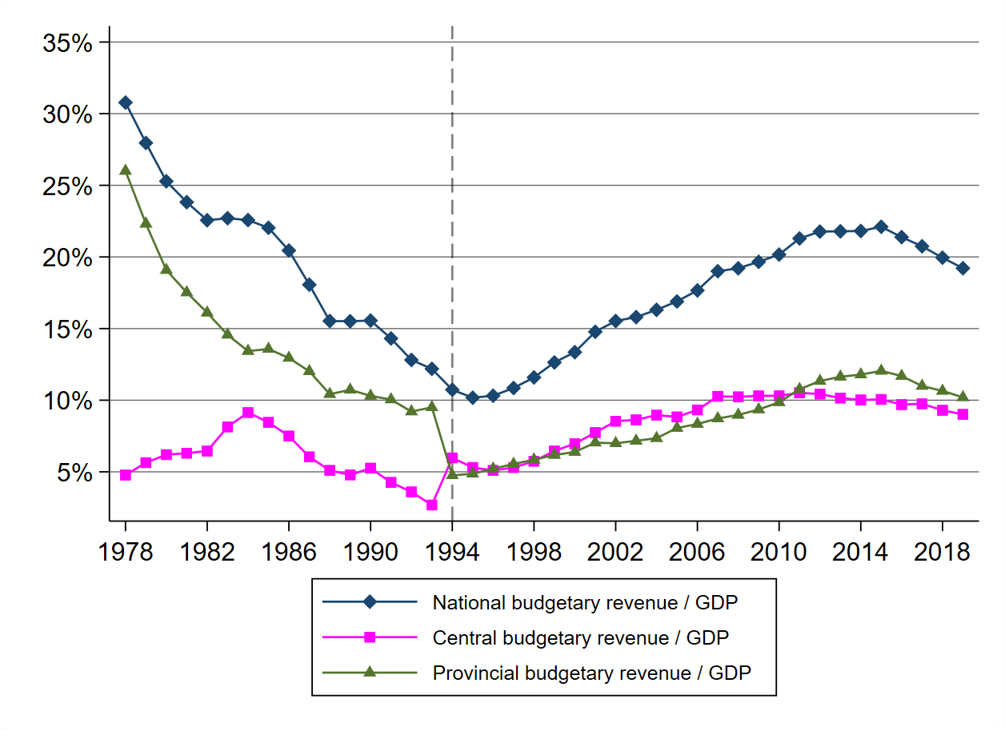
Source: Authors’ own work.

Figure A2: Trends in provincial shares in national budget

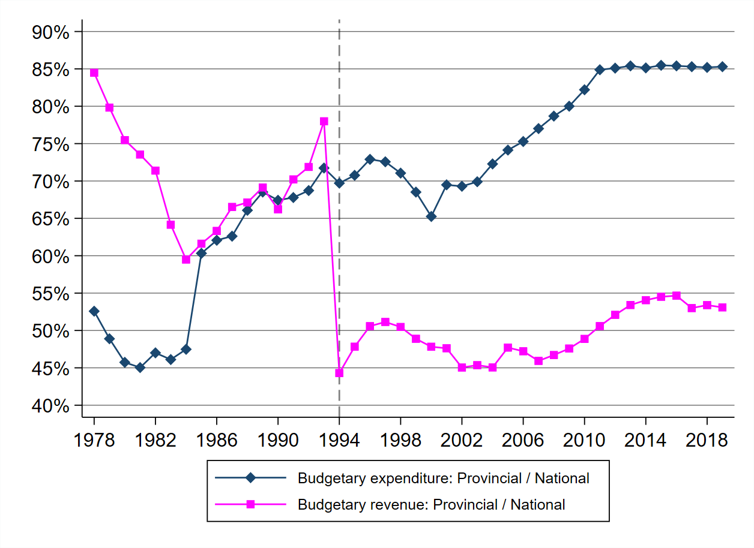
Source: Authors’ own work.

Figure A3: Trends in net fiscal transfers received by provinces

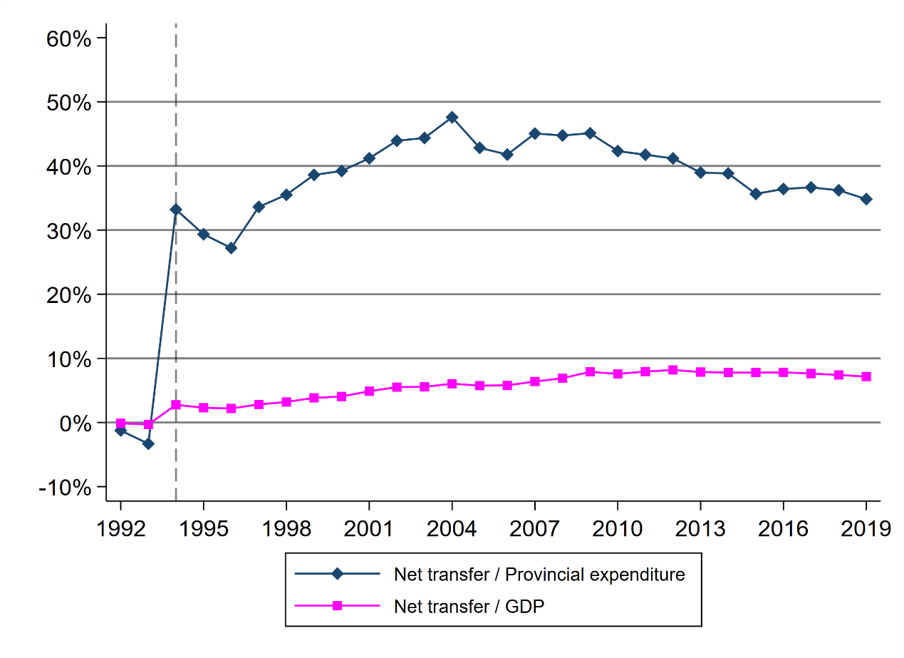
Source: Authors’ own work.
Figure A4: China’s GDP growth and its fluctuations (1978-2019)

Source: Authors’ own work.

Table A1: Growth rate and its volatility of provincial GDP in China
Region | Provinces\  indicators | g (%)  (1978-2019) | g (%)  (1978-1993) | g (%)  (1994-2019) | CoV  (1978-2019) | CoV  (1978-1993) | CoV  (1994-2019)
East China | Beijing | 9.8310 | 9.5875 | 9.9808 | 0.3400 | 0.4702 | 0.2468
East China | Tianjin | 9.8571 | 9.0125 | 10.3769 | 0.4333 | 0.5791 | 0.3452
East China | Hebei | 9.6357 | 10.0938 | 9.3538 | 0.3611 | 0.4828 | 0.2481
East China | Shanghai | 9.7548 | 8.9187 | 10.2692 | 0.3478 | 0.4639 | 0.2734
East China | Jiangsu | 12.0762 | 13.2500 | 11.3538 | 0.3946 | 0.5136 | 0.2496
East China | Zhejiang | 12.1262 | 13.9500 | 11.0038 | 0.4119 | 0.4787 | 0.2975
East China | Fujian | 12.2571 | 13.3875 | 11.5615 | 0.3405 | 0.4212 | 0.2473
East China | Shandong | 10.6905 | 11.4063 | 10.2500 | 0.3267 | 0.4207 | 0.2320
East China | Guangdong | 12.0762 | 13.6062 | 11.1346 | 0.3812 | 0.4428 | 0.2917
East China | Hainan | 10.7268 | 13.3200 | 9.2308 | 0.6129 | 0.7409 | 0.3110
Central China | Shanxi | 9.1643 | 9.2437 | 9.1154 | 0.4575 | 0.6397 | 0.3071
Central China | Anhui | 10.3310 | 9.3000 | 10.9654 | 0.4457 | 0.7389 | 0.2108
Central China | Jiangxi | 10.3143 | 9.9750 | 10.5231 | 0.2993 | 0.4170 | 0.2152
Central China | Henan | 10.6452 | 10.5875 | 10.6808 | 0.3581 | 0.5101 | 0.2356
Central China | Hubei | 10.5333 | 10.1125 | 10.7923 | 0.3384 | 0.4888 | 0.2268
Central China | Hunan | 9.8905 | 8.8000 | 10.5615 | 0.2837 | 0.3747 | 0.2151
West China | Inner Mongolia | 11.0167 | 9.8063 | 11.7615 | 0.4089 | 0.4739 | 0.3687
West China | Guangxi | 9.4524 | 9.1812 | 9.6192 | 0.3543 | 0.5198 | 0.2242
West China | Chongqing | 11.0357 | 10.1500 | 11.5808 | 0.3080 | 0.3962 | 0.2507
West China | Sichuan | 10.2429 | 9.5000 | 10.7000 | 0.2962 | 0.3913 | 0.2333
West China | Guizhou | 10.4119 | 10.2000 | 10.5423 | 0.3592 | 0.5439 | 0.1996
West China | Yunnan | 10.2024 | 10.5125 | 10.0115 | 0.3253 | 0.4635 | 0.1925
West China | Tibet | 10.5357 | 8.1062 | 12.0308 | 0.6095 | 1.2085 | 0.1653
West China | Shaanxi | 10.3667 | 9.6750 | 10.7923 | 0.3431 | 0.5214 | 0.2068
West China | Gansu | 9.5176 | 8.8775 | 9.9115 | 0.4142 | 0.6532 | 0.2229
West China | Qinghai | 8.9276 | 7.3288 | 9.9115 | 0.5048 | 0.9065 | 0.2063
West China | Ningxia | 9.4119 | 9.0188 | 9.6538 | 0.3054 | 0.4591 | 0.1825
West China | Xinjiang | 9.9333 | 10.8625 | 9.3615 | 0.2451 | 0.2668 | 0.2079
Northeast China | Liaoning | 8.5976 | 8.9438 | 8.3846 | 0.4588 | 0.5991 | 0.3409
Northeast China | Jilin | 9.0048 | 9.5688 | 8.6577 | 0.4626 | 0.6392 | 0.2754
Northeast China | Heilongjiang | 7.8833 | 7.0750 | 8.3808 | 0.3036 | 0.3509 | 0.2674
 | China | 9.4497 | 9.8713 | 9.1902 | 0.2863 | 0.3572 | 0.2273

Note: g, average annual growth rate of real GDP; CoV, coefficient of variation.
Source: Authors’ own work.

Table A2: Regressions with alternative government size measures
 | (1) | (2) | (3) | (4) | (5) | (6)
Total balance | 0.0122 *  (0.0068) | - | - | - | - | -
Central transfer | - | 0.0066  (0.0091) | - | - | - | -
Tax revenue | - | - | 0.0807**  (0.0354) | - | - | -
Nontax revenue | - | - | - | 0.1295***  (0.0426) | - | -
Income tax | - | - | - | - | 0.1096  (0.0942) | -
Social security | - | - | - | - | - | 0.0919  (0.0840)
Ln GDP | -0.0093***  (0.0030) | -0.0094 ***  (0.0030) | -0.0081***  (0.0030) | -0.0113 ***  (0.0030) | -0.0093 ***  (0.0030) | -0.0127 ***  (0.0037)
TFP volatility | 0.1202 ***  (0.0327) | 0.1344 ***  (0.0322) | 0.1264 ***  (0.0311) | 0.1410 ***  (0.0302) | 0.1432 ***  (0.0304) | 0.0692 **  (0.0338)
Credit | 0.0048 **  (0.0019) | 0.0054 ***  (0.0019) | 0.0037 *  (0.0020) | 0.0037 *  (0.0019) | 0.0050***  (0.0019) | 0.0153 ***  (0.0027)
R-Squared(within) | 0.3587 | 0.3550 | 0.3615 | 0.3670 | 0.3562 | 0.4503
No. Observations | 510 | 510 | 510 | 510 | 510 | 392
Note: Standard errors are presented in parentheses, with ***, **, and * representing significance at the 1%, 5%, and 10% levels, respectively.
Source: Authors’ own work.

Table A3: Regressions with alternative volatility measures
 | (1) | (2) | (3) | (4) | (5) | (6)
Dependent variables | Sd. Output gap | Sd. Output gap | Sd. Household consumption | Sd. Household consumption | Sd. Capital formation | Sd. Capital formation
Expenditure | 0.0646 ***  (0.0082) | - | 0.0723*  (0.0399) | - | 0.2782 ***  (0.0432) | -
Revenue | - | 0.0984***  (0.0309) | - | 0.3595**  (0.1406) | - | 0.3950 **  (0.1596)
Ln GDP | -0.0078**  (0.0030) | -0.0085 ***  (0.0032) | -0.0753 ***  (0.0154) | -0.0777***  (0.0153) | -0.0481 ***  (0.0167) | -0.0549***  (0.0174)
Volatility in TFP | 0.1236 ***  (0.0339) | 0.2088 ***  (0.0334) | 0.4251***  (0.1550) | 0.4413***  (0.1448) | 0.1045  (0.1680) | 0.4636***  (0.1642)
Credit | -0.0098 ***  (0.0020) | -0.0100***  (0.0023) | -0.0051  （0.0089） | -0.0149  (0.0099) | 0.0194**  (0.0096) | 0.0135  (0.0112)
GDP Deflator | - | - | 0.8760 ***  (0.1395) | 0.9772 ***  (0.1410) | 0.6280 ***  (0.1512) | 0.8155***  (0.1600)
R-Squared(within) | 0.4554 | 0.3958 | 0.5594 | 0.5629 | 0.3982 | 0.3460
No. Observations | 510 | 510 | 450 | 450 | 450 | 450
Note: Standard errors are presented in parentheses, with ***, **, and * representing significance at the 1%, 5%, and 10% levels, respectively.
Source: Authors’ own work.

Table A4: Government size and output volatility (GMM regression)
 | (1) | (2) | (3) | (4) | (5) | (6) | (7) | (8)
Expenditure | 0.0282  (0.0457) | - | - | - | - | - | - | -
Revenue | - | -0.0671  (0.0876) | - | - | - | - | - | -
Total balance | - | - | 0.0283 (0.0282) | - | - | - | - | -
Central transfer | - | - | - | 0.0256  (0.0274) | - | - | - | -
Tax revenue | - | - | - | - | -0.0738  (0.0839) | - | - | -
Nontax revenue | - | - | - | - | - | 0.0407  (0.1695) | - | -
Income tax | - | - | - | - | - | - | -0.1949  (0.1985) | -
Social security | - | - | - | - | - | - | - | 0.0465 (0.6380)
Ln GDP | -0.0143***  (0.0052) | -0.0141***  (0.0044) | -0.0137*** (0.0045) | -0.0136***  (0.0045) | -0.0151***  (0.0045) | -0.0148***  (0.0050) | -0.0141***  (0.0042) | -0.0212** (0.0089)
TFP volatility | 0.8564**  (0.3821) | 0.7966***  (0.2284) | 0.7772*** (0.2354) | 0.7893***  (0.2322) | 0.7872***  (0.2265) | 0.8223***  (0.2290) | 0.7325***  (0.2354) | 0.7905*** (0.2233)
Credit | 0.0096**  (0.0047) | 0.0123***  (0.0040) | 0.0090*** (0.0034) | 0.0105***  (0.0031) | 0.0115***  (0.0033) | 0.0098**  (0.0039) | 0.0104***  (0.0029) | 0.0161** (0.0065)
Number of excluded instruments | 5 | 5 | 5 | 5 | 5 | 5 | 5 | 5
Number of included instruments | 18 | 18 | 18 | 18 | 18 | 18 | 18 | 15
Anderson test of under-identification | 0.0945 | 0.0030 | 0.0018 | 0.0018 | 0.0032 | 0.0018 | 0.0063 | 0.0150
Sargan test for over- identification, Chi-sq P-value | 0.8770 | 0.8702 | 0.9705 | 0.9419 | 0.9052 | 0.7518 | 0.9281 | 0.2733
No. Observations | 504 | 504 | 504 | 504 | 504 | 504 | 504 | 392
Note: Standard errors are presented in parentheses, with ***, **, and * representing significance at the 1%, 5%, and 10% levels, respectively.
Source: Authors’ own work.

Table A5: Government size and output volatility (Threshold regressions)
Variables\models | (1) | (2) | (3) | (4) | (5) | (6) | (7) | (8)
Variables\models | Sd. GDP growth |  |  |  | Sd. Output gap
Regime-dependant variables | Expenditure | Revenue | Total  balance | Central  transfer | Expenditure | Revenue | Total  balance | Central  transfer
Ln GDP | -0.0099 ***  (0.0029) | -0.0099*** (0.0028) | -0.0099*** (0.0029) | -0.0097*** (0.0029) | -0.0051* (0.0029) | -0.0084*** (0.0030) | -0.0045 (0.0029) | -0.0059** (0.0029)
TFP volatility | 0.1175***  (0.0322) | 0.1074*** (0.0296) | 0.1184*** (0.0319) | 0.1280*** (0.0318) | 0.1399*** (0.0325) | 0.2072*** (0.0318) | 0.1451*** (0.0319) | 0.1601*** (0.0310)
Credit | 0.0060 ***  (0.0019) | 0.0038* (0.0021) | 0.0059*** (0.0019) | 0.0057***  (0.0018) | -0.0074*** (0.0019) | -0.0074*** (0.0022) | -0.0068*** (0.0019) | -0.0062*** (0.0018)
Threshold value | 0.2373* | 0.2373** | 0.2373* | 0.2373 | 0.6350* | 0.1241* | 0.6350* | 0.1220***
Below the threshold | -0.0130 (0.0096) | 0.0418 (0.0300) | -0.0112 (0.0081) | -0.0214*  (0.0116) | 0.0943*** (0.0091) | 0.1307*** (0.0297) | 0.0839*** (0.0077) | 0.2189*** (0.0201)
Above the threshold | 0.0045 (0.0081) | 0.0800*** (0.0279) | 0.0038 (0.0069) | 0.0027 (0.0090) | 0.0693*** (0.0079) | 0.0353 (0.0307) | 0.0614*** (0.0067) | 0.0534*** (0.0090
R-squared(within) | 0.3921 | 0.4141 | 0.3930 | 0.3749 | 0.5024 | 0.4556 | 0.5125 | 0.5212
No. Observations | 510 | 510 | 510 | 510 | 510 | 510 | 510 | 510
Notes: 1. Standard errors are presented in parentheses, with ***, **, and * representing significance at the 1%, 5%, and 10% levels, respectively. 2. 300 bootstrap replications for the threshold-effect test.
Source: Authors’ own work.

Appendix B: Data sources and variable definitions
Credit: sourced from People’s Bank of China (via CEIC); data for December of each year. It includes the loans to households, non-financial enterprises, government departments, and organizations.
Dependency ratio: sourced from National Bureau of Statistics of China (NBSC), online database. It is defined as the ratio of non-working-age population (aged 0-14 as well as 65 and over) to the working-age population (aged 15- 64).
Foreign trade: sourced from NBSC online database. It refers to the values of provincial commodities export and import, accounted according to the domestic origin and destination of commodities, respectively. Since they are originally reported in US dollar, we use the annual average exchange rate to convert the data into Renminbi. Moreover, since the trade statistics of Chongqing and Sichuan are individually available only from 1998 onwards, their data over 1994-1997 are separately estimated on the basis of their respective proportions of the value in 1998.
GDP, GDP growth rates, GDP per capita, and GDP deflator: sourced from NBSC online database.
Gross capital formation: sourced from NBSC online database. As a component of the provincial GDP under expenditure approach, the variable contains ‘gross fixed capital formation’ and ‘change in inventories’.
Household consumption: sourced from NBSC online database.
Krugman specialization index: following Krugman (1991), the degree of dissimilarity of production structure between two economies, say i and j, can be measured as:
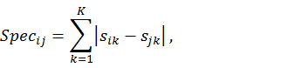
where $s_{ik}$ ($s_{jk}$) represents the share of industry k in the economy of region i (j). By construction, Spec takes a minimum value of zero if region i has an industrial structure identical to region j, and takes a maximum value of 2 if it has no sectors in common with region j.
In this paper, the index is calculated to measure the specialization of provincial GDP by industry relative to national counterpart. The GDP data are classified into nine one-digit industries: ‘primary’, ‘industry’, ‘construction’, ‘transport, storage and post’, ‘wholesale and retail trades’, ‘hotels and catering services’, ‘financial intermediation’, ‘real estate’ and ‘others’.
Output gap: following common practice, the ‘output gap’ is calculated by the Hodrick-Prescott (HP) filter using a value of 6.25 for the lambda parameter. To have a sufficiently long time-span, it is calculated from the data of the entire period of 1978-2019.
Provincial budgetary expenditure, revenue, net transfers from the central government, and other main items: all these budgetary data, including initial account and financial account, are sourced from Finance Yearbook of China, various issues.
Total factor productivity (TFP): sourced from Zhang et al. (2022), which provide estimates of China’s provincial TFP growth rates on the basis of Malmquist Indices. The data of Tibet are not available.
Urbanization rate: sourced from NBSC online database. It is defined as the ratio of urban residents to the total population.

