Table A1. Descriptive statistics and inter-correlations of variables (n=45)
Variables | mean | SD | HDI₁ | e-Gov₁ | Institutions₁ | HDI₂ | e-Gov₂ | Institutions₂
HDI₁ | 4.25 | .62 | 1
e-Gov₁ | .42 | .17 | .76 | 1
Instituions₁ | 2.09 | .78 | .83 | .83 | 1
HDI₂ | 4.31 | .64 | .94 | .72 | .76 | 1
e-Gov₂ | .50 | .18 | .77 | .88 | .79 | .79 | 1
Institutions₂ | 2.11 | .78 | .81 | .83 | .98 | .76 | .79 | 1
Note: all correlation coefficients are significant at p<.01
Source: Author’s own creation/work

Table A2. The baseline and cross-lagged panel structural models
Models |  | β | Effect size# | r² | Q²
A: Baseline Stability Model
Direct paths:
Institutions₁ Institutions₂ |  | .98*** | .96 | .96 | .95
e-Gov₁ e-Gov₂ |  | .90*** | .81 | .81 | .81
HDI₁ HDI₂ |  | .95** | .94 | .91 | .96
B: Cross-lagged e-Gov
Institutions₁ e-Gov₂ |  | .79*** | .64 | .62 | .64
e-Gov₁ NCI₂ |  | .51*** | .54 | .37 | .35
C: Cross-lagged e-Gov and Institutions
Institutions₁ e-Gov₂ |  | .79*** | .63 | .62 | .63
e-Gov₁ HDI₂ |  | .36*** | .18 | .41 | .41
Institutions₁ HDI₂ |  | .24** | .19 | .41 | .41
D: Cross-lagged e-Gov and Institutions
Institutions₁ e-Gov₂ |  | .79*** | .63 | .62 | .64
e-Gov₁ HDI₂ |  | .36*** | .18 | .41 | .41
Institutions₁ HDI₂ |  | .24** | .63 | .41 | .41
e-Gov₁ Institutions₂ |  | .85*** | .71 | .70 | .70
E: Cross-lagged e-Gov, Institutions and NCI
Institutions₁ e-Gov₂ |  | .75*** | .60 | .65 | .64
e-Gov₁ HDI₂ |  | .36** | .18 | .56 | .41
Institutions₁ HDI₂ |  | .24** | .12 | .56 | .41
e-Gov₁ Institutions₂ |  | .80*** | .66 | .54 | .71
HDI₁ e-Gov₂ |  | .07 | .03 | .65 | .64
HDI₁ Institutions₂ |  | .13 | .07 | .54 | .71
Model Goodness-of-fit indices | Models
 | A | B | C | D | E
Average path coefficient (APC) | .486*** | .425*** | .300*** | .337*** | .284***
Average r-squared (ARS) | .892** | .496*** | .517*** | .577*** | .581***
Average variance inflation factor (AVIF) | 1.280 | 1.007 | 1.407 | 1.365 | 1.450
Tenenhaus Goodness of Fit (TGoF) | .944 | .704 | .719 | .760 | .762
Nonlinear bivariate causality direction ratio (NLBCDR) | .701 | .750 | .750 | .715 | .750
Source: Author’s own creation/work
Legend:
*p <.10 **p<.05 ***p<.01i
#Cohen’s f² (Cohen 1992)
r² = r-squared
Q² = Stone-Geisser q-squared

Table A3. The baseline and cross-lagged panel mediation structural models

Models |  | β | Effect size# | r² | Q²
F: Full mediation (e-Gov₂ as Mediator)
Institutions₁ e-Gov₂ |  | .79*** | .63 | .62 | .62
e-Gov₂ HDI₂ |  | .31*** | .13 | .18 | .19
G: Partial mediation (e-Gov₂ as Mediator)
Institutions₁ e-Gov₂ |  | .79*** | .63 | .62 | .62
e-Gov₂ HDI₂ |  | .10*** | .13 | .29 | .29
Institutions₁ HDI₂ |  | .36*** | .17 | .29 | .29
H: Full Mediation (e-Gov₁ as Mediator)
Institutions₁ e-Gov₁ |  | .80*** | .64 | .65 | .66
e-Gov₁ HDI₂ |  | .51*** | .26 | .37 | .38
Income*e-Gov₁ HDI₂ |  | .35*** | .12 | .37 | .38
I: Partial Mediation (e-Gov₁ as Mediator)
Institutions₁ e-Gov₁ |  | .80*** | .64 | .65 | .66
e-Gov₁ HDI₂ |  | .36*** | .18 | .41 | .41
Institutions₁ HDI₂ |  | .24** | .12 | .41 | .41
Income*e-Gov₁ HDI₂ |  | .32*** | .11 | .41 | .41
Model Goodness-of-fit indices | Models
 | F | G | H | I
Average path coefficient (APC) | .345*** | .263*** | .423*** | .299***
Average r-squared (ARS) | .399** | .454*** | .512*** | .533***
Average variance inflation factor (AVIF) | 1.030 | 1.424 | 1.030 | 1.422
Tenenhaus Goodness of Fit (TGoF) | .632 | .674 | .715 | .730
Nonlinear bivariate causality direction ratio (NLBCDR) | .750 | .750 | .750 | .750
Source: Author’s own creation/work
Legend:
*p <.10 **p<.05 ***p<.01i
#Cohen’s f² (Cohen 1992)
r² = r-squared
Q² = Stone-Geisser q-squared

Table A4. Necessary Condition Analysis: Model Parameters
NCA Parameters | Institutions -eGov | Institutions -HDI | eGov-HDI
Ceiling Zone -  Straight Line: Ceiling Regression – Free Disposal Hull (cr-fdh) | .432 | 3.925 | .846
Effect size | .20*** | .23** | .24**
Condition inefficiency | 24.19% | 45.75% | 30.659%
Outcome inefficiency | 39.27 | 16.09% | 31.710%
Bottleneck (CR-FDH):
0 | NN | NN | NN
10 | NN | NN | NN
20 | NN | 2.5 | NN
30 | NN | 9.0 | NN
40 | NN | 15.5 | 8.4
50 | 1.1 | 21.9 | 18.6
60 | 16.0 | 28.4 | 28.7
70 | 31.0 | 34.9 | 38.9
80 | 45.9 | 41.3 | 49.0
90 | 60.9 | 47.8 | 59.2
100 | 75.8 | 54.2 | 69.3
Legend: NN = not a necessary condition ***sig at p<.01, **p<.05
Source: Author’s own creation/work using Dul’s (2020) NCA Software for R

H₂ (+)
Formal Institutions for Good Governance (Institutions)
Sustainable Human Development of Asian
Countries
(HDI)

H₁ (+)
Quality of
e-Governance
(e-Gov)
H₃ (+)

Figure A1. The conceptual model of the study
Source: Author’s own creation/work

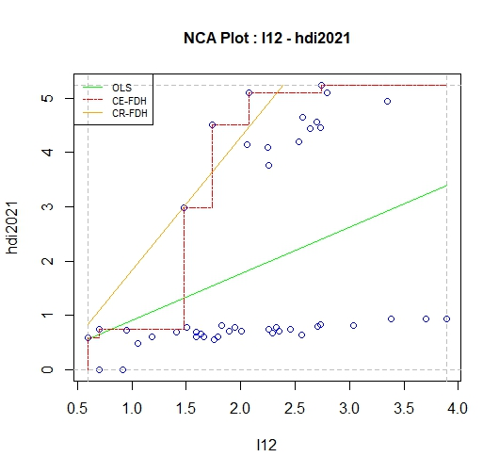
Institutions – HDI
Institutions – e-Gov
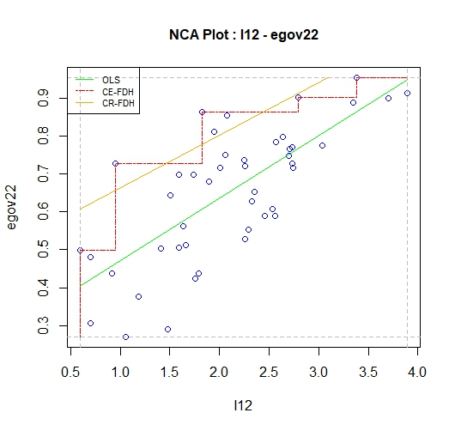
e-Gov - HDI
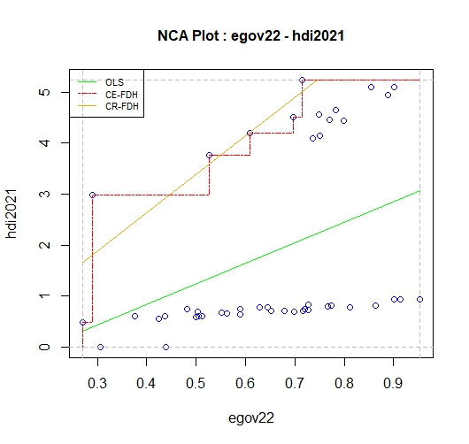

Source: The three graphs above are the author’s own creation/work using Dul’s (2020) NCA Software for R.

Figure A2. Necessary Condition Analysis: Condition Scatterplots

