Online Appendix

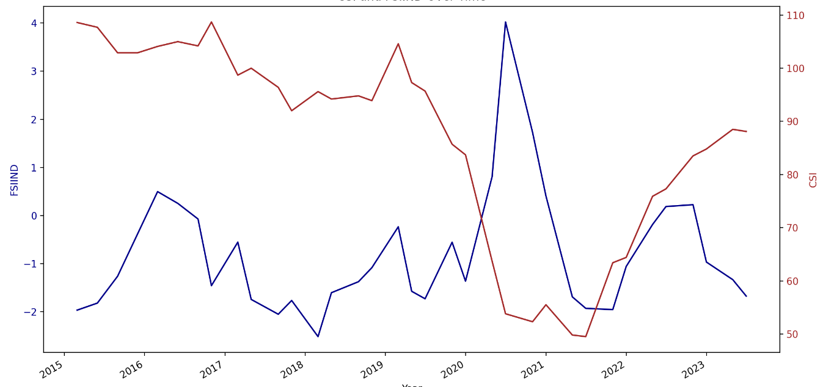
Figure A1: Time Series Plot of CSI and Financial Stress Index (FSIIND)
Note: This figure plots the time series observations of the Current Situation Index (CSI) released by the Reserve Bank of India (RBI). Data on the Financial Stress Index at the Indian level (FSIIND) comes from the Asia Regional Integration Center, Tracking Asian Integration (ARIC) of the Asian Development Bank. FSIIND is lagged by one month. The correlation coefficient is -0.37 and it is statistically significant.
Source: Authors' own work.

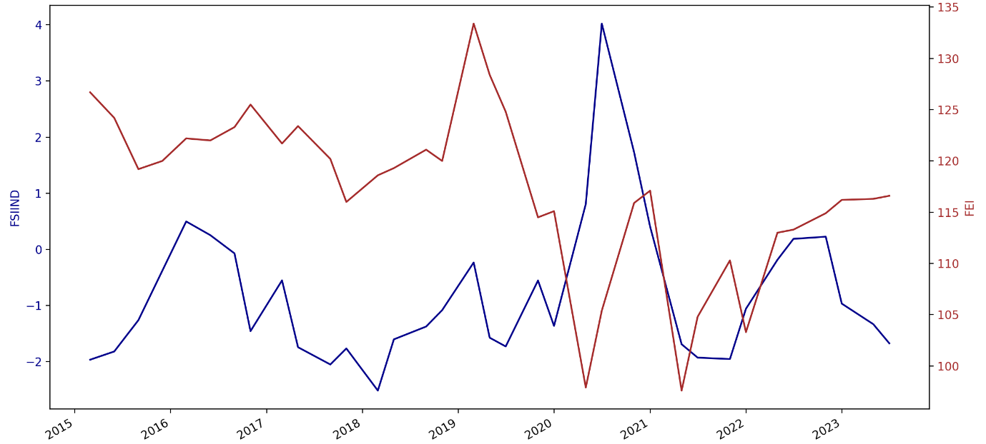
Figure A2: Time Series Plot of FEI and Financial Stress Index (FSIIND)
Note: This figure plots the time series observations of the Future Expectation Index (FEI) released by the Reserve Bank of India (RBI). Data on the Financial Stress Index at the Indian level (FSIIND) comes from the Asia Regional Integration Center, Tracking Asian Integration (ARIC) of the Asian Development Bank. FSIIND is lagged by one month. The correlation coefficient is -0.27 and it is not statistically significant.
Source: Authors' own work.

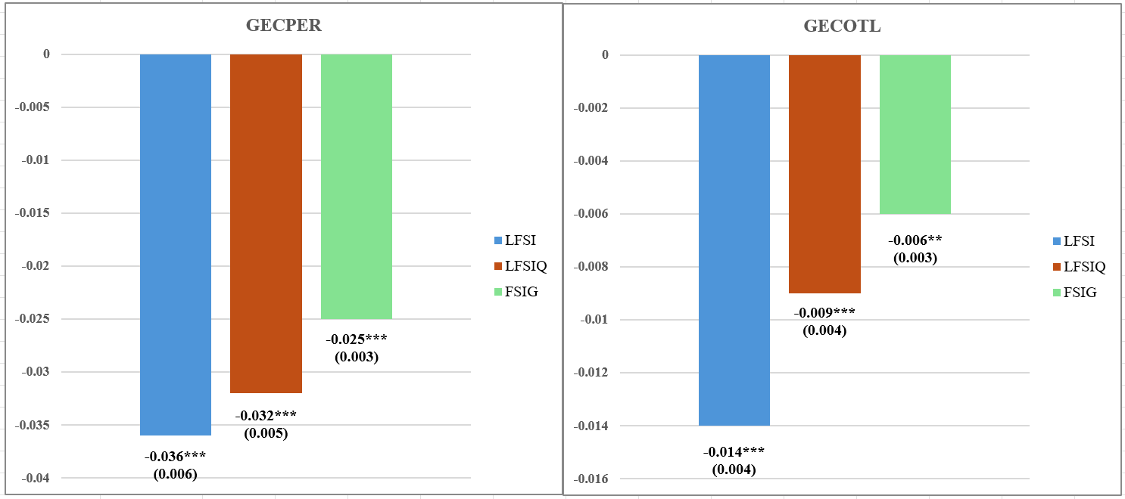
Figure A3: Robustness Analysis
Note: This figure presents the robustness analysis based on alternative lag selection and considering FSI in percentage change rather than in levels used in baseline regression. LFSI is the first lag of FSI (baseline). LFSIQ is the one-quarter lagged FSI value. FSIG is percentage change in FSI. Standard errors clustered at the city level are reported in parentheses. *, **, and *** indicate significance at the 10%, 5%, and 1% , respectively
Source: Authors' own work.

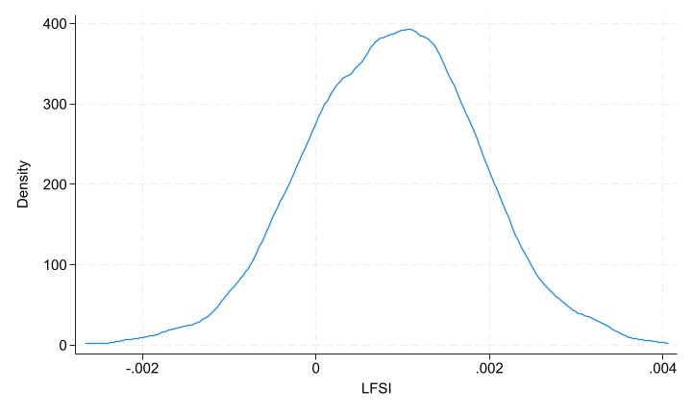Figure A4: Placebo Analysis – Kernel Density Plot of LFSI for GECPER
Note: Placebo Analysis randomly assigns LFSI to households from different survey rounds. The plot is derived from conducting 500 replications for GECPER.
Source: Authors' own work.

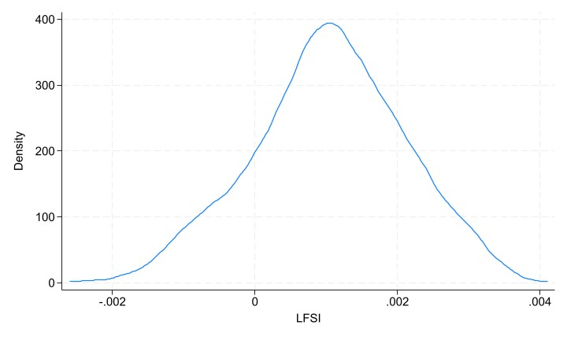

Figure A5: Placebo Analysis – Kernel Density Plot of LFSI for GECOTL

Note: Placebo Analysis randomly assigns LFSI to households from different survey rounds. The plot is derived from conducting 500 replications for GECOTL.
Source: Authors' own work.

Table A1: Variable Definition and Summary Statistics
Variables | Measurement | Mean | SD
Dependent Variables
GECPER | = 1 if the respondent perceives that the general economic condition compared to a year ago has improved, 0 if it remained the same, and -1 if it worsened | -0.224 | 0.867
GECOTL | = 1 if the respondent expects that future general economic conditions a year ahead will improve, 0 if it will remain the same, and -1 if it will worsen. | 0.196 | 0.881
Main Independent Variables
LFSI | = first lag of financial stress index (composite) | -0.749 | 1.56
LBNKBTA | =first lag of bank beta | 0.022 | 0.225
LEQRTN | =first lag of equity market returns | -0.015 | 0.803
LEQVT | = first lag of stock market volatility | -0.824 | 0.901
LDBTSPRD | =first lag of debt spread | 0.036 | 0.104
LEMPI | =first lag of exchange market pressure index | 0.032 | 0.333
Household Controls
AGEG1 | = if the respondent is between 22 to 29 years of age (reference). | 0.224 | 0.417
AGEG2 | = if the respondent is between 30 to 39 years of age. | 0.28 | 0.449
AGEG3 | = if the respondent is between 40 to 59 years of age. | 0.337 | 0.473
AGEG4 | = If the respondent is of 60 years of age or above | 0.159 | 0.365
FEMALE | = if the respondent is a Female. | 0.475 | 0.5
INCOMEG1 | = if the income of the respondent is below one lakh rupees (reference). | 0.544 | 0.498
INCOMEG2 | = if the income of the respondent is between one lakh to three lakh rupees. | 0.367 | 0.482
INCOMEG3 | = if the income of the respondent is between three lakh to five lakh rupees. | 0.063 | 0.244
INCOMEG4 | = if the income of the respondent is more than five lakh rupees | 0.026 | 0.158
EDUG1 | = If the respondent is an illiterate (reference). | 0.057 | 0.233
EDUG2 | = if the education of the respondent is below primary and up to fifth standard. | 0.126 | 0.332
EDUG3 | = if the education of respondent is of fifth standard but below tenth standard | 0.211 | 0.408
EDUG4 | = if the education of respondent is of tenth standard but below twelve standard | 0.162 | 0.368
EDUG5 | = if the education of respondent is of twelve standard but below graduate level. | 0.2 | 0.4
EDUG6 | = if the education of the respondent is graduate and above | 0.244 | 0.43
Continued on the following page

Table- A1 continued
Variables | Measurement | Mean | SD
FAMILYM1 | = if the respondent's family size consists of 1 to 2 members (reference). | 0.085 | 0.279
FAMILYM2 | = if the respondent's family size consists of 3 or 4 members | 0.478 | 0.499
FAMILYM3 | = If the respondent's family size consists of 5 or more members | 0.437 | 0.496
RETIRED | = If the respondent is retired (reference) | 0.049 | 0.215
HOUSEWF | = If the respondent is a housewife | 0.327 | 0.469
SALARIED | = if the respondent is employed. | 0.241 | 0.427
DAILYWG | = If the respondent is a daily wage worker | 0.095 | 0.293
SELFEMP | = If the respondent is self-employed or has a business | 0.189 | 0.392
NEARM1 | = if the number of earning members in a family is one (reference). | 0.596 | 0.491
NEARM2 | = If the number of earning members in a family is two | 0.291 | 0.454
NEARM2P | = if the number of earning members in a family is three or more. | 0.114 | 0.318
Other Confidence Indicators
HIPER | =1 indicates that respondents think household income has improved from a year ago, 0 indicates that it has stayed the same, and -1 indicates that it has declined. | -0.116 | 0.738
HIOTL | =1 indicates that respondents think household income will improve for a year ahead, 0 indicates that it will stay the same, and -1 indicates that it will decline | 0.413 | 0.667
HSPER | =1 indicates that respondents think household spending has improved from a year ago, 0 indicates that it has stayed the same, and -1 indicates that it has declined. | 0.635 | 0.624
HSOTL | =1 indicates that respondents think household spending will improve for a year ahead, 0 indicates that it will stay the same, and -1 indicates that it will decline | 0.703 | 0.561
ESPER | =1 indicates that respondents think spending on essentials has improved from a year ago, 0 indicates that it has stayed the same, and -1 indicates that it has declined. | 0.739 | 0.558
ESOTL | =1 indicates that respondents think spending on essentials will improve for a year ahead, 0 indicates that it will stay the same, and -1 indicates that it will decline | 0.756 | 0.527
NESPER | =1 indicates that respondents think spending on non-essentials has improved from a year ago 0 indicates that it has stayed the same, and -1 indicates that it has declined. | -0.032 | 0.812
NESOTL | =1 indicates that respondents think spending on non-essentials will improve for a year ahead, 0 indicates that it will stay the same, and -1 indicates that it will decline | 0.156 | 0.79
EMPER | =1 indicates that respondents think the employment scenario has improved from a year ago, 0 indicates that it has stayed the same, and -1 indicates that it has declined. | -0.244 | 0.853
EMOTL | =1 indicates that respondents think the employment scenario will improve for a year ahead, 0 indicates that it will stay the same, and -1 indicates that it will decline | 0.224 | 0.863
GEPPER | =1 indicates that respondents think the general price level has improved from a year ago, 0 indicates that it has stayed the same, and -1 indicates that it has declined. | 0.842 | 0.446
GPOTL | =1 indicates that respondents think that the general price level will improve for a year ahead, 0 indicates that it will stay the same, and -1 indicates that it will decline | 0.687 | 0.63
IFPER | =1 indicates that respondents think the inflation situation has improved from a year ago, 0 indicates that it has stayed the same, and -1 indicates that it has declined. | 0.775 | 0.525
IFOTL | =1 indicates that respondents think that the inflation situation will improve for a year ahead, 0 indicates that it will stay the same, and -1 indicates that it will decline | 0.737 | 0.552
Note: This table presents the definitions of the variables used in our empirical analysis and their descriptive
Statistics.
Source: Authors' own work.

Table A2: Heterogeneity Analysis- Income
Variables | GECPER | GECOTL
Variables | Coeff. | Coeff.
Variables | (S.E) | (S.E)
LFSI | -0.022*** | -0.007
LFSI | (0.007) | (0.005)
LFSI*INCOMEG2 | -0.021*** | -0.012*
LFSI*INCOMEG2 | (0.006) | (0.006)
LFSI*INCOMEG3 | -0.030*** | -0.009
LFSI*INCOMEG3 | (0.007) | (0.006)
LFSI*INCOMEG4 | -0.032*** | -0.002
LFSI*INCOMEG4 | (0.006) | (0.009)
Household Controls | Yes | Yes
City, Month, &Year Fixed-Effects | Yes | Yes
Observations | 275763 | 275763
Note: This table presents the impact of financial stress on general economic confidence. GECPER =1 if the respondent's perception towards their present general economic condition compared to a year ago has improved, 0 if it remained the same, and -1 if it worsened. Similarly, GECOTL=1 if the respondent’s outlook on the future general economic condition a year ahead will improve, 0 if it will remain the same, and -1 if it will worsen. LFSI is the first lag of the financial stress index. The income categories are as follows: INCOMEG1, households having annual income less than INR 100,000 (reference category); INCOMEG2 captures the households having annual income between INR100,000 and INR3,00,000; INCOMEG3 is classified as households earning INR300,000 and INR500,000 a year and finally, INCOMEG4 are the households earning more than INR 500,000 a year. Standard errors clustered at the city level are reported in parentheses. *, **, and *** indicate significance at the 10%, 5%, and 1% , respectively.
Source: Authors' own work.

Table A3: Heterogeneity Analysis- Education
Variables | GECPER | GECOTL
Variables | Coeff. | Coeff.
Variables | (S.E) | (S.E)
LFSI | -0.021*** | -0.003
LFSI | (0.006) | (0.008)
LFSI*EDUG2 | -0.022 | -0.020*
LFSI*EDUG2 | (0.013) | (0.010)
LFSI*EDUG3 | -0.008 | -0.005
LFSI*EDUG3 | (0.008) | (0.006)
LFSI*EDUG4 | -0.012** | -0.011
LFSI*EDUG4 | (0.006) | (0.008)
LFSI*EDUG5 | -0.019** | -0.013*
LFSI*EDUG5 | (0.007) | (0.006)
LFSI*EDUG6 | -0.022** | -0.013
LFSI*EDUG6 | (0.009) | (0.008)
Household Controls | Yes | Yes
City, Month, &Year Fixed-Effects | Yes | Yes
Observations | 275763 | 275763
Note: This table presents the impact of financial stress on general economic confidence. GECPER =1 if the respondent's perception towards their present general economic condition compared to a year ago has improved, 0 if it remained the same, and -1 if it worsened. Similarly, GECOTL=1 if the respondent's outlook on the future general economic condition a year ahead will improve, 0 if it will remain the same, and -1 if it will worsen. LFSI is the first lag of the financial stress index. The educational categories are as follows: EDUG1= Illiterate (reference), EDUG2= Up to primary and below 5th grade, EDUG3=5th grade-below 10th grade, EDUG4 = 10th grade but below 12th grade; EDUG5=12th grade and below Graduate; EDUG6= Graduate, Graduate and above and Postgraduate. Standard errors clustered at the city level are reported in parentheses. *, **, and *** indicate significance at the 10%, 5%, and 1% , respectively.
Source: Authors' own work.

Table A4: Exploring Potential Channels of Individual Survey Indicators
Variable | HIPER | HIOTL | HSPER | HSOTL | ESPER | ESOTL | NESPER | NESOTL | EMPER | EMOTL | GPPER | GPOTL | IFPER | IFOTL
Variable | Coeff. | Coeff. | Coeff. | Coeff. | Coeff. | Coeff. | Coeff. | Coeff. | Coeff. | Coeff. | Coeff. | Coeff. | Coeff. | Coeff.
Variable | (S.E) | (S.E) | (S.E) | (S.E) | (S.E) | (S.E) | (S.E) | (S.E) | (S.E) | (S.E) | (S.E) | (S.E) | (S.E) | (S.E)
LFSI | -0.040*** | -0.016*** | -0.033*** | -0.020*** | -0.026*** | -0.014* | -0.040*** | -0.030*** | -0.017*** | -0.005 | -0.015* | -0.002 | 0.000 | 0.002
LFSI | (0.007) | (0.005) | (0.006) | (0.006) | (0.008) | (0.007) | (0.003) | (0.005) | (0.004) | (0.004) | (0.007) | (0.008) | (0.005) | (0.005)
Household Controls | Yes | Yes | Yes | Yes | Yes | Yes | Yes | Yes | Yes | Yes | Yes | Yes | Yes | Yes
City, Month, &Year Fixed-Effects | Yes | Yes | Yes | Yes | Yes | Yes | Yes | Yes | Yes | Yes | Yes | Yes | Yes | Yes
Observations | 275763 | 275763 | 275763 | 275763 | 275763 | 275763 | 275763 | 275763 | 275763 | 275763 | 275763 | 275763 | 241380 | 214252
Note: This table presents the impact of financial stress on other survey indicators in the CCS survey. The definition of perception, as well as the outlook for each of the other survey indicators in the CCS survey, follows the same pattern as that of GECPER and GECOTL. LFSI is the first lag of the financial stress index. The categories of individual survey indicators are as follows: HIPER= Present Perception on household income; HIOTL= Outlook on household income; HSPER= Present perception on household spending; HSOTL= Outlook on household spending; ESPER= Present perception on essential spending; ESOTL= Outlook on essential spending; NESPER= Present perception on non-essential spending; NESOTL= Outlook on non-essential spending; EMPER= Present perception on employment; EMPTL= Outlook on employment; GPPER= Present perception towards general price levels; GPOTL= Outlook on general price levels; IFPER= Present perception towards inflation and IFOTL= Outlook on inflation. Standard errors clustered at the city level are reported in parentheses. *, **, and *** indicate significance at the 10%, 5%, and 1% , respectively.
Source: Authors' own work.

Table A5: Impact of Individual Components of FSI on Perception and Expectations towards General Economic Conditions
Variables | GECPER |  |  |  |  |  | GECOTL
Variables | Overall | BNKBTA | EQVT | EQRTN | DBTSPRD | EMPI | Overall | BNKBTA | EQVT | EQRTN | DBTSPRD | EMPI
Variables | Coeff. | Coeff. | Coeff. | Coeff. | Coeff. | Coeff. | Coeff. | Coeff. | Coeff. | Coeff. | Coeff. | Coeff.
Variables | (S.E) | (S.E) | (S.E) | (S.E) | (S.E) | (S.E) | (S.E) | (S.E) | (S.E) | (S.E) | (S.E) | (S.E)
LFSI | -0.036*** |  |  |  |  |  | -0.014***
LFSI | (0.006) |  |  |  |  |  | (0.004)
LBNKBTA |  | -0.041 |  |  |  |  |  | -0.022
LBNKBTA |  | (0.040) |  |  |  |  |  | (0.037)
LEQVT |  |  | -0.072*** |  |  |  |  |  | -0.026***
LEQVT |  |  | (0.010) |  |  |  |  |  | (0.005)
LEQRTN |  |  |  | -0.024* |  |  |  |  |  | 0.002
LEQRTN |  |  |  | (0.012) |  |  |  |  |  | (0.011)
LDBTSPRD |  |  |  |  | -0.157*** |  |  |  |  |  | -0.364***
LDBTSPRD |  |  |  |  | (0.041) |  |  |  |  |  | (0.032) | -0.221***
LEMPI |  |  |  |  |  | -0.442*** |  |  |  |  |  | (0.045)
LEMPI |  |  |  |  |  | (0.053)
Household Controls | Yes | Yes | Yes | Yes | Yes | Yes | Yes | Yes | Yes | Yes | Yes | Yes
City, Month, &Year Fixed-Effects | Yes | Yes | Yes | Yes | Yes | Yes | Yes | Yes | Yes | Yes | Yes | Yes
Observations | 275763 | 275763 | 275763 | 275763 | 275763 | 275763 | 275763 | 275763 | 275763 | 275763 | 275763 | 275763
Note: This table presents the impact of individual components of financial stress on general economic confidence. GECPER =1 if the respondent's perception towards their present general economic condition compared to a year ago has improved, 0 if it remained the same, and -1 if it worsened. Similarly, GECOTL=1 if the respondent's outlook on the future general economic condition a year ahead will improve, 0 if it will remain the same, and -1 if it will worsen. LFSI is the first lag of financial stress index. LBNKBTA is the lag of banking sector beta (measuring bank-based crisis); LEQRTN and LEQVT are the lag of equity market returns and lag of stock market volatility, respectively, measuring equity market stress; LDBTSPRD is the lag of sovereign debts spreads measuring sovereign debt stress; LEMPI is the lag of exchange market pressure index. Standard errors clustered at the city level are reported in parentheses. *, **, and *** indicate significance at the 10%, 5%, and 1% , respectively.
Source: Authors' own work.

Table A6: Asymmetric Impact of Financial Stress Index
Variables | GECPER | GECOTL
Variables | Coeff. | Coeff.
Variables | (S.E) | (S.E)
FSIH | -0.039*** | -0.042***
FSIH | (0.005) | -0.005
FSIL | -0.032** | 0.034**
FSIL | (0.012) | (0.014)
Household Controls | Yes | Yes
City, Month, &Year Fixed-Effects | Yes | Yes
Observations | 275763 | 275763
Note: This table presents the impact of financial stress on general economic confidence. GECPER =1 if the respondent's perception towards their present general economic condition compared to a year ago has improved, 0 if it remained the same, and -1 if it worsened. Similarly, GECOTL=1 if the respondent's outlook on the future general economic condition a year ahead will improve, 0 if it will remain the same, and -1 if it will worsen. FSIH refers to the above-average FSI shock and FSIL refers to below-average FSI shocks. Standard errors clustered at the city level are reported in parentheses. *, **, and *** indicate significance at the 10%, 5%, and 1% , respectively.
Source: Authors' own work.

Table A7: Robustness Check- Alternative Definition of Consumer Confidence
Variables | HHEC
Variables | Coeff.
Variables | (S.E)
LFSI | -0.048***
LFSI | (0.009)
Household Controls | Yes
City, Month, &Year Fixed-Effects | Yes
Observations | 275763
Note: This table presents the impact of financial stress on economic confidence based on an alternative definition of general economic confidence. HHEC is the aggregate of GECPER and GECOTL. LFSI is the first lag of the financial stress index. Standard errors clustered at the city level are reported in parentheses. *, **, and *** indicate significance at the 10%, 5%, and 1% , respectively.
Source: Authors' own work.

