Online Appendix to “Impact of Pilot Free Trade Zones on Outward Foreign Direct Investment: Evidence from China” published in Journal of Asian Business and Economic Studies
Section A4.2. Transmission Mechanisms
a) PFTZs and Innovation
Innovation is a key source of OAs. Do PFTZs matter for innovation? Liu and Feng (2024) employed several approaches, including a Difference-in-Differences (DiD) model, and found that establishing PFTZs enhances urban innovation. Their transmission analysis suggested that PFTZs stimulate innovation through talent concentration, market scale effects, and financial support. Notably, Liu and Feng (2024) also found that PFTZs enhance the innovation capacity of geographically adjacent cities and the entire region in which the PFTZ is located.
Su and Wang (2024) investigated the impact of PFTZs on enterprise innovation. They used data on patents of listed firms and employed a Difference-in-Differences (DiD) approach. Su and Wang (2024) found that PFTZs enhance the innovative performance of firms by easing financing constraints and enhancing industrial agglomeration. Yang et al. (2024) investigated the impact of PFTZs on technological innovation. They applied a DiD approach and unveiled that establishing a PFTZ encourages innovation by improving the business environment, producer services agglomeration, and financial development. Wang et al. (2023) link PFTZs with firms’ green innovation efficiency. They applied a DiD approach and found that PFTZs promote the green innovation efficiency of firms, especially in heavy-polluting industries, non-state-owned enterprises, and patent-intensive enterprises.
The empirical literature supports the view that PFTZs enhance urban and firm innovation and, in turn, OAs. Notably, the positive effect also spills over to neighboring cities and the province where the PFTZ is located.
b) PFTZs and Financial Development
Which effects do PFTZs have on financial development? Zhang and Yu (2020) employed a PSM-DiD approach and found that capital controls gradually weakened after the establishment of the Shanghai (China) PFTZ, thereby spurring investment and trade. Xiang et al. (2016) analyzed a similar question via the Synthetic Control (SC) approach. Their results indicated that establishing the Shanghai (China) PFTZ significantly reduces institutional barriers to trade and investment. Another SC-based study found that the establishment of the Shanghai (China) PFTZ has a positive impact on the scale, efficiency, and structure of regional financial development (Wang et al., 2022). Relatedly, Xu (2016) noted that establishing free trade accounts within a PFTZ enables the Chinese RMB to circulate freely, thereby expanding the scale of RMB cross-border use. Yao and Whalley (2016) emphasized that implementing exchange rate flexibility and economic liberalization policies within the Shanghai (China) PFTZ reduced capital controls and strengthened the connection between PFTZs and the global financial market. Hence, the empirical evidence supports the view that PFTZs successfully liberalized the FDI management system, which is conducive to generating and exporting OAs.
Overall, PFTZs have promoted institutional and enterprise innovations, which are conceptually linked to OFDI. However, empirically, it is unclear whether these innovations stimulated OFDI, an issue requiring more empirical testing.
Section A6.2. Choice of Control Variables
Variable GDP_{it} captures a province's economic size, which is crucial in understanding the scale of OFDI (Chen, 2015). We expect the coefficient of variable GDP_{it} to be positively signed as an economically larger province should lead to larger OFDI volumes. Variable GDPCap_{it} captures a province's economic wealth, which is important as wealthier provinces will also offer more significant possibilities for generating and exporting OAs. In addition, GDPCap_{it} also aims at capturing the possibility that provinces with higher levels of economic development, such as Shanghai, Guangdong, and Jiangsu, often have more liberal institutional environments that foster private enterprise. In contrast, less developed provinces may have more rigid institutional frameworks, which can affect business operations and investment dynamics (e.g., Huang, 2007). Note that jointly including GDP_{it} and GDPCap_{it} implies that the analysis captures the impact of a province’s population on OFDI. We therefore expect the coefficient on variable GDPCap_{it} to be negatively signed.
Variable Finance_{it} captures the development of the debt market in a province. More developed debt markets allow firms to invest in OAs more efficiently and to export OAs. Variable Edu_{it} measures the average years of schooling in a province. It intends to capture existing human capital, an essential input factor for generating OAs (e.g., Wong et al., 2024). Variable GDPGrowth_{it} captures a province’s business cycle. OFDI, like investments in general (e.g., Farooq et al., 2021) should be more likely in booms than in downturns. We expect the coefficients of the latter three variables to be positively signed.
Variable R&DExpenGDP_{it} intends to capture the possibility that a higher R&D spending enhances a province’s technological capabilities, providing the basis for the generation of OAs, leading to overseas investment (also see, Chen, 2015; Wong et al., 2024). Furthermore, firms from provinces with higher R&DExpenGDP_{it} may also be inclined to conduct OFDI to acquire complementary technological knowledge (asset-seeking OFDI). For both reasons, we expect the coefficient of variable R&DExpenGDP_{it} to be positive.
Variable GovExpGDP_{it} captures a province’s involvement in markets (Jing et al., 2024). On the one hand, the involvement can be in the form of subsidies and infrastructure investments, which are conducive to generating Ownership Advantages. Furthermore, government spending may support provincial (State-owned) champions in strategic sectors, pushing them to globalize. In these cases, a higher GovExpGDP_{it} should be paired with higher OFDI. On the other hand, a high GovExpGDP_{it} may imply that a province also raises high taxes or that the majority of expenditures are on transfers or other non-business-related spending items. In these cases, the association of GovExpGDP_{it} with OFDI is either negative or absent. Hence, the sign of the coefficient on variable GovExpGDP_{it} is ambiguous a priori.
Variable Openness_{it} aims to capture a province's integration in global markets (Chen, 2015). It is measured as the sum of imports and exports in GDP. The higher imports and exports, the more familiar a province’s firms should be with overseas economic environments, which should reduce the liability of foreignness and spur OFDI. Hence, we expect a positive coefficient of variable Openness_{it}.
Variable lnOFDI_Init_{i} is only utilized in the heterogeneous treatment effects models. It is calculated as the average lnOFDIit from 2003 to 2008, the years preceding the estimation sample. Including pre-sample outcomes helps mitigate a possible bias from unobserved confounders (Roth et al., 2023, p. 2232).

Table A1. Timeline of the Establishment of China’s PFTZs
Time | Province | Scope of Free Trade Zone | Focus on
09/29/2013 | Shanghai | Waigaoqiao Bonded Area, Waigaoqiao Bonded Logistics Park, Yangshan Bonded Port Area, Pudong Airport Comprehensive Bonded Area | Trade and investment liberalization and facilitation; transformation of government functions; financial openness and innovation.
04/21/2015 | Tianjin | Tianjin Port, Tianjin Airport, Binhai New Area CBD | Promote the implementation of the Beijing-Tianjin-Hebei coordinated development strategy.
04/21/2015 | Guangdong | Guangzhou Nansha New Area, Shenzhen Qianhai Shekou, Zhuhai Hengqin New Area | Deepen cooperation between Guangdong, Hong Kong, and Macao; promote financial reform and innovation; liberalize market access; and promote trade facilitation.
04/21/2015 | Fujian | Pingtan, Xiamen, Fuzhou | Take the lead in promoting free investment and trade with Taiwan; Deepen cross-strait economic cooperation.
04/28, 2015 | Shanghai (expanded region) | Lujiazui Financial Zone, Jinqiao Development Zone, Zhangjiang High tech Zone | Financial opening, innovative regulatory methods, and opening the service industry.
04/01/2017 | Liaoning | Dalian, Shenyang, Yingkou | Structural adjustment of old industrial bases; Strengthen regional openness and cooperation in Northeast Asia.
04/01/2017 | Zhejiang | Zhoushan outlying islands, the north of Zhoushan Island and the south of Zhoushan Island | Promote investment facilitation and trade liberalization of the entire oil industry chain.
04/01/2017 | Henan | Zhengzhou, Kaifeng, Luoyang | Enhance the function of the transportation and logistics hub serving the construction of the "Belt and Road."
04/01/2017 | Hubei | Wuhan, Xiangyang, Yichang | Promote the industrial transformation and upgrading of the central region and the Yangtze River Economic Belt; Promote innovation-driven development.
04/01/2017 | Chongqing | Liangjiang District, Xiyong District and Guoyuangang District | Promote the linkage development of the Belt and Road Initiative and the Yangtze River Economic Belt.
04/01/2017 | Sichuan | Chengdu Tianfu New Area, Chengdu Qingbaijiang Railway Port, South Sichuan Port | Promote the industrial transformation and upgrading of the central region and the Yangtze River Economic Belt.
04/01/2017 | Shaanxi | Central Area, Xi'an International Port Area, Yangling Demonstration Area | Promote the in-depth implementation of the strategy for the large-scale development of the western region.
10/16/2018 | Hainan | Hainan Island | Accelerate the innovation and development of the service industry.
07/27/2019 | Shanghai (expanded region) | Lingang New Area | Establish an institutional system with investment and trade liberalization as the core.
08/26/2019 | Shandong | Jinan, Qingdao, Yantai | Accelerate the innovation and development of the service industry.
08/26/2019 | Jiangsu | Nanjing, Suzhou, Lianyungang | Promote the integrated development of the Yangtze River Economic Belt and the Yangtze River Delta.
08/26/2019 | Guangxi | Nanning, Qinzhou Port, Chongzuo | Build a new international land and sea trade channel for ASEAN.
08/26/2019 | Hebei | Xiong'an, Zhengding, Caofeidian, Daxing Airport (Hebei area) | Promote the coordinated development of Beijing-Tianjin-Hebei.
08/26/2019 | Yunnan | Kunming, Honghe, Dehong | Innovate a new model of economic and social development along the border.
08/26/2019 | Heilongjiang | Harbin, Heihe, Suifenhe | Cultivate new momentum for the revitalization and development of Northeast China.
09/21/2020 | Beijing | International Business Service Area, Beijing CBD, Jinzhan International Cooperation Service Area, Canal Business District, the sub-center of the city, Zhangjiawan Design Town, Capital International Airport | Innovate the environment for the development of the digital economy, opening the service sector Driven by scientific and technological innovation.
09/21/2020 | Hunan | Changsha, Yueyang, Binzhou | Building an international investment and trade corridor connecting the Yangtze River Economic Belt and the Guangdong-Hong Kong-Macao Greater Bay Area, supporting the advanced manufacturing industry's high-quality development.
09/21/2020 | Anhui | Hefei, Wuhu, Bengbu | Building a highland of scientific and technological innovation; Promoting the high-quality development of regional integration in the Yangtze River Delta.
09/21/2020 | Zhejiang (expanded region) | Ningbo, Hangzhou, Jinhua | Build a global resource allocation base for bulk commodities with oil and gas as the core.
Source: China’s Pilot Free Trade Zones Development Report (2023). Also see UNCTAD (2023, Annex).
Table A2. Variable Description and Descriptive Statistics
Name | Description | Mean | Std. Dev | Min | Max
OFDI_{it} (log) | OFDI flows of a province (mn of RMB) | 14224.40 | 25365.22 | 0.13 | 162313.4
D_{it} | 1= for years a PFTZ is in force and 0 otherwise | 0.23 | 0.42 | 0.00 | 1.00
GDP_{it} (log) | GDP of a province (mn of RMB) | 2397861.00 | 2102979.00 | 50746.00 | 12400000
GDPCap_{it} (log) | GDP per capita of a province (RMB) | 53526.89 | 28678.48 | 11062.14 | 183963.50
Finance_{it} (log) | Outstanding Loans of provincial financial institutions in a province’s GDP | 325.51 | 119.90 | 151.75 | 813.10
Edu_{it} (log) | Average years of schooling in a province | 9.01 | 1.14 | 4.22 | 12.78
GDPGrowth_{it} | GDP growth of a province | 9.02 | 6.44 | -28.93 | 26.17
lnOFDI_Init_{i} | Average OFDI of a province over 2003 to 2008 (mn of RMB) | 5.04 | 1.70 | 0.95 | 7.724
Openness_{it} (log) | Imports plus Exports in GDP | 27.33 | 29.57 | 0.76 | 146.38
R&DExpenGDP_{it} (log) | R&D expenditures in a Province in GDP | 1.68 | 1.13 | 0.19 | 6.47
GovExpGDP_{it} (log) | Total Provincial Budget Expenditures to GDP | 28.27 | 18.84 | 10.50 | 128.86
Notes: All variables except D_{it} and GrowthGDP_{it} enter the empirical models in log form. Table 1 in Lundan, 2010 includes the variables in levels (except for lnOFDI_Init_{i} ). The maximum value of 128.86 for variable GovExpGDP_{it} is for Tibet Autonomous Region (TAR). TAR is heavily subsidized for economic development by the Chinese central government, reflecting the central government's strategy to drive economic activity in TAR.
Source: Table created by authors.

Table A3. Pairwise Correlations
 | (1) | (2) | (3) | (4) | (5) | (6) | (7) | (8) | (9)
(1) OFDI (log) | 1.000
(2) Finance (log) | 0.276 | 1.000
(3) GDPcap (log) | 0.771 | 0.494 | 1.000
(4) GDP (log) | 0.806 | 0.042 | 0.689 | 1.000
(5) Edu (log) | 0.609 | 0.289 | 0.684 | 0.647 | 1.000
(6) Growth | -0.382 | -0.420 | -0.518 | -0.316 | -0.326 | 1.000
(7) Openness (log) | 0.423 | 0.243 | 0.376 | 0.370 | 0.457 | -0.055 | 1.000
(8) R&DExpendGDP (log) | 0.619 | 0.339 | 0.645 | 0.692 | 0.730 | -0.264 | 0.547 | 1.000
(9) GovExpendGDP (log) | -0.193 | 0.341 | 0.019 | -0.507 | -0.380 | -0.181 | -0.523 | -0.431 | 1.000
Notes: Predictor variables are lagged by one year. Pairwise correlation coefficients among predictor variables are < 0.8.
Source: Table created by authors.

Table A4. Homogeneous Treatment Effects
 | (1) | (2) | (3) | (4) | (5)
D | 0.330** | 0.347** | 0.344** | 0.345** | 0.354**
 | (2.21) | (2.26) | (2.21) | (2.24) | (2.32)
 | [0.028] | [0.023] | [0.025] | [0.023] | [0.018]
Lag_Finance_{it} (log) | 3.867*** | 3.851*** | 3.867*** | 3.881*** | 3.670***
 | (3.10) | (3.04) | (3.08) | (3.15) | (2.88)
 | [0.054] | [0.055] | [0.055] | [0.052] | [0.064]
Lag_GDPCap_{it} (log) | -7.830*** | -7.667*** | -7.641*** | -7.703*** | -8.003***
 | (-4.40) | (-4.62) | (-4.58) | (-4.77) | (-5.01)
 | [0.001] | [0.001] | [0.001] | [0.001] | [0.000]
Lag_GDP_{it} (log) | 10.93*** | 10.80*** | 10.74*** | 10.76*** | 11.26***
 | (5.97) | (5.83) | (5.72) | (5.78) | (5.82)
 | [0.000] | [0.000] | [0.000] | [0.000] | [0.000]
Edu_{it} (log) | 7.774*** | 7.543*** | 7.581*** | 7.587*** | 7.559***
 | (3.55) | (4.07) | (4.18) | (4.13) | (4.12)
 | [0.030] | [0.029] | [0.030] | [0.035] | [0.034]
Lag_GDPGrowth_{it} | 0.021* | 0.020* | 0.021* | 0.021*
 | (1.90) | (1.88) | (1.89) | (1.91)
 | [0.052] | [0.058] | [0.055] | [0.052]
Lag_Openness_{it} (log) | 0.077
 | (0.31)
 | [0.776]
Lag_R&DExpenGDP_{it} (log) | -0.110 | -0.086
 | (-0.32) | (-0.26)
 | [0.711] | [0.766]
Lag_GovExpGDPi_{t} (log) | 0.256 | 0.233 | 0.201
 | (0.39) | (0.35) | (0.32)
 | [0.712] | [0.728] | [0.744]
Cons | -105.3*** | -104.1*** | -103.7*** | -102.9*** | -105.2***
 | (-5.97) | (-5.59) | (-5.39) | (-5.15) | (-4.90)
N | 401 | 401 | 401 | 401 | 401
Time Fixed Effects | YES | YES | YES | YES | YES
Province Fixed Effects | YES | YES | YES | YES | YES
VIF | 3.53 | 3.09 | 2.89 | 2.28 | 2.34
R^2 (within) | 0.66 | 0.66 | 0.66 | 0.66 | 0.65
Notes: * p < 0.1, ** p < 0.05, *** p < 0.01, cluster-robust t-statistics in (); wild bootstrapped p-values in [].
Source: Table created by authors.

Table A5. Heterogeneous Treatment Effects by Batches of PFTZs
 | ETWFE (time-invariant X) |  | RA (time-invariant X) |  | RA (time-variant X)
batch | ATT | St.Error | ATT | St.Error | ATT | St.Error
2013 | 1.6* | 0.94 | 5.55*** | 1.07 | 5.79*** | 0.77
2015 | 1.26 | 0.79 | -0.41 | 1.03 | 0.56 | 1.21
2017 | 0.79 | 0.68 | 1.38** | 0.58 | 1.33** | 0.54
2018 | -0.57 | 0.62 | -2.19*** | 0.29 | -1.73** | 0.77
2019 | 0.65 | 0.86 | 1.48 | 1.37 | -2.79 | 2.64
2020 | 2.18 | 1.91 | -1.09 | 1.06 | -7.97 | 8.50
Notes: *** / ** / * significant at 1 / 5 / 10 percent level. Cluster-robust standard errors are reported. Control variables are included and accounted for when calculating standard errors. Estimations are performed using Stata 18 (xthdidregress).
Source: Table created by authors.

Table A6. Results for Fully Heterogeneous Treatment Effects: 2013 and 2017 batches
batch | ETWFE (time-invariant X) |  | RA (time-invariant X) |  | RA (time-variant X)
2013 | ATT | St.Error | ATT | St.Error | ATT | St.Error
2013 | -0.35 | 0.63 | -0.48 | 1.95 | 2.30 | 4.46
2014 | -0.39 | 0.50 | 6.27*** | 0.79 | 4.06* | 2.46
2015 | 0.73 | 0.63 | 10.01*** | 1.08 | 13.161*** | 2.19
2016 | 0.72 | 0.93 | 2.62* | 1.48 | 1.19 | 1.88
2017 | 0.33 | 0.52 | 2.02** | 0.80 | 1.15*** | 0.48
2018 | 1.03 | 0.65 | 3.44 | 3.32 | -0.36 | 4.17
2019 | -1.20 | 1.18 | 9.22*** | 2.88 | 9.17* | 5.22
2020 | 2.92 | 5.28 | 5.36# | 3.45 | 11.57*** | 4.35
2021 | 6.20*** | 2.35 | 8.59*** | 1.93 | 9.97*** | 0.46
2022 | 5.97*** | 0.91 | 8.41*** | 0.73
2017 | ATT | St.Error | ATT | St.Error | ATT | St.Error
2017 | 0.52 | 0.50 | 0.16 | 0.43 | 0.15 | 0.65
2018 | 0.21 | 0.43 | 0.37 | 0.72 | 1.52** | 0.73
2019 | 0.53 | 0.96 | 3.49*** | 0.94 | 4.29*** | 1.32
2020 | 1.80 | 1.65 | 1.82* | 1.10 | 0.92 | 0.86
2021 | 1.38 | 1.56 | 2.03 | 1.31 | -0.24 | 0.69
2022 | 0.86 | 1.37 | 0.23 | 0.89
Notes: *** / ** / * / # significant at 1 / 5 / 10 / 12 percent level.
Source: Table created by authors.

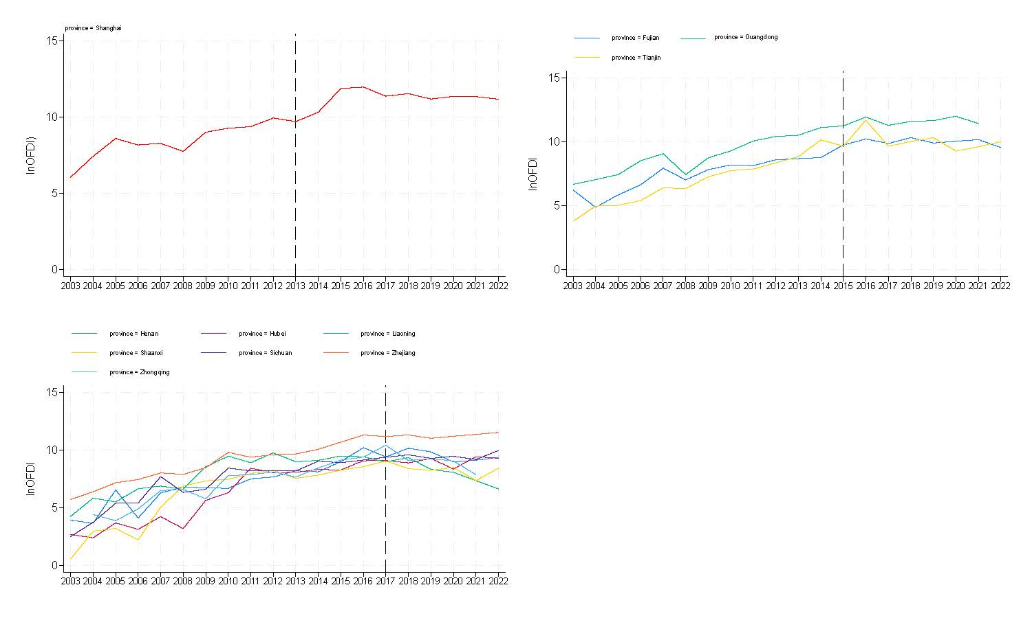
Note: The vertical bar signifies the year of establishment of the PFTZ.
Figure A1a. OFDI from PFTZs (2013 – 2017 batches)
Source: Figure created by authors.

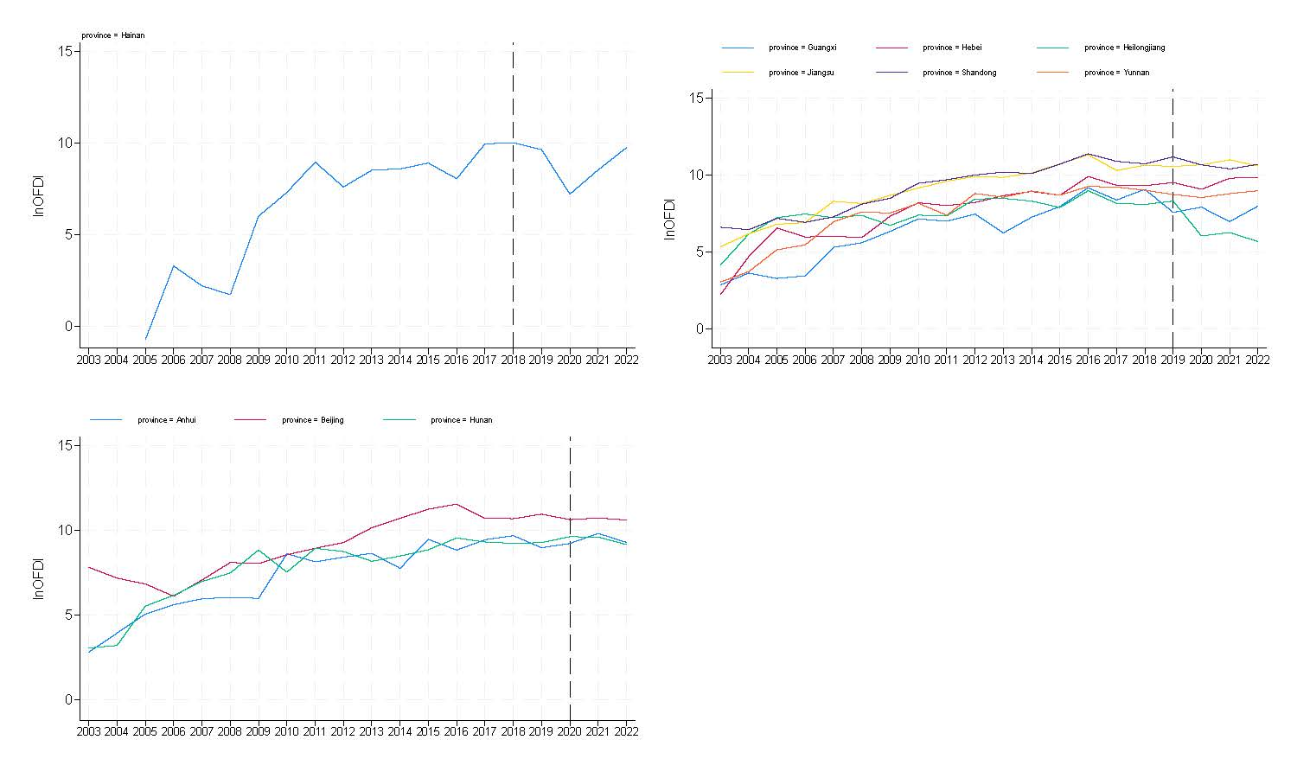
Note: The vertical bar signifies the year of establishment of the PFTZ.
Figure A1b. OFDI from PFTZs (2018 – 2020 batches)
Source: Figure created by authors.

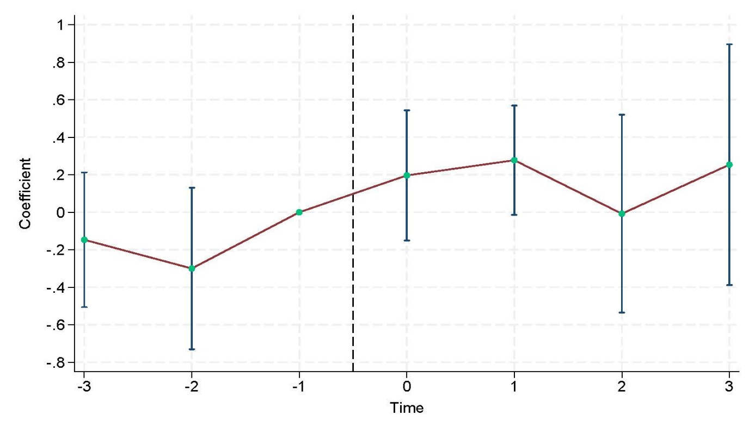Note: Produced using the lpdid estimator of Busch and Girardi (2023).
Figure A2. Parallel Trends: Event Study Results
Source: Figure created by authors.
References
Busch, A. and Girardi, D. (2023), "LPDID: Stata module implementing Local Projections Difference-in-Differences (LP-DiD)." Statistical Software Components S459273, Boston College Department of Economics.
Chen, C. (2015), “Determinants and motives of outward foreign direct investment by China's provincial firms”, Transnational Corporations, 23(1), pp. 1-28.
Farooq, U., Ahmed, J. and Khan, S. (2021), “Do the macroeconomic factors influence the firm's investment decisions? A generalized method of moments (GMM) approach”, International Journal of Finance and Economics, 26, 790–801.
Huang Y. (2007), “Ownership Biases and FDI in China: Evidence from Two Provinces”, Business and Politics, 9(1), pp. 1-45.
Li, R., Ao, Y. and Li, Z. (2021), “A Quasi-Natural Experiment Research about the Impact of FTZ Establishment on FDI to China”, Word Economy Studies, 8, pp. 91-106+137.
Wang, G., Hou, Y., Du, S. and Shen, C. (2023), “Do pilot free trade zones promote green innovation efficiency in enterprises? Evidence from listed companies in China”, Heliyon, 9(10), e21079.
Wong, H. D. W., B. Zhao, S. X., Qiang, W. W., and Lee, H. F. (2024), “The interaction between domestic and outward foreign direct investment in China: The influence of region-specific context”, PLoS One, 19(11), e0314109.
Yang, J., Li, Y., Dai, F. and Ni, J. (2024), “How can pilot free trade zones affect regional technology innovation? –evidence from China at the city level”, Applied Economics, 1–16. https://doi.org/10.1080/00036846.2024.2303408
Zhang, A. and Yu, Y. (2020), “Free Trade Zones and Urban Economic Growth: Capital, Technology, and Marketization - A Quasi-Natural Experiment Study Based on PSM-DID”, Exploring Economic Problems, 459(10), pp. 110–123.

Increasing GDPCap_{it} with GDP_{it} fixed implies that population decreases.

