Online Appendix

Table A1 Descriptive statistics

Variable | No. of obs. | Mean | STD | Minimum | Maximum
Gini of per capita income | 435 | 0.443 | 0.0586 | 0.2094 | 0.6319
Theil L of per capita income | 435 | 0.333 | 0.0911 | 0.0707 | 0.7129
Theil T of per capita Income | 435 | 0.405 | 0.1456 | 0.0751 | 1.2478
Mean per capita income | 435 | 0.455 | 0.1884 | 0.1525 | 1.4271
Proportion of households in non-agriculture | 435 | 0.665 | 0.2011 | 0.1934 | 1.0000
Mean years of education | 435 | 7.523 | 1.2390 | 3.8110 | 11.2993
Proportion of female-headed households | 435 | 0.177 | 0.0584 | 0.0000 | 0.3240

Source(s): Constructed based on the FIES in 1997, 2000, 2006, 2012 and 2018 (PSA, 1998, 2001, 2007, 2013, and 2019).

Table A2 Estimates of pooled OLS and fixed effects panel data models
Dependent variable: Income inequality measured by the Gini
 | Pooled OLS model |  |  | Fixed effects models
Independent variables | (1) |  |  | (2) |  | (3)
Mean per capita income | 1.707 | *** |  | 0.778 | *** | 0.828 | ***
 | (0.210) |  |  | (0.162) |  | (0.171)
Mean per capita income² | -2.511 | *** |  | -0.780 | *** | -0.475 | **
 | (0.321) |  |  | (0.231) |  | (0.238)
Mean per capita income³ | 1.120 | *** |  | 0.313 | *** | 0.136
 | (0.153) |  |  | (0.095) |  | (0.096)
Proportion of households in non-agriculture | -0.055 |  |  | -0.036 |  | -0.116 | ***
 | (0.034) |  |  | (0.027) |  | (0.039)
Mean years of education | -0.006 |  |  | -0.026 | *** | -0.015 | **
 | (0.006) |  |  | (0.007) |  | (0.006)
Proportion of female-headed households | 0.206 | *** |  | -0.082 |  | -0.050
 | (0.079) |  |  | (0.075) |  | (0.064)
Constant | 0.094 |  |  | 0.427 | *** | 0.231 | ***
 | (0.068) |  |  | (0.060) |  | (0.070)
Province-specific effects | No |  |  | Yes |  | Yes
Time-specific effects | Yes |  |  | No |  | Yes
No. of observations | 435 |  |  | 435 |  | 435
R squared | 0.264 |  |  | 0.690 |  | 0.808

Note(s): *** p < 0.01, ** p < 0.05, * p < 0.1. Values in parenthesis are robust standard errors.
Source(s): Estimated based on the FIES in 1997, 2000, 2006, 2012 and 2018 (PSA, 1998, 2001, 2007, 2013, and 2019).

Table A3 Estimates of spatial panel data models

Dependent variable: Income inequality measured by the Gini
 | Spatial Durbin model |  |  | Spatial Durbin model  with time-specific effects
Independent variables | (4) |  |  | (5)
Main effects of independent variables
Mean per capita income | 0.901 | *** |  | 0.902 | ***
 | (0.171) |  |  | (0.183)
Mean per capita income² | -0.763 | *** |  | -0.580 | **
 | (0.256) |  |  | (0.257)
Mean per capita income³ | 0.284 | *** |  | 0.184 | *
 | (0.108) |  |  | (0.105)
Proportion of households in non-agriculture | -0.056 | * |  | -0.089 | **
 | (0.035) |  |  | (0.039)
Mean years of education | -0.023 | *** |  | -0.016 | ***
 | (0.007) |  |  | (0.006)
Proportion of female-headed households | -0.104 |  |  | -0.056
 | (0.076) |  |  | (0.068)
Spatial effects of independent variables
Mean per capita income | -0.603 | ** |  | -0.155
 | (0.266) |  |  | (0.278)
Mean per capita income² | 0.310 |  |  | 0.088
 | (0.400) |  |  | (0.412)
Mean per capita income³ | -0.083 |  |  | -0.036
 | (0.165) |  |  | (0.170)
Proportion of households in non-agriculture | -0.062 | * |  | 0.054
 | (0.037) |  |  | (0.043)
Mean years of education | 0.011 |  |  | 0.019 | **
 | (0.009) |  |  | (0.009)
Proportion of female-headed households | 0.052 |  |  | 0.128
 | (0.113) |  |  | (0.108)
Province-specific effects | Yes |  |  | Yes
Time-specific effects | No |  |  | Yes
Spatial $ρ$ | 0.302 | *** |  | 0.036
 | (0.044) |  |  | (0.056)
No. of observations | 435 |  |  | 435

Note(s): *** p < 0.01, ** p < 0.05, * p < 0.1. Values in parenthesis are robust standard errors.
Source(s): Same as Table A2.

Table A4 Estimates of dynamic panel data models

Dependent variable: Income inequality measured by the Gini
 | Dynamic model (difference GMM estimation) |  |  | Dynamic model (system GMM estimation)
Independent variables | (6) |  |  | (7)
Income inequality measured by Gini (-1) | 0.360 | ** | 0.319 |  | **
 | (0.168) |  | (0.125)
Mean per capita income | 1.674 | *** | 1.764 |  | ***
 | (0.407) |  | (0.369)
Mean per capita income² | -1.875 | *** | -2.058 |  | ***
 | (0.610) |  | (0.559)
Mean per capita income³ | 0.723 | ** | 0.802 |  | ***
 | (0.284) |  | (0.262)
Proportion of households in non-agriculture | -0.377 | *** | -0.331 |  | ***
 | (0.064) |  | (0.056)
Mean years of education | -0.014 | * | -0.017 |  | **
 | (0.008) |  | (0.007)
Proportion of female-headed households | -0.220 | *** | -0.173 |  | **
 | (0.078) |  | (0.075)
Constant | -0.103 |  | -0.066
 | (0.110) |  | (0.091)
Province-specific effects | Yes |  | Yes
Sargan test p-value | 0.000 |  | 0.000
AR(1) test p-value | 0.000 |  | 0.000
AR(2) test p-value | 0.805 |  | 0.837
No. of observations | 261 |  | 348

Notes(s): *** p < 0.01, ** p < 0.05, * p < 0.1. Values in parenthesis are robust standard errors.
Source(s): Same as Table A2.

Table A5 Estimates of dynamic panel data models (Theil indices)

Dependent variable: Income inequality measured by the Theil Indices

 | Dynamic panel model (Arellano-Bover/Blundell-Bond system estimation)
 | Theil L index |  |  | Theil T index
Independent variables | (8) |  |  | (9)
Income inequality measured by Theil indices (-1) | 0.274 | ** |  | 0.147
 | (0.110) |  |  | (0.093)
Mean per capita income | 3.207 | *** |  | 5.032 | ***
 | (0.716) |  |  | (1.449)
Mean per capita income² | -3.791 | *** |  | -5.784 | ***
 | (1.070) |  |  | (2.123)
Mean per capita income³ | 1.493 | *** |  | 2.308 | **
 | (0.499) |  |  | (0.980)
Proportion of households in non-agriculture | -0.561 | *** |  | -0.693 | ***
 | (0.094) |  |  | (0.134)
Mean years of education | -0.030 | ** |  | -0.064 | ***
 | (0.013) |  |  | (0.022)
Proportion of female-headed households | -0.317 | ** |  | -0.492 | **
 | (0.125) |  |  | (0.230)
Constant | -0.408 | *** |  | -0.528 | **
 | (0.146) |  |  | (0.256)
Province-specific effects | Yes |  |  | Yes
Sargan test p-value | 0.000 |  |  | 0.000
AR(1) test p-value | 0.000 |  |  | 0.000
AR(2) test p-value | 0.981 |  |  | 0.575
No. of observations | 348 |  |  | 348

Notes(s): *** p < 0.01, ** p < 0.05, * p < 0.1. Values in parenthesis are robust standard errors.
Source(s): Same as Table A2.

Table A6 Estimates of spatial panel data models (Theil indices)

Dependent variable: Income inequality measured by the Theil Indices

 | Theil L index |  |  | Theil T index
Independent variables | (10) |  |  | (11)
Main effects of independent variables
Mean per capita income | 1.660 | *** |  | 3.238 | ***
 | (0.308) |  |  | (0.637)
Mean per capita income² | -1.216 | *** |  | -2.638 | ***
 | (0.421) |  |  | (0.876)
Mean per capita income³ | 0.418 | ** |  | 0.967 | ***
 | (0.171) |  |  | (0.373)
Proportion of households in non-agriculture | -0.176 | *** |  | -0.335 | ***
 | (0.064) |  |  | (0.119)
Mean years of education | -0.028 | ** |  | -0.072 | ***
 | (0.012) |  |  | (0.021)
Proportion of female-headed households | -0.116 |  |  | -0.309
 | (0.107) |  |  | (0.202)
Spatial effects of independent variables
Mean per capita income | -0.164 |  |  | 0.003
 | (0.472) |  |  | (0.784)
Mean per capita income ² | -0.021 |  |  | -0.509
 | (0.701) |  |  | (1.127)
Mean per capita income ³ | 0.034 |  |  | 0.304
 | (0.288) |  |  | (0.463)
Prop. of households in non-agriculture | -0.134 |  |  | -0.182
 | (0.078) |  |  | (0.156)
Mean years of education | 0.037 | ** |  | 0.066 | **
 | (0.014) |  |  | (0.028)
Proportion of female-headed households | 0.165 |  |  | 0.280
 | (0.176) |  |  | (0.3019
Province-specific effects | Yes |  |  | Yes
Time-specific effects | Yes |  |  | Yes
Spatial $ρ$ | 0.025 |  |  | -0.036
 | (0.061) |  |  | (0.062)
No. of observations | 435 |  |  | 435

Notes(s): *** p < 0.01, ** p < 0.05, * p < 0.1. Values in parenthesis are robust standard errors.
Source(s): Same as Table A2.

Figure A1 Augmented Kuznets curve

Figure A2 Three island groups

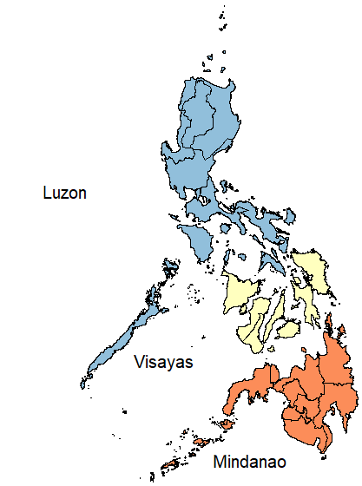

Figure A3 Semi-N-shaped augmented Kuznets curve

Figure A4 Relationship between the Gini coefficient of educational inequality and mean years of education

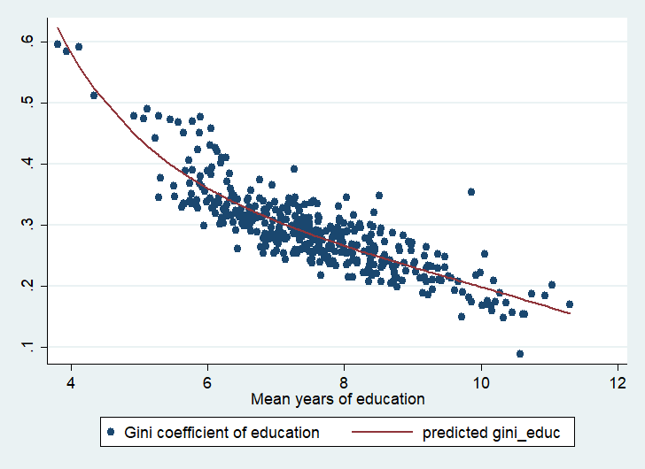
Source(s): Constructed based on the FIES in 1997, 2000, 2006, 2012 and 2018 (PSA, 1998, 2001, 2007, 2013, and 2019).

Figure A5 Gini of income inequality by province in 2018
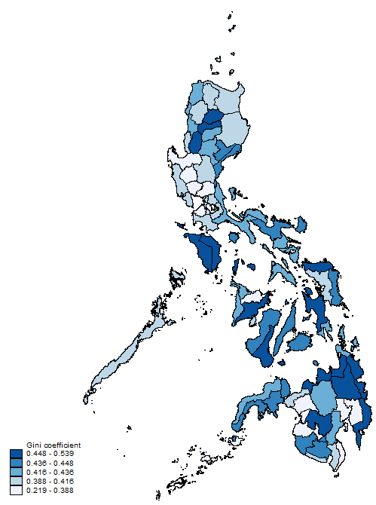
Source(s): Constructed based on the 2018 FIES (PSA, 2019).

Figure A6 Provinces in the top 20% (developed provinces) and the bottom 80% (developing provinces)
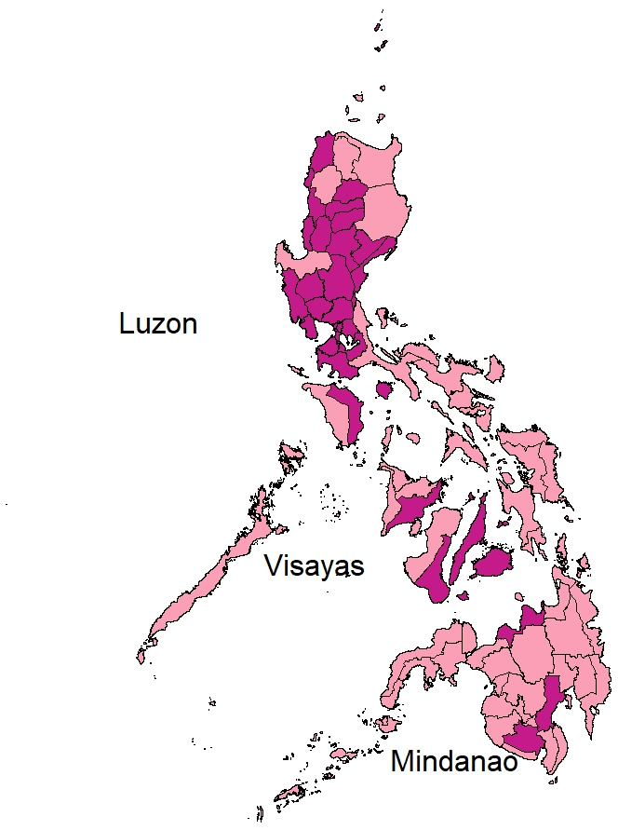
Source(s): Same as Figure A5.

Figure A7 Relationship between income Gini and mean per capita income
Figure A7A Provinces in the bottom 80% (developing provinces)
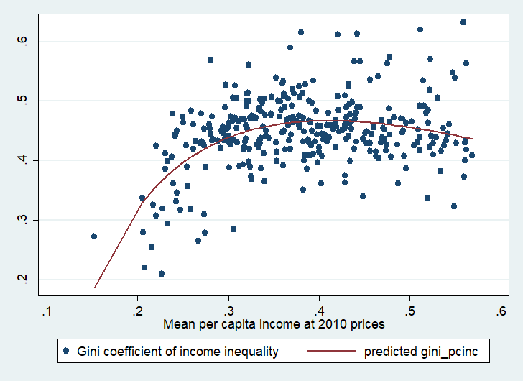
Figure A7B Provinces in the top 20% (developed provinces)
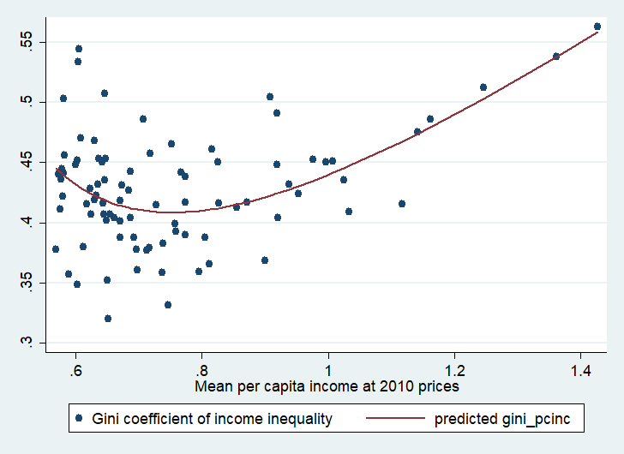
Source(s): Same as Figure A4.

Figure A8 Changes in the GDP Shares of agriculture, manufacturing, and high-productivity services, 2000 – 2020

Source(s): Constructed based on regional GDP by industry, 2000-2020 (PSA, 2024).

