ONLINE APPENDIX: TABLES AND FIGURES

Table A1. Country weights in the synthetic control indicator for exports
Donor Country | ASEAN-5  (I) | Singapore  (II) | Malaysia  (III) | Indonesia  (IV) | Thailand  (V) | Philippines  (VI) | High-Tech ASEAN-5  (VII)
Canada | 0 | 0 | 0 | 0 | 0 | 0 | 0
France | 0 | 0 | 0.459 | 0 | 0 | 0 | 0
Germany | 0.608 | 0.761 | 0 | 0 | 0 | 0 | 0.637
Norway | 0 | 0 | 0.484 | 0 | 0 | 0.086 | 0
Switzerland | 0 | 0.769 | 0 | 0 | 0 | 0 | 0
UK | 0 | 0 | 0 | 0 | 0 | 0 | 0
USA | 0 | 0 | 0.058 | 0 | 0 | 0 | 0
Italy | 0 | 0 | 0 | 0 | 0 | 0 | 0
Spain | 0 | 0 | 0 | 0 | 0.687 | 0 | 0
Netherlands | 0.131 | 0 | 0 | 0.425 | 0 | 0.182 | 0.116
Sweden | 0 | 0 | 0 | 0.091 | 0 | 0 | 0
Uruguay | 0.158 | 0 | 0 | 0.406 | 0 | 0.575 | 0.248
Belgium | 0 | 0 | 0 | 0 | 0 | 0.008 | 0
Taiwan | 0.103 | 0.16 | 0 | 0 | 0.313 | 0.148 | 0.103

Table A2. Estimated impact of the FTA on exports of ASEAN-5 countries to Korea (percentage)
Year | ASEAN-5 | Singapore | Malaysia | Indonesia | Thailand | Philippines | High-Tech ASEAN-5
 | (I) | (II) | (III) | (IV) | (V) | (VI) | (VII)
2007 | 14.6 | 39.9 | 9.0 | 6.2 | 12.6 | 9.1 | 31.3
2008 | 19.3 | 47.1 | 15.2 | 17.8 | 14.4 | 28.0 | 43.4
2009 | 27.3 | 57.2 | 10.6 | 19.2 | 37.5 | 30.6 | 45.8
2010 | 21.9 | 43.8 | 12.4 | 27.7 | 34.3 | 57.9 | 30.7
2011 | 25.2 | 42.6 | 19.0 | 34.6 | 29.6 | 36.1 | 29.2
2012 | 29.8 | 44.7 | 32.9 | 32.4 | 43.5 | 42.2 | 31.1
2013 | 27.9 | 45.5 | 22.3 | 29.9 | 40.0 | 50.0 | 33.6
2014 | 24.1 | 46.6 | 24.5 | 30.6 | 44.7 | 15.0 | 22.3
2015 | 18.4 | 37.6 | 33.2 | 25.1 | 43.3 | 38.5 | 19.0
2016 | 14.4 | 34.4 | 33.1 | 18.6 | 43.2 | 26.2 | 23.0
2017 | 24.4 | 16.1 | 43.8 | 25.3 | 46.0 | 67.2 | 19.0
2018 | 15.7 | 40.0 | 55.1 | 40.4 | 41.8 | 40.1 | 13.5
2019 | 22.5 | 31.2 | 50.7 | 39.2 | 45.2 | 59.4 | 12.9
2020 | 32.8 | 41.7 | 62.1 | 36.7 | 42.5 | 58.6 | 28.3
2021 | 32.1 | 40.1 | 61.1 | 34.3 | 47.4 | 39.5 | 24.3
2022 | 27.2 | 35.6 | 61.3 | 23.1 | 40.0 | 45.5 | 13.6
Average | 23.6 | 40.3 | 34.1 | 27.6 | 37.9 | 40.2 | 26.3
Impact = ((Real-Synthetic)/Real)*100

Table A3. Analysis of the difference between ASEAN-5 exports and the synthetic control indicator
 | Total exports |  | High-tech exports
Period | 1995–2006 | 2007–2022 | 1995–2006 | 2007–2022
 | (I) | (II) | (III) | (IV)
Mean | -3.726 | 5599.817*** | 60.286 | 3471.710***
(SE of the mean) | (167.270) | (516.723) | (116.177) | (479.383)
SE of the difference | 579.440 | 2066.891 | 402.488 | 1917.530
Ljung–Box Test order 1 | 1.221 | 5.397 | 0.615 | 7.9818
(p-value) | (0.269) | (0.020) | (0.433) | (0.005)
Ljung–Box Test order 2 | 1.552 | 5.594 | 1.007 | 10.673
(p-value) | (0.460) | (0.061) | (0.605) | (0.005)
SE: standard error; significance: ***p-value < 0.01

Table A4. Linear trend adjustment for ASEAN-5 total exports prior to the FTA, 1995–2006
 | Total exports | High-tech exports
 | (I) | (II)
Intercept | 3760.075*** | 2399.605***
(SE) | (570.088) | (511.261)
Trend | 759.085*** | 605.094***
(SE) | (87.792) | (78.733)
Residual SE | 1049.843 | 941.512
Ljung–Box Test order 1 | 0.476 | 0.825
(p-value) | (0.490) | (0.364)
Ljung–Box Test order 2 | 4.232 | 3.335
(p-value) | (0.121) | (0.189)
SE: standard error; significance: ***p-value < 0.01

Figure A1. Trends in ASEAN-5 exports vs. synthetic ASEAN-5 exports.
Treatment year: 2007. Exports in million USD.
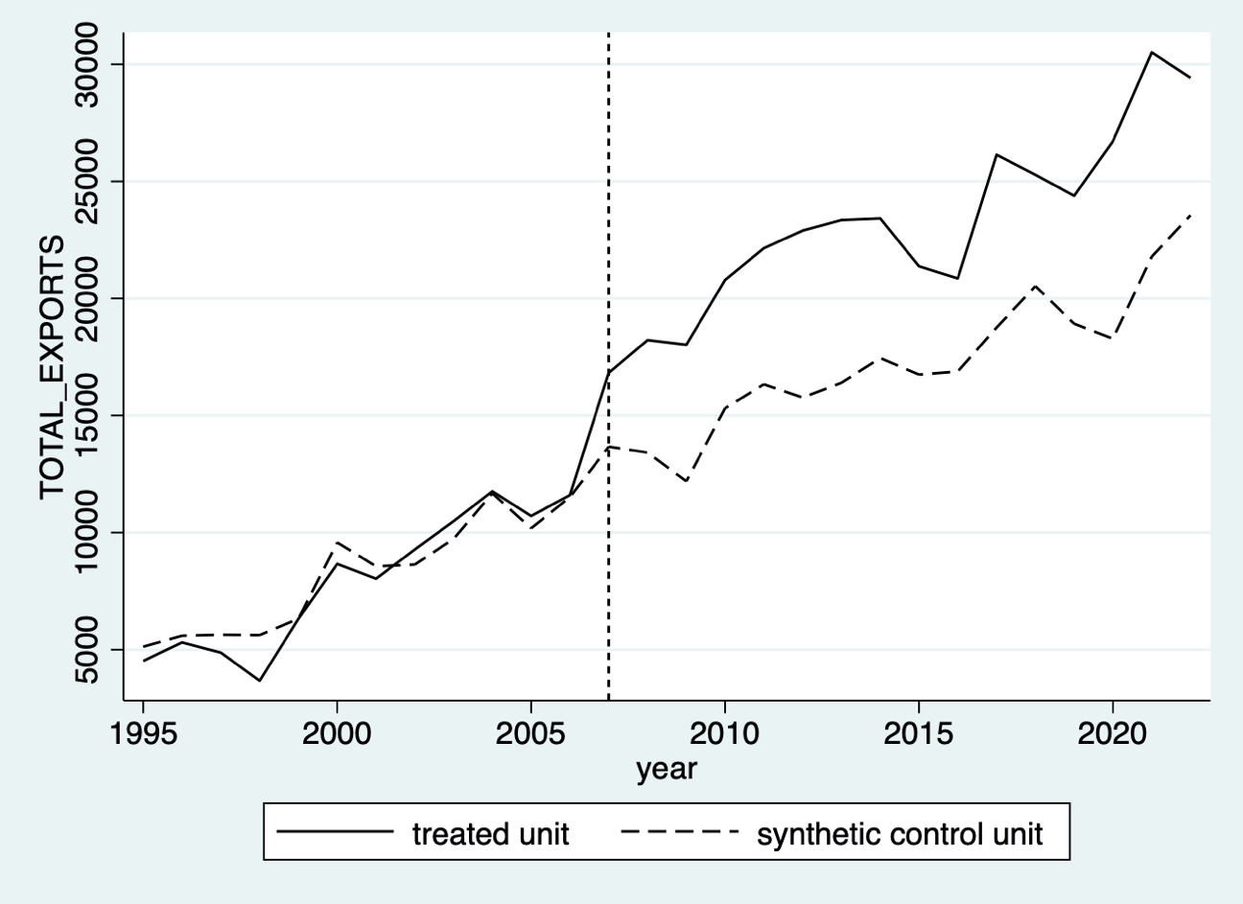

Figure A2. Trends in ASEAN-5 country member exports vs. ASEAN-5 country member synthetic exports.
Treatment year: 2007. Exports in million USD.
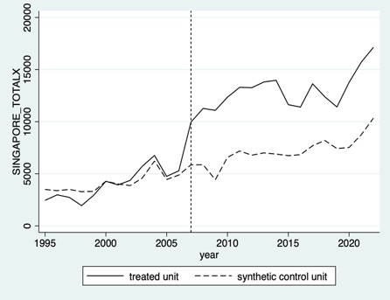

Figure A3. Trends in ASEAN-5 high-tech exports vs. synthetic ASEAN-5 high-tech exports.
Treatment year: 2007. Exports in million USD.
Figure A4. In-time placebo test. Trends in ASEAN-5 total exports vs. synthetic ASEAN-5 total exports.
Treatment year: 2006. Exports in million USD.
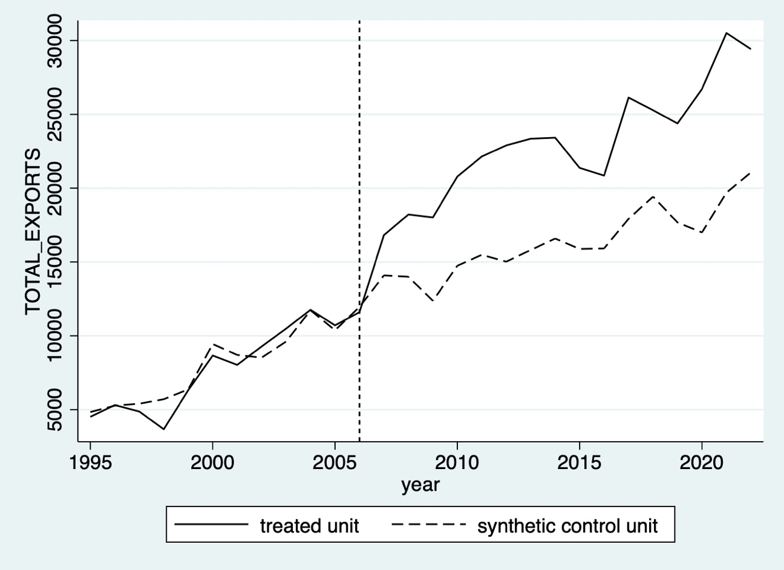

Figure A5. Leave-one-out test. Trends in ASEAN-5 total exports vs. synthetic ASEAN-5 total exports dropping country by country.
Treatment year: 2007. Total exports in million USD.
Note: The analysis is performed for donor countries with nonzero weighting in the SC.
Figure A6. In-space placebo test. Estimated and placebo effects. Total exports.

Figure A7. In-space placebo test. P-values post-treatment period. Total exports.

Figure A8. In-space placebo test. Ratio of post-MSPE to pre-MSPE. Total exports.

Figure A9. Classic and bias-corrected gap paths. Total exports.
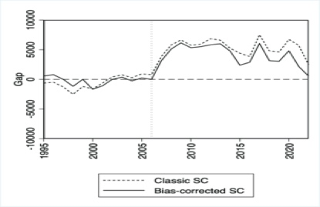

Figure A10. In-time placebo test. Trends in ASEAN-5 members’ total exports vs. synthetic ASEAN-5 members’ total exports.
Treatment year: 2006. Total exports in million USD.

Figure A11. Leave-one-out test. Trends in country total exports vs. synthetic ASEAN-5 dropping country by country.
Treatment year: 2007. Total exports in million USD.
Singapore

Malaysia

Indonesia

Thailand

Philippines
Note: The analysis is performed for donor countries with nonzero weighting in the SC.
Figure A12. In-space placebo test: Estimated and placebo effects on
ASEAN-5 members. Total exports.
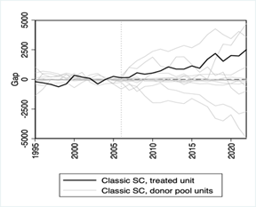
Malaysia
Singapore
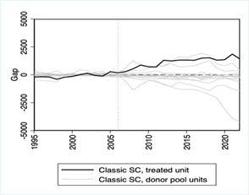
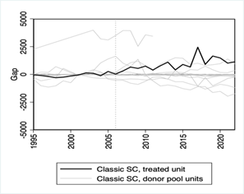
Thailand
Philippines
Indonesia
Figure A13. Classic and bias-corrected gap paths. ASEAN-5 members. Total exports.
Malaysia
Singapore
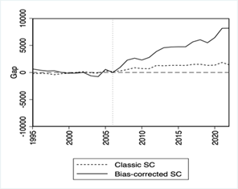
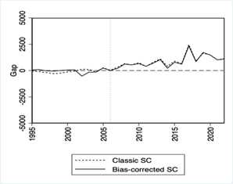
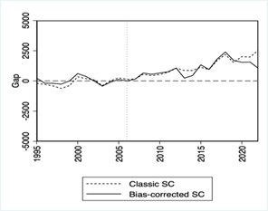
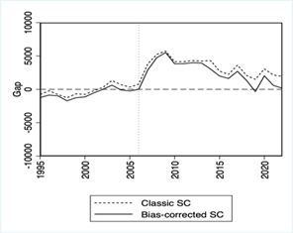
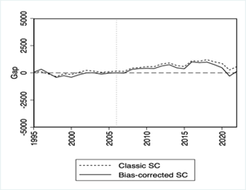
Philippines
Thailand
Indonesia

Figure A14. In-time placebo test. Trends in ASEAN-5 high-tech exports vs. synthetic ASEAN-5 high-tech exports.
Treatment year: 2006. High-tech exports in million USD.

Figure A15. Leave-one-out test. Trends in ASEAN-5 high-tech exports vs. synthetic ASEAN-5 dropping country by country.
Treatment year: 2007. High-tech exports in million USD.
Note: The analysis is performed for donor countries with nonzero weighting in the SC.
Figure A16. In-space placebo test. Estimated and placebo effects. High-tech exports.
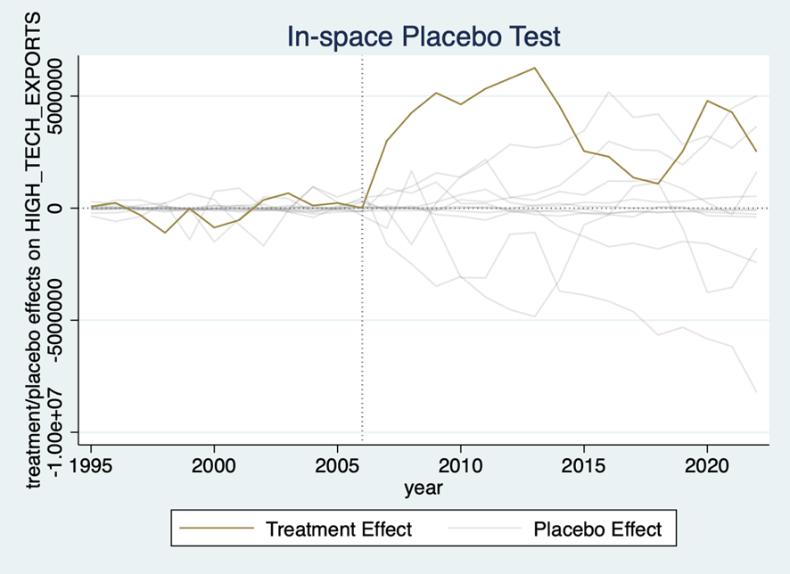
Figure A17. In-space placebo test. Estimated and placebo effects. High-tech exports 1995–2014.
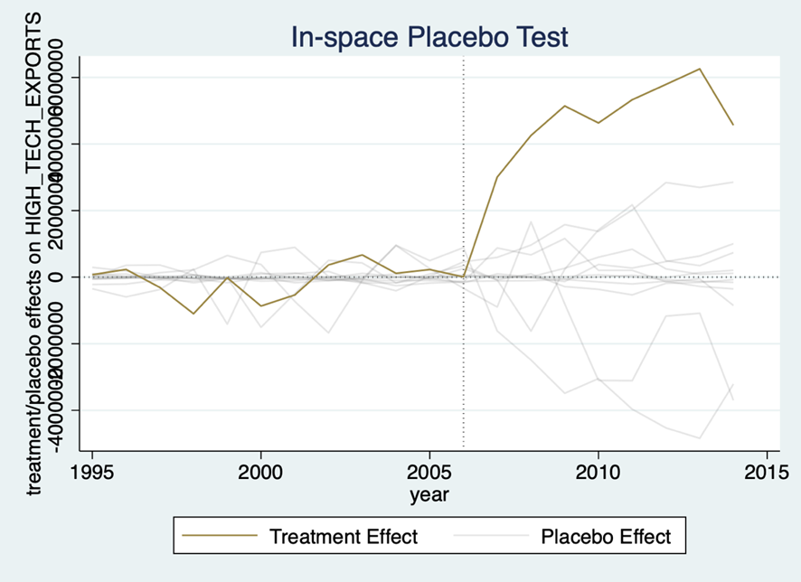

Figure A18. In-space placebo test. P-values post-treatment period. High-tech exports, 2007–2014.
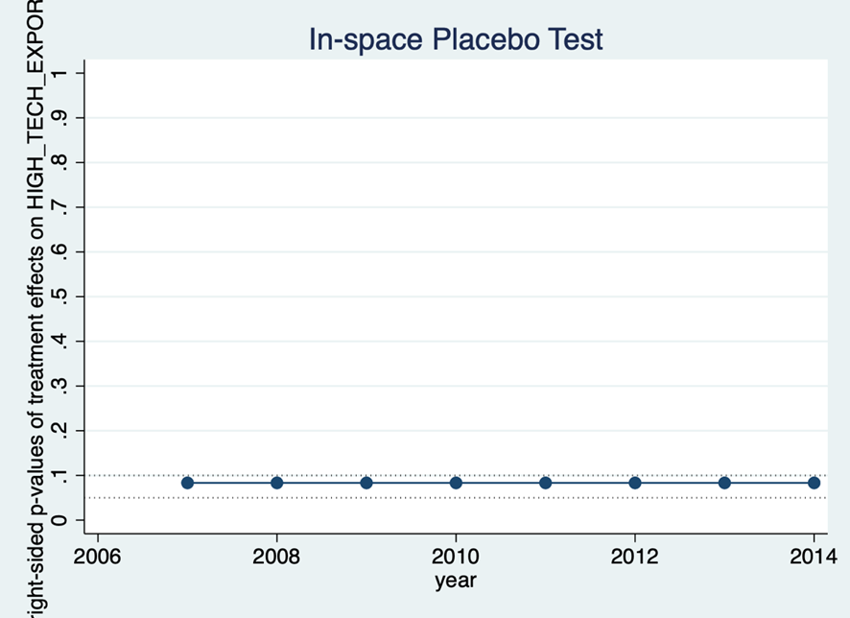
Figure A19. In-space placebo test. Ratio of post-MSPE to pre-MSPE. High-tech exports, 2007–2014.

Figure A20. Classic and bias-corrected gap paths. High-tech exports.

