Online Appendix

Solid Waste Treatment
Economic Growth
Foreign Direct Investment
H1 (+)
H3 (+)

H2 (+)

Controls: GDP per capita, Governance quality, Human capital, Infrastructure, Education, Entrepreneurship, and Non-state investment capital.

Figure A1. Conceptual framework and hypotheses.

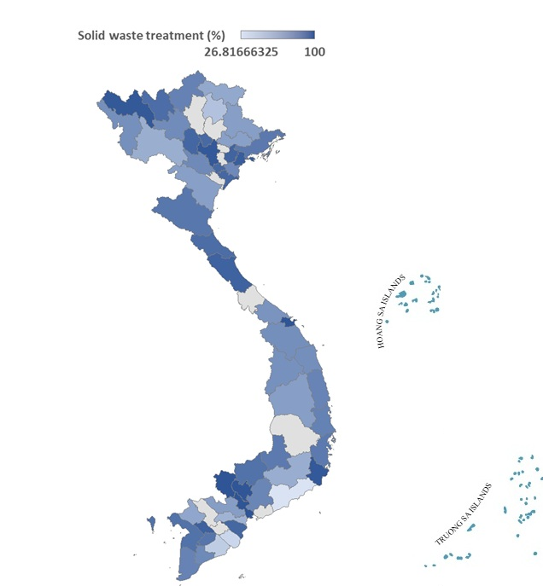
Figure A2. The distribution of SWT across provinces of Vietnam over the period 2006-2021 on average. Source: Authors' own work.

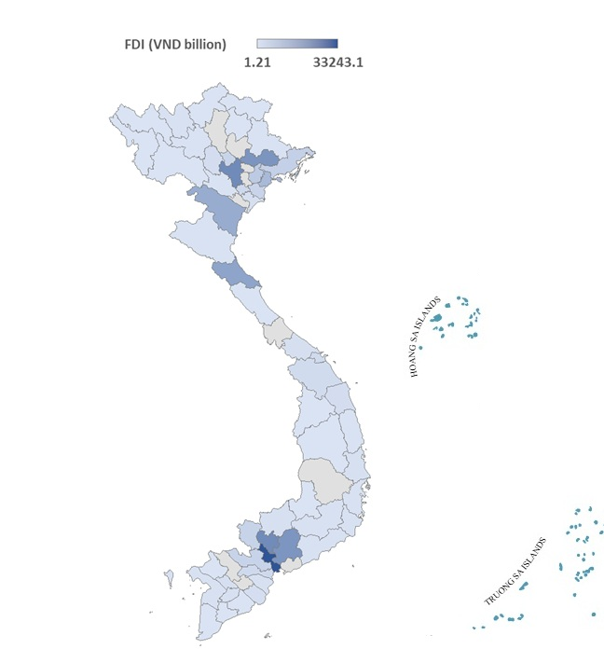

Figure A3. The distributions of FDI across provinces of Vietnam over the period 2006-2021 on average. Source: Authors' own work.

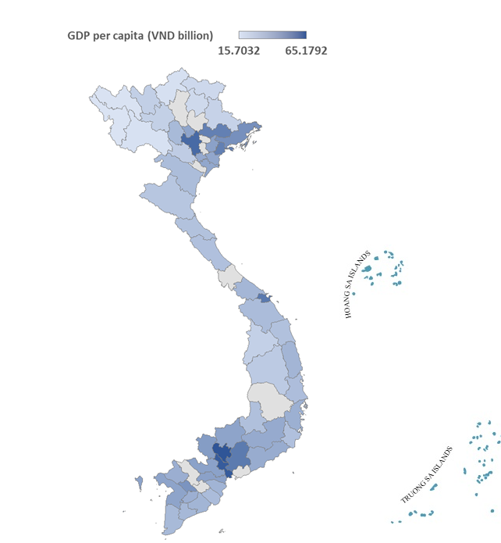

Figure A4. The distribution income level across provinces of Vietnam over the period 2006-2021 on average. Source: Authors' own work.

Table A1. Variables’ descriptions.
Variables | Measurements | Sources*
FDI | Foreign direct investment inflows (registered, constant 2010 VND billion) | VGSO
SWT | Treated solid waste (%) | VGSO
GDPP | Gross domestic product per capita (constant 2010 VND million) | VGSO
CAP | Total investment capital from the non-state sector, excluding FDI (constant 2010 VND billion) | VGSO
LGQ | Local governance quality (estimated number, ranging 1 – 10) | PAPI
LABOR | Trained labour force (%) | VGSO
TEL | The number of fixed and mobile telephone subscribers (thousand) | VGSO
FIRM | The average number of active businesses per 1000 people | VGSO
EDU | Education, proxied by percentage of high school graduates relative to the total number of candidates (%) | VGSO
*Abbreviation: Vietnam’s General Statistics Office (VGSO), Vietnam Provincial Governance and Public Administration Performance Index (PAPI). Source: Authors' own work.

Table A2. Data summary statistics.
Variables | Mean | St.var | Min | Max | Obs
FDI | 3,722.383 | 8,955.508 | 0 | 68,587.500 | 553
SWT | 75.369 | 24.909 | 3.300 | 100 | 637
GDPP | 33.307 | 15.696 | 6.804 | 89.196 | 604
CAP | 14,173.350 | 30,880.780 | 83.600 | 331,336 | 756
LGQ | 6.063 | 0.259 | 5.265 | 6.770 | 693
LABOR | 17.208 | 7.721 | 4.500 | 50.300 | 630
TEL | 1,491.903 | 3,894.729 | 18.300 | 42,244.000 | 612
FIRM | 3.749 | 4.106 | 0.100 | 29.000 | 756
EDU | 89.615 | 10.964 | 38.570 | 100 | 604

Table A3. CD-test and stationarity-test results.
Variables | CD-test | CADF (Level) | CADF (First-difference)
FDI | 76.329*** | -4.785*** | -12.638***
SWT | 85.657*** | -2.965*** | -8.539***
GDPP | 120.938*** | -2.785*** | -8.493***
CAP | 144.580*** | -2.244** | -7.662***
LGQ | 3.941*** | -3.685*** | -7.123***
LABOR | 72.138*** | -4.187*** | -11.278***
TEL | 65.384*** | -2.783*** | -7.329***
FIRM | 136.831*** | -2.320** | -8.335***
EDU | 86.856*** | -2.131 | -9.472***
The optimal lag lengths are determined by the Akaike Information Criterion (AIC). Statistical significance is indicated by *, **, and ***, for the 10%, 5%, and 1% levels, respectively. Source: Authors' own work.
Table A4. Estimation results for Eq. 1
Dependent variable: LnFDI
Regressors | (1.1) |  | (1.2)
Regressors | FE | FGLS | FE | FGLS
SWT | 0.003***  (7.82) | 0.006***  (4.54) | 0.003***  (3.12) | 0.005***  (5.75)
LnGDPP |  |  | 1.028***  (4.23) | 1.036***  (5.12)
LnLGQ |  |  | 0.503***  (4.66) | 1.419***  (3.44)
LABOR |  |  | 0.025**  (2.25) | 0.038***  (3.21)
LnTEL |  |  | 0.271**  (2.29) | 0.316***  (4.13)
LnFIRM |  |  | 0.642***  (2.36) | 0.407**  (3.61)
Year FE | Yes | Yes | Yes | Yes
Province FE | Yes | Yes | Yes | Yes
Constant | 7.155*** | 6.151*** | 8.005*** | 9.652***
Obs. | 553 | 553 | 421 | 421
Hausman | 187.91*** |  | 155.35***
Wooldridge | 174 |  | 168
MW-P | 0.000 | 0.378 | 0.000 | 0.364
LM-P | 0.372 |  | 0.476
T-statistics for FE and Z-statistics for FGLS are presented in brackets. The symbols ***, **, and * represent statistically significant levels at 1%, 5%, and 10%, respectively. P represents the P-value of the respective tests. Source: Authors' own work.

Table A5. Mediation analysis with Sobel test results
Specification | SWT → FDI (α₁) | FDI → GDPP (β₂) | Indirect effect (α₁×β₂) | Sobel Z-stat | P-value
FE (baseline) | 0.003*** | 0.297*** | 0.0009*** | 3.21 | 0.001
FGLS (baseline) | 0.006*** | 0.409*** | 0.0025*** | 4.08 | 0.000
FE (full model) | 0.003*** | 0.109** | 0.0003*** | 2.14 | 0.035
FGLS (full model) | 0.005*** | 0.235*** | 0.0012*** | 3.67 | 0.000
Indirect effect is computed as the product of coefficients from Eq. 1 and Eq. 2. Sobel test evaluates the significance of the indirect effect using the delta method. ***, ** denote significance at 1% and 5% levels, respectively. Source: Authors' own work.

Table A6. Provincial heterogeneity by SWT capacity
Dependent var.: LnFDI | Low-SWT provinces | High-SWT provinces
SWT | 0.002** (2.41) | 0.006*** (6.84)
LnGDP | 0.735*** (3.81) | 1.246*** (5.84)
LnLGQ | 0.381* (1.88) | 1.673** (4.95)
LABOR | 0.019* (1.79) | 0.051*** (3.74)
LnTEL | 0.186* (1.92) | 0.358** (4.66)
LnFIRM | 0.288* (1.81) | 0.612*** (4.25)
Year FE | Yes | Yes
Province FE | Yes | Yes
Constant | 2.376*** | 2.583***
Provinces | 30 | 33
MW-P | 0.338 | 0.436
Z-statistics for FGLS are presented in brackets. The symbols ***, **, and * represent statistically significant levels at 1%, 5%, and 10%, respectively. P represents the P-value of the respective tests. Source: Authors' own work.

Table A7. Provincial heterogeneity by FDI intensity
Dependent var.: LnGDPP | Low-FDI provinces | High-FDI provinces
SWT | 0.001* (1.82) | 0.003*** (4.96)
LnFDI | 0.072* (1.97) | 0.279*** (6.34)
LnCAP | 0.275*** (4.09) | 0.412*** (6.74)
LABOR | 0.016* (1.85) | 0.077*** (3.98)
LnLGQ | 0.462* (1.93) | 1.103*** (4.27)
LnEDU | 0.114** (2.18) | 0.359*** (3.96)
Year FE | Yes | Yes
Province FE | Yes | Yes
Constant | 2.376*** | 2.548***
Provinces | 48 | 15
MW-P | 0.421 | 0.268
Z-statistics for FGLS are presented in brackets. The symbols ***, **, and * represent statistically significant levels at 1%, 5%, and 10%, respectively. P represents the P-value of the respective tests. Source: Authors' own work.

Table A8. Provincial heterogeneity by income level
Dependent var.: LnGDPP | Low-income provinces | High-income provinces
SWT | 0.001 (1.49) | 0.003*** (4.15)
LnFDI | 0.094* (1.75) | 0.267*** (5.86)
LnCAP | 0.232*** (4.36) | 0.395*** (6.21)
LABOR | 0.024* (1.91) | 0.052*** (4.47)
LnLGQ | 0.519** (2.13) | 1.283** (3.76)
LnEDU | 0.108* (1.87) | 0.369*** (3.74)
Year FE | Yes | Yes
Province FE | Yes | Yes
Constant | 2.347*** | 2.586**
Provinces | 33 | 30
MW-P | 0.325 | 0.284
Z-statistics for FGLS are presented in brackets. The symbols ***, **, and * represent statistically significant levels at 1%, 5%, and 10%, respectively. P represents the P-value of the respective tests. Source: Authors' own work.

Table A9. Interaction effects: SWT and FDI intensity (Eq. 2)
Dependent variable: LnGDPP
Regressors | FE | FGLS
SWT | 0.001** (2.23) | 0.002*** (4.85)
LnFDI | 0.118** (2.36) | 0.241*** (5.42)
STW×LnFDI | 0.002** (2.34) | 0.003** (2.18)
LnCAP | 0.431*** (5.42) | 0.348** (2.39)
LABOR | 0.031* (1.98) | 0.053*** (4.57)
LnLGQ | 1.705*** (4.06) | 0.487** (2.26)
LnEDU | 0.196** (2.24) | 0.312*** (5.78)
Year FE | Yes | Yes
Province FE | Yes | Yes
Constant | 2.418*** | 2.603***
Obs. | 421 | 421
Hausman | 155.76***
Wooldridge | 137
MW-P | 0.000 | 0.318
LM-P | 0.276
Lagged SWT (t-1) is used. T-statistics (FE) and Z-statistics (FGLS) in parentheses.
***, ** denote 1% and 5% significance. Source: Authors' own work.

Table A10. Robustness check: Lagged SWT and FDI (Eq. 1)
Dependent variable: LnFDI
Regressors | FE | FGLS
L.SWT | 0.002** (2.29) | 0.004*** (3.38)
LnGDPP | 0.985*** (3.58) | 1.004** (2.36)
LnLGQ | 0.473*** (4.21) | 1.248*** (3.54)
LABOR | 0.021** (2.15) | 0.034*** (3.58)
LnTEL | 0.244* (1.94) | 0.301** (2.24)
LnFIRM | 0.591** (2.24) | 0.358* (1.87)
Year FE | Yes | Yes
Province FE | Yes | Yes
Constant | 7.824*** | 8.039***
Obs. | 389 | 389
Hausman | 154.26***
Wooldridge | 145
MW-P | 0.000 | 0.278
LM-P | 0.396
Lagged SWT (t-1) is used. T-statistics (FE) and Z-statistics (FGLS) in parentheses.
***, ** denote 1% and 5% significance. Source: Authors' own work.

Table A11. Robustness check: Lagged SWT, FDI and economic growth (Eq. 2)
Dependent variable: LnGDPP
Regressors | FE | FGLS
L.SWT | 0.001** (2.25) | 0.002** (2.18)
LnFDI | 0.094** (2.14) | 0.107*** (5.34)
LnCAP | 0.394*** (6.75) | 0.329** (2.36)
LABOR | 0.029* (1.93) | 0.051*** (3.95)
LnLGQ | 1.672*** (3.78) | 0.462** (2.23)
LnEDU | 0.187** (2.16) | 0.294*** (6.58)
Year FE | Yes | Yes
Province FE | Yes | Yes
Constant | 2.372*** | 2.548***
Obs. | 389 | 389
Hausman | 135.64***
Wooldridge | 128
MW-P | 0.000 | 0.266
LM-P | 0.358
Lagged SWT (t-1) is used. T-statistics (FE) and Z-statistics (FGLS) in parentheses.
***, ** denote 1% and 5% significance. Source: Authors' own work.

Table A12. Estimation results for Eq. 1 and Eq. 2 by System-GMM and diagnostic tests
Variables | FDI equation | Growth equation
 | Dependent var: LnFDI | Dependent var: LnGDPP
LnFDI (t-1) | 0.859*** (0.052)
LnGDPP (t-1) |  | 0.871*** (0.038)
SWT | 0.006** (0.048) | 0.005** (0.021)
LnFDI |  | 0.316*** (0.018)
LnGDPP | 0.672*** (0.091)
LnCAP |  | 0.319*** (0.038)
LnLGQ | 0.624*** (0.302) | 0.573*** (0.019)
LABOR | 0.108* (0.105) | 0.051** (0.028)
LnEDU |  | 0.288** (0.126)
LnFIRM | 0.548*** (0.276)
LnTEL | 0.184** (0.092)
Year FE | Yes | Yes
Province FE | Yes | Yes
Constant | 9.356*** | 2.627***
Obs. | 358 | 358
Provinces | 63 | 63
Instruments | 29 | 29
AR(1)-P | 0.034 | 0.019
AR(2)-P | 0.427 | 0.359
Hansen J-test-P | 0.526 | 0.278
Robust Windmeijer-corrected standard errors are reported in parentheses. ***, **, * denote significance at 1%, 5%, and 10% levels. P represents the P-value of the respective tests. Source: Authors' own work.

