Online Appendix

Conduct
Number of competitors
Product differentiation
Barriers to entry
Price-taking
Tacit collusion
Profitability
Productivity
Market Structure
Performance
Figure A1: The SCP Paradigm Framework

SCP paradigm
Knowledge Gaps
Empirical Questions
Theory
Limited understanding in the ASEAN firm-level context
Economies of scale
Risk aversion
Unclear balance of scale and diseconomies
Limited theory for its association with CEO gender
Contribution 1: Apply SCP + institutions with firm-level competition measures.
Contribution 2: Distinguish economies versus diseconomies using firm-size effects.
Contribution 3: Model CEO gender and risk aversion jointly with competition and size.
How does market competition influence corporate performance in ASEAN?
What role does firm size play in corporate performance?
How does CEO gender affect corporate performance?
Figure A2: The Conceptual Framework of This Research

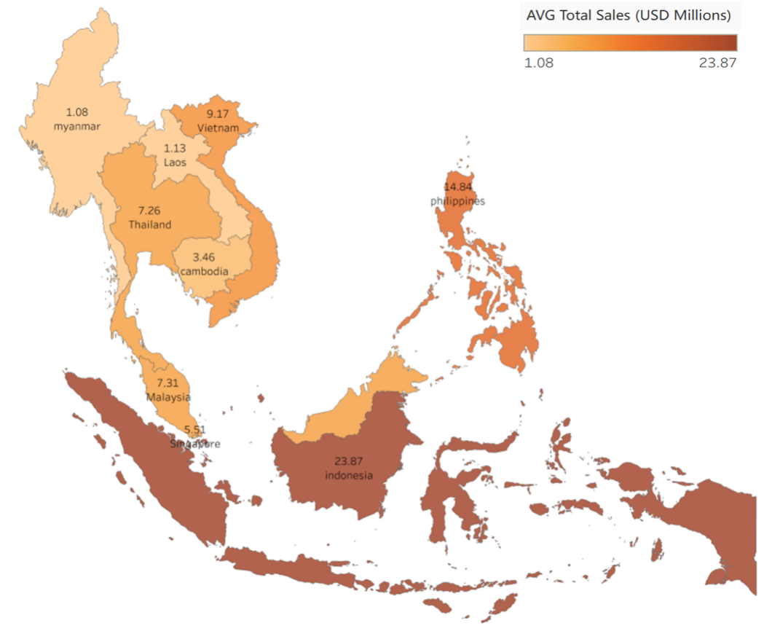
Figure A3: Firm-Level Annual Sales Performance Across ASEAN Countries

Table A1: Descriptive Statistics

 | Variable | N | Mean | SD | Min | Max
 | ASEAN
 | Total Annual Sales (million USD) | 6,199 | 15.80 | 156.00 | 0.0004 | 6500.00
 | Competitors with similar products/services (unit: 1000) | 6,199 | 0.05 | 3.81 | -0.009 | 300
 | Company size (dummy: small=1) | 6,199 | 0.41 | 0.49 | 0 | 1
 | Gender of CEO (dummy: female=1) | 6,199 | 0.27 | 0.44 | 0 | 1
 | Income level (dummy: higher-income countries=1) | 6,199 | 0.56 | 0.50 | 0 | 1
 | Years operated | 6,199 | 38.57 | 195.38 | 0 | 2032
 | Has globally recognized quality certification (dummy: yes=1) | 6,199 | 0.23 | 0.42 | 0 | 1
 | Has its own company website (dummy: yes=1) | 6,199 | 0.45 | 0.5 | 0 | 1
 | Legal Status (dummy: sole proprietorship=1) | 6,199 | 0.49 | 0.5 | 0 | 1
 | Total Annual Raw Material Cost (million USD) | 6,199 | 9.30 | 349 | 0 | 27200
 | Total Annual Labor Cost (million USD) | 6,199 | 0.70 | 5.86 | 0 | 333
 | Laos
 | Total Annual Sales (million USD) | 120 | 0.73 | 3.22 | 0.00 | 31.60
 | Competitors with similar products/services (unit: 1000) | 120 | 0.01 | 0.02 | 0.00 | 0.22
 | Company size (dummy: small=1) | 120 | 0.57 | 0.50 | 0.00 | 1.00
 | Gender of CEO (dummy: female=1) | 120 | 0.25 | 0.43 | 0.00 | 1.00
 | Malaysia
 | Total Annual Sales (million USD) | 1,089 | 11.70 | 48.50 | 0.00 | 968.00
 | Competitors with similar products/services (unit: 1000) | 1,089 | 0.28 | 9.09 | 0.00 | 300.00
 | Company size (dummy: small=1) | 1,089 | 0.43 | 0.49 | 0.00 | 1.00
 | Gender of CEO (dummy: female=1) | 1,089 | 0.30 | 0.46 | 0.00 | 1.00
 | Singapore
 | Total Annual Sales (million USD) | 115 | 2.55 | 4.67 | 0.08 | 37.80
 | Competitors with similar products/services (unit: 1000) | 115 | 0.01 | 0.02 | 0.00 | 0.15
 | Company size (dummy: small=1) | 115 | 0.50 | 0.50 | 0.00 | 1.00
 | Gender of CEO (dummy: female=1) | 115 | 0.23 | 0.42 | 0.00 | 1.00
 | Thailand
 | Total Annual Sales (million USD) | 449 | 4.72 | 41.40 | 0.00 | 834.00
 | Competitors with similar products/services (unit: 1000) | 449 | 0.01 | 0.01 | 0.00 | 0.08
 | Company size (dummy: small=1) | 449 | 0.39 | 0.49 | 0.00 | 1.00
 | Gender of CEO (dummy: female=1) | 449 | 0.67 | 0.47 | 0.00 | 1.00
 | Vietnam
 | Total Annual Sales (million USD) | 849 | 10.90 | 64.00 | 0.00 | 1240.00
 | Competitors with similar products/services in the market (unit: 1000) | 849 | 0.003 | 0.07 | -0.01 | 2.00
 | Company size (dummy: small=1) | 849 | 0.31 | 0.46 | 0.00 | 1.00
 | Gender of CEO (dummy: female=1) | 849 | 0.21 | 0.40 | 0.00 | 1.00
 | Cambodia
 | Total Annual Sales (million USD) | 362 | 5.05 | 14.10 | 0.00 | 142.00
 | Competitors with similar products/services (unit: 1000) | 362 | 0.01 | 0.02 | 0.00 | 0.15
 | Company size (dummy: small=1) | 362 | 0.33 | 0.47 | 0.00 | 1.00
 | Gender of CEO (dummy: female=1) | 362 | 0.34 | 0.48 | 0.00 | 1.00
 | Indonesia
 | Total Annual Sales (million USD) | 1,805 | 31.10 | 249.00 | 0.00 | 6500.00
 | Competitors with similar products/services (unit: 1000) | 1,805 | 0.01 | 0.01 | 0.00 | 0.20
 | Company size (dummy: small=1) | 1,805 | 0.42 | 0.49 | 0.00 | 1.00
 | Gender of CEO (dummy: female=1) | 1,805 | 0.19 | 0.39 | 0.00 | 1.00
 | Myanmar
 | Total Annual Sales (million USD) | 522 | 0.48 | 1.34 | 0.00 | 18.30
 | Competitors with similar products/services (unit: 1000) | 522 | 0.01 | 0.01 | 0.00 | 0.09
 | Company size (dummy: small=1) | 522 | 0.61 | 0.49 | 0.00 | 1.00
 | Gender of CEO (dummy: female=1) | 522 | 0.24 | 0.43 | 0.00 | 1.00
 | Philippines
 | Total Annual Sales (million USD) | 888 | 17.20 | 186.00 | 0.00 | 5330.00
 | Competitors with similar products/services (unit: 1000) | 888 | 0.01 | 0.10 | 0.00 | 3.00
 | Company size (dummy: small=1) | 888 | 0.33 | 0.47 | 0.00 | 1.00
 | Gender of CEO (dummy: female=1) | 888 | 0.24 | 0.43 | 0.00 | 1.00
Data Sources: World Bank Enterprise Surveys. N stands for the number of observations.

Table A2: Determinants of Corporate Performance in ASEAN

 | (1) | (2) | (3) | (4)
Variable (row) and sample (column) | ASEAN | ASEAN | ASEAN | ASEAN
Competitors with similar products/services (unit: 1000) | 0.01*** | 0.01*** | -0.22 | -0.36*
 | (0.00) | (0.00) | (0.23) | (0.17)
Company size (small=1) | -0.46*** | -0.38*** | -0.42*** | -0.31***
 | (0.04) | (0.04) | (0.04) | (0.05)
CEO gender (female=1) | 0.04 | 0.03 | -0.04 | -0.01
 | (0.03) | (0.03) | (0.04) | (0.04)
Income level (higher-income countries=1) | 0.04 | -0.09*** | -0.10***
 | (0.03) | (0.03) | (0.03)
Surveyed year (previous round=1; latest round=2) | -0.23*** | -0.23*** | -0.23*** | -0.34***
 | (0.03) | (0.03) | (0.03) | (0.03)
Years operated |  | -0.00 | 0.00 | 0.00***
 |  | (0.00) | (0.00) | (0.00)
Has globally recognized quality certification (yes=1) |  | 0.43*** | 0.43*** | -0.01
 |  | (0.04) | (0.04) | (0.01)
Has its own company website (yes=1) |  | 0.21*** | 0.21*** | -0.06***
 |  | (0.03) | (0.03) | (0.02)
Legal status (sole proprietorship=1) |  | -0.20*** | -0.19*** | -0.25***
 |  | (0.04) | (0.04) | (0.04)
Years operated² |  |  | -0.79 | -1.88***
 |  |  | (0.49) | (0.51)
CEO gender*Company size |  |  | 0.17*** | 0.15***
 |  |  | (0.06) | (0.06)
CEO gender*Competition |  |  | 0.22 | 0.37*
 |  |  | (0.23) | (0.17)
Log total annual raw material cost | 0.52*** | 0.50*** | 0.49*** | 0.44***
 | (0.02) | (0.02) | (0.02) | (0.02)
Log total annual labor cost | 0.42*** | 0.37*** | 0.37*** | 0.51***
 | (0.02) | (0.02) | (0.02) | (0.03)
Constant | 2.60*** | 3.33*** | 3.34***
 | (0.17) | (0.21) | (0.21)
Observations | 6,199 | 6,199 | 6,199 | 6,199
R-squared | 0.81 | 0.82 | 0.82 | 0.83
Notes: 1) Robust standard errors in parentheses; *** p<0.01, ** p<0.05, * p<0.1. 2) Data are from World Bank Enterprise Surveys. 3) The dependent variable is the log of total sales. 4) The higher-income and lower-income countries are based on World Bank’s country classifications on income levels, as detailed in the Section 3. 5) Country fixed effects are included only in Column (4) and so the constant is absorbed.

Table A3: Blinder-Oaxaca Decomposition on the Corporate Performance Disparities

 | By income level | By gender of CEO | By firm size | By surveyed year
Explained | -0.36*** | -0.19* | -2.15*** | -0.44***
Variation (%) | 72.00 | 86.36 | 84.31 | 400.00
Unexplained | -0.15*** | -0.03 | -0.41*** | 0.33***
Variation (%) | 30.00 | 13.64 | 16.08 | -300.00
Mean difference | -0.50*** | -0.22*** | -2.55*** | -0.11*
N | 6,199 | 6,199 | 6,199 | 6,199
Notes: 1) Standard errors are robust; *** p<0.01, ** p<0.05, * p<0.1. 2) Data are from World Bank Enterprise Survey. 3) The dependent variable is the log of total sales. 4) For decomposition, higher-income countries, female-led companies, small-sized companies, and previous surveyed year are used as reference group.

Table A4: Detailed Decomposition on the Corporate Performance Disparities

 | By income level |  |  |  | By gender of CEO
 | Explained (0.21***) |  | Unexplained (-0.71***) |  | Explained (-0.17) |  | Unexplained (-0.05)
 | Value | % | Value | % | Value | % | Value | %
Key Variables:
Competitors with similar products/services (unit: 1000) | -0.09 | 25.00 | -0.00 | 0.00 | 0.05 | -26.32 | -0.05 | 166.67
Company size (small=1) | -0.01** | 2.78 | 0.12*** | -80.00 | -0.00 | 0.00 | 0.06** | -200.00
CEO gender (female=1) | 0.00 | 0.00 | 0.04** | -26.67
Income level (higher-income countries=1) |  |  |  |  | 0.02** | -10.53 | -0.12*** | 400.00
Surveyed year (previous round=1) | 0.01*** | -2.78 | 0.05 | -33.33 | 0.03*** | -15.79 | -0.20** | 666.67
CEO gender*Company size | 0.00* | 0.00 | 0.00 | 0.00
CEO gender*Competition | 0.09 | 25.00 | 0.00 | 0.00
Additional Controlling Variables:
Years operated | 0.07* | -19.44 | 0.10 | -66.67 | -0.01 | 5.26 | -0.15 | 500.00
Has globally recognized quality certification (yes=1) | 0.04*** | -11.11 | 0.01 | -6.67 | -0.00 | 0.00 | -0.02 | 66.67
Has its own company website (yes=1) | 0.01*** | -2.78 | -0.01 | 6.67 | -0.00 | 0.00 | -0.05 | 166.67
Legal status (sole proprietorship=1) | 0.07*** | -19.44 | -0.16*** | 106.67 | 0.00 | 0.00 | 0.00 | 0.00
Years operated2 | -0.06* | 16.67 | -0.04 | 26.67 | 0.01 | -5.26 | 0.07 | -233.33
Log total annual raw material cost | -0.40*** | 111.11 | -0.27 | 180.00 | -0.25*** | 131.58 | 0.92*** | -3066.67
Log total annual labor cost | -0.11*** | 30.56 | 1.04*** | -693.33 | -0.04** | 21.05 | -0.77*** | 3960.00
Notes: 1) Standard errors are robust; *** p<0.01, ** p<0.05, * p<0.1. 2) Data are from World Bank Enterprise Survey. 3) The dependent variable is the log of total sales. 4) For decomposition, higher-income countries and female-led companies are used as reference group.

Table A4: Detailed Decomposition on the Corporate Performance Disparities (Continued)

 | By firm size |  |  |  | By survey year
 | Explained (-1.17***) |  | Unexplained (-1.39***) |  | Explained (-0.28***) |  | Unexplained (0.17)
 | Value | % | Value | % | Value | % | Value | %
Key Variables:
Competitors with similar products/services (unit: 1000) | -0.06 | 2.79 | -0.00 | 0.00 | -0.01 | 2.27 | 0.05 | 15.15
Company size (small=1) |  |  |  |  | -0.01 | 2.27 | 0.19*** | 57.58
CEO gender (female=1) | 0.00 | 0.00 | 0.04*** | -9.76 | 0.02** | -4.55 | 0.06*** | 18.18
Income level (higher-income countries=1) | -0.00 | 0.00 | -0.03 | 7.32 | -0.00 | 0.00 | -0.02 | -6.06
Surveyed year (previous round=1) | -0.02*** | 0.93 | -0.20** | 48.78
CEO gender*Company size |  |  |  |  | 0.00 | 0.00 | -0.03** | -9.09
CEO gender*Competition | 0.06 | -2.79 | -0.00 | 0.00 | 0.06 | -13.64 | -0.09 | -27.27
Additional Controlling Variables:
Years operated | 0.02 | -0.93 | 0.00 | 0.00 | 0.00 | 0.00 | 0.14 | 42.42
Has globally recognized quality certification (yes=1) | -0.06*** | 2.79 | -0.08*** | 19.51 | -0.02** | 4.55 | 0.01 | 3.03
Has its own company website (yes=1) | -0.06*** | 2.79 | 0.01 | -2.44 | -0.02* | 4.55 | -0.01 | -3.03
Legal status (sole proprietorship=1) | -0.11*** | 5.12 | -0.09*** | 21.95 | -0.04*** | 9.09 | 0.23*** | 69.70
Years operated2 | -0.03 | 1.40 | -0.01 | 2.44 | -0.00 | 0.00 | -0.06 | -18.18
Log total annual raw material cost | -1.26*** | 58.60 | 0.52*** | -126.83 | -0.20*** | 45.45 | -0.11 | -33.33
Log total annual labor cost | -0.63*** | 29.30 | -0.94*** | 229.27 | -0.21*** | 47.73 | 1.35*** | 409.09
Notes: 1) Standard errors are robust; *** p<0.01, ** p<0.05, * p<0.1. 2) Data are from World Bank Enterprise Survey. 3) The dependent variable is the log of total sales. 4) For decomposition, small-sized companies and previous surveyed year are used as reference group.

Table A5: DML Robustness Check

 | (1) | (2) | (3) | (4) | (5)
Variable | Competition (HighComp = 1 if ≥3) | CEO gender (female = 1) | Income level (high-income = 1) | Firm size (small = 1) | Survey year (first wave=1; second wave=2)
Log of total sales | -0.0458 | -0.199 | -0.001 | -0.371*** | -0.259***
 | (0.0313) | (0.309) | (0.0335) | (0.0416) | (0.0312)
Constant | -0.0304** | -0.0320** | -0.0321** | -0.0303** | -0.0305**
 | (0.0125) | (0.0125) | (0.0126) | (0.0125) | (0.0125)
Observations | 6,199 | 6,199 | 6,199 | 6,199 | 6,199
Notes: 1) Robust standard errors in parentheses; *** p<0.01, ** p<0.05, * p<0.1. 2) Data are from World Bank Enterprise Survey. 3) The dependent variable is the log of total sales. 4) We use the random forest to predict.

Table A6: Determinants of Corporate Performance in ASEAN, by Countries
Variable (row) and sample (column) | Laos | Malaysia | Singapore | Thailand | Vietnam | Cambodia | Indonesia | Myanmar | Philippines
Competitors with similar products/services (unit: 1000) | 2.27 | -1.88 | -4.86** | -34.81** | -0.28** | 4.38 | 0.51 | 6.31*** | -0.39
 | (1.69) | (2.40) | (1.95) | (16.97) | (0.11) | (3.87) | (2.38) | (2.14) | (1.14)
Company size (small=1) | -0.45* | 0.01 | -0.37** | -0.32* | -0.47*** | -1.35*** | -0.40*** | -0.12* | -0.16**
 | (0.25) | (0.09) | (0.16) | (0.18) | (0.11) | (0.18) | (0.10) | (0.07) | (0.06)
CEO gender (female=1) | -0.53** | 0.35*** | 0.19 | -0.25 | -0.14 | -0.22 | -0.00 | 0.25** | -0.19***
 | (0.25) | (0.09) | (0.30) | (0.17) | (0.10) | (0.18) | (0.12) | (0.11) | (0.06)
Surveyed year (previous round=1; latest round=2) |  | -0.25** |  |  | -0.43*** | -0.44*** | -0.45*** | -0.39*** | -0.06
 |  | (0.10) |  |  | (0.08) | (0.17) | (0.07) | (0.05) | (0.06)
Years operated | -0.00 | -0.00* | -0.01 | -0.00 | 0.00 | 0.00 | 0.01*** | 0.00 | 0.00
 | (0.01) | (0.00) | (0.02) | (0.01) | (0.00) | (0.01) | (0.00) | (0.00) | (0.00)
Has globally recognized quality certification (yes=1) | -0.25 | 0.20*** | 0.39*** | 0.62*** | 0.20** | 0.59*** | 0.71*** | 0.23 | 0.29***
 | (0.17) | (0.07) | (0.13) | (0.16) | (0.09) | (0.18) | (0.13) | (0.14) | (0.08)
Has its own company website (yes=1) | 0.53* | 0.06 | -0.06 | -0.34*** | 0.02 | 0.31** | 0.52*** | -0.11* | 0.06
 | (0.29) | (0.06) | (0.11) | (0.10) | (0.07) | (0.13) | (0.09) | (0.06) | (0.06)
Legal status (sole proprietorship=1) | 0.20 | -0.13 | -0.15 | -0.18** | 0.12 | 0.01 | -0.27*** | -0.19* | -0.07
 | (0.24) | (0.08) | (0.13) | (0.08) | (0.08) | (0.17) | (0.09) | (0.11) | (0.06)
Years operated² | 2.07 | 2.06* | 204.93 | 0.16 | -0.48 | -1.25 | -3.87*** | -0.34 | -0.99
 | (5.89) | (1.10) | (350.00) | (2.80) | (1.78) | (4.10) | (1.21) | (0.81) | (0.68)
CEO gender*Company size | 0.52* | -0.11 | -0.13 | 0.05 | 0.07 | 0.52** | 0.16 | 0.03 | 0.13
 | (0.27) | (0.14) | (0.30) | (0.20) | (0.16) | (0.24) | (0.15) | (0.14) | (0.10)
CEO gender*Competition | -3.87* | 1.89 | 45.18 | 22.83 | 3.06*** | -4.18 | -1.17 | -15.00** | 0.24
 | (2.14) | (2.40) | (45.72) | (18.19) | (0.48) | (6.13) | (4.35) | (7.17) | (1.14)
Log total annual raw material cost | 0.33*** | 0.48*** | 0.24*** | 0.52*** | 0.34*** | 0.63*** | 0.48*** | 0.52*** | 0.49***
 | (0.05) | (0.04) | (0.04) | (0.03) | (0.05) | (0.04) | (0.04) | (0.02) | (0.03)
Log total annual labor cost | 0.48*** | 0.55*** | 0.53*** | 0.30*** | 0.56*** | 0.04 | 0.34*** | 0.43*** | 0.46***
 | (0.11) | (0.05) | (0.08) | (0.06) | (0.04) | (0.02) | (0.06) | (0.04) | (0.03)
Constant | 3.53*** | 1.32*** | 4.46*** | 4.17*** | 3.18*** | 6.02*** | 3.58*** | 2.21*** | 2.24***
 | (0.93) | (0.44) | (0.98) | (0.53) | (0.40) | (0.56) | (0.51) | (0.35) | (0.21)
Observations | 120 | 1,089 | 115 | 449 | 849 | 362 | 1,805 | 522 | 888
R-squared | 0.76 | 0.83 | 0.80 | 0.77 | 0.79 | 0.81 | 0.79 | 0.89 | 0.91
Notes: 1) Robust standard errors in parentheses, *** p<0.01, ** p<0.05, * p<0.1. 2) Data are from World Bank Enterprise Survey. 3) The dependent variable is the log of total sales.

